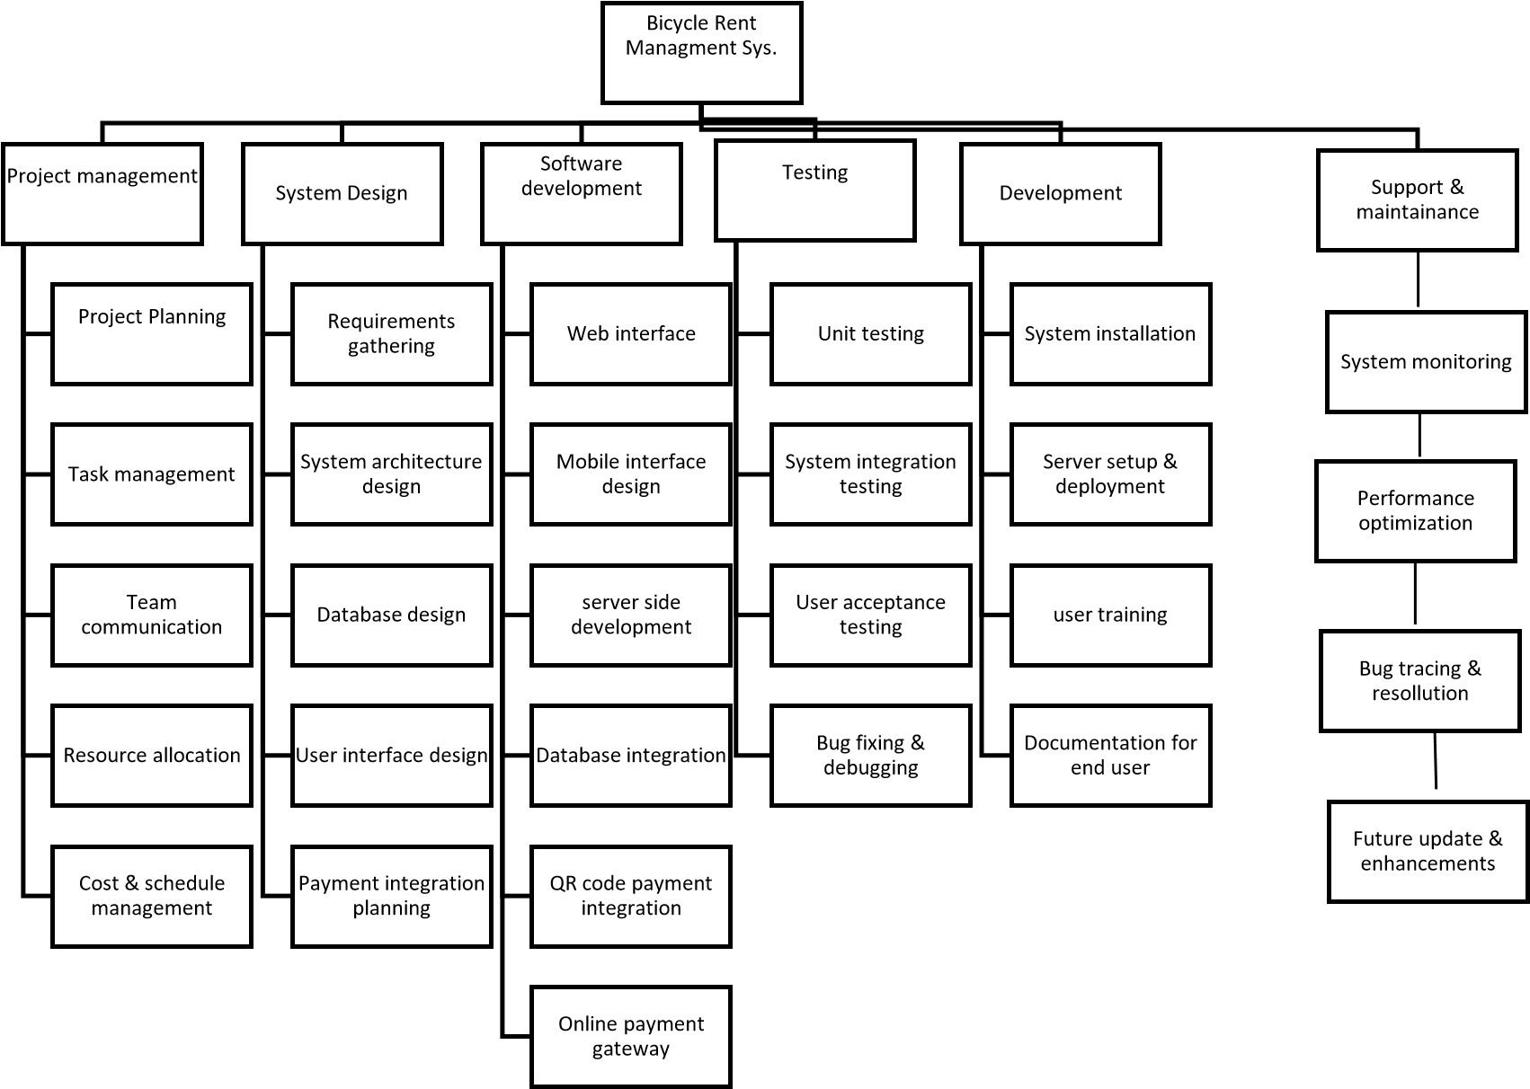

Backlog file

|  |  |  |  |  |  |  |
| --- | --- | --- | --- | --- | --- | --- |
| Group# | Lab Task# | Student  Name and  ID | Assigned Task | Date assigned | Due Date | Comment |
| 7 | 3 | 22-48023-2 | WBS | 18/12/24 | 18/12/24 |  |
| 22-48021-2 | WBS | 18/12/24 | 18/12/24 |  |
| 22-48039-2 | WBS | 18/12/24 | 18/12/24 |  |
| 22-48055-2 | WBS | 18/12/24 | 18/12/24 |  |
| 22-47997-2 | WBS | 18/12/24 | 18/12/24 | Absent for Sickness |
|  |  |  |  |  |
|  |  |  |  |  |  |  |
|  |  |  |  |  |  |  |