**Chapter 1**

**Introduction**

This chapter describes about the project over view background, objectives, scopes, project significance, the expected output and finally the conclusion for this chapter. The project background describes about the general idea of this project or system that is going to be developed. Meanwhile, the problem statements describes about the problems faced by the blood donors and receivers with the current system whereas the objectives are the aims to solve the problems. The project scope covers the system functionalities, the targeted users, the technologies used, system deployment and the chosen methodology to develop OSNB. The project significance states the importance of this project and the parties that will gain benefits from it. On the other hand, the expected output is about the functions and the features that the system will offer and lastly is the conclusion that concludes this chapter.

# Project Background

The system that is going to be developed is Online Social Networking for Blood (OSNB). This is a web-based database application system that is to be used by the blood donors and blood receivers as a means to advertise the Dhaka city blood donation events to the public in order to raise up the public awareness on the events and at the same time allows the public to make online social networking for blood donation and receiving on their desired session. In addition, the system also provides functions for the hospital administrators to manage the appointments made by the donors, the blood stock and donor. The proposed project is for a novel web based application that will help to find out required blood grouped persons instantly, based on the person’s area and blood group and helps to create a community that will help each other by donating fresh blood in the crisis and in any natural disasters strike in any city. Entire process will run by social networking (a network of people by the people) which will lead more chance to get fresh blood for needy people without having much hassle. This system also has the ability to keep track of the donor's donation records and the blood stock in the blood bank.

The intended web application OSNB will divide the entire city with several zones, based on the areas. Each area will have their own blood grouped people and through social networking they will communicate with each other based on the requirement and the location of the patient or intended person who will be requiring the blood.

The area based segmentation will provide the following benefits:

* Due to the same area, no distance travel will be requiring for the intended donor.
* Same area based specific blood donors list can be found and can make communication by email.
* The entire process will be making through social networking activities which will be much effective for instant blood donation and receiving procedure.
* The web site will arrange Camps at various festivals to collect blood through its networked community.
* Publicity to encourage people to donate blood at least twice a year.
* There will be a page to share personal experience which will encourage people to donate blood.
* Google map will use to locate blood donors and blood receiver’s location, distance of the hospital etc.
* Entire city map will show in home page with several zones and the amount of donor in each zone. Graphical representation of donor’s amount in each zone will help to identify site administrator as well as the user of the site to give more effort to increase donors in particular zone.

This project intends to computerize the blood and donor management system using social networking in order to improve the record management efficiency due to the grown size of records of data, time and other resources.

# Problem Statements

Currently, the public can only know about the blood donation events through conventional media means such as radio, newspaper or television advertisements. Even if there is electronic means, it is only used to publicize about that hospital or medical center blood donation drives provided if that hospital or medical center is having an online portal. There is no Dhaka city wide information regarding the blood donation drive available on any of the portal. Besides, for those who want to make blood donation, they cannot make early reservation or booking on the session and day that they are free online. It is a very important facility for those who are very busy and yet enthusiastic people to know

And be sure when they can make blood donation rather than trying to figure out where and when they can make blood donation when they are free. The current system that is using by the blood bank of most of the government hospital is manual system. With the manual system, there are problems in managing the donors' records. The records of the donor might not be kept safely where there might be missing of donor's records due to human error or disaster such as fire or flood. Besides that, human errors might occur when the staff keeps more than one record for the same donor. There is also no centralized database used to keep the donors' records. Each blood bank is having their own records of donors. If a donor makes donation in different hospital, no previous records can be traced except if the donor brings along the donation certificate. Hence, the donor is considered to be a first-timer if they make blood donation in a new place. Without an automated management system, there are also problems in keeping track of the actual amount of each and every blood type in the blood bank. Man-made error such as forget to record the usage or input of the blood can cause the inaccuracy in the amount of certain blood type available in the blood bank. In addition, there is also no alert available when the blood quantity is below its par level. There are some other environmental problems to donate and receive blood in Dhaka city such as traffic jam, financial problem, unavailable hospital, poor knowledge of donating and receiving blood and more.

# Objective

The main objective of this project is to develop an Online Social Networking for Blood (OSNB) using ASP.NET MVC 3, Visual Studio 2010, and SQL Server 2008 with Compact Edition. It keeps record about the blood donor categorized by areas and blood group.

The objectives of the Online Social Networking for Blood (OSNB) are as follows:

1. To provide a means for the hospital's blood bank to publicize Dhaka city information about the blood donation events to the public.
2. To allow the public and organization to make online communication on the day and session that they want or free to make blood donation and blood receiving.
3. To provide an efficient donor and blood stock management functions to the blood bank by providing the logging functions in order to control and trace the workflow.
4. To track available donors and receivers based on the area.
5. According to necessity of blood it will be easier way to donate and collecting blood using social networking trends.
6. To identify nearest blood donors and receivers.
7. Possible to track required blood groups quickly.
8. Searching option for blood.
9. To know your friends by blood.
10. Donate blood directly to patients/seeker.
11. Listing user donation history.
12. Maintaining user blood profile.
13. Separate platform for blood based community.
14. Possible to poke blood donors and blood receivers.
15. Providing the option to send instant message among the donors and receivers.
16. Based on the condition system will send email notification to blood donors and receivers.
17. To provide authentic and authorized features to the current system where private and confidential data can only be viewed by authorized user.
18. To provide the recording functions for every process of the blood in order to keep track of the blood stock accurately.
19. To provide backup and recovery and data integrity features to the database.
20. To improve the efficiency of blood stock management by alerting the blood bank administrator when the blood quantity is below its par level.
21. To provide synchronized and centralized donor and blood stock database to the blood bank.
22. Google map will be used to locate donors and receivers location.

**Chapter: 2**

**OSNB Revie**w **of Relevant Research**

# Case Study

## Dhaka City- Geographical Analysis

The population of Dhaka (areas under the jurisdiction of the Dhaka city corporation) stands at approximately 7.0 million. The city, in combination with localities forming the wider metropolitan area, is home to over 15 million as of 2013. The population is growing by an estimated 4.2% per year, one of the highest rates amongst Asian cities. Dhaka is located in central Bangladesh at 23°42′0″N 90°22′30″E, on the eastern banks of the Buriganga River. The city lies on the lower reaches of the Ganges Delta and covers a total area of 360 square kilometers (140 sq mi). It consists of 22 Thanas under its jurisdiction. Thana name and city map included at below-

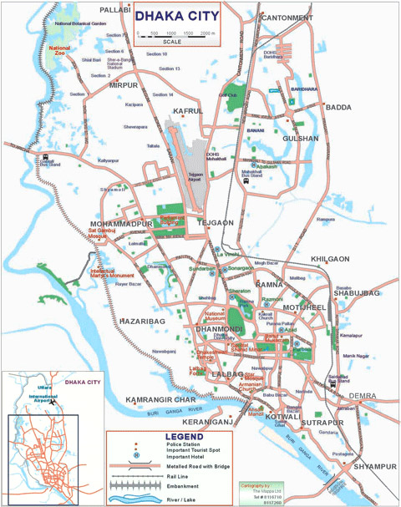

List of area being covered for Online Social Networking for Blood (OSNB) in Dhaka city-

Badda, Biman Bandar,Cantonment,,Dhanmondi,Demra,Kotwali,Gulshan,Hazaribagh,Kafrul,Kamrangir Char,Khilgaon,Lalbagh,Mugda,Mirpur,Mohammadpur,Motijheel,Pallabi,Paltan,Ramna,Sabujbagh,Shyampur,Sutrapur,Tejgaon and Uttra.

# Why Social Network?

In traditional web application usually web site runs under a particular administrator who control the content of the site and manage the site. On the other hand social networking site runs by the people for the people. As a result, if a web application builds as a social networking site to get fresh blood from social community rather than a traditional web application it will be much easier and help full to get blood.

Today, everyone has large personal networks that are easily reachable and readily available due to social network sites including Facebook, Twitter, Linked-in etc. In the blood industry, many studies have been done that shows one of the main reason people don’t donate is because “no one asked them.” When that personal ask comes from someone they know and trust the message becomes more compelling and will end up motivating that individual to give blood.

# Blood Donation

Blood transfusions typically use sources of blood: one's own (autologous transfusion), or someone else's (allogeneic or homologous transfusion). The latter is much more common than the former. Using another's blood must first start with donation of blood. Blood is most commonly donated as whole blood intravenously and collecting it with an anticoagulant. In developed countries, donations are usually anonymous to the recipient, but products in a blood bank are always individually traceable through the whole cycle of donation, testing, separation into components, storage, and administration to the recipient. This enables management and investigation of any suspected transfusion related disease transmission or transfusion reaction. In developing countries the donor is sometimes specifically recruited by or for the recipient, typically a family member, and the donation occurs immediately before the transfusion.

# Blood Type

A blood type (also called a blood group) is a classification of blood based on the presence or absence of inherited antigenic substances on the surface of red blood cells (RBCs). These antigens may be proteins, carbohydrates, glycoproteins, or glycolipids, depending on the blood group system. Some of these antigens are also present on the surface of other types of cells of various tissues. Several of these red blood cell surface antigens can stem from one allele (or very closely linked genes) and collectively form a blood group system. Blood types are inherited and represent contributions from both parents. A total of 32 human blood group systems are now recognized by the International Society of Blood Transfusion (ISBT). The two most important ones are ABO and the RhD antigen; they determine someone's blood type (A, B, AB and O with + and - denoting RhD status).

# Blood grouping systems

A complete blood type would describe a full set of 30 substances on the surface of RBCs, and an individual's blood type is one of many possible combinations of blood-group antigens. Across the 30 blood groups, over 600 different blood-group antigens have been found, but many of these are very rare, some being found mainly in certain ethnic groups. The diagram shows RhD system.

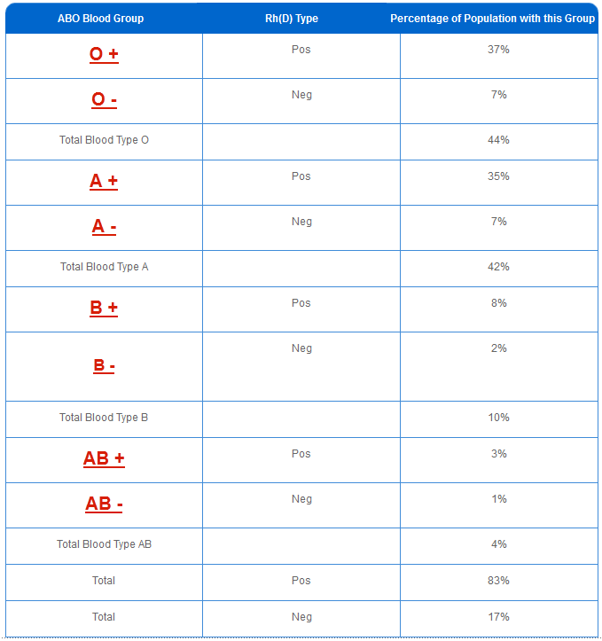

# Blood Donors and Blood Seekers

With regard to transfusions of packed red blood cells, individuals with type O Rh D negative blood are often called universal donors, and those with type AB Rh D positive blood are called universal recipients; however, these terms are only generally true with respect to possible reactions of the recipient's anti-A and anti-B antibodies to transfused red blood cells, and also possible sensitization to Rh D antigens. One exception is individuals with hh antigen system (also known as the Bombay phenotype) who can only receive blood safely from other hh donors, because they form antibodies against the H antigen present on all red blood cells.

Blood donors with particularly strong anti-A, anti-B or any atypical blood group antibody are excluded from blood donation. The possible reactions of anti-A and anti-B antibodies present in the transfused blood to the recipient's RBCs need not be considered, because a relatively small volume of plasma containing antibodies is transfused.

By way of example: considering the transfusion of O Rh D negative blood (universal donor blood) into a recipient of blood group A Rh D positive, an immune reaction between the recipient's anti-B antibodies and the transfused RBCs is not anticipated. However, the relatively small amount of plasma in the transfused blood contains anti-A antibodies, which could react with the A antigens on the surface of the recipients RBCs, but a significant reaction is unlikely because of the dilution factors. Rh D sensitization is not anticipated.

Additionally, red blood cell surface antigens other than A, B and Rh D, might cause adverse reactions and sensitization, if they can bind to the corresponding antibodies to generate an immune response. Transfusions are further complicated because platelets and white blood cells (WBCs) have their own systems of surface antigens, and sensitization to platelet or WBC antigens can occur as a result of transfusion.

With regard to transfusions of plasma, this situation is reversed. Type O plasma, containing both anti-A and anti-B antibodies, can only be given to O recipients. The antibodies will attack the antigens on any other blood type. Conversely, AB plasma can be given to patients of any ABO blood group due to not containing any anti-A or anti-B antibodies.

**Chapter: 3**

**Tools & Techniques Used For OSNB**

Web-based hypermedia systems are becoming more and more sophisticated, new modeling requirements constantly arise, and design models must constantly evolve. Since design tools should complement models to support an efficient design process, model evolution raises a technological issue: Design tools must be modified when their underlying model changes. This is why the paper proposes a general approach to efficiently update design tools in response to model evolutions. The key ideas are: a) the description of a hypermedia model in terms of a general meta-model, powerful enough to express the semantics of current and future design constructs; b) the transformation of a hypermedia design tool into a meta-CASE tool, able to cope with model updates without requiring be redefining and rebuilding from scratch. The tools and technologies used to develop OSNB are listed as below:

1. Operating System: Windows 7 Professional Edition
2. Integrated Development Environment (IDE) tool: Microsoft Visual Studio 2010
3. Database Management System (DBMS): SQL Server Express edition
4. Server Container: MS IIS
5. Technology: ASP.Net 3.2, JQuery, XML, JavaScript, Ajax, HTML, CSS
6. System Architecture: Model-View-Controller (MVC)
7. Browser: Internet Explorer 6.0 and above
8. Graphical User Interface (GUI) design: Adobe Photoshop CS5 Design Premium
9. Documentation:
10. Report: Microsoft Word 2010
11. Unified Modeling Language (UML) Diagrams: Rational Rose 2

**Chapter: 4**

**Development & Implementation**

The OSNB will be deployed in the National Blood Center, which is the center to manage and co-ordinate the blood bank, blood stock, staffs and donors. Other places such as the participating hospitals' blood bank and the branch blood centers are linked to the Dhaka city donors and receivers through the Internet.

# Scope of Methodology

There are two types of methodologies to be used in developing OSNB, namely the Object Oriented Analysis and Design (OOAD) and the Database Life Cycle (DBLC). OOAD is used as methodology to develop OSNB as a whole while DBLC is used in database development and maintenance. The detail Explanation of both methodologies will be presented in the coming chapter.

# Project Significance

Inadequate blood supplies at the hospitals and medical sectors have always been a problem. To create awareness among public of importance of donating blood, an effective means that available at all the time plays a crucial role in providing such information. With the implementation of this project, the blood bank is the organization that will gain the most benefits from. This is because of the risen of the public awareness on the blood donation events by advertising the blood donation events at 24hours a day and 7 days a week basis. Moreover, the system also provides convenient way for the public to make online reservation on their desired session. The National Blood Center administrator will be able to manage and coordinate the blood supply among the blood banks of the hospitals and medical center more efficiently as they can view the records of blood stocks in all participating hospitals. Besides, the blood bank top-level management staff can manage the blood and donor records more efficiently with better security and added automation function in alerting the administrator when the blood quantity is below par level. In addition, the administrator can also trace the person responsible in case of human error such asfault blood transfusion and blood screening result. The top-level management staff can also manage the system user more efficiently by giving each staff different access level. The blood bank medical lab technicians also gain the advantage of having an automation system in assisting higher work. This is because works can be done in more systematic and organized way when managing the blood stock in blood banks. This system also creates a convenient and paperless environment for the doctors and nurses in managing and processing the incoming donors and the blood stocks **as** the donors' records have been centralized. The registration time for old donor is shortening as the records are retrievable from the system. The suggested approach to develop this system, which is the Object-Oriented approach, is the best approach as the system will be more maintainable. According to Summerville (2001), objects are independent and thus they may be understood and modified as stand-alone entities. Changing the implementation of an object or adding services should not affect other system objects. Another advantage of using object-oriented approach in developing a system is reusable. By reusing the standard Objects or objects that have been created in the previous project, both the cost and the risk of developing the software can be reduced.

# Expected Output

The expected output from this project is the Online Social Networking for Blood (OSNB) which has two (2) main portals, one for the) public and another one for the administrator. The public portal has the functions of displaying the blood donation events to be held and allowing the public by social networking. On the other hand, the administrator portal has the functions for the Administrator to manage appointments publicizes the blood donation events, manage system users, donors and blood stocks and generate reports. Besides, some automation function such as giving alert to the administrator when the blood quantity is below par level is also provided. The kinds of reports that will be generated by the system are the blood quantity in the blood bank and workflow for each blood donation process.

# Model-View-Controller (MVC)

According to Martin Fowler, Model-View-Controller (MVC) is a system architecture that separates application into three main components, namely the model, view and controller, each playing different roles. Model is the main functionality or the domain-specific representation of the information, views are the user interfaces and the controllers are the ones who respond to user actions and invoke appropriate changes on the model and view. The purpose of separating the application is to make sure that the modification to one component will cause the least impact to the others and thus promoting system maintainability.

This architecture is especially useful in a system where there exist many types of users with many different levels of authorization. Different styles of display or data are required to facilitate different types of users. No duplicate user interface needed to be created as the model and controller will detect and react according to user role. This is because MVC architecture supports multiple presentations of data and separate styles of interaction with each presentation.

# Facts and Findings Summary

In Case Study, the interest is based on the features available on the systems, which are the technologies (Case Study) and the advantages to upload system database so that it is available online management. In the latter part, the facts and findings are based on the extra features that are going to be added to the OSNB if the time is enough. After studying so many approaches and ways to backup and recovery database, the best way to consider is to export the database data into text file and then import the data back to repopulate the database. This way also offers other advantages such as the ease in inserting bulk of initial data into the database, better database performance and also more convenient for data movement. The findings on ways to import and export text files aid in affirming that although using the DBMS utilities offers more advantage than using application program, but this decision is really DBMS dependent as not all the DBMS provide sufficient utilities and tools that able to facilitate all kind of requirements especially those that cater for validating data format. Consequently, for OSNB, may be a mix of database utilities and program logic will be used in order to make sure that the application takes advantage of the database utilities but at the same time perform validation and reformatting on the input and output file. Besides, the system architecture that is going to be used is also studied in

order to make sure that the choice is the correct one. As the OSNB has a wide range level of users, each with different roles and access right, so it is wise to use the MVC as the system architecture in order to make the system more maintainable, stable and portable.

# Project Methodology

The project methodology plays an important role in influencing the system quality. Hence, the approach to be adopted must be chosen carefully before going into the analysis phase. For this project, the Object-Oriented Analysis and Design (OOAD) approach has been chosen as the project methodology after weighing the advantages to be gained and its suitability for the OSNB, which is the application

to be developed for this project. The methodology involved in database development of the OSNB is the

Database Life Cycle (DBLC). According to Coronel [15], the DBLC contains six (6) phases, namely database initial study, database design, implementation and loading, testing and evaluation, operation, and maintenance and evolution.

# Database Initial Study

The overall purpose of the first phase of DBLC, which is the database initial study, is to analyze the blood bank situation, define the problems, constraints, objectives, and scopes and boundaries. When analyzing the blood bank situation, the blood bank's operational components, how they function and how they interact are discovered. This then leads to problem definitions. During problem discovery process, the problems solutions or the objectives are defined. After that, the scope and boundaries of the database design that includes data structure, the type and number of entities (for example, blood, staff, donor, etc.), the physical size of the database, the software to be used and so on are identified.

# Database Design

During this phase, the database conceptual, logical and physical designs are performed. The conceptual design requires the end-user views, outputs, and transaction-processing requirements to be determined. The next step to perform during this phase is to select DBMS software to be used based on its cost, features and tools available, portability, underlying model and the hardware requirements. The database design phase is then continued by performing the logical design where the conceptual model is translated into definitions of tables, indexes and views. Only certain tables such as blood details and system users need to have view as not all of the records are made visible to all users. Lastly, the physical design is performed where the data storage and data access characteristics are defined. Such design is crucial as it will affect the performance of the system.

# Database Implementation and Loading

During this phase, the performance, security, backup and recovery, integrity and concurrency control are the aspects needed to be taken into account. The factors that affect database performance are the data placements, access path definition, the use of index and the buffer size. Security must be applied during database implementation as data must be protected from access by unauthorized users. This can be done by using physical security, password security, access rights, audit trails, and data encryption on the private and confidential column such as password. Data backup and recovery is a very important process in order to ensure the availability of the consistent data as the database can be subject to data loss through unintended data deletion or power outages. The OBDRMS may use logical backup as the backup and recovery strategy. Data integrity is enforced through the use of primary and foreign key rules. With the enforcement of concurrency control, the simultaneous access to a database is allowed while preserving data integrity. All of the stated factors above can be implemented by using the Data Definition Language (DDL), Data Manipulation Language (DML) and Data Control Language (DCL).

# Database Testing and Evaluation

After the data have been loaded into the database, the database is tested for its performance, integrity, concurrent access, and security constraints. Normally, the testing and evaluation phase occurs in parallel with application programming. The testing covers the database connectivity with the application program and the successfulness of executing the Structured Query Language (SQL) statements embedded in the application program.

# Database Operation

The database is said to be in operational stage after it passes evolutionary stage. At this point, the database, its management, users and the application program forms a complete information system. It is also stages where the problems that had not been foreseen during testing phase begin to surface and thus the fixing of problems also takes place.

# Maintenance and Evolution

The periodic maintenance activities such as backup and recovery, security role assignments, security audits and performance enhancements are performed in order to make sure that the database functions as it supposed to be.

# Use Case Model for OSNB

OSNB primary functionality has been outlined using Use Case model diagram segmenting into sub system.





# Class and Concept Diagram for OSNB

## Class Diagram

OSNB Class diagram is a static diagram and it is used to model static view of a system. The static view describes the vocabulary of the system. OSNB Class diagram is also considered as the foundation for component and deployment diagrams. Class diagrams are not only used to visualize the static view of the system but they are also used to construct the executable code for forward and reverse engineering of the system. Generally UML diagrams are not directly mapped with any object oriented programming languages but the class diagram is an exception. OSNB Class diagram clearly shows the mapping with object oriented languages. So from practical experience class diagram is generally used for construction purpose. So in a brief, OSNB class diagrams are used for:

* Describing the static view of OSNB.
* Showing the collaboration among the elements of the static view of OSNB.
* Describing the functionalities performed by OSNB.
* Construction of software applications using object oriented languages.

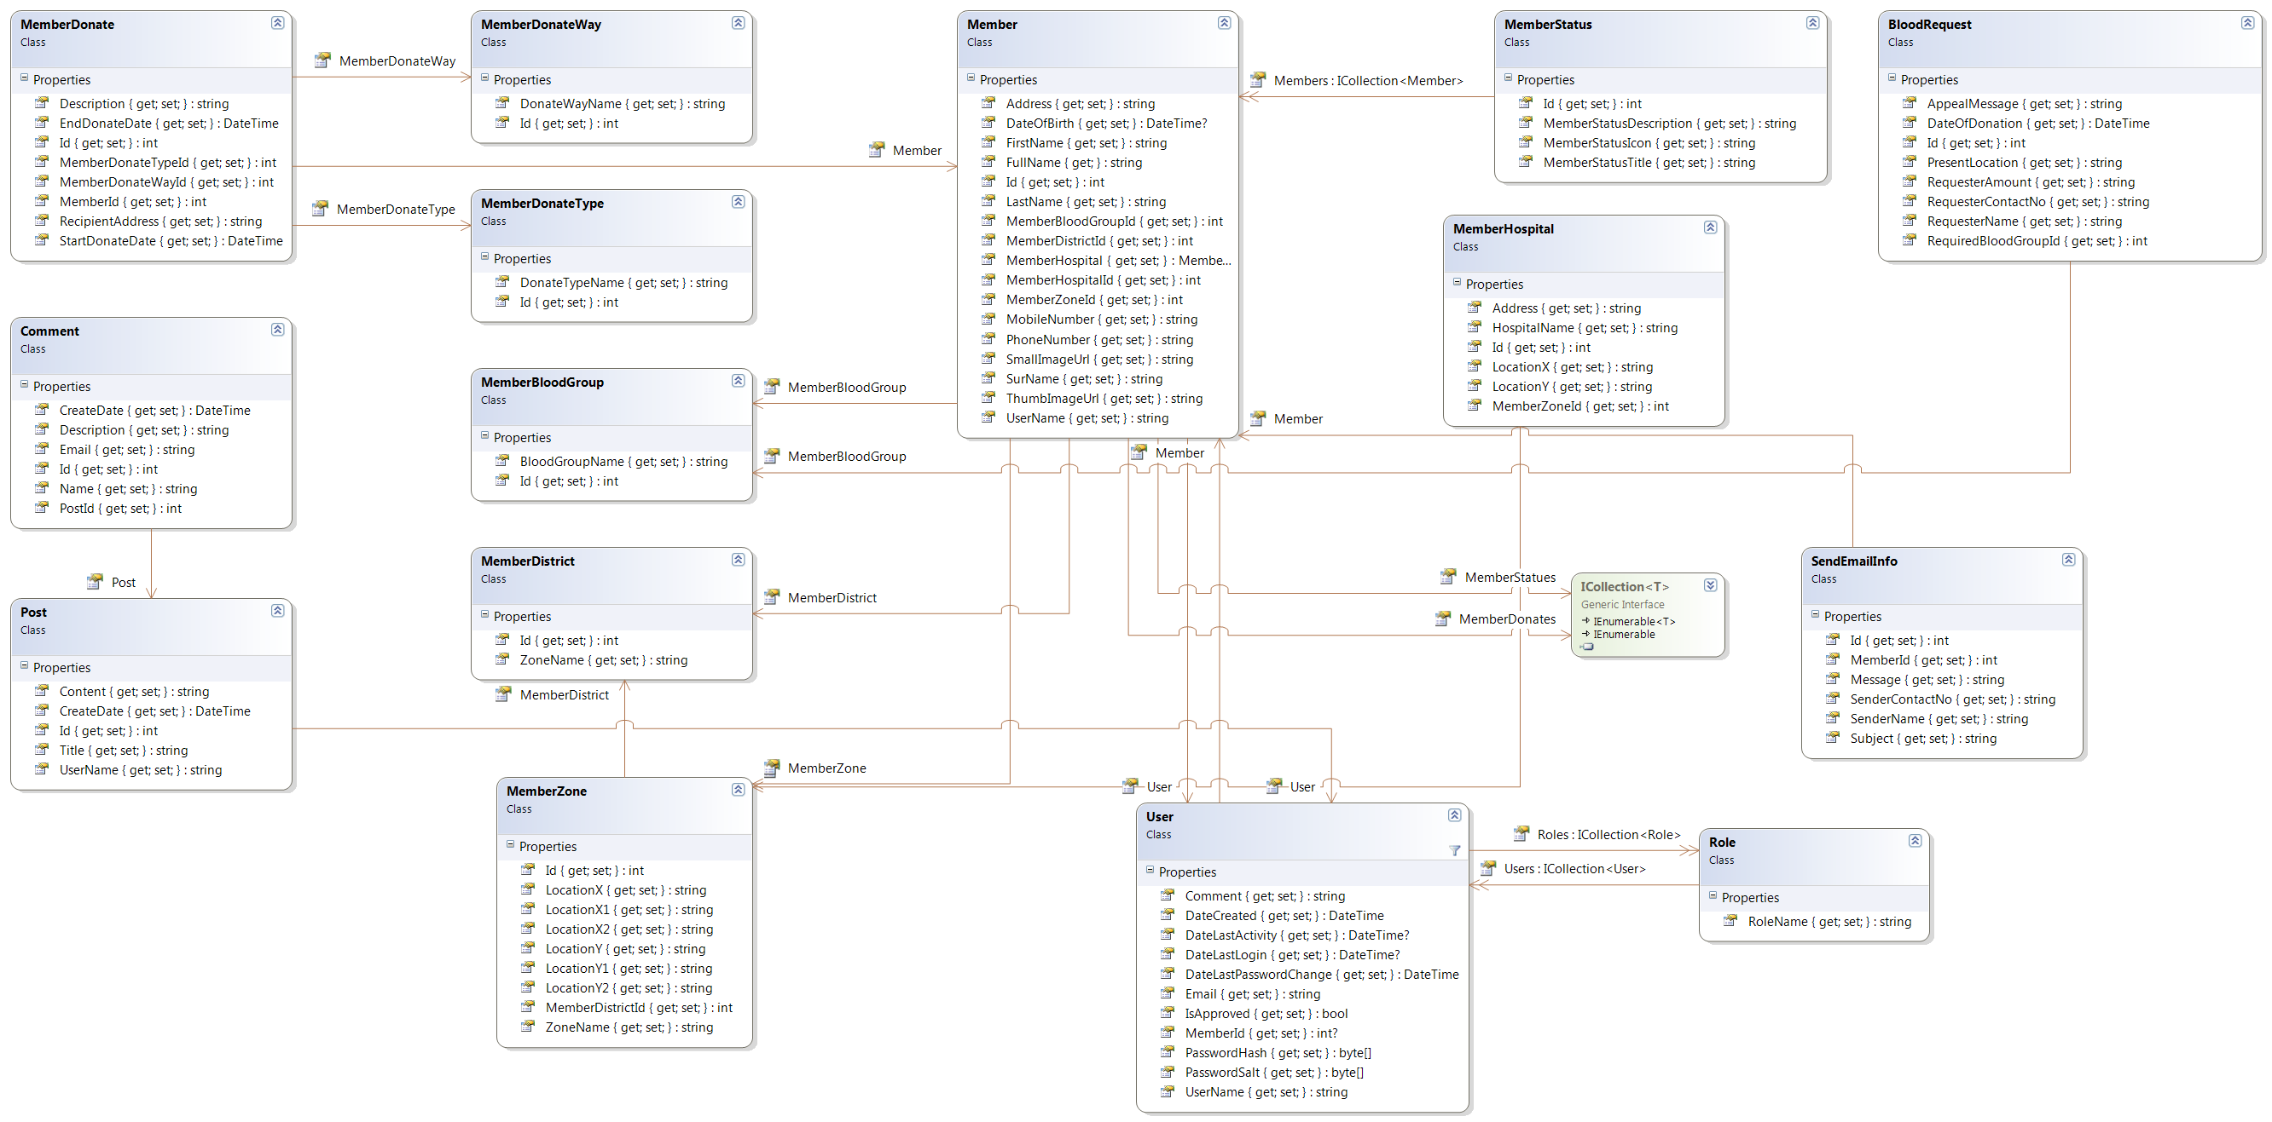

## Concept Diagram

OSNB Concept Diagram is a graphic organizer that assists in clarifying central concepts in a reading selection and in relating similar or associated information to this key idea about the system. The OSNB Concept diagram has been built on these following steps:

* **C**onvey the central idea.
* **O**ffer the overall concept.
* **N**ote any key words.
* **C**lassify characteristics.
* **E**xplore examples (and non-examples).
* **P**ractice with new examples.
* **T**ie down the definition.

OSNB Concept diagram and its contents are described clearly below-



# Process Flow Diagram for OSNB

A Process Flow Diagram - PFD shows the relationships between the major components in the system. PFD also tabulate process design values for the components in different operating modes, typical minimum, normal and maximum. A PFD does not show minor components, piping systems, piping ratings and designations.

OSNB PFD includes:

* Process Piping
* Major equipment symbols, names and identification numbers
* Control, valves and valves that affect operation of the system
* Interconnection with other systems
* Major bypass and recirculation lines
* System ratings and operational values as minimum, normal and maximum flow, temperature and pressure
* Composition of fluids

This figure depicts a small and simplified PFD of OSNB:

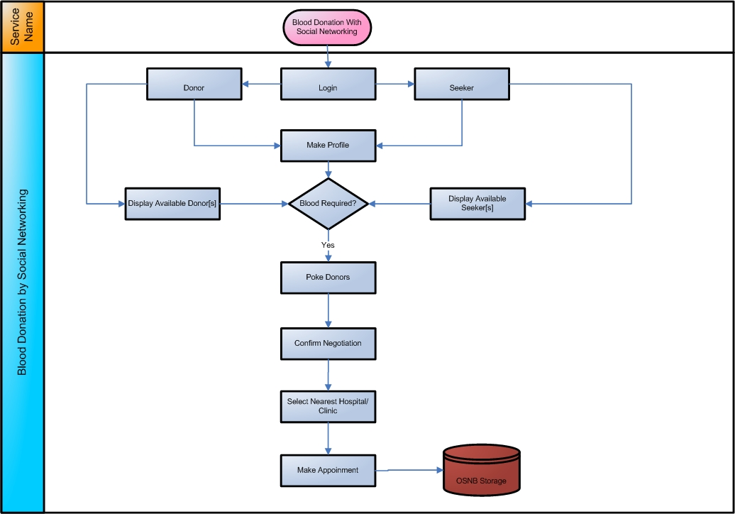

# OSNB User Interfaces

A user interface, also called a "UI" or simply an "interface," is the means in which a person controls. A good user interface provides a "user-friendly" experience, allowing the user to interact with the software or hardware in a natural and intuitive way. Here some of important Interfaces have been shown in an order-

## OSNB Home UI

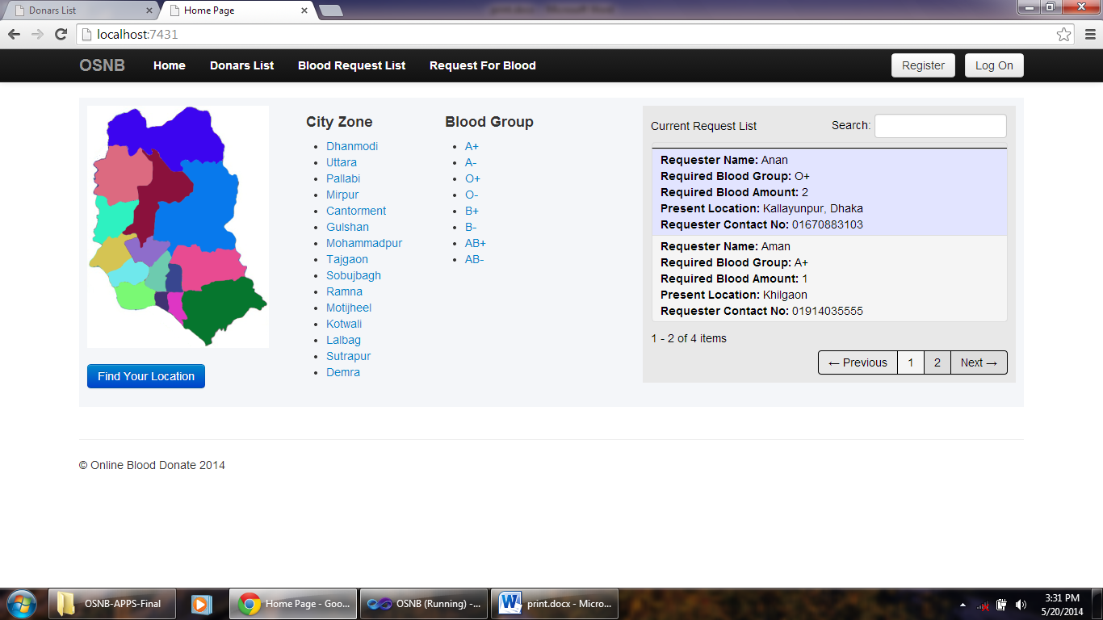

## Add Member UI

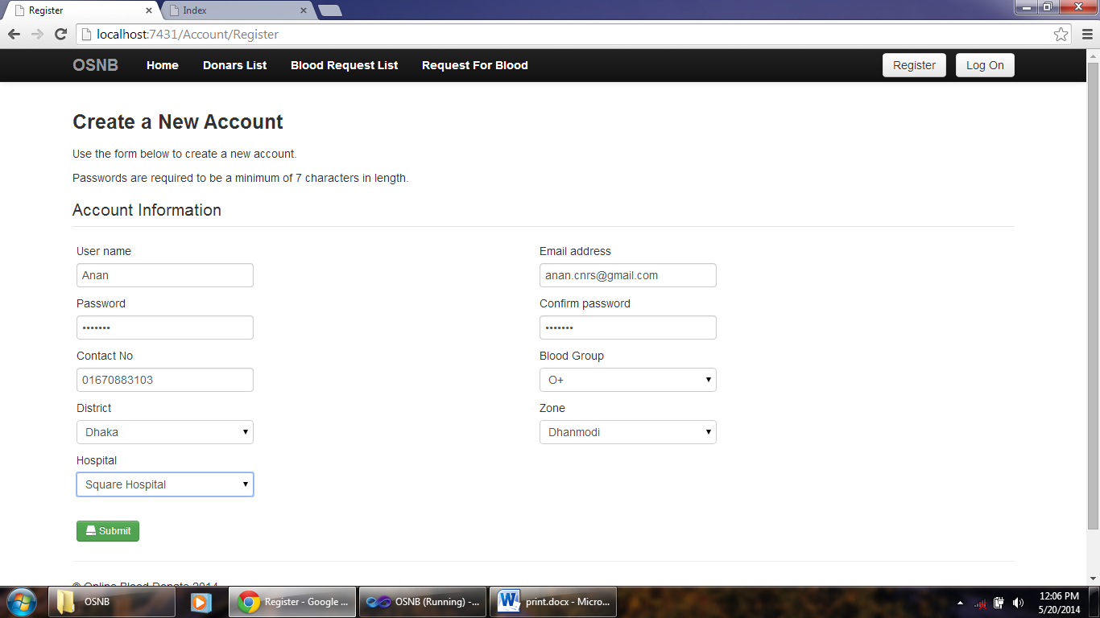

## Add Member Hospital UI

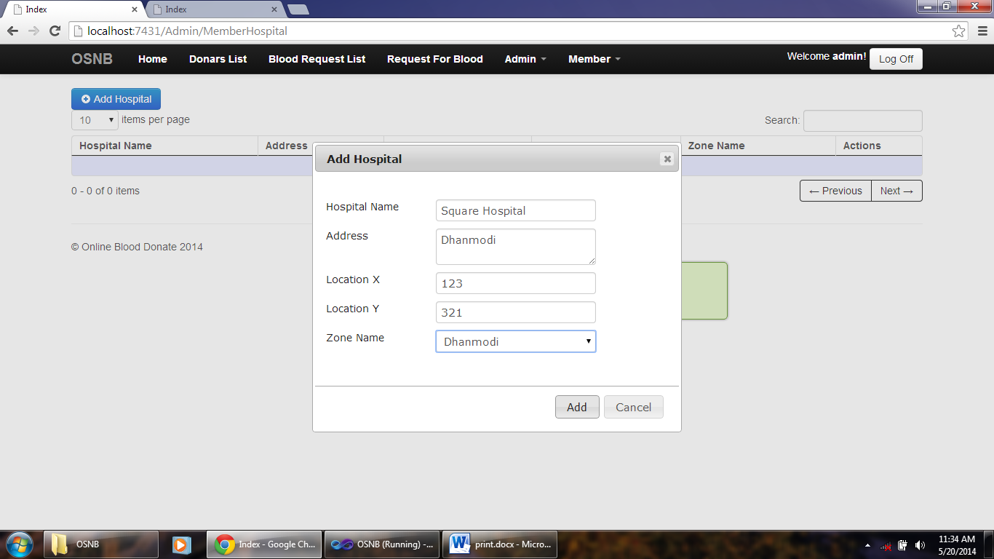

## Add Member Zone

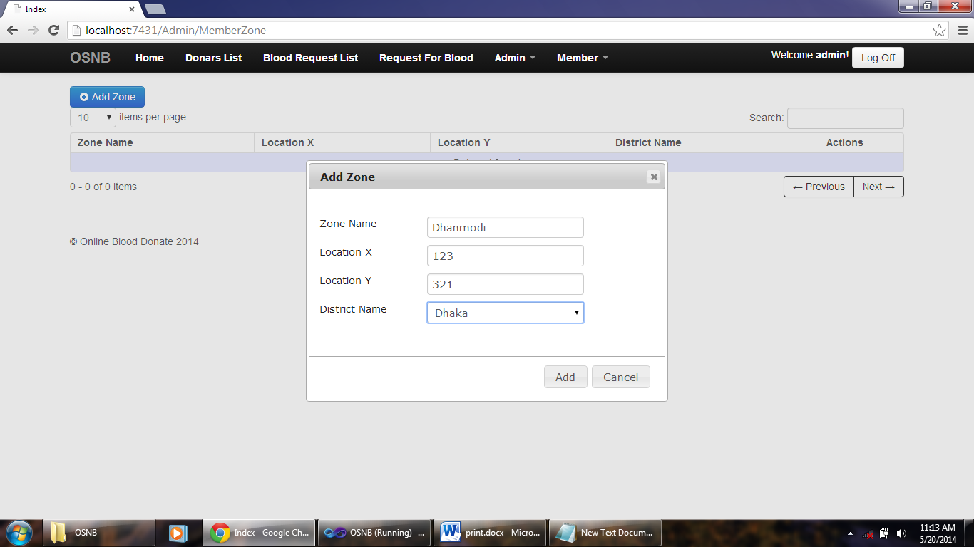

## Add Member District UI

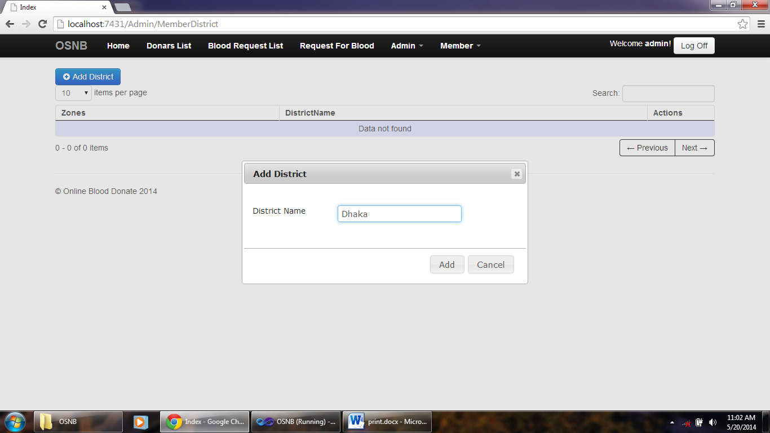

## Add Blood Group UI

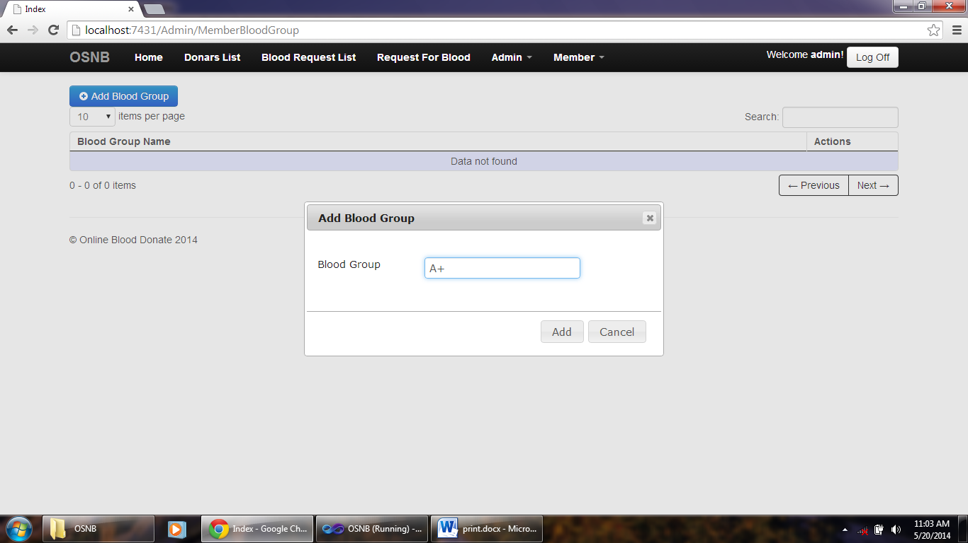

## Donor List UI

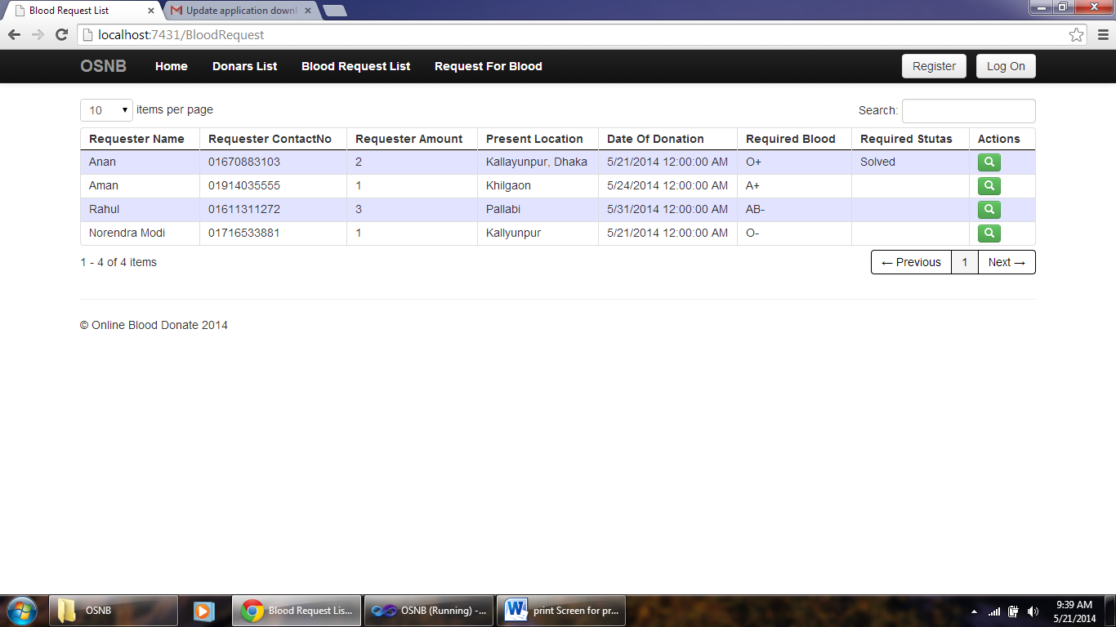

## List of Request Blood UI

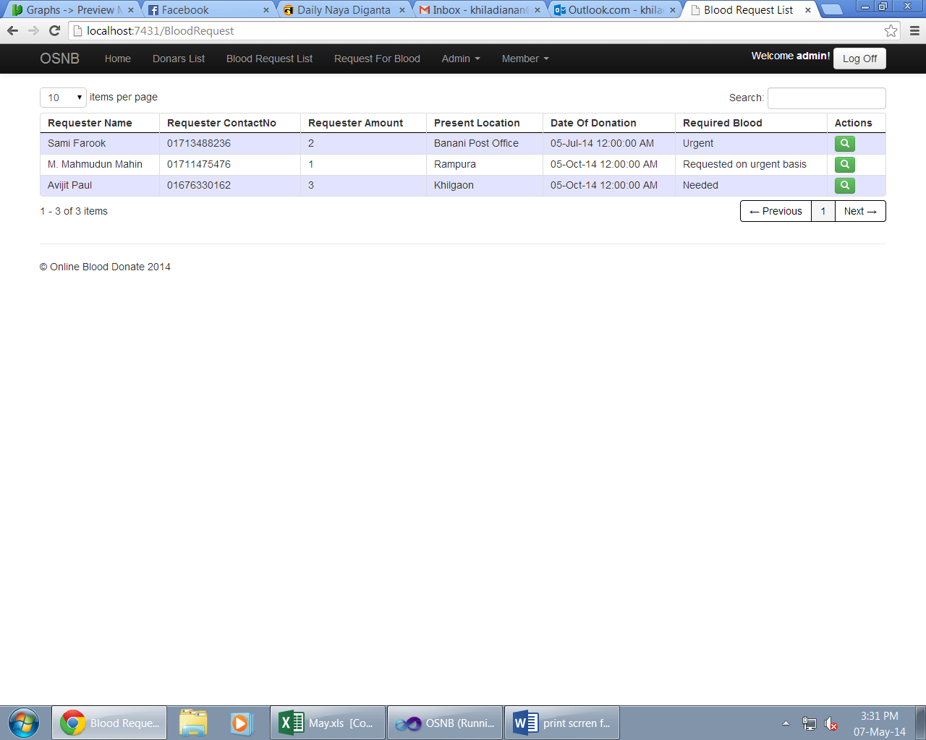

## Request for Blood UI

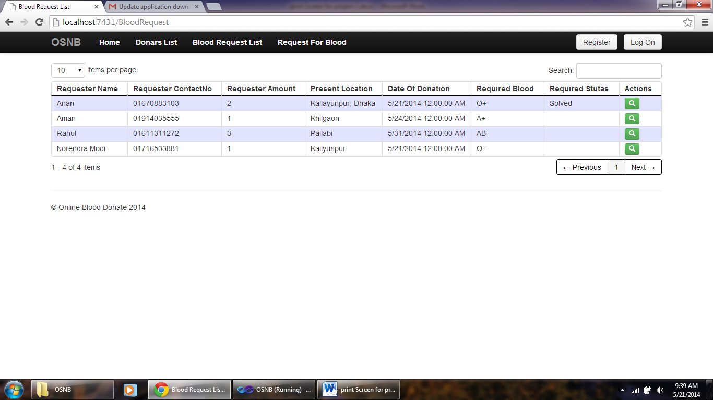

## Add User UI

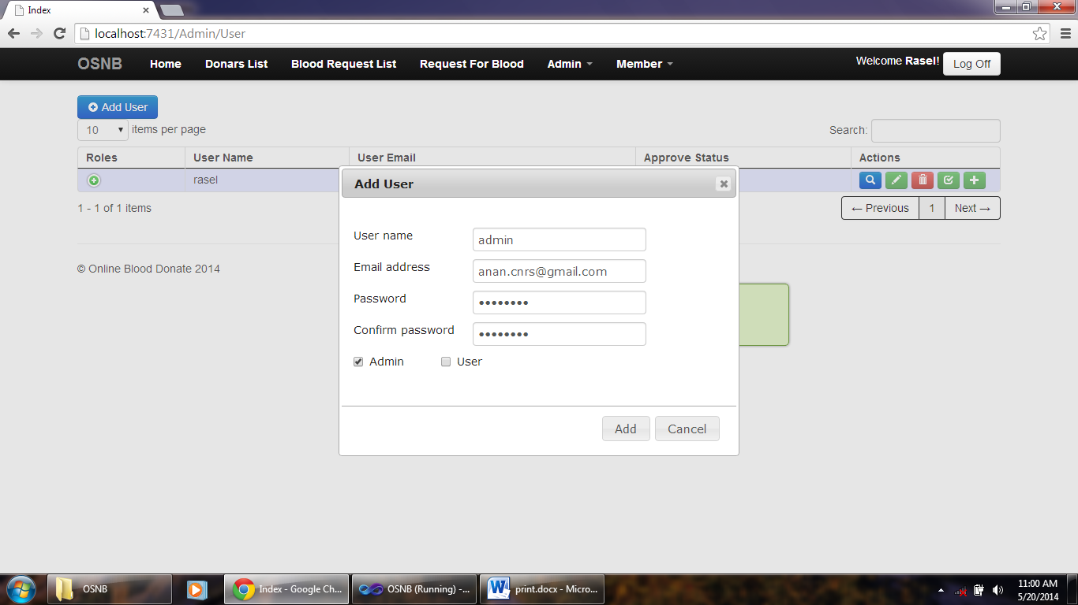

## Add Role to User UI

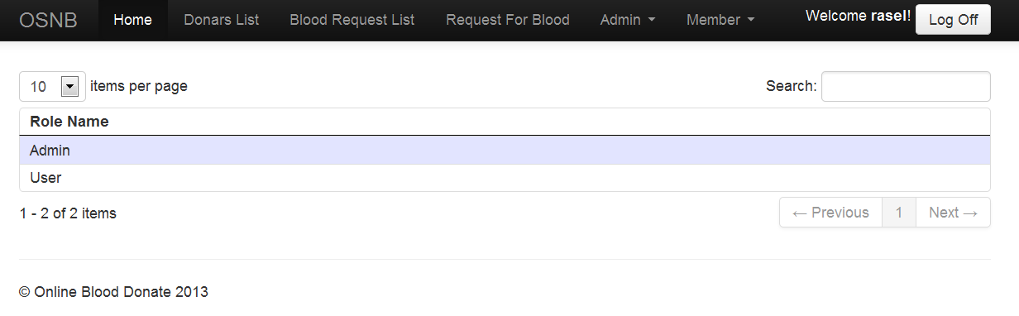

## Send a message to User UI

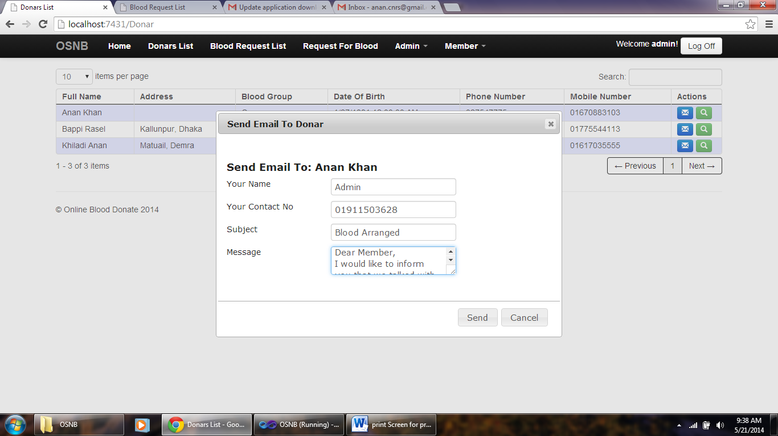

## Receive a message from Admin UI

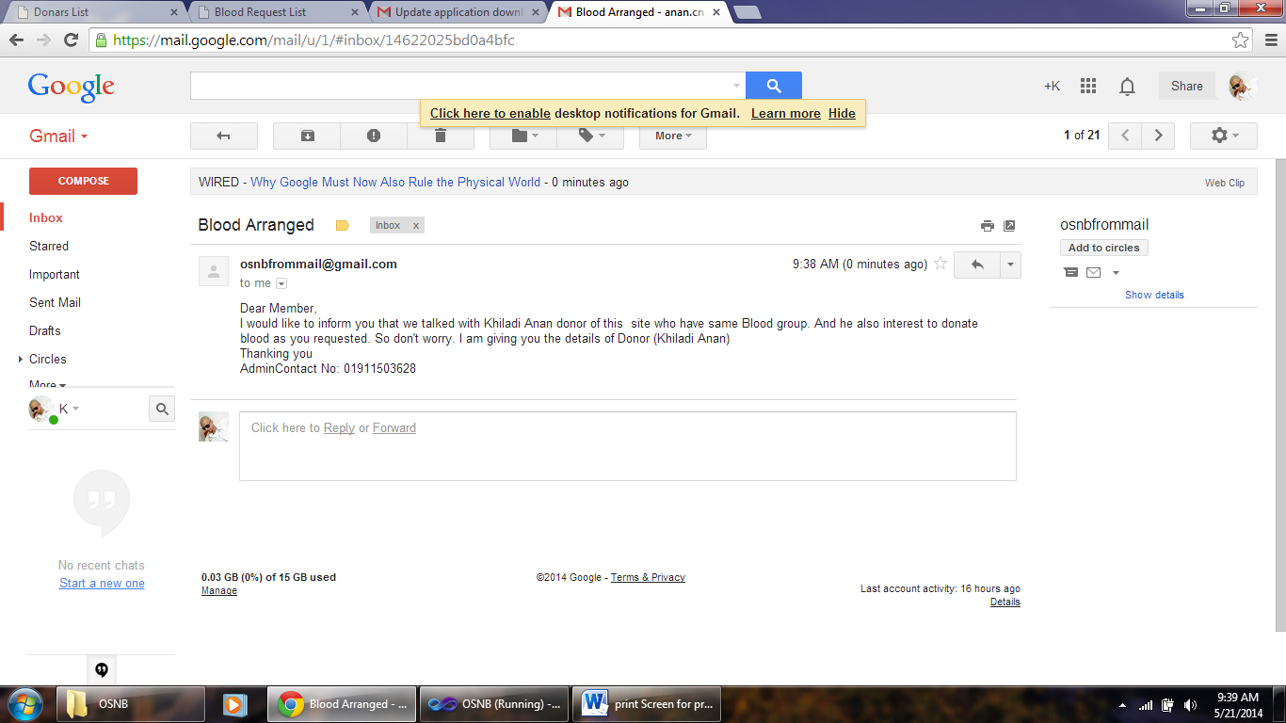

**Chapter: 5**

**OSNB Evaluation**

To evaluate ONSB it has sent to Mr. Abu bakker siddik CEO of ushasoft. He run the system and two doctors use the system to evaluate.

# Evaluated by

* Dr. Iqbal (General Surgeon, Dhaka P.G. Hospital)
* Dr. Sirajul Islam Chowdhury (Pharmacist, Habiganj Sodor Hospital )

# OSNB General Assessment

A web site produces good visual impression. Navigation is clear; all pages are lightweight and load quickly. There are 6 broken links in a website, which should be fixed. Navigation systems are clear to a normal user. Some windows open in new windows, which is not a good practice.

# Accessibility

Each accessibility rule is marked by standard’s requirements. For example: [508 (O)] – Provision “O” of the US Section 508 [W3C 13.6 (3)] – WWW Consortium accessibility standard, WCAG 1.0, Rule 13.6, priority 3, Website navigation, missing content, header markup, color contrast etc.

# Privacy and Security

OSNB privacy protects the personal information the federal government keeps on you in “systems of records (SOR)” (information an agency controls that can be retrieved by name or some other personal identifier). The Privacy Act regulates how the government can disclose, share, provide access to, and maintain the personal information that it collects. Not all information collected online is covered by the Privacy Act.

For site security purposes and to ensure that this service remains available to all users, OSNB employs monitors and filters to identify and block unauthorized attempts to upload or change information, or otherwise cause damage to the information on our Web pages. Unauthorized attempts to upload or change information on this site are strictly prohibited and may be punishable under the Computer Fraud and Abuse Act of 1986 and the National Information Infrastructure Protection Act. Except for these authorized law enforcement investigations, no other attempts are made to identify individual users or their usage habits.

**Chapter: 6**

**Future of the Project**

Due to short of time it was difficult to implement such a big idea. In future this project can be developed in such a way that will meet all the end user requirements such as

* Send notification through mobile sms rather than email.
* Blood donors and receivers can do online chat in the system.
* Google street view can show specific location of donors/receivers location.
* Group email or mobile sms can be send if any unfortunate disaster strike in the city
* Blood donation campaign can be managed by this system.
* Financial donation can be rise by this system to help poor people.
* User interface can be improved for the better use of this system

**Chapter: 7**

**Conclusion**

After defining and identifying the project background, problem statements, project’s objectives, scopes, project significance and lastly the expected output, the features and functions provided by the OSNB, which are allows for online publication of blood donation events, online communication and records management system, are adequate to solve the problems faced by the hospital blood bank such as Inefficiency in publication by using solely traditional advertising media or the publication of just the donation drives for that particular hospital or medical center and inefficiency in records management. By developing this application, the hospital will benefit from having a more efficient and effective OBDRMS to manage the database in blood banks.

OSNB evaluation project was a very ambitious undertaking. Not only did it entail the implementation of two vastly different prototypes using related, but incompatible technologies, it also entailed the evaluation of these prototypes and – primarily – the interaction scheme of information items the prototypes are intended to visualize. Hence, this project was essentially two projects in one: The implementation portion and the evaluation.