Curriculum Vitae 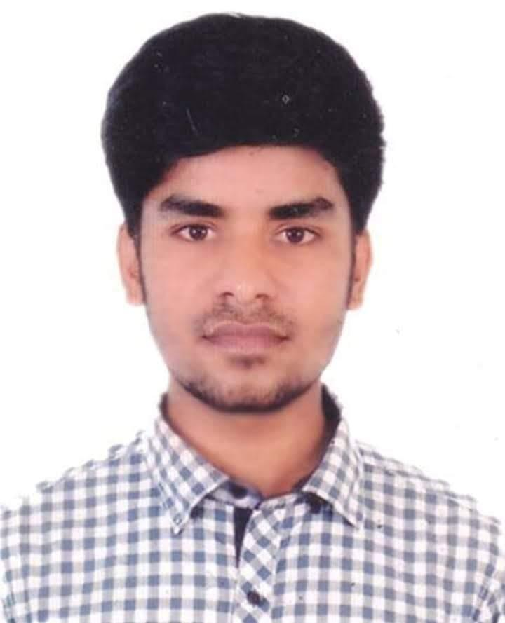

Md. Rasel Hossain

B.Sc in CSE from Daffodil International University

Mobile: +8801776683838

Email: rhhossain333@gmail.com

Git Link :<https://github.com/raselcse01>

LinkedIn: <https://www.linkedin.com/in/rasel-hossain001>

Career Objective:

I am a web developer with a strong interest in projects requiring conceptual and analytical thinking and developing different types of Application. I enjoy developing websites with end-users in mind.

EXPERIENCES:

* Final year project **“**IoT Based RFID Smart Parking System” (C)
* Student Management System.(Django)
* Electronic Ecommerce Project (Django)
* CRUD , API_CRUD, CVCreate (Django)
* Design “Facebook Page” used HTML5, CSS3 and Bootstrap.
* Besides, I have done so many projects as practice.

SKILLS:

* Good knowledge on OOP, Data Structure and Algorithm
* C, JavaScripts, Python
* HTML5, CSS3
* MySQL(Database)
* SQLight3
* Bootstrap
* Has strong power on development

EXTRA SKILLS:

* Django (Framework)
* Django REST API
* Git and GitHub
* Much better in person and Team work.
* Has strong communication skills in both Bangla and English.

PERSONAL PROFILE:

Father’s Name : Md. Azmot Ali

Mother’s Name : Rowshonara Akter

Date of Birth : 29/06/1999.

Permanent Address : Village: Charigram, P.O: Charigram

P.S : Singair, Dist: Manikganj.

Marital Status : Unmarried

Religion : Islam.

Nationality : Bangladeshi.

NID : 330 776 0458

ACADEMIC QUALIFICATION:

**2022 B.Sc in Computer Science and Engineering**

Institute : Daffodil International University

Result : 3.06 out of 4.

**2017 HSC (Higher Secondary Certificate)**

###### Group : Science

Institute : Singair Degree College

Board : Dhaka

Result : 4.00 out of 5.

**2015 SSC (Secondary School Certificate)**

###### Group : Science

Institute : Charigram S.A. Khan High School

Board : Dhaka

Result : 4.39 out of 5.

DECLARATION:

I am Md. Rasel Hossain, hereby declares that all the information I have given above is true and correct to the best of my knowledge and I have acquired the right knowledge.

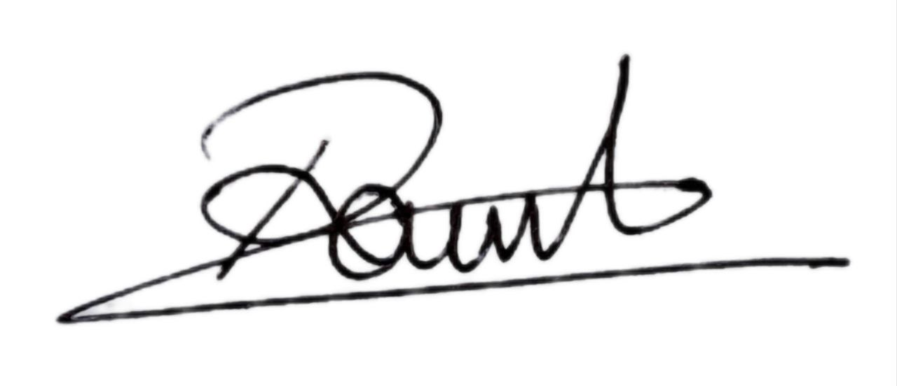

Signature: