Bootstrap 5

form-control

disabled

**form-control-lg**

**readonly**

**class="form-control-color form-control"**

**<input class="form-control" list="datalistOptions" id="exampleDataList" placeholder="Type to search...">**

**<datalist id="datalistOptions">**

**<option value="San Francisco">**

**<option value="New York">**

**<option value="Seattle">**

**<option value="Los Angeles">**

**<option value="Chicago">**

**</datalist>**

**class="form-select form-select-lg"**

**class="form-check-input"**

**<div class="form-check form-switch">**

**<input class="form-check-input" type="checkbox">**

**</div>**

**<input type="range" name="" id="" class="form-range">**

**<input type="range" class="form-range" min="0" max="5" step="2" id="customRange3">**

**<div class="form-group">**

**<label for="">Enter Your valid website url: </label>**

**<div class="input-group input-group-lg">**

**<span class="input-group-text">https://www.</span>**

**<input type="text" class="form-control form-control-lg">**

**<span class="input-group-text">.com</span>**

**</div>**

**</div>**

**<div class="form-group">**

**<div class="input-group input-group-lg">**

**<span class="input-group-text">**

**<input type="checkbox" class="form-check-input">**

**</span>**

**<input type="text" class="form-control">**

**</div>**

**<div class="input-group input-group-sm">**

**<span class="input-group-text">**

**<input type="radio" name="" id="" class="form-check-input">**

**</span>**

**<input type="text" class="form-control">**

**</div>**

**</div>**

**\*\*Floating_form**

**<div class="form-floating mb-4">**

**<input type="text"  class="form-control " id="textinput" placeholder="Enter Your Username">**

**<label for="textinput">Username</label>**

**</div>**

**ACCORDION

**<div class="accordion">**

**<div class="accordion-item">**

**<h2 class="accordion-header">**

**<button class="accordion-button" data-toggle="collapse" data-target="#sampleaccordion">More Information**

**</button>**

**</h2>**

**<div class="accordion-collapse collapse show" id="sampleaccordion">**

**<div class="accordion-body">**

**<p>Lorem ipsum dolor sit amet, consectetur adipisicing elit. Fugit consectetur ipsam ducimus! Harum dolore nobis dolorum debitis architecto in, quae veritatis officia laudantium qui hic id temporibus sequi ullam reiciendis fugiat ducimus placeat mollitia eius quo at neque voluptatum tempora. Sequi provident reiciendis molestias accusamus necessitatibus, odit hic est soluta.</p>**

**</div>**

**</div>**

**</div>**

**</div>**

**<div class="accordion accordion-flush**

**">**

**<div class="accordion-item">**

**<span class="accordion-header" style="cursor: pointer;">**

**<span class="accordion-button" data-toggle="collapse" data-target="#newcollapse"></span>**

**</span>**

**<div class="accordion-collapse collapse" id="newcollapse">**

**<div class="accordion-body">**

**<p>Lorem ipsum dolor sit amet consectetur adipisicing elit. Dolore magni modi eius itaque sed corrupti cum quas doloribus quibusdam consequuntur, animi et. Quas enim sed aspernatur odit modi aliquid repellendus. Quibusdam accusantium velit rerum blanditiis minima iusto tenetur quidem error minus similique alias nisi neque dicta expedita porro, id eos.</p>**

**</div>**

**</div>**

**</div>**

**</div>**

**Alert

**<div class="alert alert-primary">**

**<p>Lorem ipsum dolor sit amet consectetur adipisicing elit. Officiis quam necessitatibus, voluptas</p>**

**</div>**

**<div class="alert alert-primary">**

**<p>A simple primary alert with <a href="#" class="alert-link">an example link.</a>  Give it a click if you like.**

**</p>**

**</div>**

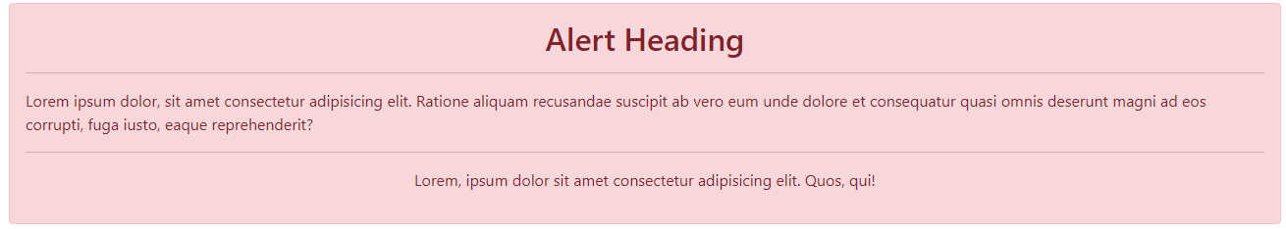**do This:

**do this

**<div class="alert alert-danger alert-dismissible show fade">**

**<button class="btn-close" data-dismiss="alert"></button>**

**<p>Lorem ipsum dolor sit, amet consectetur adipisicing elit. Culpa, fuga fugiat enim harum amet consequuntur molestiae rerum?</p>**

**</div>**

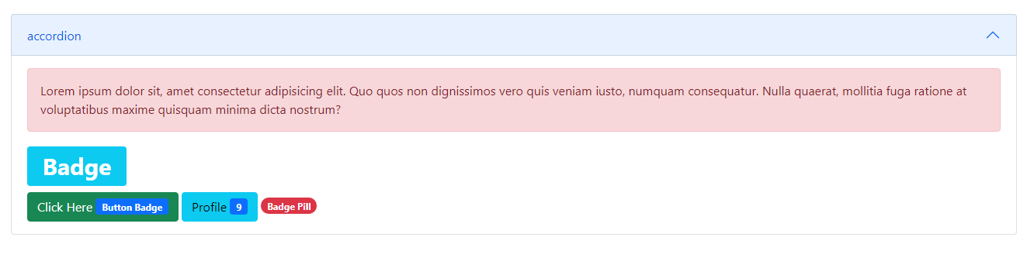

**Breadcrumb

**<nav aria-label="breadcrumb">**

**<ol class="breadcrumb">**

**<li class="breadcrumb-item active" aria-current="page">Home</li>**

**</ol>**

**</nav>**

**Buttons

**<button  type="submit" class="btn btn-danger">Sample Btn</button>**

**btn outline

**<button type="reset" class="btn btn-**

**Outline-danger">Reset Button</button>**

**btn-group

**<div class="btn-group">**

**<button class="btn btn-primary active">Hello</button>**

**<button class="btn btn-primary">Hello</button>**

**</div>**

**Do This with bootstrap 5 cards

Carousel

**Do This

