**BANGLADESH UNIVERSITY ALUMNI ASSOCIATION WEB APPLICATION**

**BY**

**MD. SHAHADAT HOSSAIN**

**ID: 201321036073**

This Report Presented in Partial Fulfillment of the Requirements for the Degree of Bachelor of Science in Computer Science and Engineering

Supervised By

**Md. Sadiq Iqbal**

Chairman

Department of CSE

Bangladesh University



**BANGLADESH UNIVERSITY**

**Dhaka, Bangladesh**

**November, 2016**

# APPROVAL

This Project titled **“Bangladesh University Alumni Association Web Application**” submitted by Md. Shahadat Hossain to the Department of Computer Science and Engineering, Bangladesh University, has been accepted as satisfactory for the partial fulfillment of the requirements for the degree of B.Sc. in Computer Science and Engineering and approved as to its style and contents. The presentation has been held on **Sep 23, 2016.**

**Board of Examiners**

**Md. Sadiq Iqbal Chairman**

**Chairman**

Department of Computer Science and Engineering

Bangladesh University

**Md. Shahriar Parvez Internal Examiner**

**Assistant professor**

Department of Computer Science and Engineering

Bangladesh University

**(Uzza Kumar Prodhan) Internal Examiner**

**Assistant professor**

Department of Computer Science and Engineering

Bangladesh University

**Md. Samawat Ullah External Examiner**

**Assistant professor**

# DECLARATION

We hereby declare that, this project ”Bangladesh University Alumni Association Web Application” has been done by us under the supervision of **Md. Samawat Ullah, Asst. Professor, Department of CSE** Bangladesh University. We also declare that neither this project nor any part of this project has been submitted elsewhere for award of any degree or diploma.

**Supervised by:**

**Md. Samawat Ullah**

**Chairman**

**Department of CSE**

**Bangladesh University**

**Submitted by:**

**Md. Shahadat Hossain**

ID: - 201321036073

Department of CSE

Bangladesh University

# 

# ACKNOWLEDGEMENT

First we express our heartiest thanks and gratefulness to almighty Allah for His divine blessing makes us possible to complete this project successfully.

We fell grateful to and wish our profound our indebtedness to **Md. Samawat Ullah**, **Asst. Professor,** Department of CSE, Bangladesh University, Dhaka. Deep Knowledge & keen interest of our supervisor in the field of preparation of our website for IT related solution influenced us to carry out this project documentation. His infinite patience, intellectual guidance, caring proposals, repetitive encouragement and support, regular active supervision, positive criticism, valuable advice, reading many inferior drafts and correcting them at all stage have made it possible to complete this project documentation.

We would like to express our heartiest gratitude to faculty member and the staff of CSE department of Bangladesh University.

We would like to thank our entire course mate in Bangladesh University, who took part in this discuss while completing the course work.

Finally, we must acknowledge with due respect the constant support and patients of our parents.

# ABSTRACT

The report presents the development of Bangladesh University Alumni Association Web Application as a service. In this project we tried to develop an interactive communication based website for alumni to each and other resources. In this project, we developed Email & Notice based web Application for alumni of Bangladesh University that helps alumni to connect with varsity and one with another and can be helped to reunion and join several types of programs and functions respected to the varsity.

The application has been designed as a web based program. Here, PHP the programming language used most probably and the database used MySQL. The frontend interface built in HTML 5, CSS 3 and the backend framework used Codeigniter 3.

**Keywords**: PHP, MySQL, Apache, HTML, CSS, javascript, jQuery, AJAX.

**TABLE OF CONTENTS**

**CONTENS PAGE**

APPROVAL ii

DECLARATION iii

ACKNOWLEDGEMENT iv

ABSTRACT v

**CHAPTER**

**CHAPTER ONE: INTRODUCTION 1-2**

1.1 INTRODUCTION 1

1.2 MOTIVATION 1

1.3 INTRODUCTION TO “BU Alumni Association Web” 2

1.4 AIMS & OBJECTIVE 2

1.4.1 Aims 2

1.5 ORGANIZATION OF THE REPORT 2

**CHAPTER TWO: FEASIBILITY STDUY 3-4**

2.1 FEASIBILITY STUDY 3

2.2 FEASIBILITY OF THE NEW SYSTEM 3

2.3 TECHNICAL FEASIBILITY 3

2.4 OPERATIONAL FEASIBILITY 4

2.5 ECONOMICAL FEASIBILITY 4

**CHAPTER THREE: SYSTEM ANALYSIS 5-9**

3.1 INTRODUCTION 5

3.2 INPUT ANALYSIS 6

3.3 INPUT DATA 6

3.4 DATA ANALYSIS 7

3.5 DATABASE ORIENTED SYSTEM APPROACH 7

3.5.1 Reduced Data Redundancy and Increased Consistency 7

3.5.2 Sharing of Data between Application 8

3.5.3 Multilevel Security 8

3.5.4 Flexible User Interface 9

**CHAPTER FOUR: SOFTWARE TOOLS 10-14**

4.1 INTRODUCTION 10

4.2 PHP 10

4.3 MySQL 11

4.4 APACHE 12

4.5 HTML 12

4.6 CASCADING STYLE SHEETS (CSS) 13

4.7 JavaScript 13

4.8 jQuery 14

4.9 Ajax (Asynchronous JavaScript and XML) 14

**CHAPTER FIVE: SYSTEM DESIGN 15-21**

5.1 SYSTEM DESIGN 15

5.2 DFD (DATA FLOW DIAGRAM) 15

5.2.1 DFD Symbols 16

5.2.2 DATA FLOW DIAGRAM OF THE SYSTEM 17

5.3 ENTITY RELATIONSHIP DIAGRAM 19

5.4 DATABASE DESIGN 20

5.4.1 Data Requirements 21

**CHAPTER SIX: IMPLEMENTATION AND TESTING 30-33**

7.1 IMPLEMENTATION 30

7.2 SERVER SETUP 31

7.2.1 Database server 31

7.2.2 Web server 31

7.3 TESTING 31

7.3.1 Objective of Testing 32

7.3.2 Testing Process 32

7.4 SUMMARY 33

**CHAPTER SEVEN: CRITICAL APPRAISAL 34-35**

CRITICAL APPRAISAL 34

**CHAPTER EIGHT: CONCLUSION 36-36**

CONCLUSION 36

9.1 INTRODUCTION 36

9.2 LIMITATION 36

9.3 FUTURE DIRECTION 36

**REFERENCES** 29

**APPENDIX A** 31

**APPENDIX B** 37

**LIST OF FIGURES**

**FIGURES PAGE NO**

Figure 3.1: Waterfall Development Methodology. 5

Figure 3. 2: Incremental development Methodology. 6

Figure 3. 3: Sharing of data between Multiple Applications. 8

Figure 3. 4: multiple level of database user privilege. 8

Figure 5. 1: DFD basic symbols. 16

Figure 5. 2: Data flow diagram of the system. 18

Figure 5. 3: Entity relationship diagram. 19

Figure 5. 4: Basic data processing. 20

Figure 6. 1: Testing process. 24

# CHAPTER ONE

# INTRODUCTION

## 1.1 INTRODUCTION

The alumni association of Bangladesh University (BU) is a national nonprofit organization, composed of BU alumni and alumni groups organized on a voluntary basis, with a view to preserve and carry forward the fine traditions of BU, to strength then the connection between the alumni at home and abroad.

The purpose of the BU alumni as stated in its Constitution is to promote the welfare of Bangladesh University and to establish a mutually beneficial relationship between Bangladesh University and its alumni.

Various side and designing methodology have been used to Alumni web application. Through our system various alumni could be interactive one with other. This provides the opportunity to apply our learning to educational communication.

**1.2 MOTIVATION**

We believe that alumni can serve as an informal support network for students at the Varsity. Having previously been international students at the varsity, alumni are in a unique position to understand student concerns, brainstorm potential solutions and possibly even mobilize resources to meet their needs.  We also believe that alumni can benefit significantly from networking with each other and by participating more actively in alumni activities.  For these reasons, we have decided to create a Student Alumni Network at the Bangladesh University through web.

**Why alumni association application for University?**

It is important to note that alumni association network recognizes that excellent resources already exist on campus to meet student needs. We acknowledge the important role that these entities play in improving the student experience and understand the many constraints that they must operate under. Our goal is merely to complement the activities of these resources, and to make constructive suggestions where possible.

## 1.3 INTRODUCTION TO “ALUMNI ASSOCIATION WEB APPLICATION”

Alumni association of Bangladesh University is an association of graduates or, more broadly, of former students (alumni). These associations often organize social events, publish newsletters or magazines, and raise funds for the organization. Many provide a variety of benefits and services that help alumni maintain connections to their educational institution and fellow graduates.

Additionally, these groups often support new alumni, and provide a forum to form new friendships and business relationships with people of similar background. Alumni associations are mainly organized around departments of Bangladesh University

## 1.4 AIMS & OBJECTIVE

Every project has some aims & objective. The aims & objective of the “Online Campus Communication” are following.

### 1.4.1 Aims & Objectives

The main aim of this project is to create a communicational service based online Communication System. The ultimate aim of this project to ensure sharing resources and information related study. To help former students who are not able to physically communicate with other.

## 

## 1.5 ORGANIZATION OF THE REPORT

The report arranges as follows, chapter one discusses the introductory parts of the project and gives a brief description of the overall exertion. Chapter two defined the feasibility study in Bangladesh University Alumni Association website. Chapter three defined the System analysis in “Bangladesh University Alumni Association website” system work.

Chapter four develops the methodology of designing and architecting the project .

# CHAPTER TWO

# FEASIBILITY STUDY

## 2.1 FEASIBILITY STUDY

The Bangladesh University has a long and distinguished history of attracting and supporting a vibrant student community on campus. Students bring diversity and rich culture to the campus community. On campus, they are active contributors and participants in campus life, leading several student organizations. As alumni, many return to their home to become stewards of BU for a lifetime. Those that stay in the outside go on to lead distinguished careers and are among the most recognizable of BU alumni.

## 2.2 FEASIBILITY OF THE NEW SYSTEM

Although theoretically it is required to consider feasibility of several candidate systems, we are limiting our scope into the new system solely due to limitations with time and capability. The new system, as proposed, aims to structurally collect, store and use all information of several website, content management system, administration all will have their own structure and relations between them. Once this is done, decision making can be made much easier, smoother and automated with assistance from the software.

## 2.3 TECHNICAL FEASIBILITY

The entire definitions, relationships and computations required for the new system are very simple when an underlying database is used. With minimal design efforts and programming, the new system can be build. Now a day almost every person has a personal computer, laptop, notebook, smart phone and internet connection. If a web based alumni application is deployed using a server, it can serve the alumni and eliminate the complexities with many of the manual activities. Expandability will be maintained in the new system. New modules can be added later on the application, if required in the future. The application will have user friendly Forms and Screens, all validation checks**.** So the new system guarantees accuracy, reliability, ease of access and data security.

## 2.4 OPERATIONAL FEASIBILITY

Majority, if not all, of the potential users of the new system have experience with computer applications and they are assumed to accept this new system willingly. If the system can be made efficient and easy enough to use, every alumni can browse this site like other site and fulfill their demand. The new system, if adopted, will come helpful to its users. It will save many activity wasted with asking people, updated information, searching website and related activities. From these considerations, operational feasibility of the new system can be considered more than satisfactory.

## 2.5 BEHAVIORAL FEASIBILITY

Behavioral feasibility determines how much effort will go in selling the proposed information system, and in educating and training the users on the system, along with the new ways of conducting the business. Behavioral study strives on ensuring that the equilibrium of the organization and status quo in the organization neither are nor disturbed and changes are readily accepted by the users.

The proposed system is behaviorally feasible because of the following:

* The users of alumni site will accept it because they are already acquainted with computers.
* This system is also meant for the general users i.e. the common people. Nowadays the internet is almost familiar to everyone. So, it is not difficult for the user to use the system, in fact they feel comfortable in using this system.
* Most of the alumni are familiar with the web browser and the process of maintaining account will be simplified for the alumni. The organization is definitely ready to welcome the computerized system.

# CHAPTER THREE

# SYSTEM ANALYSIS

## 3.1 INTRODUCTION

The system analysis is a detailed study of the various operations performed by the existing system and their relationships within and outside of the system. One aspect of analysis is defining the boundaries of the system and determining whether a candidate system should consider other related systems. Here we completed system analysis by the input analysis, output analysis and data analysis of existing system. At the preliminary stage of the analysis, we had followed the following. Waterfall Development Methodology which has been shown in figure 3.1.

Planning

Design

Implementation

Analysis

Systems

Figure 3.1: Waterfall Development Methodology.

However, for the farther progress of the project development we had to follow Incremental Development Methodology which has been shown in figure 3.2.

Define outline requirement

Assign requirement to Increment

Design system architecture

Validate increment

Integrate increment

Develop system increment

Validate system

## 

Figure 3. 2: Incremental development Methodology.

## 3.2 INPUT ANALYSIS

Inaccurate input data are the most common cause of errors in data processing. Errors entered by data entry operators can be controlled by input design. Input design is the process of converting user-originated inputs to computer-based format. In the system design phase, the expanded data flow diagram identifies logical data flows, data stores, sources and destinations. A systems flowchart specifies master files (database), transaction files, and computer programs. Input data are collected and organized into groups of similar data. Once identified, appropriate input media are selected for processing.

## 3.3 INPUT DATA

The goal of designing input data is to make data entry as easy, logical, and free from errors as possible. In entering data, operators need to know the following:

* The allocated space for each field.
* Field sequence, which must match in the source document.
* The format is which data fields are entered.

When we approach Input data design, the source documents that capture the data then select the media used to enter them into the computer. Let us elaborate on each step.

## 

## 3.4 DATA ANALYSIS

In the data analysis the data has been selected from input analysis according to the requirement of the system. The following data are included by the data analysis. In the other existing websites all service related information are kept in the database by the admin panel and the interested user have to browse the sites manually to know about the available service update. The users have to search for the appropriate service information, cost, condition of the service etc. by him in the existing websites. It is a lengthy process. So according to the requirement analysis the various data has been included in this system and the interested user will be notified his account if any service information matched with his requirement. Now it is not necessary to spend valuable time for collect service information by browsing various sites. A user just has to browse the site, make a query to database as his/her requirement information of matched related service.

## 3.5 DATABASE ORIENTED SYSTEM APPROACH

In computer science, a database is a structure collection of records or data that is stored in a computer system so that a computer program or person using a query language can consult it to answer queries. The records retrieved in answer to queries are information that can be used to make decisions. The computer program used to manage and query a database is known as a database management system (DBMS). The properties and design of database system are included in the study of information science.

### 3.5.1 Reduced Data Redundancy and Increased Consistency

Since the whole data resides in one central database, the various programs in the application can access data in different data files. Hence data present in one file need not be duplicated in another. This reduces data redundancy. However, this does not mean all redundancy can be eliminated. There could be business or technical reasons for having some amount of redundancy. Any such redundancy should be carefully controlled and the DBMS should be aware of it. Reduced data redundancy leads to better data consistency.

### 

### 3.5.2 Sharing of Data between Application

The sharing of data between applications has been shown in figure 3.3.

Central database

Member

Super Admin

Admin

Database Management System (DBMS)

Figure 3. 3: Sharing of data between Multiple Applications.

Since related data is stored in one single database, enforcing data integrity is much easier. Moreover, the functions in the DBMS can be used to enforce the integrity rules with minimum programming in the application programs. Related data can be shared across programs since the data is stored in a centralized manner. Even new application can be developed to operate against the same data.

### 3.5.3 Multilevel Security

Most implemented of popular database management systems provide out-of-box support for multiple levels of authentication for database and tables. Multiple users’ access privileges on database objects can be limited to some or all of add, remove, edit and read operations which has been shown in figure 3.4.

Database

Management

System

(DBMS)

Member

Admin

Central database

Figure 3. 4: multiple level of database user privilege.

Multiple level of database user privilege uses the same content users, Admin, database management system and central database it was discuss previous topic.

### 3.5.4 Flexible User Interface

Web browsers, the client side applications serving the program interfaces of web based applications, do not impose any limit on the height or screen size of a page in most cases. This results the freedom to offer varying quantity of information in different pages rather than restricting to specific size like typical desktop applications. In manual processes, it is often required to present huge amount of data in a single view.

# CHAPTER FOUR

# SOFTWARE TOOLS

## 4.1 INTRODUCTION

Bangladesh University Alumni Association website application is used to PHP, HTML, Apache, MySQL, javascript, jQuery, CSS.

## 4.2 PHP

**PHP** is a server-side scripting language designed for web development but also used as a general-purpose programming language. As of January 2013, PHP was installed on more than 240 million websites (39% of those sampled) and 2.1 million web servers. Originally created by Rasmus Lerdorf in 1994, the reference implementation of PHP (powered by the Zend Engine) is now produced by The PHP Group.While PHP originally stood for *Personal Home Page* it now stands for *PHP: Hypertext Preprocessor*, which is a recursive backronym.

PHP code can be simply mixed with HTML code, or it can be used in combination with various templating engines and web frameworks. PHP code is usually processed by a PHP interpreter, which is usually implemented as a web server's native module or a Common Gateway Interface (CGI) executable. After the PHP code is interpreted and executed, the web server sends resulting output to its client, usually in form of a part of the generated web page; for example, PHP code can generate a web page's HTML code, an image, or some other data. PHP has also evolved to include a command-line interface (CLI) capability and can be used in standalone graphical applications.

The canonical PHP interpreter, powered by the Zend Engine, is free software released under the PHP License. PHP has been widely ported and can be deployed on most web servers on almost every operating system and platform, free of charge.

Despite its popularity, no written specification or standard existed for the PHP language until 2014, leaving the canonical PHP interpreter as a *de facto* standard. Since 2014, there is ongoing work on creating a formal PHP specification

## 4.3 MySQL

MySQL is a relational database management system (RDBMS) and ships with no GUI tools to administer MySQL databases or management data contained within the databases. Users may use the included command line tools or use MySQL “front-ends”, desktop software and web applications that create and manage MySQL database, build databases structures, back up data, inspect status and work with data records.

* Features

As of April 2009 MySQL offered MySQL 5.1 in two different variants: the open source MySQL community server and the commercial enterprise server. MySQL 5.5 is offered under the same licenses. They have a common code base and include the following features:

* A broad subset of ANSI SQL 99 as well as extensions
* Cross platform support
* Stored procedures using a procedural language that closely adheres to SQL/PSM
* Triggers
* Cursors
* Updatable views
* Information schema
* Strict mode (ensures MySQL does not truncate or otherwise modify data to conform to an underlying data type, when an incompatible value is inserted into that type)
* X/Open XAdistributed transaction processing support, two phase commit as part of this using Oracles InnoDB engine
* Independent storage engines (MyISAM for read sped, InnoDB for transactions and referential integrity, MySQL Archive for storing historical data in little space)
* Transaction with the InnoDB and NDB cluster storage engines save points with InnoDB
* SSL support
* Query caching
* Sub-SELECTs (i.e. nested SELECTs)
* Replication support with one masters per slave many slaves per master. Multi-master replication is provided in MySQL cluster and multi-master support can be added to unclustered configurations using Galleria cluster.

## 4.4 APACHE

Often referred to as simply Apache a public domain open source web server was developed by a loosely-knit group of programmers. The first version of Apache based on the NCSA http Web server was developed in 1995. Core development of the Apache Web server is performed by a group of about 20 volunteer programmers called the Apache group. However, because the source code is freely available anyone can adapt the server for specific needs and there is a large public library of apache add-ons. In many respects development of Apache is similar to development of the Linux operating system. The original version of Apache was written for UNIX but there are now versions that run under OS/2, Windows and other platforms. The name is a tribute to the Native American Apache Indian tribe, a tribe well known for its endurance and skill in warfare. A common misunderstanding is that it was called Apache because it was developed from existing NCSA code plus various patches hence the name a patchy server or Apache server.

## 4.5 HTML

Hypertext Markup Language (HTML) is a language to specify the structure of documents for retrieval across the Internet using browser programs of the World Wide Web. HTML is an application of the Standard Generalized Markup Language (SGML) which is the International Standard (ISO 8879) for text markup. The principle is that text markup concentrates on structure rather than appearance making the files more reusable and leaving the visual details to the end user software like the browser.

HTML is a language for describing web pages:

* HTML stands for Hyper Text Markup Language
* HTML is a markup language
* A markup language is a set of markup tags
* The tags describe document content
* HTML document contain HTML tags and plain text
* HTML documents are also called web pages
* HTML tags
* HTML markup tags are usually called HTML tags
* HTML tags are keywords (tag names) surrounded by angle brackets like <html>
* HTML tags normally come in pairs like <b> and </b>
* The first tag in a pair is the start tag the second tag is the end tag
* The end tag is written like the start tag with a forward slash before the tag name
* Start and end tags are also called opening tags and closing tags.

## 4.6 CASCADING STYLE SHEETS (CSS)

Cascading Style Sheets (CSS) is a style sheet language used for describing the look and formatting of a document written in a markup language. While most used to style web pages and interfaces written in HTML and XHTML the language can be applied to any kind of XML document, including plain XML, SVG and XUL. CSS is a comerstone specification of the web and almost all web pages use CSS style sheets to describe their presentation. The CSS specification is maintained by the World Wide Web Consortium (W3C). CSS specifies a priority scheme to determine which style rules apply if more than one rule matches against a particular element. In this so-called cascade, priorities or weights are calculated and assigned to rules so that the results are predictable.

## 4.7 JavaScript

JavaScript is an interpreted programming or script language from Netscape. It is somewhat similar in capability to Microsoft’s Visual, Sun’s TCL the UNIX-derived Perl and IBM’s REXX. In general script languages such as C and C++ Script languages generally take longer to process than compiled languages but are very useful for shorter programs.

JavaScript is used in Web site development to do such things as:

* Automatically change a formatted date on a web
* Cause a linked to page to appear in a popup window
* Cause text or a graphic image to change during a mouse

JavaScript uses some ideas found in Java the compiled object-oriented programming derived from C++. JavaScript code can be imbedded in HTML pages and interpreted by the Web browser. JavaScript can also be run at the server as in Microsoft’s Active Server pages before the page is sent to the requester. Both Microsoft and Netscape browsers support JavaScript but sometimes in slightly different ways.

## 4.8 jQuery

JQuery is a cross-platform JavaScript library designed to simplify the client-side scripting of HTML. It was released in January 2006 at Bar Camp NYC by John Resign. It is currently developed by a team of developers led by Dave Methvin. Used by over 80% of the 10,000 most visited websites jQuery is the most popular JavaScript library in use today. JQuery is free open source software licensed under the MIT License. JQuery’s syntax is designed to make it easier to navigate a document, select DOM elements, create animations, handle events and develop Ajax applications. JQuery also provides capabilities for developers to create plug-ins on top of the JavaScript library. This enables developers to create abstractions for low-level interaction and animation, advanced effects and high-level theme-able widgets. The modular approach to the JQuery library allows the creation of powerful dynamic web pages and web applications.

## 4.9 Ajax (Asynchronous JavaScript and XML)

Ajax (Asynchronous JavaScript and XML) is a group of interrelated web development techniques used on the client side to create asynchronous Web applications. With Ajax web applications can send data and retrieve data from a server asynchronous (in the background) without interfering with the display and behavior of the existing page. Data can retrieve using the XML HTTP request object. Despite the name the use of XML is not required JSON is often used instead (see AJAJ) and the requests do not need to be asynchronous.

# CHAPTER FIVE

# SYSTEM DESIGN

## 5.1 SYSTEM DESIGN

System design is defined as task that focuses on the specification of a detailed computer based solution. System analysis emphasize business problem whereas system design focuses on the technical or implementation concerns of the system. When a system designer wants to design the system, he or she should have has enough sufficient knowledge about the detail system. Few steps can simplify the task of designing coding of a system dramatically. Every designer should take time to complete each of the following steps:

* Describe precisely the core functionality and the system design using data model such as ER data model.
* Normalize the system precisely the core functionality the system using normalization and draws the DFD of the system
* Describe precisely the core functionality and the system using data model as DFD.

All entities of the system have been modeled as objects in order to separate their logic from presentational code and to isolate the database queries. Isolating the database queries makes possible to make quick changes in the structures of entities and to ease the replacement of underlying database platform which is currently MySQL. With this approach of development, new entities and activities can be added to the system when needed. Thus, the system becomes highly extendable and modular.

## 5.2 DFD (DATA FLOW DIAGRAM)

The DFD was first developed by Larry Constantine as way of expressing system requirements in graphical form. This led to a modular design. A DFD also known as “bubble chart” has the purpose of clarifying system requirements and identifying major transformations that will become programs in systems. So, it is starting point of the design phase that functionally decomposes the requirements specifications down to the lowest level of detail. A DFD consists of a series of bubbles join by lines. The bubbles represent beta transformations and the lines represent data flow in the system. A DFD describes what data flow (logical) rather than how they are processed, so it does not depend on hardware, software, data structure or file organization.

### 5.2.1 DFD Symbols

In the DFD, there are four symbols, as shown in figure 6.1. The descriptions of each symbol are given below:

* A square defines a source (originator) or destination of system data
* An Arrow identifies data flow- data in motion. It is a pipeline through which information follows.
* A circle or “bubble” (an oval bubble used by somewhere) represents a process that transforms incoming data flows into outgoing data flows.
* An open rectangle is a data store – data at rest, or temporary repository of data

Or =Source or destination

= data flow

Or = process that transform data flow

Or =Data store

Figure 5.1: DFD basic symbols.

### 

### 5.2.2 Data Flow Diagram of the System

The data flow diagram of the system as flows, which has been shown in figure 6.2.

Login

**If**

**Login Success**

Member Panel Super admin panel Admin Panel

|  |  |  |
| --- | --- | --- |
| 1. Home 2. Profile 3. Edit profile 4. Update photo 5. Members 6. Members details 7. Send email 8. Notice 9. Change password 10. Logout | 1. Home 2. Department /add/edit/delete 3. Member/ add/activate 4. Members 5. Members details 6. Send email 7. Group emails 8. Notices/ add/edit/delete 9. Users /add/ edit / remove 10. Change password 11. Logout | 1. Home 2. Department 3. Member/ add/activate 4. Members 5. Members details 6. Send email 7. Group emails 8. Notices/ add/edit/delete 9. Users / 10. Change password 11. Logout |

Figure 5. 2: Data flow diagram of the system.

## 5.4 DATABASE DESIGN

Database design has been shown in figure 6.4.

Data storage

Data

Processing

Information

Figure 5. 4: Basic data processing.

* Database:

The collection of interrelated data usually referred to as the database. One or more large structured sets of persistent data usually associated with software to update and query the data.

* Data models:

Data models are a collection of conceptual tools for describing data, data relationship, data semantics, and consistency constrains.

* Database administrator:

The person who was full control over a system is called database administrator (DBA).

Database users: we can specify the users in four categories-

* Application programmers are computer professionals who interact with the system through DML calls.
* Sophisticated users interact with the system without writing programs.
* Specialized users are sophisticated users who write specialized database application.

Database management system: a database management system consists of a collection of interrelated data and set of programs to access those data. The collection of data usually referred to as database contain information about one particular enterprise. The primary goal of a DBMS is to provide an environment that is both convenient and efficient to use in retrieving and storing database information. The database provide for the safety of the information store, despite system crashes or attempts at unauthorized access. If data are to be shared among several users, the system must avoid possible anomalous result. This process was shown above in figure 6.4.

### 5.4.1 Data Requirements

Administration is identified by their id values. For login they also have a password. Different administrations have different password. A user is identified by their valid user id and password and their personnel information is stored in the administrator controller. When a customer want to service with his/her valid email address to the administrator, the administrator gives him permit to enter the system.

# CHAPTER SIX

# IMPLEMENTATION AND TESTING

## 6.1 IMPLEMENTATION

The aim of this project is to create Online Campus Communication system which follows the software as a service model. Therefore, this web site should be able to allow the following functionalities:

* The web site should be able to display the pages correctly and effectively.
* This web site should consist of some basic information such as institute profile, contact information etc.
* For the users of the Alumni Association site, it should allow the users to be registered to communicating.
* The users should have the ability to get the information using through the internet.
* For security and reliability, this web site should maintain the session effectively.

In order to satisfy the above functionalities, the system should have the following capabilities:

* The designed web sites should be concise, clear and easy to use.
* The users of these sites should communicate to each other.
* This web site should be able to build the interaction between the users dynamically.
* Databases are required for registration and sharing.
* The tools used to construct these two web sites should be available.

According to the above situation, the tools that might have been chosen were PHP for pages JavaScript, jQuery, Ajax pages and HTML for static pages. For the databases, MySQL, used to store data and information.

## 6.2 SERVER SETUP

Almost all of the work of web application takes place on the server. A specific application, called a web server, will be responsible for communicating with the browser. A relation database server stores whatever information the application requires. Finally, we need a language to broker request between the web server and the database server, it will also be used to perform programmatic task on the information comes to and from the web server. But of course none of this is possible without on operating system. The web server, programming language, and database server we must work well with the operating system.

### 6.2.1 Database server

We have two types of server one is database server and another is web server. These two will be describe later. When the system works with different types of transaction and need to keep huge data then it requires using data base server. Here we used MySQL server for database server. We have plan of developing the database in Oracle server later because we have a plan for publishing our system open so that everyone can take a part to reach resources.

### 6.2.2 Web server

There are many web servers and among them Apache and Microsoft internet information services these two dominate the market. We used Apache as a web server.

## 6.3 TESTING

Software testing is a critical element of software quality assurance and represents the ultimate review of specification, design of code generation. This testing will be carried out to ensure that the program can meet the demands of the user and fulfill the goal for which the software is made. The test would pick the areas that need to be modified and any mission or deficiencies in the way the system work. Testing is an integral part of the system development process. The main standard for software testing is contained in the ANSI/IEEE standard 829/1983 standard for software testing documentation. Some software testing may also be performed by CAST (computer aided software testing). The whole web site must be tested and the result documented. It is not only the software that is evaluated during the system testing process, it is also important to test operating procedures.

### 6.3.1 Objective of Testing

There are many objectives to test the system, as:

* Testing is a process of executing a program with the internet of finding errors.
* A good test case is one that has a probability of finding critical bugs as yet undiscovered.

### 6.3.2 Testing Process

In general the sequence of testing activities is component testing, integration then user testing. However, as defects are discovered at any one stage, they require program modification to them and this may require other stages in the testing process to be repeated. Errors in program components, say may come to light at a later stage of the testing process.

Unit testing

Module testing

Sub system testing

System testing

Acceptance testing

Figure 6.1: Testing process.

In Figure 6.1, the arrows from the top of the boxes indicate the normal sequence of testing. The arrows returning to the previous box indicate that previous testing stages may have to repeat.

## 6.4 SUMMARY

Necessary test were carried out to ensure that the system of the web site are error free and all operating processor work as per requirement. The stages of testing also correspond to the web site development. Problem of the illogical data, unclear field, inconsistent movement and performance were detected, tackled and eliminated through different tests. Defects are discovered at any one stage, they require program modification to them and this may require other stage in the testing process to be repeated.

# 

# CHAPTER SEVEN

# CRITICAL APPRAISAL

Computer system is built with usability criteria have several benefits such as improvement of productivity, reduction of cost and learning time and a notable increment of final user autonomy. But still it is very hard applying usability techniques in software development. This is due to having different concepts of usability to software engineers and usability engineers. To create acceptable usability concepts, the software engineering community must integrate usability techniques into a software engineering process that is recognizable from both fields. In this thesis, we have emphasized on usability process and identified the most significant attributes, challenges in applying usability, activities and efforts required to establish close relation between HCI/Usability and software engineering. One thing is clear that although the usability affects the target system huge, still the developers are not conscious about its significance. Most of the developers do not have sufficient knowledge about usability. It is a testing activity rather than design activity to them. Hence, there is a big gap between the developers and usability experts. Enhancement of total aspects of usability for both developers and usability engineers are required. The integration of usability activities with software development activities will help to build a product user-friendlier and more usable. Time construct did not allow designing and developing the web site according to requirements of the logical view. It is possible with availability of necessary time. Inadequate information did not allow us to structure the whole system necessary to overcome all the problem of the group. In future we cherish a desire to dig further to structure a site with more facilities and information to be of more use to the user. Our developed website has some limitations which are our developed searching in our website is not so strong and efficient enough. Due to using MySQL server 2000 for database design, we can’t use paging in our forum posting and answer section. We thought that we couldn’t design our website graphically so much attractive and smooth as professional designers. We believe this is just the start of journey. Our hope this journey will continue for long time with an increasing speed day by day and within a short period we will obtain an error less system with strong database support.

# CHAPTER EIGHT

# CONCLUSION

## 8.1 INTRODUCTION

From the very beginning of the project our aim was to design and develop a communication forum based dynamic website which is fully controlled by content management system which will assist our people to realize the web content better and introduce ourselves one of the developer who has worked out for the development of website for information and knowledge sharing through online in Bangladesh. Our developed communication forum based interactive dynamic website is mainly for alumni of Bangladesh University. Through our website we want to give opportunity to former students to communicate each other using internet any time, any where. We hope both of these facilities will be helpful our student to realize better meaning than now. Besides, we believe every innovation starts another innovation. So the development of our website will perform a pioneer rule for other related development.

## 8.2 LIMITATION

Time construct did not allow designing and developing the website according to requirements of the logical view. It is possible with availability of necessary time. Inadequate information did not allow us to structure the whole system necessary to overcome all the problem of the group. In future we cherish a desire to dig further to structure a site with more facilities and information to be of more use to the user. Our developed website has some limitations which are our developed searching in our website is not so strong and efficient enough. We thought that we couldn’t design our website graphically so much attractive and smooth as professional designers.

## 8.3 FUTURE DIRECTION

Further we will include some features in our website and we will solve all limitation are described above. We will include in future community portal for alumin association website.

# REFERENCES

To develop this project the following link and reference, which are listed below:

1. <http://www.codeigniter.com/>
2. <http://www.w3schools.com/>
3. <http://www.php.net/>
4. <http://wwwstackoverflow.com>

# APPENDIX A

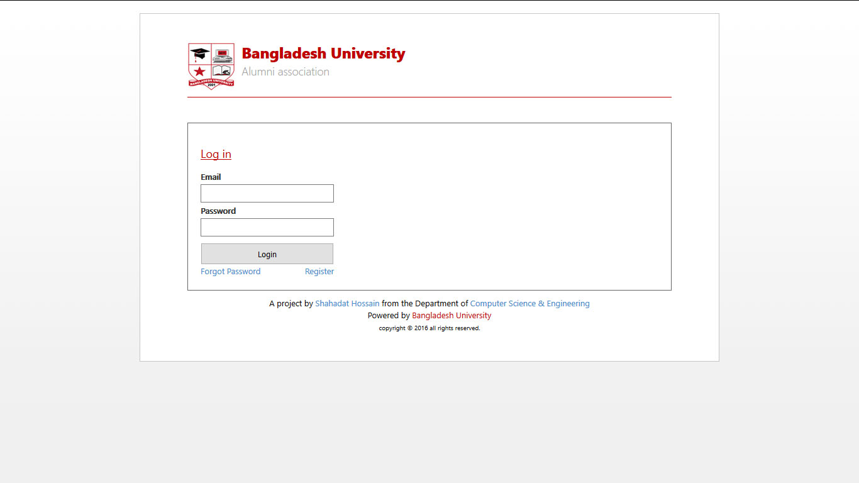

Figure A (1): Administration Dashboard Page

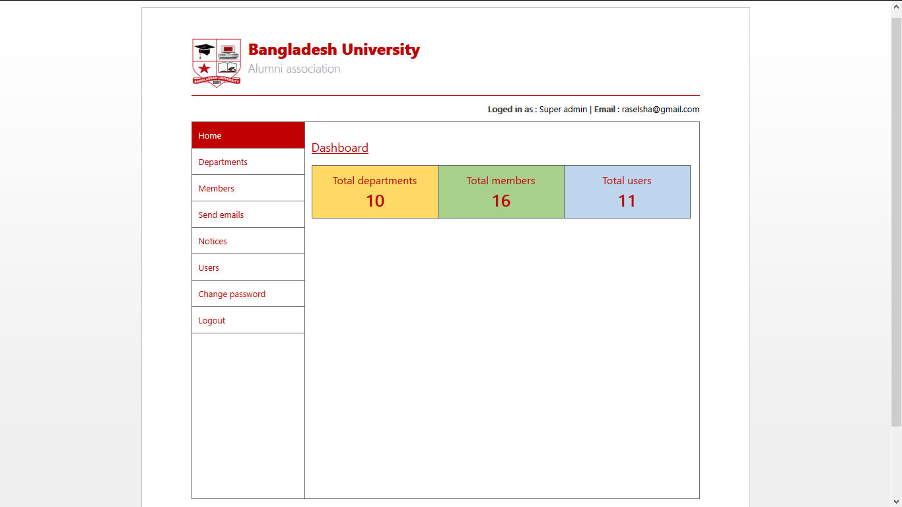

Figure A (2): Administration Dashboard Page

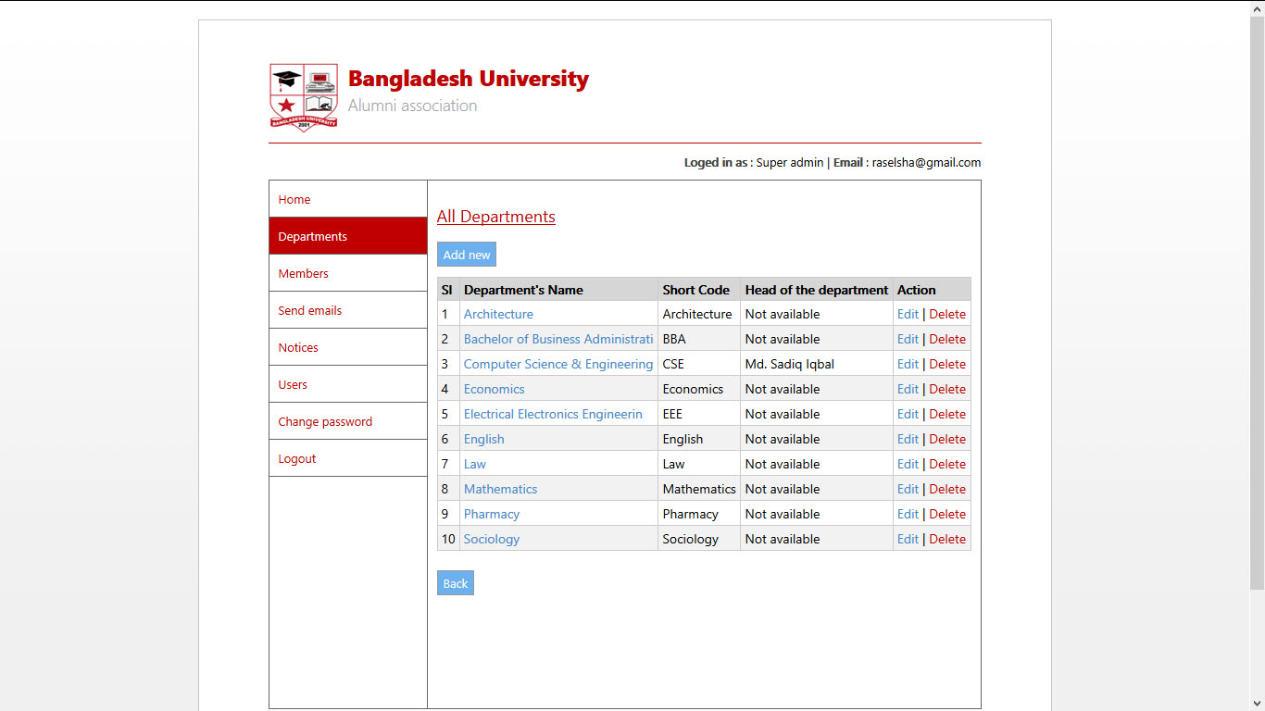

Figure A (3): Administration Dashboard Page

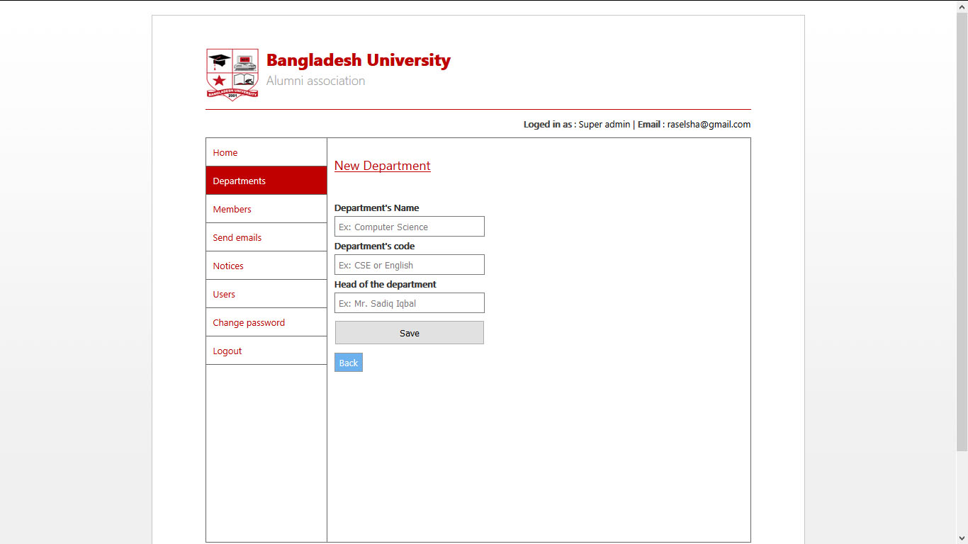

Figure A (4): Administration Dashboard Page

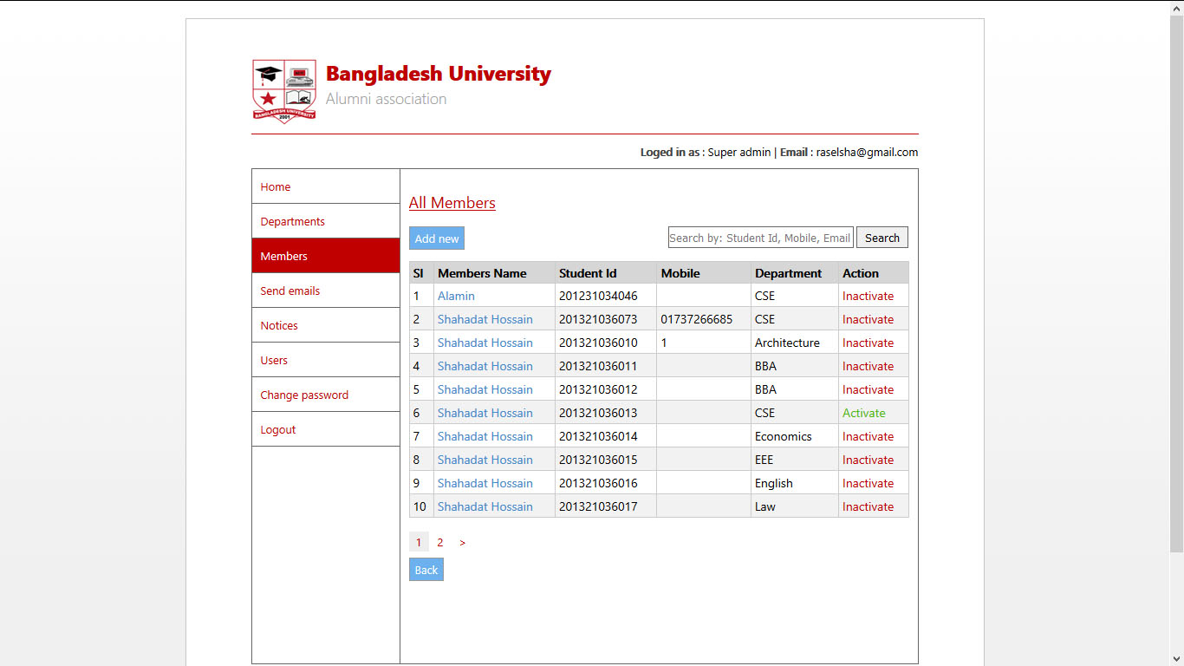

Figure A (5): Administration Dashboard Page

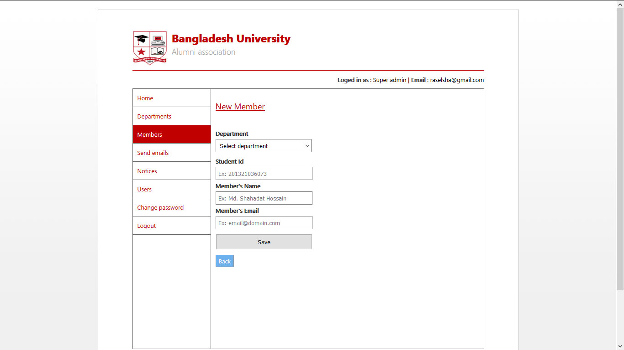

Figure A (6): Administration Dashboard Page

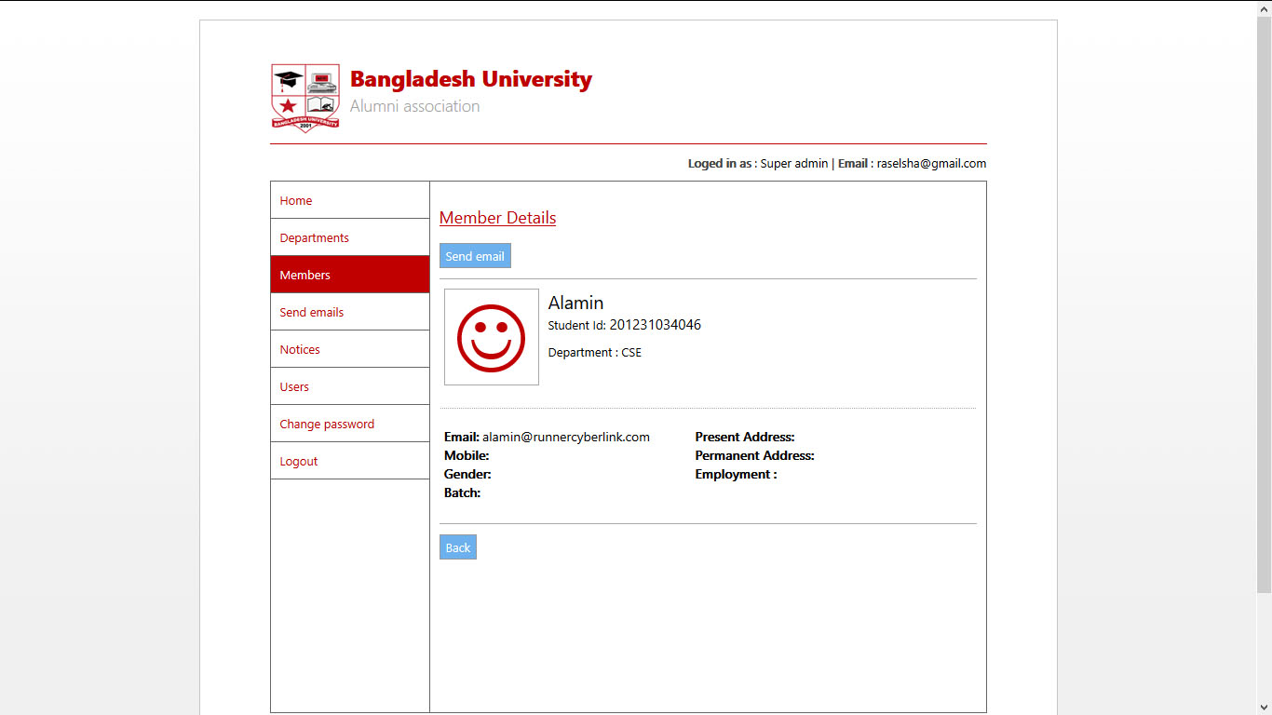

Figure A (7): Administration Dashboard Page

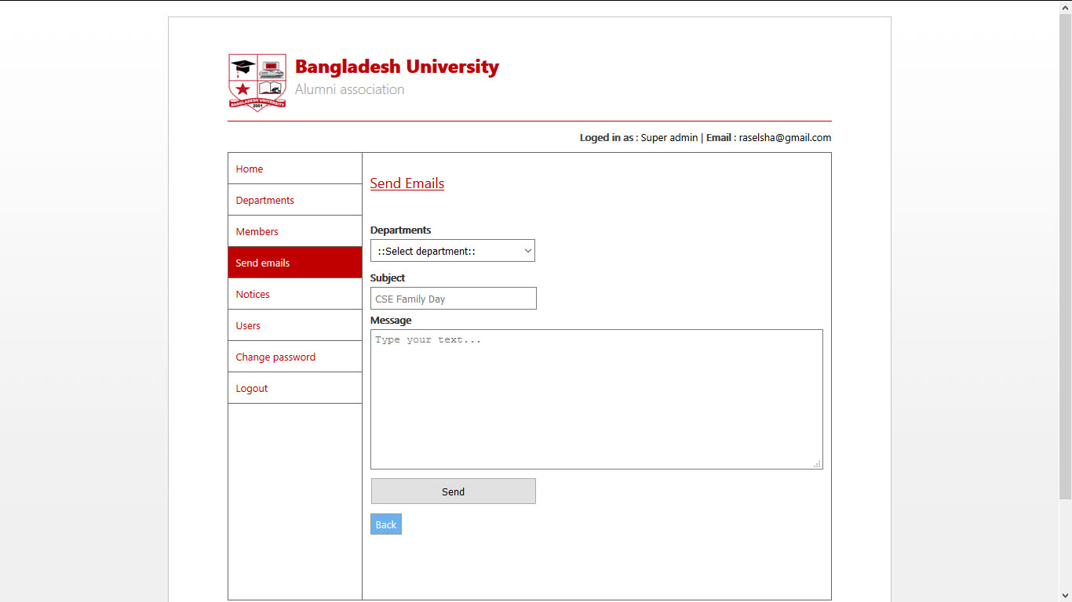

Figure A (8): Administration Dashboard Page

# 

Figure A(9): Administration Login Page

# 

Figure A(10): Administration Dashboard Page

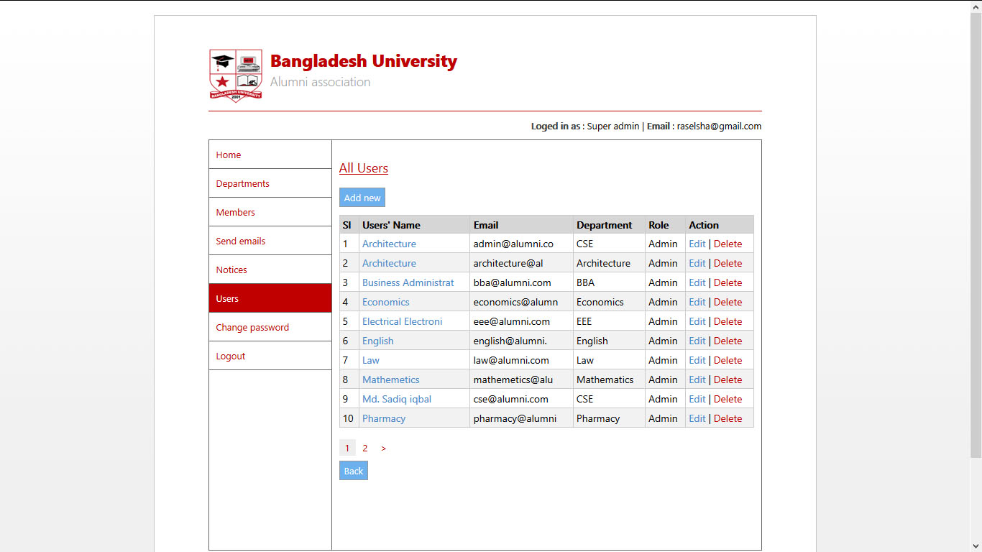

Figure A(11): Administration Dashboard Page

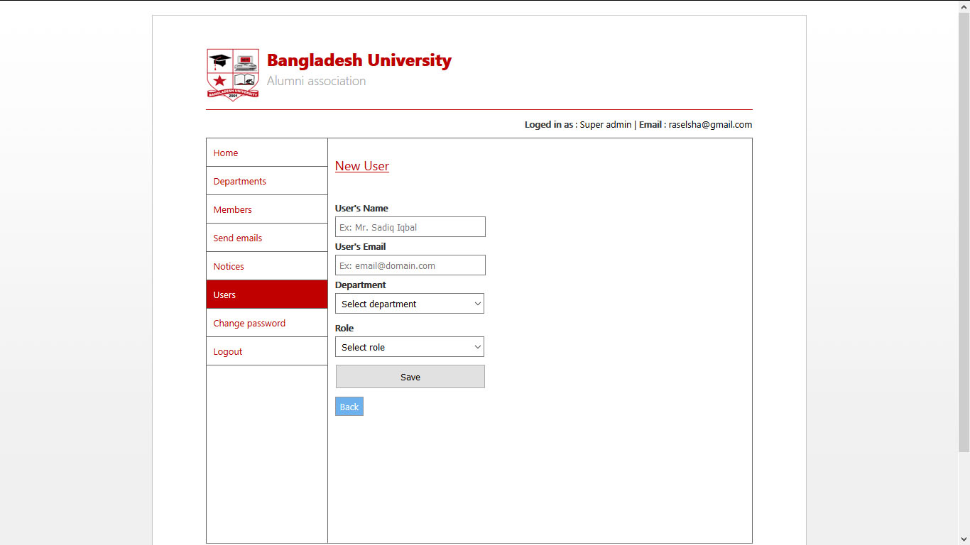

Figure A(12): Administration Dashboard Page

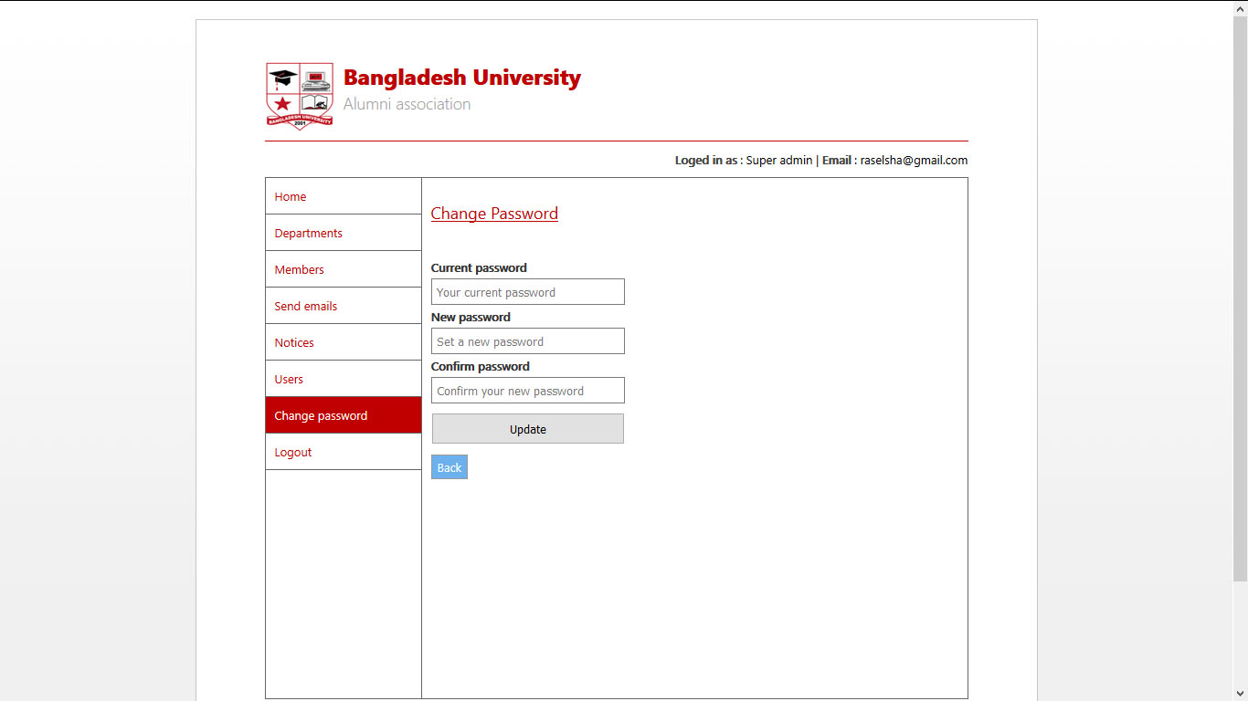

Figure A(13): Administration Dashboard Page

# APPENDIX B

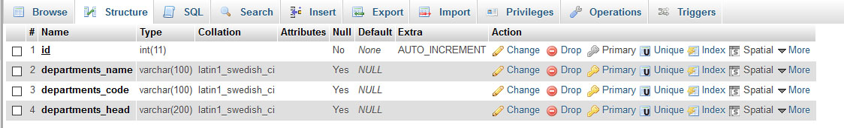

Figure B (1): Database table.

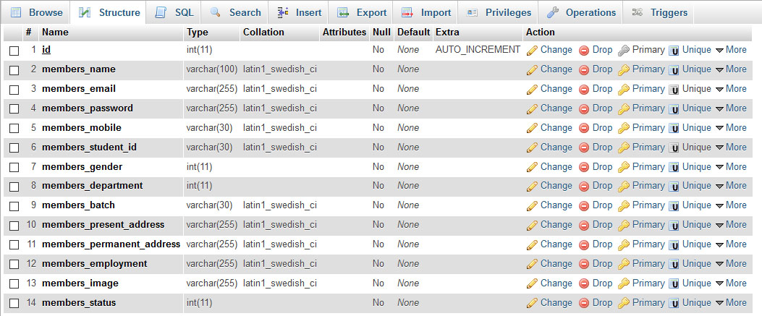

Figure B (2): Database table.

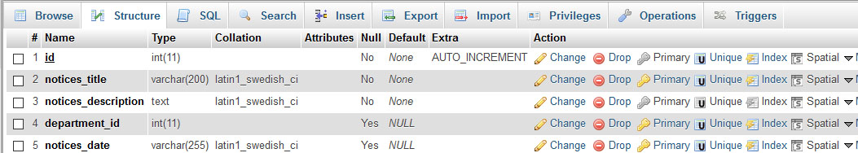

Figure B (3): Database table.

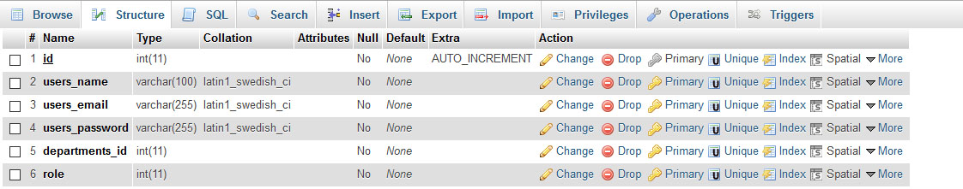

Figure B (4): Database table.