SMART STUDY PLANNER USING AI TECHNIQUES


Name: Rasesh Varshney
Registration Number: 25BCE10299
Course: Artificial Intelligence & Machine Learning
Institute: VIT Bhopal

1. Introduction
Artificial Intelligence (AI) has revolutionized the way systems interact with users by enabling intelligent decision-making.
The Smart Study Planner is designed to address time management issues faced by students by automating study schedule generation.
This project demonstrates how simple AI concepts can be applied to real-world problems effectively.

2. Problem Statement
Students often lack structured planning, leading to inefficient study patterns and stress.
This project aims to develop an intelligent system that generates optimized study schedules based on user input.

3. Objectives
Develop a user-friendly desktop application using Tkinter.
Apply AI-based weighted logic for scheduling.
Ensure proper time allocation and revision planning.

4. Methodology
The system collects input from users and processes it using weighted calculations.
Subjects with higher difficulty are allocated more study time.
A revision strategy is incorporated to enhance retention.

5. System Architecture
The system consists of input module, processing module, and output module.
The input module collects user data.
The processing module computes weights and schedules.
The output module displays results in GUI.

6. Algorithm
Step 1: Input subjects and difficulty.
Step 2: Calculate total difficulty.
Step 3: Compute weights.
Step 4: Allocate study hours.
Step 5: Generate schedule with revision.

7. Implementation
The project is implemented using Python and Tkinter.
The GUI provides an intuitive interface for users.
The backend logic ensures efficient scheduling.

8. Results
The system generates a structured daily plan.
It improves time allocation and includes revision days.

9. Advantages
User-friendly interface.
Efficient time management.
Improves productivity.

10. Limitations
No adaptive learning.
Requires manual input.

11. Future Scope
Integration with machine learning.
Mobile app development.
Cloud-based storage.

12. Conclusion
The project successfully demonstrates AI-based scheduling.
It provides a practical solution for students.

13. Learning Outcomes
Understanding AI concepts.
GUI development using Tkinter.
Problem-solving skills.

Screenshots
Application Interface
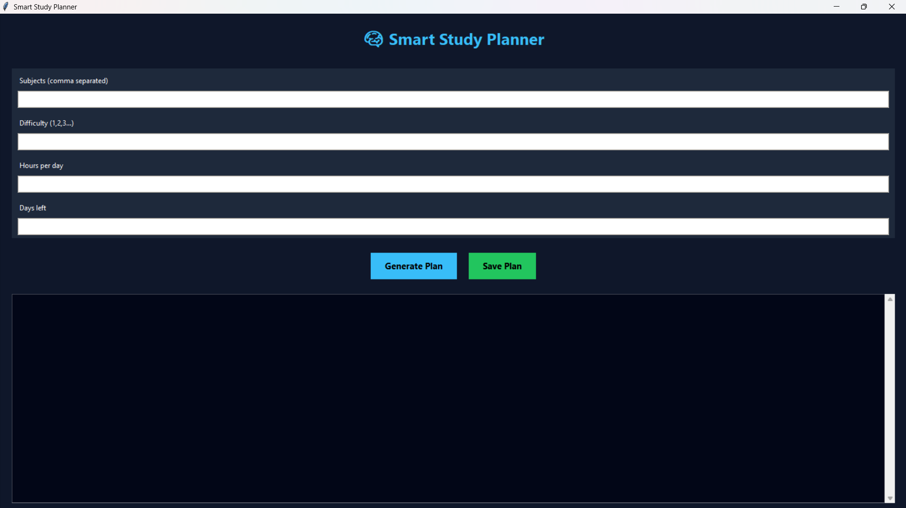
Generated Output
