DAY8 SESSION ASSIGNMENT

When to use (Rapid Application Development) RAD model When not to use (Rapid Application Development) RAD model

RAD is adopted from waterfall model, it aims at developing a software in short span of time

When to use RAD
- RAD should be used only when a system can be modularized to deliver in incremental manner.
- It should be done when there is availability of designers for modelling.
- It should be done if the budget is their to use automated code generating tools.
- It should be done if their are domain experts available with relevant business knowledge.
- It should be done when the requiement changes during the course of project and working prototypes are to be prsented to customer in small iteration of 2-3 months
- It should be used when quality of the deliverables are negotiable.

When not to use RAD

- It should not be used when the budget for the allocated project is less.
- It should not be implemented when their is shortage of high skilled resources.
- It should not be implemented if the client does not want to compromise on quality,as RAD process biggest drawback is the quality.
- It should not be used when the system cannot be modularized.

Department
Name
Location
Number
Define an ER diagram of a software Organization with all the relationship model that was discussed in the classroom
Employee
ID
Address
Name
Fname
Lname
Salary
Age
Email ID

Works for

Controls

Works on

Projects
Name
Number

Location

Describe the Entity Relationships or the following diagram

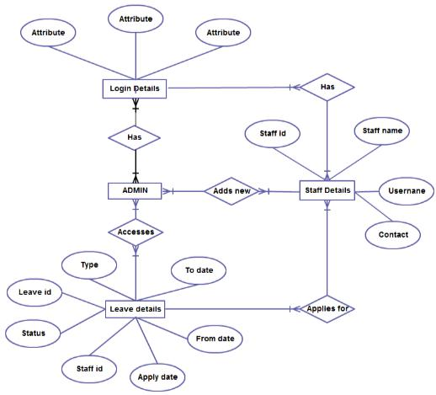

1

There are 4 entities
- Login details
- Admin
- Staff details
- Leave details

The primary key for entities are:

- Login details: No attributes are mentioned in the diagram but some examples are: Username(primary key)
- Staff details: Staffid(primary key), Username(foreign key)
- Leave details: Leaveid(primary key),staffid(foreign key)

Relationship:

- There exist one to many relation between Login details and admin
All admin must have one login id,but 1 login detail will associated with one admin.

- There exist one to many relationship between Login details and staff detail
All staff members should have one login detail, but 1 login detail is asssociated to 1 staff only.

- There exist one to many relationship between admin and staff details
One admin can enter many staff details,but 1 staff member can work under 1 admin at a time.

- There exist many to many relationship between admin and leave details
All the admin can access many leave details of employees,but for a leave detail for a particular employee will accessed by only one admin.

- There exist many to one relationship between staff details and leave details
Many staff can apply for leave,but only kind of leave will be applied by a particular staff at a particular time.

