Class Diagram

**Figure 1** illustrates the Class Diagram of the PackTrack system, modeling its core components using object-oriented principles. It defines the system’s structure through classes representing users, deliveries, activity logs, and dashboards, along with their attributes, methods, and inter-class relationships such as associations and generalizations.

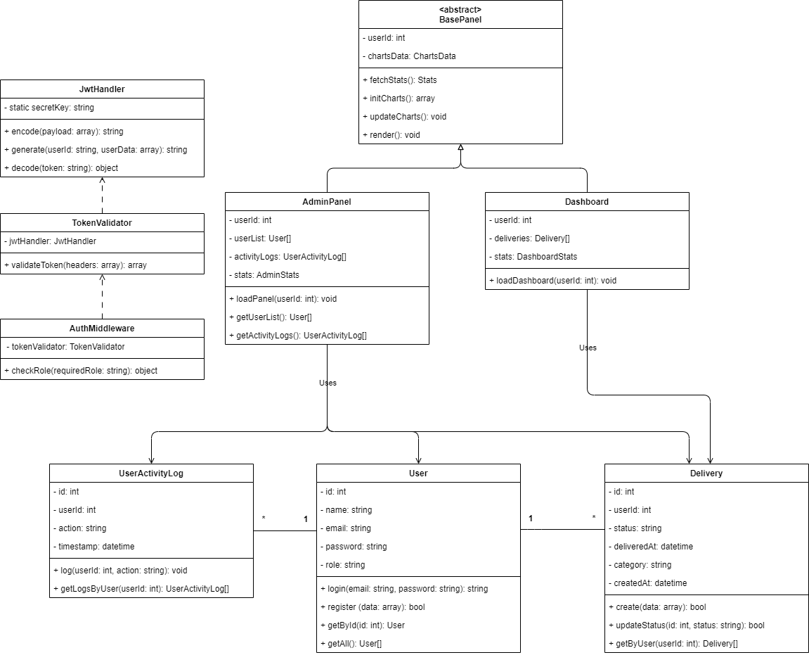

**Figure 1** Class Diagram