System ER Diagram

In **Figure1**, ERD provides a conceptual overview of the database structure using Chen notation. It illustrates key entities, their attributes (with primary keys underlined), and the relationships between them using diamonds. This diagram helps visualize how entities such as users, deliveries, and activity logs are logically connected within the system.

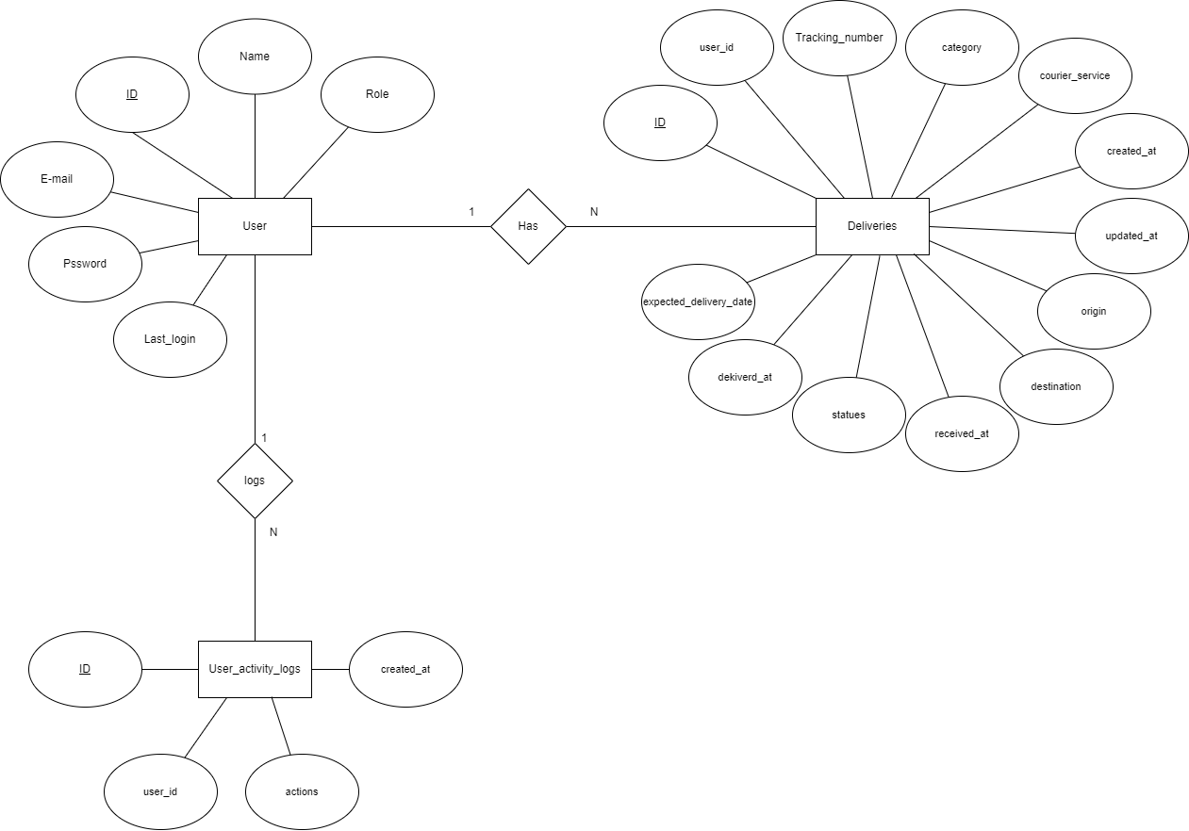

**Figure 1** PackTrack ER Diagram