Relational Schema

**Figure 1** illustrates the relational schema of the PackTrack system. It defines the core database structure, including three main tables: **users**, **deliveries**, and **user_activity_logs**. The schema outlines how these entities are related using primary and foreign keys, ensuring data consistency. Each user can have multiple deliveries and activity logs, establishing one-to-many relationships that reflect user interactions and package tracking activities.

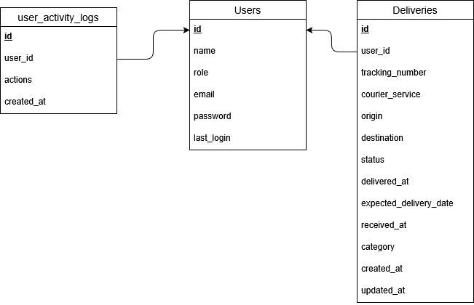

**Figure 1** Relational Schema