### Software Development Methodology (SDLC Model)

For the development of PackTrack, we will follow the Incremental SDLC Model, which enables the system to be built and delivered in structured increments. This approach is well-suited for the project as it allows:

* Step-by-step feature development to ensure functionality is built gradually.
* Flexibility to update requirements based on feedback in each phase.
* Ongoing testing to maintain system reliability after every increment.

Each increment will follow a structured cycle comprising planning, implementation, testing, and integration of specific feature group (e.g., user authentication, dashboard, API integration, admin panel).

This approach minimizes complexity while ensuring a scalable and maintainable solution.

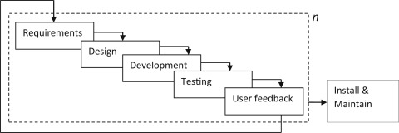

Figure 1 Incremental SDLC Model