System Architecture

**Figure 1** illustrates the system architecture of the PackTrack platform, presenting a high-level view of its layered structure and component interactions. The architecture is divided into five main layers: Client, API Controller, Middleware, Model, and Database. Each layer plays a distinct role in managing requests, processing data, and ensuring secure and efficient communication between the frontend and backend. The system is also containerized using Docker for modular deployment.

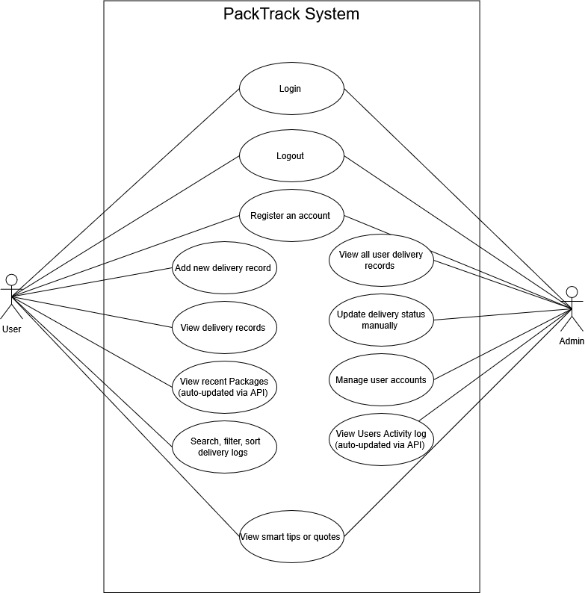

**Figure 1** System Architecture