### User Interface Mockups

We designed basic wireframes for the most essential screens of PackTrack. The UI aims to be simple, clean, and user-friendly with a dashboard-style layout.

Figure 1 shows the login form used by users and admins to access the system. The login process is secured using a JWT-based authentication mechanism, ensuring that access to the dashboards is restricted to logged-in users only.

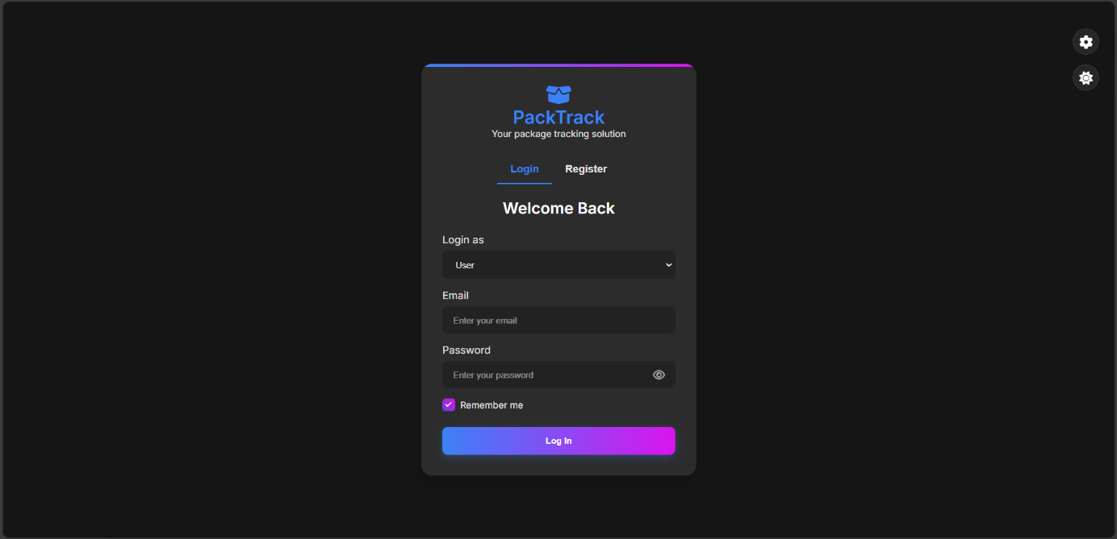

Figure 1 Login Form (JWT-Based Authentication)

Figure 2 displays the registration form. Users can sign up as either a User or an Admin. When selecting Admin, an additional field for Admin Secret Key appears. Only users with this key (provided by system owners or managers) can register as admins.

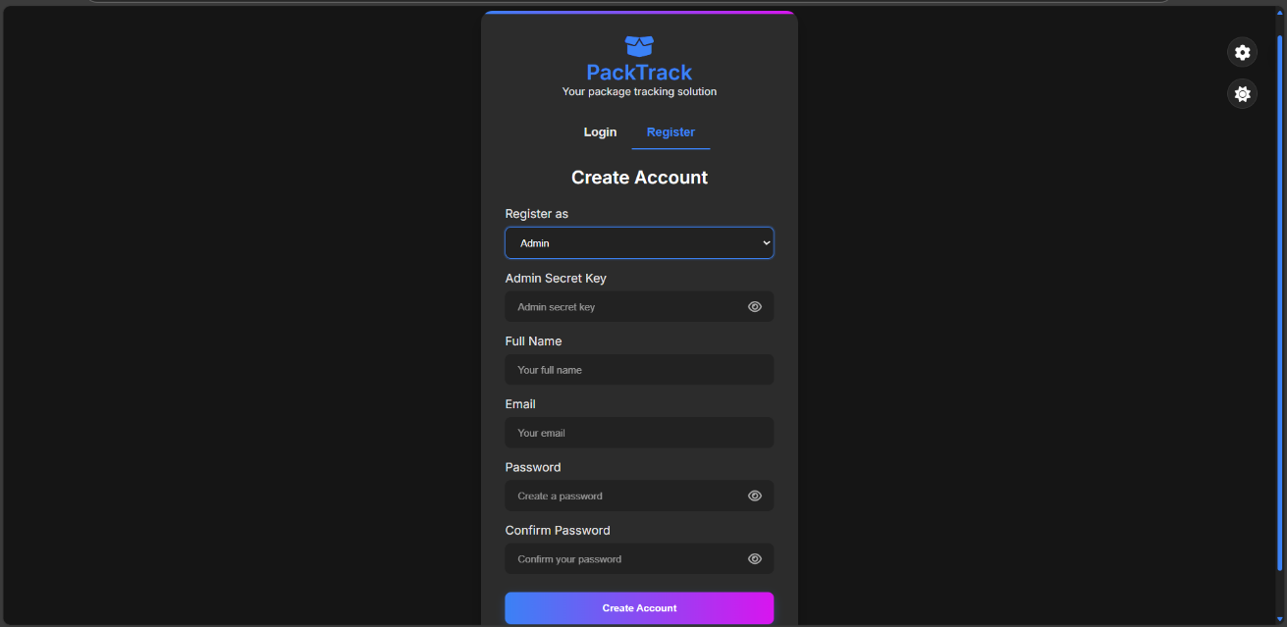

Figure 2 Registration Form with Role-Based Access

Figure 3 illustrates the User Dashboard, accessible exclusively to authenticated users, This dashboard provides an overview of package statuses for the current month, along with interactive data visualizations:

* Package Activity Chart (line chart): Tracks the number of received and delivered packages over a selected period (week, month, or year).
* Package Status Chart (donut chart): Displays the distribution of package statuses, including delivered, in transit, out for delivery, and delayed.

The dashboard also features an Add Delivery Form for submitting new package details and a Delivery Logs Table for tracking past deliveries. A navigation menu ensures seamless interaction with other sections of the application.

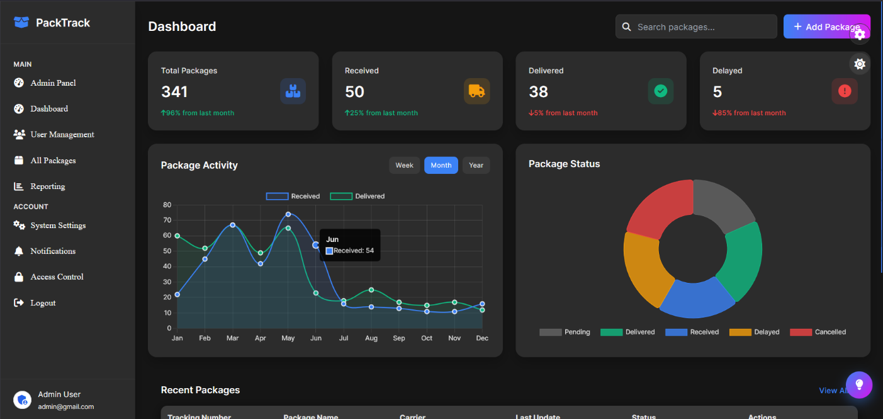

Figure 3 User Dashboard

Figures 4 and 5 present the Admin Panel, which is accessible exclusively to authenticated administrators. The panel provides a comprehensive dashboard for managing users, tracking package statuses, and monitoring system performance. Key functionalities include:

* User Management: View registered users, track their last login activity, and manage their accounts.
* System Statistics: Displays key metrics, like total users, total packages, active users, and delayed packages, with percentage-based trend indicators.
* Analytics & Reports: Interactive charts supporting data-driven decision-making.
* Activity Logs: Logs recent user actions, including login timestamps and packages status changes.

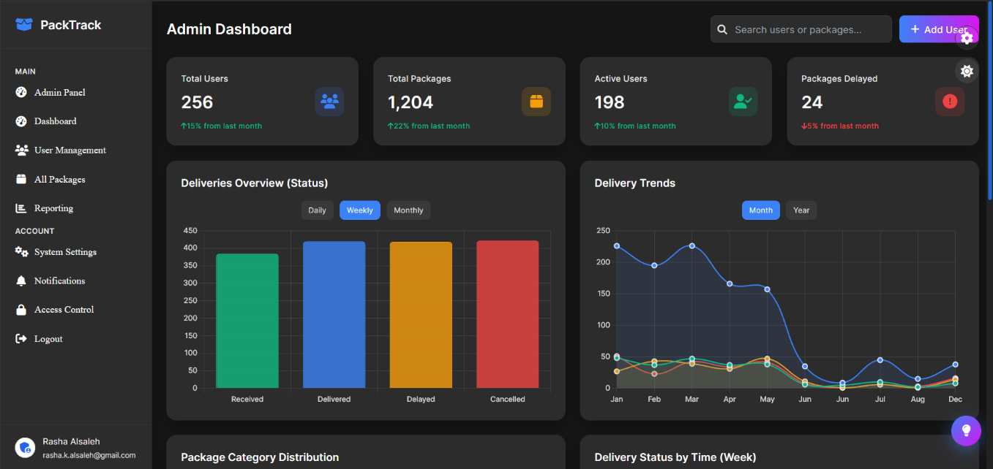

Figure 4: Admin panel Overview

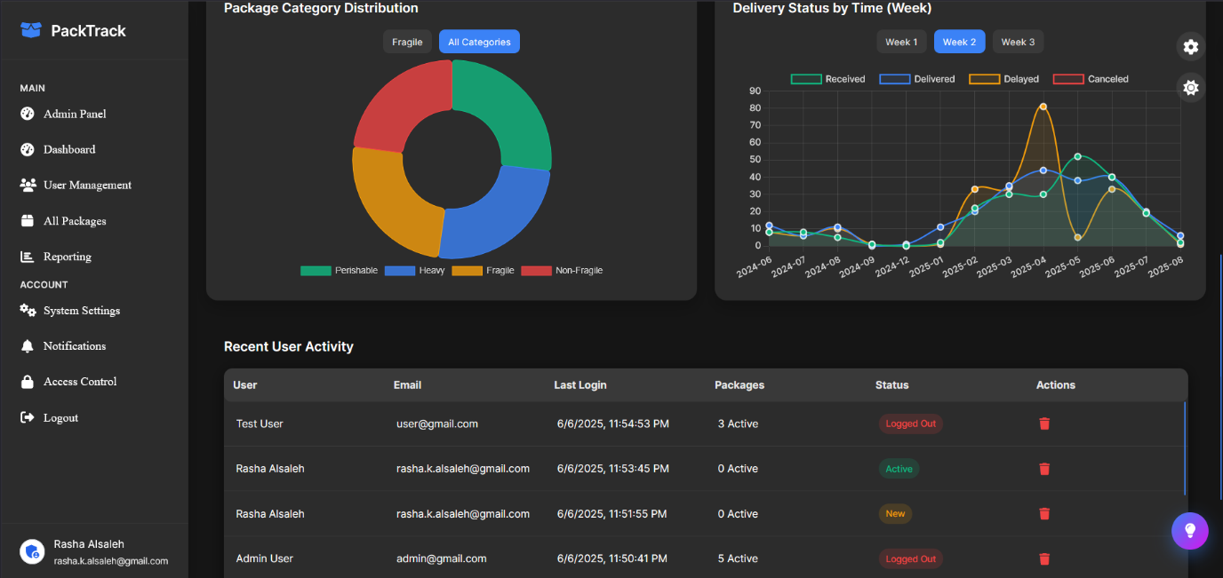

Figure 5 Admin panel & Recent Users Activity Log

Figure 6 shows a dashboard widget that adds a motivational touch to the dashboard by displaying daily quotes. It dynamically pulls content from two sources: the Quotable API (a public quote service) and a custom-built API at /PackTrack/backend/api/random/quotes.json, which includes personalized quotes crafted to match the theme of the PackTrack platform. These custom quotes often reference productivity, smart delivery practices, or user encouragement. The widget allows users to refresh the quote manually, enable automatic updates, or hide it based on their preferences.

Figure 6 Daily Quote Widget

Figure 7 appears when a user tries to access a protected route without the required permissions (e.g., accessing the admin panel as a regular user). It enforces role-based access control and ensures only authorized users can view sensitive content. Shown when users try to access content outside their permission level. It reinforces role-based restrictions using JWT validation and offers clear feedback with quick navigation options.

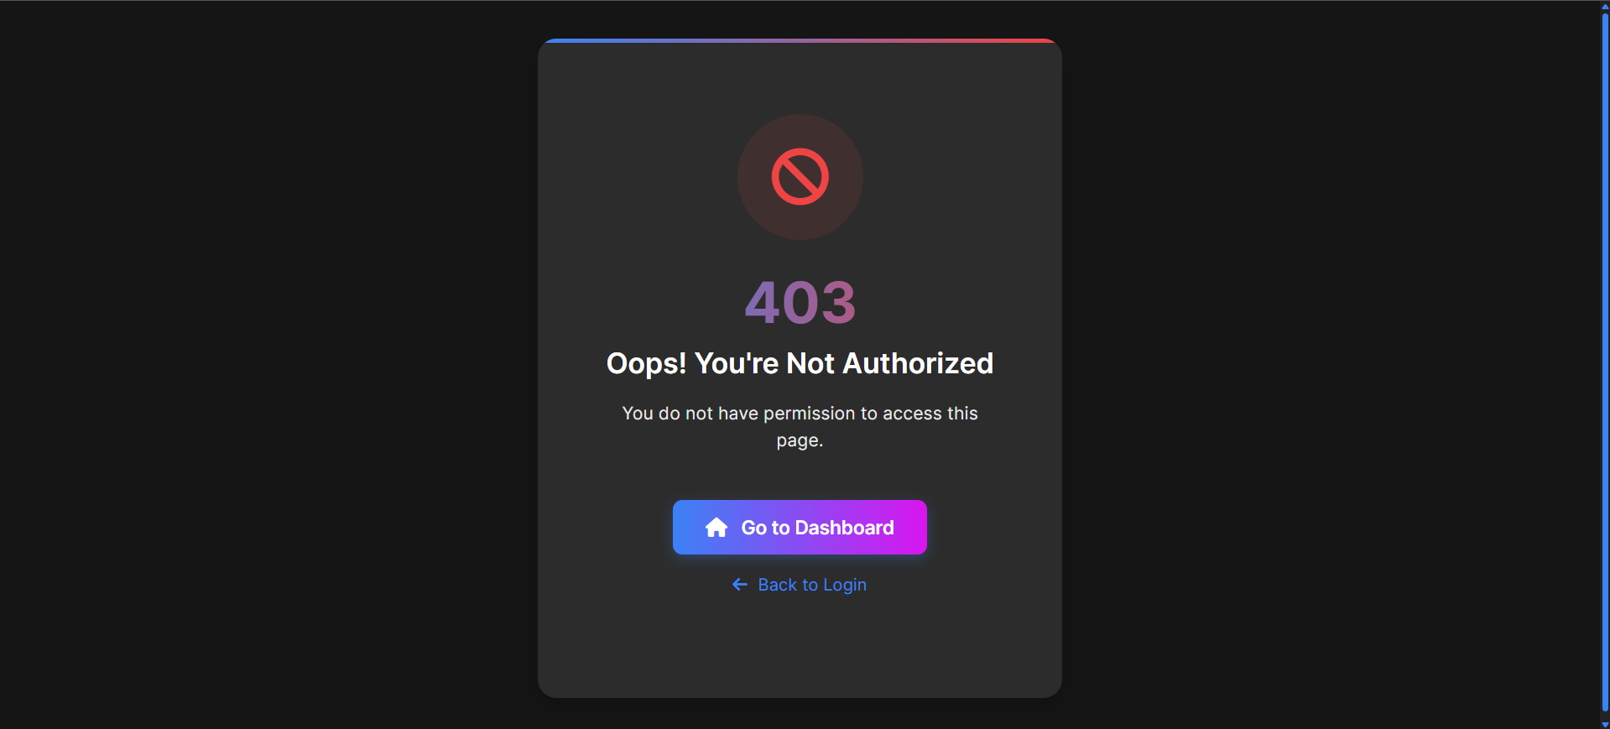

Figure 7 Forbidden Access Page (403)

Figure 8 is displayed when the server encounters an unexpected issue. It shows a helpful error message, allows users to reload or return to the dashboard, and hides technical details to protect system security.

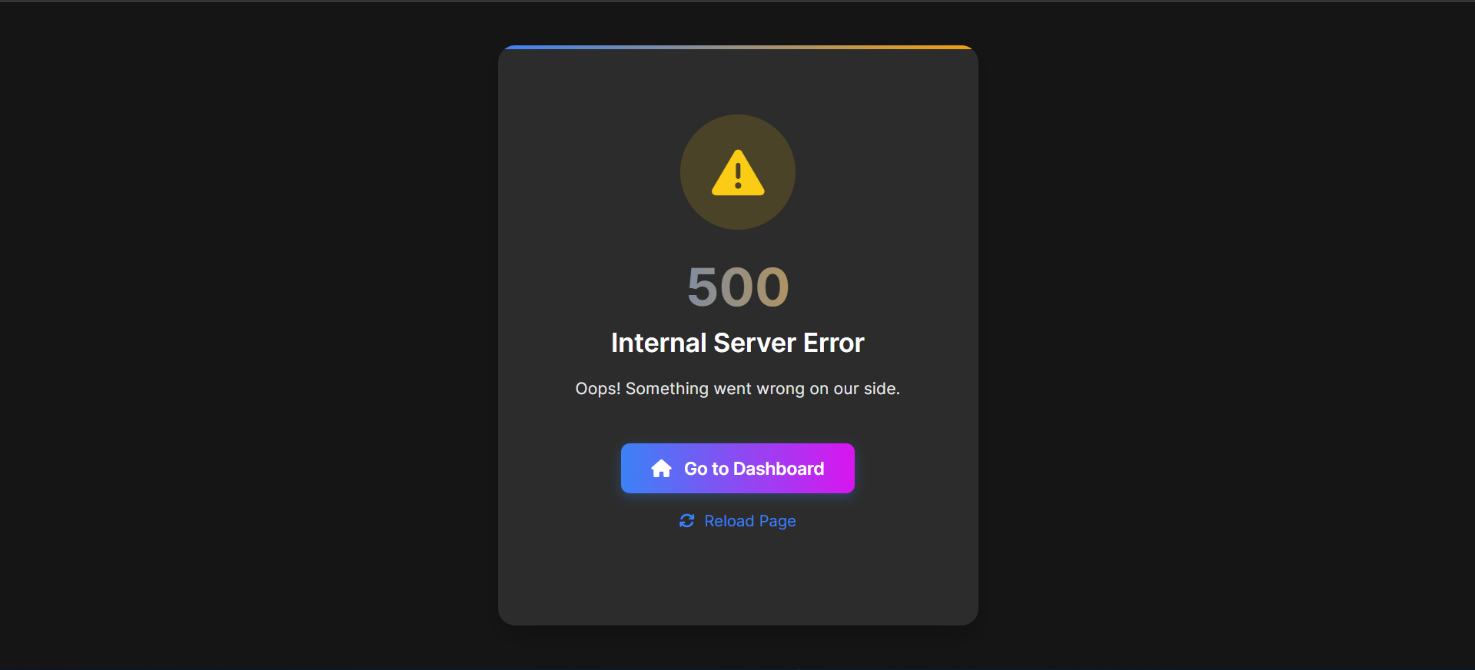

Figure 8 Internal Server Error (500)

Figure 9 shows a page that appears when a user navigates to a non-existent route in the PackTrack system. It provides a clear error message, maintains design consistency, and includes navigation options to return to the dashboard ensuring a smooth recovery from broken links or mistyped URLs.

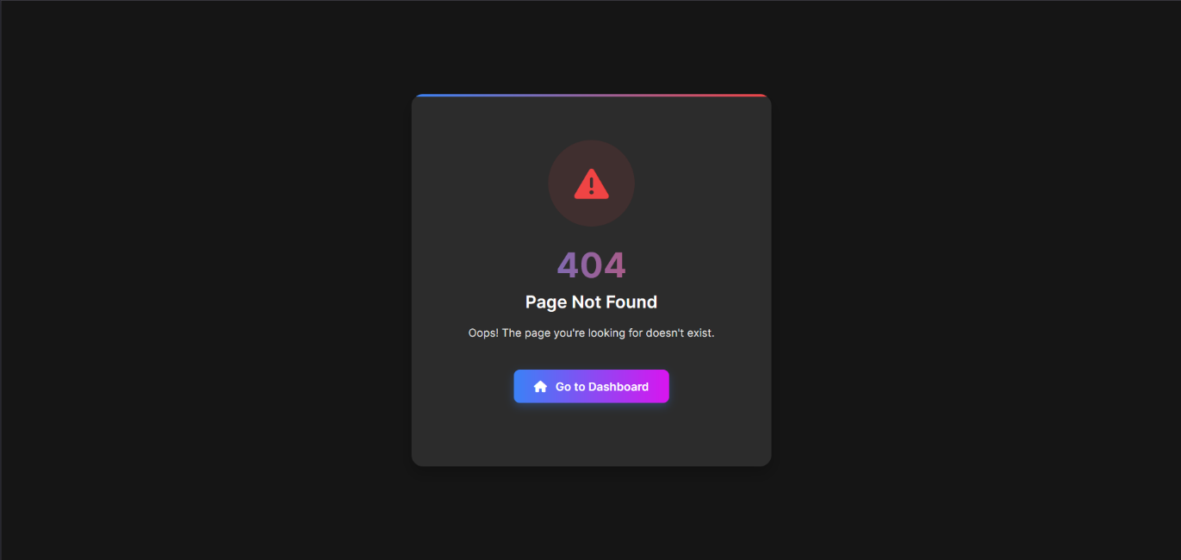

Figure 9 Not Found (404)

Figure 10 enhances the user experience by displaying an animated loading screen during page transitions or while retrieving user data. With dynamic messages and helpful tips, it keeps users informed and engaged, effectively reducing perceived wait time.

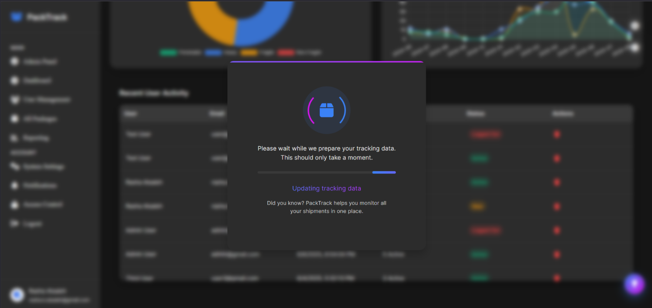

Figure 10 Loading Animation