Use Case Diagram

In **Figure1**, illustrates the use case diagram for the PackTrack System, highlighting the system’s core operations. It outlines two main actors: the User and the Admin, and the specific functions each actor can perform. The diagram also shows shared functions, such as Login, which are accessible by both actors.

Each actor has distinct privileges: the User primarily interacts with their own delivery records, tracking statuses, and performing actions like exporting data. Meanwhile, the Admin has broader system control, including managing delivery statuses, overseeing user records, and exporting system-level reports.

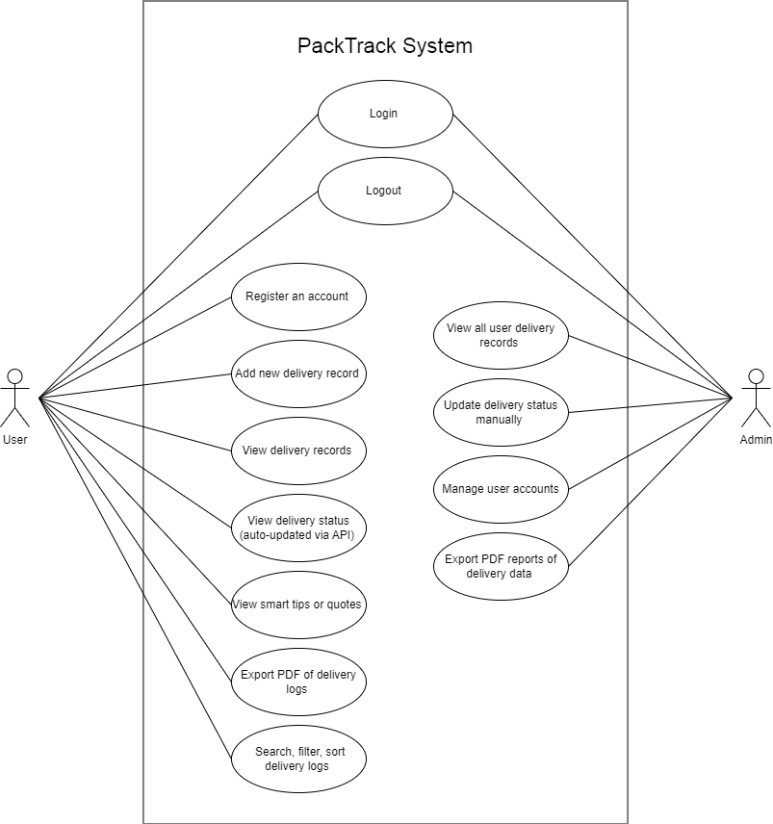

**Figure 1** Use Case Diagram