**رشا ماجد حامد عبدالحميد**

**B.N: 10 ID:311**

**ECE001 Project report**

**Topic:** Programming languages

**Applications:**

Programming language is a set of instructions and commands. The languages that programmers use to write the codes are called high-level languages. This code is compiled then to a low-level language that the computer can understand.

The most usable and popular programming languages are:

* C language: it’s used for Operating systems development, creating Database systems, making spreadsheets, compilers and network drivers.
* Python language: it’s used in Data analytics, Ai and machine learning, game development and web development.
* Java language: it’s used in creating mobile applications, embedded systems, web applications and enterprise applications.
* JavaScript language: it’s used in game development, web development, server applications and web applications.
* PHP language: it’s used to encrypt data, access cookies, connect web applications to a database and restrict user on a site.

**HTML work sample:**

**<**marquee> : to animate the images

<div class=”topnav”>: to create a navigation bar

<img src=””>: to insert image

<table style=””>: to make a table

<ul>: to create unordered list

**Home page sample code:**

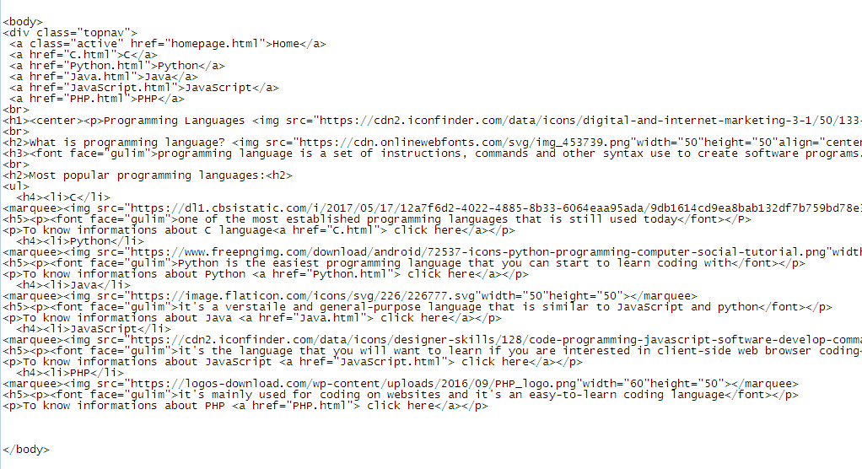

**Web page sample code:**

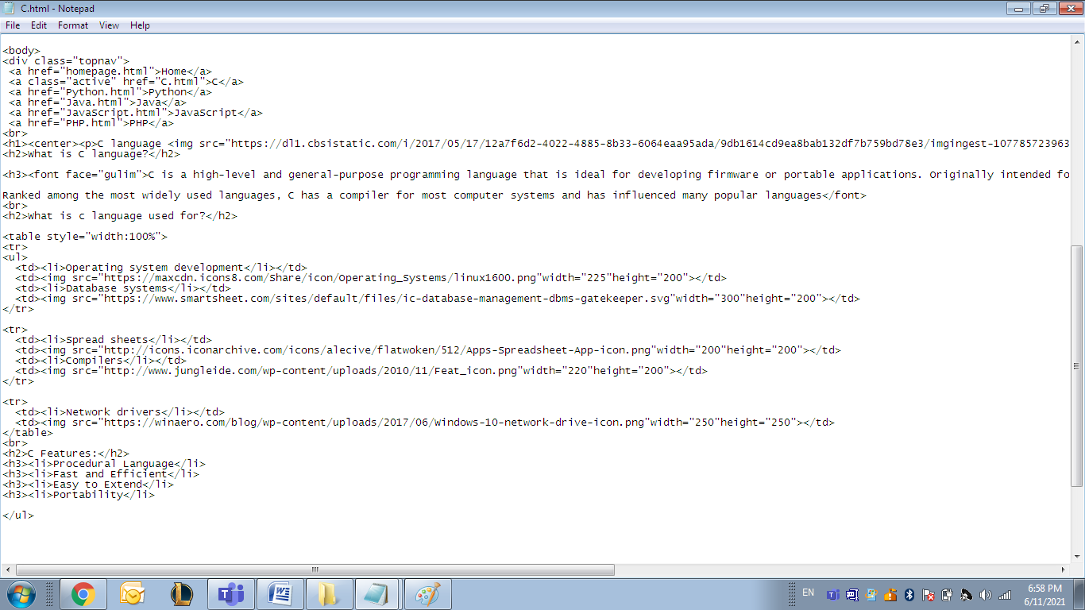

**Css work sample:**

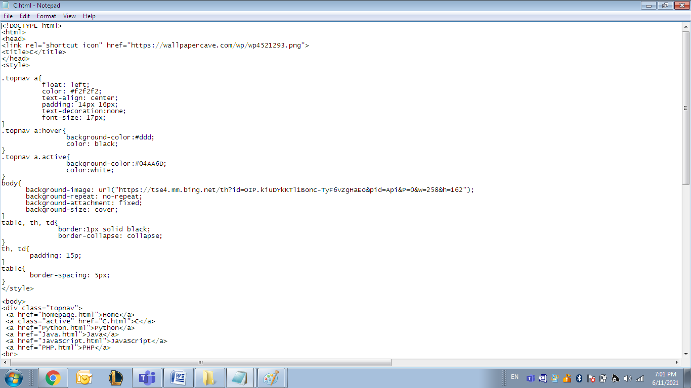

**Link:** https://rashamaged.github.io/Programming-languages.github.io/



