Brazilian E-Commerce Sales Analysis

SQL | Power BI | Excel | SQLite
Portfolio Project

- Prepared by
Rasha
- Date
July 2026

TABLE OF CONTENTS
1. Project Overview ............................................. 3
2. Dataset ...................................................... 4
3. Data Cleaning ................................................ 5
4. Database Schema (ERD) ........................................ 6
5. SQL Analysis ................................................. 7
5.1 Sales Analysis ........................................... 7
5.2 Customer Analysis ........................................ 10
5.3 Delivery & Operations Analysis ........................... 14
5.4 Financial & Business Insights ............................ 16
5.5 Advanced Insights ........................................ 18
6. Power BI Dashboard ........................................... 21
6.1 Executive Summary ........................................ 21
6.2 Customer Analysis ........................................ 22
6.3 Delivery & Operations .................................... 23
6.4 Product & Sales Analysis ................................ 24
7. Key Business Insights ........................................ 25
8. Business Recommendations ..................................... 26
9. Conclusion ................................................... 27

- Project Overview

Introduction
This project presents an end-to-end business analysis of the Brazilian E-commerce Public Dataset (Olist) using SQL and Power BI. The objective was to transform raw transactional data into meaningful business insights that support data-driven decision-making.
The analysis focuses on multiple business areas, including sales performance, customer behavior, operational efficiency, and financial performance. SQL was used to extract, clean, and analyze the data, while Power BI was used to create interactive dashboards that visualize the findings.
Throughout this project, 20 business questions were answered, covering key performance indicators (KPIs), customer segmentation, revenue trends, delivery performance, seasonal purchasing behavior, and business opportunities.
The final outcome is a comprehensive business report supported by SQL queries, interactive Power BI dashboards, and actionable recommendations that demonstrate practical data analysis skills.

2. Dataset

Dataset Source
Dataset Name: Brazilian E-Commerce Public Dataset by Olist
Source: Kaggle
Database: SQLite

Dataset Description
The dataset contains real e-commerce transactions from Olist, one of the largest Brazilian online marketplaces. It includes information about customers, orders, products, payments, sellers, reviews, and delivery operations.
The data provides a comprehensive view of the entire customer journey, making it suitable for business intelligence, sales analysis, customer analytics, and operational performance evaluation.

Selected Tables
TABLE | description
Customers | Customer information including location and unique customer identifiers.
Orders | Order details, purchase dates, delivery dates, and order status.
Order Items | Products purchased in each order, including prices and freight costs.
Products | Product information and product categories.
Payments | Payment values and payment methods used for each order.
Reviews | Customer review scores and review information after order delivery.

3. Data Cleaning

Data Cleaning Process
Before performing the analysis, the dataset was reviewed and prepared to ensure data quality and consistency.
The following steps were completed:
- Verified the integrity of relationships between all tables.
- Checked for missing values in the selected tables.
- Reviewed duplicate records to ensure data accuracy.
- Confirmed appropriate data types for dates, numerical values, and categorical fields.
- Filtered the analysis to completed (delivered) orders where required to ensure accurate business metrics.
- Validated calculations before building the Power BI dashboards.
These preparation steps ensured that the analysis was based on reliable and consistent data.

4. Database Schema

This section presents the database structure used in the analysis, including the relationships between the main tables. Understanding these relationships ensures accurate data integration and supports reliable business analysis.

Entity Relationship Diagram (ERD)
The Entity Relationship Diagram (ERD) illustrates the relationships between the main tables used in this project. These relationships enabled accurate data integration across customers, orders, products, payments, and reviews, providing a solid foundation for SQL analysis and Power BI reporting.

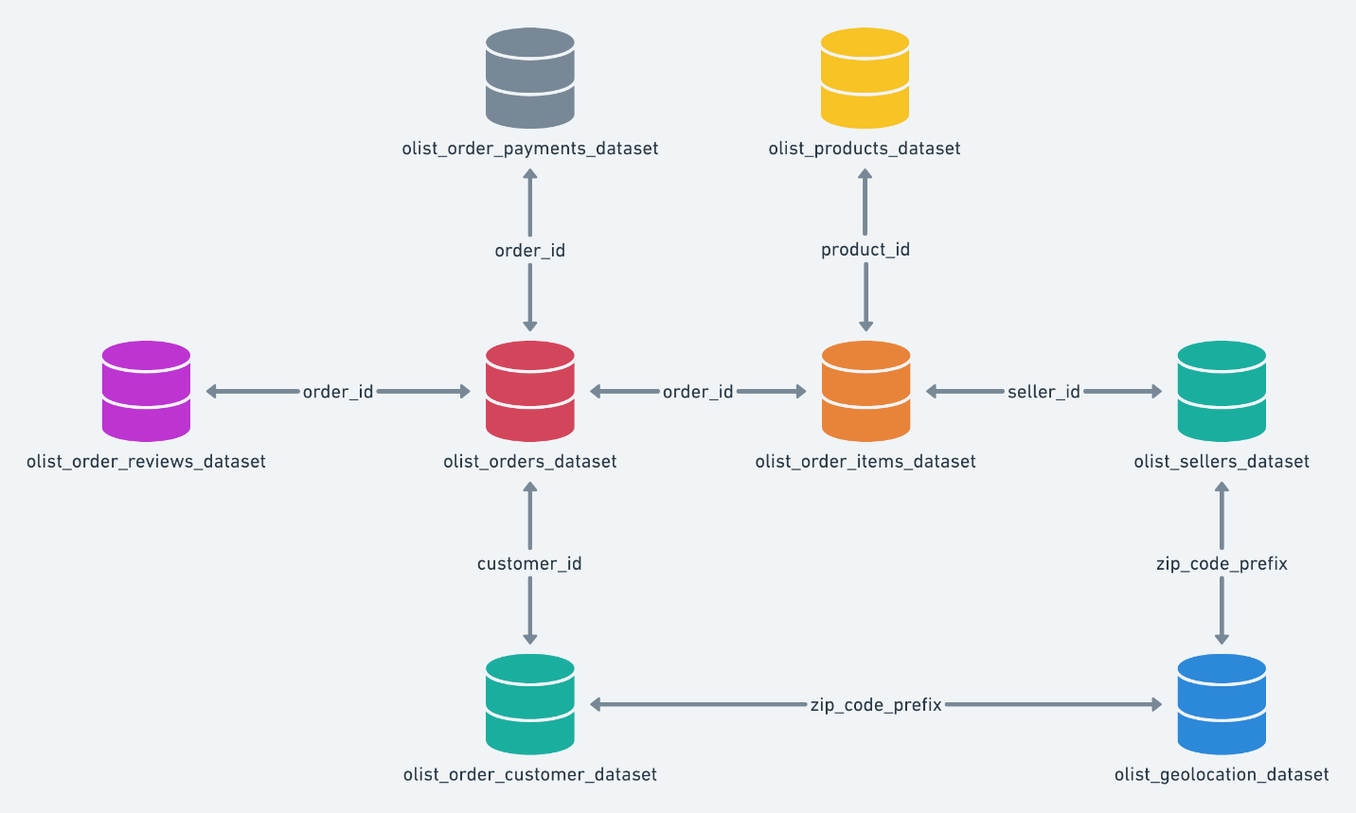

5. SQL Analysis
This section presents the SQL analysis performed to answer key business questions and extract valuable insights from the Brazilian E-commerce dataset.
Note:
- All SQL queries used in this project are available in the attached Business_Analysis.sql file
• 5.1 Sales Performance Analysis
This section analyzes the overall sales performance of the Brazilian e-commerce platform, including revenue generation, sales trends, product performance, and average order value. The analysis aims to identify key sales patterns and business opportunities.

Total Revenue Generated

Objective
Calculate the total revenue generated from all completed customer orders.

Business Insight
The platform generated more than 15 million in total revenue from completed orders, reflecting strong sales performance and a high level of business activity. This metric serves as a key indicator of the company's overall financial performance.

Analysis Result
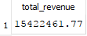

Monthly Sales Trend

Objective
Analyze monthly revenue trends to identify seasonality, growth patterns, and fluctuations in sales performance over time.

Business Insight
Monthly revenue showed noticeable fluctuations throughout the analyzed period, highlighting seasonal demand patterns and changes in customer purchasing behavior. Understanding these trends can support better sales forecasting and business planning.

Analysis Result
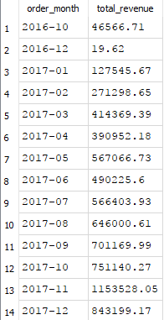

Top Product Categories by Revenue

Objective
Identify the product categories that generate the highest revenue.

Business Insight
A relatively small number of product categories contributed the majority of total revenue. These high-performing categories represent valuable opportunities for targeted marketing campaigns, inventory optimization, and strategic business investment.

Analysis Result
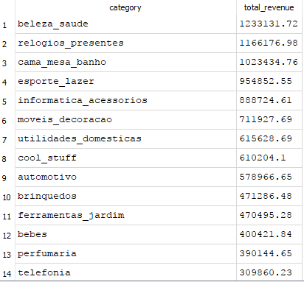

Average Order Value

Objective
Calculate the average amount spent per customer order.

Business Insight
The average order value provides valuable insight into customer purchasing behavior and spending habits. Monitoring this KPI helps evaluate pricing strategies and measure the effectiveness of sales initiatives.

Analysis Result
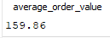

Best-Selling Products

Objective
Identify the products with the highest sales volume.

Business Insight
The analysis revealed that a small number of products consistently achieved significantly higher sales volumes than others. These products represent the company's strongest performers and should be prioritized in inventory planning, promotional campaigns, and demand forecasting.

Analysis Result
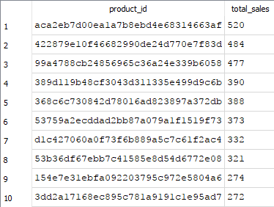

• 5.2 Customer Analysis
This section focuses on customer purchasing behavior, spending patterns, customer loyalty, and geographical distribution. The objective is to better understand customer value and identify opportunities to improve retention and business growth.

Top Customers by Total Spending

Objective
Identify the customers who generated the highest total revenue.

Business Insight
The analysis revealed that a relatively small group of customers contributed a significant portion of the total revenue. These high-value customers represent an important business asset and can be targeted through loyalty programs, personalized offers, and customer retention strategies.

Analysis Result
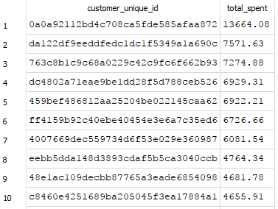

Average Spending per Customer

Objective
Calculate the average amount spent by each customer.

Business Insight
The average spending per customer provides an estimate of the revenue generated by a typical customer. This metric helps evaluate customer value, purchasing behavior, and overall revenue contribution across the customer base.

Analysis Result
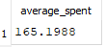

Repeat Customers Spending Analysis

Objective
Compare the average spending of repeat customers with one-time customers.

Business Insight
The analysis showed that repeat customers spend more on average than one-time customers. This finding highlights the importance of customer retention strategies, as encouraging repeat purchases can significantly increase long-term revenue.

Analysis Result
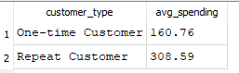

Top Cities and States by Number of Orders

Objective
Identify the cities and states with the highest order volumes.

Business Insight
Certain cities and states generated substantially more orders than others, indicating regions with stronger customer demand. These locations present valuable opportunities for focused marketing campaigns, logistics optimization, and business expansion.

Analysis Result
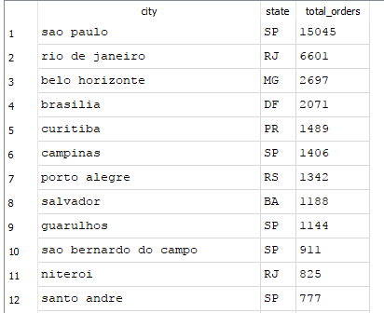

Repeat Customer Percentage

Objective
Measure the percentage of customers who placed more than one order.

Business Insight
The analysis revealed that the percentage of repeat customers is relatively low, suggesting opportunities to strengthen customer loyalty and improve retention. Implementing loyalty programs, personalized recommendations, and targeted promotions may help encourage repeat purchases and increase customer lifetime value.

Analysis Result
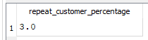

5.3 Delivery & Operations Analysis
This section evaluates delivery performance, shipping efficiency, and operational effectiveness. It also examines how delivery performance influences customer satisfaction and overall order fulfillment.

Average Delivery Time

Objective
Calculate the average time required to deliver customer orders.

Business Insight
The average delivery time reflects the efficiency of shipping and fulfillment operations. Monitoring this metric helps evaluate logistics performance and identify opportunities to improve customer experience.

Analysis Result
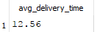

Percentage of Delayed Deliveries

Objective
Measure the percentage of orders delivered later than the estimated delivery date.

Business Insight
The analysis measures the proportion of delayed deliveries, providing valuable insight into shipping performance and operational efficiency. Reducing delivery delays can significantly improve customer satisfaction.

Analysis Result
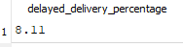

Does Delivery Delay Affect Customer Reviews?

Objective
Analyze the relationship between delivery delays and customer review scores.

Business Insight
The analysis showed that delayed deliveries generally received lower review scores than orders delivered on time, indicating that delivery performance has a direct impact on customer satisfaction and the overall shopping experience.

Analysis Result
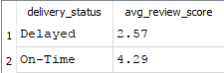

Most Common Order Statuses

Objective
Identify the distribution of order statuses across all customer orders.

Business Insight
Most orders were successfully delivered, while canceled and incomplete orders represented only a small proportion of total orders. This indicates an efficient order fulfillment process and reliable operational performance.

Analysis Result
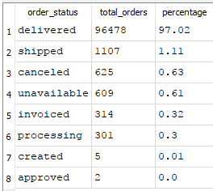

5.4 Financial & Business Insights
This section explores financial performance, pricing behavior, shipping costs, and profitability to identify business opportunities and support strategic decision-making.

Relationship Between Freight Cost and Product Price

Objective
Analyze the relationship between product prices and freight costs.

Business Insight
The analysis revealed a positive relationship between product price and average freight cost, suggesting that higher-value products generally incur higher shipping expenses due to factors such as size, weight, or handling requirements.

Analysis Result
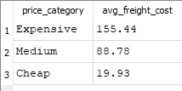

Do Expensive Products Receive Better Reviews?

Objective
Evaluate whether product price influences customer review scores.

Business Insight
Customer review scores varied across different product price categories, indicating that higher-priced products do not necessarily receive better ratings. Customer satisfaction is influenced by multiple factors beyond price alone.

Analysis Result
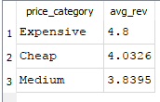

Product Categories with Highest Freight Cost

Objective
Identify product categories with the highest average freight costs.

Business Insight
Certain product categories exhibited considerably higher average freight costs than others, likely due to differences in product dimensions, weight, or shipping requirements. These findings can support logistics optimization and pricing strategies.

Analysis Result
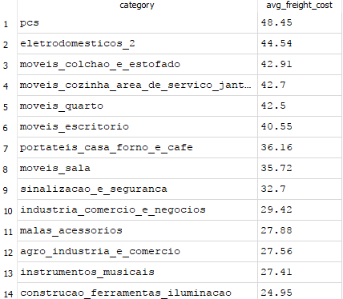

Most Profitable Months

Objective
Identify the months that generated the highest revenue.

Business Insight
Revenue varied noticeably throughout the year, with several months outperforming others. These periods may reflect seasonal demand, promotional campaigns, or consumer purchasing trends, providing valuable input for future sales planning.

Analysis Result
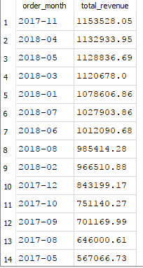

5.5 Advanced Insights
This section presents advanced analytical findings by combining customer behavior and seasonal purchasing patterns to support data-driven business strategies.

Customer Segmentation Based on Spending

Objective
Segment customers into spending groups based on their total purchase value.

Business Insight
Customers were classified into different spending segments according to their total expenditure. This segmentation helps identify high-value customers, improve targeted marketing campaigns, and support more effective customer retention strategies.

Analysis Result
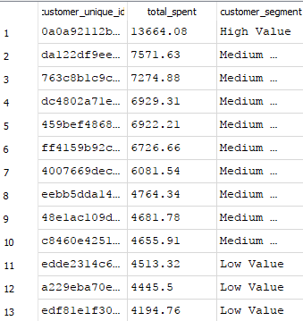

Seasonal Purchasing Behavior

Objective
Analyze order volume across different months to identify seasonal purchasing patterns.

Business Insight
The analysis revealed noticeable differences in monthly order volumes, indicating clear seasonal purchasing behavior. Recognizing these demand patterns enables better inventory management, marketing planning, and resource allocation during peak periods.

Analysis Result
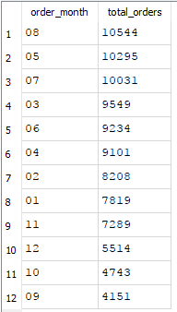

6. Power BI Dashboard
The Power BI dashboard was developed to transform the SQL findings into interactive visualizations, enabling users to explore sales performance, customer behavior, operational efficiency, and business trends through dynamic reports.

Executive Overview

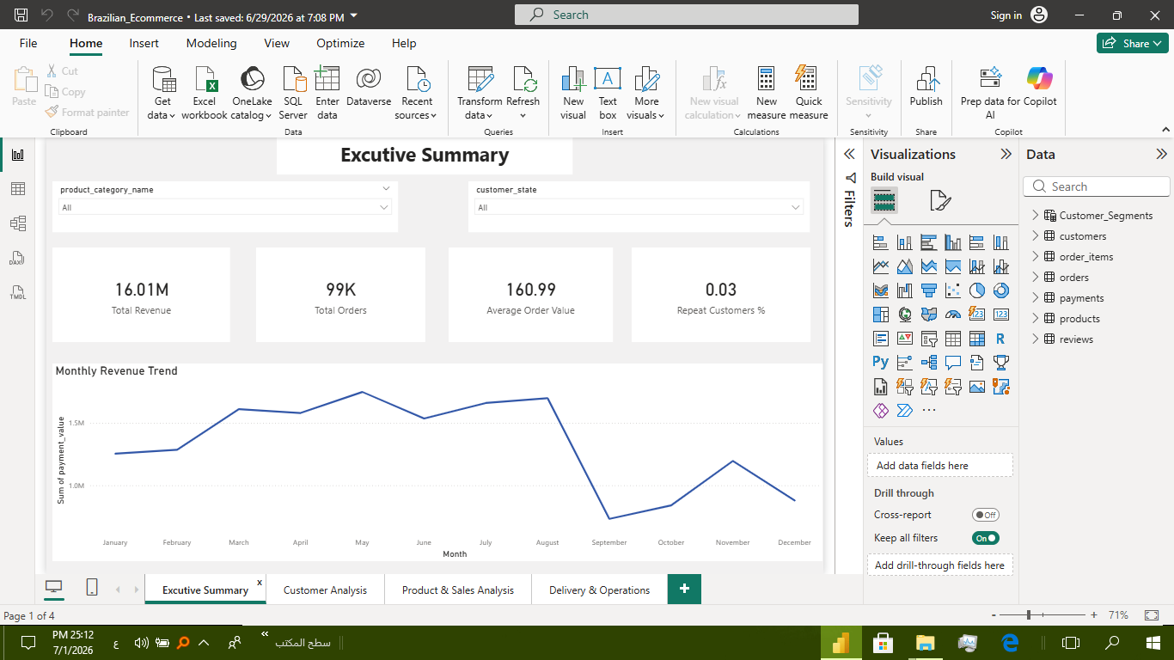
Description
This dashboard provides a high-level overview of the company's overall performance through key performance indicators (KPIs), including total revenue, total orders, average order value, and repeat customer percentage. It also presents the monthly sales trend, enabling users to quickly evaluate overall business performance over time.

Customer Analysis
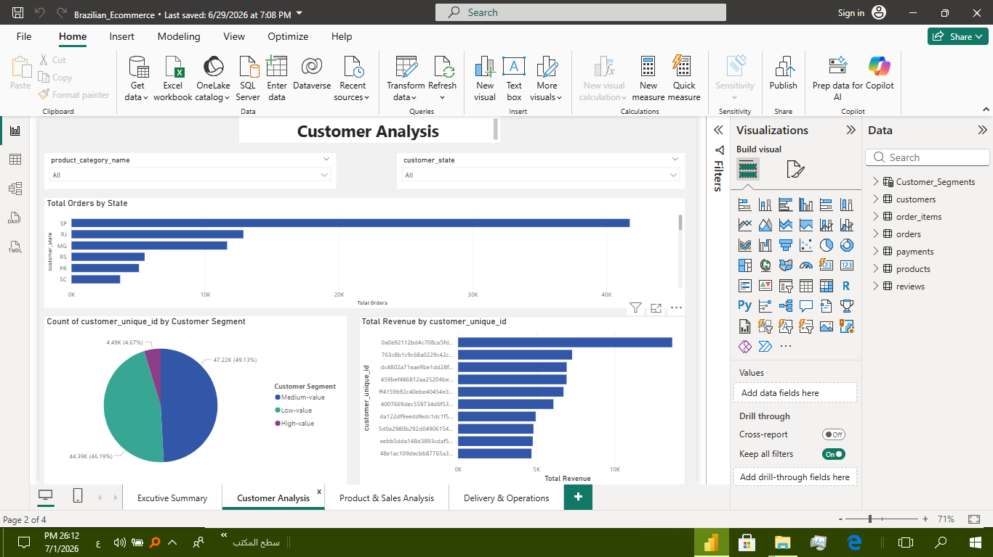
Description
This dashboard focuses on customer purchasing behavior, spending patterns, customer loyalty, and geographical distribution. It highlights top customers, customer segmentation, repeat customer metrics, and regional order distribution to support customer-focused business strategies.

Delivery & Operations Analysis

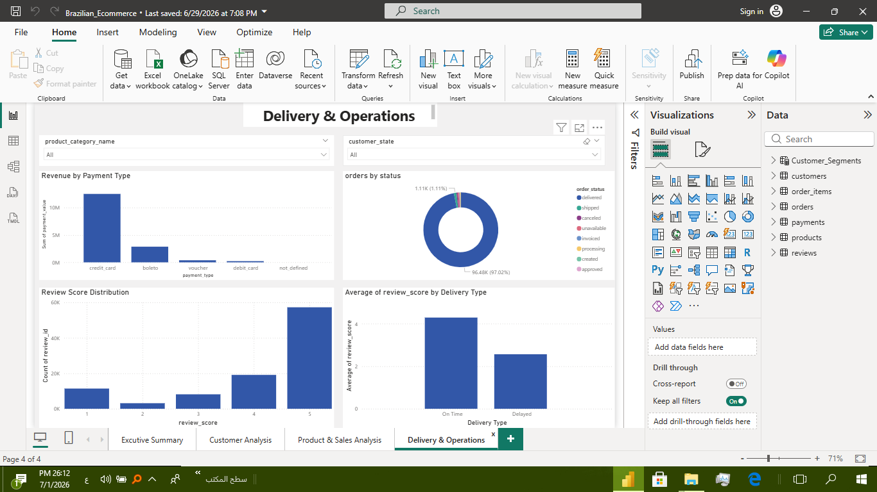
Description
This dashboard evaluates operational performance by monitoring delivery times, delayed deliveries, customer review scores, and order status distribution. These visualizations help assess logistics efficiency and identify factors affecting customer satisfaction.

Product & Sales Analysis
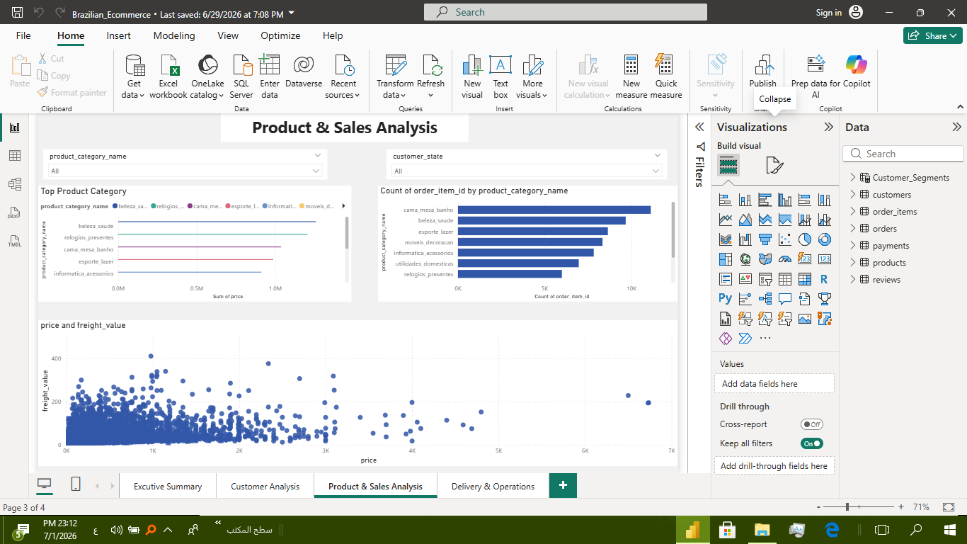Description
This dashboard analyzes product performance and sales patterns across different product categories. It highlights the top-performing product categories, the most frequently ordered categories, and the relationship between product price and freight cost. These visualizations help identify high-performing products, evaluate pricing patterns, and support product management and sales strategies.

7. Key Business Insights
The analysis produced several important business insights that summarize the overall performance of the Brazilian e-commerce platform:
- The platform generated over 15 million in total revenue, demonstrating strong sales performance.
- Sales activity fluctuated throughout the year, indicating seasonal purchasing behavior.
- A small number of product categories generated the majority of total revenue.
- High-value customers contributed a significant portion of overall sales.
- Repeat customers spent more on average than one-time customers, highlighting the importance of customer retention.
- Customer loyalty remained relatively low, suggesting opportunities to improve repeat purchase rates.
- Certain cities and states generated considerably higher order volumes than others.
- Delivery delays negatively affected customer review scores, emphasizing the importance of logistics performance.
- Most orders were successfully delivered, indicating efficient order fulfillment operations.
- Freight costs generally increased with product prices, reflecting the relationship between product value and shipping expenses.

8. Business Recommendations
Based on the analysis, the following recommendations are proposed to improve business performance:
- Strengthen customer loyalty programs to increase repeat purchases.
- Focus marketing campaigns on high-value customers and high-performing regions.
- Increase investment in the best-performing product categories.
- Improve delivery performance to reduce delays and enhance customer satisfaction.
- Optimize freight costs for categories with high shipping expenses.
- Prepare inventory according to seasonal demand patterns.
- Monitor key business KPIs regularly using interactive Power BI dashboards.
- Continue using data-driven decision-making to support future business growth.

9. Conclusion
This project demonstrated how SQL and Power BI can be combined to transform raw business data into meaningful insights.
Using SQL, business questions were answered through data extraction, aggregation, and analytical queries. Power BI was then used to convert these findings into interactive dashboards that support business monitoring and decision-making.
The project provided valuable insights into sales performance, customer behavior, logistics efficiency, and financial trends while demonstrating practical skills in data analysis, business intelligence, and data visualization.
Overall, this project reflects an end-to-end business analytics workflow, from data exploration and SQL analysis to dashboard development and business reporting.

