PEOPLELINK
U N I F I E D C O M M U N I C A T I O N S
The World's Only Fully Integrated AV Ecosystem
INSTAVC PRO — 50 PORT DEPLOYMENT
Technical Prerequisites, Architecture & Proof of Concept Plan
Prepared for
INDIAN OVERSEAS BANK
Tamil Nadu · August 2026
Confidential
NORTH AMERICA • MIDDLE EAST • AFRICA • INDIA • ANZ

Document Control
Item | Detail
Document title | InstaVC Pro 50-Port Deployment — Technical Prerequisites, Architecture and POC Plan
Prepared for | Indian Overseas Bank — Data Centre, Network, Firewall and Information Security teams
Solution | InstaVC Pro, 50 concurrent ports, with 75 registered video conferencing endpoints
Infrastructure | Virtual machine provided by Indian Overseas Bank within the Bank’s Data Centre
Version | 1.0
Date | August 2026
Classification | Confidential — for internal evaluation by Indian Overseas Bank
Status | Issued for pre-POC technical review
Table of Contents
1. Scope and Solution Summary
2. High-Level Design
3. End-to-End Network Topology
4. Virtual Machine and Server Infrastructure
5. Network Architecture and Addressing
6. Bandwidth and Media Traffic
7. Firewall Port Matrix
8. Endpoint Prerequisites
9. Protocol Support and Interoperability
10. POC Architecture, Test Cases and Acceptance Criteria
A. Annexure A — Troubleshooting and Escalation Matrix
B. Annexure B — Responsibility Matrix

1. Scope and Solution Summary
This document defines the complete set of infrastructure, network, security and application prerequisites required to deploy and validate InstaVC Pro within the Indian Overseas Bank Data Centre, together with the Proof of Concept test plan and acceptance criteria. It is intended to be issued directly to the Bank’s Data Centre, Network, Firewall and Information Security teams and to be implementable without further clarification.

1.1 Solution in scope
- InstaVC Pro multipoint conferencing platform licensed for 50 concurrent ports.
- 75 standards-based video conferencing endpoints registered to the platform.
- Single combined server instance hosting the MCU, Application Server, MCU Manager and NAT traversal services.
- Web-based administration, conference scheduling, room management and call detail records.
- Browser-based WebRTC participation alongside H.323 and SIP endpoint dial-in, within the same conference room.

1.2 Capacity model
The platform is licensed for 50 concurrent ports, where one port corresponds to one active participant in a conference. A total of 75 endpoints may be registered and provisioned against the platform, of which up to 50 may be simultaneously connected across all conferences at any one time. Where a secondary camera is added to a session, that additional stream consumes an extra licensed port and must be accounted for in the concurrency plan.

1.3 Deployment scenarios
Two deployment scenarios are described throughout this document. The Bank may adopt either, and the firewall, NAT and certificate requirements differ accordingly.
Scenario | Description
Scenario A | Published deployment. The platform is reachable through the Bank’s firewall using a public IP address with static NAT. Required where external participants, remote users or branch WebRTC users must join. Public DNS records and SSL certificates for both sub-domains are required.
Scenario B | Fully internal deployment. The platform is reachable on a private IP address only, with no NAT, no public DNS and no internet dependency. Suitable for a closed or offline Data Centre deployment. Internal DNS and internally issued certificates are used.

1.4 Delivery method
The platform is supplied either as a pre-built ISO image with the InstaVC Pro application embedded, or as an OVF appliance for direct import into the Bank’s virtualisation platform. The Bank may select whichever method aligns with its Data Centre provisioning standards.

1.5 High availability
The deployment described in this document is a single-instance configuration. Platform-level clustering and automatic service failover are not in scope. Availability is therefore provided by the Bank’s virtualisation layer through hypervisor high availability, host redundancy, snapshots and backups. Where the Bank requires application-level redundancy, a second instance can be scoped separately.

2. High-Level Design
The solution is delivered as a single virtual machine within the Bank’s server VLAN, hosting four functional components. Administrators reach the MCU Manager for configuration and reporting, browser users reach the Application Server for WebRTC participation, and endpoints dial the MCU directly using the room identifier and room password. All participants, irrespective of the access method, converge into the same conference room.
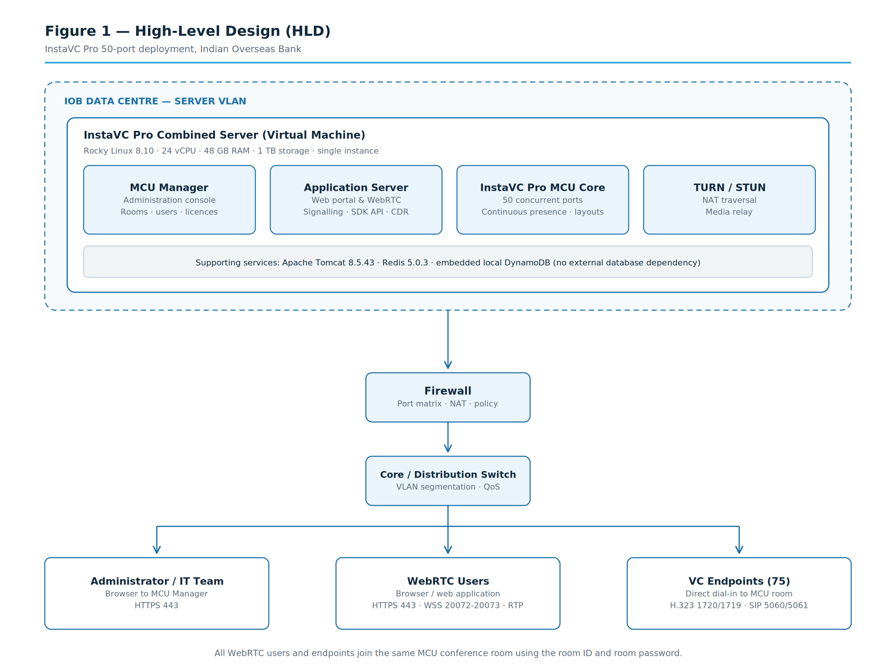
Figure 1 — High-Level Design

2.1 Component responsibilities
Component | Function
MCU Manager | Web-based administration console. Conference room creation and configuration, room identifier and password management, user administration, licence management and call detail records. Accessed by the Bank’s administrators only.
Application Server | Web portal and WebRTC service. Provides browser-based participation, conference scheduling, contacts, chat, screen sharing, whiteboard and the SDK API. Serves browser users only; endpoints do not traverse this component.
MCU Core | Multipoint control unit providing 50 concurrent ports, continuous presence, layout selection, lecture mode, host controls and protocol gateway functions between H.323, SIP and WebRTC.
TURN / STUN | NAT traversal and media relay for WebRTC participants where direct peer connectivity is not available.

2.2 Supporting services
Service | Version and role
Apache Tomcat | 8.5.43 — application container serving the web portal and administration console over HTTP and HTTPS.
Redis | 5.0.3 — in-memory data store for session and signalling state.
Database | Embedded local instance running on the application server itself. No external or cloud-hosted database is used and no outbound database connectivity is required from the Data Centre.

3. End-to-End Network Topology
The diagram below shows connectivity from the endpoint and user VLAN through the access and core switching layers, across the firewall, and into the server VLAN hosting the InstaVC Pro instance. The optional published path used in Scenario A is shown as a dashed connection.
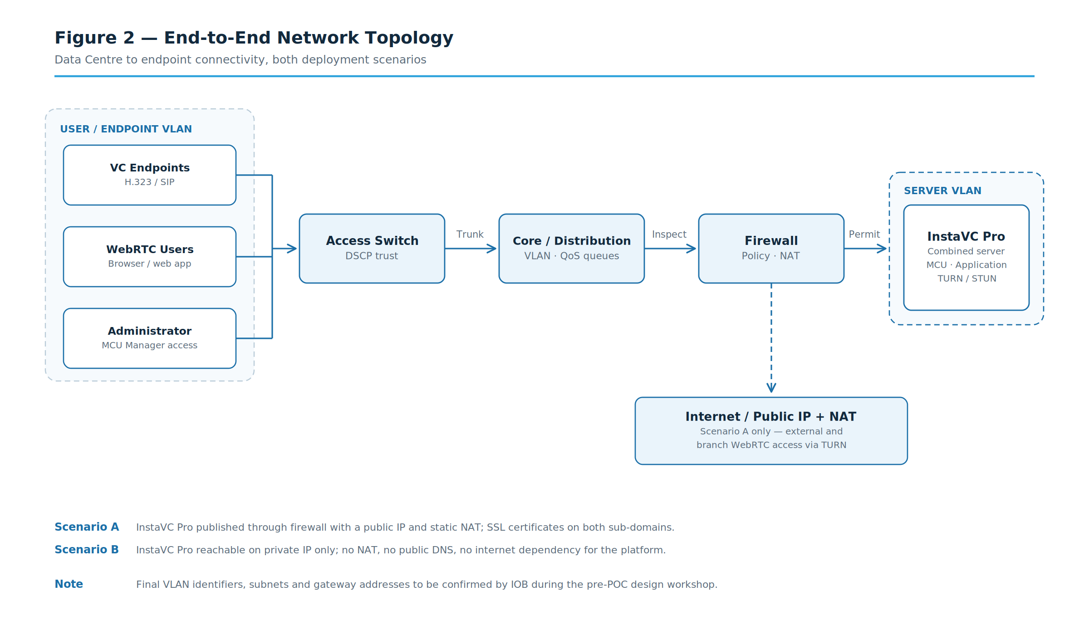
Figure 2 — End-to-End Network Topology

3.1 Connectivity requirements
- Layer 3 reachability between the user or endpoint VLAN and the server VLAN, permitted by the firewall policy defined in Section 7.
- A dedicated server VLAN for the InstaVC Pro instance, segmented from general user traffic.
- One static private IP address for the virtual machine. DHCP is not supported for the server.
- One public IP address with static NAT, required for Scenario A only.
- Consistent MTU of 1500 bytes end to end. Fragmentation of media traffic must be avoided.
- Symmetric routing between the endpoints, the firewall and the server. Asymmetric paths will break media flows.
- Internal DNS resolution for both service sub-domains, and NTP synchronisation for the server and all endpoints.

4. Virtual Machine and Server Infrastructure

4.1 Sizing for 50 concurrent ports
Attribute | Requirement
Role | Combined server — MCU, Application Server, MCU Manager, NAT traversal and WebRTC signalling
Quantity | 1 virtual machine
Processor | Intel Xeon class server processor
vCPU | 24 vCPU, reserved
Memory | 48 GB RAM, reserved
Storage | 1 TB
Operating system | Rocky Linux 8.10 (64-bit)
Network interface | 1 × 1 Gbps virtual NIC, static IP addressing
Virtualisation | Supplied as an ISO with the application embedded, or as an OVF appliance for direct import
Database | Embedded local database on the application server; no external database instance required
Application services | Apache Tomcat 8.5.43, Redis 5.0.3

4.2 Storage performance
The workload is real-time media processing rather than transactional database activity, so throughput matters more than raw capacity. The following is recommended for predictable performance.
Attribute | Recommendation
Disk type | SSD or all-flash backed datastore
Sustained IOPS | Minimum 3,000 IOPS for the virtual machine
Disk latency | Below 10 ms sustained; below 20 ms peak
Provisioning | Thick provisioned, eager zeroed where the platform supports it
CPU and memory | Reserved, with no overcommitment on the host serving this virtual machine

4.3 Resource contention
Real-time video processing is sensitive to host contention. The virtual machine should be placed on a host with sufficient headroom, and CPU ready time should remain below five per cent. Where the Bank operates a shared virtualisation cluster, a resource reservation or a dedicated host is recommended for the POC period so that measured performance reflects the platform rather than the underlying host load.

4.4 Scalability
Capacity is bounded by the licensed port count and by the processing capacity of the virtual machine. Expansion beyond 50 concurrent ports is achieved by increasing the licence and scaling the virtual machine vertically, or by separating the MCU and Application Server roles onto two virtual machines. Both paths can be executed without redesigning the network, addressing or firewall policy defined in this document, which is why the Bank is advised to size VLAN and address allocations with headroom from the outset.

5. Network Architecture and Addressing

5.1 IP addressing
Element | Requirement
InstaVC Pro server | One static private IPv4 address. DHCP is not supported.
Public address | One public IPv4 address with static NAT — Scenario A only.
Endpoints | Static IP addressing recommended, or DHCP with permanent reservations. Addresses must remain stable, as registration and dial plans depend on them.
WebRTC users | Standard corporate DHCP addressing is acceptable.
Administration | Access restricted to a defined management subnet or jump host.

5.2 VLAN segmentation
The following segmentation is recommended. Final VLAN identifiers are assigned by the Bank.
VLAN | Purpose | Notes
Server VLAN | InstaVC Pro virtual machine | Segmented from user traffic; access governed by the firewall policy in Section 7
Endpoint VLAN | Video conferencing endpoints | Dedicated voice and video VLAN with DSCP trust enabled at the access layer
User VLAN | WebRTC browser participants | Existing corporate user VLAN is acceptable
Management VLAN | Administration and monitoring access | Restricted to authorised administrator workstations or a jump host

5.3 Routing, DNS and NTP
- Routing between the endpoint, user and server VLANs must be symmetric. Asymmetric routing will cause one-way audio or video.
- Two internal DNS records are required, resolving the MCU and Application sub-domains to the server address. For Scenario A, matching public records are also required.
- All endpoints, the server and the administration workstations must synchronise to a common NTP source. Time drift causes certificate validation failures and inaccurate call detail records.
- Where the Bank operates a proxy, the server must be excluded from proxy interception for signalling and media traffic.

6. Bandwidth and Media Traffic

6.1 Per-stream bandwidth
The figures below are per participant and apply symmetrically in both the send and receive direction.
Stream type | Resolution | Bandwidth | Notes
Video — Full HD | 1080p | - 4 Mbps | Recommended for conference rooms and meeting rooms
Video — HD | 720p | 1 – 1.5 Mbps | Suitable for desktop and branch participants
Video — standard | VGA | 786 Kbps | Minimum acceptable quality; constrained links
Audio | Opus | 40 – 64 Kbps | Included in the figures above where combined
Content sharing | Up to 1080p | 0.5 – 1 Mbps | Additional to the video stream while sharing is active
Signalling | n/a | Negligible | HTTPS and control traffic only

6.2 Aggregate capacity at the server
Scenario | Calculation | Bandwidth
50 concurrent ports at Full HD | 50 × 2 - 4 Mbps | 100 – 200 Mbps
50 concurrent ports at HD | 50 × 2 - 4 Mbps | 100 – 200Mbps
Content sharing allowance | 10 concurrent shares × 1 Mbps | 10 Mbps
Sub-total at peak | Full HD plus content | Approximately 110 Mbps
Recommended headroom | 30 per cent for peak and burst | Approximately 33 Mbps
Recommended server uplink | Sub-total plus headroom | 150 Mbps minimum; 200 Mbps preferred
The server link should be provisioned at 1 Gbps to accommodate burst behaviour and future expansion, with the figures above representing sustained utilisation rather than link capacity.

6.3 Network performance thresholds
The following thresholds must be met on every path between an endpoint and the server for acceptable conferencing performance. They are also the values measured during the POC.
Parameter | Target | Acceptable | Degraded above
One-way latency | Below 100 ms | Below 150 ms | 150 ms
Jitter | Below 20 ms | Below 30 ms | 30 ms
Packet loss | Below 0.5 per cent | Below 1 per cent | 1 per cent
Link utilisation | Below 70 per cent | Below 80 per cent | 80 per cent

7. Firewall Port Matrix
The matrix below lists every port required by the platform. It is presented in the form required by the Bank’s security team for direct implementation. The remarks column identifies where a rule may be tightened at the Bank’s discretion without affecting conferencing functionality.

7.1 Service endpoints
Service | Sub-domain | Address | Purpose
MCU service | mcu.<bank-domain> | Private IP; public IP optional | H.323, SIP and WebRTC conferencing
Application service | app.<bank-domain> | Private IP; public IP optional | Web portal, NAT traversal, SDK API

7.2 Inbound rules — to the InstaVC Pro server
Source | Destination | Proto | Port(s) | Direction | Purpose and remarks
Admin subnet | InstaVC Pro | TCP | 80, 443 | Inbound | Web and administration console access over HTTPS
User subnets | InstaVC Pro | TCP | 443 | Inbound | WebRTC portal access
User subnets | InstaVC Pro | TCP | 20072, 20073 | Inbound | WebRTC signalling
User subnets | InstaVC Pro | TCP | 5040 | Inbound | SDK API
User subnets | InstaVC Pro | TCP | 5223 | Inbound | Network authentication
Endpoint subnet | InstaVC Pro | TCP | 1720 | Inbound | H.323 call signalling
Endpoint subnet | InstaVC Pro | TCP | 6000-6128 | Inbound | H.245 control channel
Endpoint subnet | InstaVC Pro | UDP | 1719 | Inbound | H.323 gatekeeper registration
Endpoint subnet | InstaVC Pro | TCP | 5060, 5061 | Inbound | SIP over TCP and SIP over TLS
Endpoint subnet | InstaVC Pro | UDP | 5060 | Inbound | SIP over UDP
All client subnets | InstaVC Pro | UDP | 32768-65534 | Inbound | RTP media streams. This is the default range. It may be narrowed at the Bank’s discretion provided the configured range accommodates the concurrent session count.
All client subnets | InstaVC Pro | UDP | 6000-7000 | Inbound | BFCP — content and floor control
All client subnets | InstaVC Pro | UDP / TCP | 3478, 5349 | Inbound | TURN and STUN NAT traversal
InstaVC Pro | Client subnets | UDP | 10000, 10002, 10004 | Outbound | Broadcast services
InstaVC Pro | Client subnets | TCP | 8000 | Outbound | Broadcast listener
Management subnet | InstaVC Pro | TCP | 5038 | Inbound | Management interface. Not required for normal conferencing operation. Recommended to be restricted to a designated jump host, or disabled after commissioning.
InstaVC Pro | DNS servers | UDP / TCP | 53 | Outbound | Name resolution
InstaVC Pro | NTP server | UDP | 123 | Outbound | Time synchronisation

7.3 NAT and policy requirements
- Scenario A requires static one-to-one NAT between the public address and the server private address. Port address translation must not be used for media traffic, as it will break RTP flows.
- SIP ALG, H.323 ALG and any application-layer inspection for these protocols must be disabled on the firewall. These features rewrite signalling and are the most common cause of call setup failure.
- SSL inspection and deep packet inspection must be excluded for the two service sub-domains. Media is encrypted end to end and inspection will terminate sessions.
- Web filtering must permit both sub-domains. For Scenario B no internet access is required by the platform.
- Firewall session timeouts for UDP media flows should be set to no less than 300 seconds to prevent mid-call teardown.
- IP whitelisting is supported. The Bank may restrict administration access to a named management subnet.

8. Endpoint Prerequisites
The platform supports standards-based H.323 and SIP endpoints. The requirements below apply to all 75 endpoints irrespective of manufacturer.
Requirement | Detail
Network connectivity | Wired Ethernet connection to the endpoint VLAN, 100 Mbps or 1 Gbps, full duplex
IP addressing | Static IP address, or DHCP with a permanent reservation so the address does not change
Bandwidth per endpoint | 1.5 – 2 Mbps symmetric for Full HD; 1 – 1.5 Mbps for HD
Protocols | H.323 with gatekeeper registration, or SIP registration; RTP and RTCP for media
Ports | As listed in Section 7 — H.323 1720 and 1719, SIP 5060 and 5061, media UDP 32768-65534, BFCP 6000-7000
DNS and NTP | Must resolve the MCU sub-domain and synchronise time with the Bank’s NTP server
Firmware | Current stable manufacturer firmware, consistent across all units of the same model
Registration | Registered to the platform in gatekeeper or SIP registrar mode; alternatively direct dial to the MCU using room identifier and password
Authentication | Conference access controlled by room identifier and room password; the room password configured on the MCU must match the value configured in the portal
Codec support | Minimum H.264 for video and a standard audio codec, to ensure successful negotiation with the MCU
Remote administration | Manufacturer web interface reachable from the Bank’s management subnet

9. Protocol Support and Interoperability
Area | Support
Signalling protocols | H.323, SIP and WebRTC, supported concurrently within the same conference
H.323 | Standalone operation or gatekeeper mode; call signalling on TCP 1720, gatekeeper on UDP 1719, H.245 control on TCP 6000-6128
SIP | SIP over UDP and TCP on 5060, SIP over TLS on 5061
Media transport | RTP and RTCP over UDP within the configured media port range
Video codecs | H.261, H.263, H.264, H.264 High Profile and VP8
Audio codecs | Opus, with negotiation to standard audio codecs supported by connecting endpoints
Content sharing | BFCP for endpoints on UDP 6000-7000; browser-based screen sharing for WebRTC participants
NAT traversal | TURN and STUN services hosted on the platform
Conference architecture | Multipoint control unit providing continuous presence, protocol gateway functions and call control across all three protocols
Conference features | Automatic and manual layout selection, over ten layouts, active speaker and voice-activated switching, lecture mode, host controls, mute and unmute all, room lock and lobby, participant removal, whiteboard and screen sharing
Third-party interoperability | Standards-based interoperability with third-party H.323 and SIP endpoints and infrastructure. Specific third-party systems in the Bank’s estate should be identified before the POC so that interoperability testing can be included in the test plan.

10. POC Architecture and Acceptance Criteria

10.1 POC scope
The Proof of Concept validates the platform on the Bank’s own infrastructure against the prerequisites defined in this document. A representative subset of endpoints is sufficient to prove every functional test case; concurrency and load testing are then performed to validate the 50-port capacity.

10.2 Measurement approach
- In-call media statistics available within the conference interface provide per-stream codec, bitrate, resolution, frame rate, packet loss and available bandwidth.
- Network path measurement using ping and iperf3 between representative endpoint locations and the server, before and during load.
- Packet capture at the access and core layers to verify DSCP markings are preserved end to end.
- Firewall and switch interface counters for utilisation, drops and denied sessions during the test window.
- Administration console for registration status, active sessions, participant counts and call detail records.

10.3 Exit criteria
The POC is considered successful when all test cases in Section 10.2 meet their stated acceptance criteria, the measured network performance is within the Section 6.3 thresholds, and the firewall policy operates without exception during a full-load conference.

Annexure A — Troubleshooting and Escalation Matrix

A.1 Common issues
Symptom | Probable cause | Action
Endpoint fails to register | Gatekeeper or SIP ports blocked; incorrect server address | Verify UDP 1719 and TCP 1720 or SIP 5060 and 5061; confirm endpoint configuration
Call connects, no media | RTP UDP range not permitted; NAT translating media | Verify the media port range on the firewall; confirm static NAT rather than PAT
One-way audio or video | Asymmetric routing; ALG rewriting signalling | Verify routing symmetry; disable SIP and H.323 ALG
Call drops mid-session | Firewall UDP session timeout too short | Increase UDP timeout to 300 seconds or more
Poor video quality under load | Insufficient bandwidth or QoS not applied | Verify utilisation against Section 6; confirm DSCP markings preserved
Browser cannot join | WebRTC signalling ports or TURN blocked | Verify TCP 20072 and 20073 and TURN 3478 and 5349
Certificate warning in browser | Certificate missing or sub-domain mismatch | Verify certificates issued for both sub-domains and trusted internally
Cannot join a room | Room identifier or password mismatch between MCU and portal | Align the room configuration in the MCU Manager with the portal room settings

A.2 Escalation matrix
A senior technical resource for software and a senior technical resource for endpoints will be nominated to support the activity end to end, covering pre-POC discussions, infrastructure validation, POC setup, troubleshooting and the final technical evaluation.

Annexure B — Responsibility Matrix
Activity | Indian Overseas Bank | Solution Provider
Virtual machine provisioning and resource allocation | Responsible | Advises
Operating system image deployment (ISO or OVF) | Supports | Responsible
IP addressing, VLAN and routing configuration | Responsible | Advises
DNS and NTP configuration | Responsible | Advises
SSL certificate procurement and issuance | Responsible | Advises
Firewall rule implementation | Responsible | Provides matrix
QoS and switching configuration | Responsible | Provides guidelines
Platform installation and configuration | Supports | Responsible
Licence application | Supports | Responsible
Conference room and user configuration | Supports | Responsible
Endpoint cabling, addressing and firmware | Responsible | Advises
Endpoint registration and dial plan configuration | Supports | Responsible
Server hardening and patching | Responsible | Advises
Antivirus, EDR and backup policy | Responsible | Provides exclusions
POC test execution | Joint | Joint
Results recording and technical sign-off | Joint | Joint
Administrator and user training | Supports | Responsible
End of document

