WEEK 3 PROJECT PLAN
Exploratory Data Analysis (EDA) and Visualization Design
Telecom Customer Churn Data Science Project
Submitted by: Kazi Rashad
Stream: BTech Computer Science Engineering
College: Dr VK Patil College of Engineering and Technology
Subject: Data Science Project

1. Executive Summary
This Week 3 plan defines a structured Exploratory Data Analysis (EDA) and visualization framework for the telecom customer churn project. The purpose of EDA is to transform the prepared telecom dataset into understandable statistical and visual evidence before machine-learning modelling. The analysis will examine customer characteristics, service adoption, tenure, contracts, billing behaviour and churn patterns. Python libraries including Pandas, NumPy, Matplotlib, Seaborn and Plotly will be used according to the analytical question and visualization requirement.
Every major visualization is connected to a business question and an interpretation strategy. Descriptive statistics establish the structure of the data, while distribution, comparison, relationship and categorical analyses identify potential churn patterns. Statistical tests will be used when appropriate, with assumptions considered before testing. Correlation will be interpreted as association rather than causation.

2. Link With Weeks 1 and 2
Week 1 established the telecom customer churn problem and selected the IBM Telco Customer Churn dataset as the primary project dataset. Week 2 defined the data acquisition, preprocessing and quality-assurance strategy. Week 3 builds on those stages by defining how the prepared data will be explored, visualized and translated into business insights.

3. EDA Objectives
- Understand the structure and distribution of important telecom variables.
- Measure churn overall and across relevant customer segments.
- Identify relationships between churn and tenure, contract, services and billing.
- Detect unusual patterns, skewness and potential remaining data-quality issues.
- Use statistics and visualizations to generate evidence-based hypotheses.
- Translate important patterns into practical telecom business questions and recommendations.
- Prepare a documented foundation for feature engineering and machine-learning modelling.

4. Exploratory Framework: Business Questions and Hypotheses
Question / hypothesis | Variables | Planned analysis | Business use
How is churn distributed overall? | Churn | Frequency, percentage, bar chart | Baseline churn
Does churn vary by contract type? | Contract, Churn | Grouped proportions/bar chart | Retention by contract segment
Is shorter tenure associated with higher churn? | Tenure, Churn | Distribution comparison | Early-life retention
Do monthly charges differ by churn status? | MonthlyCharges, Churn | Summary statistics, box plot | Billing/value investigation
Do service categories show different churn patterns? | InternetService, TechSupport, OnlineSecurity, Churn | Cross-tabs and categorical plots | Service improvement
Does payment method show different churn? | PaymentMethod, Churn | Grouped proportions | Payment/customer experience review
Are numeric billing variables related? | MonthlyCharges, TotalCharges, Tenure | Correlation/scatter plot | Understand revenue structure
Which segments appear most vulnerable? | Contract, tenure, services, charges, Churn | Segmented EDA/dashboard | Prioritize further analysis

5. Descriptive Statistics
Numeric variables will be summarized using count, mean, median, standard deviation, minimum, maximum and quartiles. Categorical variables will be summarized using unique counts and frequencies/proportions. Churn will be examined as the primary outcome. Median and quartiles will receive attention where distributions are skewed.
df.shape
df.info()
df.describe()
df.describe(include="object")
df["churn"].value_counts(dropna=False)
df["churn"].value_counts(normalize=True, dropna=False) * 100

6. Distribution Analysis
Distribution analysis will examine tenure, monthly charges and total charges using histograms, KDE where appropriate, box plots and summary statistics. The goal is to identify concentration, spread, skewness, long tails and unusual observations without automatically treating legitimate extremes as errors.
import matplotlib.pyplot as plt
import seaborn as sns
sns.histplot(data=df, x="tenure", kde=True)
plt.title("Distribution of Customer Tenure")
plt.show()
sns.boxplot(data=df, x="churn", y="monthly_charges")
plt.title("Monthly Charges by Churn Status")
plt.show()

7. Categorical Analysis
Categorical analysis will compare churn across contract type, internet service, payment method, technical support and other relevant service categories. When group sizes differ, within-segment churn rates will be preferred to raw counts.
churn_by_contract = pd.crosstab(df["contract"], df["churn"], normalize="index") * 100
print(churn_by_contract)
sns.countplot(data=df, x="contract", hue="churn")
plt.xticks(rotation=20)
plt.title("Customer Churn by Contract Type")
plt.show()

8. Correlation and Relationship Analysis
Pearson correlation will be considered for approximately linear numeric relationships. Spearman correlation can be used for monotonic relationships when Pearson assumptions are less appropriate. Scatter plots will supplement correlation analysis. Correlation will not be interpreted as proof of causation.
numeric = df.select_dtypes(include="number")
corr = numeric.corr(method="pearson")
sns.heatmap(corr, annot=True, fmt=".2f")
plt.title("Numeric Variable Correlation Matrix")
plt.show()

9. Statistical Methods and Tests
Method | Purpose | Telecom example | Interpretation
Mean / median / quartiles | Describe numeric variables | Charges, tenure | Central tendency/spread
Frequency / proportion | Describe categories | Contract, payment | Segment composition
Variance / standard deviation | Measure dispersion | Monthly charges | Customer variability
Pearson correlation | Linear numeric association | Tenure vs total charges | Direction/strength
Spearman correlation | Monotonic association | Skewed/ordinal relationships | Rank association
Chi-square test | Categorical association | Contract vs churn | Evidence of association
Two-sample t-test | Compare two numeric group means | Charges by churn | Evidence of mean difference
Mann–Whitney U | Compare distributions without normality assumption | Tenure by churn | Evidence of distribution difference
ANOVA | Compare means across >2 groups | Charges across contracts | Evidence of group mean difference
Tests will be selected after checking assumptions. Statistical significance will not be treated as practical importance; effect size, sample size and business relevance will also be considered.

10. Python Libraries and Tools
Library/tool | Role | Justification
Pandas | Data summaries and aggregation | Grouping, cross-tabs, descriptive statistics
NumPy | Numerical computation | Efficient numerical operations
Matplotlib | Static plotting | Flexible report-ready charts
Seaborn | Statistical visualization | Clear distributions, categories and relationships
Plotly | Interactive visualization | Interactive charts and dashboard prototypes
Jupyter Notebook | EDA environment | Combines code, results, plots and explanations

11. Proposed Visualization Set
Visualization | Question | Variables | Design
Bar chart | Which segments have higher churn? | Contract/PaymentMethod + Churn | Category vs count/rate
Histogram | How are tenure/charges distributed? | Tenure or MonthlyCharges | Value vs frequency
Box plot | Do charges/tenure differ by churn? | Churn + numeric variable | Group vs numeric distribution
Heatmap | Which numeric variables are related? | Numeric features | Correlation matrix
Scatter plot | How do two numeric variables relate? | Tenure + TotalCharges/MonthlyCharges | Numeric vs numeric
Grouped/stacked bar | How does churn vary across two categories? | Contract/service + Churn | Segment comparison
Interactive dashboard | Which segments show strongest patterns? | Multiple variables | Filters + KPIs + charts

12. Visualization Sketches / Outlines
The following are conceptual plot outlines to guide implementation; they are not actual results.

A. Churn by Contract — Bar chart
X-axis: Contract Type | Y-axis: customer count or churn rate | Compare contract segments.

B. Monthly Charges by Churn — Box plot
X-axis: Churn Status | Y-axis: Monthly Charges | Compare median, spread and extremes.

C. Numeric Correlation — Heatmap
Rows/columns: numeric features | Cells: correlation coefficients | Identify relationships.

D. Tenure Distribution — Histogram
X-axis: Tenure | Y-axis: Frequency | Optional grouping by churn.

E. Interactive Dashboard — Concept
KPI cards at top; churn by contract/service; tenure/charge distributions; filters for customer segments.

13. Dashboard Design Blueprint
Component | Content | Purpose
KPI cards | Total customers, churn count/rate, average monthly charge | Immediate overview
Customer segmentation | Contract, internet service, payment method | Compare churn segments
Customer behaviour | Tenure and charge distributions | Understand lifecycle/billing
Relationship view | Correlation/scatter analysis | Explore numeric relationships
Filters | Contract, service, payment method, churn | Focused analysis
Insight panel | Key patterns and limitations | Support decisions

14. Interpretation Strategy
Each visualization will be interpreted using four steps: Observation — state the visible pattern without exaggeration; Evidence — support it with counts, percentages, summary statistics or tests where appropriate; Business meaning — explain why the pattern may matter to a telecom operator; Action — propose a practical next step while stating when further validation is needed.
Visualization | Interpretation approach | Possible action if supported
Churn by contract | Compare within-contract churn rates and sizes | Retention/onboarding strategy
Charges by churn | Compare medians, distributions and practical differences | Review pricing/value experience
Tenure by churn | Look for early-life churn patterns | Improve early engagement
Service categories | Compare service-level churn | Investigate support/service quality
Correlation heatmap | Identify related numeric features | Review redundant modelling features
Dashboard | Combine segment patterns | Prioritize high-risk segments

15. Avoiding Misleading Visualizations
- Use honest scales and clear labels.
- Use rates/proportions when raw group sizes differ.
- Do not imply causation from observational charts.
- Show or mention small segment sizes where relevant.
- Do not delete legitimate extreme values merely to improve a chart.
- Keep churn definitions and filters consistent.
- Document aggregation and dashboard filter logic.
- Prefer simple, readable charts over unnecessary decoration.

16. Python EDA Workflow
import pandas as pd
import numpy as np
import matplotlib.pyplot as plt
import seaborn as sns
import plotly.express as px
df = pd.read_csv("data/processed/telco_churn_clean.csv")
print(df.shape)
print(df.describe(include="all"))
print(df["churn"].value_counts(normalize=True) * 100)
segment = df.groupby("contract")["churn"].value_counts(normalize=True)
print(segment)
fig = px.bar(df, x="contract", color="churn", barmode="group", title="Churn by Contract Type")
fig.show()

17. EDA Quality Checks
Check | Python approach | Purpose
Missing values | df.isna().sum() | Confirm preprocessing
Duplicates | df.duplicated().sum() | Prevent double counting
Category validity | value_counts(), set comparison | Detect unexpected labels
Numeric ranges | min(), max(), conditions | Detect impossible values
Sample sizes | groupby().size() | Avoid weak segment conclusions
Churn denominator | Counts + churn rates | Ensure correct percentages
Correlation input | select_dtypes(include="number") | Use valid numeric fields
Chart reproducibility | Save code/parameters | Recreate results

18. Insight Validation Protocol
- Recalculate important percentages from the prepared dataset.
- Check that chart totals agree with source tables.
- Compare important findings using more than one appropriate view where useful.
- Check sample sizes before recommendations.
- Use statistical tests only when their requirements are reasonably satisfied.
- Report practical differences/effect sizes where appropriate.
- Separate observed facts, hypotheses and recommendations.
- Consider possible confounding variables before strong conclusions.

19. Documentation and Reproducibility
Each EDA notebook/script should record dataset version, preprocessing version, analysis date, libraries used, filters, aggregation logic and visualization parameters. Charts should be generated from code rather than manually edited.
telecom-customer-churn-data-science/
├── Week-1/
├── Week-2/
├── Week-3/
│ ├── README.md
│ ├── Week_3_EDA_and_Visualization_Design.docx
│ └── eda_notebook.ipynb # after implementation
├── data/
├── notebooks/
├── src/
└── reports/

20. Expected Outputs
- EDA notebook with reproducible Python analysis.
- Descriptive-statistics tables.
- Distribution plots for major numeric variables.
- Categorical churn comparison charts.
- Correlation analysis and heatmap.
- At least three business-focused visualizations.
- Optional interactive Plotly dashboard/prototype.
- Written interpretation for important visualizations.
- Candidate churn drivers/hypotheses for later modelling.
- Documented limitations and quality checks.

21. Risks and Mitigation
Risk | Mitigation
Overinterpreting correlation | State association only; validate further
Small segments | Report sample sizes and use caution
Class imbalance | Use rates and suitable later modelling metrics
Misleading scales | Use honest, clearly labelled axes
Chart overload | Select visuals based on business questions
Multiple comparisons | Treat exploratory tests cautiously
Confounding | Compare relevant segments and validate in modelling
Reproducibility | Save notebooks, scripts and parameters

22. Success Criteria
- EDA scope is directly connected to telecom business questions.
- Descriptive statistics are defined for important variables.
- Distribution, categorical and relationship analyses are planned.
- At least three visualization types address specific telecom questions.
- Matplotlib, Seaborn and Plotly roles are clearly defined.
- Statistical methods and test-selection logic are documented.
- Each visualization has an interpretation strategy.
- Potential findings are translated into evidence-based business actions.
- EDA quality checks and reproducibility procedures are documented.
- The plan bridges cleaned data and later machine-learning work.

23. Conclusion
This Week 3 EDA and Visualization Design establishes a structured approach for converting the prepared telecom churn dataset into statistical evidence and business insight. Each visualization is connected to a defined question about customer behaviour, services, contracts, billing or churn. Python libraries support reproducible analysis and clear communication. The resulting EDA will provide validated hypotheses and a stronger understanding of the dataset before feature engineering and model development.

24. References / Recommended Documentation
- Pandas documentation — data analysis and descriptive statistics.
- NumPy documentation — numerical computing.
- Matplotlib documentation — Python visualization.
- Seaborn documentation — statistical visualization.
- Plotly Python documentation — interactive visualization.
- Scikit-learn documentation — later machine-learning workflow.

25. Visual Prototypes for the Proposed EDA
The following conceptual visual prototypes strengthen the EDA plan by showing the intended chart structure, comparison logic and presentation style. The values are illustrative placeholders only; they are not results from the telecom dataset and must be replaced with actual calculations during implementation.

25.1 Churn Rate by Contract Type
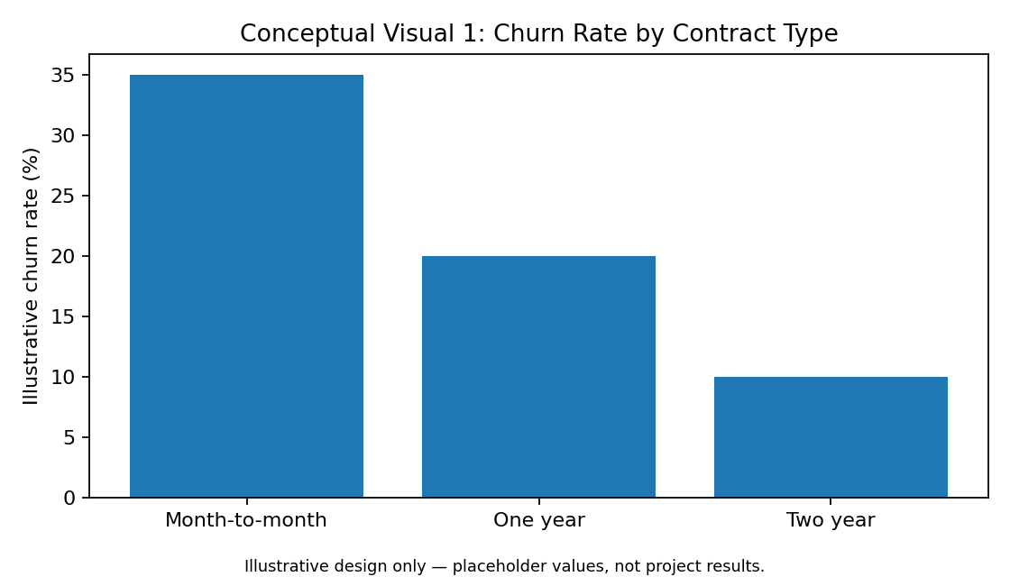
Business question: Does customer churn vary across contract types? The final chart should use actual within-segment churn rates and, where useful, sample sizes.

25.2 Monthly Charges by Churn Status
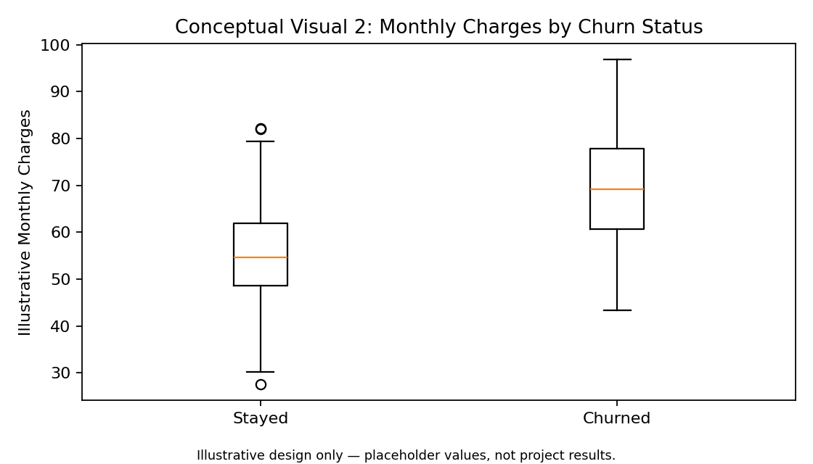
Business question: Are monthly charges distributed differently for customers who churn versus customers who stay? The box plot highlights median, spread and potential extremes.

25.3 Numeric Relationship / Correlation View
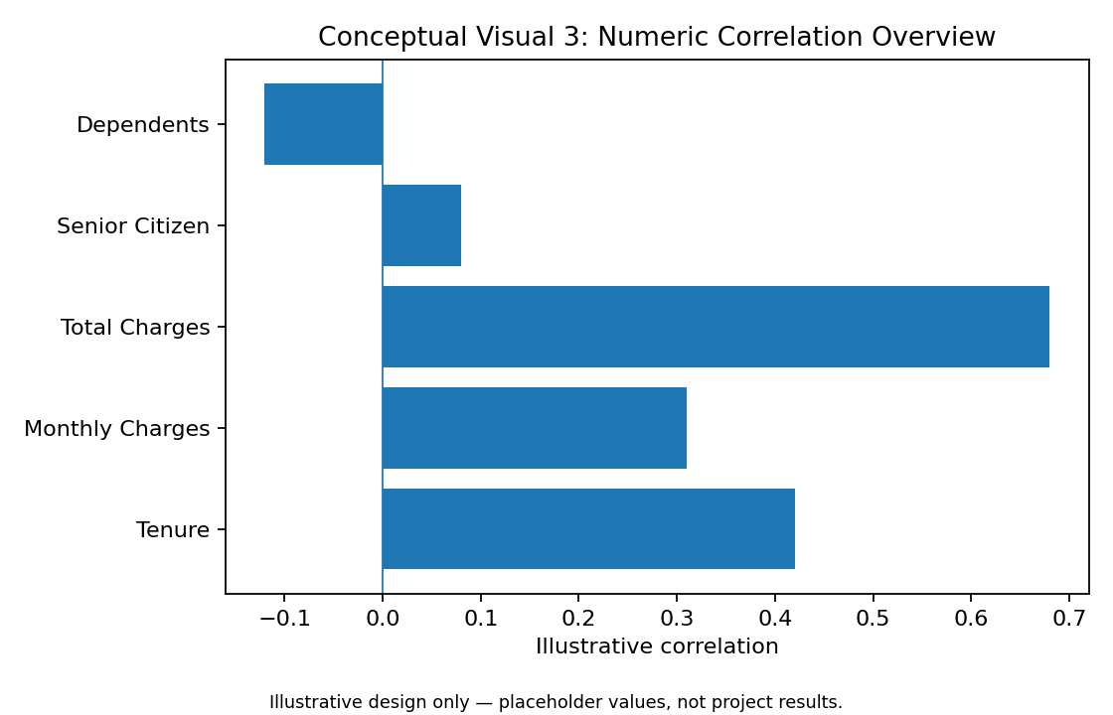
Business question: Which numeric variables show stronger relationships? The final analysis will calculate correlations from the prepared dataset and will not interpret correlation as causation.

26. Proposed Interactive Dashboard Mock-up
The final dashboard is planned as a one-page decision-support view combining KPI cards, segment comparisons, customer distributions and interactive filters. This structure lets stakeholders move from an overall churn view to a specific customer segment.
Dashboard area | Planned content | Purpose
Top KPI row | Total Customers | Churn Rate | Avg. Monthly Charge | Avg. Tenure | Fast executive overview
Left panel | Churn by Contract / Payment Method | Identify high-churn segments
Right panel | Monthly Charges & Tenure distributions | Understand customer behaviour
Bottom panel | Correlation/relationship view + filters | Explore relationships and segments

27. Final Visualization Deliverable Checklist
- Include at least three business-focused visualization types.
- Use clear titles, axis labels, units and legends.
- Use actual dataset values during implementation; conceptual values in this document are not results.
- Prefer churn rates when comparing groups of different sizes.
- Include sample sizes when they materially affect interpretation.
- Connect every chart to a business question and interpretation.
- Validate chart totals against the underlying data tables.
- Use Plotly for interactive dashboard elements where appropriate.
- Save the chart-generating code so every figure can be reproduced.

