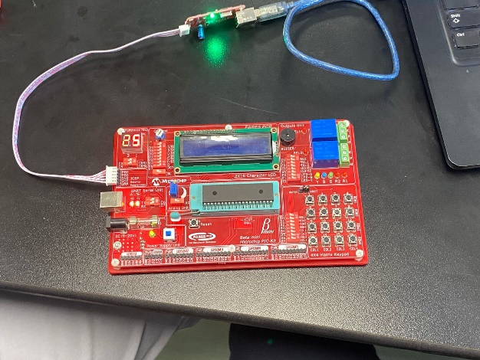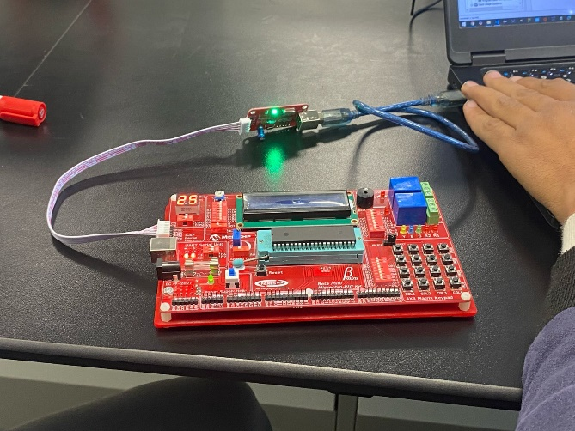

Code  
#pragma config FOSC = HS // Oscillator Selection bits (HS oscillator: High-speed crystal/resonator on RA6/OSC2/CLKOUT and RA7/OSC1/CLKIN)

#pragma config WDTE = OFF // Watchdog Timer Enable bit (WDT disabled)

#pragma config PWRTE = ON // Power-up Timer Enable bit (PWRT enabled)

#pragma config MCLRE = ON // RE3/MCLR pin function select bit (RE3/MCLR pin function is MCLR)

#pragma config CP = OFF // Code Protection bit (Program memory code protection is disabled)

#pragma config CPD = OFF // Data Code Protection bit (Data memory code protection is disabled)

#pragma config BOREN = ON // Brown-out Reset Selection bits (BOR enabled)

#pragma config IESO = ON // Internal External Switchover bit (Internal/External Switchover mode is enabled)

#pragma config FCMEN = ON // Fail-Safe Clock Monitor Enable bit (Fail-Safe Clock Monitor is enabled)

#pragma config LVP = OFF // Low-Voltage Programming Enable bit (RB3/PGM pin has digital I/O, HV on MCLR must be used for programming)

#pragma config BOR4V = BOR40V // Brown-out Reset Selection bit (Brown-out Reset set to 4.0V)

#pragma config WRT = OFF // Flash Program Memory Self Write Enable bits (Write protection off)

#define _XTAL_FREQ 4000000

#include <xc.h>

#define motor_pin_1 0

#define motor_pin_2 1

#define motor_pin_enable 2

#define SET_BIT(reg , bit) (reg |= (1<<bit))

#define CLR_BIT(reg , bit) (reg &= ~(1<<bit))

//

//int main()

//{

// TRISE = 0 ;

// PORTE = 0xff;

//

// TRISC = 0 ;

// PORTC = 0xff;

//

// TRISD = 0 ;

// PORTD = 0b00110000;

//

// ANSEL = 0 ;

// ANSELH = 0;

//

// SET_BIT(PORTE, motor_pin_enable);

//

//// PORTB = 0x01;

//// direction portd

//// portc c

//

//

// while(1)

// {

//// // set direction to right

//// SET_BIT(PORTE, motor_pin_1);

//// CLR_BIT(PORTE, motor_pin_2);

//// __delay_ms(1000);

//// SET_BIT(PORTE, motor_pin_2);

//// CLR_BIT(PORTE, motor_pin_1);

////

//// __delay_ms(1000);

// }

//

//

//

// return 0 ;

//}

const uint8_t segment_map[10] = {

0b00111111, // 0

0b00100001, // 1

0b01110110, // 2

0b01110011, // 3

0b01101001, // 4

0b01011011, // 5

0b01011111, // 6

0b00111001, // 7

0b01111111, // 8

0b01111011 // 9

};

void display_number(uint8_t num) {

uint8_t tens = num / 10; // Extract tens place

uint8_t ones = num % 10; // Extract ones place

for(int i = 0 ; i<5 ;i++)

{

PORTC = 0b00100000; // Select left digit (C5)

PORTD = segment_map[ones];

// for(unsigned int i=0; i<65000; i++);

__delay_ms(10);

PORTC = 0b00010000; // Select right digit (C4)

PORTD = segment_map[tens];

// for(unsigned int i=0; i<65000; i++);

__delay_ms(10);

}

}

void main(void) {

ANSEL = 0;

ANSELH = 0;

TRISD = 0b00000000;

TRISC = 0b00000000;

TRISB = 0b00000011;

INTCON |= 1<<7;

INTCON |= 1<<3;

IOCB0 = 1;

IOCB1 = 1;

// while(1)

// {

// PORTD = 0b00100001;

// for(unsigned int i=0; i<65000; i++);

// PORTD = 0b01110110;

// for(unsigned int i=0; i<65000; i++);

// PORTD = 0b01110011;

// for(unsigned int i=0; i<65000; i++);

// }

while (1) {

// display_number(25);

for (uint8_t i = 0; i <= 99; i++) {

display_number(i);

__delay_ms(100);

}

}

return;

}