HW18

1. Creating node1 and node2 using these commands as shown below:

• ./geth --datadir node1 account new

• ./geth --datadir node2 account new

1. Get the address of each node (shown in the screen shot below) and save it in a separate file

Node 1

* + Public address of the key: 0x7e37e1AbF233C2AC086dAD0a2a41125e18d8557C
  + Path of the secret key file: node1\keystore\UTC--2021-02-07T01-14-10.718348200Z--7e37e1abf233c2ac086dad0a2a41125e18d8557c

Node 2

* + Public address of the key: 0xaf5ED1a08Eb8431D63DA5F0C15b0439C97dCe8Aa
  + Path of the secret key file: node2\keystore\UTC--2021-02-07T01-15-15.659015100Z--af5ed1a08eb8431d63da5f0c15b0439c97dce8aa
  + 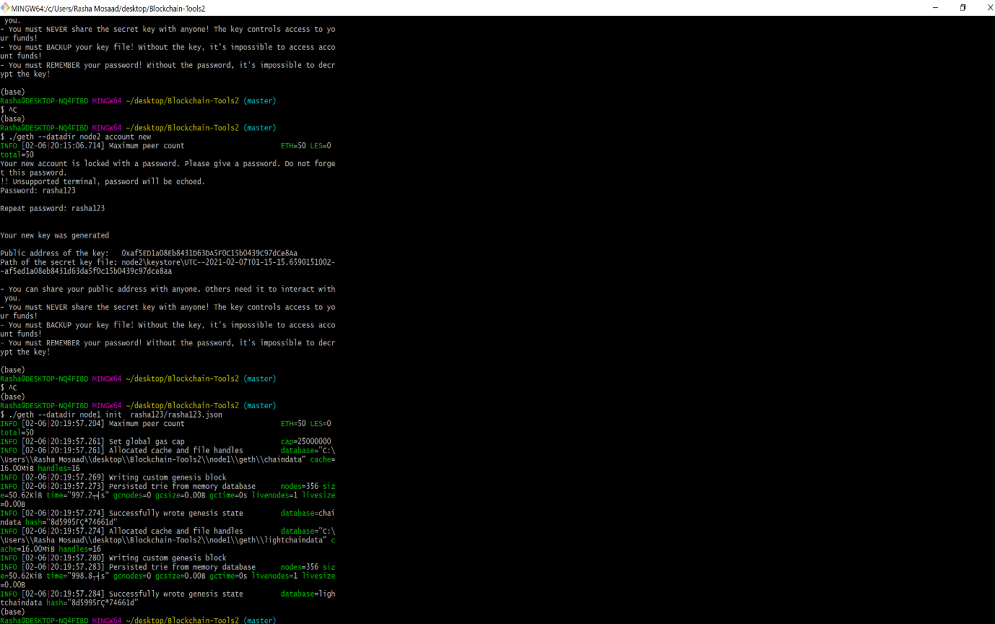

1. I ran puppeth, named my network “rasha123” and selected the option to configure a new genesis block which was #2
2. I chose the Clique (Proof of Authority) consensus algorithm.
3. I pasted both the account addresses I listed above from the first step one at a time into the list of accounts to seal.
4. I pasted the same node addresses again in the list of accounts to pre-fund. There are no block rewards in PoA, so I will need to pre-fund.
5. I chose to pre-fund the pre-compiled accounts with wei.
6. I chose the second prompt from the main menu, which is "Manage existing genesis" option.
7. I then exported genesis configurations. It failed to create two of the files, but I was able to create rasha123.json.

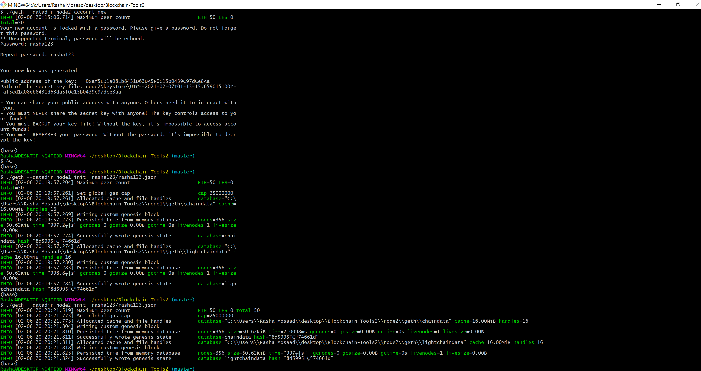

1. After exporting the gensis configurations, I initialized the nodes with the genisis’ json file using these commands (show in the above screen shot):
   * + ./geth --datadir node1 init rasha123/rasha123.json
     + ./geth --datadir node2 init rasha123/rasha123.json
2. Then I ran the nodes in separate terminal windows with the commands to start mining:

* ./geth --datadir node1 --unlock "0x7e37e1AbF233C2AC086dAD0a2a41125e18d8557C" --mine --rpc --allow-insecure-unlock

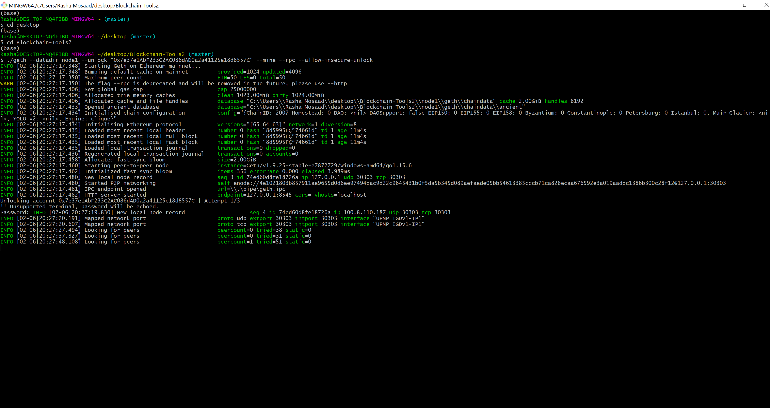

* ./geth --datadir node2 --unlock "0xaf5ED1a08Eb8431D63DA5F0C15b0439C97dCe8Aa" --mine --port 30304 --bootnodes "enode://4e1021803b857911ae9655d0d6ee97494dac9d22c9645431b0f5da5b345d089aefaede05bb54613385cccb71ca828ecaa676592e3a019aaddc1386b300c28f12@127.0.0.1:30303" --allow-insecure-unlock –ipcdisable

(I could not locate the screen shot for the mining of node 2 but this step was successful)

1. I then went to MyCrypto, created a custom node called it rasha123 and connected to it using chainid: 2007. Then I used my saved keystore (from folder node1 on Blockchain-Tools2 directory) + password (rasha123) to unlock my wallet and got this balance of Ethereum as shown below. 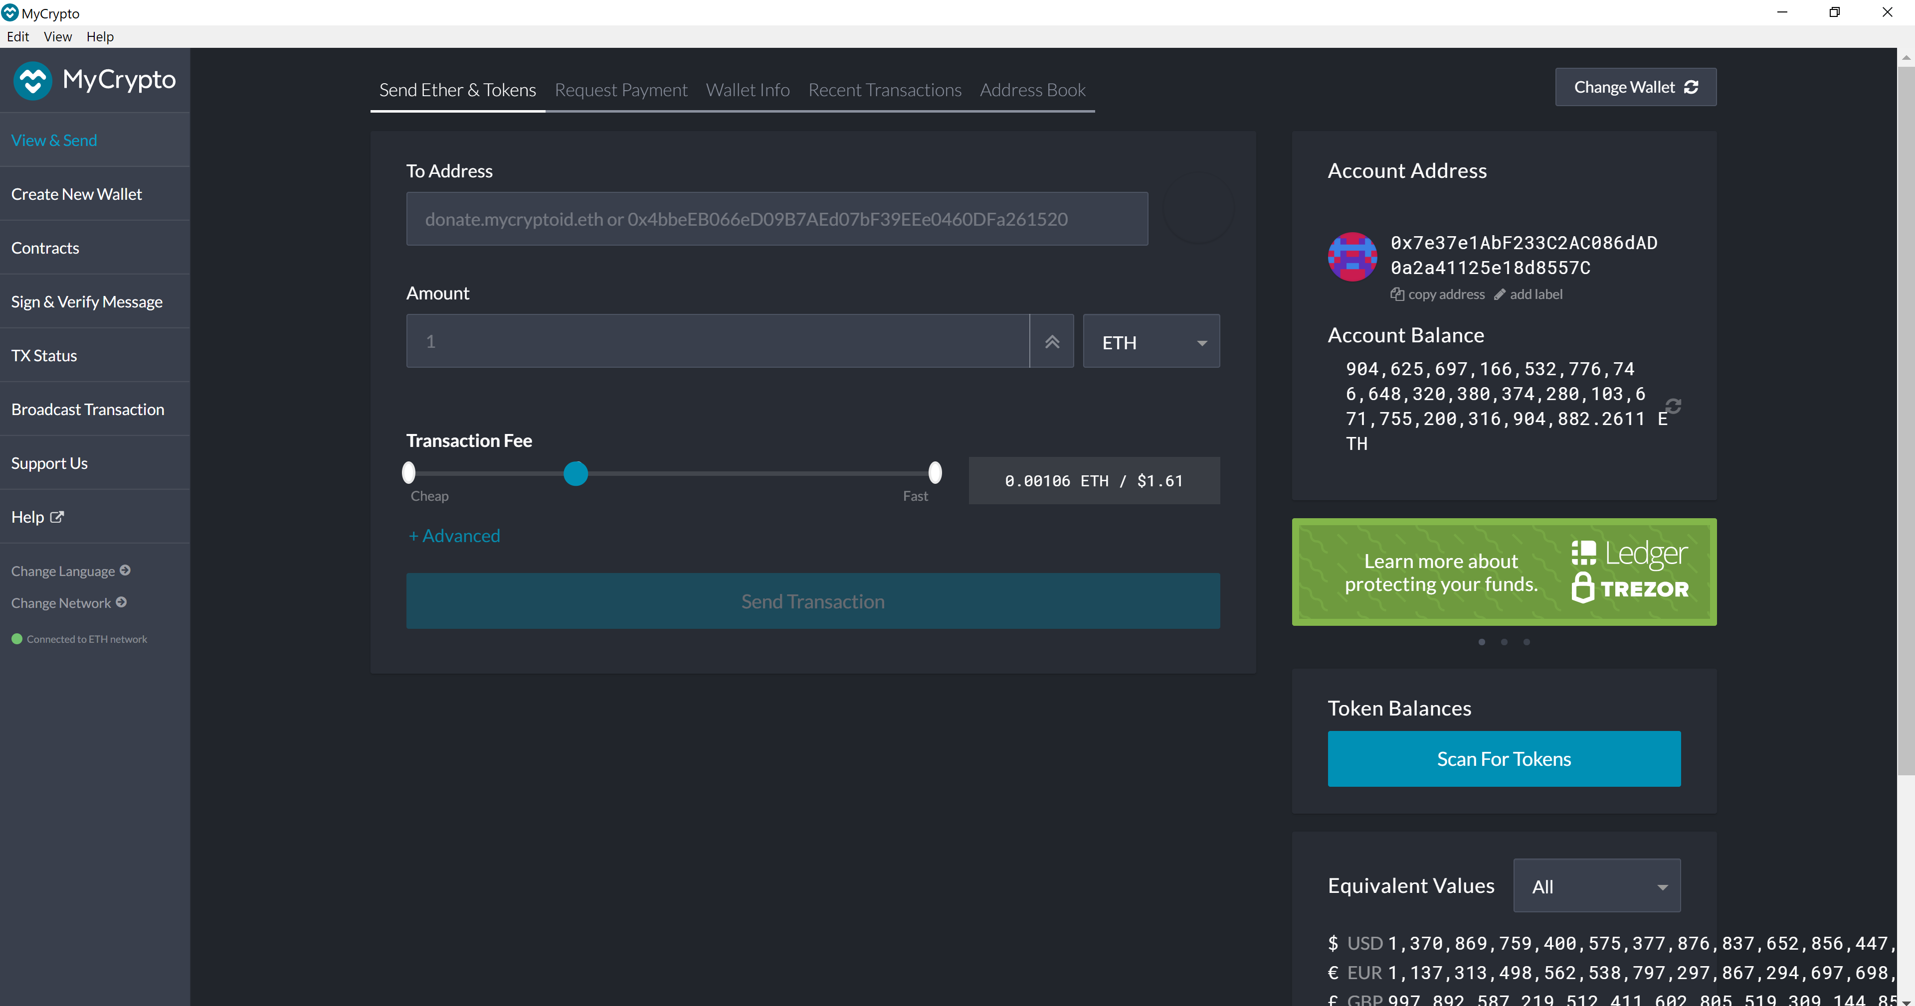
2. Using node2 address: 0xaf5ED1a08Eb8431D63DA5F0C15b0439C97dCe8Aa I sent a transaction of ETH 1500 to myself. Then I used the transaction hash to check the status of the transaction which was successful.

