HW-19

1. I was able to establish the symlink and use ./derive instead of the whole path. Below are some screen shots.

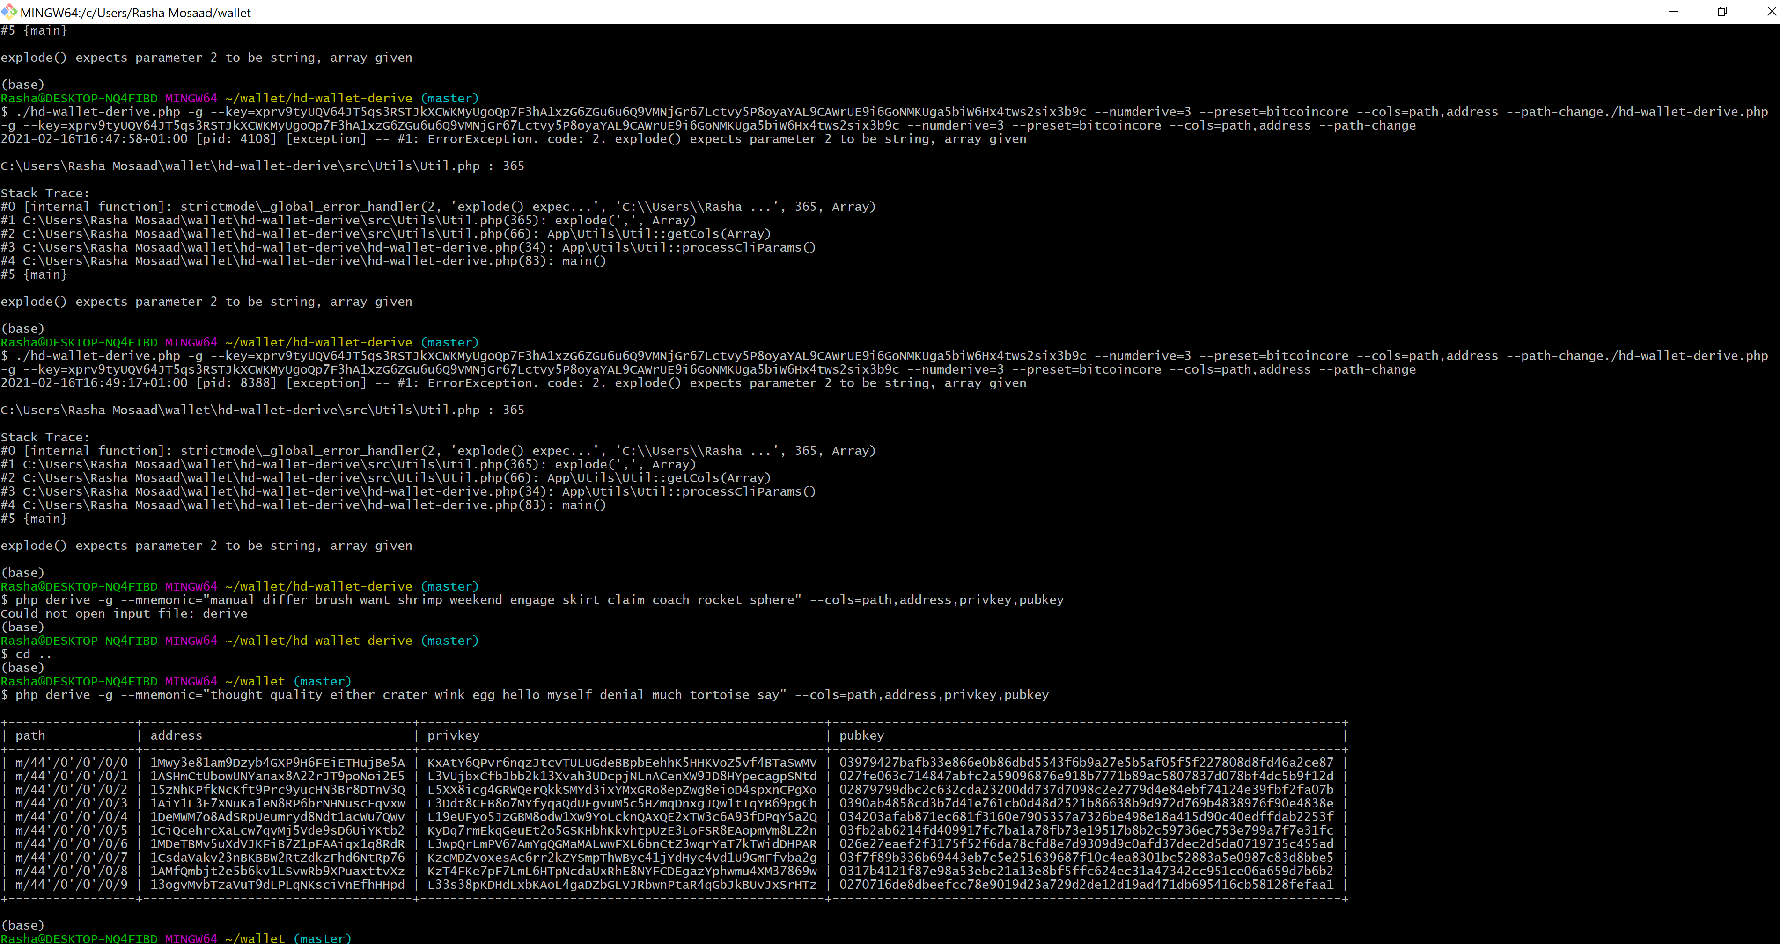

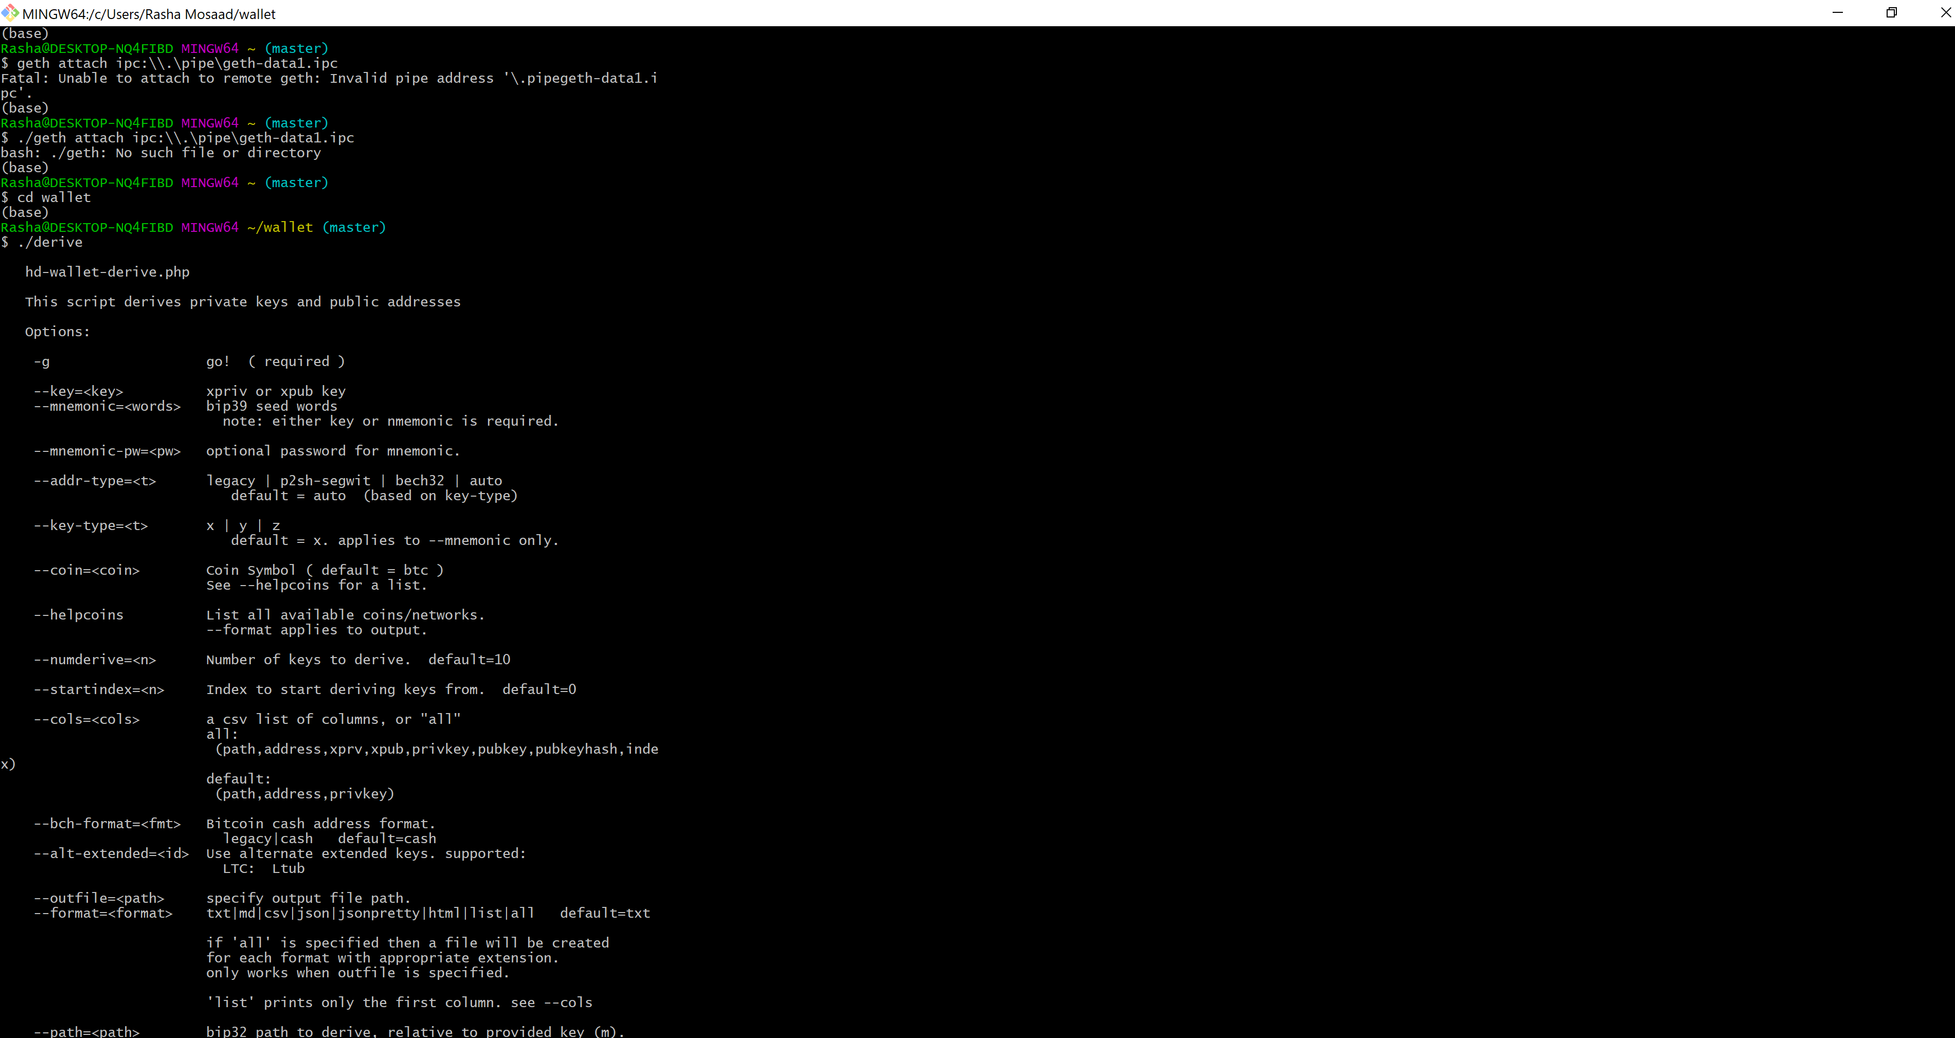

And I verified that the symlink is working by typing ./derive and got the above list of commands.

1. I created a new mnemonic and got all the derived addresses
2. Also this is the screen shot of my wallet directory

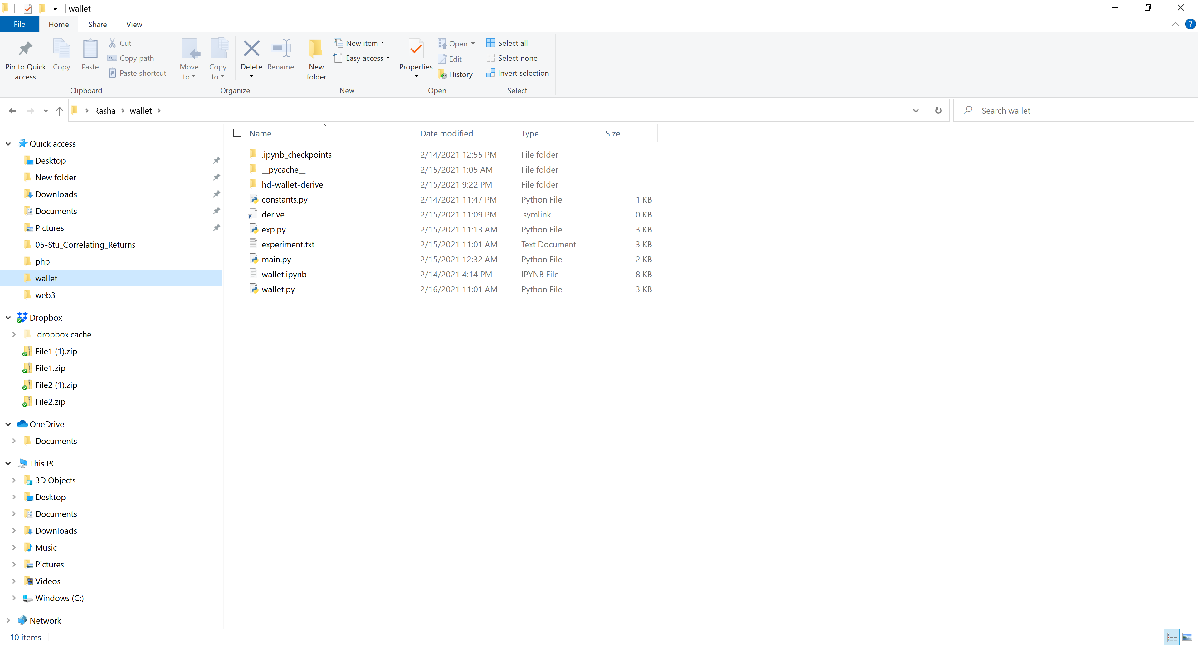

1. In wallet.py I used the starter code and tried to create the functions required for the HW. Two VS code files are attached: wallet.py and constants.py
2. I used the pneumonic converter to derive child addressed for every coin. Screenshot below

