1. After writing the code, the file was compiled successfully.

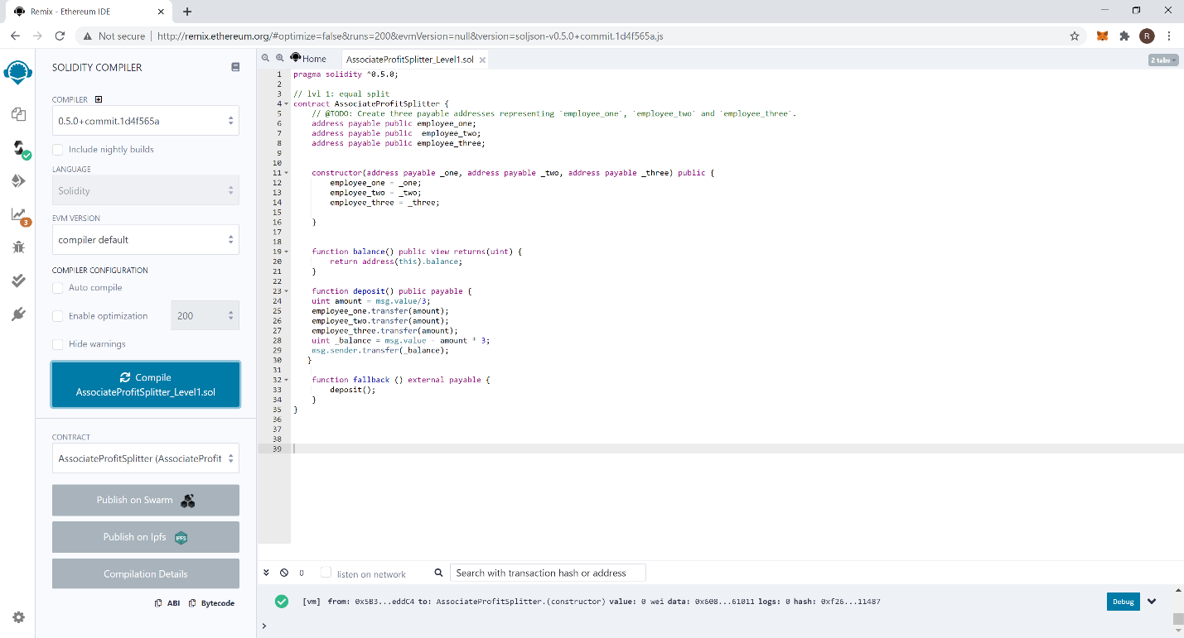

1. A sceenshot for the ledger was taken before deploying the contract.

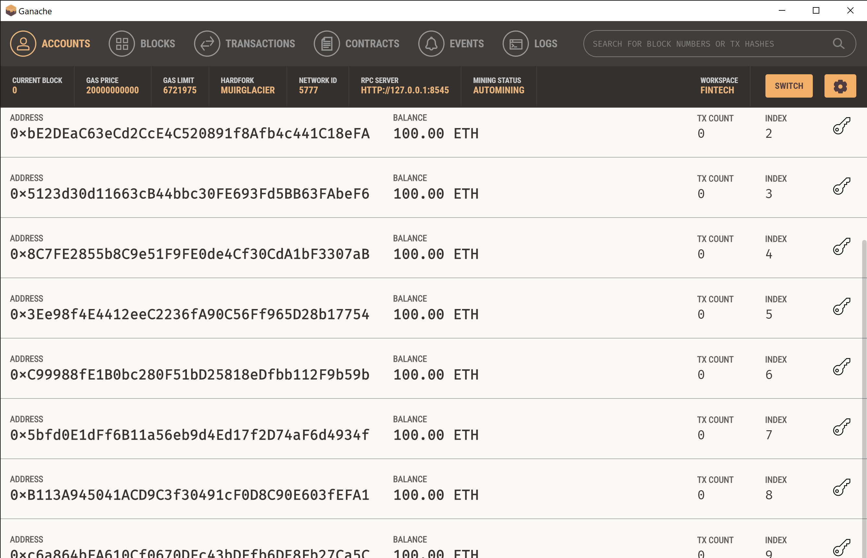

1. A screen shot of Metamask showing contract deployment

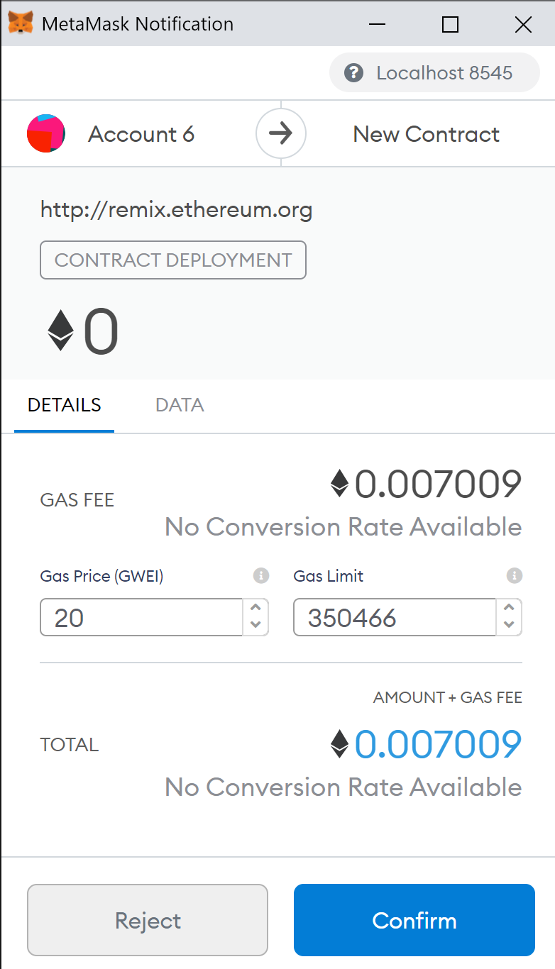+

1. A screenshot of contract deployment on Remix to accounts index 3, 4, 5 on Ganache

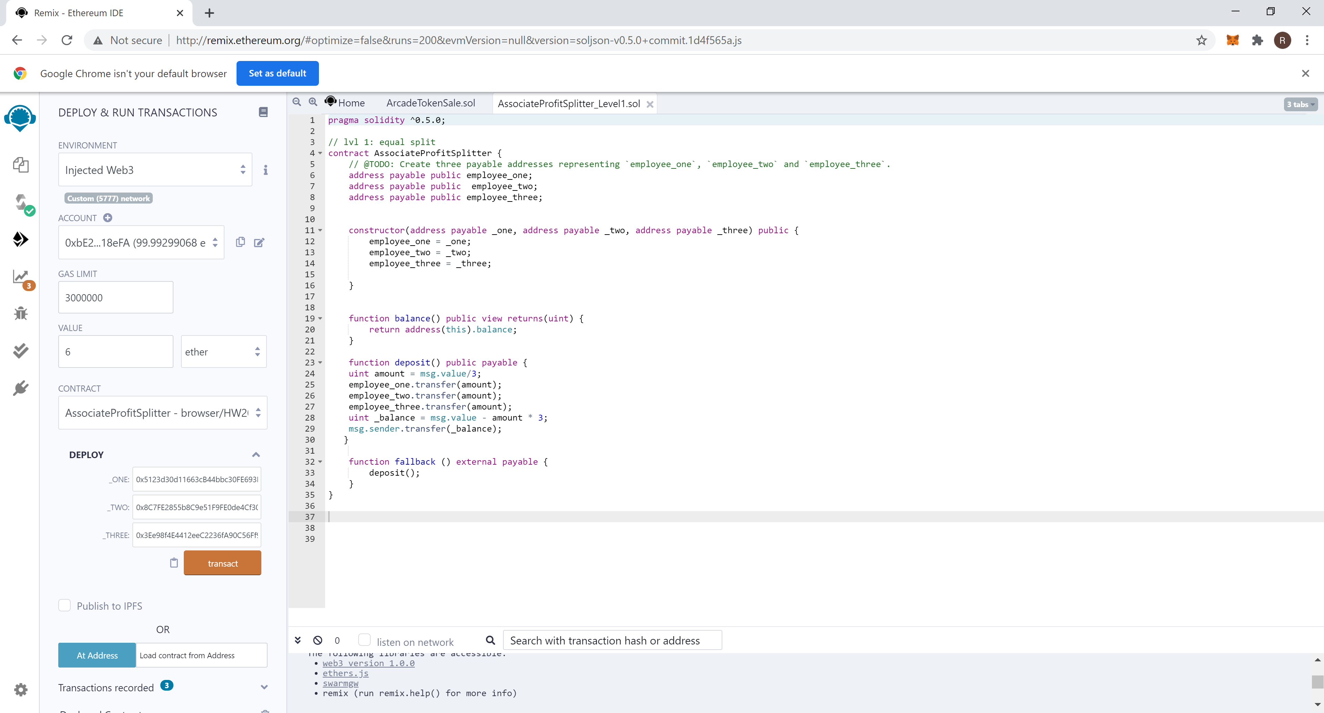

1. A screen shot of depositing 6 ether into each employee’s account



1. A screen shot of the deposit going through Metamask

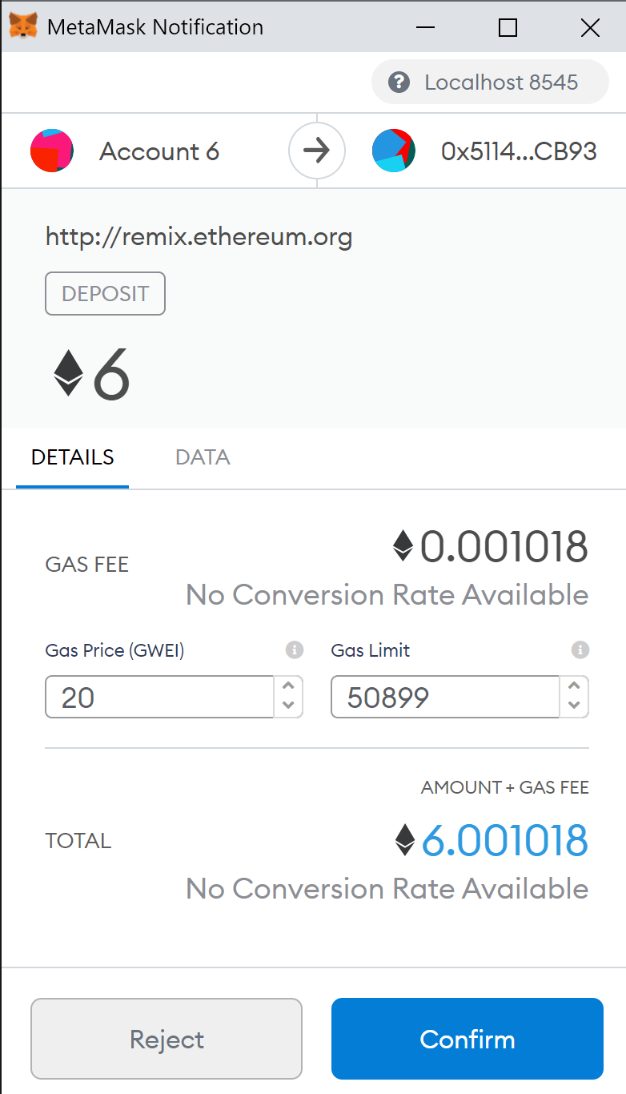

1. A screen shot of the deposit, fallback, balance and addresses of employee one, two and three.

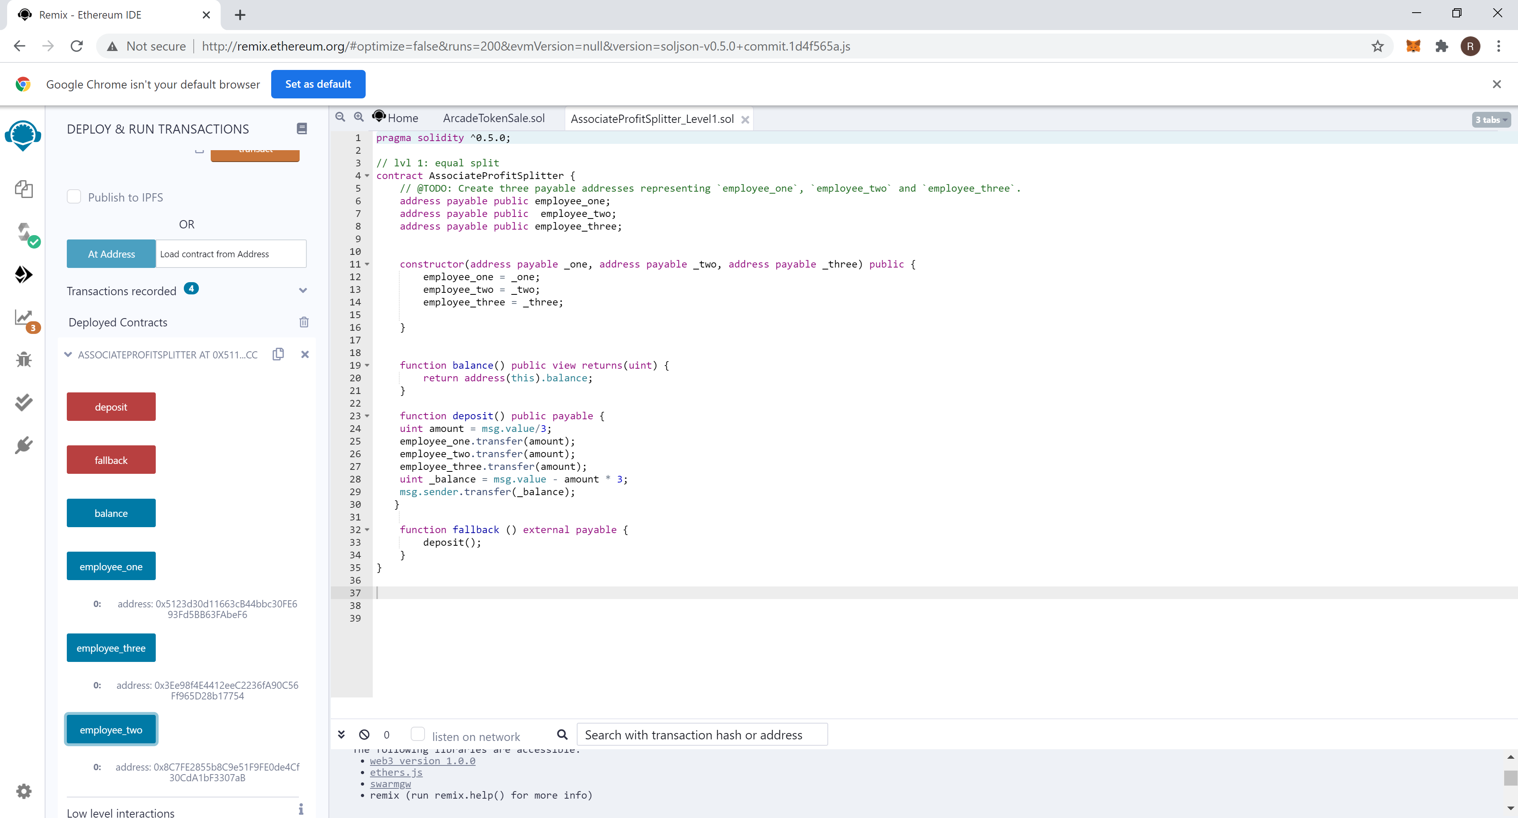

1. A screenshot of the ledger showing 2 Ethers added to accounts 3,4, and 5 and 6.1 ethers deducted from account 2 including 0.1 ether for gas cost.

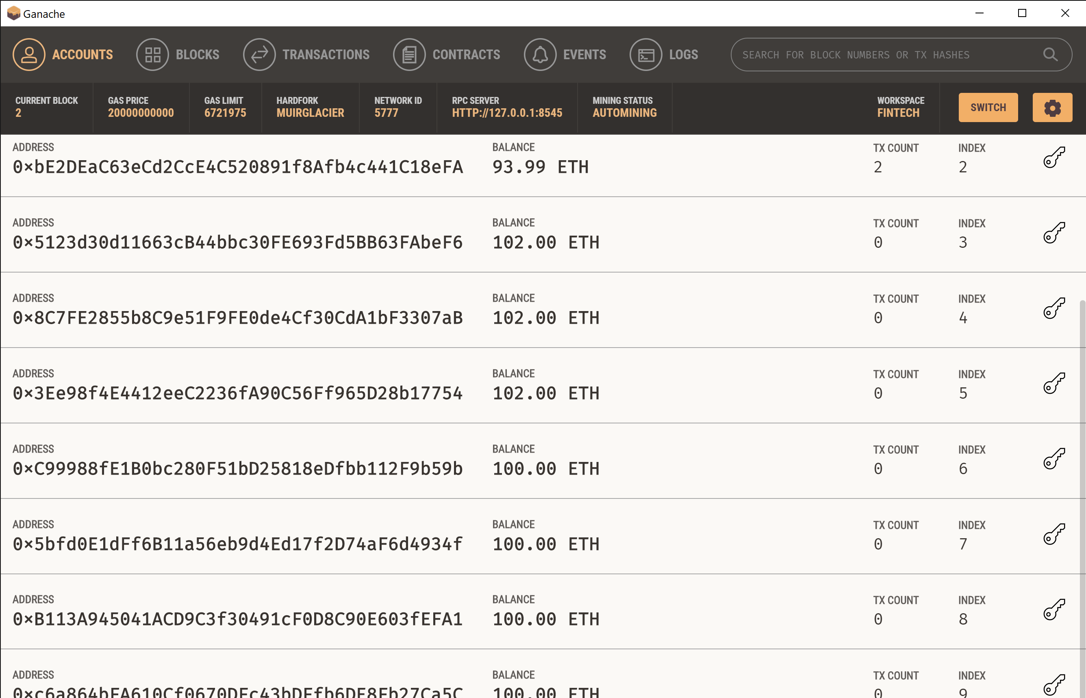

1. Final screen shot showing final balance = zero proving that the fallback function is working.

