Deployment over the Kovan Network after using the Kovan Ether Faucet.

Deployment and deposit on Kovan Test Network can not be reflected on the ledger on Ganache due to the very small amount of wei deposited.

1. Contract deployment through Metmask on Kovan Test Network

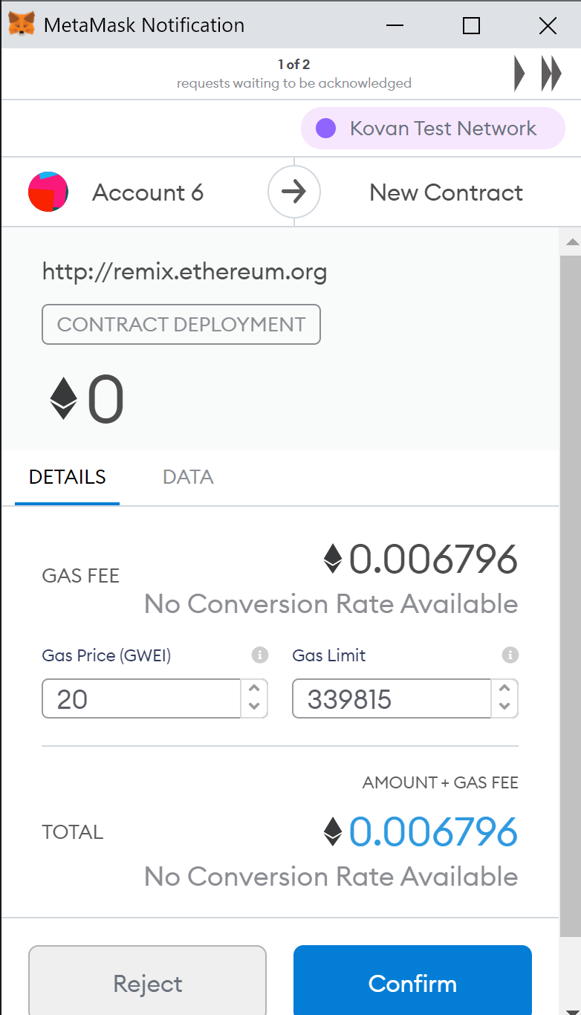

1. Deposit of 101 wei to the three accounts

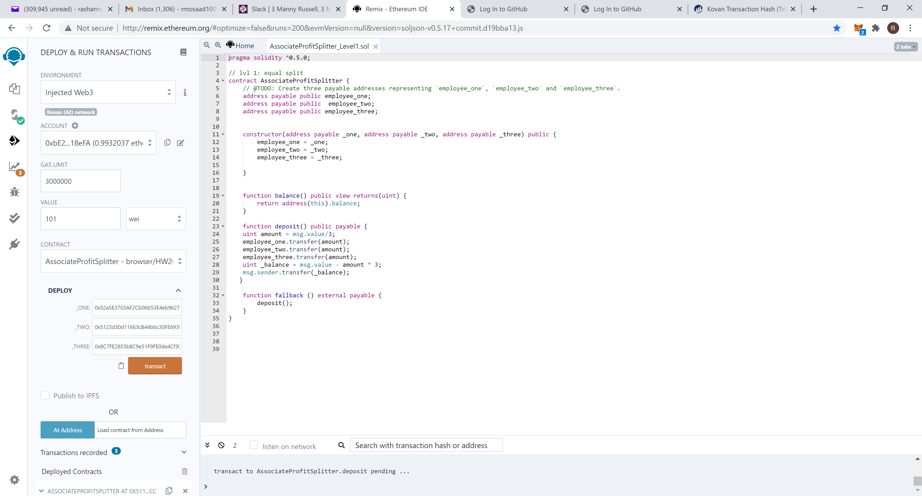

1. Deposit function on Remix

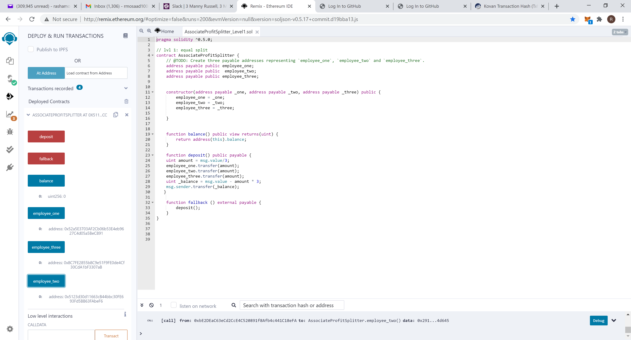

1. Deposit through Metamask
2. 