- Solidity Code compiled for Level 2
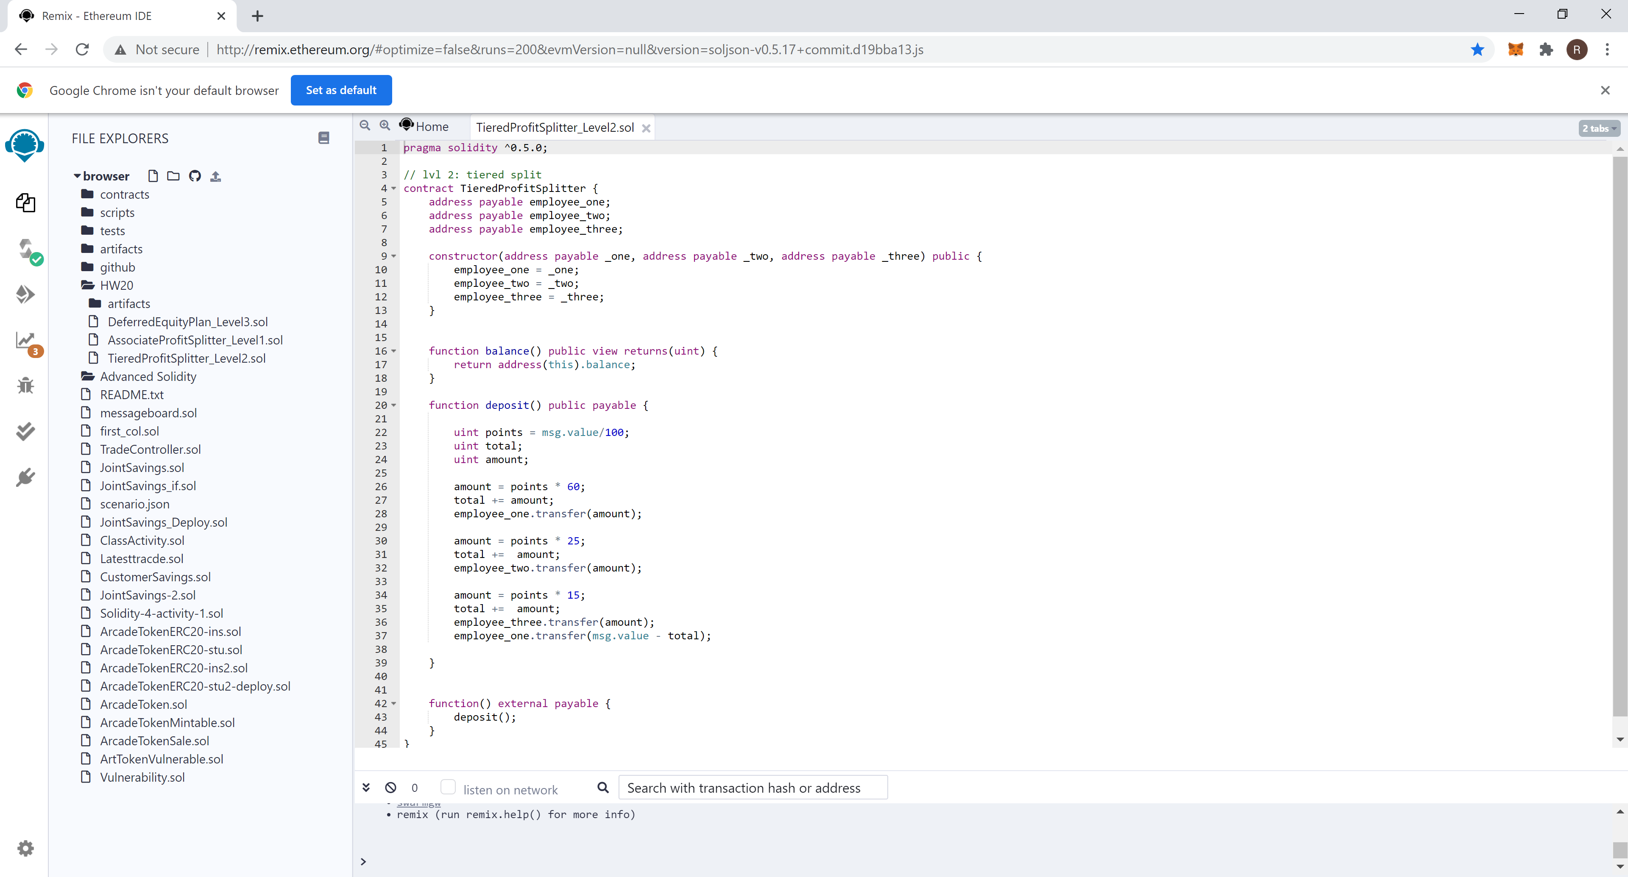
- Contract Deployment on Remix

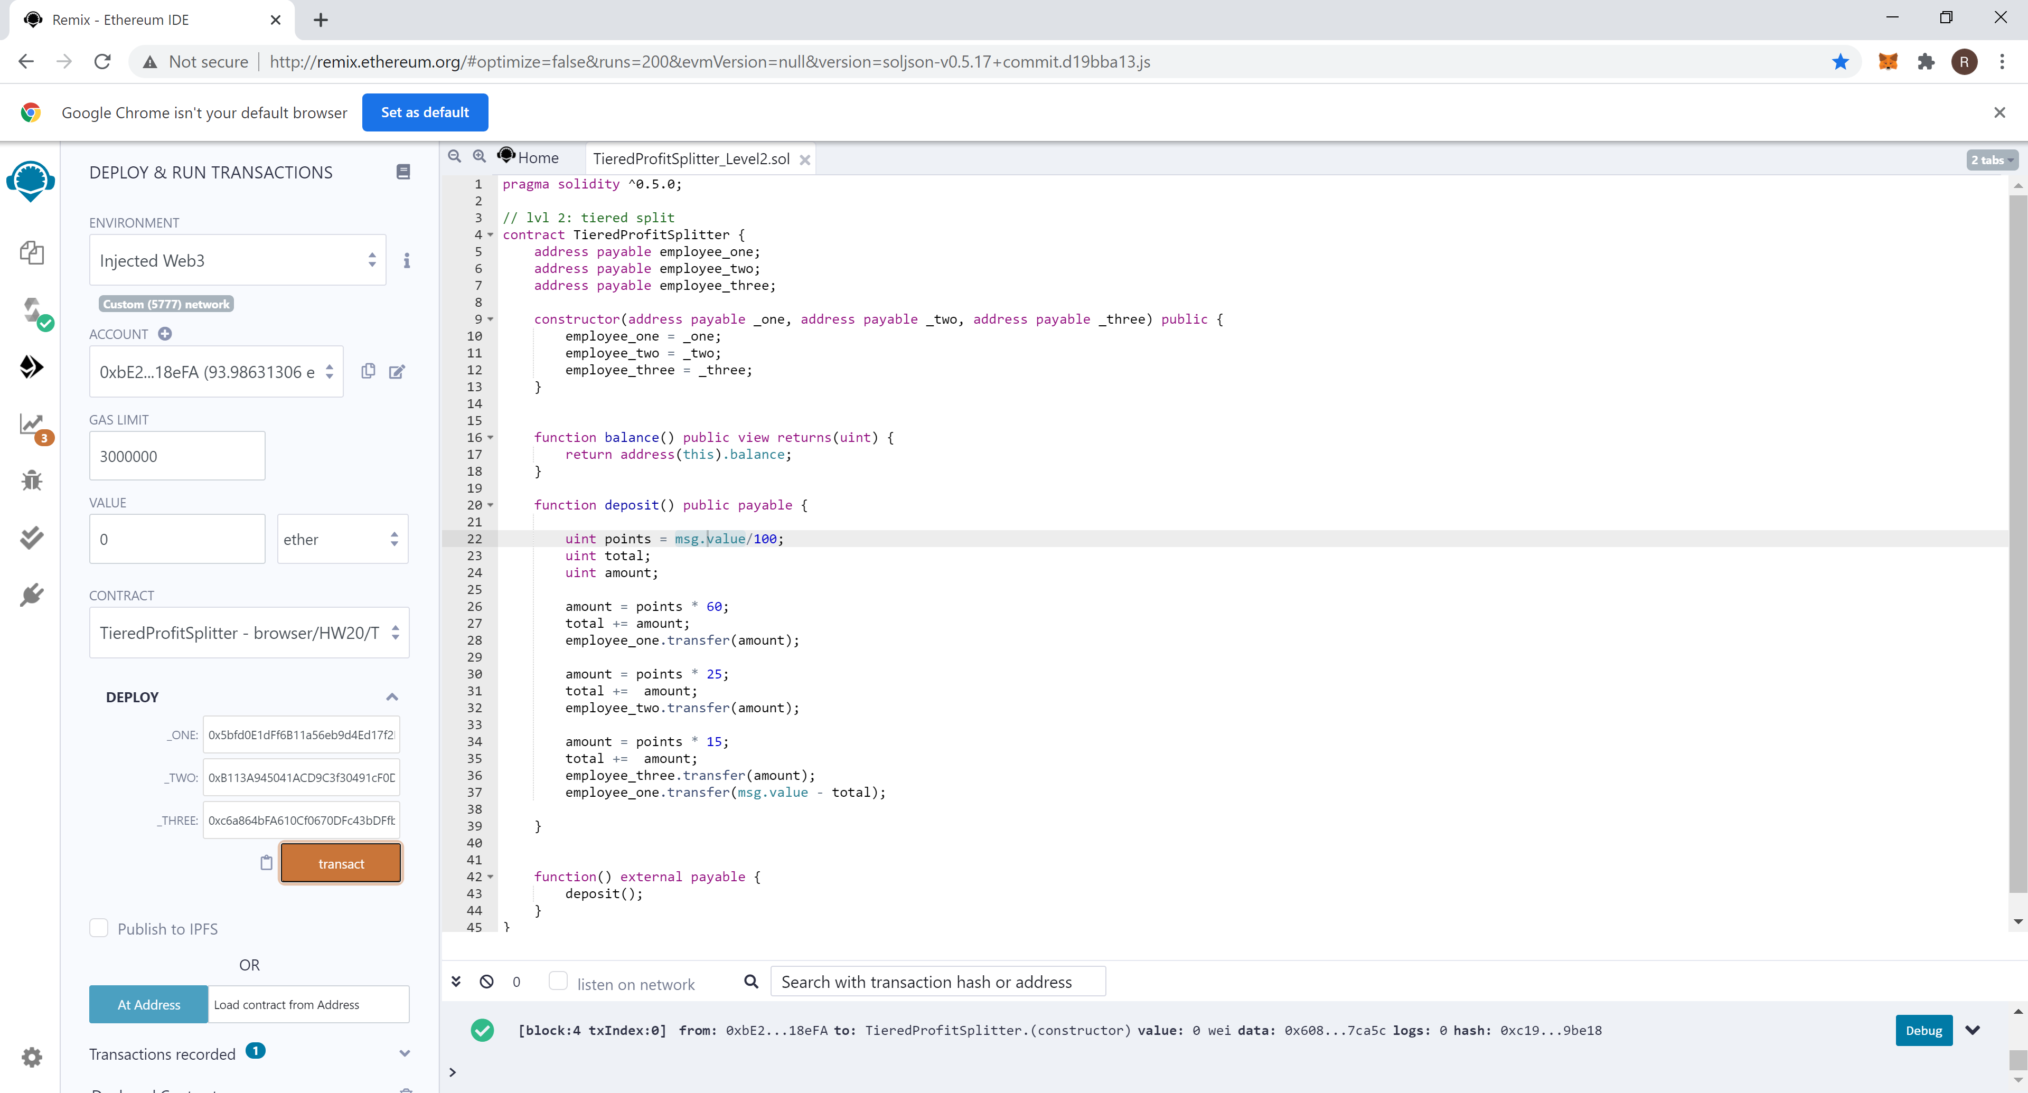

- Contract deployment through Metamask

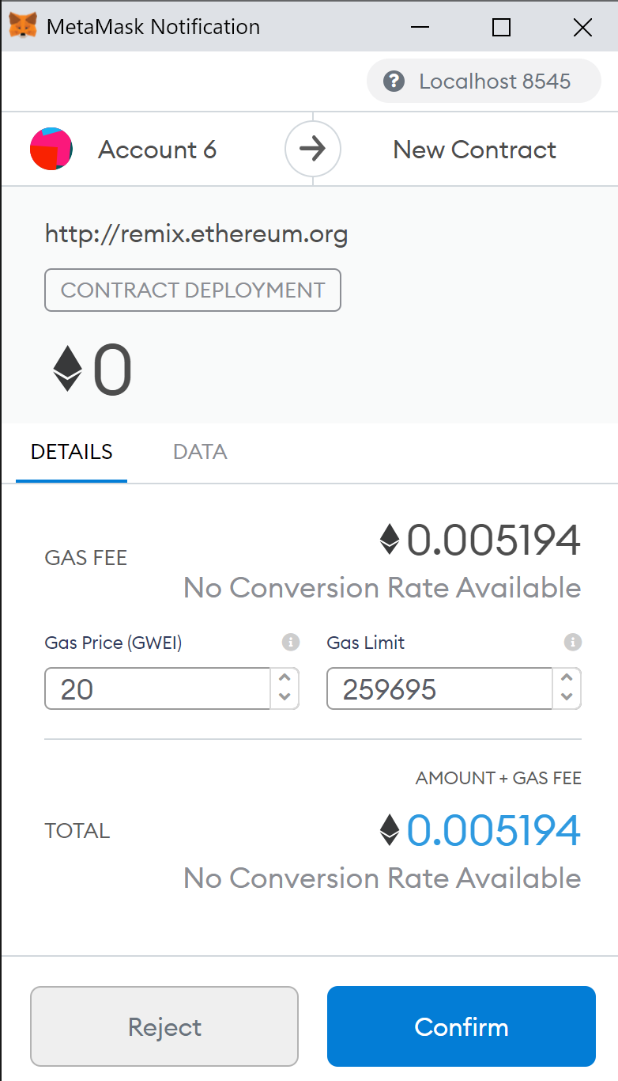

- Ledger of accounts 7,8 and 9 before deposit

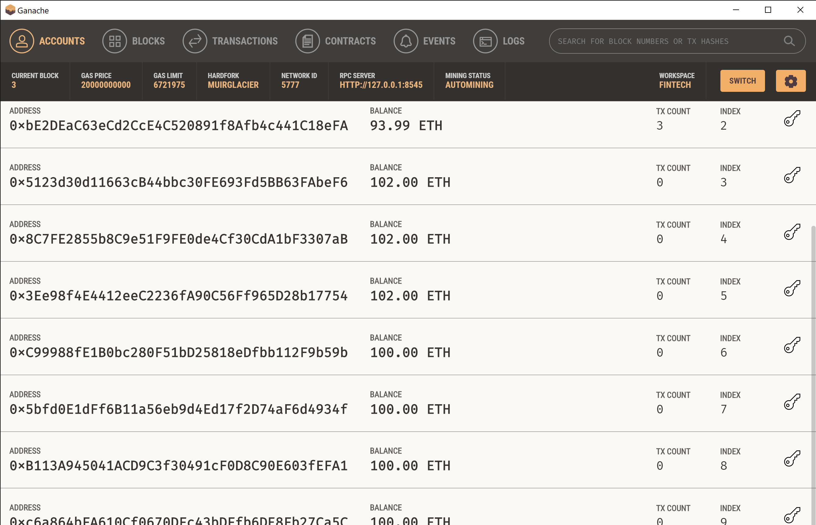
- Deposit of 9 ethers to the three employees

- Deposit through Metamask

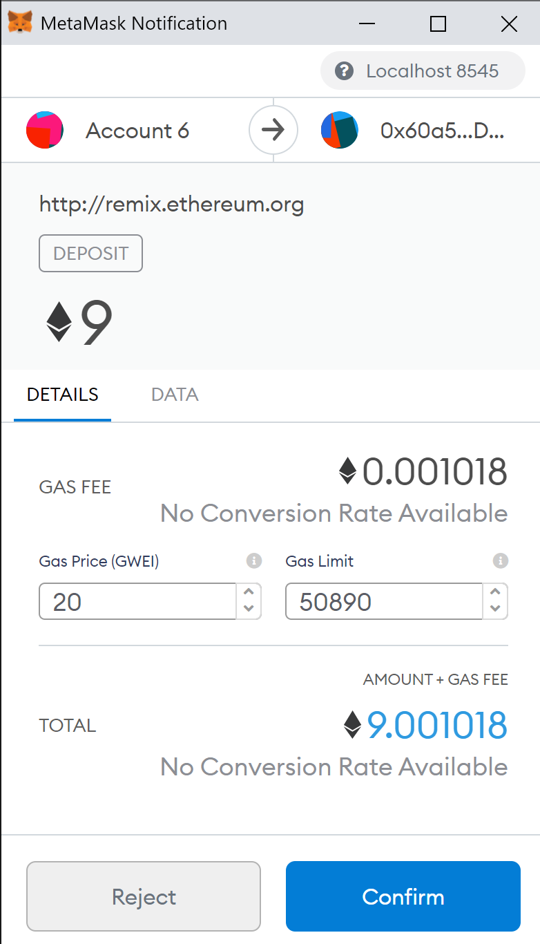

- Deposit function on Remix

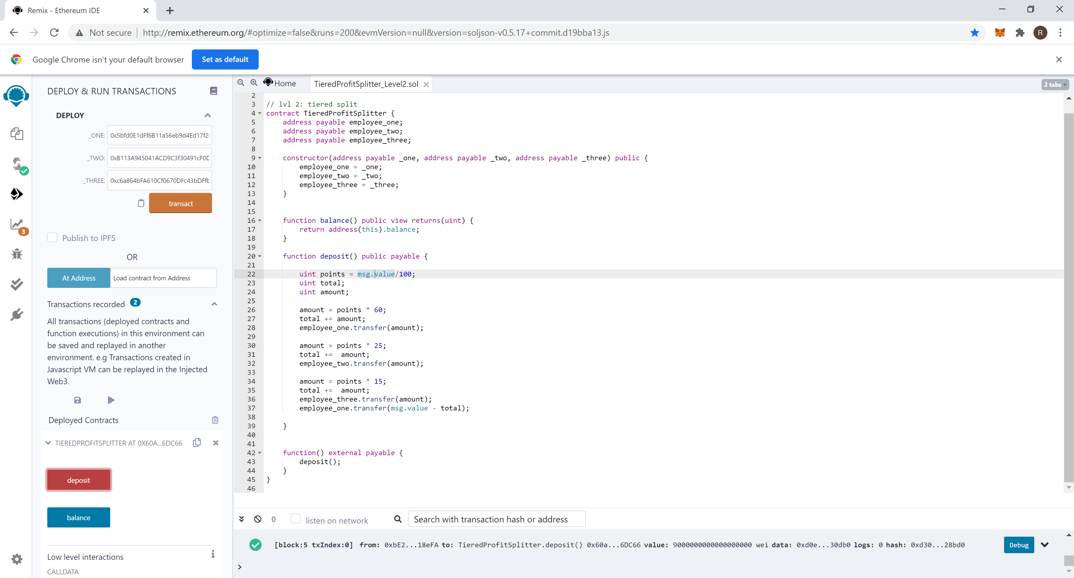

- Ledger reflecting the deposit for employees in accounts 7, 8 , and 9.
The first amount deposited in account 7 is: 9 ether * 60% = 5.4 ethers
The first amount deposited in account 8 is: 9 ether * 25% = 2.25 ethers
The first amount deposited in account 9 is: 9 ether * 15% = 1.35 ethers

