HW21 – Screenshots

1. Contract deployment

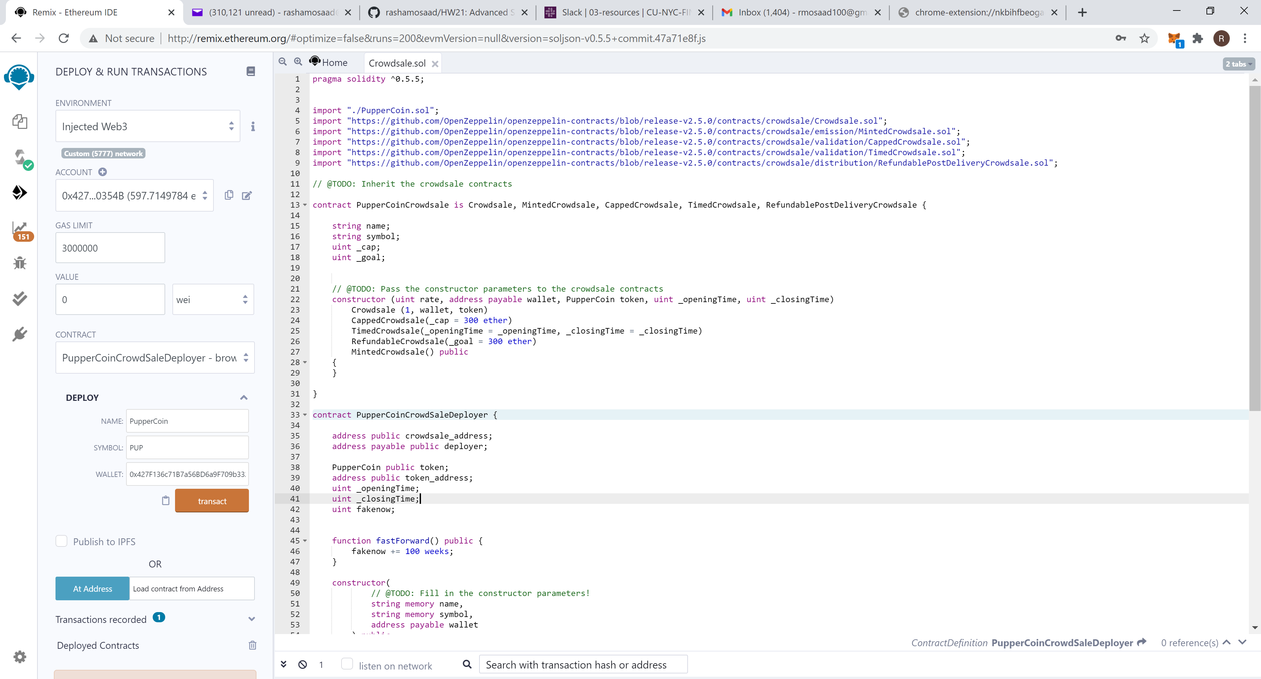

1. Deployer account on Metamask: 0x427F136c71B7a56BD6a9F709b332cDAF1190354B

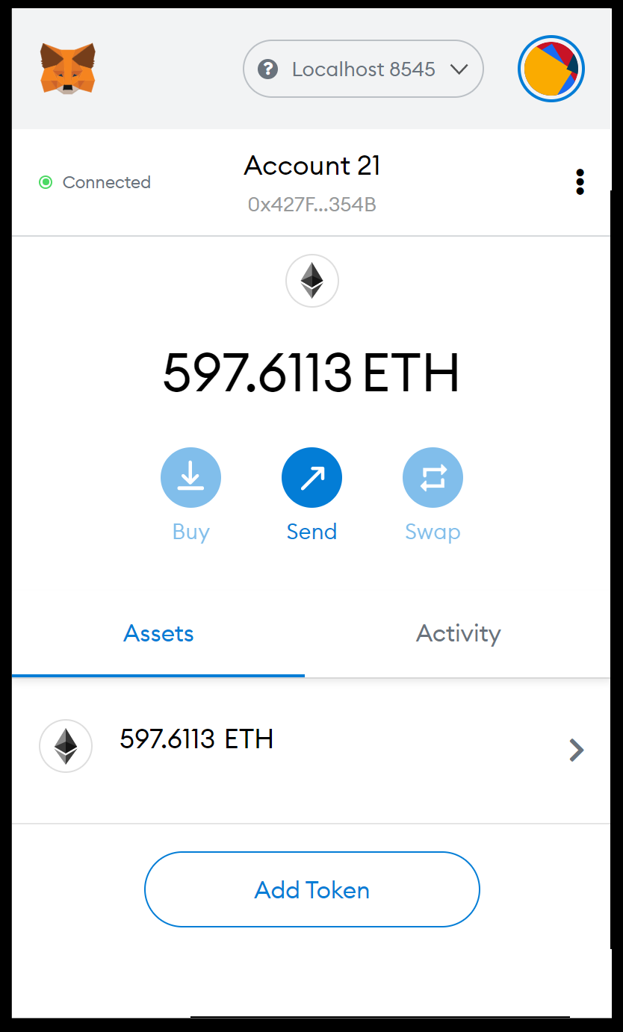

1. Initiating the Contract

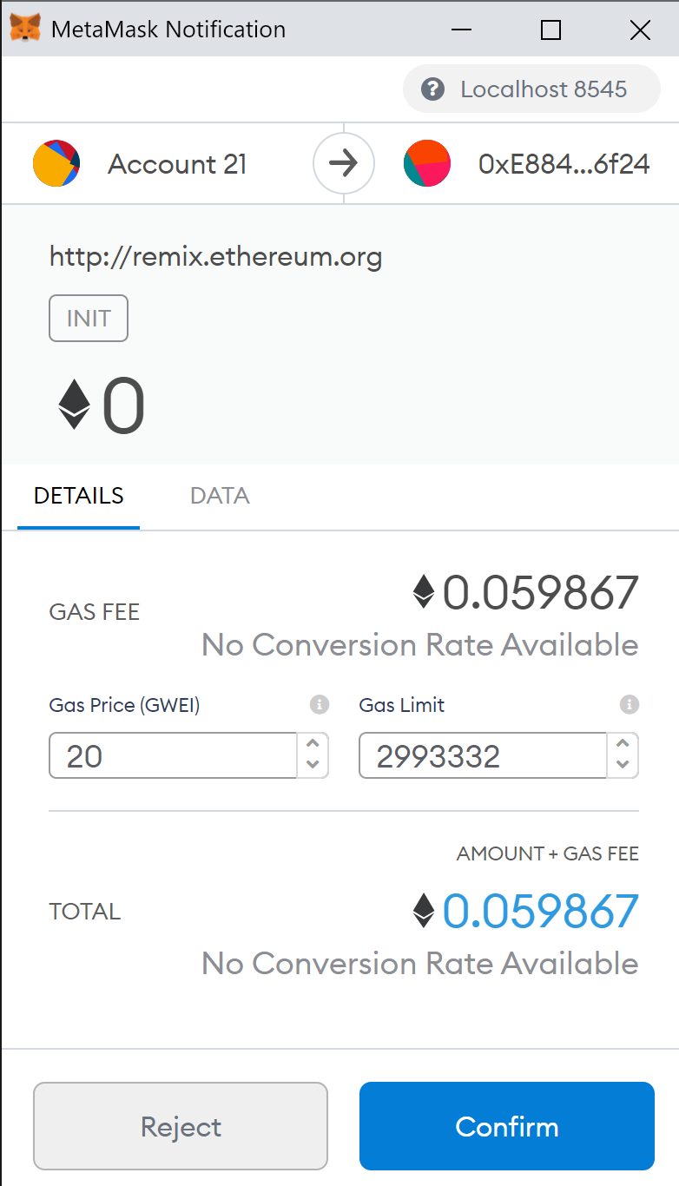

4 . First part of the contract is deployed showing contract address, token address and that isOpen = True

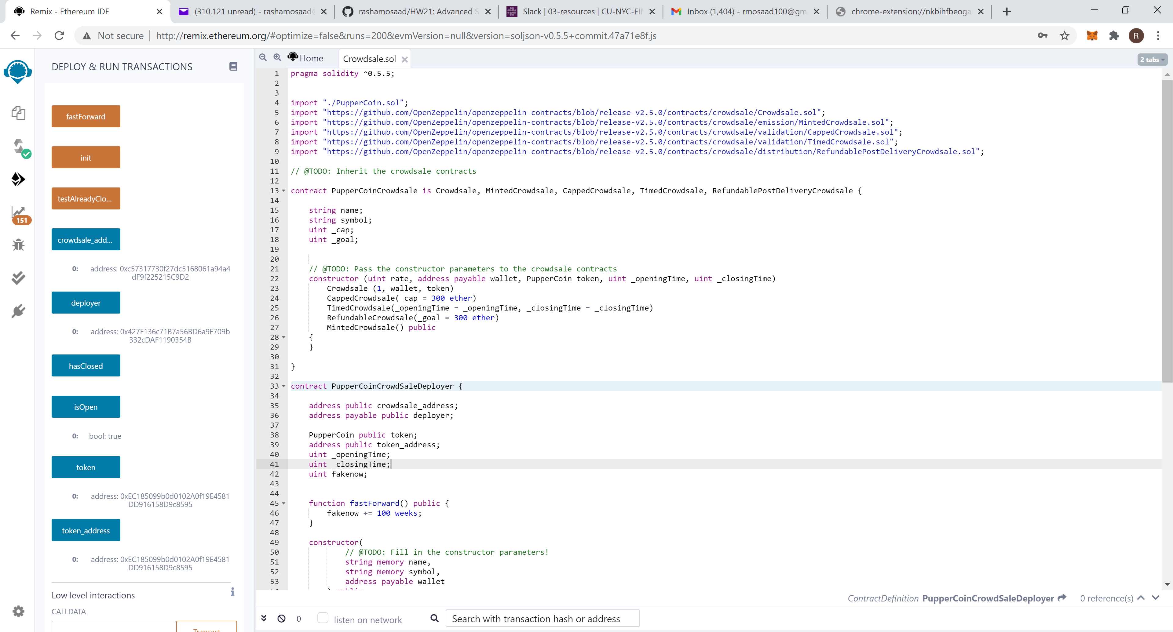

1. The second part of the contract is deployed

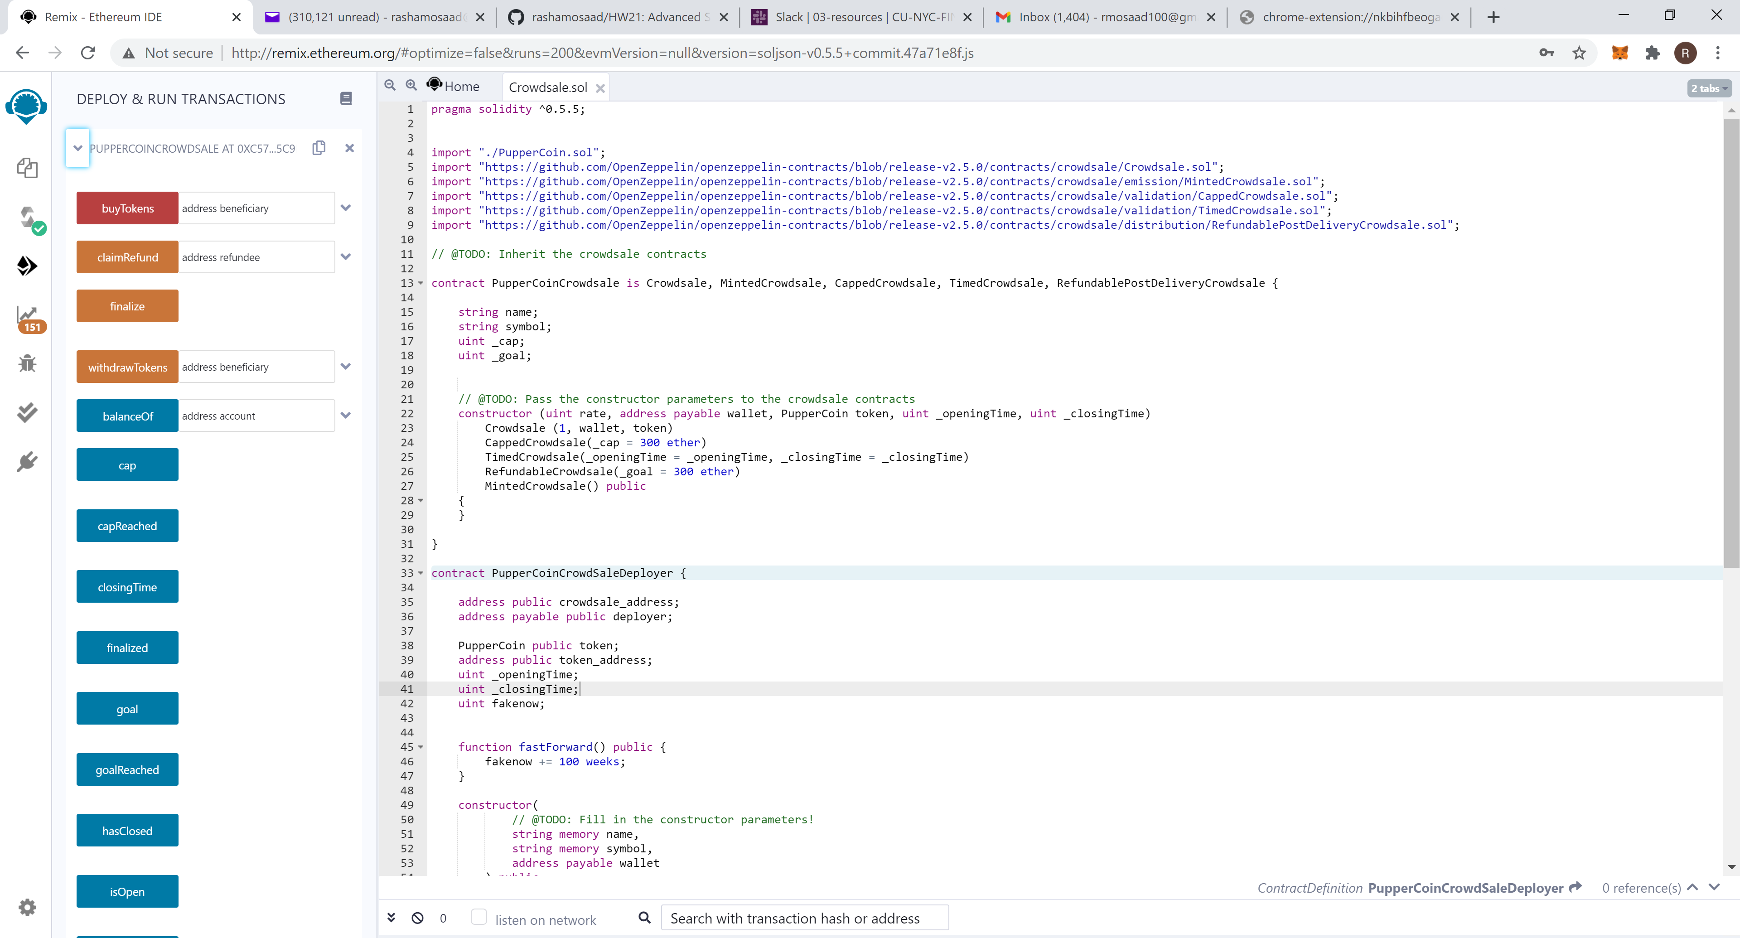

1. The third part of t he contract is deployed

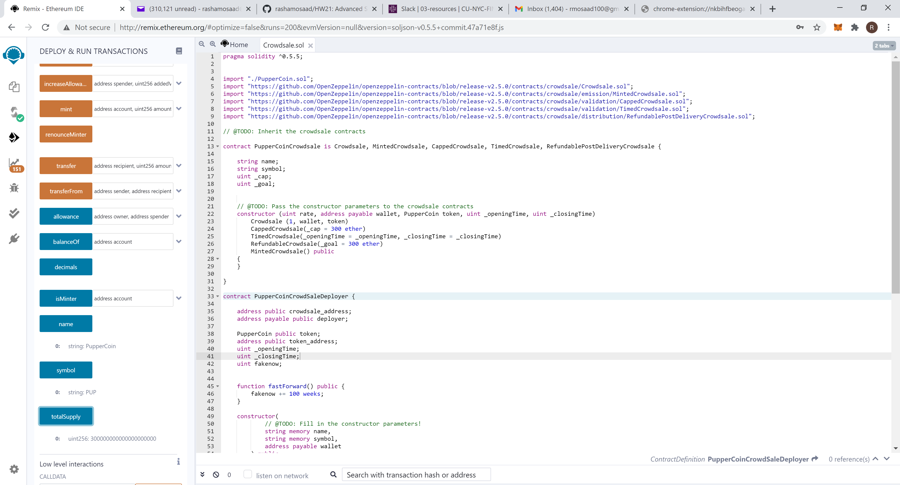

1. Buying tokens (300 Ether) to reach the goal in one step.

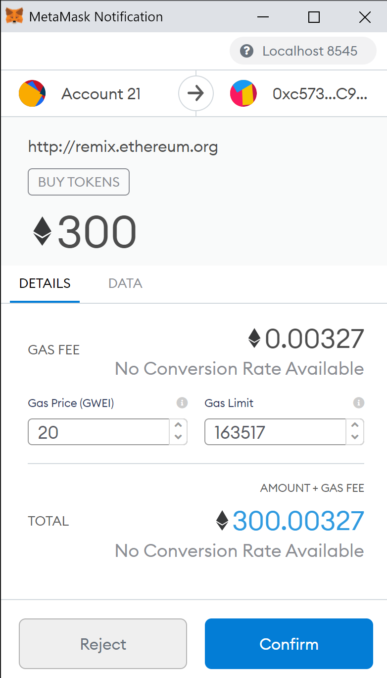

1. After isOpen turned false I called the function “finalize”
2. Verified that the 300 PUPS were reflected on Metamask.

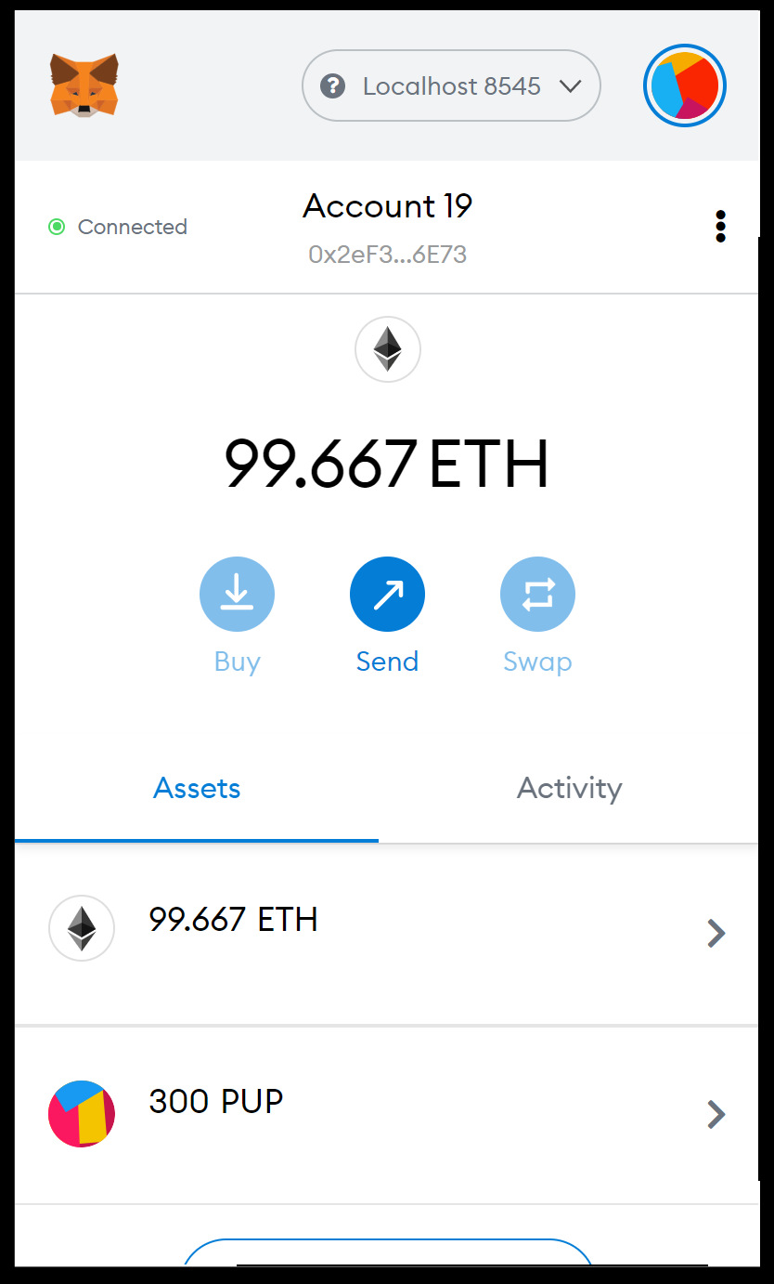

1. Verified that the 300 PUPS were reflected on Crypto.

* 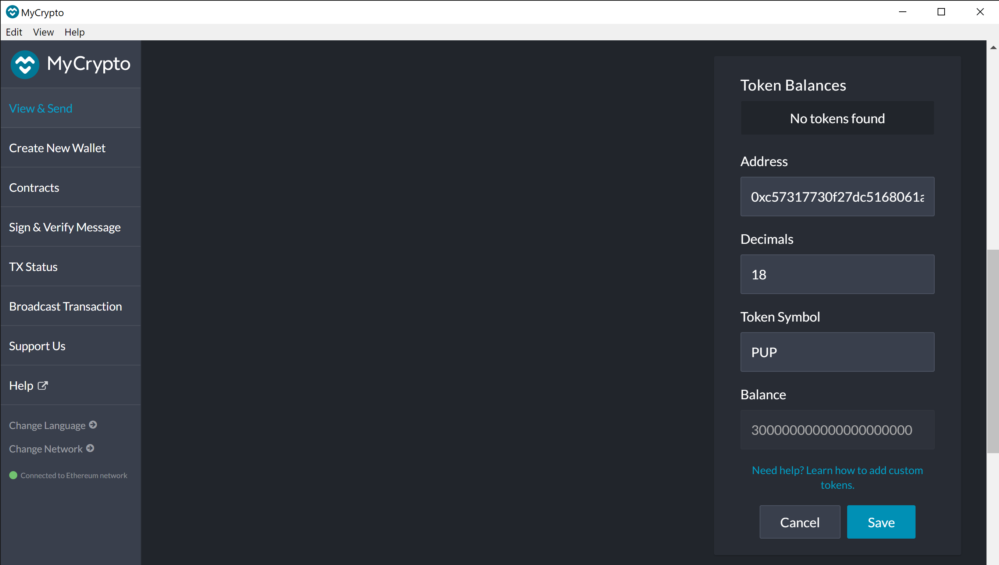
* **I also deployed the account on Ropsten but working with faucets and waiting to replenish my Ether every 24 hours took much longer in execution.**
* **I also checked that the contract closes (isOpen turned false) after 5 minutes since I changed the code from**

**By the changing the code from fakenow + 24 weeks to fakenow + 5 minutes.**