Los Angeles Crime and Arrest data analysis

Rashmi Gangadharaiah Dr. Karuna Joshi
Department of Information Systems Department of Information Systems
University of Maryland, Baltimore County University of Maryland, Baltimore County
Baltimore, Maryland -21250 Baltimore, Maryland -21250
Email: rashcg1@umbc.edu

Abstract: The paper focuses on the analysis of the crime in Los Angeles city crime incidents and arrests records. LA area is the most populated area in California resulting in thinking of more crime. The analysis helps the LAPD about the crime incidents in the city to enforce more safety and reduce the crime. Understanding the reasons and statistics behind the crime incidents in the city can help the police department to take necessary measures.
Keywords: Exploratory analysis, crime frequency, crime area, unsupervised learning, clustering
- INTRODUCTION
The research aims at the analysis of the historical crime and arrest records. The Los Angeles Police Department has made the crime and arrests records public to increase the transparency and to maintain the relationship with the community its servers.[4] The exploratory data analysis identifies the relationship between the various attributes like crime description, area name, age, location, and arrest areas. The paper aims at the victim’s age group involved in the crime. Also, how the areas where crime incident took place and the areas where LAPD made the arrest. I have used the unsupervised clustering algorithm like K-means algorithm and Density based clustering methods to group the data.
- RELATED WORK
There are many related research papers on crime analysis using the decent code, the weapon used, seasonal crime, time series analysis of the crime. There are some reference papers attached at the end of this paper which are related to crime analysis.[5]
- DATASET
The dataset reflects the crime and arrest incidents of Los Angeles city dated back to 2010.[2] The data is transliterating from original crime reports typed on the paper. There are few missing values and inaccuracies occurred while transcribing the data. The address in the dataset is provided to the nearest hundred blocks. The arrest data is similar to crime data. The crime data has 26 columns and 1.88 M rows. The arrest data has 17 columns and 1.22 column. After the exploratory analysis of data, the critical columns for my study were, VictimAge, Crime Code, CrimeCodeDescription, Area Name and Location from Crime dataset.[3] From the arrest dataset, AreaName and Location columns were considered.
- HYPOTHESIS:

- The age group which has more crime trends.
The proportion of the population involved in crime tends to peak youth and then decline with age. In this hypothesis, the victim’s ages are considered with the count of crime category to analyze if youth are involved in committing sever crime.
- Area of crime and area of Arrest are related.
In this hypothesis, the areas of crime and arrest are considered to see the location relation. By this analysis, the police department can perceive the crime area, and they can improve the safety measures in the areas where more crime incidents are reported.
- METHODOLOGY

- DATA PREPROCESSING:
The real-world data is incomplete, noisy, inconsistent with outliers in it. The raw data obtained after transcribing had missing values and other inconsistency to use it for the analysis. [8]
- Data Cleaning and Data Reduction
All the variables in the dataset were not important for the analysis. Also, there were a few columns which did not have any value. The columns which were completely empty were dropped. The victim age column had 90756 NA values, making 8.5% of whole data, hence they were deleted. Location column in the data was type array which had address and geo coordinates embedded in it. Since the analysis was to identify the crime and arrest location, the location column was split to get latitude and longitude
- Data Discretization/ Data Binning:
To analyze the age group involved in the more crime rate the victim age was binned into 10 bins. [10]
bin = [10,20,30,40,50,60,70,80,90].
Equal width binning method was used to put the age into bins. Age from 0-10 was in bin (0-10] and so on. This was done using python.
Also, the crime code description was discretized. There were 169 unique crime code description but some of them would fall under same category when classified in abstract level. The number of factors were 12 after discretization. Below are the 12 factors into which crime code description were discretized. The discretization was done in excel.
Table1: Crime Categories
Threats | Burglary
SexualAbuse | Theft
Robbery | Vandalism
Assault | Misc
ChildAbuse | Violation
Shooting | Fraud
- Data Transformation:
The location column of type location which has address and geo coordinated embedded in an array was split to get latitude and longitude. Using python function eval the geo co-ordinates were stripped. There were no missing values in latitude and longitude columns.
- EXPLORATORY DATA ANALYSIS:
This is the critical process of performing initial investigation of the data to discover the pattern with the help of statistics. This step helps to get insights in identifying the outliers and test the hypothesis with the help of graphical representation.
Fig1 and Fig 2 gives the top crimes with the description and the count of each crime. Based on the analysis of all the other crimes, the crimes were categorized into 12 categories to bring the abstract understanding of the crimes. Fig 2 shows the top crime categories after discretization [8]
Table1 lists all the 12 crime categories that are considered for discretizing the crime types in the data.
Fig 3 explains the age group and the crime count for each age group. After looking at the figure the first hypothesis was formulated.
Fig 4 explains about the crime categories and count against each age group. Theft has higher count compared to other crimes categories.
Fig 5, Fig6, Fig7 are plotted to see the relationship between the crime areas and the arrest areas. The scatter plots on the maps shows some clusters based on the area name, but it does not give the count or clear picture about the relation between the areas of crime and arrest.

- Major Crime Indicator (Top 20)

Fig1: Major crime indicators

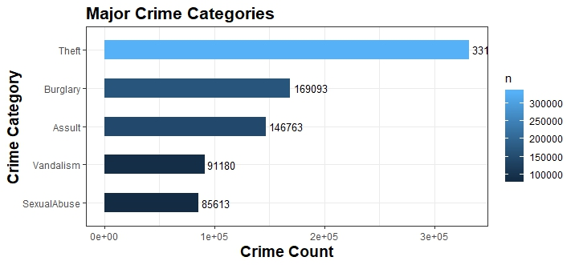
Fig2: Major crime indicators
- Age Group and crime count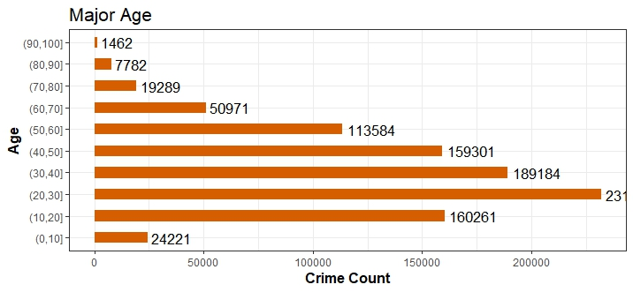Fig3: Age groups and their crime count
- Crime category and Age Group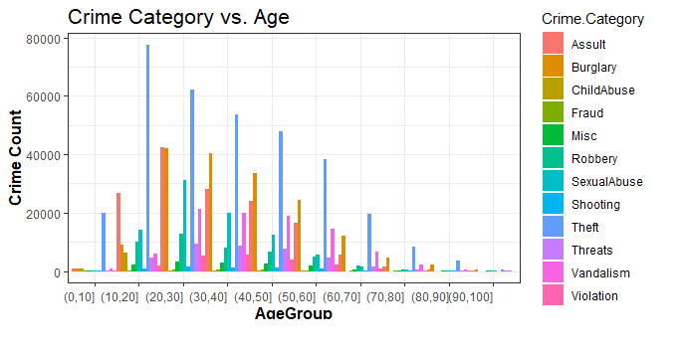Fig4: Crime Category and Age Group

- Crime and Arrest area plot:
Fig5: Bar graphs for crime and arrest area
- Crime Area plot on a map:
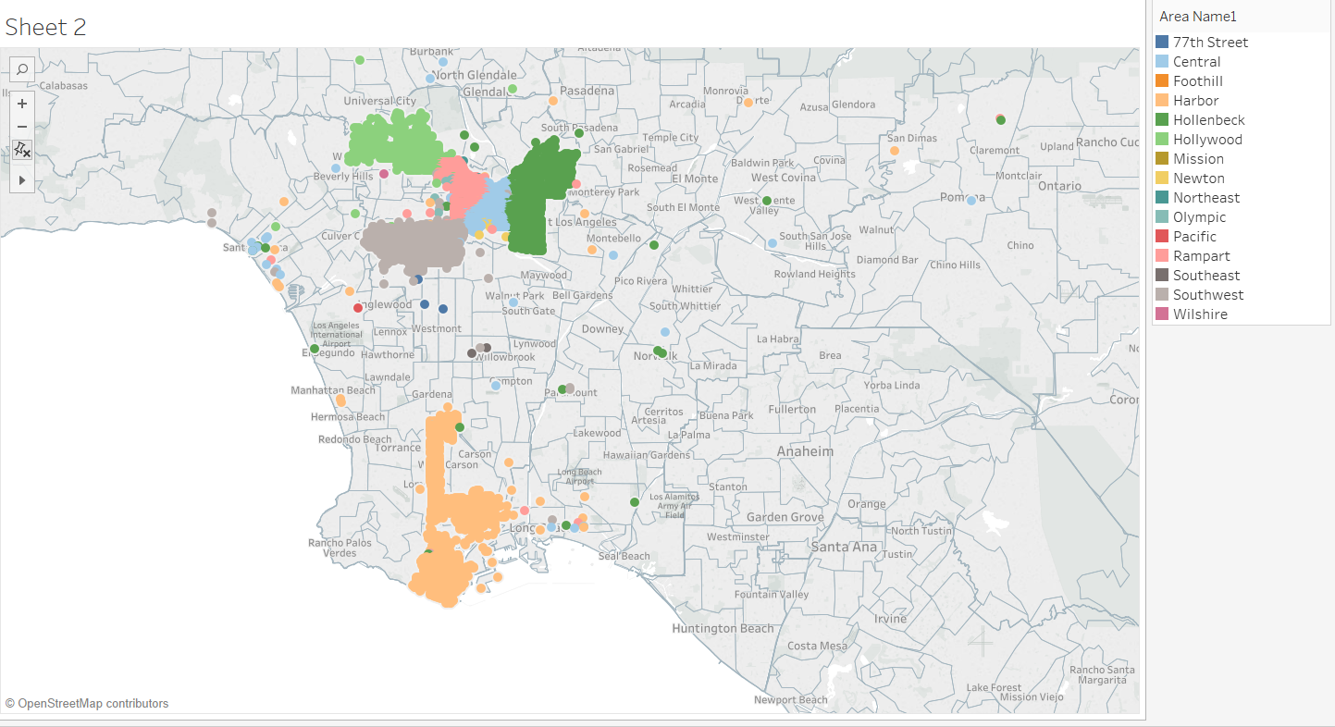
Fig6: Latitude and longitudes of crime area on geo map
After the exploratory analysis, it is clear that there is no qualitative/ quantitative relationship that exits between the crime and arrest areas as there was no unique variable to match the arrest and crime records. Only with the area name or address one cannot simply conclude that there can be relation between the area where crime took place and the place where police arrested the criminal.

- Arrest area plot:
Fig7: Latitude and longitude scatter plot of arrest area on geo map

- MODEL BUILDING:
After the thorough research of the dataset, the hypothesis formed were considered to decide on the model. Since the problem statement is to identify the age groups that commits more crimes, it can be categorized as a unsupervised learning approach. K-means clustering is a simple unsupervised clustering method, which was used in this project to derive the pattern from the dataset.
- K-Means Clustering
K-means is an unsupervised learning approach, used when class label is not known to group the data points to the clusters. A cluster is group of similar features grouped together. The k-means algorithm finds the k centroids and assigns each data point to the closet to the centroid.[6]
In this project, K-means cluster is applied on Age group and Crime category. First the data is transformed to get the count of crime according each crime category and each age group
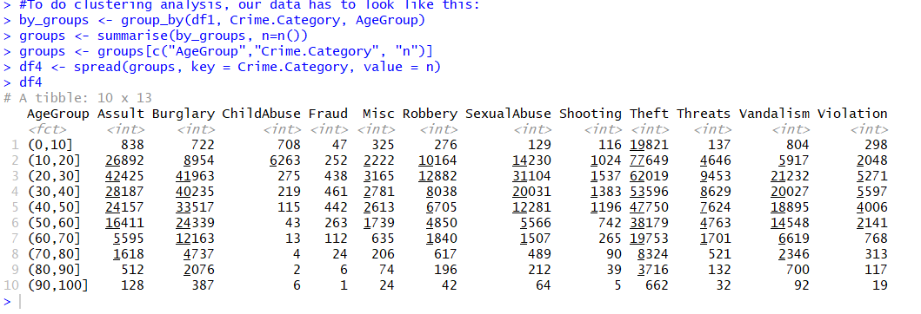

Fig8: Data for K-means clustering
Then using elbow method to determine the number clusters, gives the below graph from which it is evident that 2 optimal clusters can be formed.
Fig9: Elbow method
Applying the k-means clustering on data, gives 2 clusters. One cluster with high crime involvement with and the second cluster with low crime involvement with age groups clustered accordingly. Below snippet show the k-means clustering results.

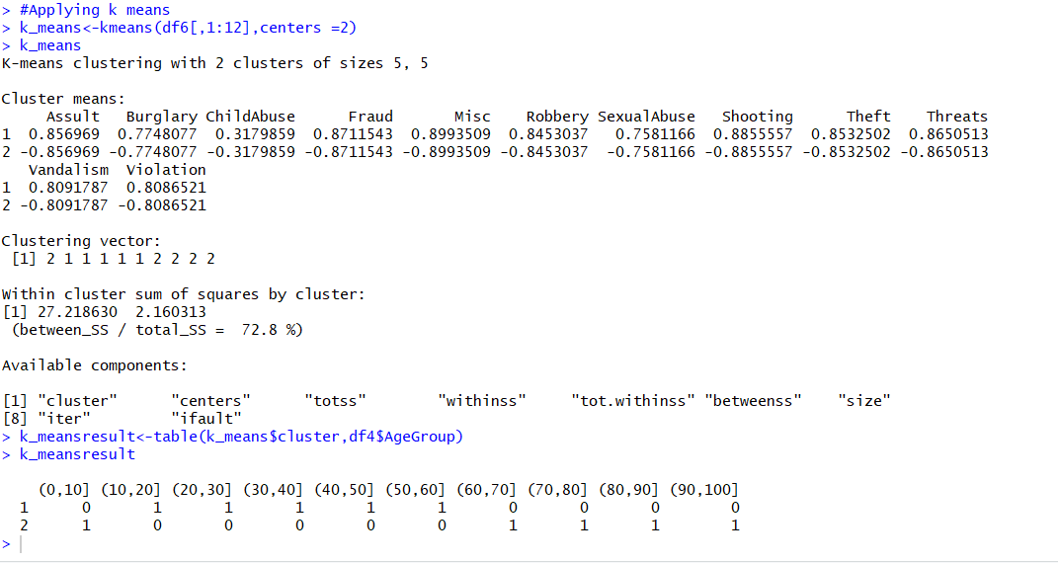
Fig10: K-means clustering results on AgeGroup

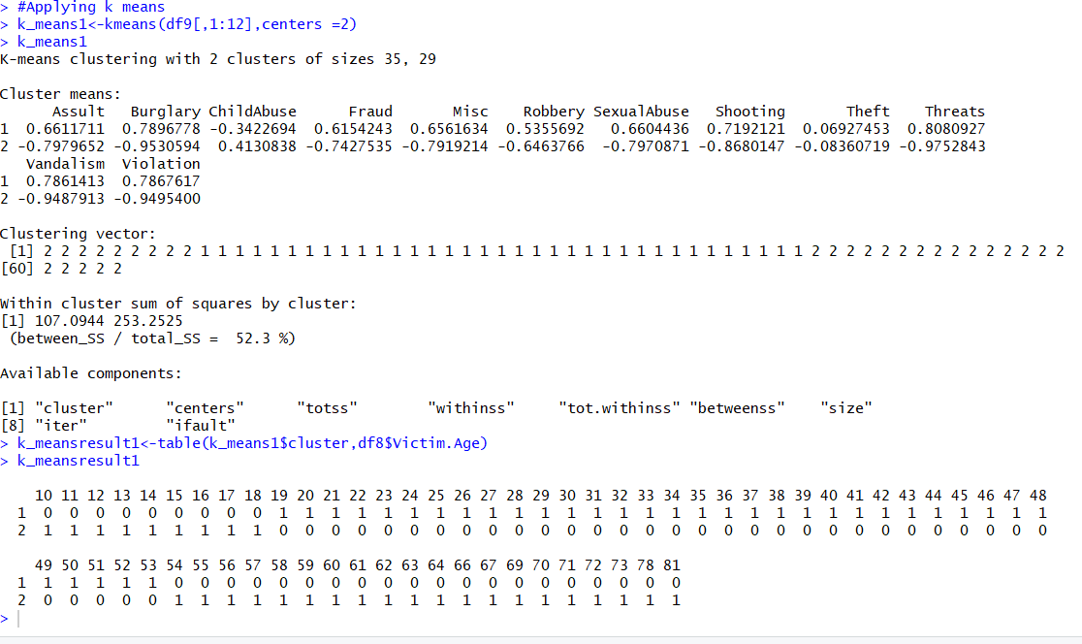
Fig11: K-means results on Victim Age
Interpretation:
- Cluster1 has 5 age groups involved in high crime rate. And cluster has 5 age groups involved in low crime rate.
- Cluster 1-Low Crime: Age values from 10 to 17 and >55 are involved in low crime.
- Cluster 2-High Crime: Age values from 18 to 54 are involved in high crime.To understand it more accurately, the k-means is applied toVictim Age instead of Age Group.
- Fig 9 shows the result of the k-means on victim age and crime category.
- Cluster 1-Low Crime: Age group between 60 to 100 and 10 are involved in low crime.
- Cluster 2-High Crime: Age group between 20 to 50 are involved in high crime.
- K-means searches for the minimum sum of squares assignment, i.e. it minimizes unnormalized variance (=total_SS) by assigning points to cluster centers. The k means cluster within sum of squares cluster is 52.3%
Fig 10 explains the first principal component variance between the clusters. The 2D representation of cluster graph is generated using custplot function in R. The 84.86%point variability does not actually explain about the accuracy of the k-means clustering.
Fig12: 2D representation of K-means Clustering
Fig13: K means cluster and Age group table plot

Fig 11 shows the age group distribution into clusters. As it can be visualized in the above graph, all the ages from 10 to 60 is in grouped to one cluster and age group 60 to 100 and 0 to 10 are grouped to another cluster.
- K-means for second hypothesis
After the exploratory analysis of the crime and arrest areas by plotting the scatter plot on the map, shows the obvious clusters based on the area names. But there also outliers in the data. Some addresses have same area names which forms outliers. These outliers have to be removed to understand the relation/ identify the patterns between the crime and arrest areas. Clustering is one method to identify the outliers. K-means algorithm using scipy library in python was used to detect the outliers. The k-means for arrest data resulted in no change in detecting the outliers. More advanced clustering techniques like density-based clustering can be used to detect the outliers.
- RESULTS
The result of the k-means algorithm for first hypothesis shows that the within cluster sum of squares errors is a lower value ie 52.3%. The k-means algorithm grouped the age group and crime rate pretty well forming 2 clusters with high crime and low crime with clusters mean has shown in fig11.
- CONCLUSION AND FUTURE WORK
After the exploratory data analysis, a lot of information like top crimes, crime count, age group and crime category from data was revealed.
From the k-means model assessment, first hypothesis on the crime trends are found high among early adulthood and decreases with the age
For second hypothesis, the crime and arrest data should have a common variable to relate between the crime area and arrest area.
The work can be extended to find the crime record and corresponding arrest record. Using which the most common crime area where there is less safety (arrest are less) can be assessed with more safety measures.

- REFERENCES

- Agarwal, J., Nagpal, R., & Sehgal, R. (n.d.). Crime Analysis using K-Means Clustering. Retrieved December, 2013, from http://citeseerx.ist.psu.edu/viewdoc/download?doi=10.1.1.402.1621&rep=rep1

- Arrest Data from 2010 to Present | Los Angeles - Open Data Portal. (n.d.). Retrieved from https://data.lacity.org/A-Safe-City/Arrest-Data-from-2010-to-Present/yru6-6re4

- Crime Data from 2010 to Present | Los Angeles - Open Data Portal. (n.d.). Retrieved from https://data.lacity.org/A-Safe-City/Crime-Data-from-2010-to-Present/y8tr-7khq

- (n.d.). Retrieved from https://ieeexplore-ieee-org.proxy-bc.researchport.umd.edu/document/7873764/metrics#metrics

- Li, Z., Zhang, T., Yuan, Z., Wu, Z., & Du, Z. (2018). Spatio-Temporal Pattern Analysis and Prediction for Urban Crime. Retrieved from https://ieeexplore-ieee-org.proxy-bc.researchport.umd.edu/document/7873764/metrics#metrics

- Garbade, M. J. (2018, September 12). Understanding K-means Clustering in Machine Learning. Retrieved from https://towardsdatascience.com/understanding-k-means-clustering-in-machine-learning-6a6e67336aa1

- K-means Cluster Analysis. (n.d.). Retrieved from https://uc-r.github.io/kmeans_clustering

- Markov, Z. (n.d.). Retrieved from http://www.cs.ccsu.edu/~markov/ccsu_courses/DataMining-3.html

