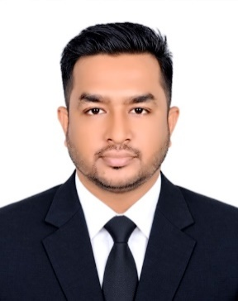
RASHED KHAN
SQA Engineer
House 56, Road 04, Block D, Turag, Dhaka-1230, Bangladesh
+8801683-849353 | +8801753945709
rashedkhaneee61@gmal.com
www.linkedin.com/in/rashed-khan112
https://github.com/rashed112

Professional Summary
Software Quality Assurance Engineer with over 2 years of professional experience in testing and quality validation, transitioning from industrial system testing to software quality assurance. Seeking a challenging role where I can apply hands-on expertise in manual testing, API and performance testing, automation testing. Committed to continuous learning, effective collaboration, and ensuring product stability while growing professionally in a dynamic team environment.

Technical Skills
- Manual Testing: Functional Testing, Integration Testing, Regression Testing, Smoke Testing, Non-Functional Testing
- Programming & Markup Languages: Java, SQL
- Automation Frameworks: Selenium WebDriver,
- API Testing: Postman, REST Assured, Newman, JSON Schema Validation
- Performance Testing: Apache JMeter, Load testing
- Core Methodologies: SDLC, STLC, Agile, Scrum, Functional, Regression, Smoke, Defect Lifecycle
- Tools & DevOps: Git, GitHub, Jira

Work Experience
Ningbo Cixing Company Limited - Dhaka, Bangladesh | Associate Test Engineer | Jan 2024 -July 2026
- Tested full systems: software, hardware, sensors, controllers & UI
- Performed Functional, Integration, Regression, Smoke, Sanity & Non-Functional Testing
- Test case writing and execution
- Test planning
- Bug report writing and Tracked defects in JIRA

Key Achievements
Performed immediate system testing on deployments, identified risks, and ensured 100% system stability prior to release and reduced manual testing time with Python automation.
Projects
- Manual Testing Project: Odoo-ERP-Project
- API Testing Project: API-Project
- Performance Testing Project: JMeter-Project
- Automation Testing Project: TestNG-Project
- Junit Testing Project: Junit-project
Education
BSc in Electrical & Electronics Engineering
City University | Graduated: 2021 | CGPA: 2.91 / 4.00

Certifications
- SQA learning Academy
- SQALOGY
- Software Manual & Automation Testing

Professional References
Md. Mamun Reza
Senior SQA Engineer
BRAC-IT Services Ltd.
Email: mamun.reza@bracits.com
Phone: +8801737337078
(2) Md. AKM Faisal
Senior Software Test Engineer
Stardust Telecom Limited
Email: akm.faisal@sqalogy.com
Phone: +8801787671357

