Week 3

Task 1 :

In this task we are going to transfer massage between two host and we are using command netcat . In short nc. So the command will be nc -l -p 12345 for host 2 to make a server in host 2.
Nc----- netcat
-l-------- list
-p-------- port
12345---- is port number.

In host 1 we are making it as a client. So the command for this will be nc 10.10.1.2 12345

Here 10.10.1.2 is the ip of host number 2. And then the port number.
However after entering we can sent massage each other like that

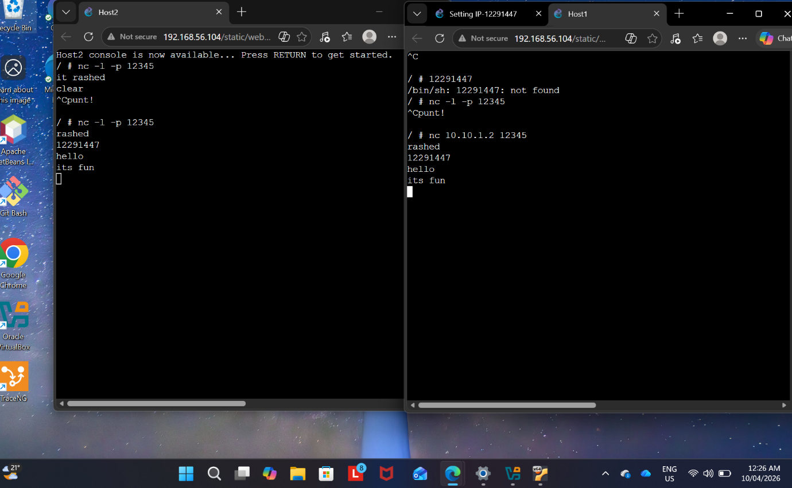

Task 2:

In task 2 we need to export the capture file to our device by filezilla browser. Here is a copy of that

