Development of Event Management System Brothers Dream It Ltd

A practicum report submitted by
Md. Rashed Miah
ID# 18203020
A Practicum Report Submitted to Fulfillment of the Requirements
for the Award of Bachelor of Computer Science and Engineering (BCSE)

Department of Computer Science and Engineering
College of Engineering and Technology
IUBAT – International University of Business Agriculture and Technology
Spring 2022

Development of Event Management System for Brothers Dream It Ltd
Md. Rashed Miah

A Practicum Report Submitted to Fulfillment of the Requirements for the Award of Bachelor of Computer Science and Engineering (BCSE)
The practicum has been examined and approved,

_____________________________
Prof. Dr. Utpal Kanti Das
Chairman and Professor

_____________________________
Dr. Hasibur Rashid Chayon
Coordinator and Associate Professor

_____________________________
Rashedul Islam
Assistant Professor

Department of Computer Science and Engineering
College of Engineering and Technology
IUBAT – International University of Business Agriculture and Technology
Spring 2022

Letter of Transmittal
17 April 2022
The Chairman
Practicum and Placement Committee College of Engineering and Technology (CEAT)
Department of Computer Science and Engineering
IUBAT–International University of Business Agriculture and Technology
4 Embankment Drive Road, Sector 10, Uttara Model Town
Dhaka 1230, Bangladesh

Subject: Letter of Transmittal.

Dear Sir,
With due respect, this is my pleasure to present my project report entitled― Event Management System, I have prepared this report as partial fulfillment of the practicum. I have tried my level best to prepare this project to the required standard.

It was certainly a great opportunity to work on this paper to actualize my theoretical knowledge in the practical arena. Now, I am looking forward or your kind appraisal regarding this practicum report.

I shall remain deeply grateful to you if you kindly go through this report and evaluate my performance. I hope that you would find the report comprehensive and competent augmented.
Yours sincerely,
_____________
Md. Rashed Miah
ID #18203020
Program: BCSE

Student’s Declaration
I am Md. Rashed Miah, student of IUBAT-International University of Business Agriculture and Technology, declaring that this project paper on the stated topic has only been prepared for the fulfillment of CSC490 (Practicum), as the partial fulfillment of―Bachelor of Computer Science and Engineering degree.
It has not been prepared for any other purposes, rewards, or presentation.

_____________
Md. Rashed Miah
Student ID #18203020
Program: BCSE

Supervisor’s Certification
This is to certify that Practicum report on “Event Management System” has been carried out by Md. Rashed Miah, ID# 18203020 of IUBAT-International University of Business Agriculture and Technology as a partial fulfillment of the requirement of practicum defense course. The report has been prepared under my guidance and is a record of the bona fide work carried out successfully. To the best of my knowledge and as per his declaration, no part soft his report has been submitted anywhere for any degree, diploma or certificate.

Now he is permitted to submit the report. I wish his all success in his future endeavors.

_______________________________
Rashedul Islam
Assistant Professor
Department of Computer Science and Engineering
IUBAT–International University of Business Agriculture and Technology

Department Certification
On behalf of the Department of Computer Science and Engineering of International University of Business Agriculture and Technology, we the undersigned certify that this Practicum Report “Event Management System” for the award for the bachelor of Computer Science and Engineering (BCSE) degree was duly presented by Md. Rashed Miah, ID# 18203020 and accepted by the department.

_________________________
Prof. Dr. Utpal Kanti Das
Chair and Professor

______________________
Rashedul Islam
Assistant Professor
Department of Computer Science and Engineering
IUBAT- International University of Business Agriculture and Technology

Organization Certification

Abstract
An event management system is used to handle all event-related activities. In any case, several service providers operate concurrently, making it difficult to manage these providers. It is also critical for the event organizer to have all of these service providers' contact information on hand so that he may call them at any moment to schedule an event at a certain time. We created this program to manage all of these activities. To be successful in the event management industry, the user must have a strong network of service provider relationships. These connections are essentially service providers who can be swiftly summoned to participate in any particular event. To make an event a success, event managers require a variety of service providers such as sound system providers, lighting providers, canteen services, stage construction, and so on. In any case, several service providers operate concurrently, making it difficult to manage these providers. It is also critical is for event planner to have those service providers' contact info on hand so that he may call anyone at any moment to schedule an activity at a specific moment. In the current system, Events Organizations must do most managerial things manually. All transaction information is kept on paper. There is no mechanism in place to track historical spending for any event. To do so, they must check the payment record, which is a moment and exhausting task. . This system is developed by Laravel 8.x framework where Hypertext Markup Language (HTML). Cascading Style Sheet (CSS), bootstrap, Structure Query Language (SQL), PHP, and JavaScript is implemented.

Acknowledgments
In the name of Almighty, who is the most merciful and the most graceful, it’s my pleasure to take this occasion to thank a few people, who have, assisted, encouraged, directed and supported me during my practicum program. Firstly, I want to thank my family, who has endowed their immeasurable-innumerable support and encouragement to attain this exquisite event of my life.
I am very appreciative to Prof. Dr. Utpal Kanti Das, Chair of Department of computer Science and Engineering, IUBAT- International University of Business Agriculture and Technology for his unrelenting direction and sustain throughout the semester.
I would like to pay my gratitude to my practicum supervisor Rashedul Islam, Assistant Professor of Computer Science and Engineering Department, who has given me the opportunity to make such a report for not only in this semester but also throughout my education life at IUBAT by giving her valuable suggestions and advices at any time, at any situation. I would able to make this report effectively and properly only for her right direction.
Sincerely yours
________________
Md. Rashed Miah
ID #18203020
Program: BCSE

Table of Contents
Letter of Transmittal iii
Student’s Declaration iv
Supervisor’s Certification v
Department Certification vi
Organization Certification vii
Abstract viii
Acknowledgments ix
List of Figures xv
List of Tables xviii
Chapter I. Organization Overview 1
1.1 Organization Overview 2
1.2 Organization Services 3
1.2.1 Web Development 3
1.2.2 Mobile Application 3
1.2.3 Digital Marketing 3
1.3 Organization Location 4
1.4 Organization Vision 4
1.5 Organization Mission 5
1.6 My Position in this Organization 5
1.7 Organizational Structure 5
Chapter II. Introduction 7
2.1 Introduction 8
2.2 Background of Study 8
2.3 Objective 9
2.4 Board Objective 9
2.5 Specific Objective 9
2.6 Proposed system benefits 9
2.7 Methodology 10
2.7.1 Primary data 10
2.7.2 Secondary data 10
2.8 Limitation of the project 10
2.9 Process Model 11
2.10 Reason for choosing incremental process model 11
2.11 Feasibility study 12
2.11 Technical Feasibility 12
2.11 Economic Feasibility 12
2.12 Operational Feasibility 13
Chapter III. Requirement Engineering 14
3.1 Requirement Engineering 15
3.1.1 User requirements & system requirements 15
3.2.2 Functional requirement 18
3.3.3 Non-Functional Requirement 19
3.3.4 Hardware Requirement 19
3.3.5 Software requirement 20
3.3.6 Use case diagram 20
Chapter IV. System Planning 23
4.1 Scope of Project 24
4.1.1Some more scopes are 24
4.2 System Project Planning 24
4.3 Complexity matrix 26
4.4 Identifying complexity 27
4.4.1 Identifying Complexity of transition function 27
4.4.2 Identify Complexity of data function 30
4.4.3 Unadjusted function point calculation 31
4.4.4 Performance & Environment Impact 32
4.4.5 Process Based Estimation 35
4.4.6 Effort Distribution 36
4.4.7 Time Schedule 36
4.4.8 Cost Estimation 37
4.4.9 Hardware Cost 38
4.4.10 Software Cost Estimation 38
4.4.11 Other Cost 39
4.12 Accounts Table 39
Chapter V. Risk Engineering 40
5.1 Risk Management 41
5.2 Stages of Risk 41
5.3 Identification 41
5.4 Classification 42
5.5 Assessments 42
5.6 Analysis 42
5.7 Implementation 42
5.8 Categories of Risk 43
5.9 Project Risk 44
Chapter VI. Analysis Modeling 46
6.1 Software Analysis Pattern 47
6.2 Activity Diagram 47
6.3 Data Flow Diagram 59
6.4 ERD diagram 64
Chapter VII. Designing 68
Chapter VIII. Quality Assurance 80
8.1 System Quality Management 81
8.1.1 Software Quality Management Process 82
8.2 System Testing 83
8.2.1 System Testing Methodology 84
8.3 System Testing Design 85
Chapter IX. Conclusion 87
8.1 Preface 88
8. 2 Practicum and Its Value 88
8.3 Future Plan 89
8.4 Conclusion 90
Reference 88

List of Figures
Figure 1.1 Organization’s location (Source: Google map) 4
Figure 1.2 Organization structure of Brothers Dream it Ltd 6
Figure 3.1 Use case Symbol 21
Figure 3.2 Use-case diagram 22
Figure 4.1 Effort distribution estimation 36
Figure 4.2 Time Schedule 37
Figure 6.1 Activity diagram for donor 48
Figure 6.2 Activity Diagram for User 50
Figure 6.3 Activity diagram for Admin 51
Figure 6.5 DFD Diagram 53
Figure 6.6 DFD Diagram 54
Figure 6.7 DFD for admin (part 1) 55
Figure 6.8 DFD diagram 56
Figure 6.8 DFD diagram (part 3) 57
Figure 6.10 Context level diagram 59
Figure 6.11 Level 1 DFD 60
Figure 6.12 Level 2 Process 1 61
Figure 6.13 Level 2 process 2 61
Figure 6.14 Level 2 Process 3 62
Figure 6.15 Level 2 Process 4 62
Figure 6.16 Level 2 Process 5 63
Figure 6.17 Level 2 Process 6 63
Figure 6.18 ER diagram 64
Figure 6.19 All DB Table 65
Figure 6.20 Category Table 65
Figure 6.21 Admin Table 65
Figure 6.22 User Table 66
Figure 6.23 Team Table 66
Figure 6.24 Customer Table 67
Figure 6.26 Report Table 67
Figure 7.1 Landing page of user 60
Figure 7.2 User registration login 62
Figure 7.3 User login page 63
Figure 7.4 Admin login page 64
Figure 7.5 Featured of Dashboard 65
Figure 7.6 Add event form 66
Figure 7.7 Add serivce form 66
Figure 7.8 Add Team Member 66
Figure 7.9 Add image gallery form 67
Figure 7.10 Category team list 67
Figure 7.11 Event list 68
Figure 7.12 Service list 68
Figure 7.13 Client message 69
Figure 7.14 Order list 70
Figure 7.15 Gallery form 70
Figure 7.16 Order list 71
Figure 7.17 Report form……………………………………………………………………..71
Figure 7.18 View Service list………………………………………………………………..72
Figure 7.19 Booking service…………………………………………………………………73
Figure 7.20 View Cart list……………………………………………………………………73
Figure 7.21 Invoice total list………………………………………………………………..74
Figure 7.22 Do Payment……………………………………………………………………75
Figure 7.23 about us……………………………………………………………………….75

List of Tables
Table 4.1 Complexity Matrix 1 26
Table 4.2 Complexity Matrix 2 26
Table 4.3 Complexity Matrix 3 26
Table 4.4 Functional complexity (Transaction Function) 26
Table 4.5 Functional complexity (Data Function) 27
Table 4.6 Identifying complexity (Transaction Function) 27
Table 4.7 Data Function point 30
Table 4.8 Unadjusted Function point contribution for transition function 31
Table 4.9 Unadjusted Function Point Contribution for Data Function 32
Table 4.10 Performance and Environmental Impact 32
Table 4.11 Counting Function Point 34
Table 4.12 Process-Based Estimation 35
Table 4.13 Personal Cost Estimation 37
Table 4.14 Hardware Service Percentage 38
Table 4.15 Software service percentage 38
Table 4.16 Other Cost Table 39
Table 4.17 Account Table 39
Table 5.1 Project Risk 1 44
Table 5.2 Project Risk 2 45
Table 5.3 Technical Risk 1 45
Table 8.1 System Testing Scenario – 1 85
Table 8.2 System Testing Scenario – 2 85
Table 8.3: System Testing Scenario – 3 86

Chapter I. Organization Overview

Chapter 1 is representing the organizational overview, mission, vision and about company’s various services. In this chapter detailed organizational overview is discussed along with the organizational hierarchy and my position over there as intern.

Organization Overview
Brothers Dream it Ltd is a full-featured web solution, software development, mobile application, graphic & multimedia, domain hosting and digital marketing service providing company in Bangladesh. Its core with the highly qualified Designers and Developers having experience of more than 4 years in various and complex designs and development. Brother Dream it solution Ltd has satisfied the clients with the services like Web design and development, Mobile app design and development, Software development, SEO and Social Media Designing & Development. We are customer centric and divert our efforts to act as a one-stop solution provider in the area of IT. In every area of our, operations we work hard in understanding the Client’s requirement and providing the Brothers Dream it Ltd. We firmly believe in the philosophy of ‘Our vision is to make every youth skilled & employed’. We take pride in a team of highly qualified, skilled and motivated Professionals who are encouraged to lead, innovate and excel. Our team consists of top professionals who share a common vision and passion, providing our clients with critical insights and advice to succeed in today’s competitive environment. We believe in offering Expertise, Excellence Services via our experience and giving our clients with the highest and finest end use of services.

Organization Services
Brothers Dream it Ltd is an Information Technology service provider organization which provides all kinds of professional and creative software, Enterprise software integration, Management info system, E-commerce, Game development, Web development & Mobile app solutions globally.

1.2.1 Web Development
At Brothers Dream it Ltd we focus on creating search engine friendly, aesthetically appealing and interactive website designs. It is a known fact that to build a strong web presence and to secure the countless marketing opportunities available on the internet, a good website is imperative, thus triggering a race for website design while designing and developing your website, our professionals keep in mind key factors like easy-navigation, overall consistency and content quality, stipulated timeframes and budget and backend support.

1.2.2 Mobile Application
We have a strong mobile application developer team of expert engineers whose have the experience to build versatile mobile applications for various industries. All our expert engineer working in android and IOS platform for more than four years. We work on native android which provide faster response of app and ensure the quality. We can design, build, prototype and implement your idea through a process of planning, building, testing, and deployment.

1.2.3 Digital Marketing
Brothers Dream it Ltd offer various kinds of packages to make your company best in the internet world. Digital Marketing means promoting a product or brand which is very much essential to make a business successful. It increases visibility on web to your potential customers. As much as you are visible, you are getting closer to your business goal. It’s your most important strategy to expand your business. K is a full-service digital agency that has clients ranging from renowned companies to innovative startups.

Organization Location
House 19 Road-01, Sector 6, and Dhaka 1230
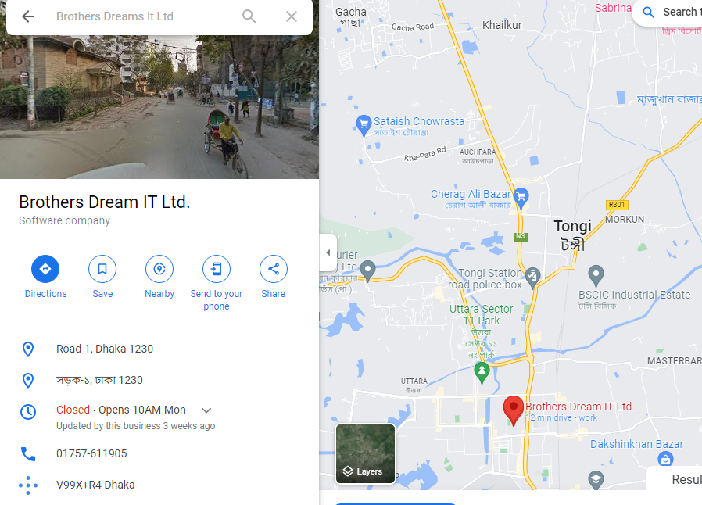

Figure 1.1 Organization’s location (Source: Google map)

Organization Vision
The mission of Brothers Dream it Ltd is to become a top leading IT company of Bangladesh and their vision is to empower the youth and become a successful IT company of digital Bangladesh. Brothers Dream it Ltd achieves competitive edge and has gained operational effectiveness and efficiency through the innovative use of technology.

Organization Mission
Brothers Dream it Ltd was born as a one stop skills development platform provider. Their offerings coupled with the impeccable team behind it ensure satisfaction of client needs in relation to their characteristics.

My Position in this Organization

This organization has hired me as an intern developer. In this organization, I am guided by a supervisor. He's quite helpful and informed. He has taught me a great deal. My project was effectively done on schedule. It was only feasible because of my supervisor's supervision. Maintaining office hours was also a learning lesson for me. I also follow the rest of the organization's guidelines. I am delighted to be working with this office. It's certainly helped me prepare for the start of my profession.

Organizational Structure
The structure of the organization is drawn below:

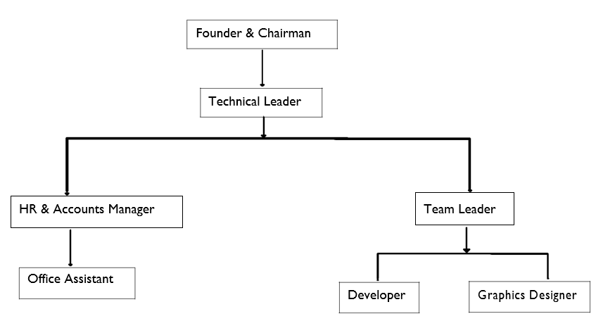

Figure 1.2 Organization structure of Brothers Dream it Ltd

Chapter II. Introduction

2.1 Introduction

The Event Management System (EMS) project was created to streamline the processing of finding events. Our suggested software simplifies the event discovery process for both organizers and customers. Customers may schedule an event based on their preferences, and if authorized, they can follow their information online. Event Management system is a very effective procedure for handling all event related Scheduling in an exact and simple manner. An event management system is a user interface that allows a consumer to select a specific event and book it online. This system includes information on the organizers, as well as information about various sorts of events and their venues. In Bangladesh, finding an event that is better acceptable for a person is a time-consuming and hard task. It might take weeks or even months to discover events near you to attend, and it can be difficult to gather information about an event. Organizers and sponsors can readily discover consumer information with this system, and because it is paperless, the effort is decreased. It is quite beneficial to individuals who are interested in events, as it gives a highly dependable and simple form for their relevant facts. All of the information and event details are also accessible with a mouse click. This technology facilitates contact between the client and the event organizer. This technology allows you to produce reports quickly and conveniently.

2.2 Background of Study
Before developing the system, I have visited some organization, also read some documents on the system. I have visited some organization where this process is handled by traditional way. In terms of donation, I have found some problem with the system. So, by studding them I found some points that can be solved by implementing a new system that will be more helpful for us.

2.3 Objective

The system's primary objective is to run the organization, automate manual operations, track progress, and collect contributions.

2.4 Board Objective
My objective is to design a userfriendly system for the region that will make the operations easier and more enjoyable. Users can also save a large amount of time by utilizing this approach.

2.5 Specific Objective
The web based Event Management System can support issues like
- The system stores all data in a centralized database. As a result, there is simple accessibility and uniformity.
- Event Details of different categories and the other details are also available at the click of a mouse.
- Help to provide a good service.
- Customer can book an event based on his/her criteria and track his booking details and this event updates from online.
- By clicking the button, you can view the information for each component.
- Allows you to simply produce reports.
- Control the organizations effectively.

2.6 Proposed system benefits
A project scope clearly specifies the work necessary to finish the project while also keeping
track of the ongoing project and satisfying our clients. The system is constructed in a fairy
straight forward manner. Some of the system's advantages are listed below. Provide instant information
- Save user’s valuable time.
- Records can easily maintainable.
- Data are secured.

2.7 Methodology
Data Source
The source of data required for the purpose of this project are
- Primary data.
- Secondary data.

2.7.1 Primary data

Within the organization, primary data is created. The organization's expertise, as well as face-to-face interviews with the client, customer, and site administrators, assist us in gathering primary data. Interviews and practical experience were used to acquire primary data.

2.7.2 Secondary data

Secondary data is gathered by real-life experience, reading certain articles, and gathering information from the internet. Sources offer a more complete picture of the project. That is why I am looking for an online method.

2.8 Limitation of the project
Some limitation of my project are:
- Payment method is manual.
- No email notification system.
- Customer cannot find more categories and types which are not in the software system.
- Not possible to arrange huge budget event management

2.9 Process Model
In certain cases, the software requirements are clearly specified, yet the user need the program soon. The incremental process paradigm is an excellent choice in this scenario. We can release software in sections using this strategy. The software's capabilities may be expanded in future releases. The user can utilize the program and provide comments on how well it works. It entails both development and maintenance. When a product meets all specifications, it is said to be completed.
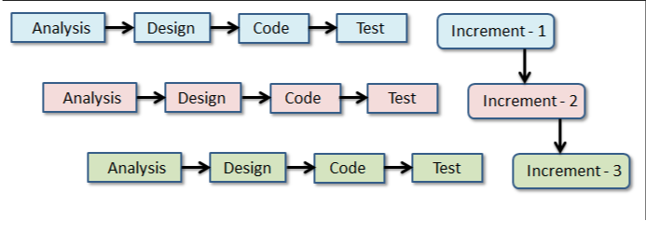

Figure 2.1 Incremental process model (source: educba.com)

2.10 Reason for choosing incremental process model
- Provide better support for process iteration.
- Reduce rework on a part.
- Time efficient.
- Allow easy deliver of part of product.
- Lower risk of process failure.
- Delivery process is easier.

2.11 Feasibility study
The feasibility assessment analyzes if the proposed solution is practical or achievable for the organization. This indicates that the jobs we shall undertake are either valuable or not. There are three major areas of inquiry and idea generation for a new system. Three primary variables are addressed while examining the system's feasibility in order to determine whether the system's automation is realistic.
- Technical feasibility.
- Economic feasibility.
- Operation feasibility.

2.11 Technical Feasibility
Technical feasibility addresses concern about hardware capability, reliability and availability and the skills of the development team. So, I found that this model is technically feasible, because this can be developed by the following lines. To develop this project, need a high-level programming language like HTML, CSS, Bootstrap, Laravel Framework of PHP. For database such as Xampp Server. To store data and an IDE (Sublime Text, VS code or PHP storm) need a cloud server and a computing device like a computer or Smartphone with a simple configuration and data connection. All the technology which is mention above is ready to use. So, our project is technically feasible.

2.11 Economic Feasibility
Economic feasibility determines to what extent a new system, is cost effective. My software is economically feasible. As I mention I need only one operating system, IDE and a browser. So, the cost will be less. On the other way, this will reduce our paper cost. Because I am using a database to store all the data. From donor side, when any new donor wants to open an account, give donation or look at the payment status that time they only need to provide information. As a result, I can state that this program is commercially viable.

2.12 Operational Feasibility
Concerns concerning user acceptability, management support, and the requirements of entities and elements in the organization's external environment are addressed by operational readiness. It is technically doable. Our software's operation is simple enough for anyone to grasp. They do not require any further training to comprehend it. Members can access their services by logging on to our website. As a result, it is logistically possible.

Chapter III. Requirement Engineering

The process of determining the capabilities that what a system must provide to a client, as well as the constraints through which it functions and is created. A need indicates a user's desire for a system that performs a specific function, such as operating a device, issuing a request, or locating information.

3.1 Requirement Engineering
The process of identifying, documenting, and managing requirements in the engineering design process is known as requirement engineering. There are numerous definitions of requirement gathering, but they really share the premise that needs entail determining what people want from a computer system and understanding what their demands mean in terms of design. Software engineering, which focuses on the process of developing the system that user’s desire, is closely connected to requirement engineering.
- User Requirement
- System requirements
- Functional requirements
- Non-functional requirements
- Hardware requirements
- Software requirements.

3.1.1 User requirements & system requirements
Event Management
- User requirement 1 User can create account on the system by themselves.
  - System requirement 1.1 User can access signup page & submit their information on the system.
- User Requirement 2 User can see and update their information from their profile
  - System requirement 2.1 User can easily accessible by booking their
  - System requirement 2.2 Specific user can see his/her own information by clicking my profile button and update their information by clicking update button.
- User Requirement 3 Customer can see Event Types and Schedule.
  - System requirement 3.1 Customer can book any event
- System requirement 3.2 Customer can see food packages and organizer details on each event description.
- User Requirement 4 Customer can book any event
  - System requirement 4.1 Customer will get a supervisor for every event.
System requirement 4.2 Customer can search events and see supervisor details for this particular event
Admin
- User Requirement 1 Admin can see expenditure provided by the system
  - System Requirement 1.1 Admin need to login
  - System Requirement 1.2 Admin can manage (Add, Update, Delete) event categories
- User Requirement 2 Admin can create causes
  - System Requirement 2.1 Admin need to login
  - System Requirement 2.2 By clicking on create causes button admin can create causes by giving regarding information into a form.
  - System Requirement 2.3 Admin can manage (Add, Update, Delete) event information
  - System Requirement 2.4 Admin will associate an event with an organizer
  - System Requirement 2.5 By clicking on edit button admin will get edit info pages. After clicking update button admin can update event information.
  - System Requirement 2.6 By clicking on delete button admin can delete any event.
- User Requirement 3 Admin can add schedule for events
  - System Requirement 3.1 Admin need to login
  - System Requirement 3.2 Admin can update schedule for events
  - System Requirement 3.3 Admin will associate an event with an organizer
  - System Requirement 3.4 By clicking on view button admin can view specific event.
  - System Requirement 3.5 By clicking on edit button admin will get edit info pages. After clicking update button admin can update event information.
  - System Requirement 3.6 By clicking on delete button admin can delete a checkout list.
- User Requirement 4 Admin can view total price
  - System Requirement 3.1 Admin need to login
  - System Requirement 3.2 By clicking on create button admin can create event by giving regarding information into a form.
  - System Requirement 3.3 Admin can view all the created event.
  - System Requirement 3.4 By clicking on view button customer can view event details with price
  - System Requirement 3.5 By clicking on edit button admin will get edit info pages. After clicking update button admin can update team information.
  - System Requirement 3.6 By clicking on delete button admin can delete a team member.
- User Requirement 4 Admin can see the status
  - System requirement 4.1 Admin need to login
  - System requirement 4.2 by clicking on status admin can approve event status and customer will be able to payment.
- User Requirement 5 Admin can see the payment list
  - System requirement 5.1 Admin need to login
  - System requirement 5.2 Admin will be able to see all the payment.

3.2.2 Functional requirement
Admin
- Registration
- Login
- Create, Update and Delete Event
- Add and Update event schedule
- Add, Update and Delete Venue information
- View Event Details
- Add Sponsor
- View Expenditure Details
- Add, Update and Delete supervisor of an event
- Add, Update and Delete Food Packages.
- Admin can see payment list
- Logout
Customer
- Login
- View upcoming events
- Cake event
- Pay online
- View Organizer of events.
- See venue and schedule of upcoming events
- Customer information edit
- See the update of booked event detail
- Admin can see payment list
- Logout

3.3.3 Non-Functional Requirement
- User cannot create more than one account using one email
- System will store all the input in database
- Database backup system will be available
- All user can access their account after validating email & password.

3.3.4 Hardware Requirement
The hardware listed by no means a minimum requirement to run the system, but rather a base limit for running the system smoothly and comfortably. This is also considering the potential amount of traffic that may go through the server.
- Inter CORE I5 processor
- 4 GB (DDR4) RAM
- 128 GB SSD
- Better internet connection.

3.3.5 Software requirement
- Web server: Xampp server Bitnami 8.1.1
- Server-side scripting: Laravel framework of PHP
- Database Engine: MYSQL
- Database Tools: MySQL Administrator, MySQL Query Browser
- Designing Tools: Draw.io
- Text Editor: VS code, Sublime Text, PhpStrome, Notepad

3.3.6 Use case diagram
Use case symbol
Import parts which are used in use case:
- Actor: An actor is someone who is not a part of the system.
- Use case: A use case is a representation of a system function or operation. It is created in the shape of a circle and is labeled with purpose.
- System Boundary: A system is a rectangle-shaped set of events that take place when a user interacts with the system. This is an optional element but useful when you visualizing a large system.
- Relation: A relationship is a link among a use case as well as an actor.

Symbol of Use case
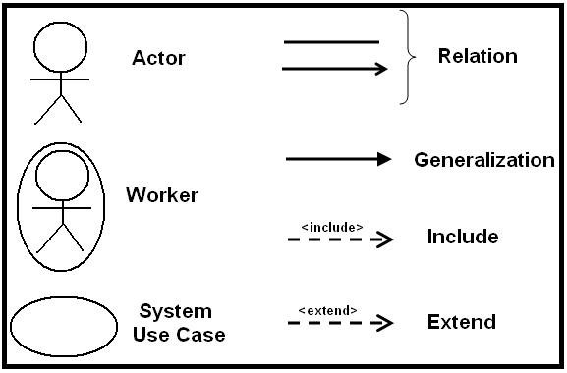

Figure 3.1 Use case Symbol

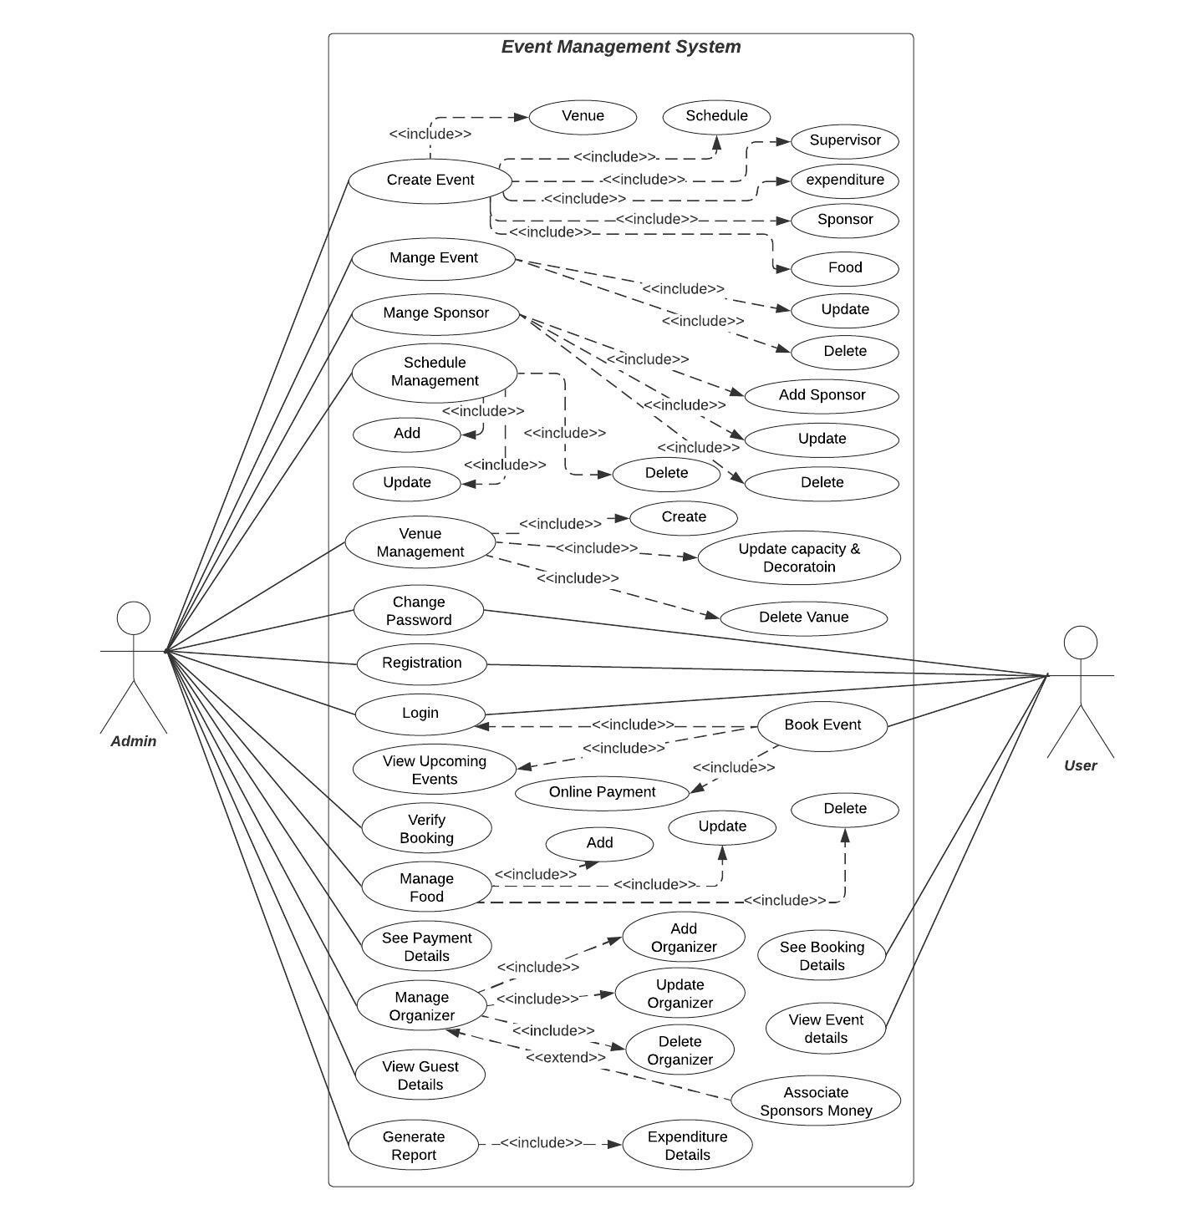

Use Case Diagram

Figure 3.2 Use-case diagram
3.3.3 Use case text
The use case diagram is used for the project 'Development of Online Event Management System' to depict the many sorts of roles in a system and how those roles interact with the system. This system is basically a meeting place for event organizers, sponsors, and customers.
- Login: If they are registered, administrators and customers can log in to the system.
- Event Management: Customer can see Event Types and Schedule. Admin can manage (Add, Update, Delete) event categories. Admin has executor(Add, Update, Delete) event information. Customer can book any event. Customer can see food packages and organizer details on each event description.
- Search Event and Organizer info Management: Admin will associate an event with an organizer. Customer will get a supervisor for every event. Customer can search events and see supervisor details for this particular event.
- Venue Capacity and type issue: Admin can manage (Add, Update, Delete) Venue capacity and type. Customer can see venue capacity and type for all the upcoming events. Organizers can see venue capacity and type for all the upcoming events.
- Schedule Management: Admin can add schedule for events. Admin can update schedule for events. Customer can see schedule for upcoming events.
- Payment Management: Admin can see expenditure provided by the system. Customer can pay for booking an event. Sponsors give payment for event.
- Report Generation: Report will be generated based on, how many events are booked there in particular and how much money invested by sponsor and collected form events.

Chapter IV. System Planning

The section on planning process demonstrates the function of the project 'Event management system.' The chapter also includes function point estimation, effort allocation, and a program scheduling table.

4.1 Scope of Project

The project's goal is to please our consumers. The system is simple to use for non-technical users.

4.1.1 Some more scopes are
- A browser application must be available from any location using an internet explorer.
- A browser application must be available from any location using an internet explorer.
- There are no license or renewal costs.

4.2 System Project Planning
Before beginning any project, it is necessary to estimate the work to be done, the resources that will be needed, the time that will pass from start to finish, and to examine the project to decide whether or not it is possible. Software project management begins with a series of actions known as software project planning. I estimate the work to be done, the resources that will be needed, the time it will take from start to completion, and ultimately I examine the project to determine whether it is viable or not.
The following activities of software project planning that have followed in this project are
- System project Estimation
- Function Point Estimation
- Based Estimation
- Effort Distribution
- Task scheduling project
- Schedule chart cost
- Estimation
System Project Estimation
The precision of a software project estimate is determined by a variety of factors.
- The size of the product to be built was correctly approximated.
- The extent to which the project plan represents the development team's or engineer's capability.
- The business criteria' consistency and the environment that supports the software engineering effort.
The most crucial aspect of the software system that I must address is software capacity assessment. If the program size is not value is obtained, it will result in a variety of issues including such scheduling issues, budget issues, and so on. As the project progresses, I must validate that the program scope is limited before estimating the software size. The most crucial aspect of the software project that I must address is software size estimation. If the program size is not properly calculated, it will result in a variety of issues such as scheduling issues, budget issues, and so on. Before estimating the software size, I need to guarantee that the application range is limited as the project progresses.

4.3 Complexity matrix
Table 4.1 Complexity Matrix 1
FTR’s | Data Elements
 | 1-4 DETs | 5-15 DETs | 16 or more DETs
0-1 FTR | Low | Low | Average
2 FTRs | Low | Average | High
3 or more FTRs | Average | High | High
Table 4.2 Complexity Matrix 2
EO/EQ | 1-5 DETs | 6-19 DETs | 20 or more DETs
1 FTR | Low | Low | Average
2 to 3 FTRs | Low | Average | High
4 or more FTR’s | Average | High | High
Table 4.3 Complexity Matrix 3
ILF/ELF | 1-19 DETs | 20-50 DETs | 50+ DETs
1 RET | Low | Low | Average
2 to 3 RETs | Low | Average | High
6 or more RETs | Average | High | High
Complexity Matrix for UFP
For function point Estimation, estimation techniques - FP counting process)

Table 4.4 Functional complexity (Transaction Function)
Functional Complexity (Transaction) | Transaction Function Type
 | EI | EO/EQ
L (Low) | 3 | 4
A (Average) | 4 | 5
H (High) | 6 | 7
Table 4.5 Functional complexity (Data Function)
Functional Complexity (Data) | Data Function Type
 | ILF | ELF
L (Low) | 7 | 5
A (Average) | 10 | 7
H (High) | 13 | 10

4.4 Identifying complexity

4.4.1 Identifying Complexity of transition function
Table 4.6 Identifying complexity of transition function
Transition  Function | Field/ File Name Involved | FTR | DET
Create Users Account (EI) | Name, Email, Password, Address, Phone, Role, Image Create button  File Name: Users | 1 | 8
Logging in (3*EI) | Email, Password, Log in Button  File Name: Users | 1 | 3
Customer can view their Profile (EQ) | Name, Email, Password, Address, Phone, Role, Image, View Button, Back to Dashboard Button  File Name: Customer | 1 | 9
Customer can Update their Profile (EI) | Name, Email, Password, Address, Phone, Role, Image, View Button, Back to Dashboard Button, Update Button, Back to Home Button  File Name: Customer | 1 | 11
Customer Can View Upcoming Events (EQ) | Event Categories, Event name, Event Description, Venue Type, Venue Capacity, Organizer Name, Schedule, Amount, Event Photo, Food Details, Sponsor Name, Supervisor Phone Number, Apply Button, Back Button  File Name: Customer, Event type, Event, Organizer, Venue | 5 | 14
Customer can View Event Types (EQ) | Event Categories, Event names, View Button  File Name: Event, Customer | 2 | 3
Customer can Book Event (EI) | Booking info, Event Categories, Event name, Event Description, Venue Type, Venue Capacity, Organizer Name, Schedule, Amount, Event Photo, Food Details, Sponsor Name, Supervisor Phone Number, Book Button, Back Button  File Name: Customer, Event, Booking, Venue | 4 | 15
Customer can Update Booking info (EI) | Booking info, Event Categories, Event name, Event Description, Venue Type, Venue Capacity, Organizer Name, Schedule, Amount, Event Photo, Food Details, Sponsor Name, Supervisor Phone Number, Book Button, Back Button  File Name: Customer, Event, Booking, Venue | 4 | 15
Customer can Remove Booking (EI) | Booking info, Event Categories, Event name, Event Description, Venue Type, Venue Capacity, Organizer Name, Schedule, Amount, Event Photo, Food Details, Sponsor Name, Supervisor Phone Number, Book Button, Back Button  File Name: Customer, Event, Booking, Venue | 4 | 15
Admin can Add Event Category (EI) | Event Category, Name, Save Button, Back to Dashboard Button  File Name: Event Type | 1 | 4
Admin can Delete Event Category (EI) | Event Category, Name, Delete Button, Back to Dashboard Button  File Name: Event Type, Admin | 2 | 4
Admin can Update Event Category (EI) | Event Category, Name, Save Button, Back to Dashboard Button  File Name: Event Type | 1 | 4
Admin can Add Food (EI) | Food Name, Description, Image, Price, Save Button, Back to Dashboard Button  File Name: Food | 1 | 6
Admin can Delete Food (EI) | Food Name, Description, Image, Price, Save Button, Back to Dashboard Button  File Name: Food, Admin | 2 | 6
Admin can Update Food (EI) | Food Name, Description, Image, Price, Save Button, Back to Dashboard Button  File Name: Food | 1 | 6
Admin can Add Venue (EI) | Venue Name, Description, Image, Capacity, Type, Save Button, Back to Dashboard Button  File Name: Venue | 1 | 7
Admin can Delete Venue (EI) | Venue Name, Description, Image, Capacity, Type, Save Button, Back to Dashboard Button  File Name: Venue, Admin | 2 | 7
Admin can Update Venue (EI) | Venue Name, Description, Image, Capacity, Type, Save Button, Back to Dashboard Button  File Name: Venue | 1 | 7
Admin can Add Sponsor (EI) | Sponsor Name, Description, Logo, Address, Phone, Email, Investment, Save Button, Back to Dashboard Button  File Name: Sponsor | 1 | 9
Admin can Delete Sponsor (EI) | Sponsor Name, Description, Logo, Address, Phone, Email, Investment, Save Button, Back to Dashboard Button  File Name: Admin, Sponsor | 2 | 9
Admin can Update Sponsor (EI) | Sponsor Name, Description, Logo, Address, Phone, Email, Investment, Save Button, Back to Dashboard Button  File Name: Sponsor | 1 | 9
Admin can Add Event (EI) | Event Name, Description, Category, Images, Venue, Sponsor, Supervisor, Schedule, Amount, Save Button, Back to Dashboard Button  File Name: Event | 1 | 11
Admin can Delete Event (EI) | Event Name, Description, Category, Images, Venue, Sponsor, Supervisor, Schedule, Amount, Save Button, Back to Dashboard Button  File Name: Event, Admin | 2 | 11
Admin can Add Organizer (EI) | Organizer Name, Description, Image, Address, Phone, Email, Save Button, Back to Dashboard Button  File Name: Organizer | 1 | 8
Admin can Delete Organizer (EI) | Organizer Name, Description, Image, Address, Phone, Email, Save Button, Back to Dashboard Button  File Name: Admin, Organizer | 2 | 8
Admin can Delete Event (EI) | Event Name, Description, Category, Images, Venue, Sponsor, Supervisor, Schedule, Amount, Save Button, Back to Dashboard Button  File Name: Event | 1 | 11
Admin can Update Organizer (EI) | Organizer Name, Description, Image, Address, Phone, Email, Save Button, Back to Dashboard Button  File Name: Organizer | 1 | 8
Admin can View Bookings (EQ) | Customer Name, Address, Phone, Email, Booking Schedule, Event Name, Amount, Venue Name, View Button, Back to Dashboard Button  File Name: Venue, Customer, Bookings | 3 | 10
Customer Can Search Events (EQ) | Event Name, Event Venue, Sponsor Name, Supervisor Name, Category, Search Button  File Name: Event, Venue | 2 | 6
Customer Can Search Events (EQ) | Event Name, Event Venue, Sponsor Name, Supervisor Name, Category, Search Button  File Name: Event, Venue | 2 | 6
Admin can Update Profile (EI) | Name, Email, Password, Address, Phone, Role, Image, View Button, Back to Dashboard Button, Update Button  File Name: Admin | 1 | 10
Admin Can Search Sponsor (EQ) | Sponsor Name, Sponsor Phone Number, Search Button  File Name: Event, Sponsor | 2 | 3
Admin can Add Supervisor for Events (EI) | Organizer Name, Email, Address, Phone, Image, Event Name, Venue, Schedule, Save Button, Back to Dashboard  File Name: Event, Organizer, Venue | 3 | 10
Generate Report (EO) | Investment, Bookings, View Button, Back to Dashboard  File Name: Investment, Bookings | 2 | 4

4.4.2 Identifying Complexity (Data Function)
Table 4.7 Identifying Complexity (Data Function)
Data Function | Field/ File Name Involved | RET | DET
Users (ILF) | ID, Name, Email, Password, Address, Phone, Role, Registration Date, Active Status | 1 | 9
Event (ILF) | ID, Name, Description, Sponsor, Image, Venue, Supervisor, Price, Food, Schedule | 6 | 10
Venue (ILF) | ID, Name, Venue Type, Capacity, Address | 2 | 5
Organizer (ILF) | ID, Organizer Name, Phone, Address, Email, Amount Details, Gender | 2 | 7
Sponsor (ILF) | ID, Name, Address, Logo, Email, Phone, Investment Amount | 2 | 7
Booking (ILF) | ID, Booking Time, no of guest, Booking Details, Status, Customer ID, Event ID | 3 | 7
Food (ILF) | ID, Price, Description, Name, Image | 2 | 5
Admin (ILF) | ID, Name, Email, Password, Address, Phone, Role, Registration Date | 1 | 8

4.4.3 Unadjusted function point contribution (Transition Function)
Table 4. 8 Unadjusted Function Point Contribution (Transition Function)
Transition  Function | FTR | DET | Complexity | UFP
Create Users Account (EI) | 1 | 8 | Low | 3
Logging in (3*EI) | 1 | 3 | 3*Low | 9
Customer can view their Profile (EQ) | 1 | 9 | Low | 3
Customer can Update their Profile (EI) | 1 | 11 | Low | 3
Customer Can View Upcoming Events (EQ) | 5 | 14 | High | 6
Customer can View Event Types (EQ) | 2 | 3 | Low | 3
Customer can Book Event (EI) | 4 | 15 | High | 6
Customer can Update Booking info (EI) | 4 | 15 | High | 6
Customer can Remove Booking (EI) | 4 | 15 | High | 6
Admin can Add Event Category (EI) | 1 | 4 | Low | 3
Admin can Delete Event Category (EI) | 2 | 4 | Low | 3
Admin can Update Event Category (EI) | 1 | 4 | Low | 3
Admin can Add Food (EI) | 1 | 6 | Low | 3
Admin can Delete Food (EI) | 2 | 6 | Average | 4
Admin can Update Food (EI) | 1 | 6 | Low | 3
Admin can Add Venue (EI) | 1 | 7 | Low | 3
Admin can Delete Venue (EI) | 2 | 7 | Average | 4
Admin can Update Venue (EI) | 1 | 7 | Low | 3
Admin can Add Sponsor (EI) | 1 | 9 | Low | 3
Admin can Delete Sponsor (EI) | 2 | 9 | Average | 4
Admin can Update Sponsor (EI) | 1 | 9 | Low | 3
Admin can Add Event (EI) | 1 | 11 | Low | 3
Admin can Delete Event (EI) | 2 | 11 | Average | 4
Admin can Add Organizer (EI) | 1 | 8 | Low | 3
Admin can Delete Organizer (EI) | 2 | 8 | Average | 4
Admin can Delete Event (EI) | 1 | 11 | Low | 3
Admin can Update Organizer (EI) | 1 | 8 | Low | 3
Admin can View Bookings (EQ) | 3 | 10 | Average | 4
Admin Can Search Events (EQ) | 2 | 6 | Average | 4
Customer Can Search Events (EQ) | 2 | 6 | Average | 4
Admin can Update Profile (EI) | 1 | 10 | Low | 3
Admin Can Search Sponsor (EQ) | 2 | 3 | Low | 3
Admin can Add Supervisor for Events (EI) | 3 | 10 | High | 6
Generate Report (EO) | 2 | 4 | Low | 4
Total: 123

4.4.5 Unadjusted Function Point Contribution (Data Function)
Table 4. 9 Unadjusted Function Point Contribution (Data Function)
Data Function | RET | DET | Complexity | UFP
Users (ILF) | 1 | 9 | Low | 7
Event (ILF) | 6 | 10 | Average | 10
Venue (ILF) | 2 | 5 | Low | 7
Organizer(ILF) | 2 | 7 | Low | 7
Sponsor (ILF) | 2 | 7 | Low | 7
Booking (ILF) | 3 | 7 | Low | 7
Food (ILF) | 2 | 5 | Low | 7
Admin (ILF) | 1 | 8 | Low | 7
Total: 59

4.4.6 Performance and Environment Impact
Table 4.10 Performance and Environment Impact
GSC | DI
1. Data Communications | 4
2. Distributed Data Processing | 0
3. Performance | 4
4. Heavily Used Configuration | 2
5. Transaction Rate | 0
6. Online Data Entry | 3
7. End-user Efficiency | 3
8. Online Update | 0
9. Complex Processing | 2
10. Reusability | 4
11. Installation Ease | 3
12. Operational Ease | 2
13. Multiple Site | 0
14. Facilitate Change | 3
Total Degree of Influence (TDI), ΣFi = | 30

4.4.7 Counting Adjusted Function point
Value Adjustment Factor (VAF) = (0.65+ (0.01 x TDI)) = (0.65 + (0.01x30)) = 0.95

Counting Adjusted Function Point:
UFP = UFP (Data function) + UFP (Transaction Function)
= 59+123 = 182
Adjusted Function Point Count = UFP x VAF
= 182 x 0.95 = 172.9

Our Productivity for PHP = 15.5
Effort for PHP = 172.9 x 15.5
= 2679.95 person hours / 8hours [8 hours of working per day (8 hours at Office)]
= 334.99375 Person Days
= Approximately, 335 Person Days.
= 335/24 Person Month
= 13.9583 Person Month
= 13.96 /4 Person Months
= 3.49 Months for 4 persons.

4.4.8 Process Based Estimation
The process is divided into a comparatively small collection of actions in process-based estimation, and the work necessary to complete each job is estimated. Delineating software functions based on project scope is the first step in process-based estimate. For each component, a sequence of application process operations must be carried out.
Table 4.11 Process-Based Estimation
Activity | CC | Planning | Engineering |  | Construction |  | Imp. | Total
Function |  |  | Analysis | Design | Code | Test
F1 | 0.16 | 0.16 | 0.15 | 0.2 | 0.35 | 0.15 | 0.05 | 1.075
F2 | 1.05 | 1.05 | 1.15 | 1.25 | 1.75 | 0.25 | 0.07 | 5.695
F3 | 1.01 | 1.01 | 1.15 | 1.2 | 2.75 | 2.25 | 0.1 | 8.585
F4 | 0.545 | 0.545 | 0.35 | 0.55 | 0.45 | 0.35 | 0.5 | 2.77
F5 | 0.01 | 0.01 | 0.075 | 0.025 | 0.15 | 0.05 | 0.03 | 0.382
F6 | 0.2 | 0.2 | 0.15 | 0.25 | 0.25 | 0.15 | 0.3 | 1.307
F7 | 0.237 | 0.337 | 0.33 | 0.37 | 0.52 | 0.31 | 0.08 | 1.892
F8 | 0.225 | 0.225 | 0.35 | 0.3 | 0.375 | 0.35 | 0.045 | 1.699
F9 | 0.25 | 0.25 | 0.2 | 0.35 | 0.59 | 0.31 | 0.59 | 2.361
F10 | 0.22 | 0.22 | 0.37 | 0.53 | 1.33 | 0.97 | 0.4 | 3.869
F11 | 0.175 | 0.175 | 0.2 | 0.463 | 0.740 | 0.260 | 0.125 | 1.971
F12 | 0.25 | 0.25 | 0.325 | 0.75 | 1.275 | 0.275 | 0.4 | 3.288
F13 | 0.257 | 0.357 | 2.74 | 0.55 | 0.8 | 0.02 | 0.005 | 4.437
F14 | 0.215 | 0.215 | 0.25 | 0.275 | 0.355 | 0.3 | 0.04 | 1.457
F15 | 0.02 | 0.02 | 0.3 | 0.25 | 0.55 | 0.13 | 0.05 | 1.325
Total | 6.169 | 6.169 | 9.485 | 10.05 | 17.28 | 8.08 | 4.81 | 56.677
user | 10% | 12% | 17% | 18% | 21% | 14% |  | 100%

4.4.9 Effort Distribution

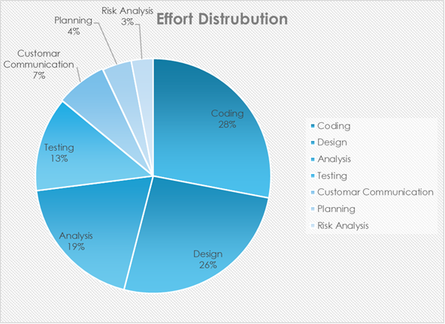
The software project estimation method results in an estimation method of both the production units required to complete the software development in this project; 28% of full software development has been allocated to Coding/Implementation, 23% to 19% analysis, 26% design, and the remaining 13% to software testing and support.

Figure 4.1 Effort distribution estimation

4.4.7 Time Schedule
Total system development is a collection of tasks. These duties should be completed in a timely and systematic manner. The project timeline serves as the system developer's guidance. This project's timetable is shown in the chart below.
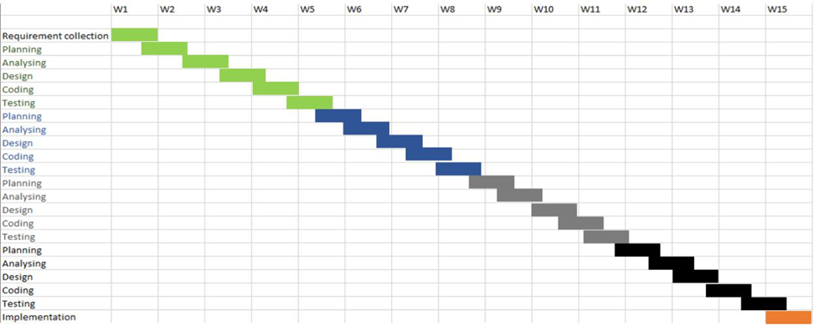

Figure 4.2 Time Schedule

4.4.8 Cost Estimation
Personnel Cost
Number of days in a year = 365
Number of government holidays in a year =25 [Excluding Friday]
Number of weekly holidays in a year = 104 [Friday and Saturday only]
Total number of working days to develop the project = 365-(104+25) = 236 days
Total number of working days per month to develop the project = 236/12 =19.666 days
Organization working hours per day = 7 hours
Organization working hours per month=19.666*7 = 137.662 hours
Total working hours in 4 months = 19*7*4 = 532 hours

Table 4.13 Personal Cost Estimation
Designation | Person | Working  Hours | Salary/  Month | Salary/  Hour | Individual  Salary | Total Salary
System Analyst | One | 532 | 20000 | 145.98 | 50661.98 | 102550.20 BDT
Coder | One | 532 | 10000 | 72.99 | 38830.68
Designer | One | 532 | 9000 | 65.69 | 20947.08
Tester | One | 532 | 5000 | 36.49 | 10412.68

4.4.9 Hardware Cost
The initial step is to add the digits or numerals, beginning with life and ending with one. For example, an asset with a dash of 5 has a digit sum of 5+4+3+2+1 = 15. To get the percentage for each year, divide the year's total by the year's number. The 49 rates in the above example would be computed as follows:
Table 4.14 Hardware Service Percentage
Year | Service Percentage
1st Year | 5/15 = 0.3334 * 100% = 33.34%
2nd Year | 4/15 = 0.2667 * 100% = 26.67 %
3rd Year | 3/15 = 0.2 * 100% = 20%
4th Year | 2/15 = 0.1333 * 100 % = 13.33%
5th Year | 1/15 = 0.0667 * 100% = 6.67%

4.4.10 Software Cost Estimation
The cost of software is used in the project
Table 4.15 Software service percentage
Name | Quantity | Price per year | Price for 4  months | Total Cost
Windows 10 Professional | 1 PC | 8200 | 2066.07 | 5291.33 BDT
Microsoft office | One user | 2800 | 1100.00
Visual Studio Code | One user | 10874 | 2624.67
Google Chrome | N/A | Free | Free
MySQL Server (Xampp) | N/A | Free | Free

4.4.11 Other Cost
Table 4.16 Other Cost Table
Purpose | Amount | Total Cost
Transport | 1000 | 2900BDT
House Rent | 900
Electric Bill | 500
Other Minors | 500

4.12 Accounts Table
Table 4.17 Account Table
Cost Sector | Cost
Personal Cost | 102550.20
Hardware Cost | 20211
Software Cost | 5291.33
Other Cost | 2900
Total = | 130952.53
In Word: One Lac Thirty thousand nine hundred fifty-two takas only
All logical and functional tasks are completed here. Everything is discussed here, including the costs, functions, aims, and logics. In the following chapter, I will go through the software's risk management.

Chapter V. Risk Engineering

5.1 Risk Management
A risk is a potentially significant situation that may or may not occur. Analyzing possible hazards in a project is essential. Many difficulties might arise if the risks of a software project are not appropriately examined and estimated. Anyone creating any form of system will come across it, and it must be controlled.

5.2 Stages of Risk
Risk analysis and management are a set of processes that assist a software team in comprehending and managing unpredictability. Many issues can afflict a quality software. A risk is a prospective issue; it may or may not occur. Irrespectively of the conclusion, it's a great idea to identify it, analyze its likelihood of occurrence, estimate its effect, and develop a contingency plan should the problem materialize. Risk analysis and management are a set of processes that assist software developers in understanding and managing uncertainty. The following stages are taken in order to build a risk assessment model.

5.3 Identification
The practice of recognizing possible dangers or hazards through data collecting is known as risk identification. There are several data collecting and manipulation technologies and methodologies available. The team is collecting data and characterizing possible dangers to Web sites using both automated and human methodologies. Web crawling is one efficient method of gathering information on the status of Web pages and sites.

5.4 Classification

The process of building a structured model to categorize risk and fitting observable risk features and occurrences into the model is known as risk categorization. To identify and classify the hazards to Web pages, Web sites, and hosting servers, the team use both quantitative and qualitative methodologies.

5.5 Assessments

The process of determining relevant risk scenarios or sequences of events that potentially result in harm or loss, as well as the likelihood of these events, is known as risk assessment. Rosenthal defines a general risk assessment standard as "clear, coherent, consistent, complete, comprehensive, unbiased, consistent, fair, justifiable, durable, adaptable, and supported by adequate and effective instruction."

5.6 Analysis
The potential effect of risk patterns or scenarios, the potential extent of loss, and the direct and indirect costs of recovery are all determined through risk analysis. This stage analyzes vulnerabilities, takes into account the organization's willingness to tolerate risk given the potential repercussions, and creates mitigation strategies.

5.7 Implementation
Risk Implementing risk management policies, processes, and mechanisms describes how to manage and respond to identified hazards. The program should balance the value of assets with the direct and indirect expenses of avoiding or recovering from damage or loss. To properly care for a web-based system, we must consider the following aspects.
- Hardware and software environment, including any operating system and Web server updates, the installation of security patches, the removal of insecure services, the usage of firewalls, and so on.
- Administrative processes such as negotiating with respected service providers are examples of administrative procedures.
- Renewal of domain name registration, and so forth. Network design and upkeep, including capacity balance and traffic monitoring.
- Management and use tracking Policies and practices for restore and archives, particularly replacement media sharing.
- Interval between media replacements, number of backups produced, and storage location The user's location and its vulnerability to fire, water, earthquake, and power outage.
- Power outages, power outages, temperature variations, theft, and vandalism.

5.8 Categories of Risk
There are several types of hazards that must be addressed in each software project. The following categories of risks have been considered in this software project.
- Project risks: These dangers pose a threat to the project's schedule. If these risks materialize, it is likely that the project's timeline would be pushed back and prices will rise. Potential budgetary, scheduling, human, resource, customer, and requirement issues, as well as their influence on the software project, are identified as project risks.
- Technical risks: These risks jeopardize the quality and timeliness of the program being developed. Implementation may become difficult or impossible if a technological risk becomes a reality. Potential design, implementation, interface, verification, and maintenance issues are identified as technical risks. Furthermore, specification ambiguity, technical uncertainty, and technological obsolescence are risk issues.
- Business risks: These risks threaten the viability of the software to be built. The business risks can be market risks, building a system that no one really wants. Strategic risks, building a system that no longer fits into the overall business strategy for the company. Management risks, losing the support of senior management due to a change in focus or a change in people. Budget risks, losing budgetary or personnel commitment.
Type of Impact: Catastrophic (1), Marginal (2), Tolerable (3), Critical (4).
Type of probability: very low (<10%), low (10–25%), moderate (25–50%), high (50–75%), very high (>75%)

5.9 Project Risk
In my system, the bellow mentioned project risks I needed to manage
Table 5.1 Project Risk 1
Project risk 1
Name | Change in requirement
Probability | Low
Impact | Marginal
Description | Customer may change their requirement
Mitigation and Monitoring | Requirements are redefined by the company due to time or business needs. Meeting will be held with the company regularly. This ensures that the product we are producing solves a problem
Management | Emergency meeting between both parties to identify new project requirement and goals
Status | Not Occur

Table 5.2 Project Risk 2
Project risk 2
Name | Poor Quality of documentation
Impact | Catastrophic
Description | Documentation quality may poor
Mitigation and Monitoring | Routine Meeting will be held to offer
 | documentation suggestions and topics. The
 | progress on documentation will also have a
 | monitor in each meeting.
Management | Meeting will call and discuss about quality
 | improvement of documentation. New things
 | will assigned to responsible person.
Status | Monitoring it
Table 5.3 Technical Risk 1
Project risk 3
Name | Computer crash
Impact | Catastrophic
Description | Computer may crash due to several reason
Mitigation and Monitoring | We should take proper follow up of computers.
 | Need to use them carefully.
Management | If computer has been crashed then we will restore
 | backup.
Status | Managed it.

Chapter VI. Analysis Modeling

Analysis modeling use a combination of text and diagrammatic forms to express data, function, and behavior requirements in a way that is reasonably simple to grasp and, more importantly, simple to check for accuracy, completeness, and consistency. This section contains resources for traditional and object-oriented analysis (OOA) methodologies, as well as UML resources.

6.1 Software Analysis Pattern
Objectives of software analysis
- Analysis of Domains
- Describe the client's needs.
- Create a foundation for the development of a software design.
- Define a set of criteria that will be validated after the software is completed.

6.2 Activity Diagram
Activity diagrams are graphical representations of processes of sequential activities and actions that allow for selection, iteration, and concurrency. Activity diagrams are meant to depict both computational and organizational processes in the Uml Diagram. The total flow of control is depicted through activity diagrams.

Activity diagram for User
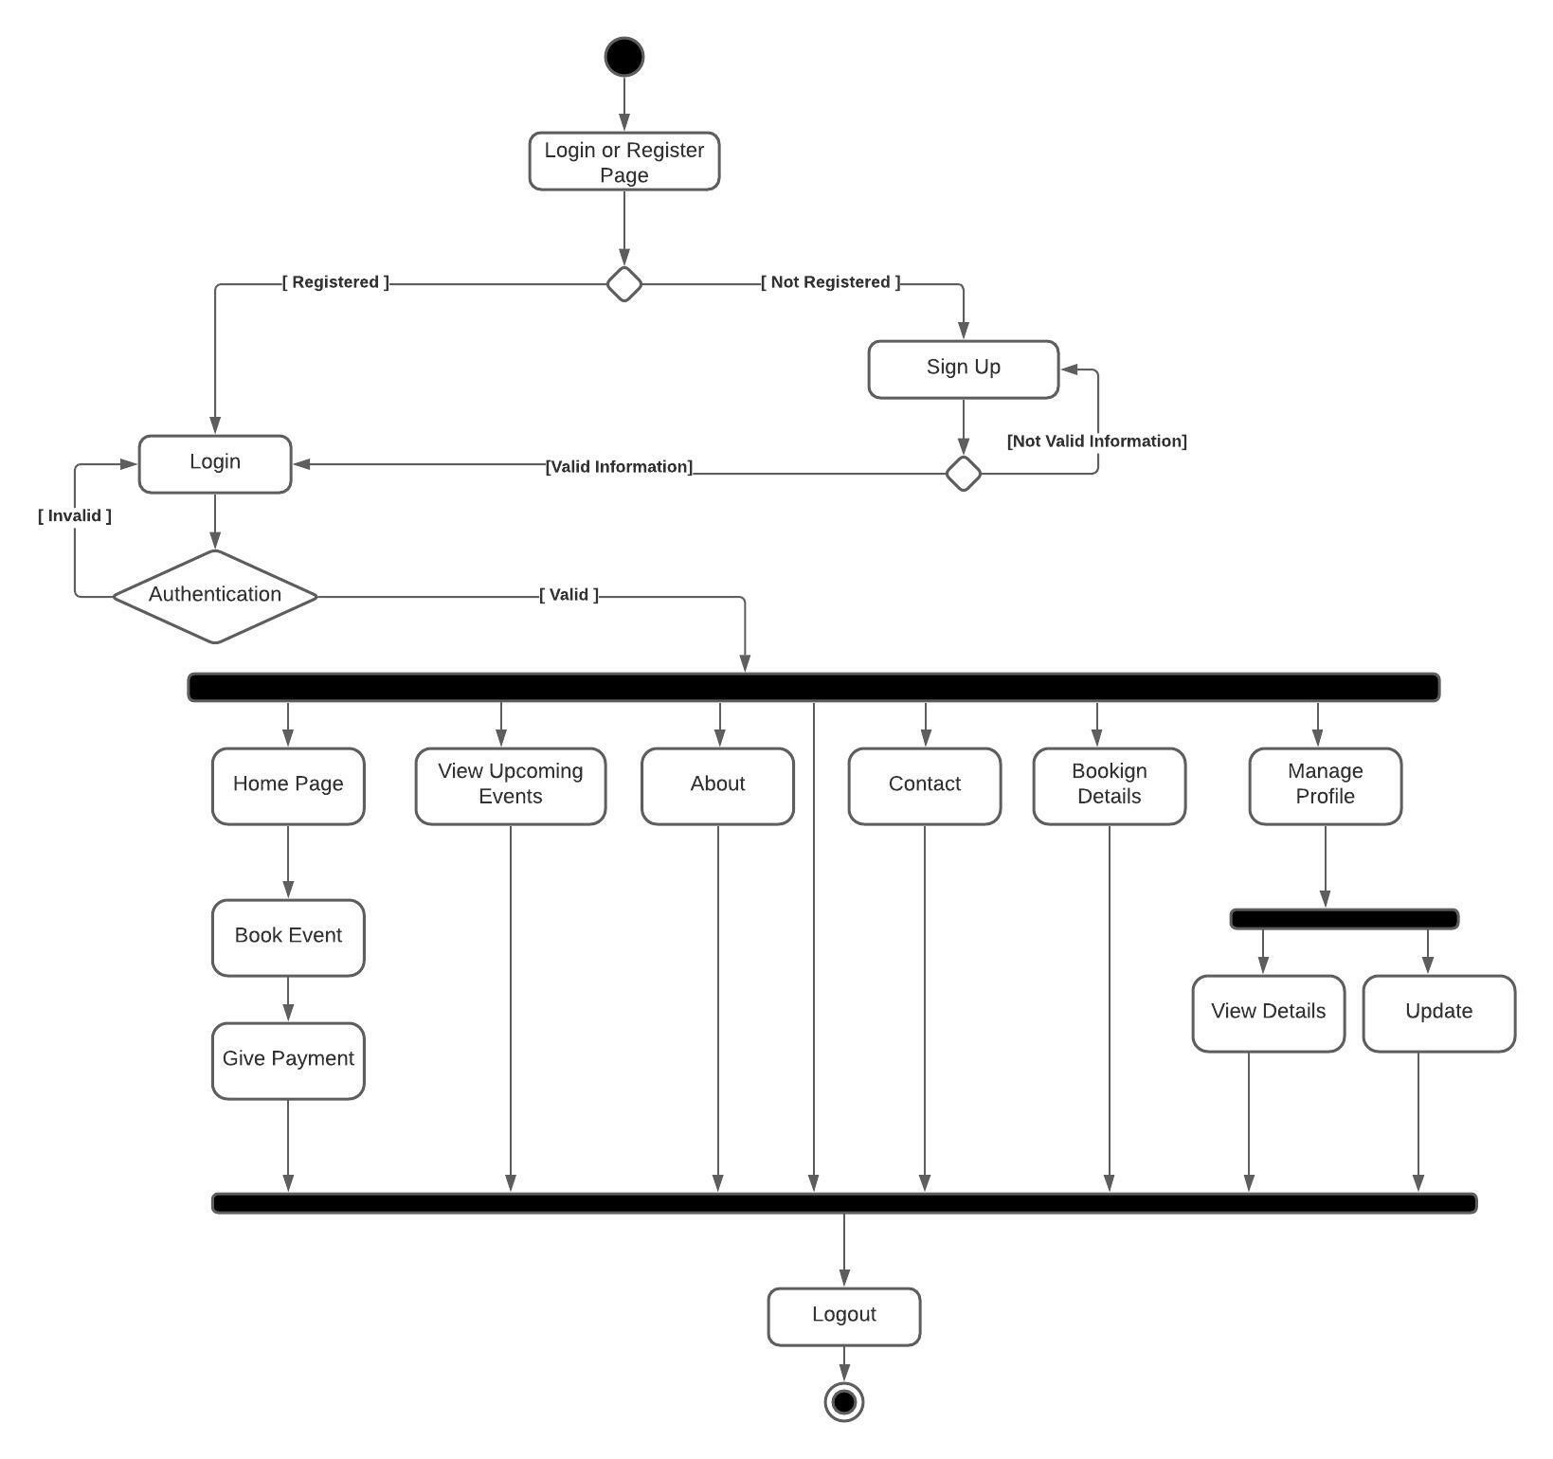

Figure 6.1 Activity diagram for user

Activity diagram for Admin
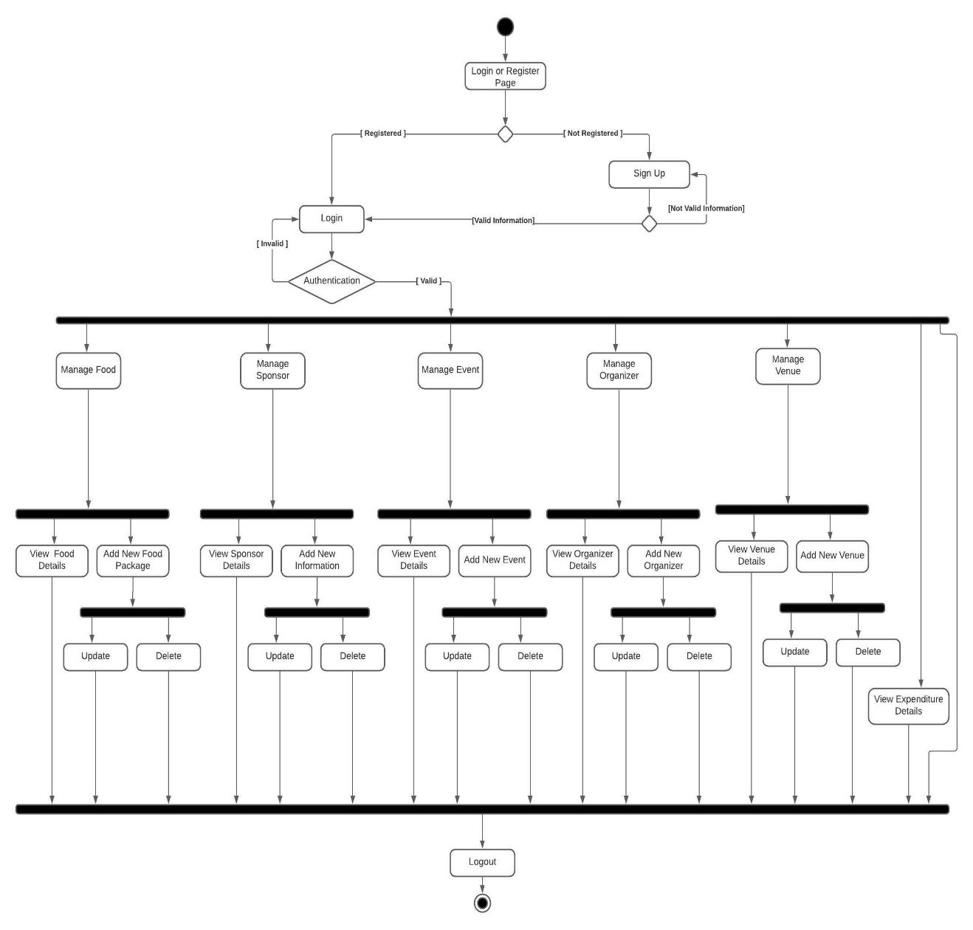

Figure 6.2 Activity Diagram for Admin

6.4 Data Flow Diagram: Context Level Diagram (0 Level) A Data Flow Diagram (DFD) is a typical visual depiction of information flows inside a system. DFD diagrams the information flow for any process or system. It shows data inputs, outputs, storage sites, and the pathways between each destination using predetermined symbols such as rectangles, circles, and arrows, as well as brief text labels. It demonstrates how data centers and exits the system, what alters the data, and where it is kept.
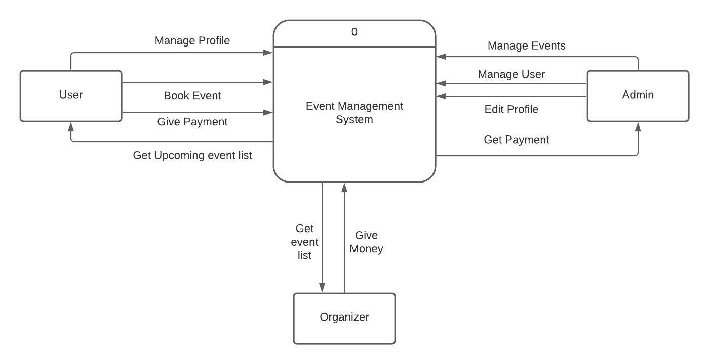

Figure 6.10 Context level diagram

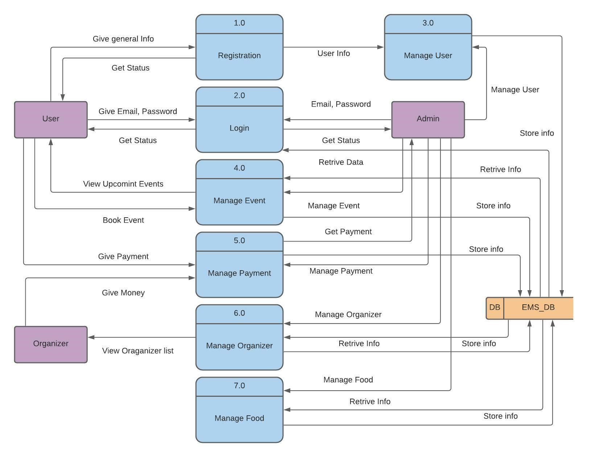

Figure 6.11 Context level diagram
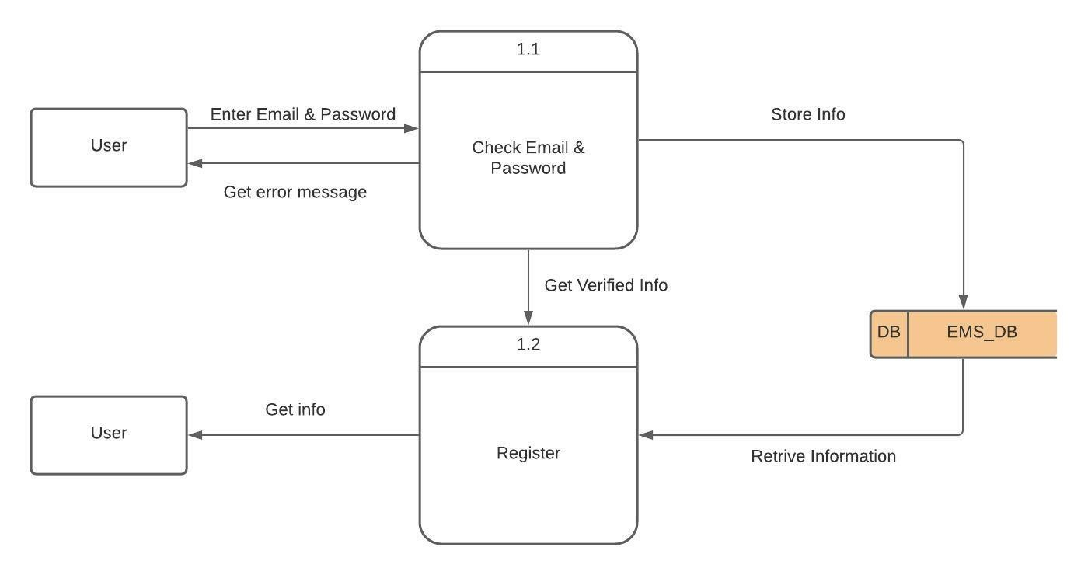
Figure 6.12 Level 2 Process 1

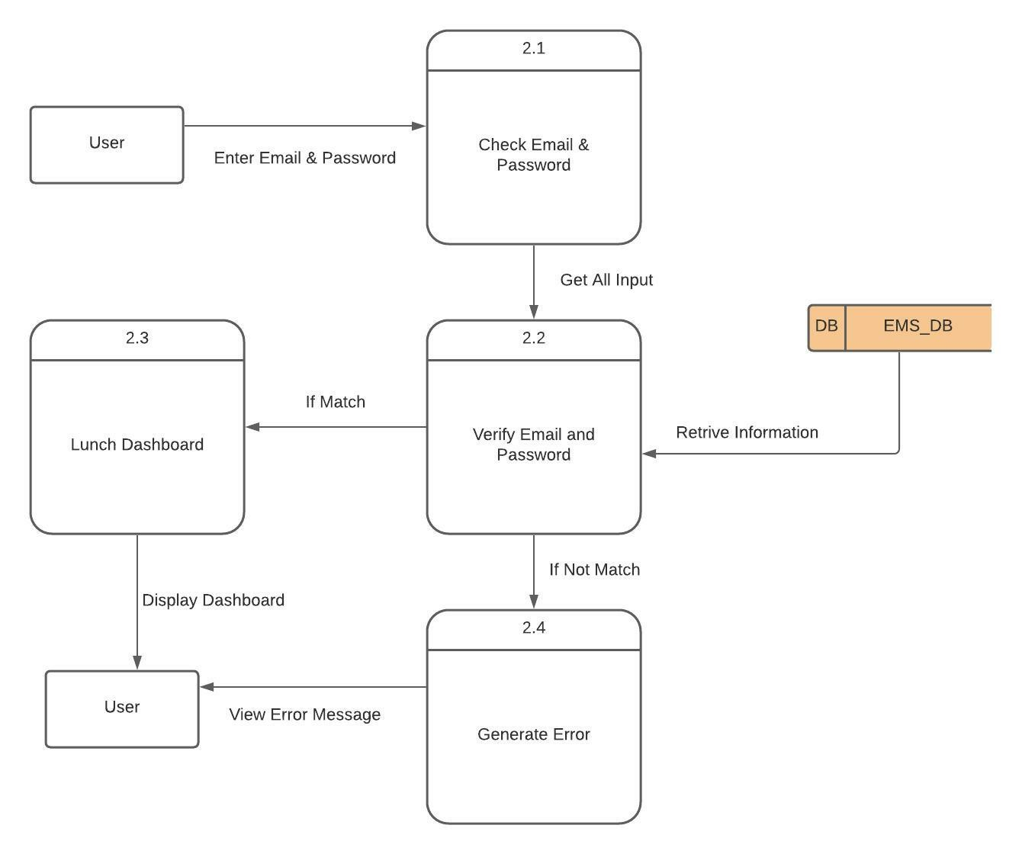

Figure 6.13 Level 2 process 2
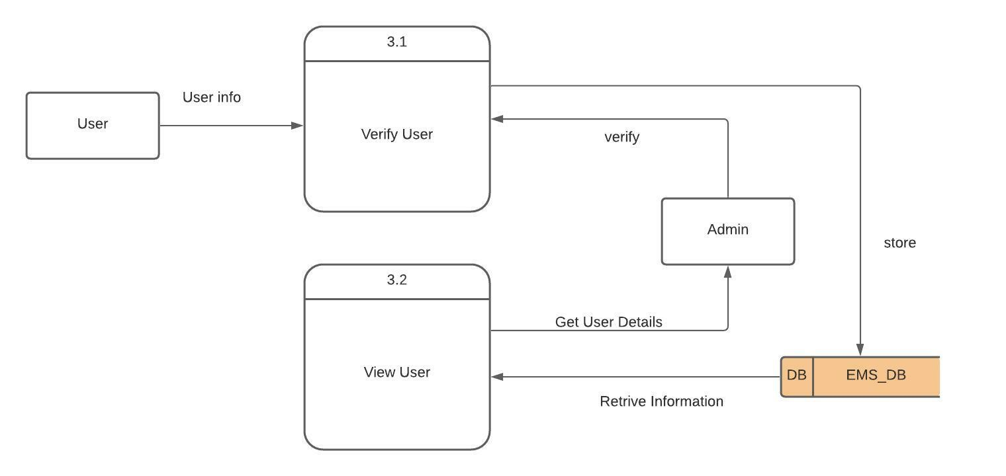

Figure 6.14 Level 2 Process 3

Figure 6.14 Level 2 Process 3
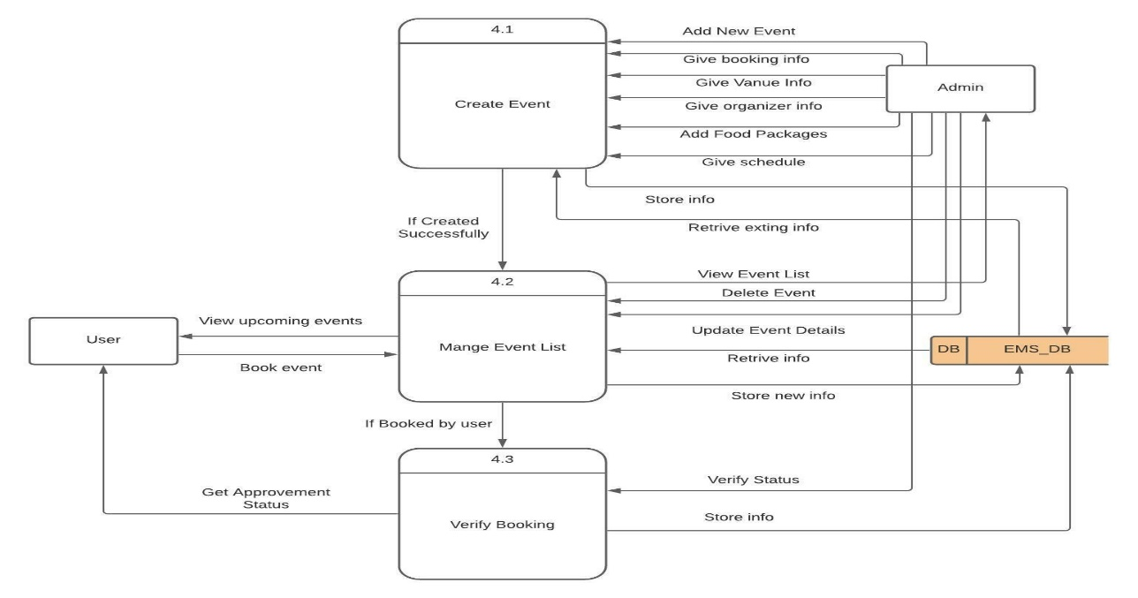
Figure 6.15 Level 2 Process

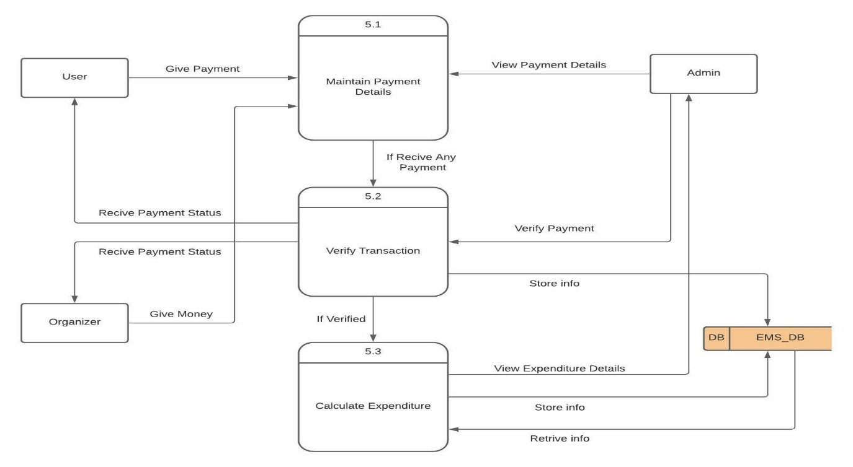

Figure 6.16 Level 2 Process 5

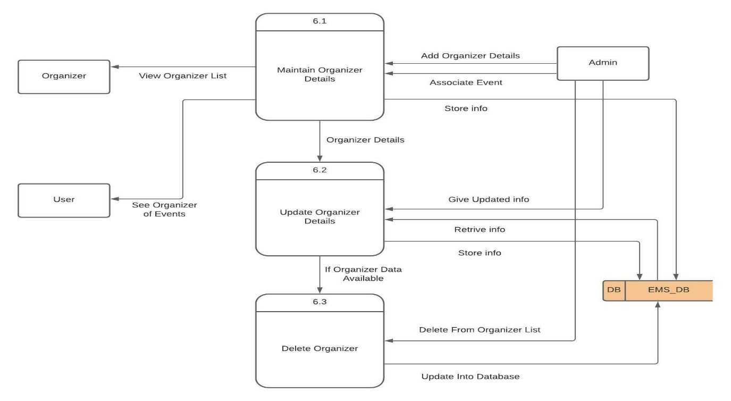

Figure 6.17 Level 2 Process 6

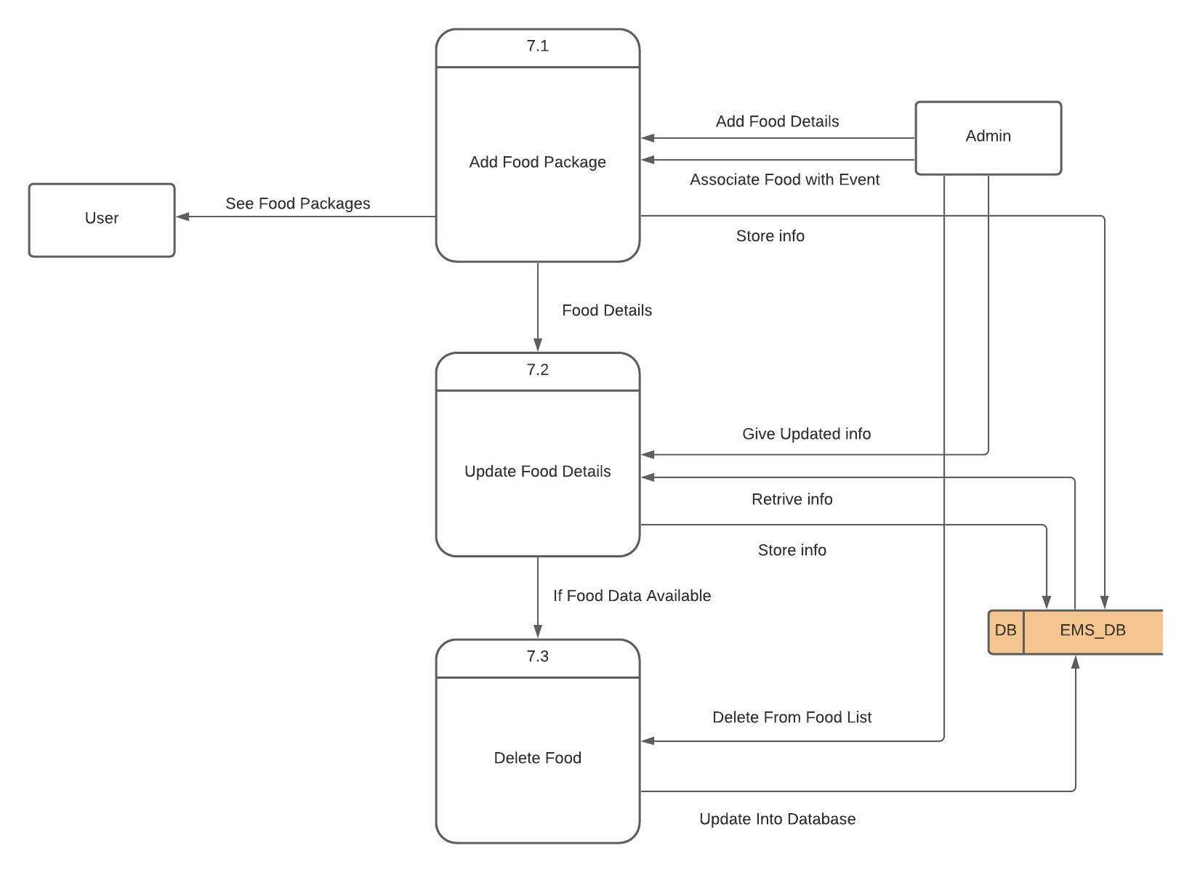
Figure 6.18 Level 2 Process 7

6.5 ERD diagram
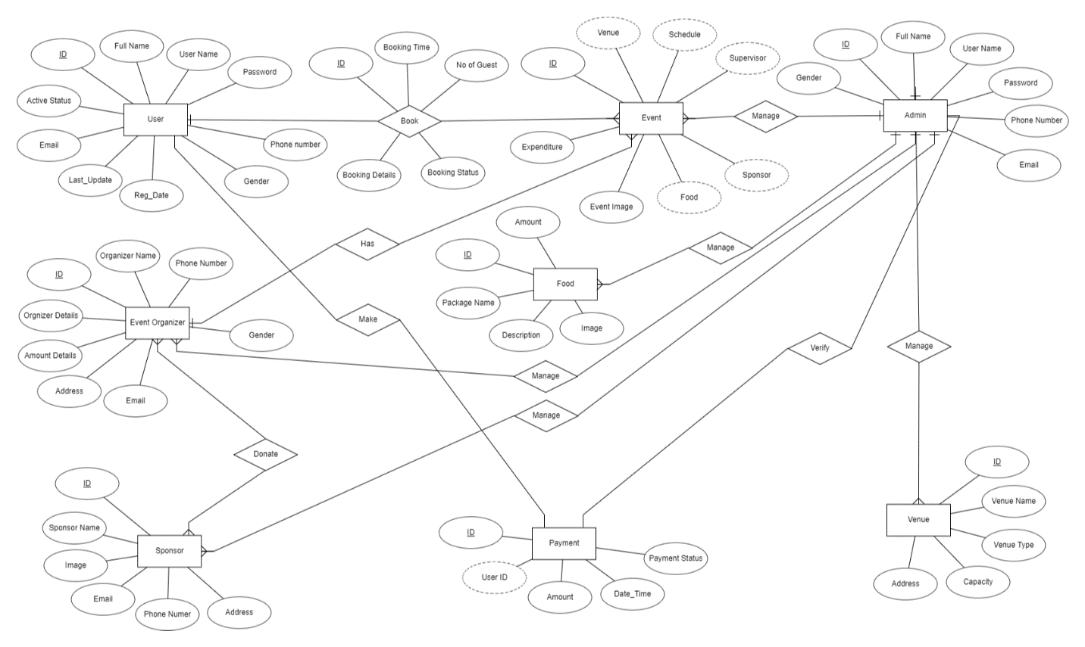
Figure 6.18 ER Diagram
Database table structure all
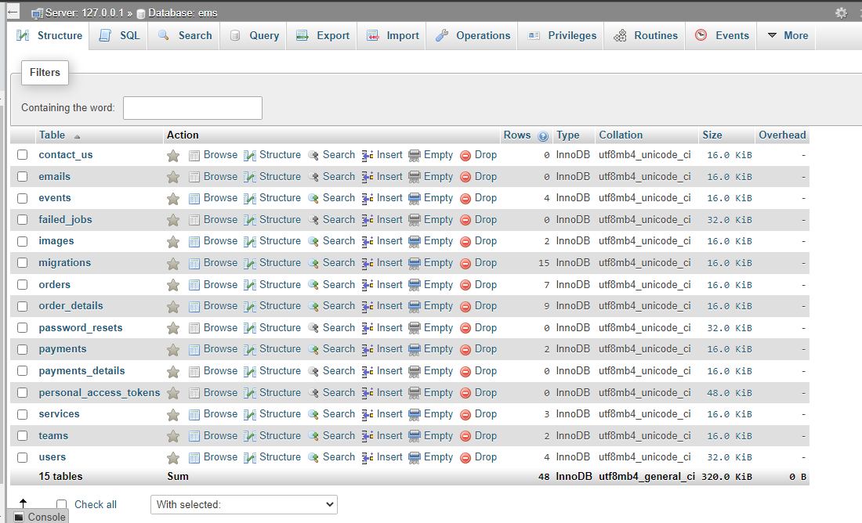

Figure 6.19 All DB Table
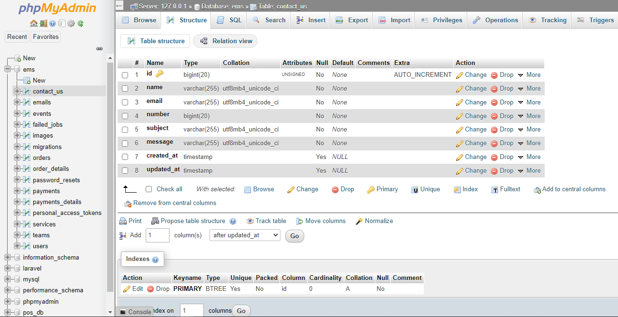

Figure 6.20 Email Table


Figure 6.21 Contact us Table
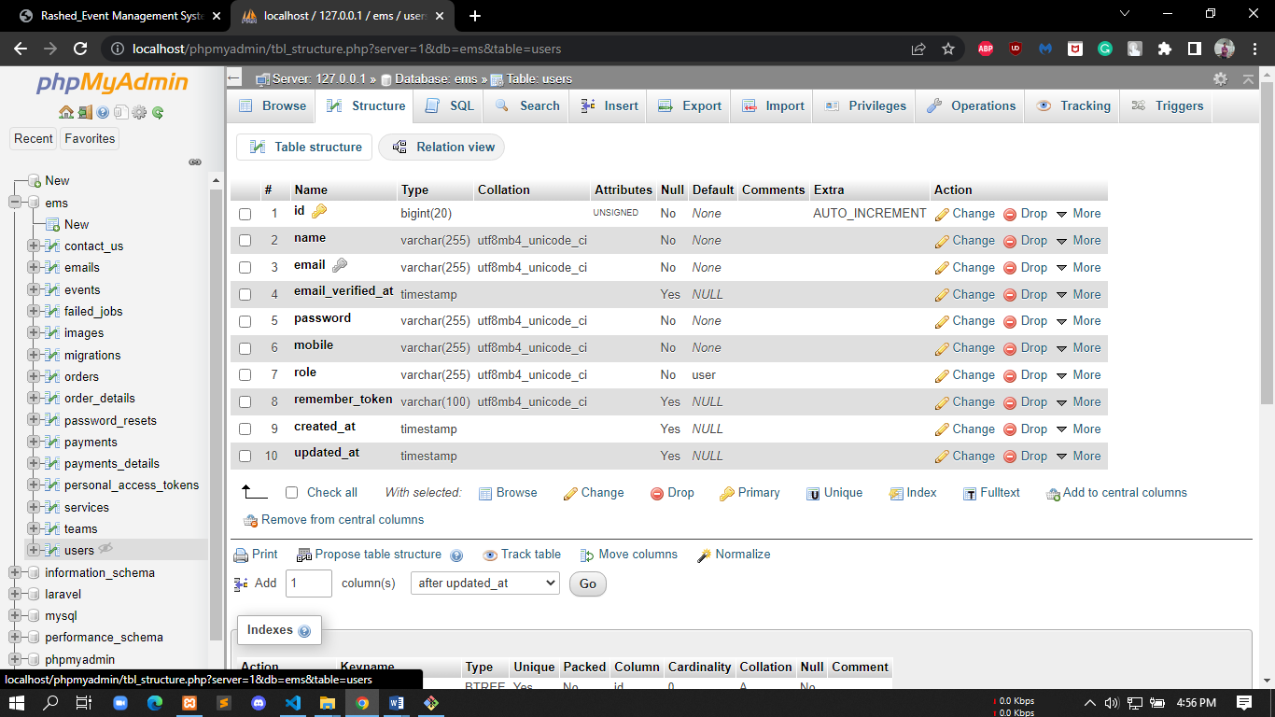

Figure 6.22 User Table
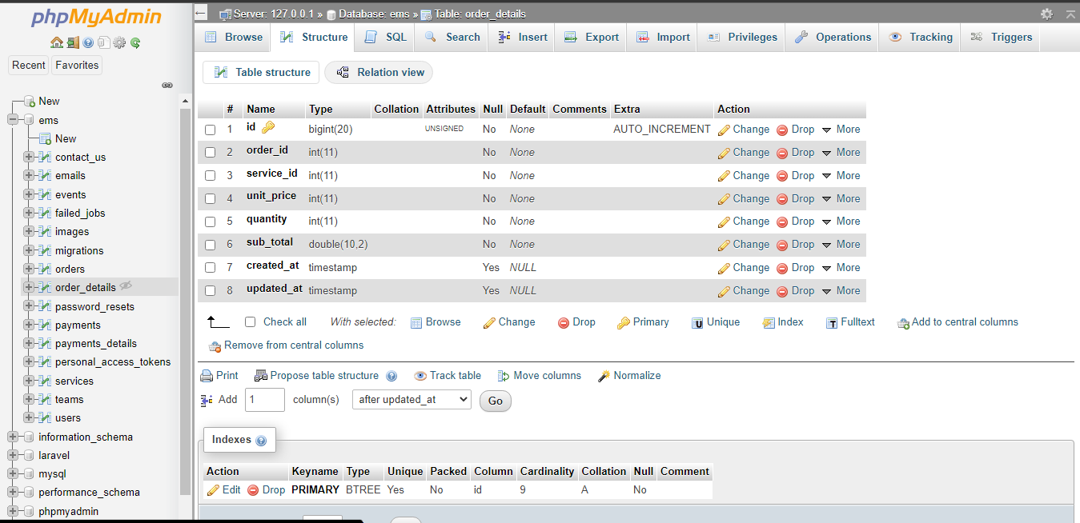

Figure 6.23 Order details Table

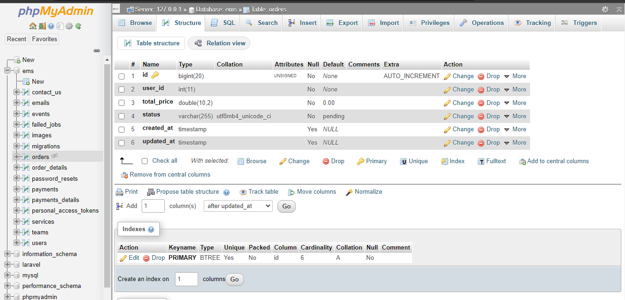

Figure 6.24 Order Table
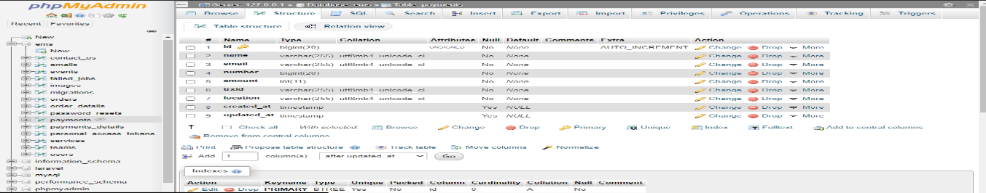

Figure 6.25 Payment Table
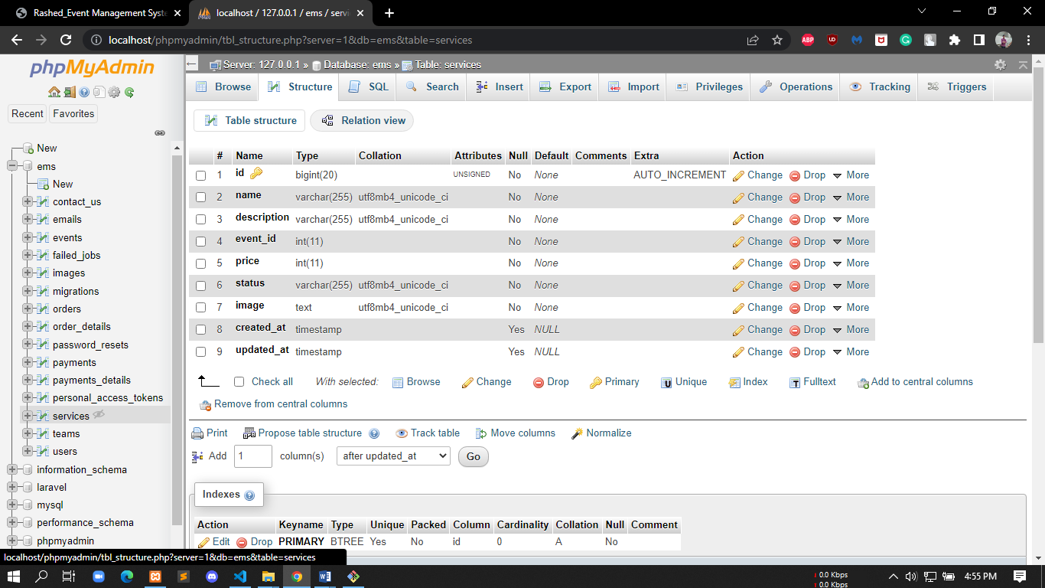

Figure 6.26 Service Table

Chapter VII. Designing

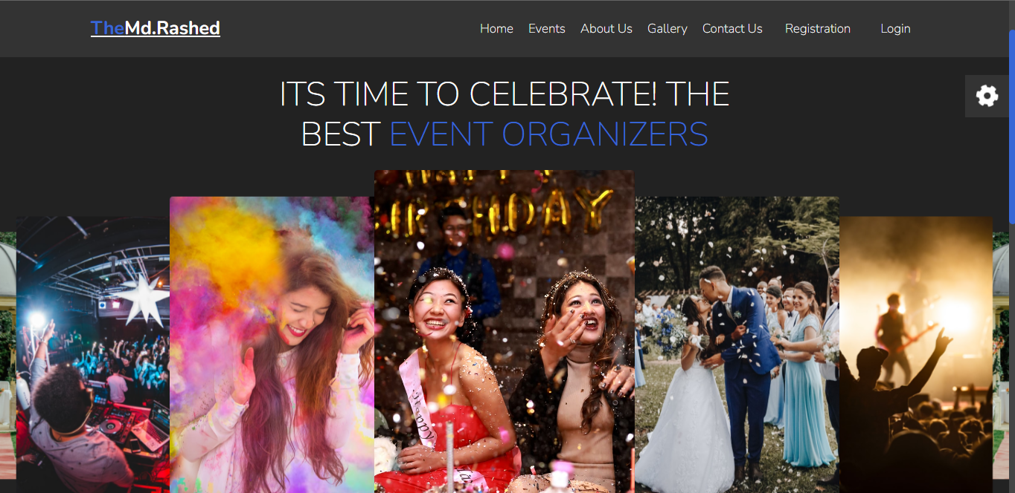

Figure 7.1 Landing page of user
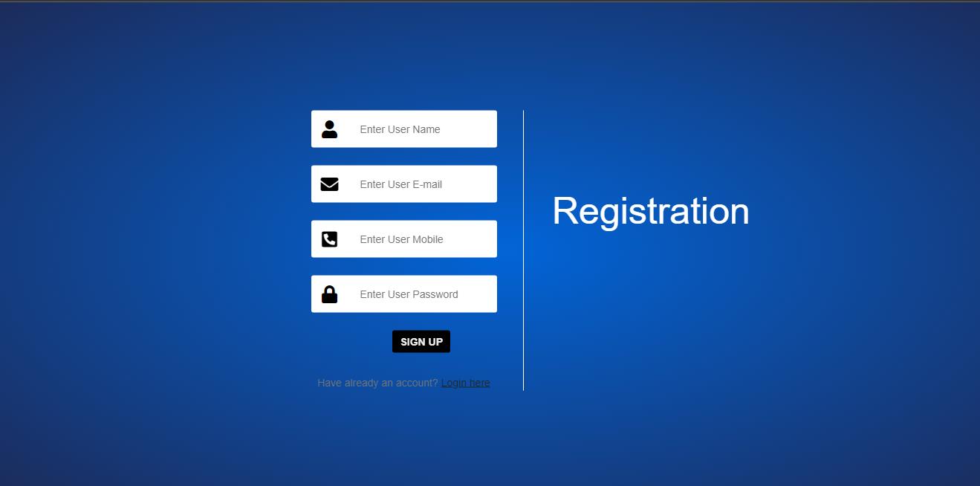

Figure 7.2 User Registration form



Figure 7.3 User login page
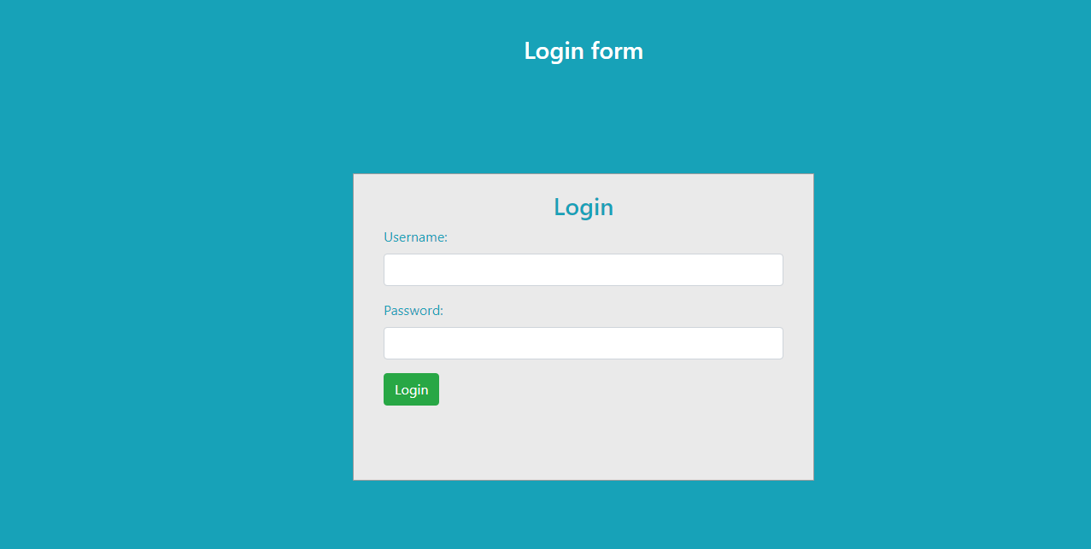

Figure 7.4 Admin log in pag

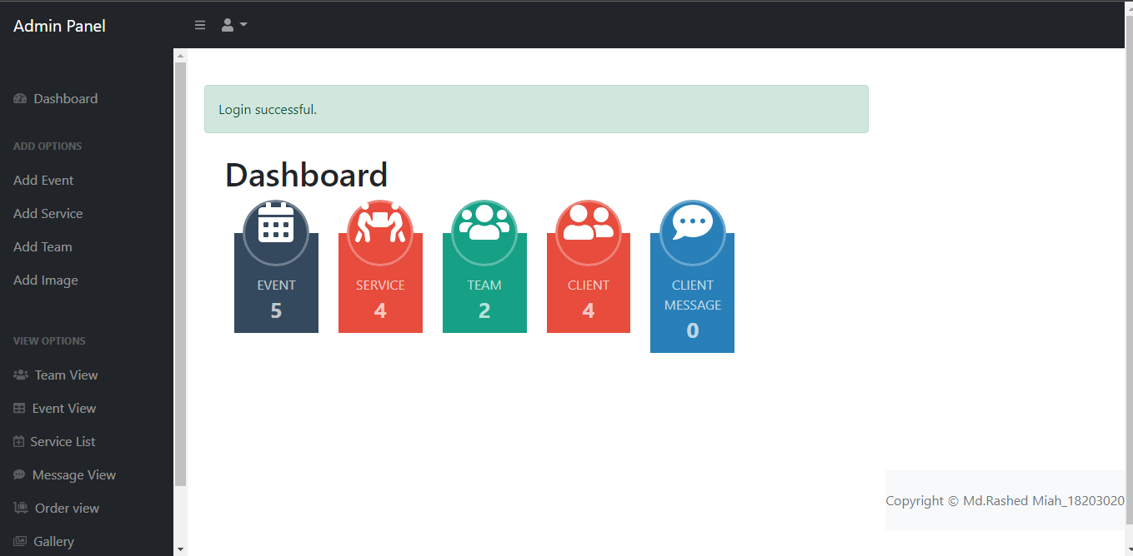

Figure 7.5 Featured of Dashboard
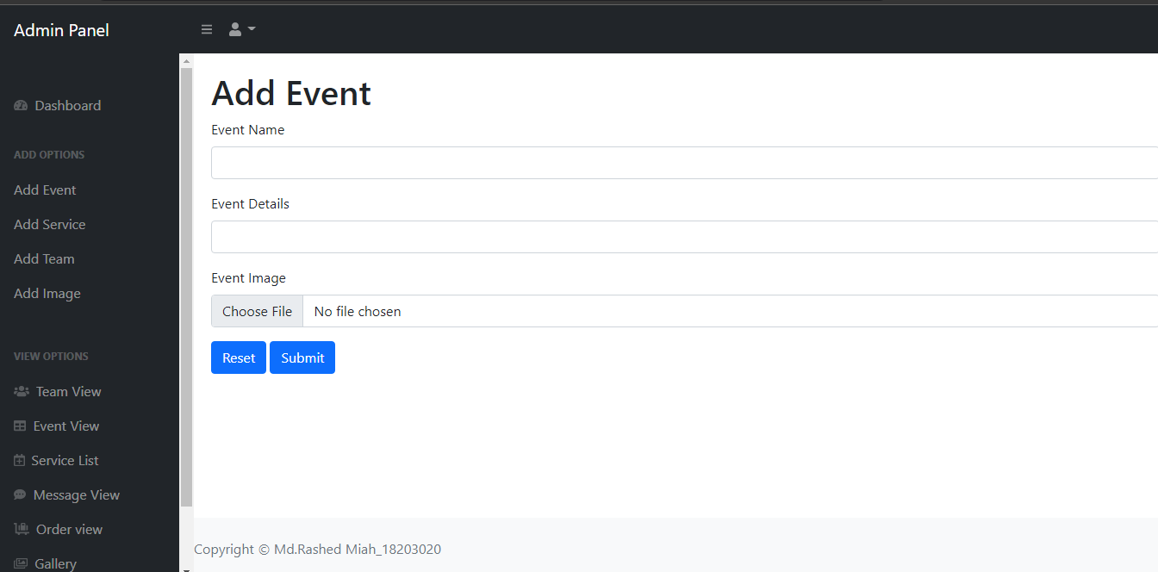

Figure 7.6 Add event form

Figure 7.6 Cause details
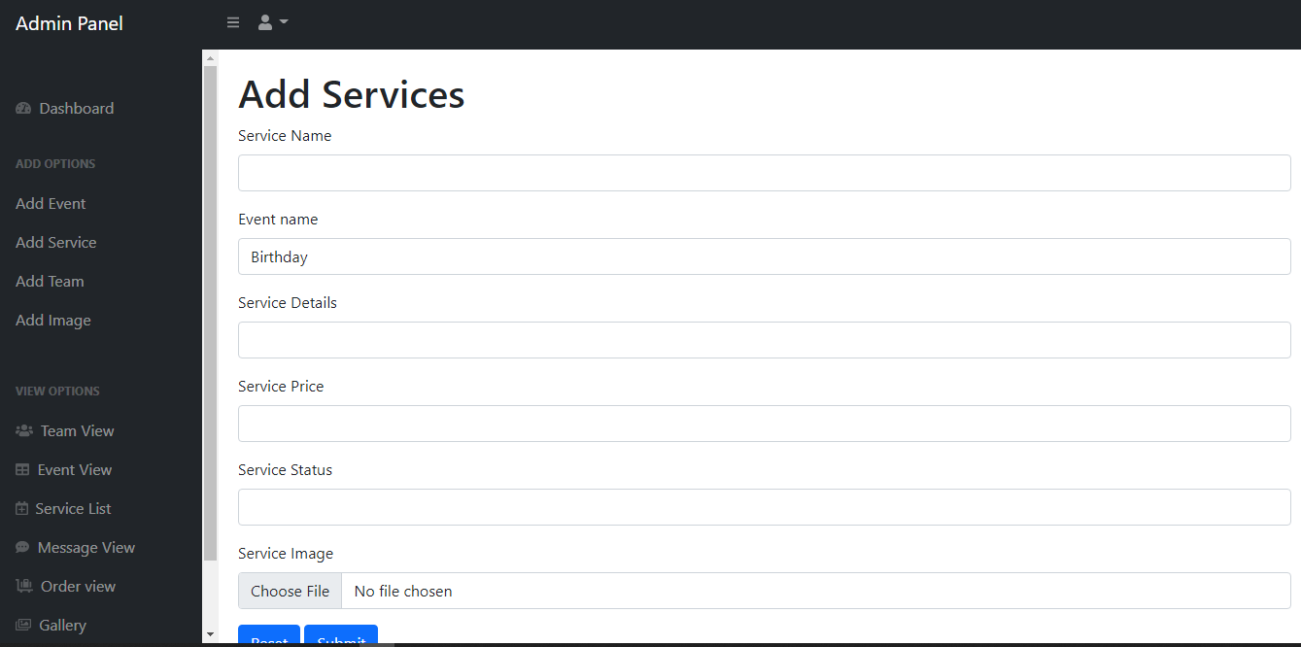

Figure 7.7 Add Service form
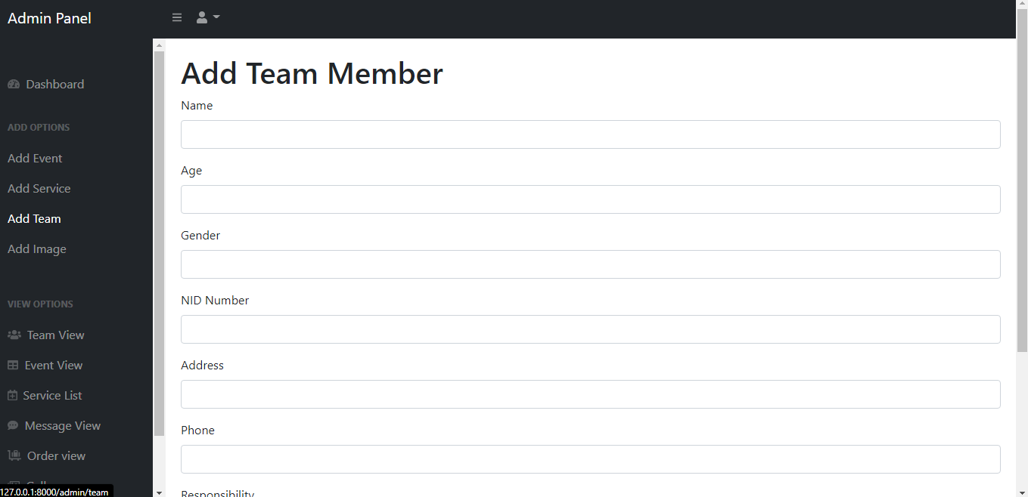

Figure 7.8 Add Team Member

Figure 7.8 Volunteers
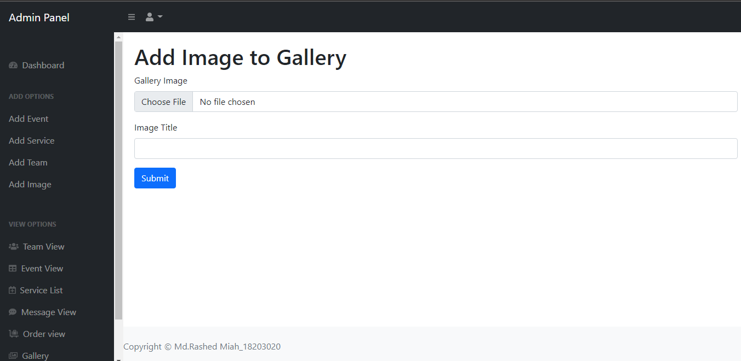

Figure 7.9 Add image gallery form

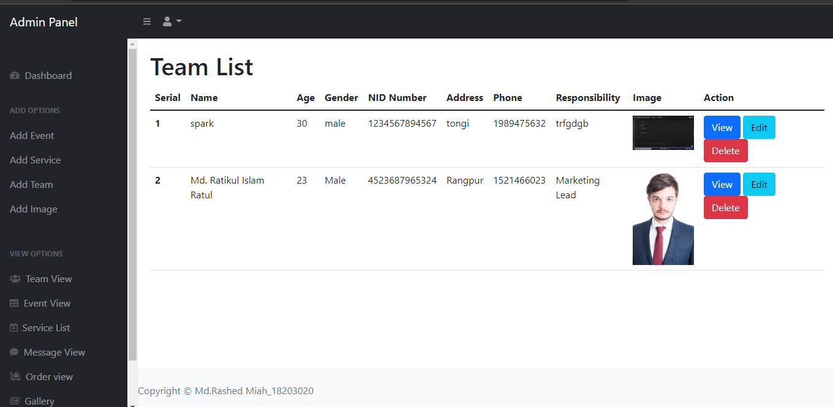

Figure 7.10 Category Team List

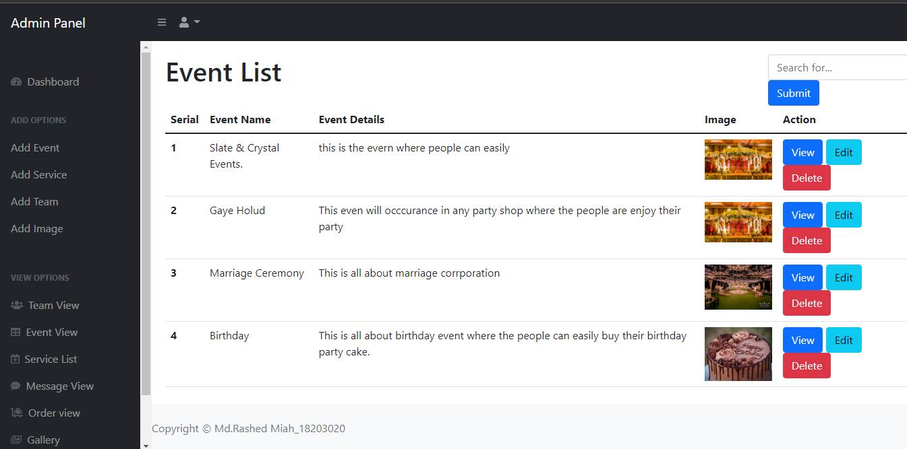

Figure 7.11 Event list
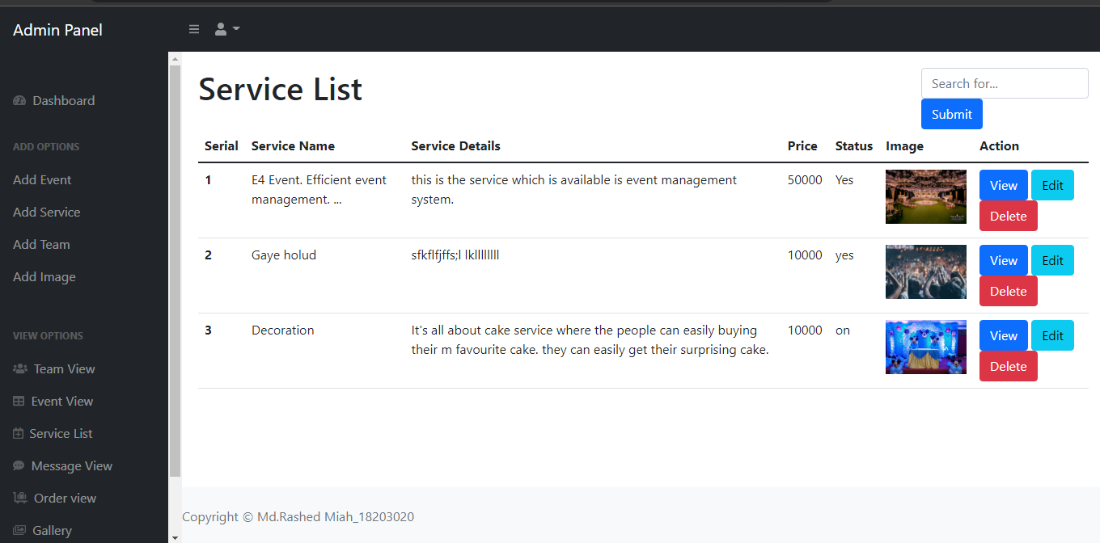

Figure 7.12 Service List

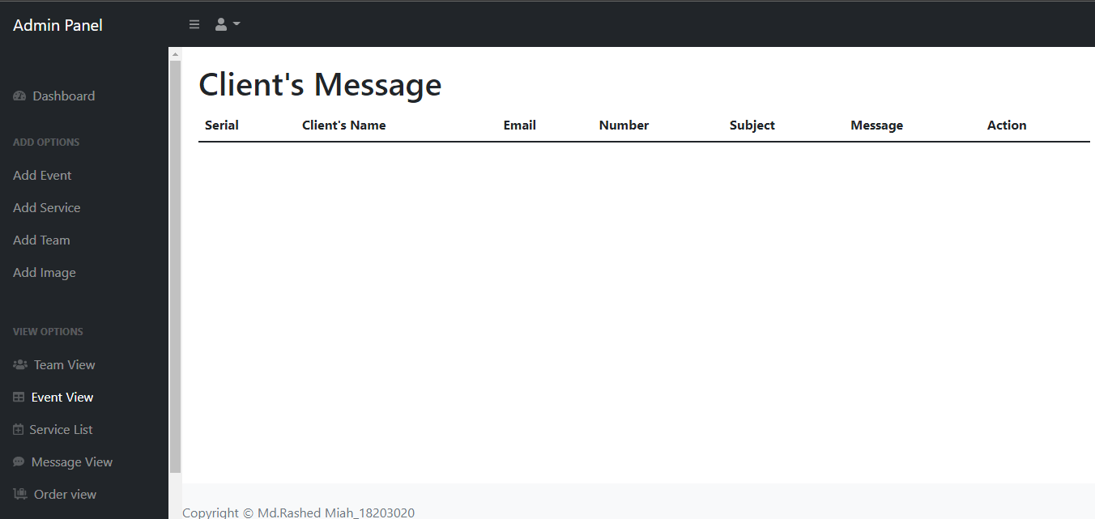

Figure 7.13 Client’s Message

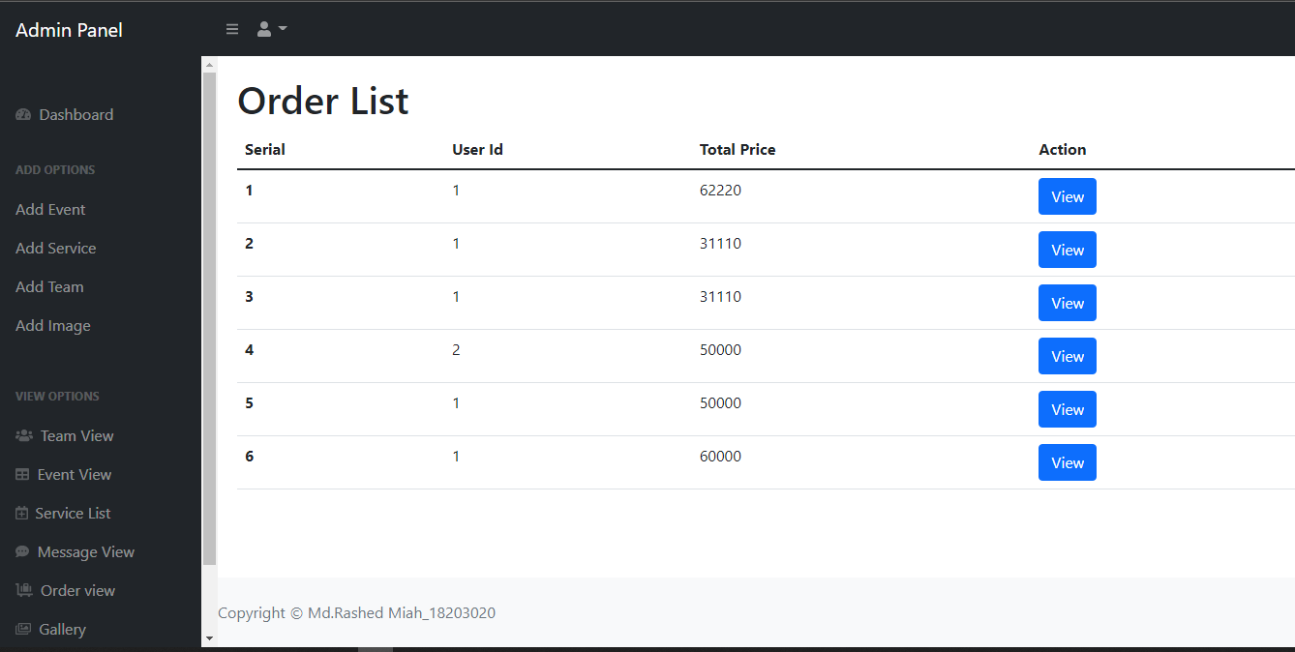

Figure 7.14 Order list
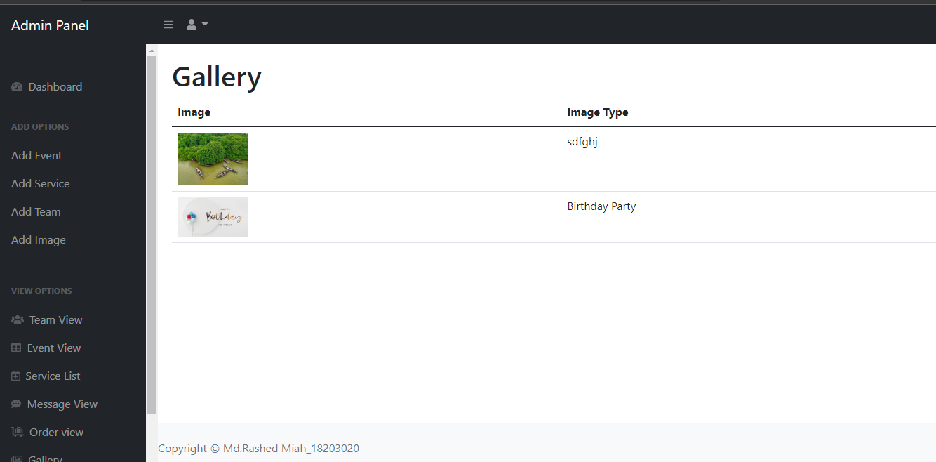

Figure 7.15 Gallery form

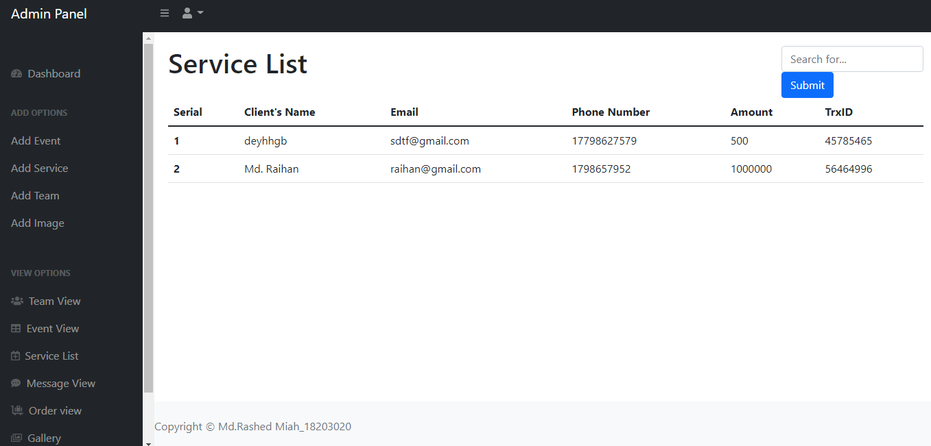

Figure 7.16 Service list
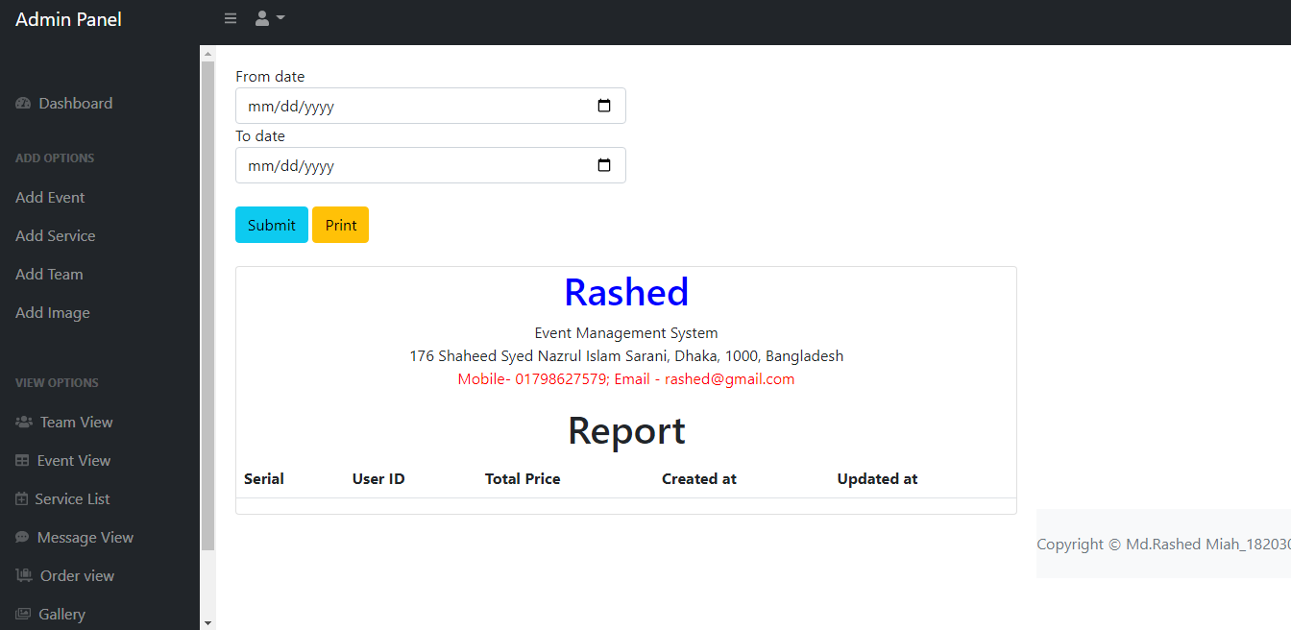

Figure 7.17 Report form

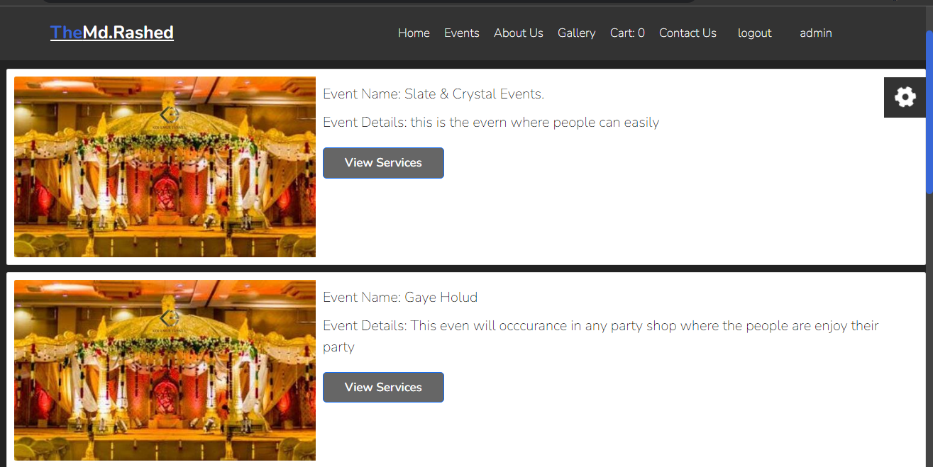
Figure 7.18 View Service List

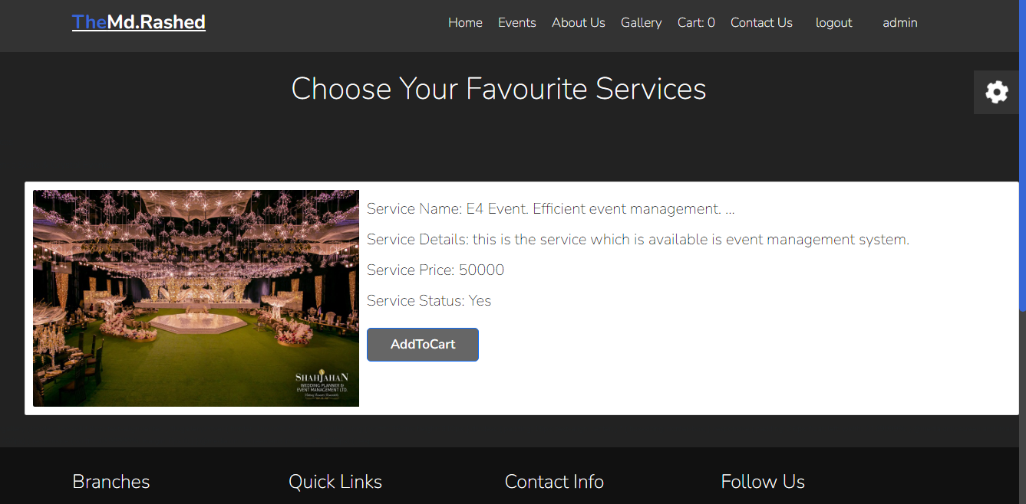
Figure 7.19 Booking service

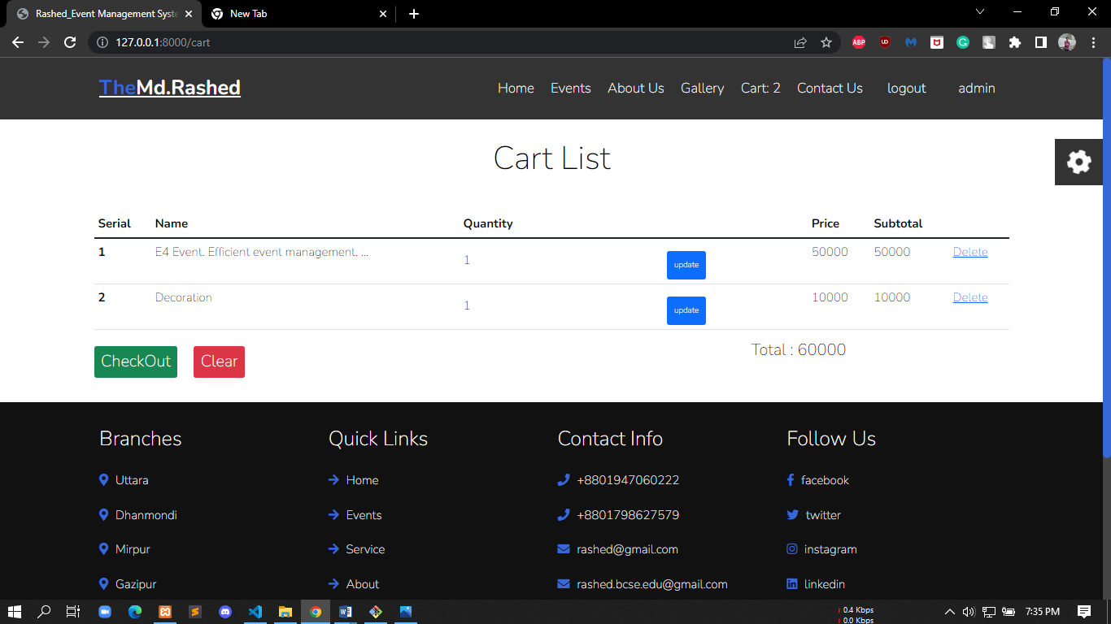
Figure 7.20 View Cart List

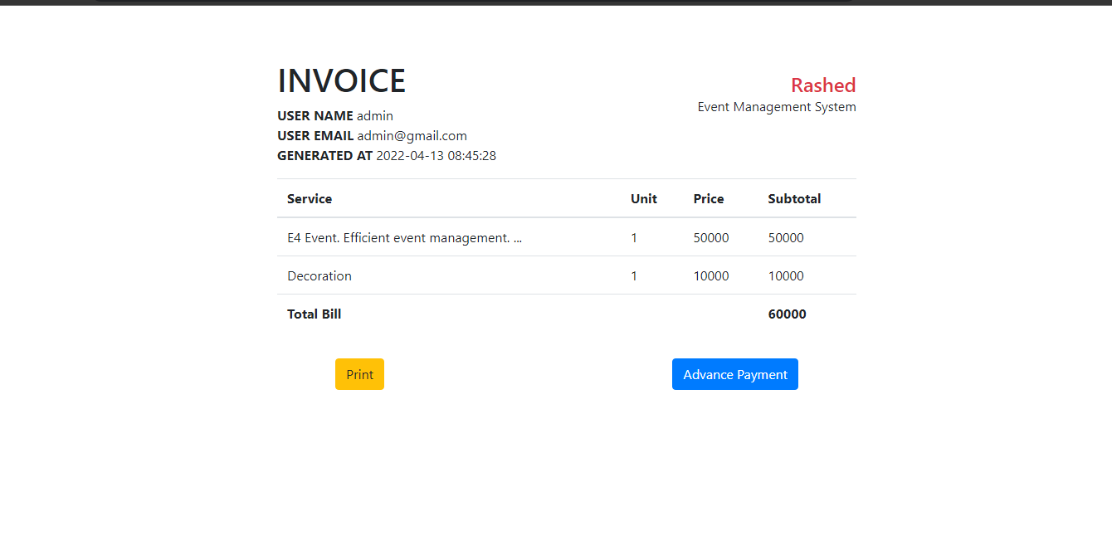
Figure 7.21 Invoice Total Bill

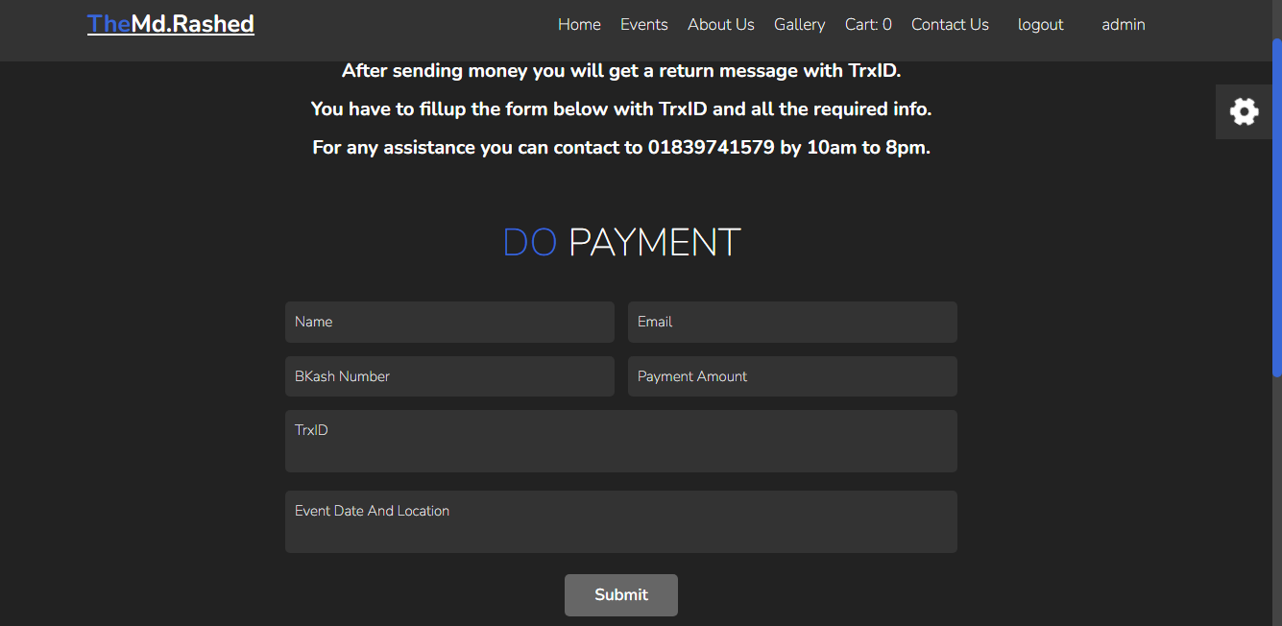
Figure 7.22 Do Payment
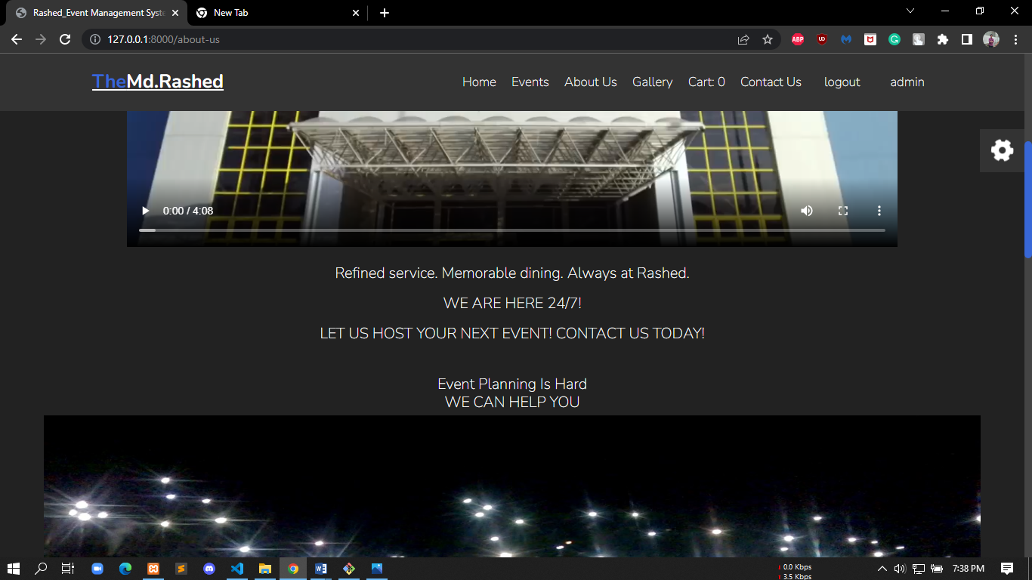
Figure 7.23 about us

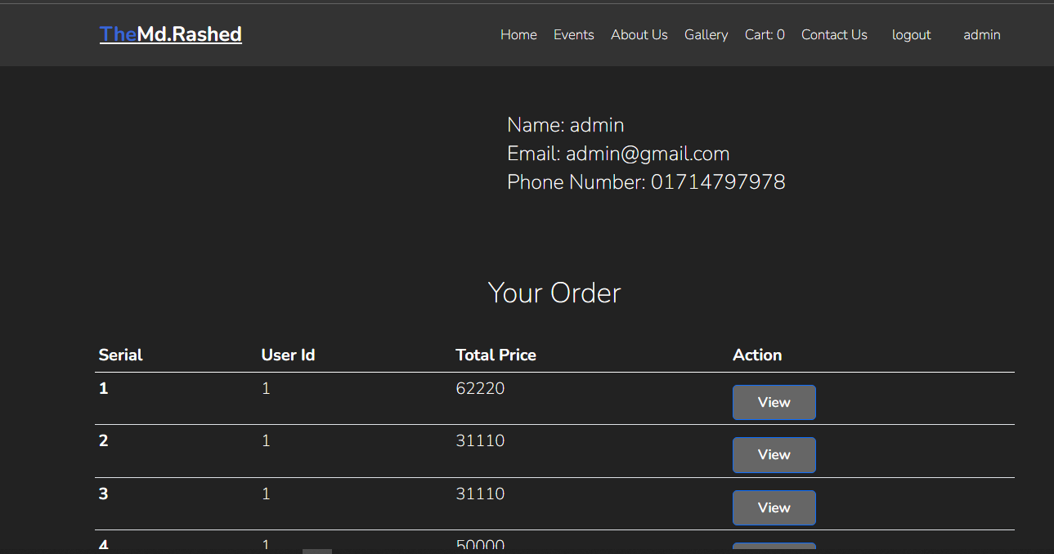

Figure 7.24 Order Price with User Id

Chapter VIII. Quality Assurance

System management Quality assurance is described in this chapter. Internal and External Quality management is also here.

8.1 System Quality Management
A software testing strategy incorporates software test case design approaches into a well-planned set of procedures that result in the effective development of software. The system offers a road map that defines the actions that must be taken as part of the testing process. Several criteria are used to evaluate the various software. External quality is what a user encounters while the software is operating. Internal quality refers to features of code that are not apparent to the end user. External quality is important to the user, but internal quality is solely important to the developer. Some quality factors are objective and can be quantified. Some quality criteria are subjective, hence they are measured in a more arbitrary manner. There are primarily two kinds of quality
External quality:
- Features
- Speed
- Space
- Network usage
- Stability
- Robustness
- Ease-of-use
- Determinism
- Security
- Power consumption
Internal quality:
- Test coverage
- Testability
- Portability
- Thread-safeness
- Conciseness
- Maintainability
- Documentation
- Legibility
- Scalability

8.1.1 Software Quality Management Process
- The goal of Software Quality Management (SQM) is to oversee the quality of software and development, as well as the development process itself.
- A product that fits its specifications and pleases the user.
- A quality culture is one in which quality is seen as everyone's duty.
Some of the SQM methods specified in the standard:
Quality Assurance Process: Quality assurance assures that the project will be finished in accordance with the previously agreed-upon specifications, standards, and functionality requirements, with no faults or potential difficulties. To ensure this, it monitors and attempts to enhance the development process from the start of the project. It is geared at prevention.
Verification and Validation Process: Verification and validation (V&V) is the process of ensuring that a software system satisfies requirements and serves its intended purpose in software project management, software testing, and software engineering. As part of the software development lifecycle, it is often the duty of software testers. A customer will either examine the program or witness it in action in a test environment. At this stage, it is critical that the customer that requires the program ensures that it meets all of the characteristics that were previously asked or wanted. Only once this assurance has been provided may the next stage of the verification and validation process be initiated. While this is not the final chance to alter the software to do the duties necessary, it is one of the previous phases before a project is completed, and being too eager to accept the software may cause difficulties later and result in more money being required for the software subsequent revisions. The following stage in software verification and validation is straightforward. The software will be approved and validated as needed by the client company. This step normally entails a thorough examination of numerous criteria. While this may appear to be time-consuming, it is an essential component of the procedure to guarantee that the end result is exactly to the requirements of all parties involved. The complete verification and validation procedure is a component of the ideal quality control sequence.

8.2 System Testing

System testing is a way of monitoring and evaluating the behavior of a fully integrated software product or system based on predetermined specifications and functional criteria. It is a response to the question.

Is the entire system operating in compliance with its pre-defined requirements? It falls under system testing, which means that only the software's exterior working features are examined during this testing. It does not require any inside knowledge of coding, programming, design, or anything else and is entirely user-centered.

8.2.1 System Testing Methodology
Only after passing through numerous rounds of software testing is a software product deemed ready. Every major and little component of the program is tested to ensure its quality and efficacy, from its internal structure and code to its fundamental features, functionality, performance, and more.
Two Category of Software Testing:
- Black Box Testing
- White Box Testing
Black Box Testing: Black-box testing, also known as behavioral testing, focuses on the software's functional requirements. It allows the software developer to generate sets of input circumstances that completely exercise all functional requirements for a program. The Human Resource Manage System modules will be tested using the black-box testing approach.
White Box Testing: White-box testing, sometimes known as glass-box testing, is a test case design approach that derives test cases from the control structure of the procedural design. A software engineer can create test scenarios utilizing white-box testing methodologies,

- Ensure that all independent pathways in a module have been tested at least once.
- All logical judgments must be carried out on both their true and false sides.
- Execute all loops inside their operational constraints and at their borders.
- Internal data structures should be tested to confirm their authenticity. White-box testing will be used for modules that involve sophisticated computations or decision-making code, such as checking the availability of a library item.

8.3 System Testing Design
Table 8.1 System Testing Scenario – 1
Scenario | My system's user login testing scenario
Input’s | Login requires the user's e-mail address and password.
Desired Output’s | When you input your e-mail and password, you will be granted access level Define.
Actual Output’s | My system works well for logging in..
Verdict | Obtaining a result from expected and actual outputs  This system has been determined to be successful for login depending on the user's role.

Table 8.2 System Testing Scenario – 2
Scenario | Admin can create cause
Input’s | Regarding information related to cause
Desired Output’s | When all required info entered correctly, new causes will be added to the system
Actual Output’s | For creating new cause system works correctly.
Verdict | Getting result from desired outputs and actual outputs  Decided this system is successful for creating new cause.

Table 8.3: System Testing Scenario – 3
Scenario | Admin can create category
Input’s | Category required information for Create
Desired Output’s | When all required info entered correctly, new category will be  added in the system
Actual Output’s | For new category Create, my system works correctly
Verdict | Getting result from desired outputs and actual outputs  decided this system is successful for new category.

System accuracy and system testing is done in this project. In next chapter I am going to conclude the project and final referencing system will also be done.

Chapter IX. Conclusion

8.1 Preface

The age of modern science and communication is critical for the development of more efficient operational and management procedures. In order to sustain service at all times, better and more consistent services must be provided to the working population. I was lucky and honored to be able to work with some of these efficient, industrious, and kind engineers. My sincere appreciation, gratitude, and salutations to these great people from the bottom of my heart.

8. 2 Practicum and Its Value

The primary purpose of this study is to explain a system that allows a project to be completed more efficiently and rapidly with adequate assistance from the user and administrator. Every user may acquire their chosen goods and check the progress of their payment by utilizing this system. The system will become more user pleasant as a result of this.
By employing this, the event system's administration will become better and more efficient; it will take less time to complete tasks than the conventional method, and it will also need less paper work.
Undergraduate engineering courses last four years and provide students with theoretical and practical skills. The practicum program explains those subject issues to another level gifted with practical working abilities by using that knowledge and watching live operating system. Given this, it brings us great pleasure to report that our practicum was a huge success.

There are no additional options for practical job experience. Prior to starting a job, students should acquire real-world work experience in a significant subject of study. They place a significant value on an applicant's professional experience. Students with more work experience are given more job options.
Brothers Dream it Ltd provides us with the chance to work in a professional setting. Throughout the internship, I did my best to make my system as efficient as possible. I adhered to the concepts, methods, tools, and approaches that I had learnt throughout my time at IUBAT. Successful software development is a combination of best practices, theoretical understanding, and the developer's creativity.

8.3 Future Plan

This project is in its early stages. As a result, we will add more functionality to this
System and, based on customer demand, we will maintain and support it. The following are some more features:
- The system will send invoices to the bank and the client through email
- A notification system will be implemented for appointment bookings and status updates.
- Payment getaway integration for online payment

8.4 Conclusion
The most rewarding aspect of working at Brothers Dream it Ltd is being a part of the software design and implementation process. Our most recent experience revolved on the design and backend issues; I learned a lot of new things that were previously unknown to us. The goal of software planning was to create a framework that would allow for better experience and management in the event management sector. Although I was unable to incorporate all of the features that I had hoped to include in this program, I worked very hard to make it completely functioning in such a short period. As my programming expertise expands over time, I will strive to improve it in any manner imaginable. I hope that this software project benefits its donor and inspires programmers to create more complex Event Management Systems and associated issue resolution. I am grateful to my esteemed teachers for their assistance in achieving the project's objectives by providing helpful suggestions and guidelines. I feel I will be able to apply this experience in my future careers.

Reference
[1] AKHTAR, N., 2017. Final Year Project Report Event Management System University of Management and Technology.
[2] Anon., n.d. SCRIBD. [Online]
Available at: https://www.scribd.com/document/342098952/Synopsis-of-Event-Management-System
[3]Anon., n.d. SolutioDot. [Online]
Available at: https://solutiondots.com/blog/event-management-system-comprehensive-solution-events-management/
[4] Oliver Thomas, B. H. P. L., 2007. Towards a Reference Process Model for Event Management. Business Process Management Workshops.
[5] Samuel Dias, A. B. A. B. G., 2014. Web Platforms for Conference Management. ProjMAN 2014 - International Conference on Project MANagement.

