Smart IoT Plant Care System for Automated Irrigation and Monitoring

Rashedul alam

*American internation university - Bangladesh*

*Dept. of Computer Science Engineering*

[23-50536-1@student.aiub.edu](mailto:23-50536-1@student.aiub.edu)

Shaikh Sameer

*American internation university - Bangladesh*

*Dept. of Computer Science Engineering*

[23-50556-1@student.aiub.edu](mailto:23-50556-1@student.aiub.edu)

Kallol dey

*American internation university - Bangladesh*

*Dept. of Computer Science Engineering*

[23-50540-1@student.aiub.edu](mailto:23-50540-1@student.aiub.edu)

Md. Fazla Rabbi

*American internation university - Bangladesh*

*Dept. of Computer Science Engineering*

[23-50062-1@student.aiub.edu](mailto:23-50062-1@student.aiub.edu)

Zifanur Rahman

*American internation university - Bangladesh*

*Dept. of Computer Science Engineering*

[23-50518-1@student.aiub.edu](mailto:23-50518-1@student.aiub.edu)

*Abstract— There are many devices in Bangladesh which are used with man power (manual) that is they are operated with physical presence of a human being. They will not measure the water content of the soil and the required temperature to know if the soil actually needs watering or not.* *System of smart watering of plants is created For lessening manual work. By putting this system in your field or farm you not only save water but make your plants be the most effective they could be*. *A simple automatic plant watering system will do the job. The system incorporates soil moisture and rain sensors, a DHT11 for temperature and humidity, and also includes PIR sensors for motion tracking. Real-time monitoring of sensor data with the Blynk IoT platform is done through a NodeMCU ESP8266 microcontroller, which also employs a water pump example controlled through a relay module which enhances moisture levels of the soil to an optimal value while minimizing water waste. In the context of smart agriculture and home gardening, the design is energy efficient, powered by 18650 rechargeable batteries.*

*Keywords— IoT, Smart Irrigation, NodeMCU, Soil Moisture Sensor, Automated Plant Care*

# Introduction

Plants are essential to life. They give us oxygen, food, and contribute to a healthy environment. Many people love growing plants at home, but with busy lives and limited space, it’s easy to forget about their care, especially when it comes to watering. Without proper attention, plants can suffer, wilt, or even die. One of the most common issues is improper watering, either too much or too little, both of which can damage plants. Water scarcity is another pressing concern worldwide, and agriculture is one of the largest consumers of water. Traditional irrigation methods, like sprinklers or surface irrigation, often waste water and are inefficient. These outdated systems don’t adapt to changing weather conditions, meaning they can either overwater or underwater plants, leading to poor plant health and unnecessary water consumption. That’s where technology comes in. With the rise of smart systems, we now have the opportunity to automate plant care. This project focuses on creating a Smart IoT Plant Care System that uses soil moisture sensors and an NodeMcu micro controller to automatically monitor and water plants based on real-time data. This system ensures plants get just the right amount of water when they need it, reducing waste and keeping plants healthy. It's a simple, efficient solution that can be used for both small home gardens and larger farms.This project supports several **United Nations Sustainable Development Goals (SDGs).** It promotes **SDG 6: Clean Water and Sanitation** by using water efficiently and reducing waste. It also aligns with **SDG 9: Industry, Innovation, and Infrastructure** by using IoT technology to improve agricultural practices. Additionally, it contributes to **SDG 15: Life on Land** by supporting healthier plants and sustainable land use, helping to preserve ecosystems.

The primary goal of this project is to design and implement a secure, efficient, and cost-effective watering system using widely available components. By replacing traditional watering methods with an IoT-based mechanism, the system ensures enhanced efficiency in water usage and eliminates the need for manual intervention. Components such as the Nodemcu, soil moisture sensors, and a mobile application interface (through the Blynk platform) provide real-time feedback and allow for user-friendly operation. Additionally, the project aims to create a scalable solution that can be expanded to include advanced features, such as weather-based irrigation adjustments and plant health Detection in the future.

This report is organized into several sections to understand the project comprehensively. The Introduction section covers the background, motivation, and objectives, while the Literature Review highlights recent advancements in Smart Plant watering system. The Methodology and Modeling section explains the system's design, components, and working principle. In Results and Discussion, the experimental findings, cost analysis, and system performance are presented. Finally, the Conclusion and Future Work summarizes the contributions and discusses potential improvements, ensuring a complete project overview.

# LITERATURE REVIEW

Over the years, several systems have been developed to automate plant irrigation and make water usage more efficient. These systems use sensors to measure soil moisture and automatically control watering, but each has its own strengths and limitations.One early system used an Arduino board and soil moisture sensor to control watering. While it was helpful in reducing manual work and saving water, it only focused on soil moisture and didn’t account for other factors like rain or temperature [1].Another system used an Arduino-based smart watering solution with humidity sensors and smartphone control. While it worked well for small gardens, it didn’t use multiple sensors, which limited its ability to adapt to changing weather conditions [2].Similarly, a system that used a PIC microcontroller and soil moisture sensors was developed to automate watering in small gardens. This system was effective for managing soil moisture but didn’t adjust to changes in the weather, such as rainfall or temperature shifts [3].Another system, using NodeMCU and soil moisture sensors, allowed users to control watering through a mobile app. However, it still didn’t take into account weather changes, which is important for accurate irrigation [4].A different approach used an ESP32 microcontroller and soil moisture sensors to automate watering in homes. While this worked well for small-scale use, it didn’t respond to weather changes like rain or temperature [5].A more comprehensive system utilized NodeMCU, DHT11, MQ135, and soil moisture sensors to monitor temperature, humidity, air quality, and soil moisture. It automated irrigation based on soil dryness and uploaded data to the cloud for real-time monitoring. However, this system focused more on air quality than on improving irrigation responsiveness to weather changes [6].Finally, a smart plant monitoring system using .NET Gadgeteer was developed to track soil moisture, light, and temperature. This system allowed both automated and manual control of watering, using cloud services and weather forecasts to predict watering needs. While effective, it depended on certain platforms and required constant internet access [7]. This system uses **IoT** technology to automate irrigation by integrating **soil moisture sensors** and **temperature sensors.** The system measures soil moisture levels and adjusts irrigation accordingly, ensuring that the plants receive the right amount of water. Additionally, the system monitors the temperature to adapt the irrigation process to different seasons or climate conditions. This system helps save water by reducing the need for manual intervention. However, it still lacks weather forecasting integration, which could make the system more adaptable to sudden weather changes like rain or temperature fluctuations [8]. This system focuses on providing an **affordable solution** for **home gardeners** using **Wi-Fi** connectivity and **mobile apps** for remote control. The system uses a **soil moisture sensor** to detect when the soil is too dry and automatically activates the irrigation system. The mobile app provides users with control over watering schedules and allows them to monitor the system in real time. Although effective for small-scale gardening, the system doesn’t include environmental sensors such as temperature or rain sensors, which limits its ability to adapt to changing weather conditions[9]. This study presents a **solar-powered IoT irrigation system,** designed for energy efficiency. It uses **soil moisture sensors** and **solar panels** to operate the irrigation system in remote areas. The system adjusts water usage based on real-time soil conditions, ensuring that water is not wasted. The system’s main advantage is its use of renewable energy, making it suitable for off-grid areas. However, it does not integrate weather sensors, which could further optimize the irrigation process by considering external environmental factors like rain or temperature changes[10].

# METHODOLOY AND MODELING

This project uses simple and easily available electronic components, along with an IoT-based setup, to automate plant irrigation and make water usage more efficient. The system combines both hardware and software to monitor key factors like soil moisture, temperature, and humidity in real-time. The NodeMCU microcontroller is at the core of the system, processing data from the sensors and controlling the irrigation process based on the moisture levels. A mobile app interface lets users remotely monitor and adjust the irrigation settings, making it easier to ensure plants receive just the right amount of water. The goal is to create a smart and flexible solution that works for small home gardens and larger farming operations alike.

The Smart IoT Plant Care System automatically takes care of plants by monitoring key factors like soil moisture, temperature, and humidity. When the soil moisture is low, the system turns on the water pump, which can also be controlled manually via a physical switch or the Blynk app.

In Fig.1, **NodeMCU ESP8266** is the brain of the system, connecting everything together and allowing you to control it through the **Blynk app** on your phone. It collects data from different sensors and sends it to the app for easy monitoring. The **Soil Moisture Sensor** checks the soil’s dryness and turns on the **water pump** when the soil is too dry. The **DHT11 sensor** measures the temperature and humidity, helping to keep track of the environment around the plants. The **Rain Drop Sensor** detects if it's raining, and if so, it prevents the system from watering the plants, also lighting up an LED on the app to notify you. The **PIR Motion Sensor** detects animals moving near the plants and triggers a buzzer, sending you an alert on the app. The **1-channel 5V Relay** is used to turn the **water pump** on or off, depending on the moisture level in the soil. The **LCD Display I2C Module** shows real-time data, like the moisture level, temperature, humidity, and whether the water or motion sensors are active, making it easy to read and monitor. **Jumper Wires** are used to connect all the components together, ensuring they communicate properly. The system is powered by a **7.4V battery**, which provides enough energy to keep everything running smoothly, especially the water pump. Finally, the **Push Button** allows you to manually control certain functions, like turning the water pump on or off whenever need. In Fig.2 shows the hardware implementation of this project.

# 

Fig.1 : Experimental setup

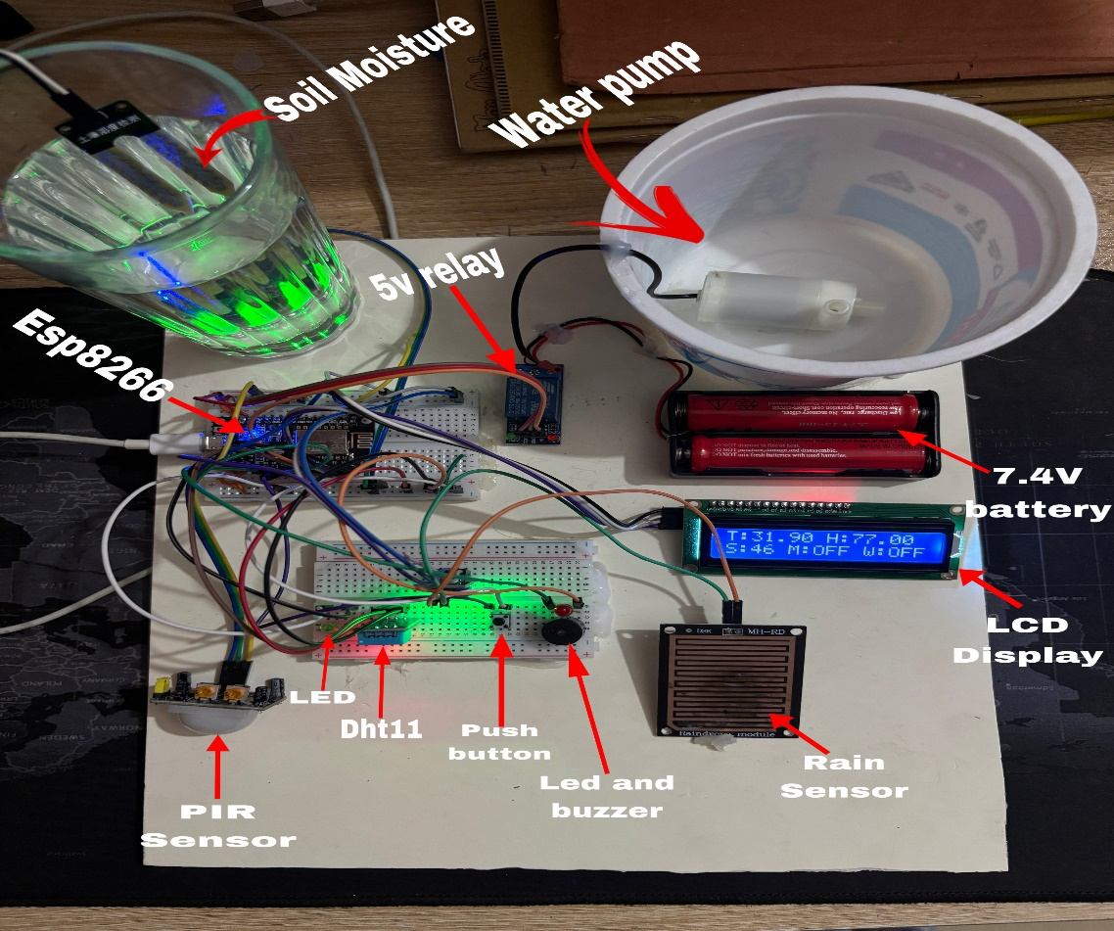

Fig.2 : Hardware Setup

# RESULT AND DISCUSSION

## Simulation

For the simulation of the Smart IoT Plant Care System, we used **Proteus**, a powerful simulation software for electronics design. The simulation involved setting up all the components, such as the **NodeMCU ESP8266, soil moisture sensor, DHT11 temperature and humidity sensor, water pump, relay, rain drop sensor, PIR motion sensor,** and **LCD display** on the Proteus workspace. The system was programmed using the **Arduino IDE** and uploaded to the virtual **NodeMCU** board within the Proteus environment.

In Fig.3 illustrates the interfacing of a soil moisture sensor module with a NodeMCU ESP8266 board for monitoring soil moisture levels.

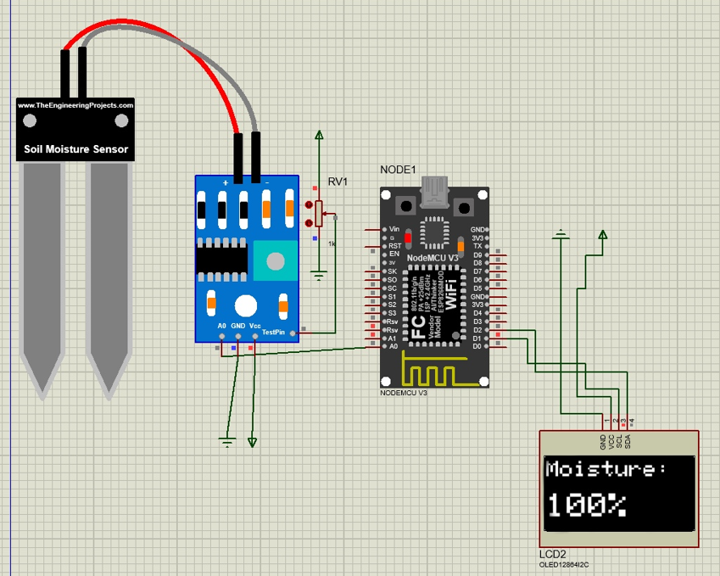

Fig.3.: Simulation for the soil moisture sensor

In Fig.4 PIR sensor detect is there any Motion or not The First, Fig. 4(a) displays “Motion” when Motion Detected. And the Second Fig. 4(b) displays “No Motion” when there is no motion Detected .

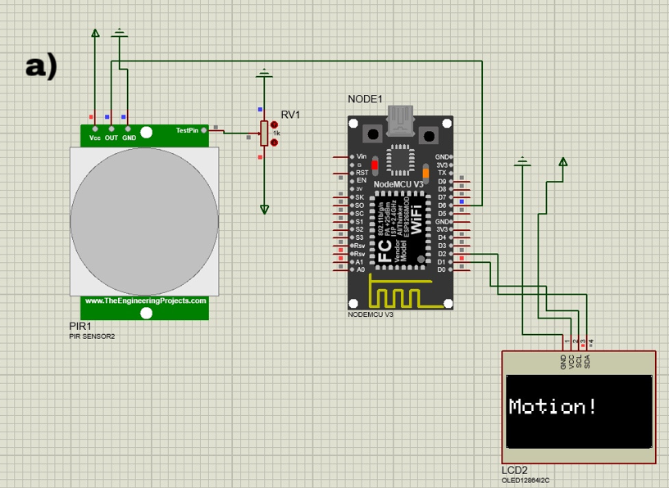

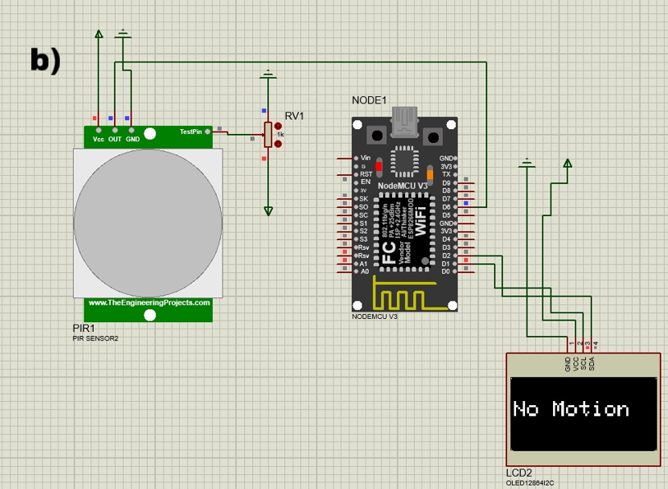Fig.4 : Simulation for PIR sensor a)When motion detected b)When there is no motion.

In Fig. 5, When the rain sensor detects water droplets on its plate, the signal board sends a HIGH/LOW signal to the NodeMCU, which processes the input and displays **“Status: Rain Detected or No Rain”** on the OLED screen. In Fig. 5(a) shows that when Rain sensor detect rain it gets High and displays the “Rain Detected!” status and In Fig. 5(b) when rain sensor Detect No rain it displays “No Rain” on the Screen.

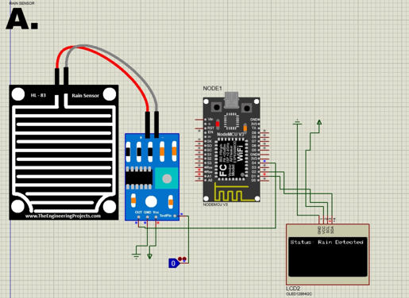

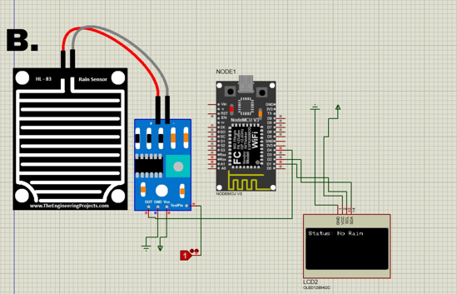

Fig. 5: Simulation For Rain Drop Sensor.a)When rain detected b) When there is no rain

In **Fig. 6**, the **water pump** is connected to the **5V relay module**, which controls the on/off state of the pump. In Fig.5(a) When the switch on the relay module is toggled **on**, the relay receives a high signal, which activates the motor, turning on the pump and supplying water to the plants. Conversely, In Fig.5(b) when the switch is toggled **off,** the relay receives a low signal, which deactivates the motor and turns off the pump.

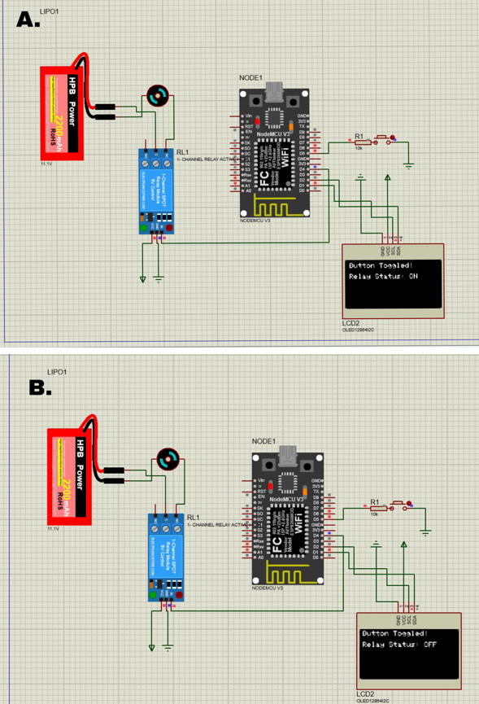

Fig. 6: Simulation for Motor .a)When motor off b)When motor On

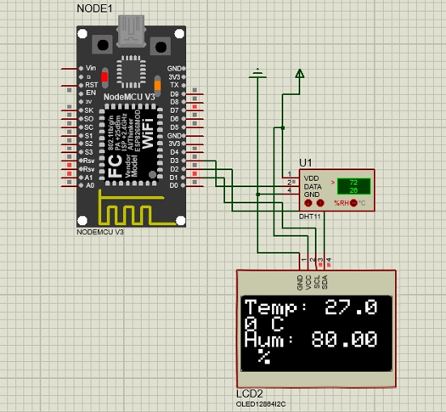

Fig. 7: Simulation for DHT11 Humidity Sensor

In Fig.7 shows that The DHT11 humidity sensor measures the humidity and temperature and the measured data showed in the display.

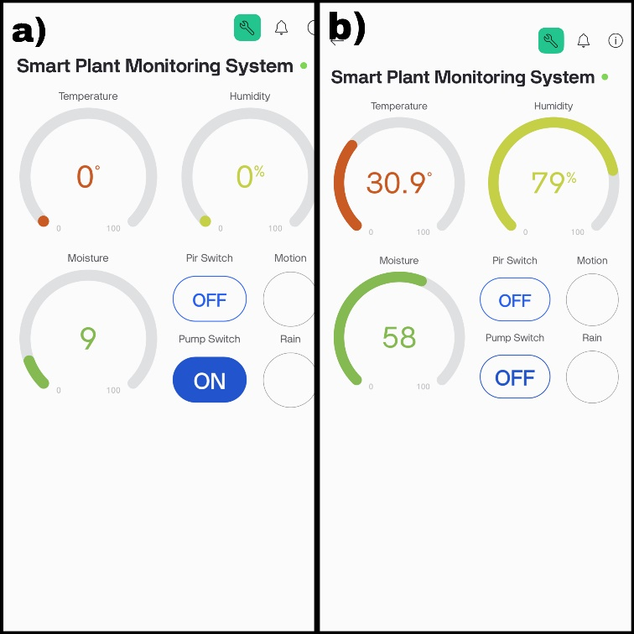

Fig.8: Blynk Setup a) Pump on when moisture value below 35 b) Pump of When moisture value above 35

This Fig.8 displays a mobile dashboard interface for monitoring and controlling a smart irrigation system. It shows real-time temperature, humidity, and soil moisture levels along with controls for PIR and pump switches. The interface also indicates motion and rain detection status. In Fig.8(a) shows that when the moisture level below 35 water pump turns on and in Fig.8(b) shows that when moisture level above 35 the water pump get off automatically. In Fig 7 when turning on the PIR switch Notification will send in device Like Fig.11(a).

## Hardware Implementation

In **Fig. 10(a),** the **LCD display** shows real-time data, including **humidity**, **temperature**, and the **status** of the **motion sensor** and **motor**. This provides the user with a clear overview of the system’s operational state. **Fig. 10(b)** demonstrates that when the **soil moisture** falls below **35%,** the **pump automatically turns on,** and a **green LED** lights up to indicate watering. This ensures that the system is taking appropriate action to maintain plant health. In **Fig. 10(c),** when **motion is detected**, the **red LED** lights up, and a **notification** is sent to the user’s device. The notification ensures that the user is alerted instantly about any movement. **Fig. 11(a)** shows this **motion alert,** with a notification reading **"Motion Detected".** Finally, **Fig. 11(b)** demonstrates the **rain detection feature,** where a notification like **"Rain Detected"** is sent, helping the user avoid unnecessary irrigation during rainfall. This adds an extra layer of automation and efficiency to the system.

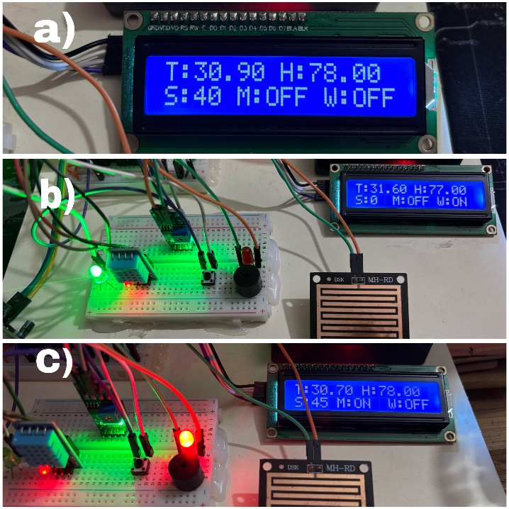

Fig. 10: Display a)Status b) when pump on c) when motion on

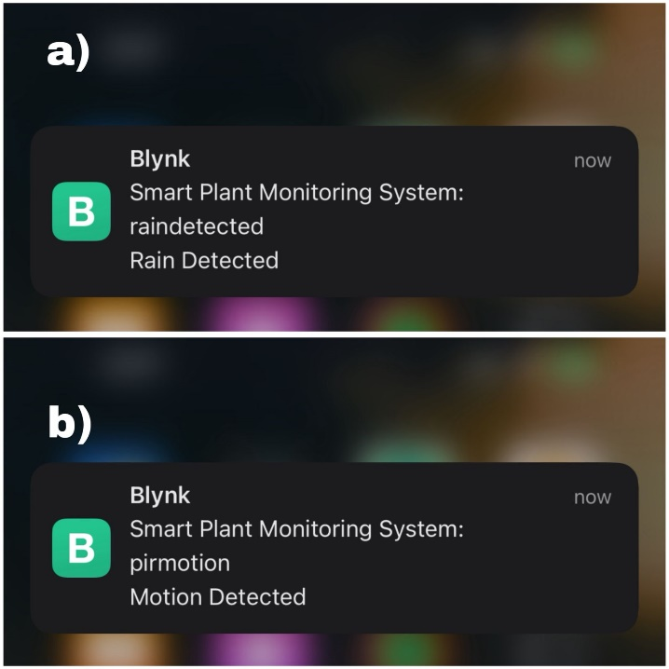

Fig. 11: Notifications When if a) there Rain or b) Motion Detected.

In the experimental setup, the Smart IoT Plant Care System was assembled with real components on a breadboard. The the **rain drop sensor** accurately detected rainfall, preventing unnecessary watering, and the **PIR motion sensor** successfully identified animal activity, triggering the **buzzer** and **LED** as expected. The system’s responses were consistent with the simulation results, with minimal delay between the detection of environmental factors and the system's reactions. For instance, when the soil moisture was below the threshold, the water pump activated promptly, and when rain was detected, the watering system ceased, and a notification was sent via the **Blynk app.** The motion sensor also functioned reliably, sending a "Motion Detected" notification and triggering the buzzer. The system performed well under various conditions, demonstrating accurate real-time monitoring, adaptive watering, and seamless notifications.

In the **simulation** environment, due to the limitations of simulating the entire system together, I tested each sensor separately using **Proteus.** The **PIR motion sensor** was tested to ensure it detected movement and triggered the buzzer and LED, while the **humidity sensor (DHT11)** was verified for accurate temperature and humidity measurements. The **rain drop sensor** was checked for its ability to detect rain and prevent watering, and the **soil moisture sensor** was tested to ensure it triggered the water pump when moisture levels were low. In the **experimental setup,** all sensors were used simultaneously. The **NodeMCU** was programmed to handle inputs from all sensors at once. When the soil moisture dropped, the water pump was activated, and the **rain sensor** detected rainfall, halting the irrigation. The **PIR motion sensor** triggered the buzzer and LED in case of animal movement, while the **DHT11** sensor displayed the temperature and humidity. The experimental results closely matched the simulation, with minor variations due to hardware differences. Overall, the system performed well in both the simulated and experimental setups.

The cost analysis of the Smart IoT Plant Care System was based on the prices of individual components used in the system. The **NodeMCU** costs 340 BDT, while the **Rain Drop Sensor** and **Soil Moisture Sensor** are priced at 80 BDT each. The **DHT11 humidity sensor** costs 120 BDT, and two **3.7V lithium batteries** are priced at 78 BDT each. The **1-channel 5V relay** is 85 BDT, and the **Water Pump** is 120 BDT. The **16x2 LCD display with I2C interface** costs 220 BDT, and two **half-size breadboards** are priced at 75 BDT each. **Jumper wires** (male to male) cost 60 BDT for 20 pieces, while **jumper wires** (male to female) are also priced at 60 BDT for 20 pieces. The **Buzzer** costs 20 BDT, and two **LEDs** cost 5 BDT each. Finally, the **Push Button** is priced at 5 BDT. The total estimated cost for the entire system is approximately 1800 BDT. This affordable cost makes the Smart IoT Plant Care System a cost-effective solution for automating plant care, saving water, and improving efficiency. The low cost of the components allows for easy implementation in both small home gardens and larger-scale agricultural applications.

While the system offers several benefits, there are some limitations to consider. The sensors, such as the soil moisture and rain drop sensors, may not always provide precise readings, affecting the system's responsiveness. The system operates on a 7.4V battery, which needs to be recharged or replaced frequently, especially for larger setups or continuous use. Adapting to environmental changes like temperature and humidity is challenging without additional sensors for calibration. Remote monitoring through the Blynk app requires an internet connection, so system parameters can't be accessed without it. Although watering is automated, tasks like troubleshooting and sensor recalibration still require manual intervention. The rain sensor may not detect light rain, causing discrepancies in the watering process. Additionally, as systems scale for larger commercial or farming purposes, the cost increases significantly.

# CONCLUSION AND FUTURE ENDEAVORS

The Smart IoT Plant Care System focuses on self-sustaining plant watering and monitoring. It provides real-time watering adjustments and keeps an eye on water use, soil condition, and plant health. Using the Blynk app, the system can be controlled remotely and sends notifications about water use. This app makes the system easy to use for both IoT experts and regular users.

This project highlights how IoT innovations can tackle real-life problems. It automates boring tasks and offers eco-friendly solutions. It also shows how simple IoT setups can be, providing options for home gardeners and larger-scale growers, including farmers. Additionally, it helps conserve soil moisture and boost overall plant health.

While the Smart IoT Plant Care System is effective as it is, there are several chances for future improvements:

To enhance the system's performance, several improvements can be made. additional sensors like light, pH, and nutrient sensors to improve plant health monitoring. Weather integration would allow the system to adjust irrigation schedules based on expected rainfall or temperature changes. Incorporating solar power or low-energy components could make the system more energy-efficient, especially for larger farms. AI-based irrigation, using machine learning to predict needs, would make the system more intelligent and responsive. Finally, expanding the system's scalability to manage multiple irrigation zones and improving the mobile app with features like scheduling and data analysis would further enhance user control and system efficiency.

# REFEERNCES

1. K. N. Siva, R. Kumar G., A. Bagubali, and K. V. m Krishnan, “Smart watering of plants,” *IEEE Xplore*, Mar. 01, 2019. <https://ieeexplore.ieee.org/document/8899371/>
2. [2] M. B. I. Astutiningtyas, M. M. Nugraheni, and S. Suyoto, “Automatic Plants Watering System for Small Garden,” *International Journal of Interactive Mobile Technologies (iJIM)*, vol. 15, no. 02, pp. 200–207, Jan. 2021, doi: <https://doi.org/10.3991/ijim.v15i02.12803>.
3. [3] A. Gupta and S. kumawat, “Automatic Plant Watering System,” *International Journal of Modern Trends in Engineering & Research*, vol. 5, no. 3, pp. 165–171, Mar. 2018,doi:<https://doi.org/10.21884/ijmter.2018.5080.w8lcz>.
4. [4] A Suhana Nafais, K. Mir, S. D. Kumar, and J. T. Mani, “IoT Based Plant Watering System,” *2022 International Conference on Advances in Computing, Communication and Applied Informatics (ACCAI)*, vol. 15, no. 65, pp. 1–6, May2024,doi:<https://doi.org/10.1109/accai61061.2024.10601839>.
5. [5B. Kumbar, B. Galagi, B. shankar, and N. Honnalli, “Smart Irrigation System Using Internet of Things,” *Bonfring International Journal of Research in Communication Engineering*, vol. 6, no. Special Issue, pp. 04–09, Nov. 2016, doi: <https://doi.org/10.9756/bijrce.8189>.
6. A. Rane, B. R. Vidhale, P. Kale, and Ganesh Khekare, “Design of An IoT based Smart Plant Monitoring System,” *2022 10th International Conference on Emerging Trends in Engineering and Technology - Signal and Information Processing (ICETET-SIP-22)*, vol. 15, no. 64, Apr. 2022, doi:https://doi.org/10.1109/icetet-sip-2254415.2022.9791690.
7. S. Sadasviam, “SMART HEALTH MONITORING SYSTEM,” *International Journal of Recent Trends in Engineering and Research*, vol. 3, no. 6, pp. 335–341, Jul. 2017,doi: <https://doi.org/10.23883/ijrter.2017.3314.xggcx>.
8. S. Gnanavel, M. Sreekrishna, N. DuraiMurugan, M. Jaeyalakshmi, and S. Loksharan, “The Smart IoT based Automated Irrigation System using Arduino UNO and Soil Moisture Sensor,” *2022 4th International Conference on Smart Systems and Inventive Technology (ICSSIT)*, vol. 15, no.44,Jan.2022,doi:https://doi.org/10.1109/icssit53264.2022.9716368.
9. Yovanka Davincy Setiawan, W. Hartanto, Elsha Erlina Lukas, N. Don, S. Kurniawan, and Boby Siswanto, “Smart Plant Watering and Lighting System to Enhance Plant Growth Using Internet of Things,” *Procedia Computer Science*, vol. 227, no. 5, pp. 966–972, Jan. 2023, doi: https://doi.org/10.1016/j.procs.2023.10.604.
10. M. Sarode, A. Shaikh, S. Krishnadas, and dr. y. s. rao, “automatic plant watering system,” asian journal of convergence in technology, vol. 6, no. 3, pp. 90–94, dec. 2020, doi: https://doi.org/10.33130/ajct.2020v06i03.014.