Title Page

Detecting Rice Diseases at Early Stage Using Computer Vision​

Detecting Rice Diseases at Early Stage Using Computer Vision​

Mohammad Rashedul Alam
Department of Electrical and Computer Engineering
North South University
Dhaka,Bangladesh
rashedul.alam@northsouth.edu
line 1: 2nd Given Name Surname
line 2: dept. name of organization
(of Affiliation)
line 3: name of organization
(of Affiliation)
line 4: City, Country
line 5: email address or ORCID
Aminul Islam
Department of Electrical and Computer Engineering
North South University
Dhaka,Bangladesh
aminul.islam02@northsouth.edu

Abstract—This
Keywords—component, formatting, style, styling, insert (key words)

Introduction (Heading 1)
This template,

MOtivation

Selecting a Template (Heading 2)
First,
.

background & significance
The origins and continued evolution of agriculture in the face of infectious diseases and pests Perhaps the greatest technological advance that humans have ever made has been the domestication of plants during the agricultural revolution. The development of systems to monitor large fields using the Normalized Difference Vegetation Index (NDVI) started more than 25 years ago when Normalized Difference Vegetation Index( NDVI) was used in the so-called remote sensing field [3]. It was an important milestone in the advance of automatic methods for analyzing plant growth and biomass. Ever since, new technologies have increased our capacity to obtain data from biological systems. The ability to measure chlorophyll status from satellite images allowed plant health to be measured in large fields and predict crops and productivity in very large areas such as the Canadian, the Indian in Pakistan. Thus, the field of remote sensing is an important basis where knowledge about data acquisition and analysis started.

Recently, high-throughput analysis methods are commonly used in molecular biology. High-throughput phenotyping has been introduced to capture phenotypical data in larger quantities. Automated greenhouses, in which plants are grown and analyzed automatically and images
are taken in regular intervals, are the basis for high throughput phenotyping for plants. Image analysis software augments an observer’s ability to evaluate plant phenotypes. For this purpose various fully automatic high-throughput plant growth and phenotyping platforms have been developed.

The field of plant phenotyping is still under rapid development at the moment. Image-based plant phenotyping is beginning to prove its value not only in basic science, but also in crop breeding and precision agriculture, providing a quantitative basis of the description of plant-environment-interactions. Key to the success is the ease and applicability of modern image analysis approaches that are applied at multiple points in time throughout crop development, thereby allowing for cost-efficient high-throughput phenotyping at appropriate ontogenetically stages. Since the potential of image analysis in the context of plant phenotyping is far from being adequately exploited, the scientific field of plant phenotyping can be expected to continue prospering throughout the coming years.
.

metod and design
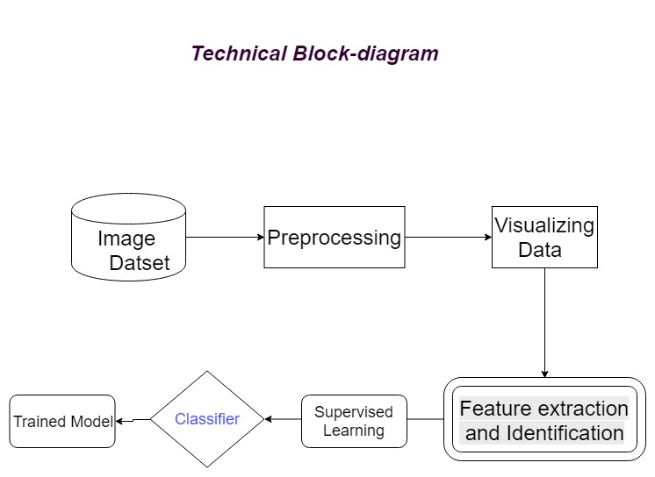
A. Dataset
A large amount of dataset of Rice image with diseases is needed to be collected. Although the model is focused on rice disease detection it can be trained using different leaf dataset and can be later modified for rice disease detection. The dataset has to be divided into three portions for Training, Cross-Validation and Testing with a ratio of 60:20:20.
B. Preprocessing
The collected images need to be preprocessed before any classification and training can be done. The blurry and low-quality images need to be corrected. Using deconvolution, the blurry images can be corrected to some degree. A good PSF (Point Spread Function) is needed that will correct the blurred images most. The image has to be converted to grayscale to reduce the dimension of image and detect the contour of leaf. The disease area and shape can be extracted from the greyscale image easily.

C. Algorithms

1. Convolutional neural network models

Convolutional neural network works the same way as human visual system. In Human visual system neurons are triggered when we see certain shape. For example, some neurons are fired when exposed to vertical edges, some for horizontal and vertical edges. Neural network works the same way. CNN are trained through supervised learning to detect characteristics from the training images. CNNs are an evolution of traditional artificial neural networks, focused mainly on applications with repeating patterns in different areas of the modeling space, especially image recognition. Their main characteristic is that, with the methodology used in their layering, they drastically reduce the required number of structural elements (number of artificial neurons) in comparison to traditional feedforward neural networks. For image recognition applications, several baseline architectures of CNNs have been developed, which have been successfully applied to complicated tasks of visual imagery.

Acknowledgment (Heading 5)
The

References

- Ferentinos, Konstantinos P. “Deep Learning Models for Plant Disease Detection and Diagnosis.” Computers and Electronics in Agriculture, vol. 145, 2018, pp. 311–318., doi:10.1016/j.compag.2018.01.009.
- Ferentinos, Konstantinos P. “Deep Learning Models for Plant Disease Detection and Diagnosis.” Computers and Electronics in Agriculture, vol. 145, 2018, pp. 311–318., doi:10.1016/j.compag.2018.01.009.
- Tucker C. Red and photographic infrared linear combinations for monitoring vegetation. Remote Sens Environ . 2016.10.16

IEEE conference templates contain guidance text for composing and formatting conference papers. Please ensure that all template text is removed from your conference paper prior to submission to the conference. Failure to remove template text from your paper may result in your paper not being published.

