From 140 to 860,000: Electric Vehicle Adoption in Germany, 2010–2025 — Growth, the Subsidy Shock, and the European Comparison
Rashed Rana Master's student, Artificial Intelligence for Industrial Applications, OTH Amberg-Weiden, Germany
Manuscript prepared for journal submission. All results are computed from the published datasets cited below; the complete analysis code (Python and SQL) is openly available (see Data Availability).

Abstract
Germany sold 140 electric cars in 2010 and 860,000 in 2025. This study analyses that fifteen-year transition using the International Energy Agency's electric-car series, republished by Our World in Data, for 2010–2025, with descriptive statistics, growth accounting, ordinary least-squares regression and a structured SQL analysis, and benchmarks Germany against European peers, China, the United States and the world. The electric share of new car sales rose from 0.005% in 2010 to 30.0% in 2025, with sales growing at a compound rate of 106.3% per year between 2010 and 2022 and doubling roughly every 1.1 years. The take-off came in 2020, when sales jumped 261.1% in a single year (108,000 to 390,000) as the purchase subsidy was raised and the EU fleet CO2 target took effect. The defining event of the series is the subsidy shock: after the Umweltbonus purchase subsidy was cut in January 2023 and terminated in December 2023, German electric sales fell 31.3% between 2022 and 2024 (830,000 to 570,000) and the market share fell 11 percentage points (31% to 20%), while the EU-27 share was flat and France, the Netherlands, the United Kingdom and China all gained. The total new-car market was roughly unchanged over the same period, so the collapse was a share collapse, not a market collapse. In 2025 the market rebounded to record sales of 860,000 and a 30% share — before any new purchase subsidy existed. Across 59 countries in 2022, income is a significant but weak predictor of adoption (OLS slope 10.63 percentage points per log unit of GDP per capita, R² = 0.19, p = 0.0006); Germany sat 11.2 points above its income-predicted share, consistent with policy, not income, doing the heavy lifting. Cumulative electric sales of 4.34 million by 2025 leave Germany far from its target of 15 million electric cars on the road by 2030, which would require about 2.13 million sales per year — 2.48 times the 2025 pace.

1. Introduction
Road transport is the hardest part of Germany's energy transition to move. Electricity generation has been transformed in a generation, but cars turn over slowly, cost more to replace than a power station costs to re-fuel, and their buyers decide one household at a time. Electric cars — battery-electric and plug-in hybrid cars together, as counted in this paper — are the main technology on offer for decarbonising that sector, and Germany is the test case that matters most in Europe: it is the continent's largest car market, its largest car producer, and the country whose industrial future is most tied to the electric transition [1]. In 2025 Germany was the world's third-largest electric car market by volume, behind only China and the United States, yet only 19th of 59 countries by market share. That tension — industrial scale without adoption leadership — is the subject of this paper.
The German series is unusually instructive because it contains a sharp, dated policy change inside a long growth trend. For twelve years electric sales grew almost without interruption, doubling roughly every 1.1 years. Then, within thirteen months, the federal purchase subsidy (the Umweltbonus) was cut, restricted to private buyers, and abolished altogether, and sales fell for two consecutive years — the only two-year fall in the series — before rebounding to a record in 2025. Few countries offer so clean a before-and-after, and few offer it in a market large enough to matter for European climate targets.
This paper asks four questions. First, how fast did electric adoption actually grow in Germany, and when did it take off? Second, what happened when the subsidy was removed, and was the fall specific to Germany? Third, where does Germany stand internationally in 2025? Fourth, how much of the cross-country pattern does income explain, and how much is left for policy? The answers come entirely from published data: the International Energy Agency's electric-car series as republished by Our World in Data, covering 2010–2025, with GDP per capita from the World Bank series carried in the Our World in Data CO2 dataset. Every number in the paper is produced by the accompanying Python and SQL code; nothing is typed by hand.

2. Literature review
The literature on electric vehicle adoption converges on four groups of drivers: purchase price and incentives, charging infrastructure, vehicle characteristics (above all range), and consumer attitudes and socio-economic position. Egbue and Long [4] surveyed technology enthusiasts and found that battery range was the largest concern, followed by cost, while sustainability weighed less than cost and performance; they also found that consumers resist technologies they consider unproven, so policy that ignores those concerns fails. Coffman, Bernstein and Wee [5], reviewing the field a decade into the modern electric car, concluded that the evidence on incentives was mixed — particularly on timing and magnitude — and that public charging infrastructure was associated with uptake, although the direction of causality was unclear.
The cross-country econometric literature is more decisive about incentives. Sierzchula et al. [3] regressed 2012 market shares for 30 countries on incentives and socio-economic factors and found financial incentives, charging infrastructure and local production presence to be significant, with charging infrastructure the strongest correlate. Münzel et al. [6] reviewed the econometric literature and estimated a panel model for 32 European countries (2010–2017), finding that €1,000 of additional incentive raised the plug-in share by about 5–7% in relative terms, controlling for income and fuel prices. Schub, Plötz and Sprei [11] extended this to company cars — which dominate German registrations — and found that a €1,000-per-year recurring company-car incentive raised sales shares by 17–40% for battery-electric cars. Hardman et al. [7] reviewed charging behaviour and found home charging the most important location, followed by work and then public charging; Gnann et al. [8] modelled fast-charging needs and found that about one fast-charging point per 1,000 battery-electric cars could suffice at high power levels; Funke et al. [9] reviewed how much charging infrastructure electric vehicles need and how it compares internationally.
Norway is the reference case for what sustained, generous policy can do. Figenbaum [10] documents how three decades of tax exemptions — registration tax from 1990, VAT exemption from 2001, free tolls and parking — built the world's most electrified new-car market, reaching 97% electric share in 2025 in the data used here. Germany's Umweltbonus, introduced on 2 July 2016 at €4,000 for battery-electric cars and €3,000 for plug-in hybrids, raised to up to €9,000 in 2020, then cut in January 2023 (with plug-in hybrid support ended entirely), restricted to private buyers in September 2023, and terminated on 18 December 2023 [13], offers the opposite experiment: a large subsidy removed quickly. The International Energy Agency's Global EV Outlook 2025 [1] records the global context — more than 17 million electric cars sold worldwide in 2024, over 20% of new car sales, with European sales stagnating as subsidies were phased out — and notes that the EU CO2 targets for cars were unchanged between 2023 and 2024, removing one source of pressure exactly when German support ended. The EU fleet target itself, 95 g CO2/km from 2020 with a further 15% tightening from 2025, is set by Regulation (EU) 2019/631 [12].
This paper contributes a complete, reproducible account of the German case through 2025 — including the rebound year — using a single consistent data source, a cross-country income regression for the same year as the literature's benchmarks, and an explicit test of whether the 2023–2024 fall was a German phenomenon or a European one.

3. Data and methods
Data. Electric car sales (battery-electric plus plug-in hybrid) and the electric share of new car sales come from the International Energy Agency's Global EV Outlook series, as republished by Our World in Data in its "electric-car-sales" and "electric-car-sales-share" datasets [2]. Coverage is annual, 2010–2025, for 64 countries plus the European Union (27) and world aggregates. GDP per capita (2011 international-$) comes from the World Bank series carried in the Our World in Data CO2 dataset, which is published through 2022; the cross-country regression therefore uses 2022, the latest year with both variables. Throughout the paper "electric car" (EV) means battery-electric plus plug-in hybrid; where cited work reports battery-electric cars only, this is stated.
Methods. All headline figures are computed in Python (pandas/statsmodels) and saved to `outputs/results.json`; nine documented SQL queries (SQLite) reproduce the key tables in `outputs/sql_results.md`. Growth is measured with compound annual growth rates and a log-linear trend fitted by ordinary least squares (OLS) on 2010–2022. The subsidy shock is measured as the change in sales and share between 2022 and 2024 for Germany and for peers, and cross-checked against the list of countries whose share fell (SQL Q8). The implied total new-car market is derived as EV sales divided by EV share; because the source rounds shares (to whole percentages in recent years), these totals are approximate. The cross-country model is OLS of EV share on the natural logarithm of GDP per capita for 2022 (n = 59), with a sensitivity check excluding Nepal, an outlier discussed below. The 2030 target arithmetic divides the remaining gap to 15 million cars by the five years 2026–2030. Causality is not claimed from the timing of the subsidy removal alone: the paper treats it as a before-and-after comparison against peer countries, not as an identified causal estimate.

4. Results

4.1 Fifteen years of growth
Germany sold 140 electric cars in 2010 and 860,000 in 2025 — a 6,142.9-fold increase (Figure 1). The electric share of new car sales rose over the same period from 0.005% to 30.0%. Growth was fastest early: the compound annual growth rate of sales was 106.3% per year between 2010 and 2022, and 78.9% per year over the full 2010–2025 period. A log-linear trend fitted to 2010–2022 has a slope of 0.624 per year (R² = 0.948), equivalent to sales doubling every 1.11 years; the share trend over the same years was +2.11 percentage points per year, though with a weaker fit (R² = 0.595) because the growth came in steps, not smoothly.
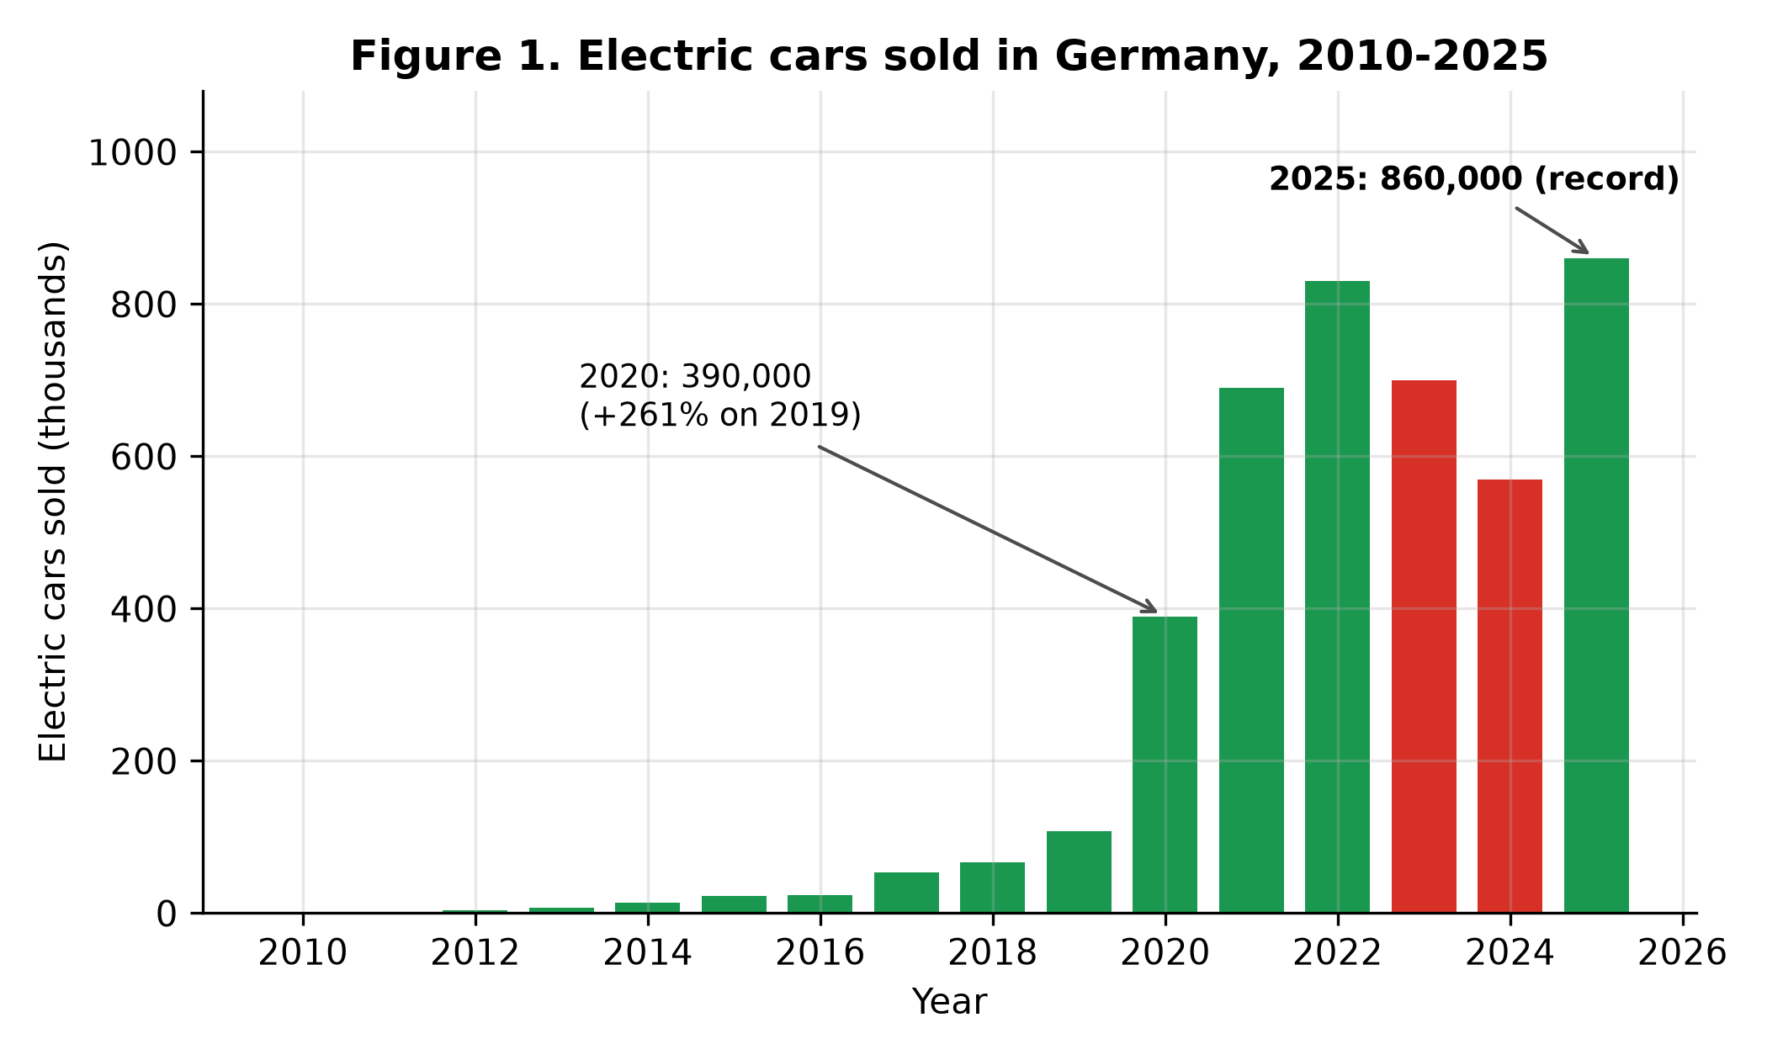
Figure 1. Electric cars sold in Germany, 2010–2025. Sales fell in 2023 and 2024 — the only two-year fall in the series — and then set a record in 2025.
Cumulative electric sales reached 2.21 million by the end of 2022, 3.48 million by the end of 2024 and 4.34 million by the end of 2025. That cumulative figure is an upper-bound proxy for the electric fleet on the road, since it ignores retirements; the true fleet is somewhat smaller.

4.2 The 2020 take-off
For most of the 2010s electric cars were a rounding error in Germany: 23,000 sold in 2015 (0.73% share), 108,000 in 2019 (3.0%). The take-off came in 2020, when sales jumped 261.1% in one year — from 108,000 to 390,000 — and the share leapt from 3% to 14%. Sales then rose to 690,000 in 2021 (26%) and 830,000 in 2022 (31%). Two things coincided in 2020: the purchase subsidy was raised to up to €9,000 (the "Innovation premium"), and the EU fleet target of 95 g CO2/km took effect [12, 13], forcing manufacturers to sell electric cars or pay fines. The data cannot separate the two effects, and this paper does not try; the point is that 2020, not any earlier year, is when electric cars stopped being marginal in Germany. The EU-27 share followed the same pattern (2.9% in 2019, 10.0% in 2020), confirming that the take-off was European, driven by the fleet target, with the German subsidy adding national momentum.

4.3 The subsidy shock of 2023–2024
The defining event of the German series is the removal of the Umweltbonus. The subsidy was cut in January 2023 and plug-in hybrid support ended; commercial buyers lost eligibility in September 2023; and the scheme was terminated entirely on 18 December 2023 [13]. German electric sales fell from 830,000 in 2022 to 700,000 in 2023 (−15.7%) and 570,000 in 2024 (−18.6%) — a total fall of 31.3% — and the market share fell from 31% to 24% to 20%, a loss of 11 percentage points (Figure 2).
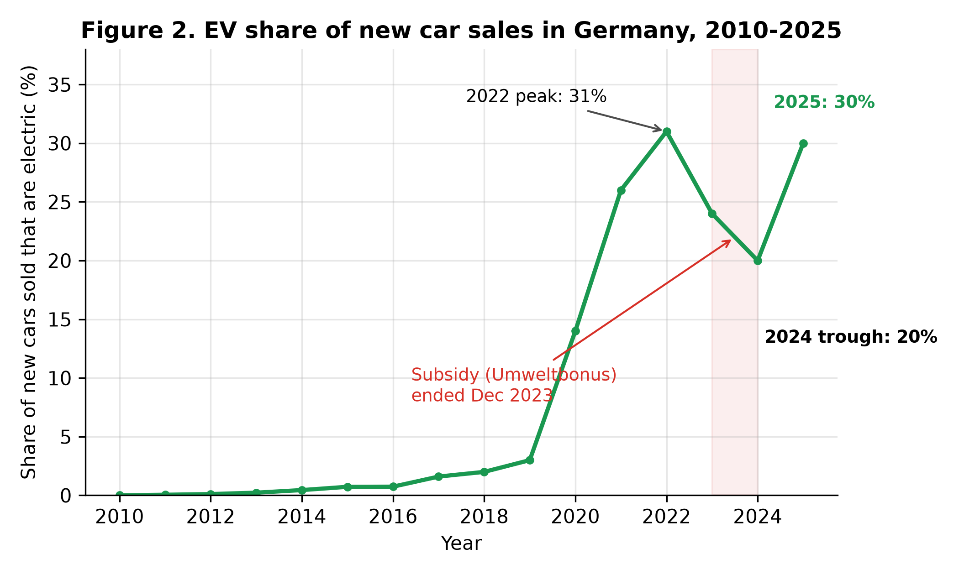
Figure 2. EV share of new car sales in Germany, 2010–2025. The subsidy was cut in January 2023 and terminated in December 2023; the share fell 11 points in two years and recovered in 2025.
Three checks show this was a German policy event, not a market collapse. First, the total new-car market did not collapse: the implied total market — EV sales divided by EV share — was 2.68 million in 2022, 2.92 million in 2023 and 2.85 million in 2024, up 6.4% over the two years (Figure 4). Buyers kept buying cars; they stopped buying electric ones. Second, peers moved the other way (Figure 3): between 2022 and 2024 the EU-27 share was flat (21% to 21%), France gained 4.0 points (20% to 24%), the Netherlands 13.0 points (35% to 48%), the United Kingdom 5.0 points (22% to 27%), China 19.0 points (29% to 48%) and the United States 2.3 points (7.7% to 10.0%). Third, among all countries in the data, only two lost more share than Germany between 2022 and 2024 — Iceland (−26 points) and New Zealand (−13 points) — and New Zealand had likewise just removed its purchase subsidy, the Clean Car Discount, on 31 December 2023 [15]. Germany was the third-largest loser in the world, and the largest among major markets.
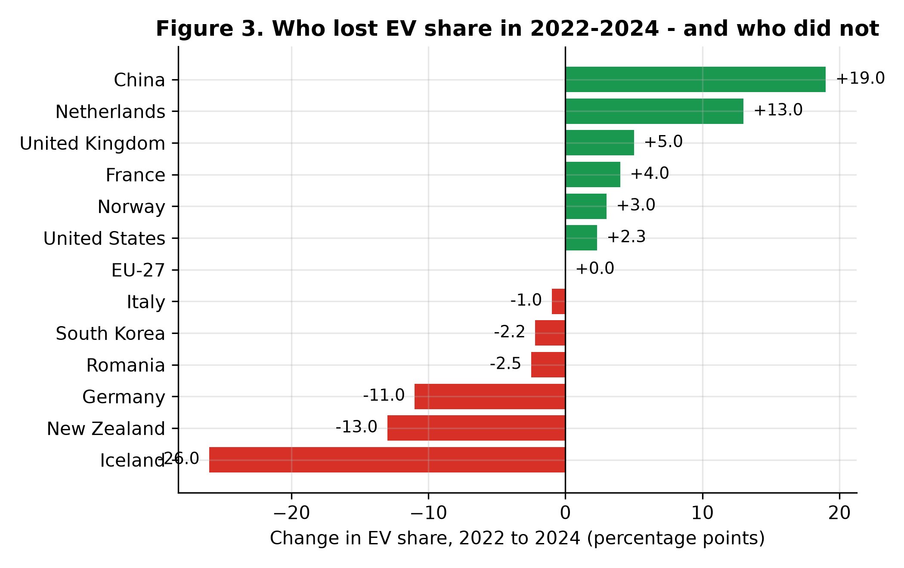
Figure 3. Change in EV share of new car sales, 2022 to 2024. Germany was the third-largest loser worldwide; the countries that lost most had all recently removed purchase incentives.
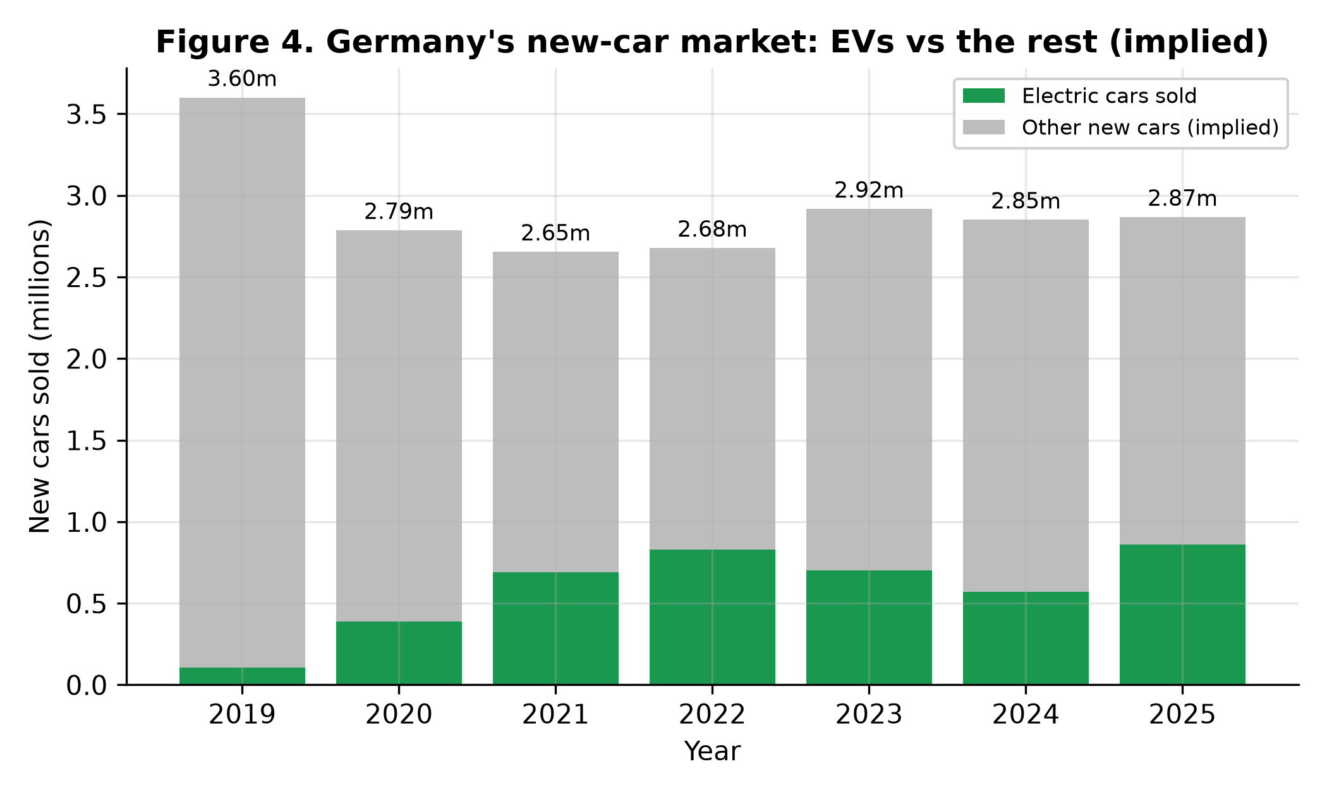
Figure 4. Germany's new-car market (implied totals: EV sales divided by EV share), 2019–2025. The total market was roughly flat while the electric share collapsed — the fall was a share collapse, not a market collapse.
The rebound came in 2025, before any new purchase subsidy existed: sales rose 50.9% to 860,000 — a new record — and the share recovered 10 points to 30.0%, just one point below the 2022 peak. A new income-graduated purchase grant was only introduced on 1 January 2026, so it cannot explain the 2025 recovery. The plausible drivers are the 15% tightening of the EU fleet CO2 target from 2025 [12], cheaper models reaching the market, and the depreciation allowance for company cars introduced in 2024 — but the data used here cannot separate them, and the paper records the rebound as a fact to be explained, not as proof of any single cause.

4.4 Germany in the world, 2025
By 2025 the world sold 21.2 million electric cars, a quarter of all new cars (25.0% share), and Germany's 860,000 sales made it the third-largest market in volume — 4.1% of world electric sales — behind China (13.3 million) and the United States (1.53 million). But by share, Germany ranked only 19th of 59 countries with data (Figure 6). Norway sold 97% electric, Denmark 71%, Sweden 61%, the Netherlands 58% and China 53%; the United Kingdom reached 35% and France 26%, while the EU-27 stood at 27% and the world at 25%. Germany, at 30%, sat just above the EU average and five points above the world average — respectable, but far from the leaders.
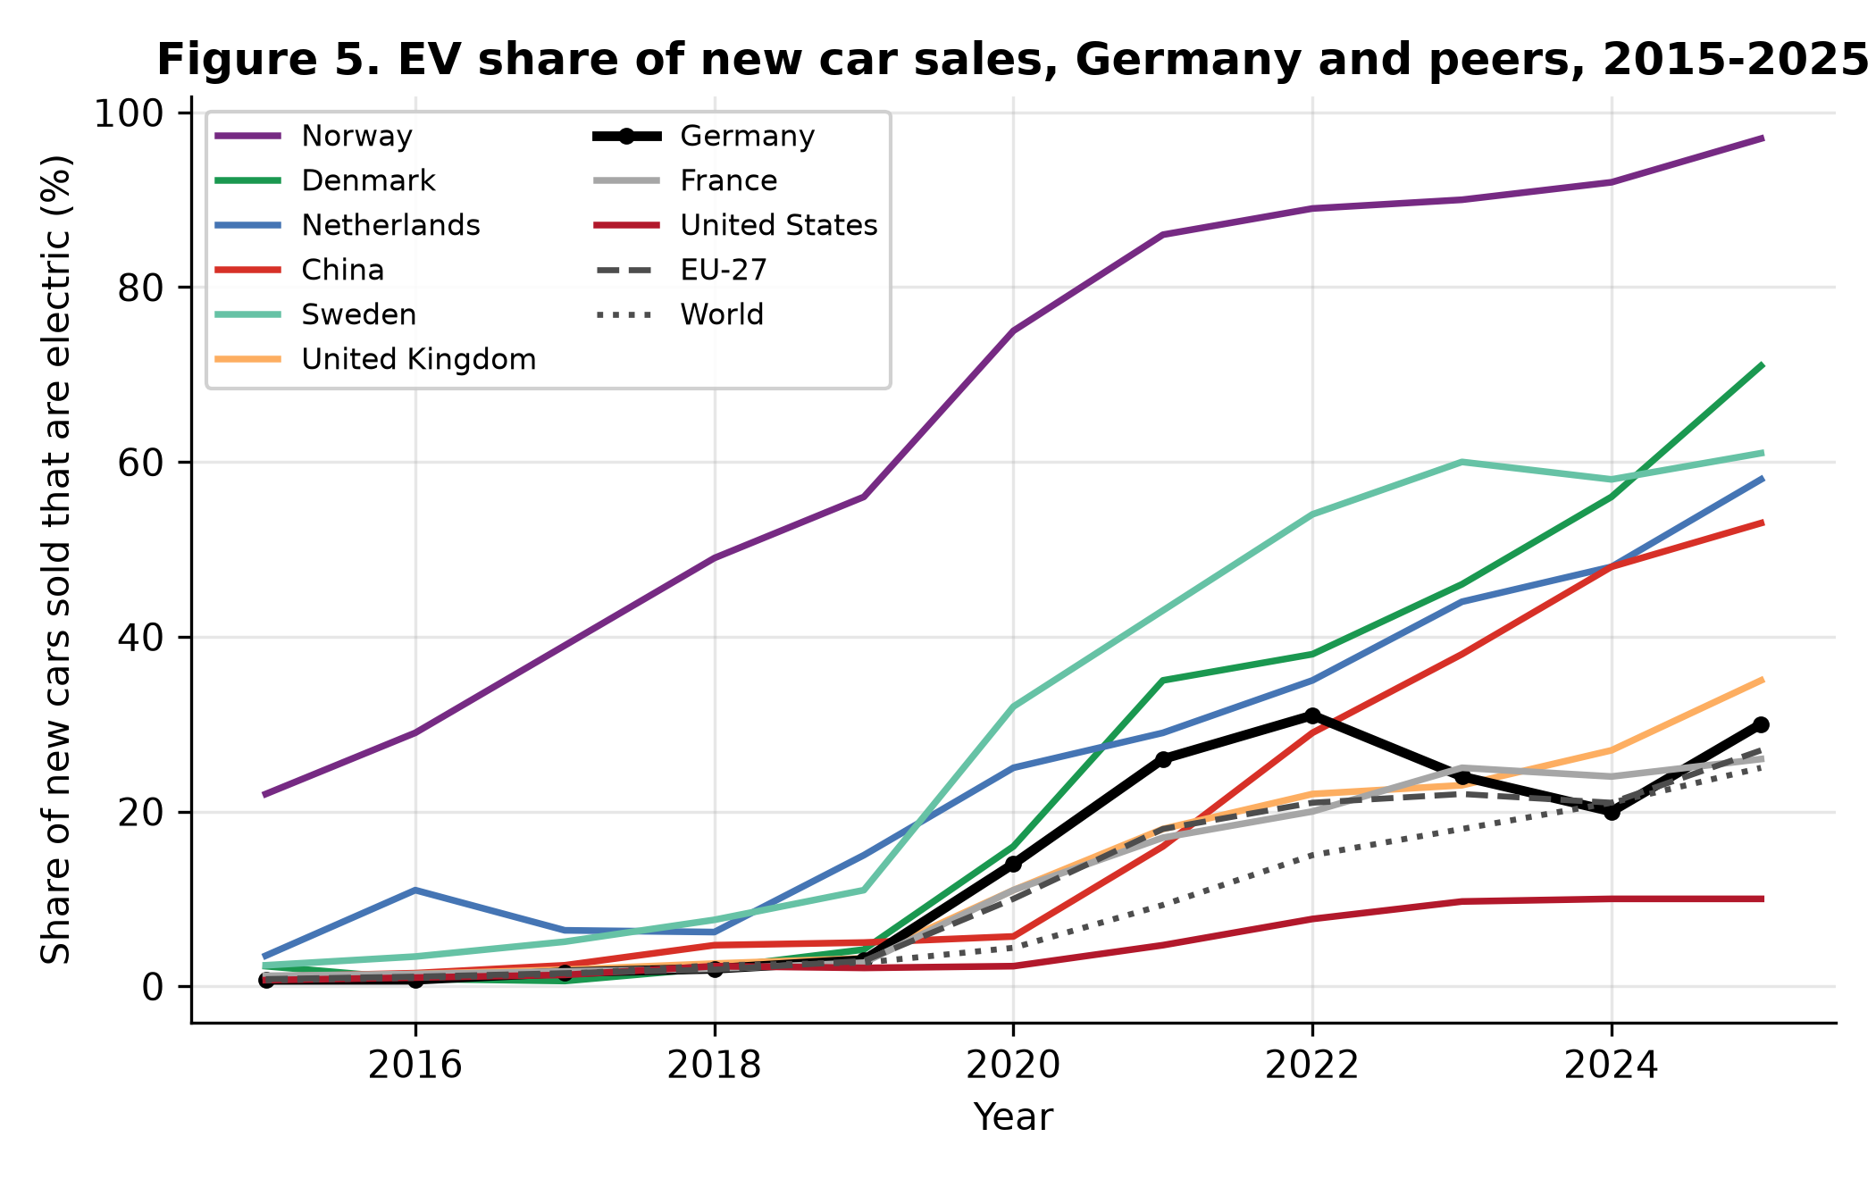
Figure 5. EV share of new car sales, Germany and peers, 2015–2025. Germany's line is the only one among the leaders that falls in 2023–2024.
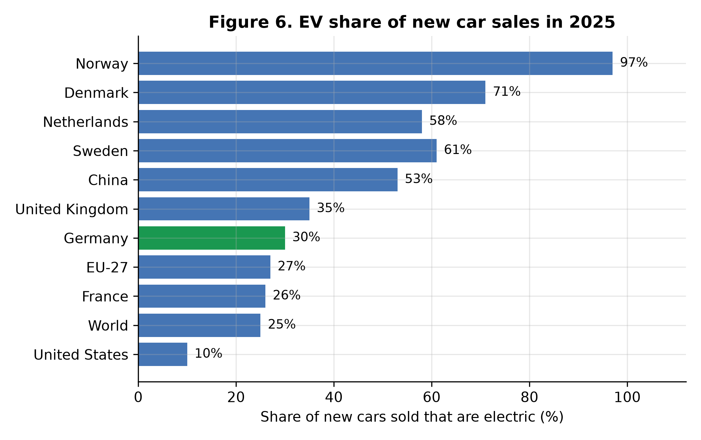
Figure 6. EV share of new car sales in 2025. Germany ranks 19th of 59 countries by share, but 3rd by volume.
The trajectories (Figure 5) show that Germany's dip is the exception, not the rule: every other country in the comparison rose or held steady through 2023–2024. They also show how late Germany's take-off was relative to the north: Norway passed 20% in 2015, when Germany was at 0.73%; the Netherlands passed 25% in 2020, when Germany was at 14%. Germany caught up fast in 2020–2022 and then gave back a third of its gain in two years.

4.5 Income and adoption: the cross-country regression
Is Germany's adoption level what its income would predict? For 2022 — the latest year with GDP per capita for the same countries — an OLS regression of EV share on the logarithm of GDP per capita across 59 countries gives a slope of 10.63 percentage points per log unit (p = 0.0006), an intercept of −94.44, and R² = 0.189 (Figure 7). Income matters — the correlation is 0.434 — but it explains less than a fifth of the variation in adoption. At Germany's GDP per capita of $46,495, the model predicts a 19.8% share; Germany's actual share was 31.0%, a residual of +11.2 points. In other words, Germany adopted well ahead of what its income alone would suggest — consistent with the literature's finding that policy and infrastructure, not income, separate leaders from laggards [3, 6].
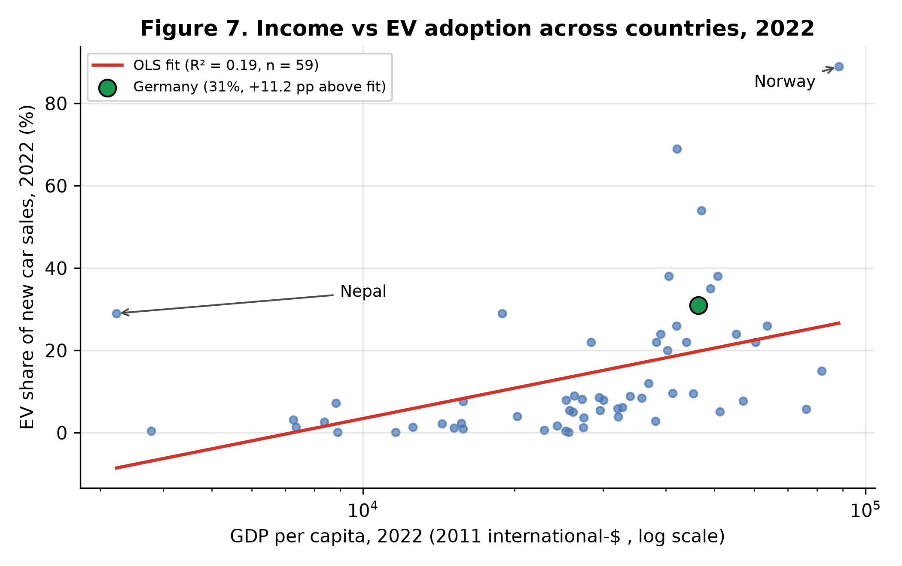
Figure 7. EV share of new car sales against GDP per capita, 2022 (n = 59). Income is significant but explains only 19% of the variation; Germany sits 11.2 points above its income-predicted share.
Two outliers deserve comment. Norway (89% share in 2022) sits far above the line, as three decades of tax exemptions would predict [10]. Nepal (29% share at $3,229 GDP per capita) sits far above it for the opposite reason: a near-total exemption of electric cars from import duty made them the cheap option. Excluding Nepal, the slope rises to 13.95 and R² to 0.278 (n = 58); the conclusion is unchanged. The regression is descriptive, not causal: income correlates with charging infrastructure, education, urbanisation and policy capacity, all omitted here.

4.6 The broken trend and the 2030 target
The log-linear trend fitted on 2010–2022 (Figure 8) describes the early phase well (R² = 0.948), but it cannot be extrapolated: extended to 2024 it predicts 3.94 million sales — more than the entire German new-car market of 2.85 million that year. Exponential growth at the early-phase rate was already arithmetically impossible by 2023, even before the subsidy ended; saturation, not only policy, ended the doubling era. The honest reading of Figure 8 is that the growth regime changed, and the subsidy removal determined how hard the landing was.
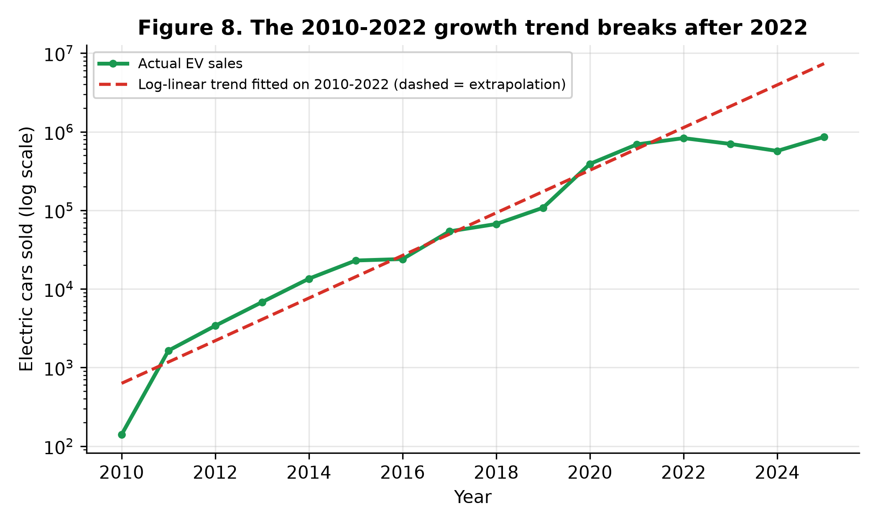
Figure 8. Electric car sales on a log scale, with the trend fitted on 2010–2022 extrapolated. The extrapolation exceeds the whole German car market by 2024: the early growth rate could not have continued.
That arithmetic matters for the target. Germany aims to have 15 million electric cars on the road by 2030 [14]. Cumulative sales by the end of 2025 were 4.34 million — an upper bound on the fleet, since it ignores retirements — leaving a gap of 10.66 million cars to be added in the five years 2026–2030, or about 2.13 million sales per year. That is 2.48 times the record 2025 pace of 860,000. Even if sales grew 20% every year from 2025, they would reach only about 2.14 million in 2030 itself, and the five-year total would still fall short. On the evidence of this series, the 15-million target is not reachable on the current trajectory; it would require a second take-off of the size of 2020–2022, sustained for five years.
Year | EV sales | EV share (%) | Implied total market
2010 | 140 | 0.005 | —
2015 | 23,000 | 0.73 | —
2019 | 108,000 | 3.0 | 3,600,000
2020 | 390,000 | 14.0 | 2,785,714
2021 | 690,000 | 26.0 | 2,653,846
2022 | 830,000 | 31.0 | 2,677,419
2023 | 700,000 | 24.0 | 2,916,667
2024 | 570,000 | 20.0 | 2,850,000
2025 | 860,000 | 30.0 | 2,866,667
Table 1. Germany: electric car sales, electric share of new car sales, and the implied total new-car market (EV sales divided by EV share; totals are approximate because the source rounds shares).
Country | EV sales 2025 | EV share 2025 (%) | EV share 2015 (%)
Norway | 172,800 | 97.0 | 22.0
Denmark | 134,700 | 71.0 | 2.3
Sweden | 173,000 | 61.0 | 2.4
Netherlands | 228,000 | 58.0 | 3.5
China | 13,300,000 | 53.0 | 1.1
United Kingdom | 700,000 | 35.0 | 1.1
Germany | 860,000 | 30.0 | 0.73
EU-27 | 2,900,000 | 27.0 | 0.82
France | 450,000 | 26.0 | 1.2
World | 21,200,000 | 25.0 | 0.68
United States | 1,530,000 | 10.0 | 0.7
Table 2. Electric car sales and shares in 2025 for Germany and comparators, with 2015 shares for reference.
Model | n | Slope (pp per log GDP pc) | R² | p (slope)
EV share ~ log GDP per capita, 2022 | 59 | 10.63 | 0.189 | 0.0006
Excluding Nepal | 58 | 13.95 | 0.278 | < 0.0001
Table 3. Cross-country OLS regression of EV share on log GDP per capita, 2022. Germany: actual share 31.0%, predicted 19.8%, residual +11.2 points.

5. Discussion
Three findings stand out. First, the German electric transition is real but fragile: fifteen years of growth produced a 30% market share, yet a single policy decision removed a third of it within two years. The literature predicts exactly this sensitivity — Münzel et al. [6] estimate 5–7% relative share gains per €1,000 of incentive, and the German bonus was worth up to €9,000 — but the German case shows the effect in reverse, at national scale, and larger than the cross-sectional estimates imply, because the removal coincided with the end of plug-in hybrid support and with flat EU fleet targets [1]. Second, the fall was German, not European: no peer country fell, and the only countries that fell further had also removed incentives. That comparison is the paper's strongest evidence that the subsidy, rather than a general market downturn, caused the fall — reinforced by the flat total market. Third, income does not explain adoption: Germany out-adopted its income by 11 points in 2022, Nepal did so at one fourteenth of Germany's income, and the richest countries are not the leaders. Policy design — the size, duration and predictability of incentives, plus charging infrastructure [3, 7, 8] — is doing the work that income cannot.
The 2025 rebound complicates any simple "subsidy on, sales up; subsidy off, sales down" story. Sales recovered to a record without a purchase subsidy, in the year the EU fleet target tightened by 15% [12]. One plausible reading is that the market has matured: cheaper models, more choice and a larger charging network now carry growth that only subsidies could carry in 2020. Another is that the rebound is manufacturer-driven compliance with the 2025 fleet target rather than consumer demand. The data used here cannot distinguish these readings; distinguishing them needs model-level price and registration data, and is the clear next step.
For Germany's industrial policy the implication is uncomfortable. The country is Europe's largest car producer and its third-largest electric market, yet it ranks 19th on adoption and its 15-million-car target requires two and a half times the record sales pace, every year to 2030. The new income-graduated purchase grant introduced on 1 January 2026 may help, but the 2023 experience shows that abrupt removal destroys more than gradual introduction creates. Predictable, long-lived incentives — the Norwegian lesson [10] — matter more than generous, short-lived ones.

6. Limitations
This study has five main limitations. First, the analysis is annual and national: it cannot show within-year dynamics (the December 2022 and January 2024 jumps reported in monthly registration data) or regional differences, and it cannot identify the causal effect of the subsidy removal — the peer comparison is suggestive, not an identification strategy. Second, the IEA/OWID series counts battery-electric and plug-in hybrid cars together; the two technologies responded differently to the subsidy changes (plug-in hybrid support ended first), and this paper cannot separate them. Third, the implied total market is derived from rounded shares and is approximate; the cumulative-sales fleet proxy ignores retirements and overstates the fleet. Fourth, the cross-country regression is a single-variable cross-section for 2022: it omits charging infrastructure, fuel prices, model availability and policy variables that the literature finds important [3, 5, 6], and GDP per capita is published only through 2022, so the regression cannot use the latest adoption year. Fifth, this paper has no charging-infrastructure data: charging density is one of the strongest correlates of adoption in the literature [3, 7], and its absence is the largest gap in the analysis.

7. Conclusions
Electric cars went from 140 sales in 2010 to 860,000 in 2025 in Germany, and from 0.005% to 30.0% of new car sales. The market took off in 2020, collapsed by a third when the purchase subsidy was removed in 2023–2024 while every peer country gained, and rebounded to a record in 2025 without a subsidy. Income explains little of the international pattern; policy explains much of it. The 15-million-car target for 2030 requires about 2.13 million sales a year — 2.48 times the record pace — and is not reachable on the current trajectory. The German experience is a cautionary tale in both directions: subsidies can build a market in three years, and removing them abruptly can take a third of it away in two.

Data availability
All data are public. Electric car sales and shares: International Energy Agency, Global EV Outlook series, via Our World in Data (ourworldindata.org/grapher/electric-car-sales and /electric-car-sales-share, CC BY). GDP per capita: World Bank series via the Our World in Data CO2 dataset (github.com/owid/co2-data). Analysis code (Python), SQL queries, figures and results are in the project repository: github.com/rashedrana/germany-electric-vehicle-adoption.

References
1. International Energy Agency (2025). Global EV Outlook 2025. Paris: IEA. 2. Our World in Data (2026). "Electric car sales" and "Share of new cars that are electric" (data compiled from IEA, Global EV Outlook). ourworldindata.org/grapher/electric-car-sales. GDP per capita from the World Bank, via Our World in Data, CO2 and Greenhouse Gas Emissions dataset (github.com/owid/co2-data). 3. Sierzchula, W., Bakker, S., Maat, K. & van Wee, B. (2014). "The influence of financial incentives and other socio-economic factors on electric vehicle adoption." Energy Policy 68, 183–194. doi:10.1016/j.enpol.2014.01.043. 4. Egbue, O. & Long, S. (2012). "Barriers to widespread adoption of electric vehicles: An analysis of consumer attitudes and perceptions." Energy Policy 48, 717–729. doi:10.1016/j.enpol.2012.06.009. 5. Coffman, M., Bernstein, P. & Wee, S. (2017). "Electric vehicles revisited: a review of factors that affect adoption." Transport Reviews 37(1), 79–93. doi:10.1080/01441647.2016.1217282. 6. Münzel, C., Plötz, P., Sprei, F. & Gnann, T. (2019). "How large is the effect of financial incentives on electric vehicle sales? — A global review and European analysis." Energy Economics 84, 104493. doi:10.1016/j.eneco.2019.104493. 7. Hardman, S., Jenn, A., Tal, G., Axsen, J., Beard, G., Daina, N., Figenbaum, E., Jakobsson, N., Jochem, P., Kinnear, N., Plötz, P., Pontes, J., Refa, N., Sprei, F., Turrentine, T. & Witkamp, B. (2018). "A review of consumer preferences of and interactions with electric vehicle charging infrastructure." Transportation Research Part D 62, 508–523. doi:10.1016/j.trd.2018.04.002. 8. Gnann, T., Funke, S., Jakobsson, N., Plötz, P., Sprei, F. & Bennehag, A. (2018). "Fast charging infrastructure for electric vehicles: Today's situation and future needs." Transportation Research Part D 62, 314–329. doi:10.1016/j.trd.2018.03.004. 9. Funke, S. Á., Sprei, F., Gnann, T. & Plötz, P. (2019). "How much charging infrastructure do electric vehicles need? A review of the evidence and international comparison." Transportation Research Part D 77, 224–242. doi:10.1016/j.trd.2019.10.024. 10. Figenbaum, E. (2017). "Perspectives on Norway's supercharged electric vehicle policy." Environmental Innovation and Societal Transitions 25, 14–34. 11. Schub, H., Plötz, P. & Sprei, F. (2025). "Electrifying company cars? The effects of incentives and tax benefits on electric vehicle sales in 31 European countries." Energy Research and Social Science 120, 103914. doi:10.1016/j.erss.2024.103914. 12. Regulation (EU) 2019/631 of the European Parliament and of the Council of 17 April 2019 setting CO2 emission performance standards for new passenger cars and for new light commercial vehicles. Official Journal of the European Union L 111, 25 April 2019, p. 13. 13. Fuchs, B. (2026). "E-Mobility in Germany — A Comparison of Regional Development." In Proceedings of the 9th International Conference on Sustainable Mobility, Springer. (Umweltbonus timeline: introduced 2 July 2016; up to €9,000 in 2020; reduced January 2023; terminated 18 December 2023.) 14. European Alternative Fuels Observatory (2025). "Bridging the policy-action gap in Europe's electric vehicle market: Data-driven insights on market evolution, targets, and incentive phase-out strategies." Proceedings of EVS38, Gothenburg, June 2025. (Germany's target of 15 million electric vehicles by 2030; BEV share 18.28% in 2023 to 13.47% in 2024.) 15. New Zealand Government (2024). "Government ends 'Ute Tax'." Beehive, 1 January 2024. (Clean Car Discount ended for vehicles registered after 31 December 2023.)

Declaration
This manuscript was prepared with AI assistance for data analysis and drafting, under the author's direction. All results were computed from the published datasets with the openly available code listed above and verified by the author, who takes full responsibility for the content. This disclosure will be adapted to the author guidelines of the venue at the time of submission.

