From 6% to 59%: A Data Analysis of Germany's Renewable Electricity Transition, 2000–2024, with a Comparison to France, Poland and Denmark
Rashed Rana Master's student, Artificial Intelligence for Industrial Applications, OTH Amberg-Weiden, Germany
Manuscript prepared for journal submission. All results are computed from the published datasets cited below; the complete analysis code (Python and SQL) is openly available (see Data Availability).

Abstract
Germany's electricity system has been rebuilt within a single generation. Using the Our World in Data energy dataset (compiled from Ember's Electricity Data Explorer and the Energy Institute Statistical Review) and the OWID CO₂ dataset, this study analyses annual data for 2000–2024 using descriptive statistics, growth accounting, ordinary least-squares regression and a structured SQL analysis, and benchmarks Germany against France, Poland and Denmark. The renewable share of German electricity rose from 6.2% in 2000 to 58.6% in 2024, crossing 50% in 2023, and its growth accelerated across three policy eras: +1.18 percentage points per year in 2000–2010, +2.28 in 2011–2019 and +4.31 in 2020–2024. Wind and solar supplied 80.8% of all renewable growth. Coal's share fell from 52.2% to 21.4% and nuclear generation ended completely (29.8% → 0%). The carbon intensity of electricity fell 41.3% (573 → 336 gCO₂/kWh) and is strongly associated with the renewable share (r = −0.95; OLS slope −4.56 gCO₂/kWh per percentage point, p < 0.001); a multivariate model shows the proximate driver is the coal share (r = 0.996), which renewables displaced. Two shocks — COVID-19 (demand −3.5% in 2020) and the 2022 energy crisis (carbon intensity +6.4% in one year on a temporary coal rebound) — are clearly visible but did not reverse the trend. Reaching the 80%-by-2030 target requires +3.56 points per year from 2024: above the 24-year average pace (+2.05) but below the 2020–2024 pace (+4.31), so the target is arithmetically reachable only if the recent acceleration is sustained. The comparison shows that decarbonisation strategy matters: Denmark leads on renewables (89.2%) and per-capita cuts (−55.5%), while France achieves the lowest carbon intensity (41 gCO₂/kWh) through nuclear power.
Keywords: renewable energy transition; Germany; Energiewende; electricity mix; carbon intensity; regression analysis; energy policy

1. Introduction
Few industrial countries have attempted to rebuild their electricity system as deliberately, and as publicly, as Germany. The Renewable Energy Sources Act (Erneuerbare-Energien-Gesetz, EEG) of 2000 introduced guaranteed feed-in tariffs and priority grid access for renewable generators. After the Fukushima accident in March 2011, the federal government reversed its earlier lifetime extension for nuclear plants and legislated a complete phase-out, which was completed in April 2023. The Coal Phase-Out Act of 2020 set an end date for coal generation (2038 at the latest, with a stated ambition of 2030), and the amended EEG of 2023 raised the expansion target to 80% renewable electricity by 2030, on the path to a greenhouse-gas-neutral electricity system by 2035.
This sequence of decisions makes Germany a natural case study for a set of empirical questions that public debate often answers with narratives rather than numbers:
- RQ1 (Scale and pace). How large and how fast was the change in Germany's electricity mix between 2000 and 2024, and has the pace been constant across the policy eras?
- RQ2 (Drivers). Which sources account for the renewable growth, and which sources did they displace?
- RQ3 (Emissions). How closely does the fall in the carbon intensity of electricity track the renewable share, and through which variable does the association operate?
- RQ4 (Resilience). How did the two largest recent shocks — the COVID-19 pandemic and the 2022 European energy crisis — register in the data, and were their effects temporary?
- RQ5 (Strategy). How does Germany's renewables-led path compare with Denmark's earlier wind-led path, France's nuclear-led path, and Poland's coal-centred path?
The study answers these questions with a fully reproducible data analysis: every number reported below is generated by published code (Python and SQL) from two openly available datasets. The contribution is threefold. First, the paper quantifies the completed 2000–2024 period — including the first two years after the nuclear exit — with a small set of transparent statistics rather than a narrative. Second, it separates association from mechanism in the emissions result: the renewable share correlates almost perfectly with falling carbon intensity, but the multivariate analysis shows the proximate driver is the coal share, which renewables displaced; treating the bivariate slope as a causal effect would be a misreading the paper explicitly avoids. Third, it evaluates the 80%-by-2030 target arithmetically against three different trend windows, showing that the verdict — reachable or not — depends on which era's pace is extrapolated, a nuance missing from most public debate.
Section 2 reviews the relevant literature. Section 3 describes the data and methods. Section 4 presents the results by research question. Section 5 discusses implications, Section 6 states limitations, and Section 7 concludes.

2. Literature Review
Policy design and diffusion. The German support scheme has been studied since its early years. Jacobsson and Lauber (2006) explain the unusually rapid diffusion of wind turbines and solar cells in Germany by the design of the feed-in system and by the political process behind it: a parliamentary advocacy coalition sustained generous, technology-specific support against incumbent opposition, creating protected markets in which the technologies could mature. This "market creation" account predicts exactly the pattern visible in the aggregate data analysed here — slow initial growth under the 1991 Feed-in Law, then sustained acceleration once the EEG (2000) stabilised investor expectations.
Costs and the critical debate. The scheme's costs were contested from the start. Frondel et al. (2010), reviewing the EEG's first decade, argue that the feed-in tariffs failed to harness market incentives, imposed massive expenditures, and delivered limited net employment or climate benefits relative to their cost. Their critique is a useful reminder that deployment success (the subject of this paper) and cost-effectiveness (not measured here) are different evaluation criteria; a complete assessment of the Energiewende needs both. The IEA's most recent in-depth review similarly concludes that the Energiewende "has been effective at increasing the share of renewable energy supply" in electricity, while criticising the uneven progress in transport and heating and urging faster grid expansion and hydrogen development (IEA, 2020).
Variability, market value and system costs. A second strand of the literature asks what happens as variable renewables (VRE) grow beyond niche shares. Hirth (2013) shows that the market value of wind and solar falls with their penetration — wind's value factor declines towards 50–80% of the average electricity price at 30% penetration, and solar's falls faster — because VRE output concentrates in hours when it depresses prices. Ueckerdt et al. (2013) formalise the same point as "system LCOE": the integration costs of variability rise with penetration and are not captured by plant-level cost comparisons. Sinn (2017), working with hourly German data, argues that buffering VRE volatility without conventional back-up would require implausibly large storage, and that beyond roughly a third of production, oversupply makes further expansion progressively harder. These studies frame the central open question for the period after 2024: Germany has now passed the penetration levels at which integration costs were predicted to bite (wind and solar alone supplied 43.5% of generation in 2024), so the next phase of the transition is analytically different from the phase documented here.
This study's position. Most empirical accounts of the German transition are either policy narratives, cost-benefit evaluations, or model-based system studies. A transparent, replication-first statistical account of the full 2000–2024 outcome data — deployment, displacement, emissions, shocks, and a cross-country benchmark in one place — remains scarce, and is what this paper provides.

3. Data and Methods

3.1 Data
All series come from two openly published datasets maintained by Our World in Data (OWID). The OWID energy dataset compiles electricity generation by source, source shares of generation, electricity demand and the carbon intensity of electricity from Ember's Electricity Data Explorer and the Energy Institute Statistical Review of World Energy (Ember, 2024; Energy Institute, 2024). CO₂ emissions per capita come from the OWID CO₂ dataset, sourced from the Global Carbon Project (2024). The analysis uses annual observations for four countries — Germany, France, Poland and Denmark — over 2000–2024 (n = 25 per country; 100 rows in the extracted analysis table). The four were chosen as archetypes: Germany (large industrial system, renewables-led policy), Denmark (earliest and deepest wind penetration), France (nuclear-led decarbonisation) and Poland (coal-centred system starting latest).
Table 1. Variables used.
Variable | Unit | Role
renewables_share_elec | % of generation | main outcome (RQ1, RQ3)
wind_electricity, solar_electricity | TWh | growth drivers (RQ2)
coal_share_elec, nuclear_share_elec, gas_share_elec | % of generation | displacement (RQ2, RQ3)
carbon_intensity_elec | gCO₂/kWh | emissions outcome (RQ3)
co2_per_capita | tonnes | emissions outcome (RQ3, RQ5)
electricity_demand | TWh | control / shock measure (RQ3, RQ4)

3.2 Methods
Four complementary methods are used. (i) Descriptive statistics and growth accounting: changes in percentage points and in absolute generation (TWh), and compound annual growth rates (CAGR) for wind and solar generation. (ii) Trend analysis: ordinary least squares (OLS) of the renewable share on calendar year, fitted for the full period and separately for three policy eras (2000–2010, the EEG build-up; 2011–2019, the post-Fukushima decade; 2020–2024, the crisis-and-acceleration era), and used to evaluate the 80%-by-2030 target under alternative extrapolations. The projections are deliberately naive benchmarks, not forecasts (Section 6). (iii) Regression analysis of emissions: a bivariate OLS of carbon intensity on the renewable share, and a multivariate OLS adding the coal share, the gas share and electricity demand, reported with standard errors, t-statistics and p-values (n = 25). Because generation shares are compositional (they sum to approximately 100%), the multivariate coefficients are interpreted relative to the omitted sources, and multicollinearity is discussed rather than hidden. (iv) SQL analysis: the analysis table was loaded into a SQLite database and interrogated with nine documented queries (share series, milestone years, decade growth, shock windows, rankings), whose outputs are published with the project and cross-check the Python results. All computations were performed in Python (pandas, statsmodels) and SQLite; the code and the extracted dataset are openly available (Data Availability), and every figure and table in this paper is generated from them.

4. Results

4.1 Scale and pace: a nine-fold expansion that accelerated (RQ1)
The renewable share of Germany's electricity rose from 6.22% in 2000 to 58.64% in 2024 — a 9.4-fold increase (Figure 1). Renewable generation overtook coal generation in 2019 (Figure 7), and the 50% threshold was crossed in 2023 (54.69%), nine years after Denmark (2014) but well ahead of France and Poland, which remained below 32% in 2024. The fitted linear trend over the full period is +2.05 percentage points per year (R² = 0.95).
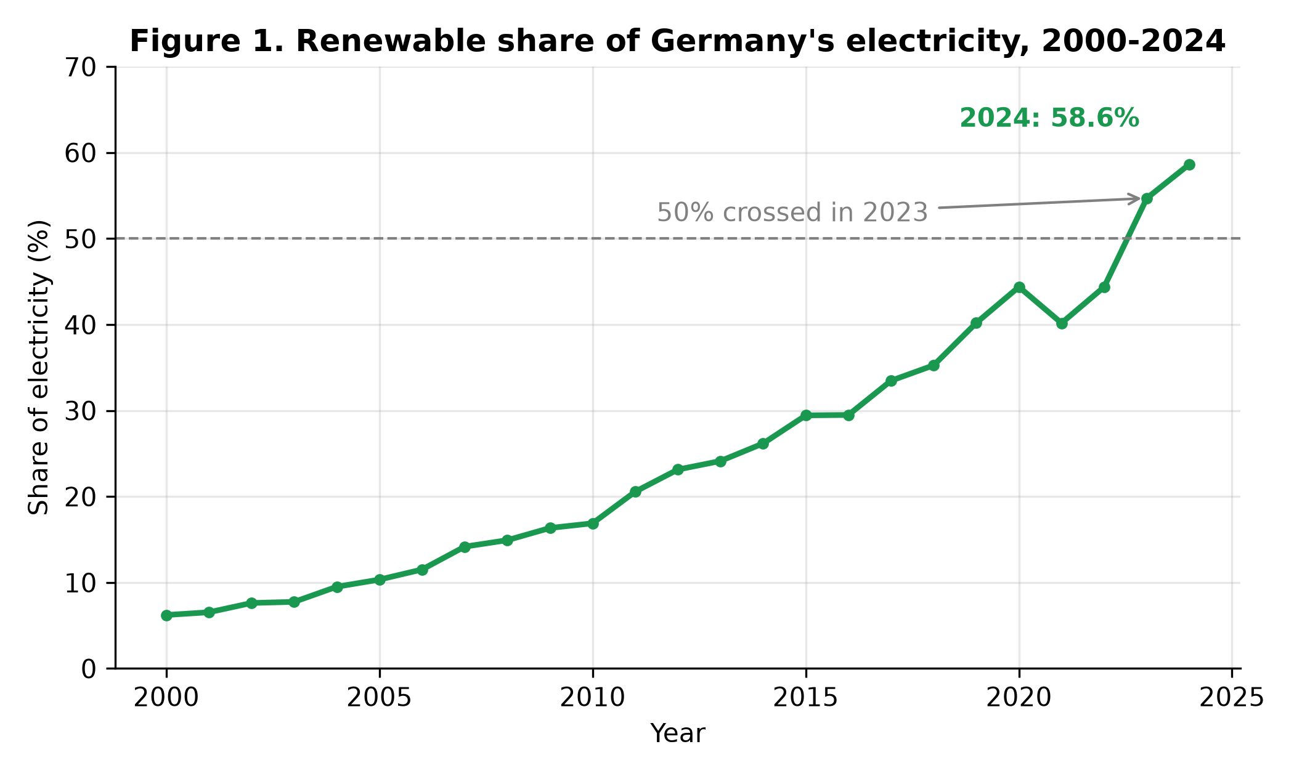
Figure 1. Renewable share of Germany's electricity, 2000–2024.
The pace was not constant. Splitting the period into the three policy eras reveals a clear acceleration:
- 2000–2010 (EEG build-up): 6.22% → 16.89%, trend +1.18 points/year;
- 2011–2019 (post-Fukushima): 20.57% → 40.19%, trend +2.28 points/year;
- 2020–2024 (crisis and acceleration): 44.37% → 58.64%, trend +4.31 points/year.
This acceleration changes the arithmetic of the 80%-by-2030 target. From 58.64% in 2024, the target requires +3.56 points per year for six years. That is far above the 24-year average pace (+2.05, which would reach 80% only in 2039) and above the 2011–2019 pace (+2.28) — but below the pace actually achieved in 2020–2024 (+4.31). The target is therefore neither safely on track nor out of reach: it is attainable if, and only if, the most recent era's pace — which itself benefited from falling demand (Section 4.5) — is sustained for six more years.

4.2 Drivers: wind and solar supplied four-fifths of the growth (RQ2)
Total renewable generation grew from 35.4 TWh (2000) to 290.9 TWh (2024). Wind and solar together account for 80.8% of that increase (Figure 3). Wind generation rose from 9.35 TWh to 141.6 TWh (CAGR 12.0%) and reached 28.55% of all electricity in 2024. Solar grew fastest of all: from 0.10 TWh in 2001 (the first non-zero year in the dataset) to 74.13 TWh in 2024 (CAGR 33.3%), a 14.95% share. Together, wind and solar alone supplied 43.5% of Germany's electricity in 2024 — a larger share than nuclear power supplied in 2000 (29.8%), at what was then its historical peak role in the system. Hydropower, the leading renewable in 2000, grew only slowly, as did biomass after its initial expansion; the transition is overwhelmingly a wind-and-solar story, exactly as the early diffusion literature expected from the EEG's technology-specific tariffs (Jacobsson & Lauber, 2006).
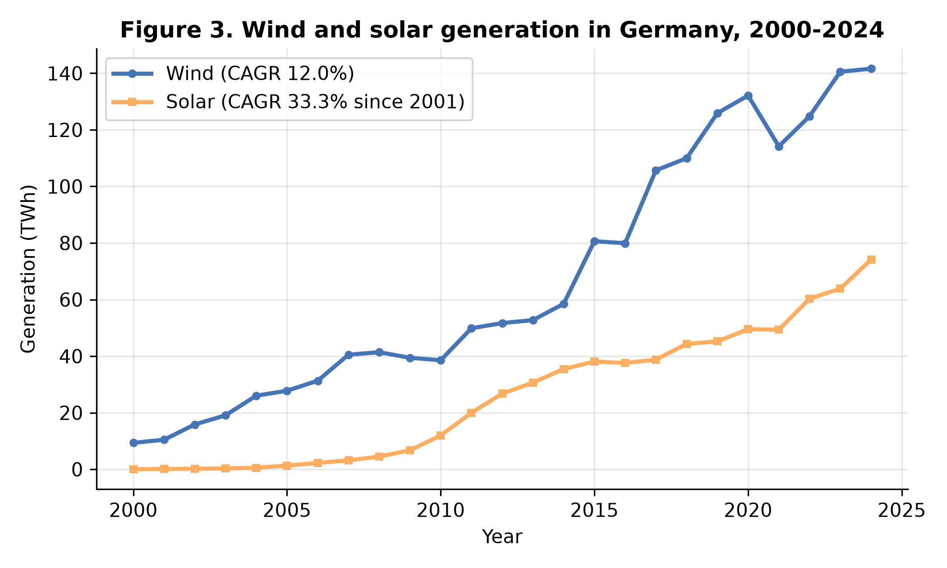
Figure 3. Wind and solar generation in Germany, 2000–2024.

4.3 Displacement: coal halved, nuclear ended (RQ2)
The mirror image of the renewable rise is the decline of the incumbents (Figures 2 and 7). Coal's share fell from 52.15% (2000) to 21.44% (2024), and coal generation fell in absolute terms from 296.7 TWh to 106.3 TWh. Nuclear power declined from 29.81% of generation in 2000 to 6.12% in 2022 and 0% in 2024, following the completion of the phase-out in April 2023 — the first full calendar year without nuclear generation in the dataset is 2024. Gas partly filled the gap left by both, rising from 8.65% to 15.81%.
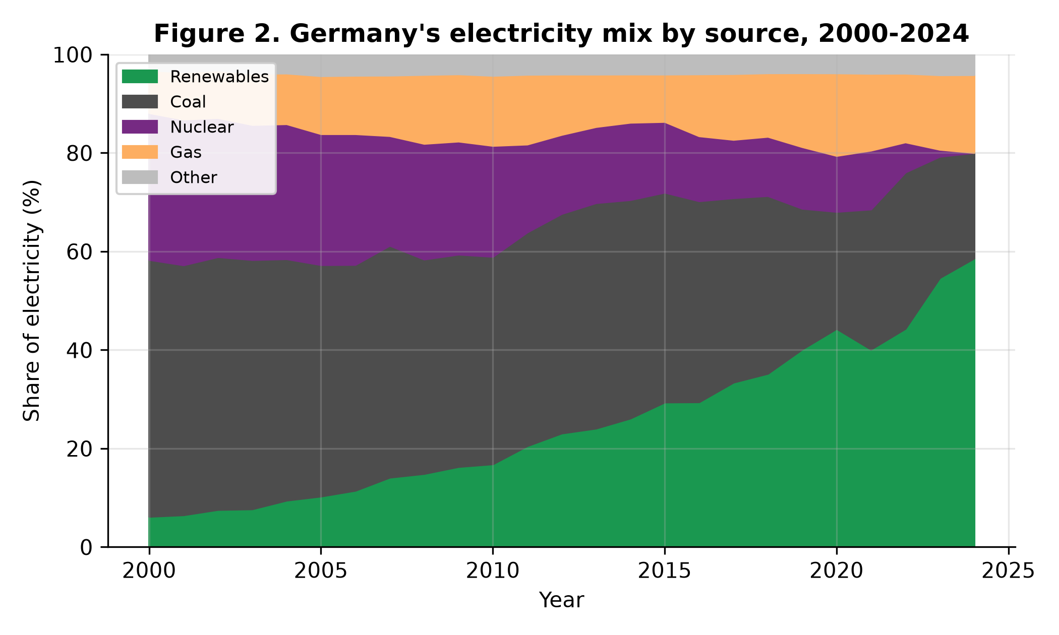
Figure 2. Germany's electricity mix by source, 2000–2024.
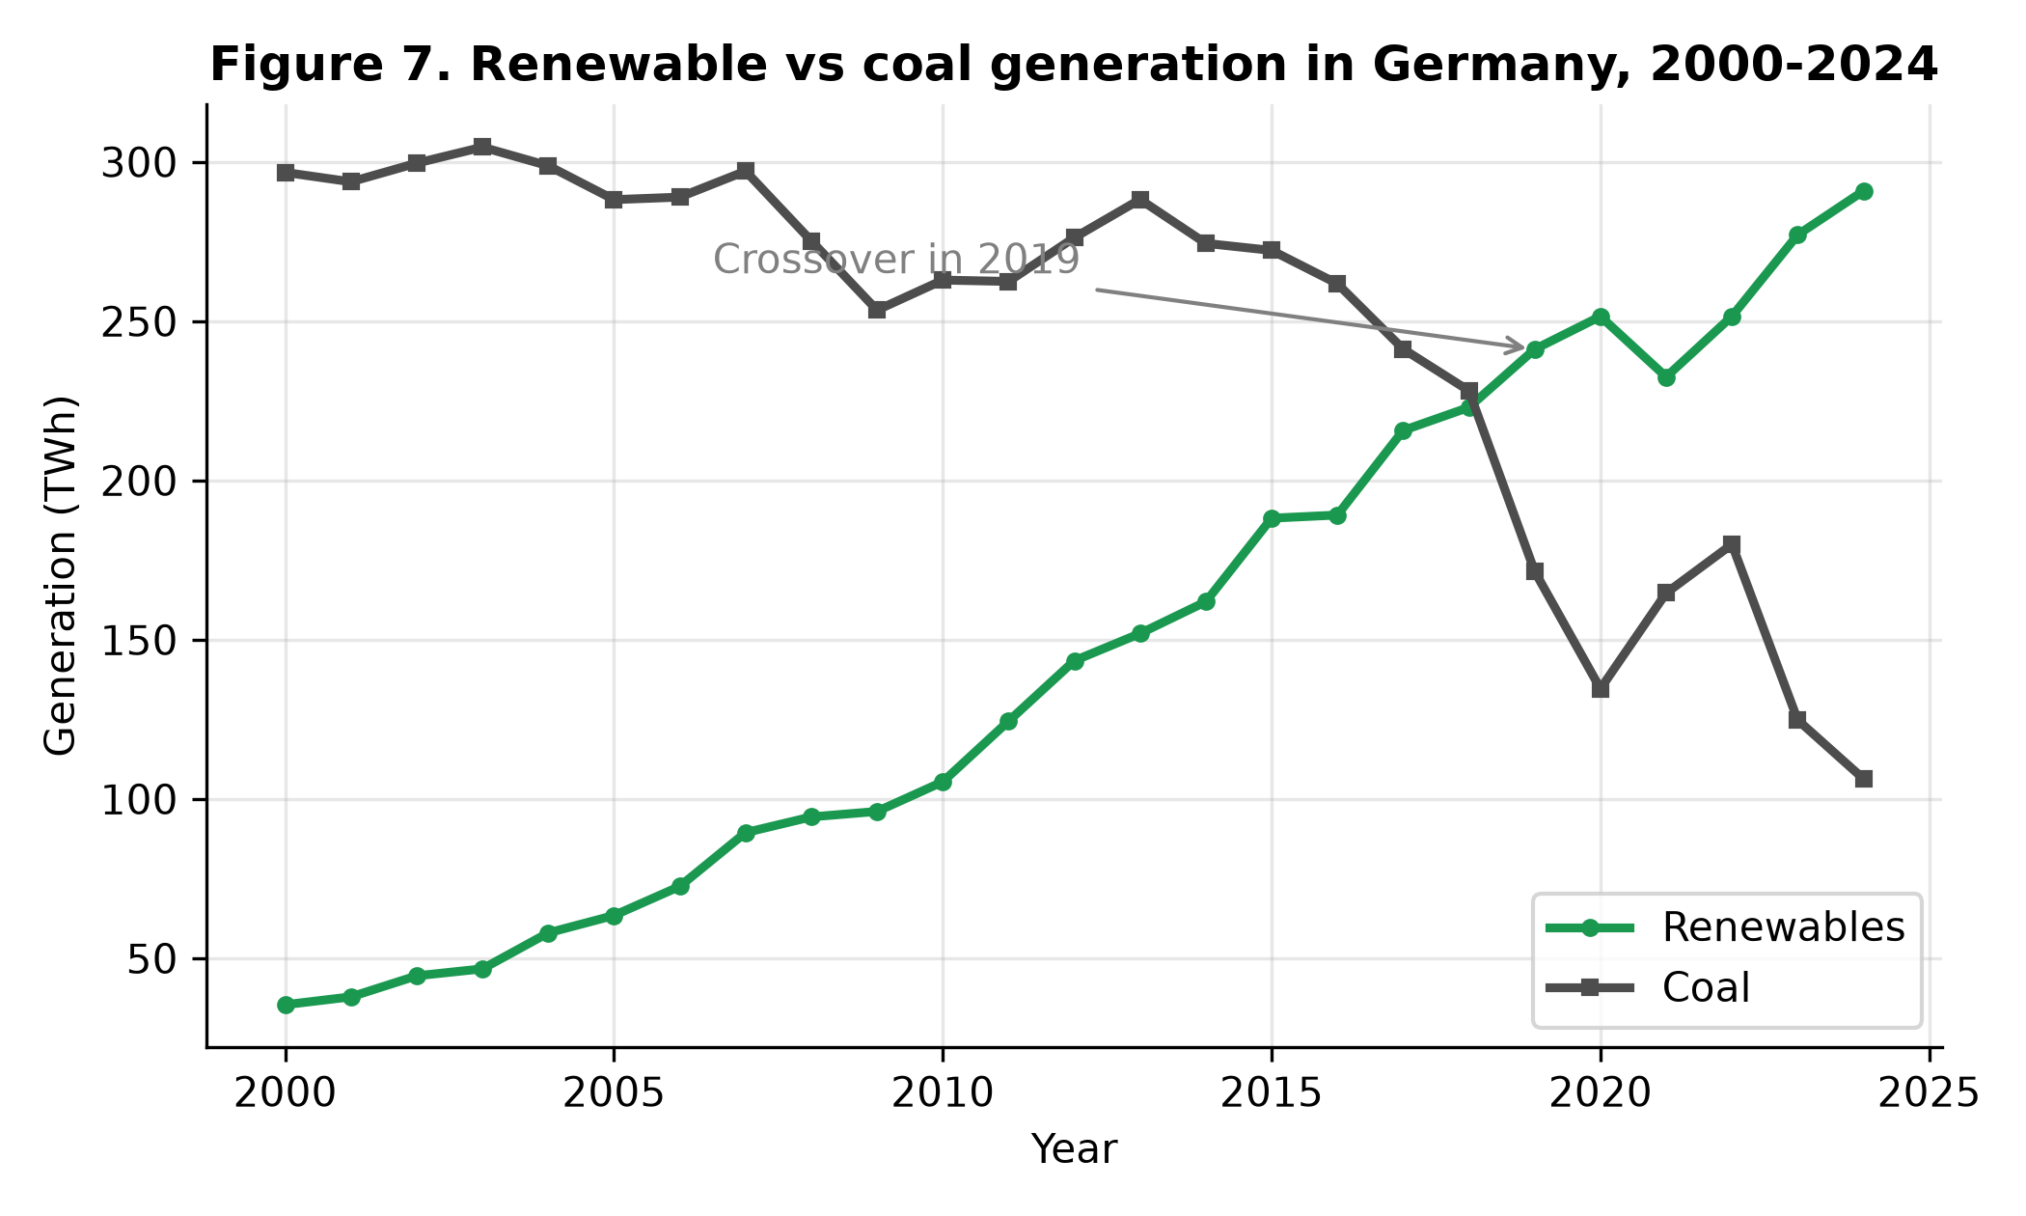
Figure 7. Renewable vs coal generation in Germany, 2000–2024.

4.4 Emissions: association, mechanism, and a warning against causal reading (RQ3)
The carbon intensity of German electricity fell from 573.2 gCO₂/kWh in 2000 to 336.4 gCO₂/kWh in 2024 (−41.3%) (Figure 8). The bivariate association with the renewable share is very strong: Pearson r = −0.95, and the OLS regression gives a slope of −4.56 gCO₂/kWh per additional percentage point of renewable share (SE 0.30, t = −15.18, p < 0.001, R² = 0.909, n = 25). CO₂ emissions per capita fell from 10.99 t to 6.79 t (−38.2%) over the same period (Figure 6).
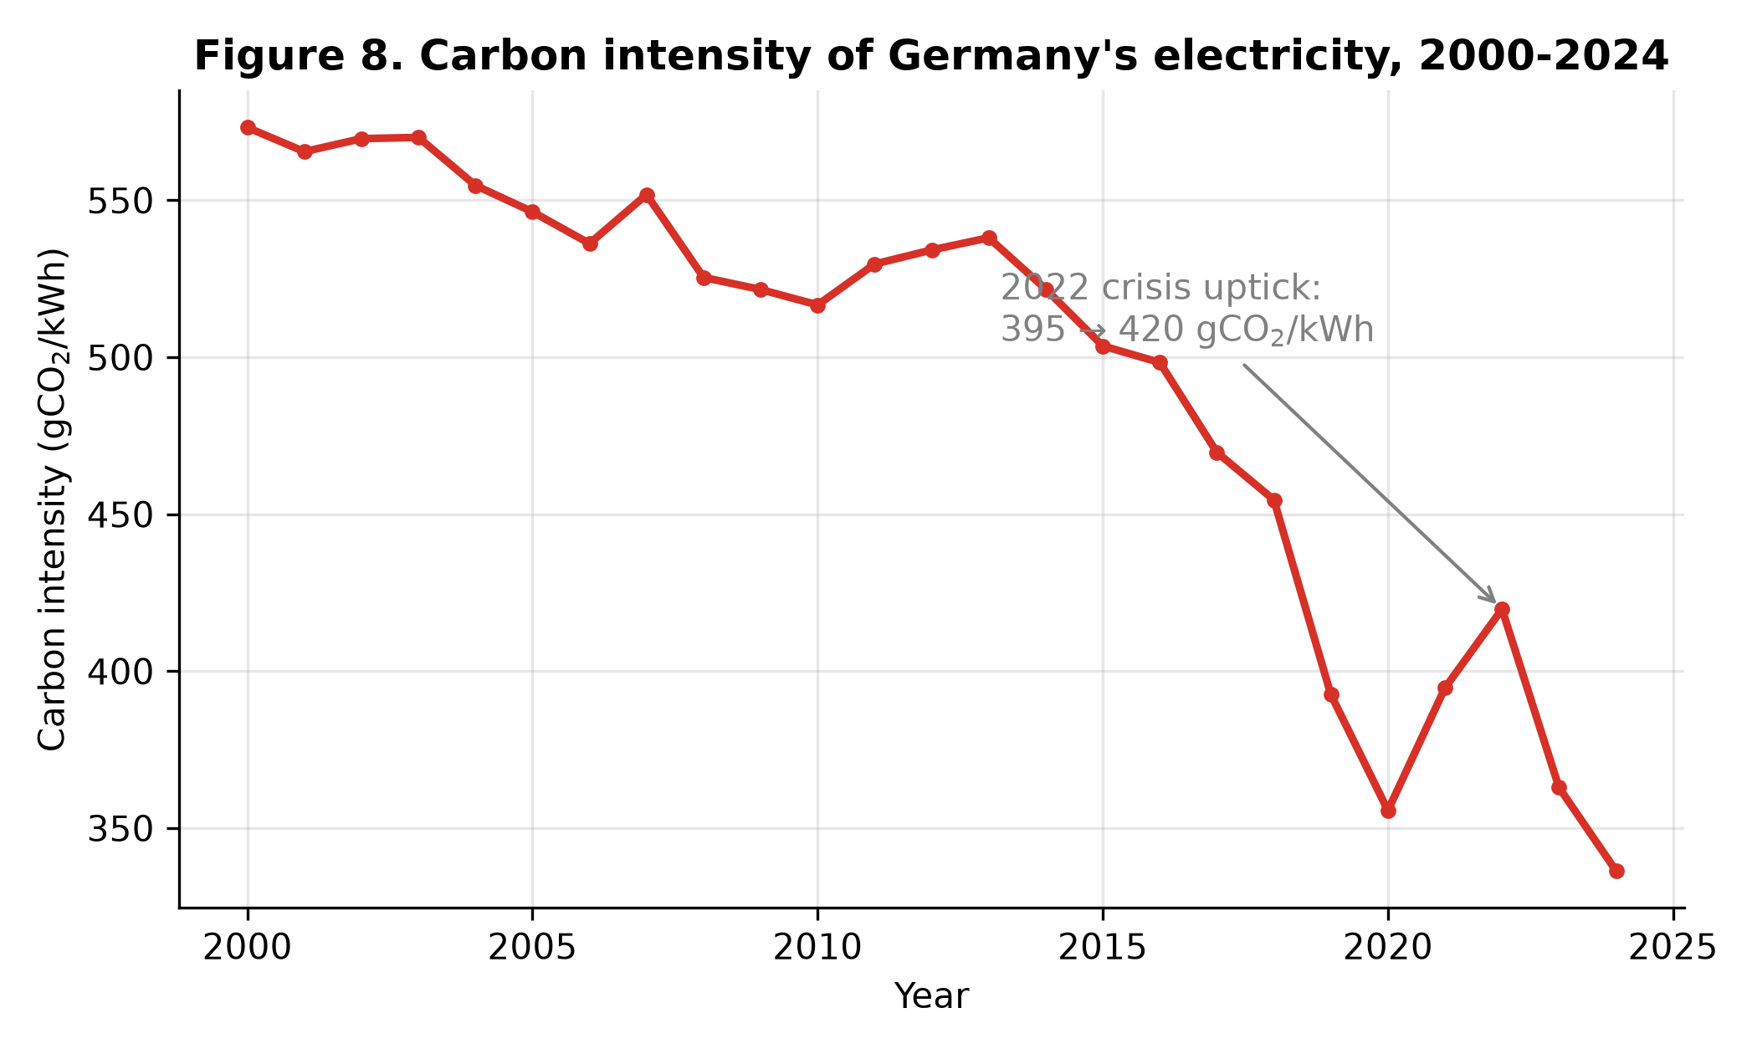
Figure 8. Carbon intensity of Germany's electricity, 2000–2024.
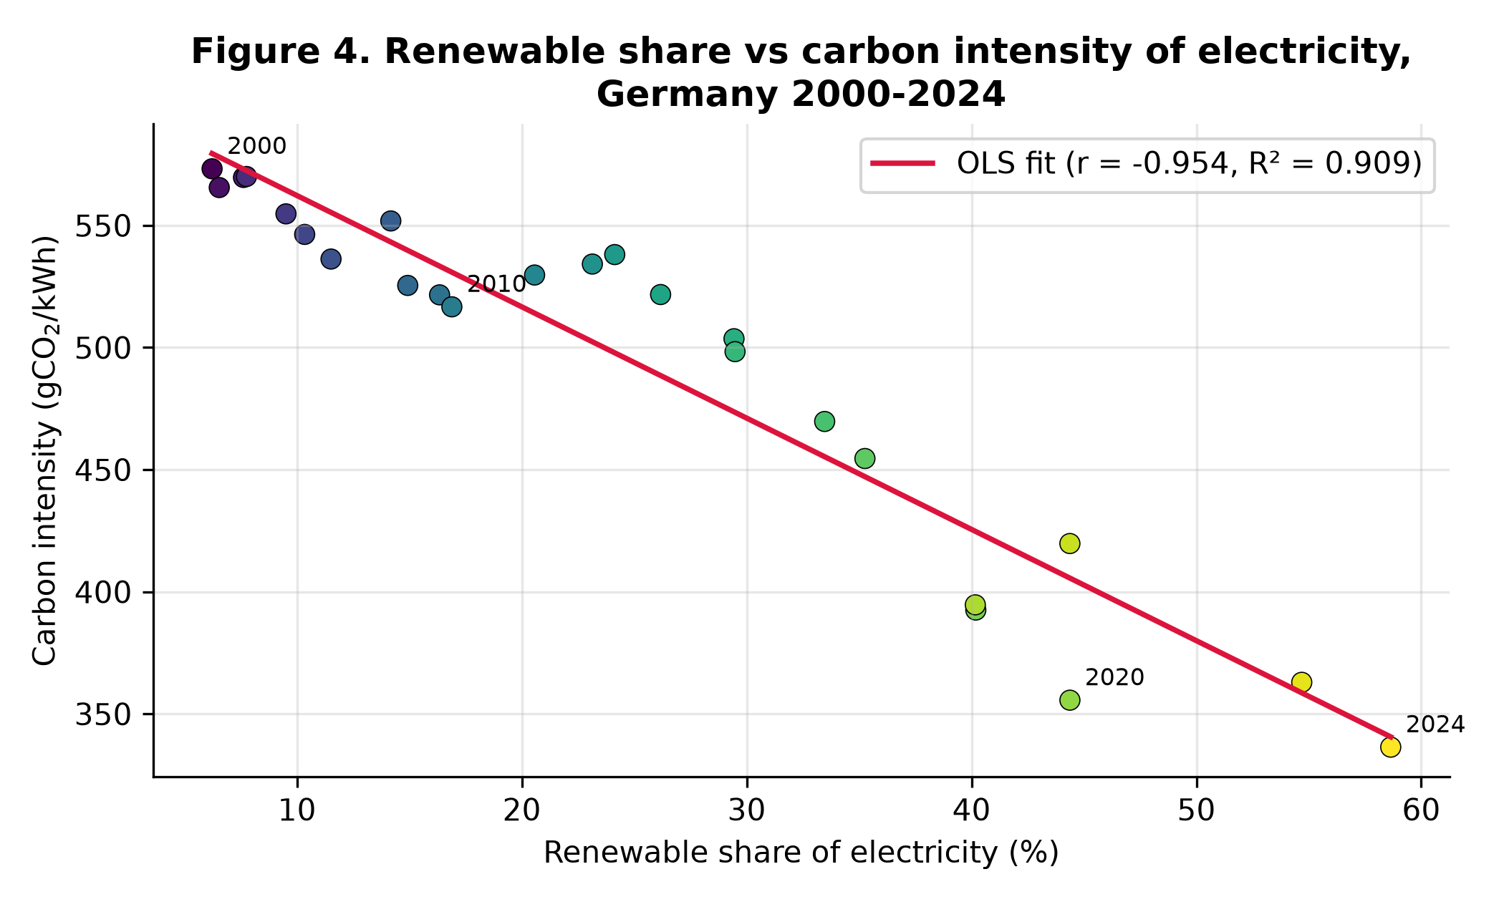
Figure 4. Renewable share vs carbon intensity of electricity, Germany 2000–2024.
The multivariate model (Table 2) shows through which variable this association operates — and why the bivariate slope must not be quoted as "the effect of renewables". With the coal share, gas share and demand included, the model fits almost perfectly (R² = 0.999), because carbon intensity is close to an accounting identity of the generation mix. The dominant coefficient is the coal share: +10.57 gCO₂/kWh per percentage point (p < 0.001), followed by gas (+6.05, p < 0.001); consistently, the raw correlation between the coal share and carbon intensity is 0.996. The renewable-share coefficient changes sign (+0.91) once the fossil shares are held constant — a mechanical consequence of compositional data (shares sum to ~100%, so one share can only rise at another's expense) rather than evidence that renewables raise emissions. The correct reading of the two models together is a displacement mechanism: renewables and the coal share are correlated at r = −0.95, renewables grew by replacing coal first and nuclear second, and it is the coal replacement that delivers the carbon-intensity decline. Studies that report only the bivariate relationship overstate what the data can say; the mechanism matters for policy, because replacing the remaining 21.4% of coal generation offers roughly twice the carbon-intensity gain per point of replacing gas.
Table 2. OLS regression of the carbon intensity of electricity (gCO₂/kWh), Germany, 2000–2024 (n = 25). Standard errors in parentheses.
Variable | Coefficient | Std. error | t | p
Constant | −81.84 | 22.49 | −3.64 | 0.002
Renewable share (%) | 0.91 | 0.13 | 6.82 | <0.001
Coal share (%) | 10.57 | 0.34 | 30.92 | <0.001
Gas share (%) | 6.05 | 0.59 | 10.26 | <0.001
Electricity demand (TWh) | 0.08 | 0.03 | 2.41 | 0.026
R² = 0.999, adjusted R² = 0.999, F = 6119.96 (p < 0.001). The near-perfect fit reflects the near-identity between carbon intensity and the fossil shares; coefficients on compositional shares are interpreted relative to the omitted sources (nuclear, hydro and other), as discussed in the text.

4.5 Two shocks: COVID-19 and the 2022 energy crisis (RQ4)
The annual data register both shocks cleanly. Electricity demand fell 3.5% in 2020 (567.4 → 547.7 TWh) during COVID-19, partly recovered in 2021 (+2.3%), and the renewable share jumped in 2020 (40.19% → 44.37%) partly because the denominator shrank. In 2022, after the cut in Russian pipeline gas, the gas share of generation fell from 15.60% to 13.95%, the coal share rebounded from 28.45% to 31.74%, demand fell 3.7%, and the carbon intensity of electricity rose 6.4% in a single year (394.6 → 419.7 gCO₂/kWh) — the only interruption of its decline in the series. By 2024 the coal share had fallen to a period low (21.44%) and carbon intensity to 336.4 gCO₂/kWh, confirming the rebound was a one-year crisis response inside a structural trend. One further fact conditions all share-based results: German electricity demand peaked in 2007 at 614.5 TWh and has trended downward since (−2.59 TWh/year), so part of the renewable share's growth is a denominator effect — a point taken up in Sections 5 and 6.

4.6 Comparison: three different decarbonisation strategies (RQ5)
The 2024 comparison (Table 3, Figures 5–6) shows that a low-carbon system can be approached by different routes at different speeds. Denmark, starting earliest, reached 89.19% renewables and achieved the largest per-capita emission cut of the four (−55.5%). France has by far the cleanest electricity (40.5 gCO₂/kWh) despite a modest renewable share (27.18%), because 67.72% of its generation is nuclear. Poland illustrates the cost of delay: still 54.32% coal, it has the highest carbon intensity (608.2 gCO₂/kWh) and the smallest per-capita reduction (−12.9%). Germany sits between the archetypes: the fastest renewable build-out of any large system in the sample (+52.4 points since 2000), yet a carbon intensity still eight times France's, because one-fifth of its electricity still comes from coal.
Table 3. Electricity transition indicators, 2000–2024. Sources: OWID energy and CO₂ datasets; values computed by the project code.
Country | Renewables 2000 (%) | Renewables 2024 (%) | Coal 2024 (%) | Nuclear 2024 (%) | Carbon intensity 2024 (gCO₂/kWh) | CO₂ per capita 2000 → 2024 (t) | Change (%)
Germany | 6.22 | 58.64 | 21.44 | 0.00 | 336.4 | 10.99 → 6.79 | −38.2
France | 12.74 | 27.18 | 0.18 | 67.72 | 40.5 | 6.86 → 3.93 | −42.8
Poland | 1.63 | 31.15 | 54.32 | 0.00 | 608.2 | 8.29 → 7.23 | −12.9
Denmark | 15.54 | 89.19 | 4.99 | 0.00 | 131.8 | 10.17 → 4.52 | −55.5
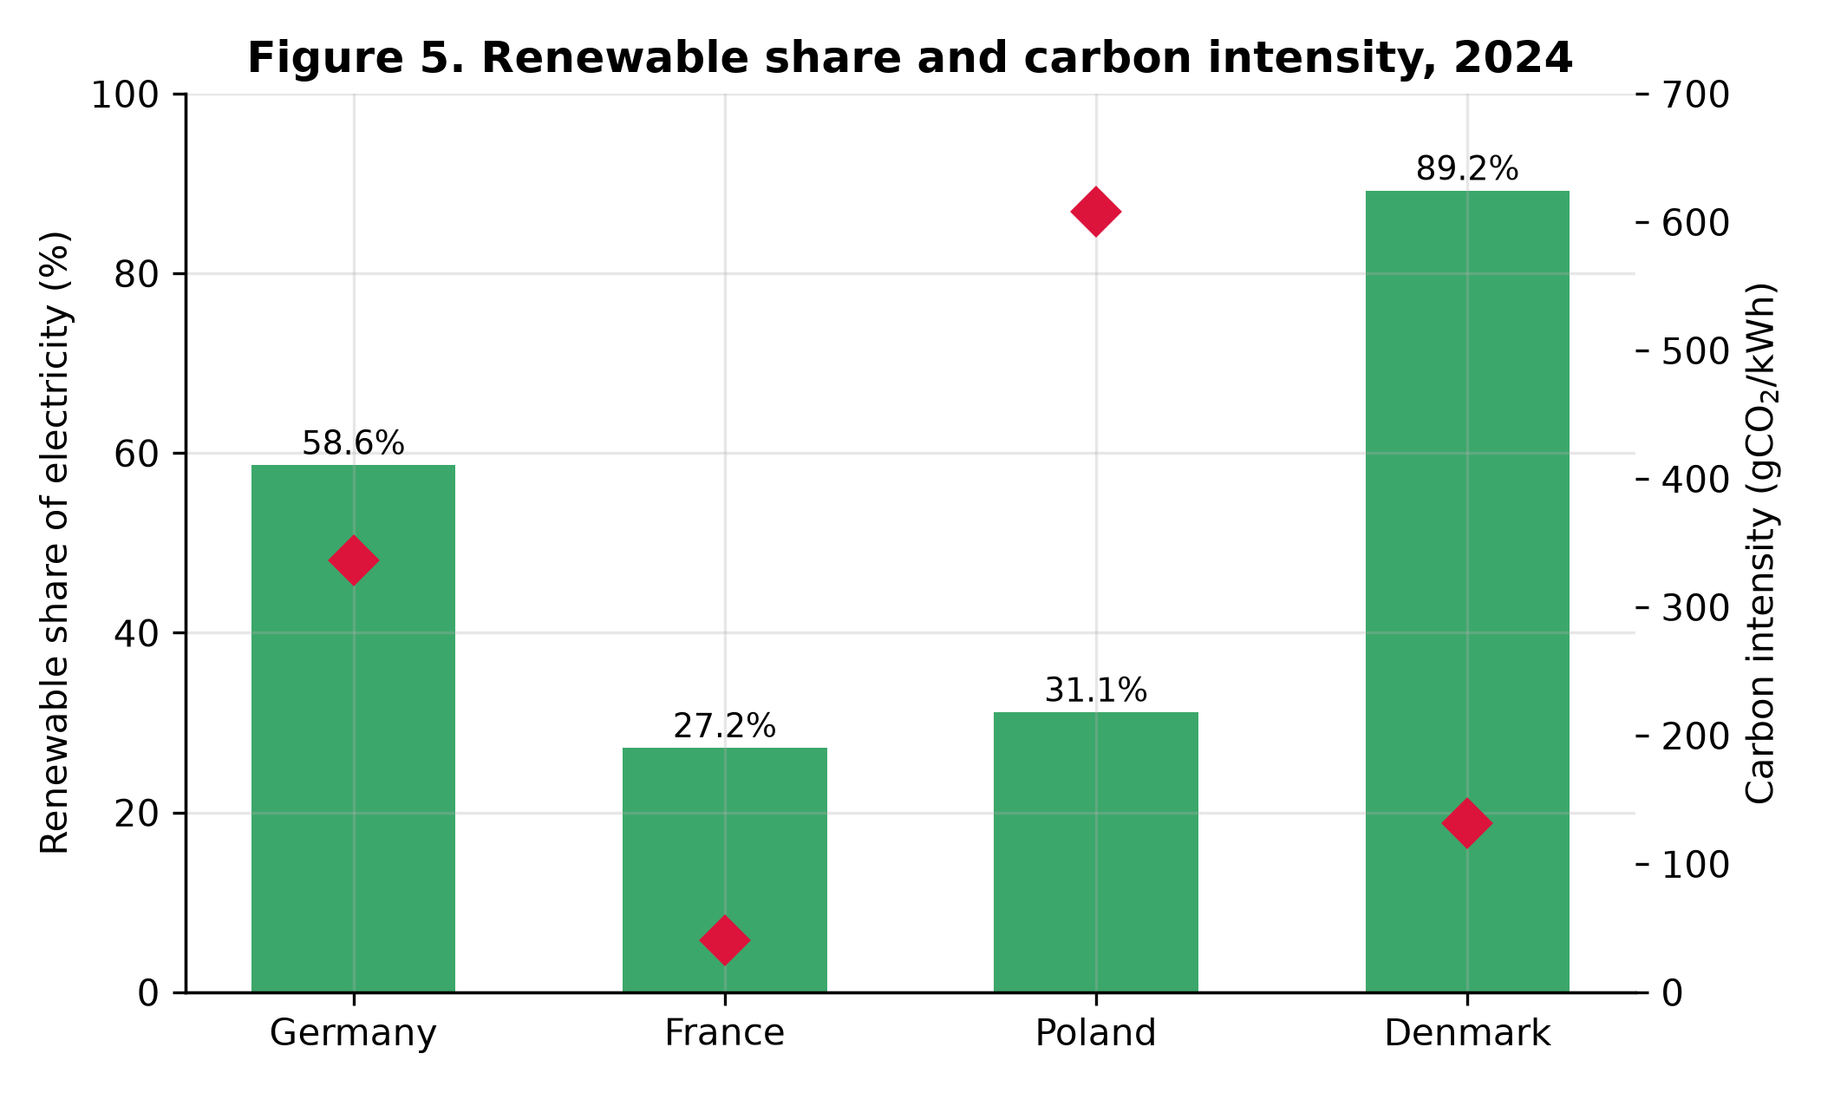
Figure 5. Renewable share and carbon intensity, 2024.
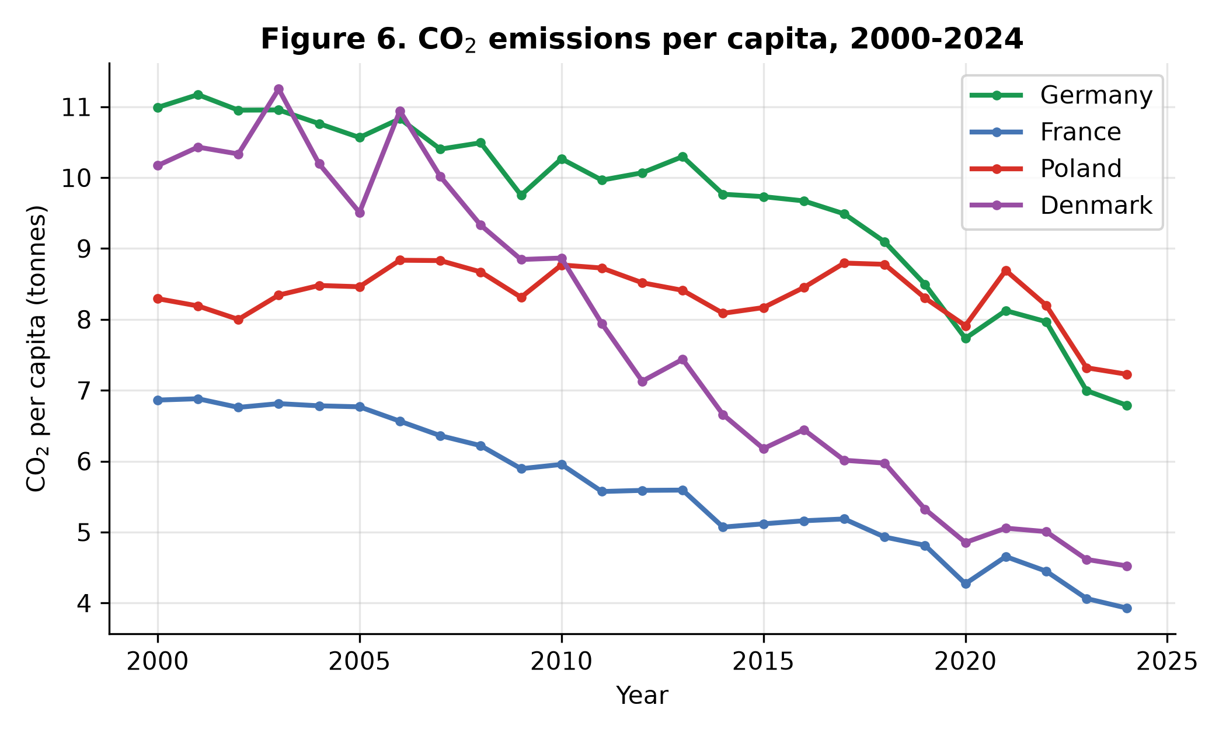
Figure 6. CO₂ emissions per capita, 2000–2024.

5. Discussion
The pace question is now the whole question. The historical part of the German transition is, by the numbers, a success: a nine-fold increase in renewable share, a completed nuclear exit, a halved coal share and a 41% cut in electricity carbon intensity, achieved without a single year of system failure and with only a one-year reversal under the largest energy-supply shock in post-war European history. What the trend analysis adds is precision about the future: the 80%-by-2030 target requires a pace (+3.56 points/year) that Germany has sustained only in the most recent, demand-assisted era. Public debate that cites the 24-year average ("too slow, the target will be missed") and debate that cites the recent acceleration ("well on track") are both extrapolating real numbers — from different windows. The honest statement is conditional: the target is reachable at the 2020–2024 pace, and that pace must now be maintained for six consecutive years without the help of falling demand.
Composition is the second question. Because wind and solar supplied 80.8% of renewable growth, Germany has entered the penetration range in which the variability literature (Hirth, 2013; Ueckerdt et al., 2013; Sinn, 2017) predicts rising integration costs and falling market values. The annual data used here cannot test those predictions — they concern hours, not years — but they define the research frontier for this dataset's continuation: as wind and solar pass 43.5% of generation, the binding constraints become grids, storage, flexibility and market design, not deployment volume. The multivariate result points the same way: with coal displacement identified as the emissions mechanism, the remaining 21.4% of coal generation is the single largest lever left, and replacing it with firm low-carbon capacity or flexibility yields more than replacing gas.
Strategy comparison cuts both ways. France demonstrates that a nuclear-led system can be far cleaner per kilowatt-hour than Germany's is today, and did so decades earlier; Denmark demonstrates that a renewables-led system can go furthest overall, helped by a small, interconnected grid and exceptional wind resources. Neither comparison reverses the evaluation of the German path — Germany is decarbonising a large, industrial, formerly coal-and-nuclear system — but together they show that "renewable share" and "clean electricity" are different metrics, and that Germany currently leads on the first while trailing on the second.
On cost, this paper is deliberately silent. The deployment record documented here is compatible with both the supportive reading of the EEG (Jacobsson & Lauber, 2006; IEA, 2020) and the cost critique (Frondel et al., 2010). Deciding between them requires cost data — support payments, system costs, avoided externalities — that this study does not analyse; Section 6 lists this as a boundary, not a finding.

6. Limitations
Five limitations bound the conclusions. (1) Association, not causation. All regressions are estimated on 25 annual observations of trending series; coefficients describe co-movement, and the multivariate model's near-perfect fit reflects the accounting structure of the data rather than discovered causation. (2) Compositional regressors. The generation shares sum to ~100%, inducing mechanical correlations (the renewable share's sign change in Table 2 is the visible symptom); the paper mitigates this by interpreting the bivariate and multivariate models jointly, but a log-ratio specification would be the stricter treatment. (3) Annual aggregation. Hourly phenomena — negative prices, curtailment, storage needs — are invisible at this frequency; the variability literature cited operates on hourly data for this reason. (4) The denominator effect. Shares are ratios: the renewable share rose partly because demand fell from its 2007 peak (614.5 TWh) to 522.3 TWh. Absolute renewable generation also grew 8.2-fold, so the transition is not an artefact of demand decline, but share-based targets inherit this sensitivity. (5) Scope. Costs, employment, land use, public acceptance and trade in electricity (notably Denmark's interconnection) are outside the dataset and the analysis.

7. Conclusions
Between 2000 and 2024 Germany moved from 6.2% to 58.6% renewable electricity, ended nuclear generation, cut coal's share from 52.2% to 21.4%, reduced the carbon intensity of its electricity by 41.3% and CO₂ per capita by 38.2%. Wind and solar drove the change (80.8% of renewable growth); the emissions decline operated through coal displacement; and two major shocks — a pandemic and an energy crisis — disturbed the trend for a single year each without reversing it. The remaining agenda is precisely quantifiable: sustain at least +3.56 percentage points per year to reach 80% renewables by 2030, and remove the last fifth of coal generation, which the regression evidence identifies as the largest remaining emissions lever. Whether the post-2024 system can do this at penetration levels where integration costs rise is the question the next study — ideally on hourly data — should take up.

Data Availability
Analysis code, the extracted dataset, the nine SQL queries and all figures are openly available in the project repository: github.com/rashedrana/germany-renewable-energy-analysis. Source datasets: OWID energy data (github.com/owid/energy-data) and OWID CO₂ data (github.com/owid/co2-data), both published under CC BY licences.

References
- Ember (2024). Electricity Data Explorer; Global Electricity Review 2024. ember-energy.org.
- Energy Institute (2024). Statistical Review of World Energy 2024. energyinst.org.
- Frondel, M., Ritter, N., Schmidt, C. M. & Vance, C. (2010). "Economic impacts from the promotion of renewable energy technologies: The German experience." Energy Policy 38(8), 4048–4056. doi:10.1016/j.enpol.2010.03.029.
- German Federal Government (2023). Renewable Energy Sources Act (Erneuerbare-Energien-Gesetz, EEG 2023) — 80% renewable electricity target for 2030.
- Global Carbon Project (2024). Global Carbon Budget 2024.
- Hirth, L. (2013). "The market value of variable renewables: The effect of solar wind power variability on their relative price." Energy Economics 38, 218–236. doi:10.1016/j.eneco.2013.02.004.
- IEA (2020). Germany 2020: Energy Policy Review. OECD/IEA, Paris. doi:10.1787/cedb9b0a-en.
- Jacobsson, S. & Lauber, V. (2006). "The politics and policy of energy system transformation — explaining the German diffusion of renewable energy technology." Energy Policy 34(3), 256–276.
- Ritchie, H., Roser, M. & Rosado, P. (2022). "Energy." Our World in Data. ourworldindata.org/energy.
- Sinn, H.-W. (2017). "Buffering volatility: A study on the limits of Germany's energy revolution." European Economic Review 99, 130–150. doi:10.1016/j.euroecorev.2017.05.007.
- Ueckerdt, F., Hirth, L., Luderer, G. & Edenhofer, O. (2013). "System LCOE: What are the costs of variable renewables?" Energy 63, 61–75. doi:10.1016/j.energy.2013.10.072.

Declaration
This manuscript was prepared with AI assistance for data analysis and drafting, under the author's direction. All results were computed from the published datasets with the openly available code listed above and verified by the author, who takes full responsibility for the content. This disclosure will be adapted to the author guidelines of the venue at the time of submission.

