

Course: Networking
Assignment: Edge Link Company

Section (A):
- Network Planning:
In order to install the EdgeLink network throughout the Amman headquarters and the regional offices in Irbid, Zarqa, Aqaba, Salt, Ajloun, Jerash, Tafila and Ma’an, a hierarchical IP addressing scheme was implemented over the Local Area Networks (LANs) and used the private range of addresses 172.16.0.0/16.
It was this address block that was subdivided into smaller subnets so that it could efficiently utilise addresses and that the requirements of every location can be met. The /25 subnet mask (255.255.255.128) was assigned to each branch LAN; this mask can support 128 IP addresses within the network and 126 host addresses can be used out of these 128 IP addresses and the network and broadcast addresses.
The size of this subnet has been chosen to accommodate the assignment requirement of a maximum of 100 users per branch as well as allow future expansion without necessarily having to re-subnet it now. Amman headquarters also had several subnets / 25 to isolate user devices and server infrastructure thus enhancing better network organisation and easy management. Each site has its own subnets allocated within it and this makes the logical segmentation, minimizes broadcast news in the individual LANs and improves the performance of the entire network. An independent address range of 193.1.1.0/24 was employed in order to connect between Wide Area Network (WAN) routers. This was subnetted into /30 networks (255.255.255.252) to enable point to point links between routers. The number of usable IP addresses within each /30 subnet is always two which works perfectly in router-to- router communication and reduces the number of IP addresses wasted.
This type of subnetting allows easy distinction between LAN and WAN traffic, easy OSPF route advertisements, and a routing convergence across the network that is faster and more stable. Also, with the same size of subnet in all the branches, it is easily scalable because new sites can be added by assigning unused subnets of the available address ranges.
LAN IP Addressing Table:
Site / LAN | Subnet Address | Subnet Mask | Hosts Range | Gateway (Router LAN IP) | Broadcast
Amman HQ – Users LAN | 172.16.0.0 | 255.255.255.128 | 172.16.0.1 – 172.16.0.126 | 172.16.0.1 | 172.16.0.127
Amman HQ – Servers LAN | 172.16.0.128 | 255.255.255.128 | 172.16.0.129 – 172.16.0.254 | 172.16.0.129 | 172.16.0.255
Zarqa LAN | 172.16.1.0 | 255.255.255.128 | 172.16.1.1 – 172.16.1.126 | 172.16.1.1 | 172.16.1.127
Irbid LAN | 172.16.1.128 | 255.255.255.128 | 172.16.1.129 – 172.16.1.254 | 172.16.1.129 | 172.16.1.255
Ajloun LAN | 172.16.2.0 | 255.255.255.128 | 172.16.2.1 – 172.16.2.126 | 172.16.2.1 | 172.16.2.127
Jerash LAN | 172.16.2.128 | 255.255.255.128 | 172.16.2.129 – 172.16.2.254 | 172.16.2.129 | 172.16.2.255
Salt LAN | 172.16.3.0 | 255.255.255.128 | 172.16.3.1 – 172.16.3.126 | 172.16.3.1 | 172.16.3.127
Aqaba LAN | 172.16.3.128 | 255.255.255.128 | 172.16.3.129 – 172.16.3.254 | 172.16.3.129 | 172.16.3.255
Tafila LAN | 172.16.4.0 | 255.255.255.128 | 172.16.4.1 – 172.16.4.126 | 172.16.4.1 | 172.16.4.127
Ma’an LAN | 172.16.4.128 | 255.255.255.128 | 172.16.4.129 – 172.16.4.254 | 172.16.4.129 | 172.16.4.255

WAN Addressing Table:
Router | WAN Link | Router WAN IP | Subnet Mask | Hosts Range | Broadcast
Amman HQ | to Zarqa | 193.1.1.1 | 255.255.255.252 | 193.1.1.1 – 193.1.1.2 | 193.1.1.3
 | to Ma’an | 193.1.1.34 | 255.255.255.252 | 193.1.1.33 – 193.1.1.34 | 193.1.1.35
Zarqa | to Amman | 193.1.1.2 | 255.255.255.252 | 193.1.1.1 – 193.1.1.2 | 193.1.1.3
 | to Irbid | 193.1.1.5 | 255.255.255.252 | 193.1.1.5 – 193.1.1.6 | 193.1.1.7
Irbid | to Zarqa | 193.1.1.6 | 255.255.255.252 | 193.1.1.5 – 193.1.1.6 | 193.1.1.7
 | to Aqaba | 193.1.1.9 | 255.255.255.252 | 193.1.1.9 – 193.1.1.10 | 193.1.1.11
Aqaba | to Irbid | 193.1.1.10 | 255.255.255.252 | 193.1.1.9 – 193.1.1.10 | 193.1.1.11
 | to Ajloun | 193.1.1.13 | 255.255.255.252 | 193.1.1.13 – 193.1.1.14 | 193.1.1.15
Ajloun | to Aqaba | 193.1.1.14 | 255.255.255.252 | 193.1.1.13 – 193.1.1.14 | 193.1.1.15
 | to Jerash | 193.1.1.17 | 255.255.255.252 | 193.1.1.17 – 193.1.1.18 | 193.1.1.19
Jerash | to Ajloun | 193.1.1.18 | 255.255.255.252 | 193.1.1.17 – 193.1.1.18 | 193.1.1.19
 | to Salt | 193.1.1.21 | 255.255.255.252 | 193.1.1.21 – 193.1.1.22 | 193.1.1.23
Salt | to Jerash | 193.1.1.22 | 255.255.255.252 | 193.1.1.21 – 193.1.1.22 | 193.1.1.23
 | to Tafila | 193.1.1.25 | 255.255.255.252 | 193.1.1.25 – 193.1.1.26 | 193.1.1.27
Tafila | to Salt | 193.1.1.26 | 255.255.255.252 | 193.1.1.25 – 193.1.1.26 | 193.1.1.27
 | to Ma’an | 193.1.1.29 | 255.255.255.252 | 193.1.1.29 – 193.1.1.30 | 193.1.1.31
Ma’an | to Tafila | 193.1.1.30 | 255.255.255.252 | 193.1.1.29 – 193.1.1.30 | 193.1.1.31
 | to Amman | 193.1.1.33 | 255.255.255.252 | 193.1.1.33 – 193.1.1.34 | 193.1.1.35

Routers Passwords:
Router | Console Password | Enable Secret Password
Amman Router | Amman1234 | Amman1234
Zarqa Router | Zarqa1234 | Zarqa1234
Irbid Router | Irbid1234 | Irbid1234
Aqaba Router | Aqaba1234 | Aqaba1234
Ajloun Router | Ajloun1234 | Ajloun1234
Jerash Router | Jerash1234 | Jerash1234
Salt Router | Salt1234 | Salt1234
Tafila Router | Tafila1234 | Tafila1234
Ma’an Router | Ma’an1234 | Ma’an1234
Topology Diagram:
Figure 1: It is a diagram that represents my network topology of EdgeLink Company. It is a Point-to-Point WAN topology and 10 star topologies of LAN. This figure was made on Cisco Packet Tracer 9.0.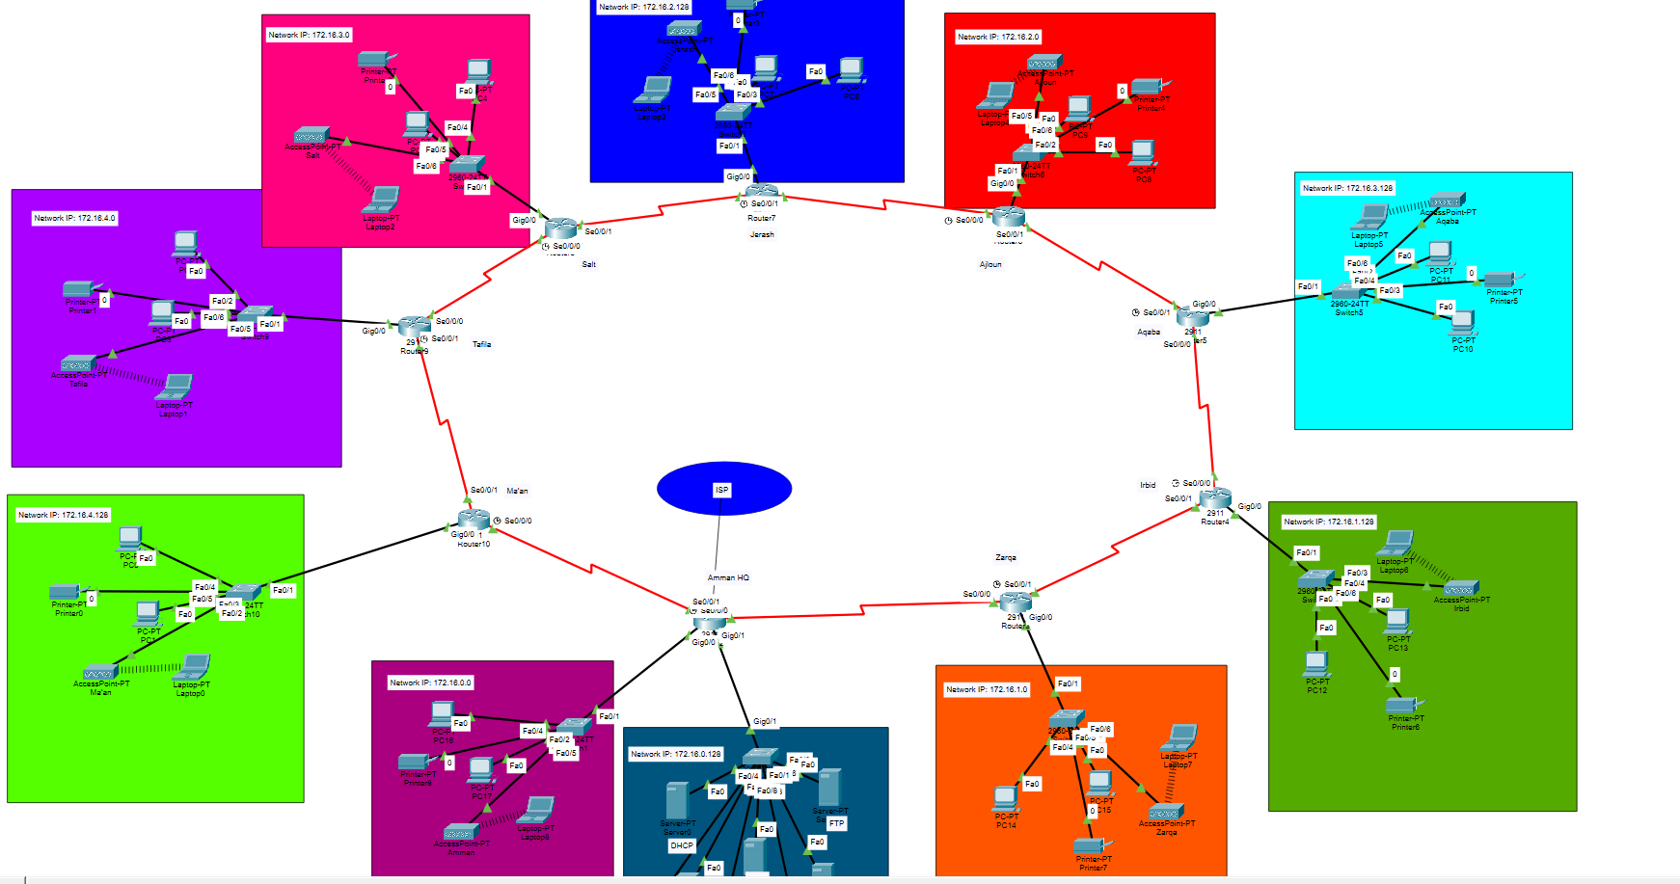
Figure 1
Example of the Wan Topology:
The WAN topology has a point to point connection of routers and the point is allocated with a /30 subnet. This design will guarantee effective IP utilization, transparentness of the router-to- router communication, and fulfilling the assignment condition of point-to-point WAN architecture.
Figure 2: is an example of the WAN topology from my packet tracer app.
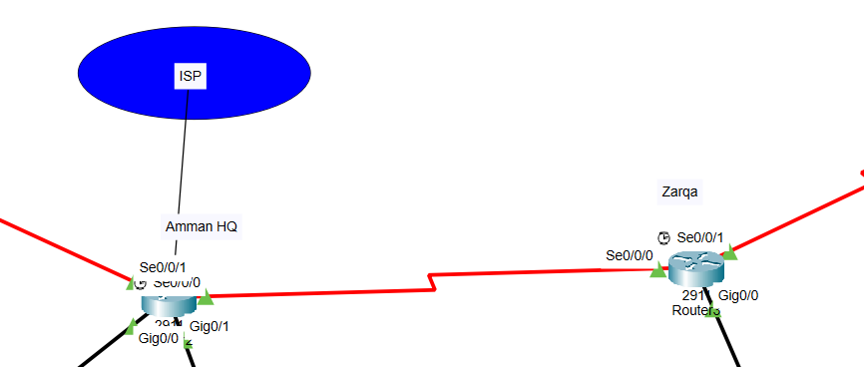
Figure 2
Example of the LAN Topology:
The topology of every branch LAN is star-shaped with end devices within the LAN being connected by the central switch which is connected to the router. This design is easier to manage, reduces effects of a failure in a device and is scalable. Each LAN was allocated dedicated /25 subnets and Amman HQ was better organised and secured by having Amman HQ user and server LANs.
Figure 3: is an example of the LAN topology from my packet tracer app.
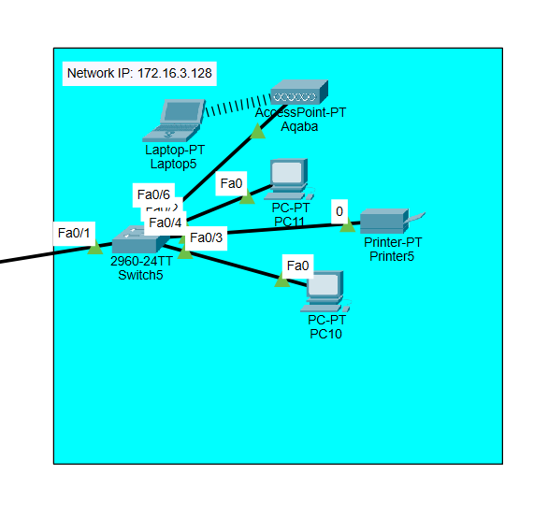Figure 3
Design Justification (Efficiency, Scalability, and Security):
The network was meant to suit the assignment requirement of point-to-point WAN topology to link the Amman headquarters to all the branch offices. The /30 subnets were used to implement point-to-point links, and in doing so, offer only two addresses on a single link that are usable. This will provide good use of IP addresses, prevent wastages of addresses, and also clearly isolate WAN from LAN communications. In the case of local networks, assigned subnets of the 25 /25 were used to each branch LAN to accommodate 100 users per branch as needed. The similarity of the subnet size of the sites makes the network easier to keep track of, troubleshoot, and to grow in the future.
The division of the Amman headquarters into user and server LAN further enhances efficiency by sorting out traffic and minimising overheads of broadcasting. Scalability All the structures of IP addressing plan and application of OSPF as routing protocol support scalability. OSPF is a dynamic router that advertises routes among the routers, such that new branches or subnets can be added without extensive reconfiguration. More point-to-point WAN connections may be easily added by assigning new /30 subnets with the current address range of WAN. Logical segmentation and controlled addressing increase the level of security.
Critical devices like routers, servers, and printers have fixed IP addresses so that they can have an assured access and end-user devices get addresses dynamically through DHCP. Concentrating network services in the Amman headquarters makes it easier to manage the core services and has the advantage of enabling the management to control core services better. The simplest security at the device level such as passwords and intro screens identify further security at the network infrastructure against unauthorised access..
- System Implementation
In this section, the network configuration of EdgeLink Networks using existing design is described and implemented. The acquired system consists of router and LAN setup, point to point WAN connection, dynamic route setup, network services and simple security settings.
To verify that routing, addressing and services are as intended, configuration evidence is given in the form of screenshots. The deployed network was also run to test that it had complete end-to end connectivity between the headquarters and all the branch offices. The success of the routing updates, dynamic IP assignment, service availability, and security controls prove that the system will be functioning in line with the planned network design and addressing scheme.
- Router Interface Configuration
Figure 4: LAN Interface Configuration from my topology.
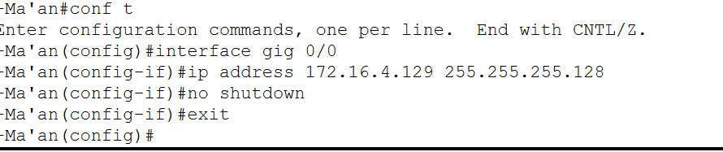
Figure 4

Figure 5: WAN Interface Configuration from my topology.
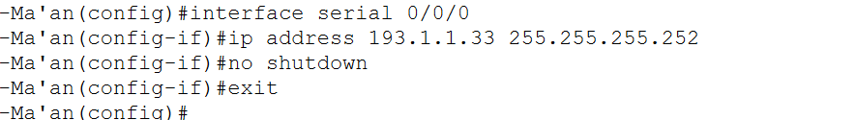
Figure 5

Figure 6: Displays the output when I issued (Show IP interface brief) the command, it displays that all the interfaces are up, and the connectivity is good at Ma’an Router, according to my topology.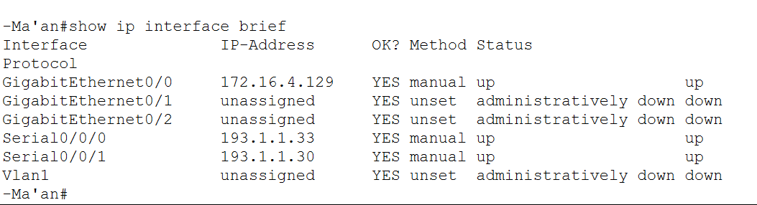
Figure 6

- Routing Configuration (OSPF)

Figure 7: This figure proves that OSPF is properly installed in the network. My topology was able to experience successful routing between the headquarters and all branch locations, shown by the fact that routes to the remote LANs and WAN subnets are dynamically learned.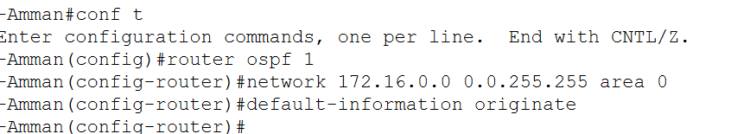

Figure 7

Figure 8: Shows the Loopback configuration in my topology.
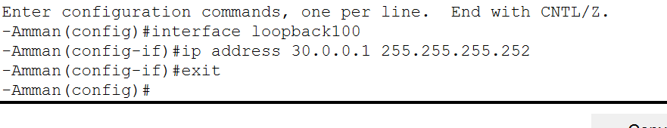
Figure 9+10: shows the result while commanding ( show running-config), from my topology in Router Amman HQ.
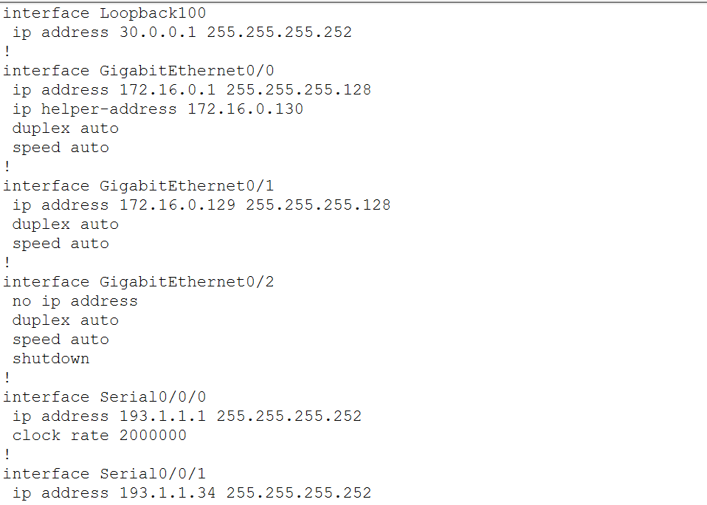
Figure 9
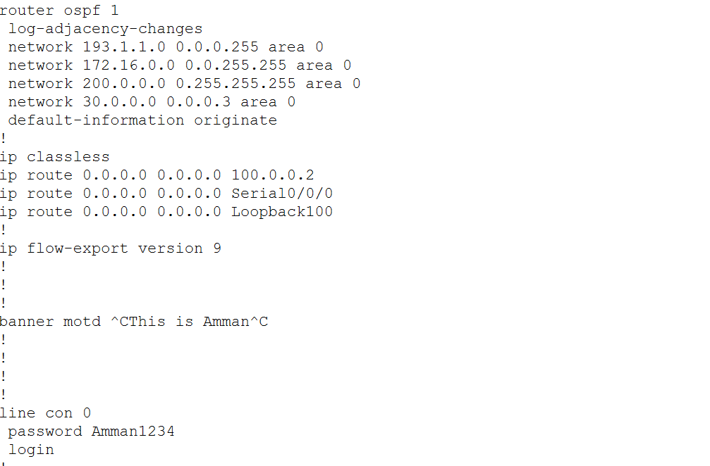
Figure 10

- DHCP server configuration

Figure 11: The figure presents the centralised DHCP server at the headquarters. The server gives dynamic IP addresses to all LANs of the branches in predetermined pools of addresses in my topology. 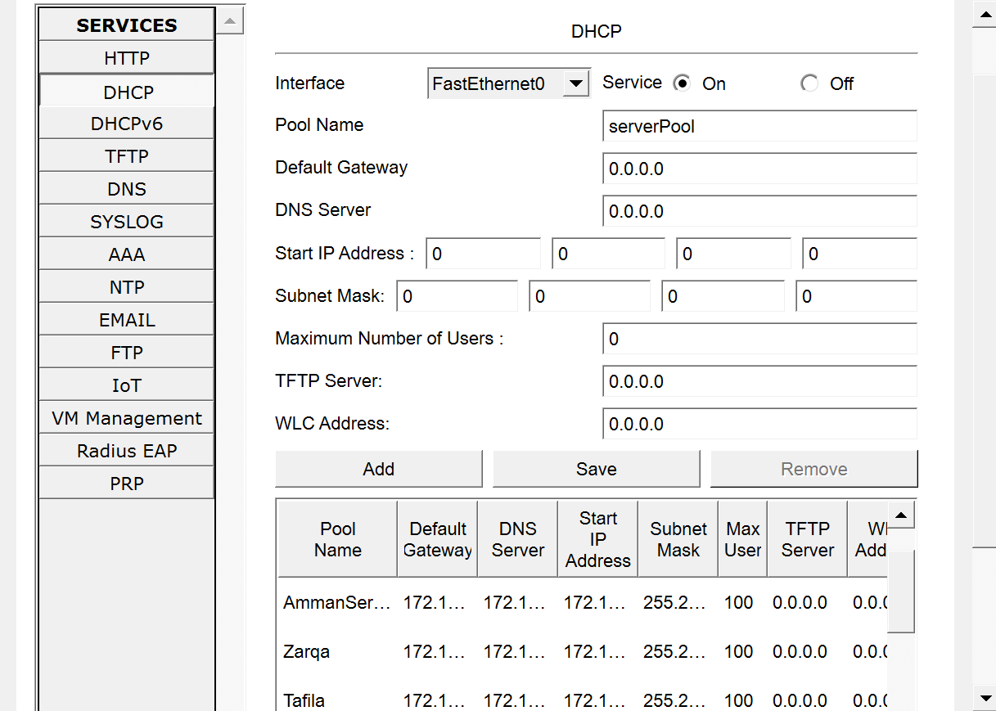
Figure 11

- Dynamic IP assignment on end device
Figure 12: The figure indicates that end devices are able to acquire IP addresses dynamically through DHCP and this is evidence that branch routers are correctly configured to act as a DHCP relay.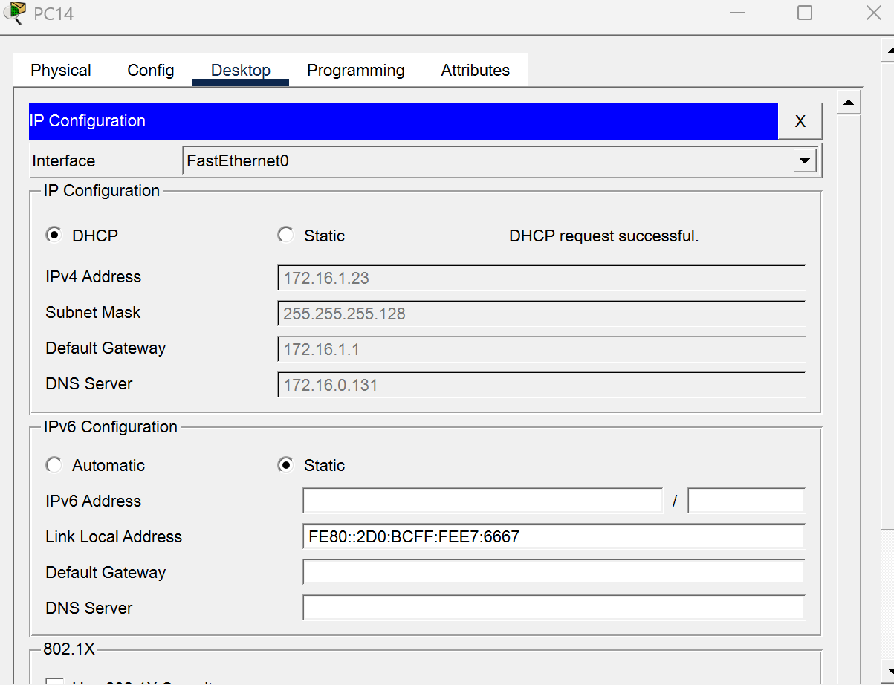
Figure 12

- DNS Configuration

Figure 13: This diagram represents the DNS server setup, which is used to provide the domain name service to the whole network services in all locations in my topology.
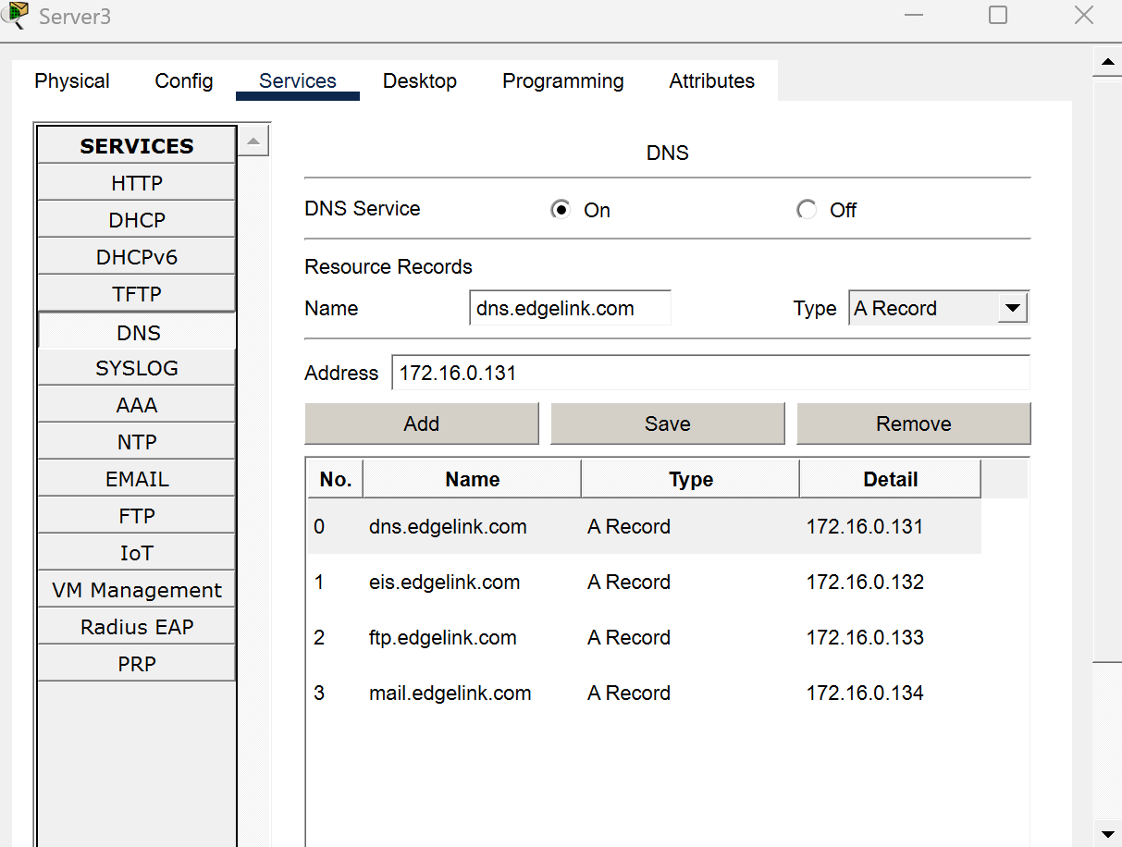

Figure 13

- Web server configuration and access
Figure 14: This diagram shows that the HTTP and HTTPS services are also available and operational within the client devices, which indicates that the application-layer service deployment has been implemented successfully in my topology.
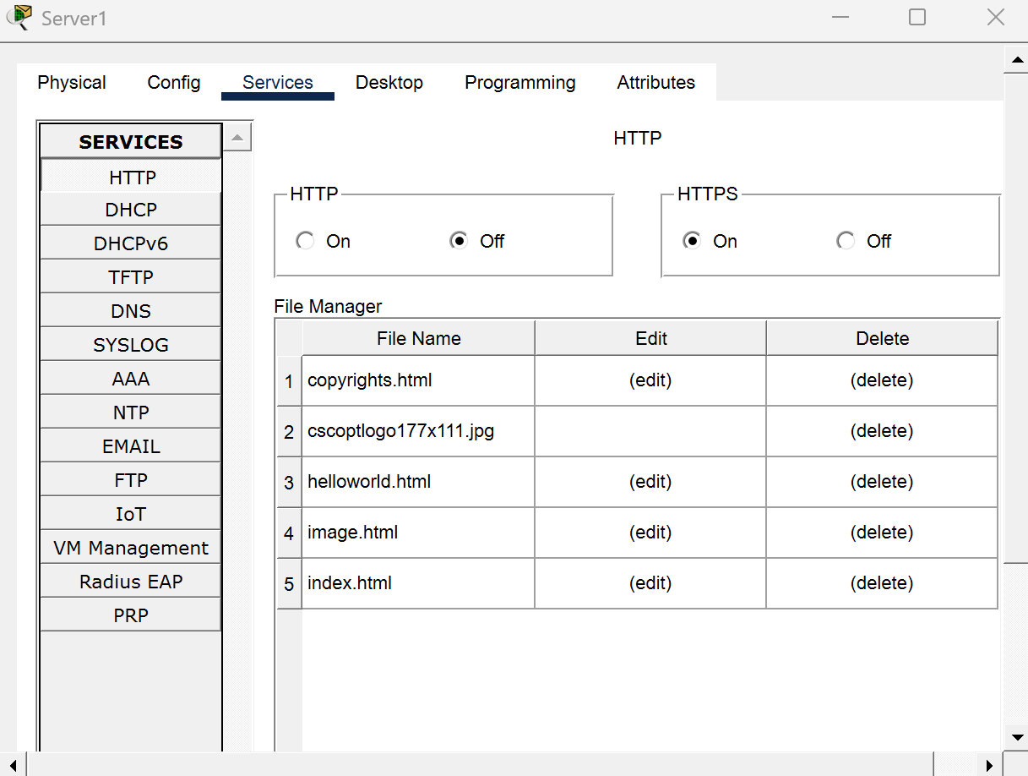
Figure 14
- FTP service configuration
Figure 15: In this figure, the basic security settings using the password of the devices, and login banners are implemented which will guard network devices against unauthorised access by my topology.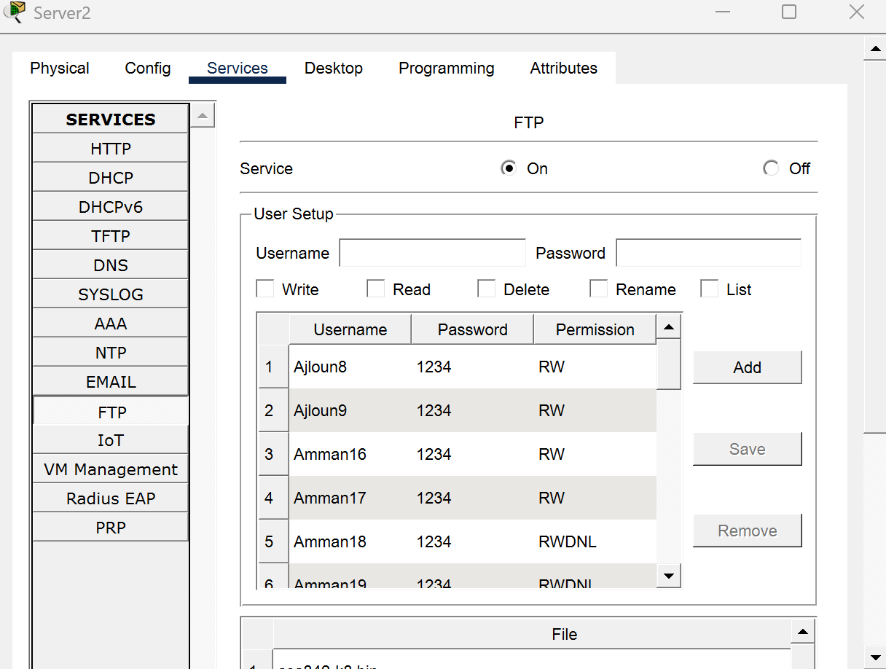
Figure 15
- Router security configuration

Figure 16: This figure demonstrates the adoption of fundamental security configurations such as passwords that are used in the devices and login banners to prevent unauthorized access into network devices by my topology.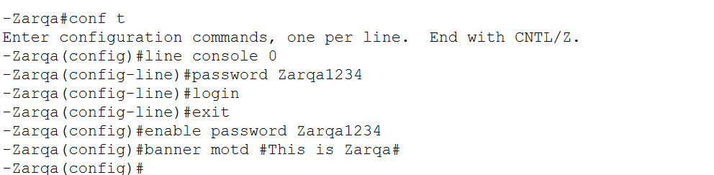
Figure 16
- Maintenance Schedule
A preventive maintenance plan was developed to maintain the implemented network in terms of its performance and security qualities and to ensure their constant availability. This plan is directed at the active monitoring, periodic backup, timely updates, efficient fault management, and preparedness to the disaster recovery. The maintenance activities will be categorized as daily, weekly and monthly activities to help reduce downtime and eliminate the chances of network failures.
Preventive Maintenance Activities:
The daily maintenance operations are aimed to monitor the health of the network and make sure that the critical services do not fail. These are availability checking of core network services like DHCP, DNS, Web, Email and FTP and checking of router and server status. The identification of faults early will result in the solution of the faults before it affects the users. Routine maintenance activities will consist of backup of configurations and checking of routing. The router and server configurations are also regularly saved up to facilitate quick recovery in case there was misconfiguration or failure of the device. OSPF neighbour associations and routing tables are checked to ensure that there is stability of WAN connectivity between the headquarters and branch offices. Stability and security: the long-term stability is covered by the monthly maintenance activities. Such activities involve checking security credentials, access controls, executing system updates, and disaster recovery testing. Point to point testing of WAN connectivity links therein guarantees that the network still runs as per the design done.

Maintenance Area | Task | Frequency
Monitoring | Check router and server status | Daily
Monitoring | Verify DHCP, DNS, Web, Email, and FTP availability | Daily
Fault Management | Identify and log network faults | Daily
Backups | Backup router and server configurations | Weekly
Routing | Verify OSPF neighbours and routing tables | Weekly
Updates | Review firmware and service updates | Monthly
Security | Review passwords and access controls | Monthly
Disaster Recovery | Test configuration restoration from backups | Monthly
Connectivity | Perform end-to-end ping and traceroute tests | Monthly

Fault Management and Disaster Recovery
The fault management is performed by constant monitoring of the device status and service availability. In case an error is detected, the faulty part is discovered, isolated, and solved with configuration backups and diagnostic apps (ping and traceroute).
This strategy will minimize service disruption and will bring the service to normal operation at a quick time. Periodic restoration testing and regular configuration backups are assisted to undertake disaster recovery planning. Backed-up configurations enable efficient restoration of network devices and servers in the circumstances of a major failure to ensure that little downtime is experienced, and that network services are not hampered.
This preventive maintenance strategy will make the network to be reliable, secure and aligned to the organisational needs and to accommodate the future expansion.

- Testing and Verification
End to end connectivity testing was conducted with ping and traceroute commands to check connection between the two nodes of the point to point topology of the WAN. Branch router to branch router tests were performed as well as branch router to branch PC tests, headquarters to headquarters tests and branch router to simulated-ISP loopback.
Ping from branch PC to local gateway:
Figure 17: Indicates that my topology portrays pc Zarqa 14 ping the local gateway IP address (172.16.1.1).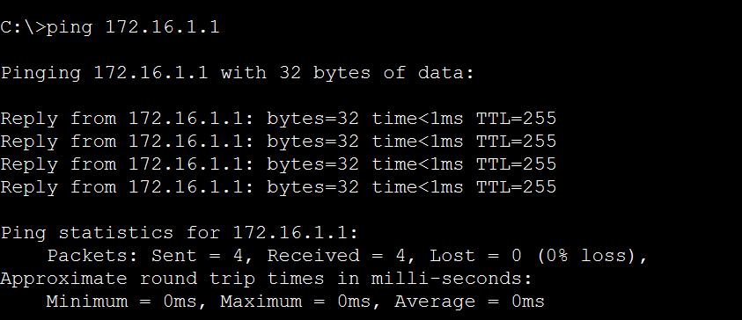
Figure 18: Shows sending messages between PC’s in different branches in my topology.
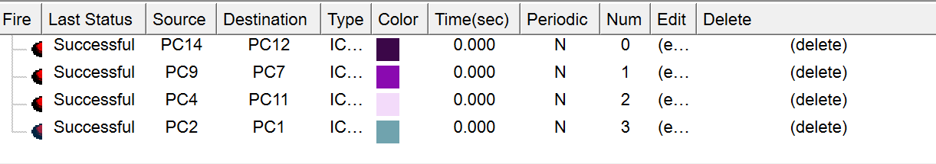

OSPF testing and proof of ISP:
Figure 19: Shows result while commanding (show ip route) in Amman router in my topology.
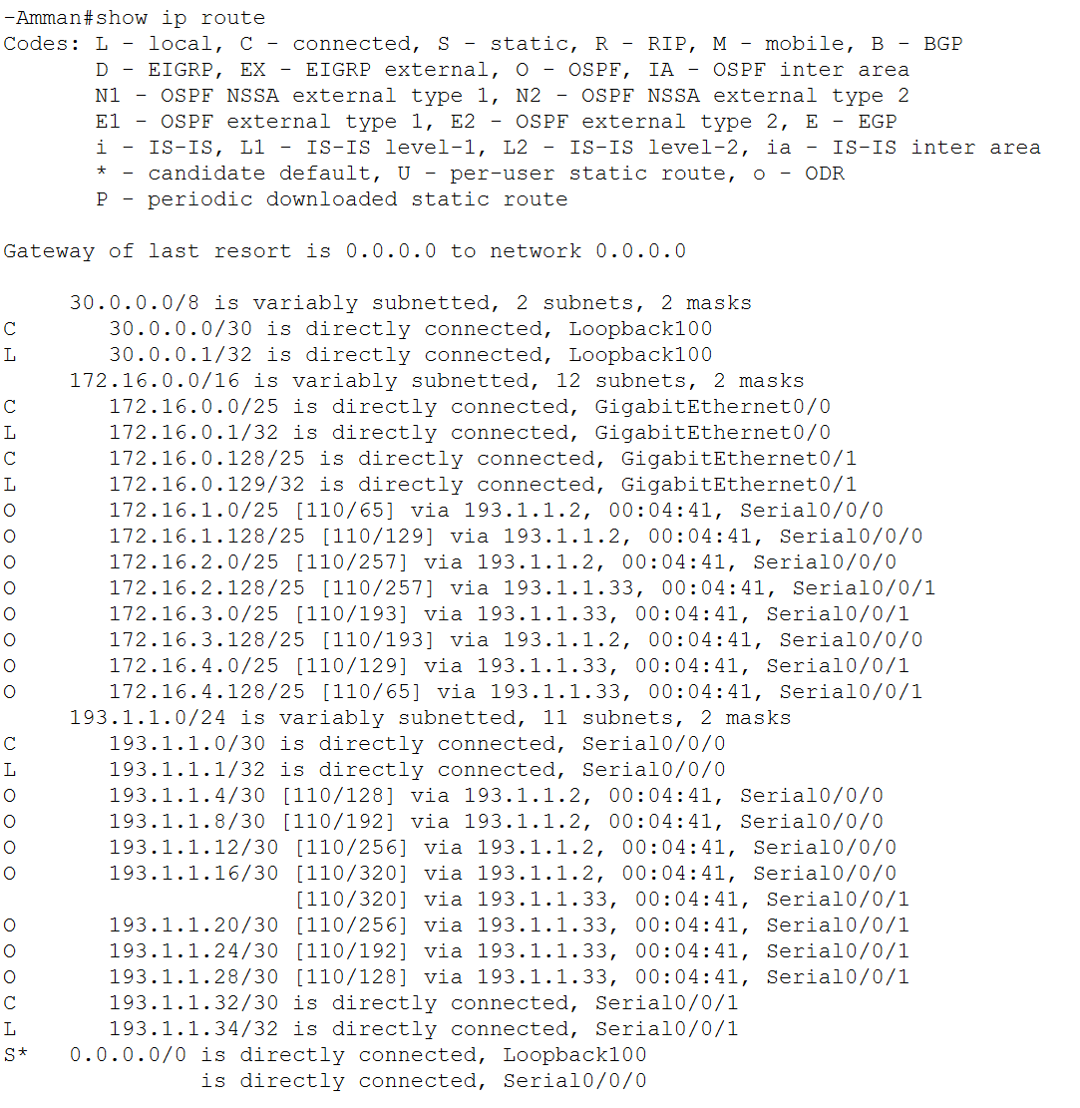
Figure 19
DHCP testing:
Figure 20: Shows a Dynamic IP address in PC Zarqa15 in my topoloy.
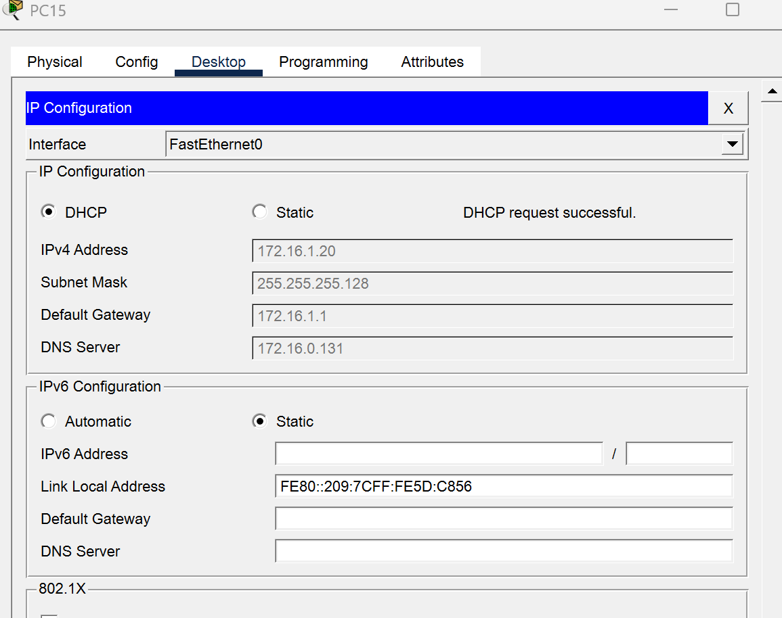
Figure 20
DNS service testing:
Figure 21: Shows the web browser result while browsing the DNS ping or domain name in my topology.
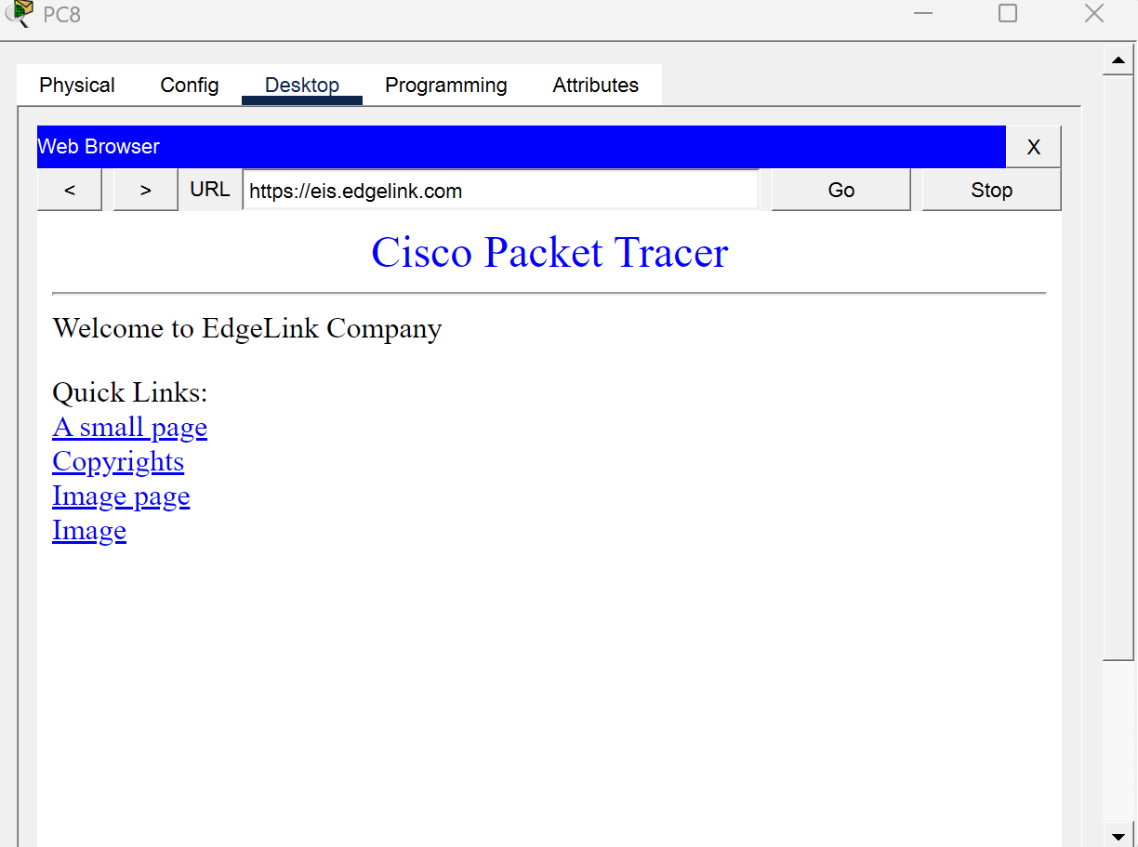
Figure 21
FTP service testing:
Figure 22: Shows pinging the ftp domain name in PC Zarqa15 in my topology.
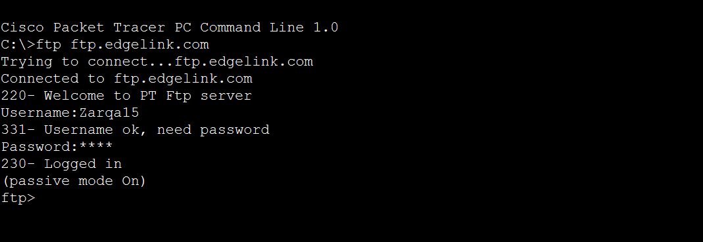
Figure 22
Email sending service testing:
Figure 23: shows sending an email from a PC Zarqa15 to PC Aqaba10 in my topology.

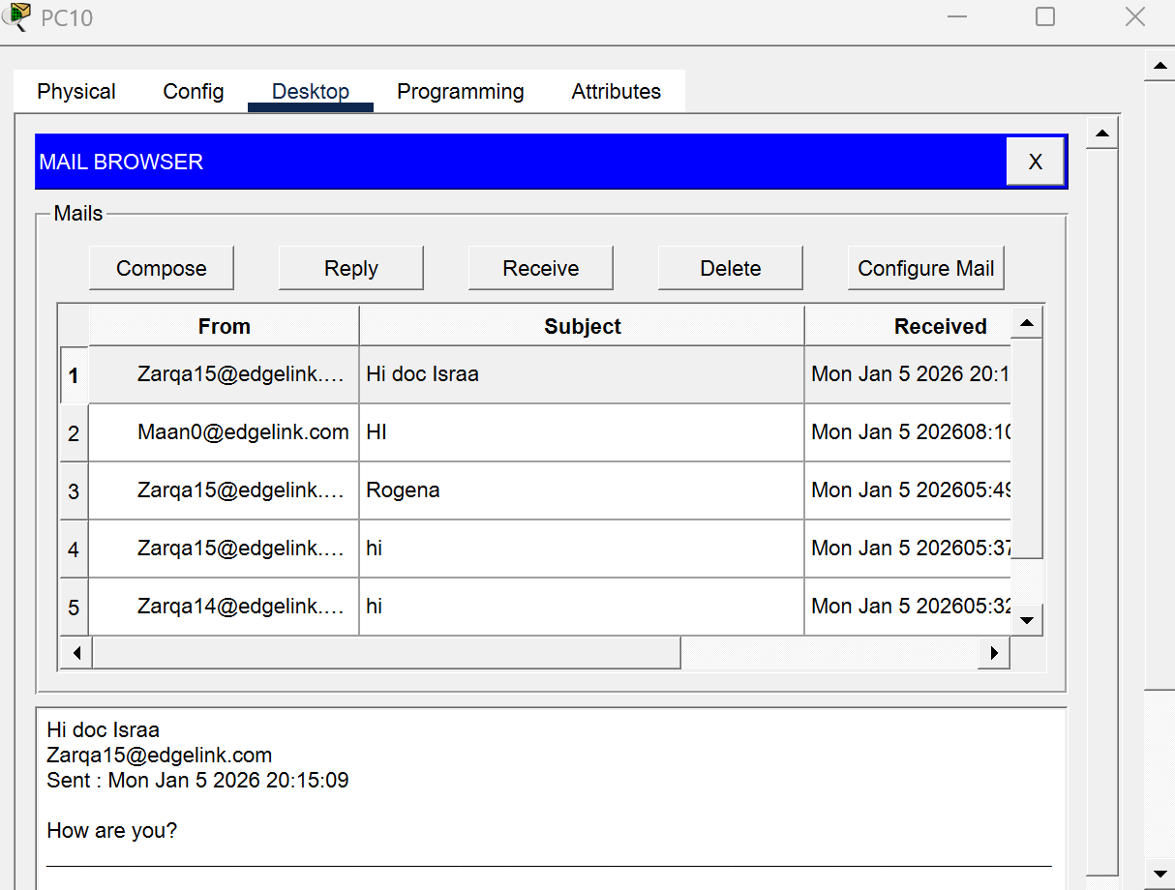
Figure 23
Test Category | Test Description | Expected Result | Actual Result
Local Connectivity | Ping from PC to local default gateway | Successful ICMP reply | Successful
Routing (OSPF) | Verify OSPF neighbour establishment | Neighbours in FULL state | Successful
Routing (OSPF) | Check routing table for learned routes | Remote networks visible | Successful
DHCP Service | DHCP server configuration review | Address pools correctly configured | Successful
DNS Service | DNS server configuration review | DNS service enabled and operational | Successful
Web Service | HTTP/HTTPS server configuration review | Web services enabled | Successful
Email Service | Email server (SMTP/POP3) configuration review | Email services enabled | Successful
FTP Service | FTP server configuration review | FTP service enabled | Successful

5. Server Deployment Justification (Fernandez, 2023)
Enterprise networks services can be implemented using physical servers, virtualized servers or cloud computing platforms. The difference between the deployment models lies in the cost, performance, scalability, complexity of management, and security. In such a network as EdgeLink which is healthcare-oriented, it is crucial to choose an appropriate deployment strategy, which will guarantee a reliable delivery of services.
Physical Server Deployment
Physical servers are associated with assigning particular hardware resources to a particular network service like DHCP, DNS, Web, Email, and FTP. This deployment model is also highly performing since such resources as CPU, memory, and storage are not shared with other workloads. Physical servers additionally offer complete administrative control over hardware and software setups, which is the most important in a healthcare setting where data integrity, availability and compliance are paramount.
Physical servers were chosen in the EdgeLink network so that the performance could be predictable and the headquarters had control over core services. This will reduce the latency, there will be no resource contention and the administrators will be able to provide stringent security policies. In spite of the fact that the physical servers cost more to set up in terms of hardware and power, they are more reliable and easier to use when compared to the nature and the needs of the assignment.
Deployment of Virtualized Server
With hypervisors, virtualized servers permit several services to be executed on a single physical server. The strategy enhances better use of hardware and lowers expenses through workload consolidation. Scalability and flexibility are also provided by virtualization because new virtual servers can be developed within a short period.
However, virtualized environments add more complexity to configuration, management and troubleshooting. Resource contention may also influence performance in cases where several services are using the same physical hardware.
The option was not chosen in the current EdgeLink implementation because of the small size of the simulated network, and the emphasis on the basic concepts of networking instead of the virtualization management. Attributes: This is a cloud-based server deployment type that has undergone testing initially.
Cloud-Based Server Deployment
This is an initial type of cloud-based server deployment that has been tested. Cloud-based server offers very high scalability, fault tolerance and less on-site hardware needs. Services are available on demand and can be scaled depending on the demand. Even with all these benefits, deploying a cloud creates the dependency of a third-party service provider and constant access to the internet.
It can also pose issues on data privacy, security and compliance especially of sensitive healthcare data. Since the project was an academic project and the need was to deploy an ISP-connected WAN and not cloud-based WAN solutions, the cloud deployment was not adopted in this design.

Deployment Model | Description | Performance | Scalability | Cost | Security & Control | Suitability for EdgeLink
Physical Servers | Dedicated hardware is assigned to each network service such as DHCP, DNS, Web, Email, and FTP | High and predictable performance due to dedicated resources | Limited scalability; requires additional hardware for expansion | High initial hardware and power costs | Very high control and security; full administrative access | Highly suitable due to healthcare data sensitivity, performance requirements, and assignment scope
Virtualized Servers | Multiple virtual machines run on a single physical host using a hypervisor | Moderate to high; performance may be affected by resource sharing | High scalability through rapid VM creation | Lower hardware cost; efficient resource utilisation | Moderate control; requires careful resource and security management | Suitable for large-scale environments but adds complexity beyond project scope
Cloud-Based Servers | Services are hosted on third-party cloud platforms and accessed over the internet | Variable; dependent on internet connectivity and provider | Very high scalability with on-demand resources | Lower upfront cost; ongoing subscription fees | Reduced direct control; data privacy and compliance concerns | Not suitable due to healthcare sensitivity and assignment constraints

Section (B):
6. Types of Network and Network Management Models.
Types of Network depending on the area covered. (GeeksforGeeks, 2017)
Personal Area Network (PAN)
A PAN is a small scale network that is involved in short distance communications between personal devices including smartphones, tablets and medical sensors. PANs may be applied to the wearable medical devices or staff personal device within a healthcare setting. Advantage: Cheap and simple to implement.
Limit: Extremely small range and not appropriate when communicating with an enterprise.
Local Area Network (LAN)
LAN is a network that is used to connect devices over a small geographical locality like a hospital floor, a clinic, or an office building. At the headquarters and branch offices, EdgeLink is using LANs to connect the PCs, printers, servers and network devices.
Benefit: Fast speed with low latency and quality in-house communication.
Limitations: Can only exist in one location and would have to be structured using cabling and maintenance.
Wide Area Network (WAN)
A WAN joins several LANs over wide geographical areas. In the EdgeLink network, WAN links will be used and the headquarters of Amman is connected to regional branch offices through point-to-point connections.
Asset: Ensures the provision of centralised services and communication between many sites.
Constraint: Higher complexity and reliance on routing protocols and stable links.
Storage Area Network (SAN)
A SAN is a dedicated network, which is aimed at giving fast access to storage systems. Medical records, imaging systems, and backups are some of the SANs used in healthcare settings.
Benefit: High performance and reliable data storage access.
Limit: It is expensive and complex and cannot be used in small or medium sized deployments.
Network Management Models
Peer-to-Peer Network Model
In a peer-to-peer model, all devices have equal roles and can share resources directly without a central server.
Advantage: Low-cost and very simple, appropriate in very small environments.
Limit: Scarcity of scalability, low security, and lack of ease in managing, hence, not appropriate in healthcare settings where sensitive information must remain inaccessible to unauthorized people.
Client- Server Network Model.
In a server model, specialized servers offer services like authentication, file storage and access to applications by clients. This model is adopted by EdgeLink whereby DHCP, DNS, Web, Email, and FTP services are being centralised at the headquarters.
Advantage: It has centralised management, enhanced security, enhanced scaling, and it is easy to enforce the policies.
Constraint: Higher initial setup cost and dependency on server availability.

Evaluation In EdgeLink Healthcare Environment.
In the system of EdgeLink healthcare, the most appropriate strategy should be the LAN and WLAN type of network and a server-based model of scheme management. LANs are used to offer high speed and stability in communication at individual locations whereas WAN links the centralised services to coordinate all the branches.
The server based model has the advantage of secure management of sensitive healthcare information, centralised control, and scalability as the organisation increases. This does not apply to EdgeLink because peer-to-peer networking does not allow great security and is not controlled in a central manner. On the same note, although SANs are beneficial in large scale storage of medical data, they can be expensive and complex than the existing needs.
All in all, the chosen types of networks and management model offer a well-balanced solution to the performance, security, and scalability needs in a medical facility.performance, security, and scalability requirements within a healthcare setting.
7. Network Topology Types (GeeksforGeeks, 2017b)
Network topology defines the way devices and networks are connected and is important in determination of scalability, cost, fault tolerance, and performance. In this section we will be discussing and comparing four popular types of topology: Star, Hub-and-Spoke, Full Mesh, and point-to-point and evaluate their applicability to enterprise applications like EdgeLink.
Star Topology:
The star topology consists of all the end devices connected to a central switch or hub. It is a topology that can be applied in Local Area Networks (LANs).
- Scalability: The scalability is high because more devices can be easily added through the connection to the central switch.
- Cost: Moderate, requiring switches and structured cabling.
- Failure: Good; The failure of one end device does not extend to other devices but failure of the central switch affects the whole LAN.
- Performance: High, with every device being connected to the switch via its own link.
Star topology is highly applicable in branch and headquarters LANs where the performance and the manageability are the priorities.
Hub-and-Spoke Topology:
In a hub-and-spoke topology, multiple branch networks (spokes) connect to a central site (hub), typically over WAN links.
- Scalability: Moderate; adding new spokes is straightforward but increases load on the hub.
- Cost: Lower than mesh topologies due to fewer WAN links.
- Fault Tolerance: Limited; failure of the hub can disrupt communication between all spokes.
- Performance: Is very much dependent on the capacity of the hub and bandwidth of the links.
This topology is mostly applied in enterprise WANs that have a heavy central location but add a point of failure.
Full Mesh Topology:
Full mesh topology is where all the nodes are interconnected to each other.
- Scalability: Poor; the number of links grows rapidly as nodes are added.
- Cost: High because of numerous connections that are needed.
- Fault Tolerance: Excellent; multiple alternate paths ensure high resilience.
- Performance: High, because traffic is able to use the shortest way possible.
Full mesh topologies are very reliable but are usually costly and complex to implement in medium size enterprise networks.
Point-to-Point Topology:
A point-to-point topology is a topology that involves two network devices that are connected by a special link. It is often implemented in the case of WAN connections between routers.
- Scalability: Moderate; more links can be added when it is needed.
- Cost: Low to moderate, as only two endpoints are involved per link.
- Fault Tolerance: Limited on a case-per-link basis, but any failure is contained to the affected connection.
- Performance: High, as the link is dedicated and free from contention.
EdgeLink WAN connectivity is through point to point links to guarantee efficient IP address usage, predictable performance and simplified routing
Topology | Scalability | Cost | Fault Tolerance | Performance
Star | High | Moderate | Good | High
Hub-and-Spoke | Moderate | Low | Limited | Moderate
Full Mesh | Low | Very High | Excellent | High
Point-to-Point | Moderate | Low–Moderate | Moderate | High

Star topology is the best option to use in the LAN setup with EdgeLink network as it is efficient in terms of performance and it is very easy to manage it compared to point to point topology which is efficient and easy to maintain in a WAN setup. Hub-and-spoke and full mesh topologies both have benefits in particular situations but bring about trade-offs in cost, scaling or fault tolerance which render them less suitable to the present network design.
Network Topology | Advantages | Disadvantages
Star | • Easy to install and manage  • High performance due to dedicated links  • Failure of one device does not affect others  • Easy to scale by adding devices | • Central switch is a single point of failure  • Higher cabling cost compared to bus topology
Hub-and-Spoke | • Lower cost than mesh topologies  • Centralised management and control  • Simple to add new branch connections | • Hub is a single point of failure  • Performance depends heavily on the hub  • Increased latency for inter-branch traffic
Full Mesh | • Excellent fault tolerance  • Multiple redundant paths  • High reliability and availability | • Very high cost  • Poor scalability  • Complex configuration and maintenance
Point-to-Point | • Simple and easy to configure  • Efficient IP address usage  • High performance with dedicated links  • Easy to troubleshoot | • Limited redundancy per link  • Link failure affects connected devices  • Scalability requires additional links

8. Device Operation (GeeksforGeeks, 2015)
Network communication depends on the synchronous work of various network machines, and each of them fulfills a particular role during information transmission and management. The routers, switches, servers and wireless access points are integrated in the EdgeLink network to provide reliable, secure and efficient communication in the whole organisation.
Routers
Routers work at the Network Layer (Layer 3) of OSI model and perform the operations of forwarding data packets between networks. They calculate the optimum route of data to be used between a source network and a destination network by using IP addresses. Routers in the EdgeLink network are used to link branch LANs to the headquarters via point-to-point WAN links and to allow inter-subnet communication. Routers also allow dynamical routing protocol like OSPF that enables routers to dynamically learn and refresh routing information.
This has provided effective data delivery and network resiliency. Moreover, routers also provide default gateway services to the end devices, which means that packets can leave the local network and be sent to far-off networks.

Switches
The use of switches is mainly at the Data Link Layer (Layer 2) and to pass data packets in a local area network according to MAC addresses. Switches can guarantee that the data is transmitted to the appropriate destination device and not all other devices in the network by keeping a MAC address table which limits the potential waste of network traffic. Switches are used in EdgeLink network to connect PCs, printers, servers, and wireless access points in every LAN. This switch application helps in supporting a star topology which enhances performance, eases the management and isolates faults such that failure in one gadget does not impact on the whole network.
Servers
Servers are centralised services that aid in the network functioning and interaction with users. Such services are available at the Application Layer (Layer 7) in the OSI model. In EdgeLink network, servers provide very essential services, which include DHCP, DNS, Web (HTTP/HTTPS), Email and FTP. Servers facilitate efficient information exchange through client request services, sharing of shared resources as well as enforcing uniform configurations within the network. Headquarters placement of servers enhances easier management, more security, and accessibility of the services to all the branch offices over the WAN.
Wireless Access Points (WAPs)
Wireless access points offer wireless connectivity as they allow wireless devices to link to the wired network infrastructure. WAPs can be used at the Physical Layer (Layer 1) and Data Link Layer (Layer 2), which converts wireless signals to wired Ethernet frames. The EdgeLink network has wireless access points that are used to facilitate mobility in the network, which allows the laptops and wireless devices to connect to the network services without any physical connectors.
They also provide LAN cover without breaking the connection with the central services via switches and Routers, and therefore allow smooth communications among wired and wireless devices.
Interaction and Data Transfer of devices.
The combination of these devices makes it possible to communicate over the network end-to-end. Switches are used to control local data transmission, routers are used to handle traffic across networks, servers are used to offer vital services to the network, and wireless access points are used to extend network accessibility to mobile devices. This synchronized operation provides trusted data transfer, economical resource utilization, and scalability communications across the entire edge link locations.

- Hardware and Software Interdependency
Path of the Data Packets through the Network. (GeeksforGeeks, 2025)
When a user transmits data between a source work station and a destination work station, the information has a defined sequence through which it passes via several network devices. The paths start at the work station that serves as the source where the Network Interface Card (NIC) transforms the data into electrical or wireless signal which can be transmitted. The packet is first transferred to a switch in a local area network.
The switch analyzes the destination MAC address and sends the frame only to the appropriate port in an efficient method of local delivery. In case the destination device is on another network, the switch sends the packet to the router who plays the role of the default gateway. The router looks at the destination IP address, and based on the routing table, the router selects the optimal route to the destination network. The packet is then sent over the WAN by one or more routers until it is sent to the destination network. The packet is eventually sent through the destination switch and sent to the destination workstation, where it is handled by the receiving NIC.
TCP/IP Model Operation (Encapsulation and De-encapsulation)
TCP/IP model controls the way data is prepared, relayed as well as obtained on the network. Encapsulation of data takes place at the source workstation as it is sent down the TCP/IP layers:
- Application Layer: Data are created by applications like a web client or email client.
- Transport Layer (TCP): This breaks down the data and allocates port numbers so as to ensure a safe delivery.
- Internet Layer (IP): The IP address of the source and destination is added to permit the routing between networks.
- Network Access Layer: The information is encasement with MAC addresses and translated into transmission signals.
When the packet moves across switches and routers, only certain header data is looked into or changed. MAC addresses are switched and IP addresses are routed. On arrival of the packet at the workstation destination, de-encapsulation takes place. Each TCP/IP layer eliminates its specific header until the original data is sent to the destination application.
Hardware and Software Interdependency
The network communication depends on the high level of interdependency of hardware and software. Hardware components like NICs, switches, and routers offer the physical capabilities to transfer data where networking software dictates the manner in which data are addressed, routed and handled. NICs rely on software drivers and TCP/IP protocols to format the data accordingly. Switches are based on firmwares and MAC address tables, whereas routers are based on routing protocols like OSPF to dynamically acquire network paths. Hardware devices cannot analyze or process data streams without networking software. On the other hand, software protocols need hardware resources to transmit data physically. This interdependency guarantees the reliability of the end to end communication by integrating physical connectivity, logical addressing, routing intelligence as well as protocol based data management.
10. Assessment of Networking Principles and Protocols:
IP, TCP, and UDP Protocol Analysis (GeeksforGeeks, 2025)
Protocol | Primary Function | Contribution to Communication & Service Delivery | Impact on Reliability, Performance & Scalability
IP (Internet Protocol) | Provides logical addressing and packet routing between networks | Enables communication between different LANs and branch sites by uniquely identifying devices and networks | Supports scalability through subnetting and hierarchical addressing; allows efficient packet forwarding across the WAN
TCP (Transmission Control Protocol) | Provides reliable, connection-oriented data transfer | Ensures accurate delivery of data for services such as Web, Email, and FTP through acknowledgements and retransmissions | High reliability but higher overhead; slightly reduced performance compared to UDP; essential for data integrity in enterprise networks
UDP (User Datagram Protocol) | Provides fast, connectionless data transmission | Supports lightweight communication for services such as DNS queries where speed is prioritised | Low overhead improves performance; reduced reliability due to lack of acknowledgements; suitable for scalable, low-latency services

DHCP and DNS (GeeksforGeeks, 2021)
The Dynamic Host Configuration Protocol (DHCP) is an automated system of assigning IP addresses to end devices, which saves labor on administration and also decreases the number of configuration errors. The DHCP in the EdgeLink network promotes scalability, which means that new devices can be added to the network automatically without any human intervention. Centralised DHCP adorns uniformity and control of various offices.
Domain Name System (DNS) is used to convert human-usable domain names into IP addresses, so that the users can access services without the requirement of memorising the IP addresses. DNS enhances user friendly and accessibility of services which is useful in efficient service delivery and minimization of possibilities of user errors.

SMTP and POP3 Protocol Analysis (GeeksforGeeks, 2019)
Protocol | Primary Function | Role in Service Delivery | Impact on Reliability & Performance
SMTP (Simple Mail Transfer Protocol) | Handles sending and transferring emails between clients and mail servers | Enables reliable email delivery across the EdgeLink WAN between headquarters and branch offices | Uses TCP to ensure reliable transmission; slight performance overhead due to error checking and acknowledgements
POP3 (Post Office Protocol v3) | Retrieves emails from the mail server to client devices | Allows users to access and download emails from the central mail server | Reliable due to TCP usage; simple protocol with limited features, suitable for scalable email access

Routing Protocols Analysis (Static Routing, RIP, and OSPF) (Study-ccna.com, 2016)
Routing Method | Description | Benefits | Constraints | Suitability for EdgeLink WAN
Static Routing | Routes are manually configured on each router | Simple and predictable; no routing overhead | Not scalable; high administrative effort; no automatic adaptation to failures | Not suitable due to multiple branches and scalability requirements
RIP (Routing Information Protocol) | Distance-vector protocol using hop count as a metric | Easy to configure; low resource usage | Slow convergence; limited to 15 hops; poor scalability | Not suitable for enterprise WAN environments
OSPF (Open Shortest Path First) | Link-state protocol that dynamically calculates optimal paths | Fast convergence; scalable; efficient route calculation | More complex configuration than RIP | Highly suitable and selected for the EdgeLink WAN

The reason why OSPF was chosen to the EdgeLink WAN is because it is scalable, has a fast convergence and can support dynamic routing in branches at different sites.
IP, TCP, UDP, DHCP, DNS, SMTP, POP3, and OSPF will be used together to enhance the overall performance and effectiveness of the EdgeLink network. IP also allows the sites to communicate on a scale, whereas TCP and UDP allow services to be reliable and fast according to their requirements. DHCP and DNS minimize the configuration effort and ease of access to services; hence, enhancing efficiency. SMTP and POP3 are helpful in achieving effective email communication throughout the WAN. OSPF improves both performance and scalability as it chooses the best path dynamically and can respond to the changes in the network fast. These protocols taken collectively guarantees consistency in communication, effective service provision and scalability of the network infrastructure.
Section (C):
Performance Analysis
The results of the testing and monitoring give feedback that the network works under the current design. The connectivity tests were performed, and it indicated that the communication between end devices, local gateways, and between the WAN was consistent and successful, indicating that routing is stable, and IP settings are appropriate. The checked routing tables of OSPF and neighbour states proved to allow efficient route convergence and low routing overhead, which added to good overall network performance. Certain performance and security restrictions were encountered in testing. The first problems with DHCP and access to services indicated the reliance on proper gateway and relay settings, showing that such errors may temporarily affect the availability of services. Also, the centralisation of services at the headquarters presents a single point of failure in case there is a hit to the server availability. But these restrictions could be overcome by corrections in the configuration, and can be overcome further by redundancy and frequent monitoring. On the whole, the testing feedback shows that the network has performance capability to meet the present-day operation requirements though the monitoring results indicate that there is more that can be done to improve the resilience and the performance of the network such as redundancy and further security controls.
Enhancement Plan
In order to scale the EdgeLink network further, improve redundancy, security and efficiency, it is suggested to carry out a number of improvements according to the testing feedback and future organisational needs.
Scalability Enhancements
The existing IP addressing plan can be developed with hi-tech VLAN segmentation to cover the future growth of 3,000 users per branch. Setting up a VLANs by department would eliminate unnecessary broadcasts and enhance performance of the network as well as permit more efficient utilization of the IP address space available. Also, routing-level scalability can be improved by implementing the OSPF design across multiple areas. This would scale routing table size and routing update overhead reducing convergence in a growing network.
The current LAN subnets would be required to be extended to serve up to 3,000 users per branch. The minimum subnet capable of accommodating a minimum of 3 000 hosts is /20 that includes 4094 available IP addresses. The assigned LAN range is 172.16.0.0/16 thus, assigning each branch a /20 block allows scaling the network with addressing being structured and non-overlapping.
Figure 24: Showing the subnetting from my notebook.

Figure 24
Redundancy Improvements
This can be done through addition of back up WAN connections between the strategic points and implementation of redundant servers on important systems like DHCP, DNS. This would remove points of failure and provide continuity of service in the occurrence of hardware failure or link outages. The introduction of router redundancy mechanisms might be also implemented in future in order to enhance the network availability and resilience.
Security Enhancements
To ensure that plain-text credentials are not being exposed and the passwords of routers are not exposed, it is possible to encrypt passwords and apply more robust authentication schemes. Moreover, disabling the HTTP and implementing the use of HTTPS only on the web server would guarantee encrypted communication as well as prevent sensitive healthcare information interception. The improvements are in line with the best-practices in security and refine the overall security posture of the network.
Efficiency Improvements
The efficiency of the networks can be enhanced by centralised monitoring and logging systems that will allow one to detect the performance problems early and make the work of the troubleshooter easier. Periodical optimisation of routing setups and the location of services would also facilitate faster response time and maximum utilisation of network resources as the user demand rises.
Technology and Topology Evaluation (GeeksforGeeks, 2020)
Technology | Efficiency | Fault Tolerance | Resource Utilisation | Overall Suitability for EdgeLink
Ethernet | High efficiency with fast speeds and low latency; supports switched communication | Good fault tolerance in star topology; failure of one device does not affect others | Efficient bandwidth use; data sent only to intended devices | Highly suitable for core LAN and WAN infrastructure
Wi-Fi | Moderate efficiency due to shared medium and possible interference | Limited fault tolerance; access point failure affects multiple users | Reduces cabling requirements; flexible use of wireless resources | Suitable as a complementary technology for mobility
Token Ring | Low efficiency compared to modern technologies; outdated speeds | Poor fault tolerance; single failure can disrupt entire ring | Inefficient resource usage due to token overhead and legacy hardware | Not suitable for modern enterprise networks

Critical Reflection
The design and implementation of the EdgeLink network enabled me to realize how the planning decisions would directly influence the actual operation of the network. During the planning process, it was necessary to develop organized LAN and WLAN delivering. Efficient use of LAN subnets of /25 was needed to support the maximum number of users per branch which was 100 and efficient use of point to point WAN subnets of /30 to ensure that WAN was efficient and simple to troubleshoot.
The decision on which OSPF to use also helped to keep the network at a manageable level than when using the static routing since the routing was automatically learned across all the sites. Some of the greatest problems that were encountered by me were not the topology but the issue of configuration accuracy and stability.
The primary example was DHCP: although the pools of DHCP server appeared to work correctly, certain branches could not receive addresses because of minor errors like a wrong default gateway, overlapping LAN subnets or using the ip helper-address on an incorrect interface. Those problems have taught me that DHCP requires a combination of various elements to be functioning (right subnet, right gateway, right relay interface, and right reachability to the server).
To address this, there needed to be a systematic process of troubleshooting: ensuring that the interfaces are active, ensuring the presence of the gateway IP, riding the ping reachability and only at this point, the relay setup. Access to service (web and email) was also another challenge.
There was a time that services had been activated yet clients still could not connect and this showed the significance of good server positioning, no dynamic addressing, and gateway setting on the server-side LAN. Resolving this enhanced my realization that services being ON is not adequate, routing and proper Layer 3 configuration should be proper to have application-layer services functioning across the board.
A number of choices were taken to ensure that the design was realistic and in line with the teaching in the labs. Indicatively, implementing point-to-point WAN links and OSPF was a clean implementation as it fitted the assignment requirements, and the separation of the headquarters into user and server LANs enhanced the organisation and security.
By consolidating services at the HQ, the management was made easier, but a restriction was also created, since the failure of the HQ servers will affect the services of the branches. This taught me the essence of redundancy, backups and monitoring in ensuring a rounded off network solution.

REFERENCES:
All of the screenshots are from my topology.
Figure 24 from my notebook.
GeeksforGeeks (2017). Types of area networks LAN, MAN and WAN. [online] GeeksforGeeks. Available at: https://www.geeksforgeeks.org/computer-networks/types-of-area-networks-lan-man-and-wan/ [Accessed 8 Jan. 2026].
Fernandez, R. (2023). Virtual Servers vs. Physical Servers: Comparison and Use Cases. [online] ServerWatch. Available at: https://www.serverwatch.com/servers/virtual-servers-vs-physical-servers/ [Accessed 9 Jan. 2026].
GeeksforGeeks (2025). Computer Network Models. [online] GeeksforGeeks. Available at: https://www.geeksforgeeks.org/computer-networks/computer-network-models/ [Accessed 9 Jan. 2026]
GeeksforGeeks (2019). Difference between SMTP and POP3. [online] GeeksforGeeks. Available at: https://www.geeksforgeeks.org/computer-networks/difference-between-smtp-and-pop3/ [Accessed 10 Jan. 2026].
GeeksforGeeks (2017b). Types of Network Topology. [online] GeeksforGeeks. Available at: https://www.geeksforgeeks.org/computer-networks/types-of-network-topology/ [Accessed 9 Jan. 2026].
‌ GeeksforGeeks (2020). Difference Between WiFi and Ethernet. [online] GeeksforGeeks. Available at: https://www.geeksforgeeks.org/computer-networks/difference-between-wi-fi-and-ethernet/ [Accessed 10 Jan. 2026].
Study-ccna.com. (2016). Routing protocols. [online] Available at: https://study-ccna.com/routing-protocols/ [Accessed 10 Jan. 2026].
GeeksforGeeks (2021). Types of Network Protocols and Their Uses. [online] GeeksforGeeks. Available at: https://www.geeksforgeeks.org/computer-networks/types-of-network-protocols-and-their-uses/ [Accessed 10 Jan. 2026].
GeeksforGeeks (2015). Network Devices (Hub, Repeater, Bridge, Switch, Router, Gateways and Brouter). [online] GeeksforGeeks. Available at: https://www.geeksforgeeks.org/computer-networks/network-devices-hub-repeater-bridge-switch-router-gateways/ [Accessed 10 Jan. 2026].

