1. PROJECT PROPOSAL

1.1 Background to the Problem
Now a days, many businesses depend on fast and reliable delivery management services. In a Delivery management system, there are some roles like seller, customer, admin, carrier and employee etc. Sellers need an easy way to send products to customers, customers want to track on there shipment, employees must have to verify the payments and assign carriers into the individual shipment, carriers need to update delivery status. When they do the tasks manually, a lot of mistakes can happen-such as wrong tracking updates by the carriers, lost of shipment information, or miss match in assigning carriers, lost of documentation of the shipments.
If we want solve these problems, the Delivery Management System software was created. It takes all the parts of the delivery process into one Desktop based application so every user can do their own work easily. The employee can add ,update and delete any shipment , carrier and routes, update and check his information and also check payment status. The sellers can create shipments easily, create new account and also delete account. .The carriers can see his appointed shipment, can update tracking information and customers can see the delivery status. Admin is the main role of this project he can Update, Delete, Create simultaneously all the role and he also effect the shipment by changing information if found any wrong.
After getting all information in a database and providing each user with a different dashboard, the system prevent errors, saves time, and keeps data organized. This makes delivery faster, clearer, and more reliable for the users.
The target group of users:

1. Admin
Admin can create: Employees, Carriers, Routes, Update Payment, Tracking. He view all records and able to delete the Employees, Carriers & Shipments.

2. Employees
Employee can add carriers with the shipments, check payment status .He can view all shipments and can update payment also update his own profile, can delete shipment from the system.
3. Carrier
Carrier can view Assigned Shipments . Update Tracking Status and His own Info.

4.Seller
Seller is a client who can create shipment, delete Shipments, can view tracking status, He also can make payment and delete his account.

5. Customer
He can View his shipments which are assign from seller to him . Update his profile and Delete his Account .

- information.

3.2 User Story Table
AS A\ AN | I want to | So that | Acceptance criteria
Admin | Create a new Admin  Profile | I can enroll myself in the system | An OTP is sent to user’s mobile and confirmation mail to the registered email
 | Log in securely to access the admin dashboard with my email and password. | I can oversee and modify shipment, payment, and tracking records. | password System verifies admin credentials from Login table
 | View all shipments, payments, employees,  carriers, and routes | I can oversee systemwide activities and ensure accuracy | Admin can see all data from Shipment, Payment, Carrier,  Employee, and Route tables
 | Add new employees, carriers, shipments, and  routes | I can expand system functionality and manage operational growth | Admin can create new records using valid forms

 | Access tracking information for any  shipment | I can verify delivery progress and assist in customer service issues | Tracking Status is visible for all shipments
 | Update shipment, payment, tracking, and route information | I can resolve disputes, correct errors, and ensure proper workflow | Admin can modify any field in Shipment, Payment, Carrier,  Employee, and Route tables
 | Delete employees,  carriers, and shipments | I can remove inactive or incorrect records from the system | Deletion allowed for Admin
Employee | log in securely to access the employee dashboard. | I can enroll myself into employee dashboard | need registered employee email and password
 | verify whether a shipment is fully paid or unpaid. | I can update the payment status as Paid | need shipment reques
 | assign shipment orders to carriers only after payment is confirmed. | i can accept customer shipment and assign a carrier | need carrier id ,and payment id ,shipment id
 | remove shipment | I can remove shipment details from the database | need delete button
 | update employee  information | I can update all information of the  employee | need update button
 | add or delete carrier | I can remove and add new carrier or delete old carrier | need carrier add and delete button
 | add routes | I can add new roots and its address( form -to) | need add routs button
 | update the tracking status of shipments. | I can provide customer shipment tracking  information | need shipment id
Customer | log in securely | to view shipment details. | providing password &  clientID
 | track | only shipment tied to clientID | providing clientID
 | verify shipment using name and email | to be member | providing contact no., password , DOB, gender.
 | System checks details | against the system table | providing contact no., password , DOB, gender.
 | be member | order product | providing contact no., password , DOB, gender.
 | sign up by filling out a registration form. | to be a new user | providing contact no., password , DOB, gender.
 | create an account (new user) | log in to the system. | providing password and  clientID
Carrier | Log in securely to my carrier dashboard | I can access my assigned shipments and manage  deliveries | Must enter valid email & password
 | View all shipment orders assigned to me | I can know which deliveries I am  responsible for | Shipment details include: CarrierID, ShipmentID,  Client info, Route & Status.
 | Update the tracking  status of a shipment | Customers and employees can track real-time delivery  progress | Editable status options: Pending, In Transit, Shipped to Delivered. System updates Shipment table & timestamp is recorded.
 | Update my own profile information | My contact information remains accurate for the company | Carrier can update Name, Contact, Address, Password & Profile updates do not affect Login credentials unless changed.
 | Mark a shipment as  Delivered | The system can complete the shipment process | Status changes to Delivered & shipment no longer appears in pending lists.
 | View route information for assigned shipments | I can understand the origin and destination before starting delivery | RouteID correctly linked to Shipment & No access to edit route data.
Seller | Create a shipment order | I can send goods to my customers | System allows entering goods type, weight, volume, pickup & drop-off address, receiver details. Shipment saved with ClientID. PaymentStatus defaults to Pending.
 | Have the system autoassign a RouteID | I don’t manually choose or manage routes | System checks for existing route. If route exists, reuse RouteID; otherwise create new RouteID automatically.
 | View all shipment orders I created | I can track and manage my shipments | System shows only shipments linked to my ClientID with details (goods, weight, status, delivery time). Access to others’ shipments is blocked.
 | See delivery estimate automatically | I know when the  shipment should arrive | When payment changes from Pending → Paid/Unpaid, system sets EstimatedDeliveryTime = Today + 3 days.
 | Manage my own profile | I can keep my  information updated | Seller can view/update own profile only; can delete own account without affecting others.

4. SOFTWARE DESIGN
4.1 System Design:
Use case Diagram:
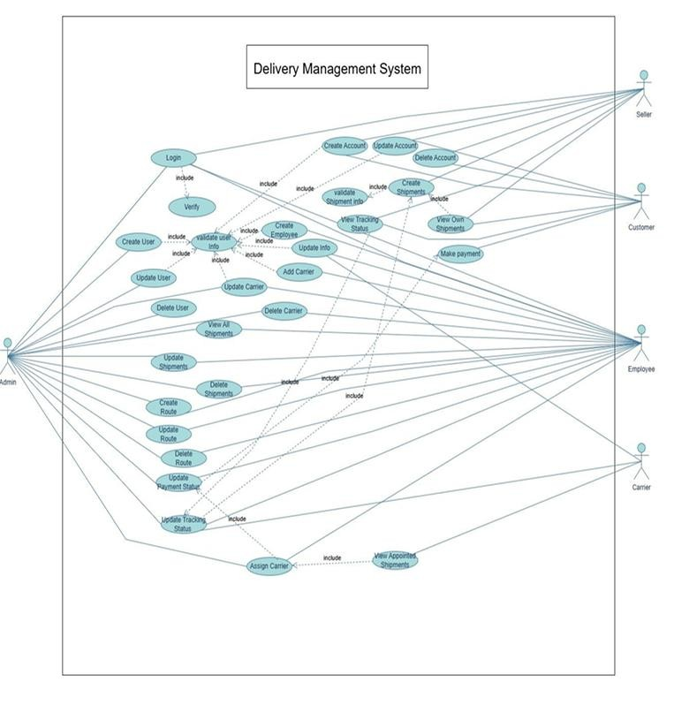
Figure 1: Use Case Diagram

4.2 UI / Wireframe Design using Figma
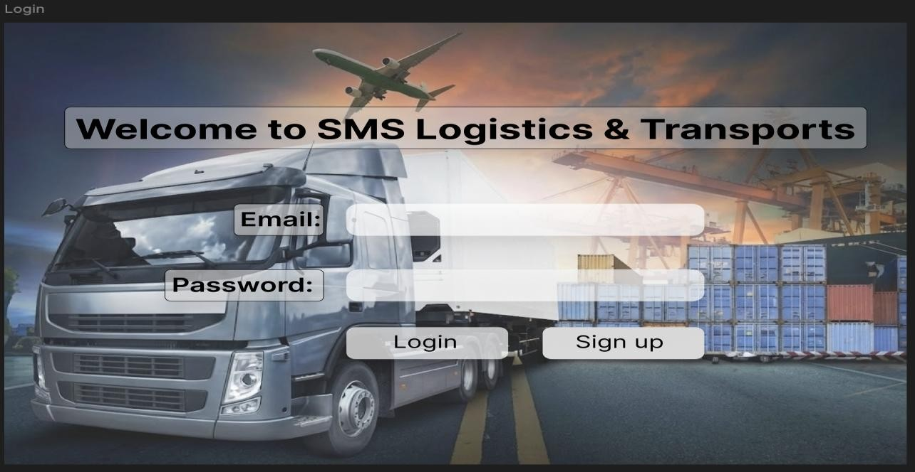
Figure 1: Login page
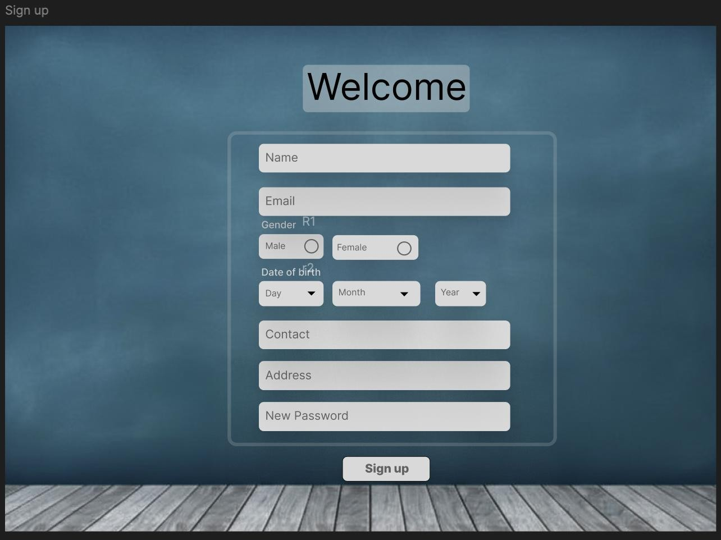
Figure 2: Sign up page

