1.2 Selection of Process Model
In our Delivery Management System, we picked Extreme Programming (XP) as a development model. The XP model works well for our projects where requirements can change and where we can get feedback from customers and use common sense principles to develop our project easily. It helps us to stay flexible and focused on delivering quality at each step of the process.

XP is a software development method which built around the idea of doing simple to understand practices, getting feedback from customers, and improving the system over time. XP encourages continuous communication between the development team and the customer to make sure the software always fulfills the customer's needs.

Exploration: In This phase we can gather requirements from the customer and our development team gets knowledge about the tools and technologies that we will use. This phase can take two weeks of our project time.
Planning: At first, we can write the user stories (features) and estimate the effort of the working of the user stories for the implementation we can give priorities of the user stories and the releasing schedule will create.
Iterations to Release: Before the first release of our system several iterations will include, and it takes two weeks for implementation. In the first iteration the architecture of the hole system will be created. Customers can select the stories in each iteration. When all the iteration is completed, our project will be ready for production.
Productionizing: When the system is ready for release, we can do extra testing and performance checks. We can also review any last-minute changes that might need to be included in our project. Maintenance: After the first release, we can keep our system running and produce some new iteration simultaneously. We can also have some developers to maintain our project.
Death: After the satisfaction of the customer needs this phase occurred and we can write our necessary documents of the system.

XP Process Flow
Here’s a simple diagram to show the XP process:

Exploration
↓
Planning
↓
Iterations to Release
↓
Productionizing
↓
Maintenance
↓
Death

Why XP is the Best Fit for This Project
We chose XP for the Delivery Management System for several reasons:
Pair programming:
In the Pair programming it allows two people to program at a time, one person is brainstorming, another is involved with writing code. By this we can used to write code efficiently for a long time.
Frequent Requirement Changes:
Our system consists of different user roles- admin, employee, carrier, client, and their needs will likely change as we develop. XP works well here because it’s built to adapt quickly to changing requirements through its short development cycles.
Metaphor: In metaphor there is a shared story which is a summary of the overall project describes how the system will work for development. By this our project team will get a clear understanding of what the project needs.
40-hour week: Developer can maximum 40-hour work in a week. So that the developers’ working productivity will increase.
Reduced Risk:
XP reduces the risk of major issues later in the process because we get constant feedback and release small, incremental updates regularly. If something isn’t working, we can address it immediately rather than discovering it later in the project.
On-site customer:
We can understand the requirements perfectly and the problems because a customer must present full time and available for our team.

XP will work perfectly in our Delivery Management System Because XP values like communication, simplicity, feedback, courage, respect which will enhance our project progress.
Besides it’s Practices will also help us to develop the project smoothly.

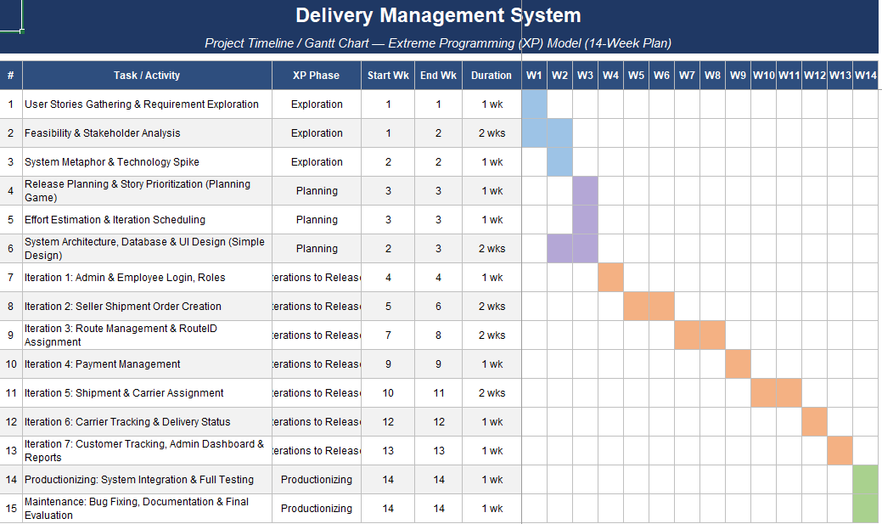

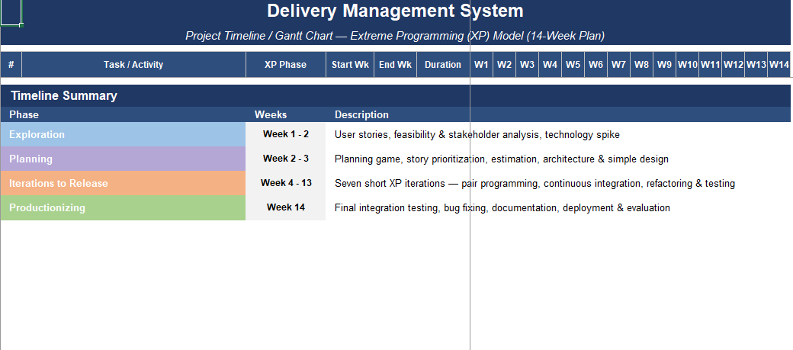3.3.1 Functional Requirements

Admin Requirements

Table - 1: Functional Requirements for Admin
Req. ID | Requirement
2.3.1.0 | Admin Dashboard – All administrative features accessible after secure login.
2.3.1.1 | Admin Profile Management
2.3.1.1.1 | Create a new admin profile by entering required details (name, email, password).
2.3.1.1.2 | Securely log in to the dashboard using email and password.
2.3.1.1.3 | Send OTP to mobile and confirmation email upon profile creation.
2.3.1.2 | System Data Overview
2.3.1.2.1 | View all records: shipments, payments, employees, carriers, and routes in a list/table.
2.3.1.2.2 | Access detailed tracking information for any shipment in the system.
2.3.1.3 | Record Management (CRUD Operations)
2.3.1.3.1 | Add new employees, carriers, shipments, and routes to the system.
2.3.1.3.2 | Update details for shipments, payments, tracking status, and routes.
2.3.1.3.3 | Delete (remove) records for employees, carriers, and shipments.
2.3.1.3.4 | All changes (add, update, delete) must reflect immediately in the system views.
Employee Requirements

Table - 2: Functional Requirements for Employee
Req. ID | Requirement
2.3.1.4 | Employee Dashboard – All employee features accessible after secure login.
Req. ID | Requirement
2.3.1.5 | Login & Profile
2.3.1.5.1 | Log in securely using registered email and password.
2.3.1.5.2 | Update personal employee information.
2.3.1.6 | Shipment & Payment Processing
2.3.1.6.1 | Verify the payment status (Paid/Unpaid) of a shipment request.
2.3.1.6.2 | Assign a confirmed (paid) shipment to an available carrier, linking ShipmentID, CarrierID, and PaymentID.
2.3.1.7 | Shipment Lifecycle Management
2.3.1.7.1 | Update shipment information and tracking status (e.g., Pending, In Transit).
2.3.1.7.2 | Remove (cancel/delete) shipment orders from the system.
2.3.1.8 | Carrier & Route Management
2.3.1.8.1 | Add new carriers to the system.
2.3.1.8.2 | Delete carrier records.
2.3.1.8.3 | Define and add new shipment routes with origin and destination addresses.

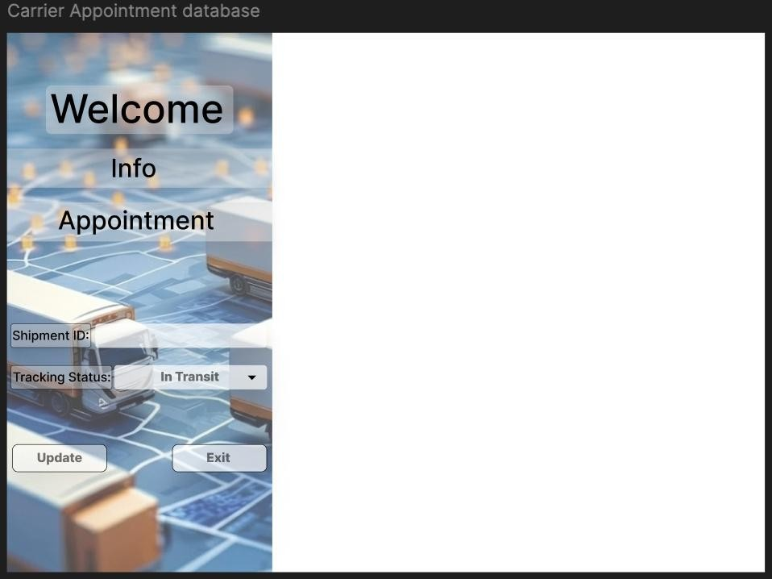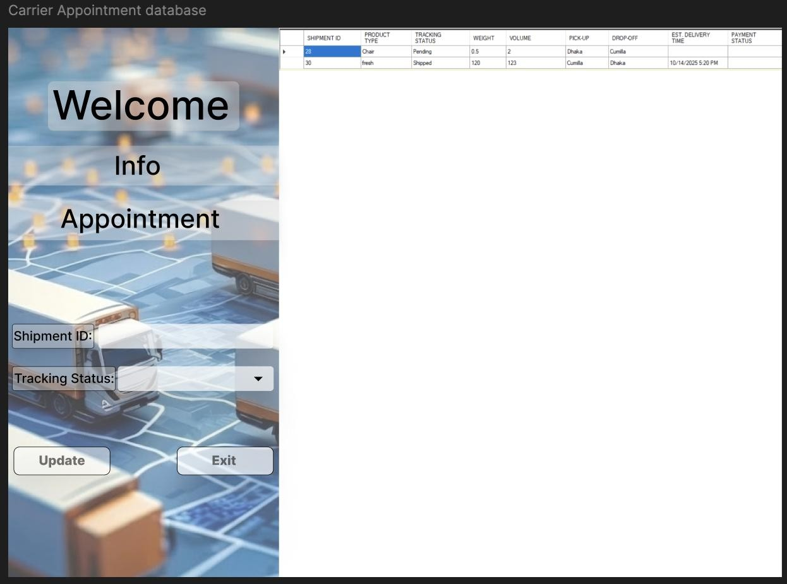

TC_02: Verify employee can verify payment and assign a paid shipment
Project Name: Delivery Management System |  |  | Test Designed by:MD. Ahasanul Haque Zihad
Test Case ID: TC_02 |  |  | Test Designed date: 07/09/2026
Test Priority (Low, Medium, High): High |  |  | Test Executed by: Project Team
Module Name: Payment Verification & Assignment |  |  | Test Execution date: 09/09/2026
Test Title: Verify employee can verify payment and assign a paid shipment
Description: Verify the required function works correctly in the Delivery Management System.
Precondition: Employee is logged in and a shipment with pending payment exists.
Dependencies: Required user account and related system data are available.
1. Open shipment list  2. Select a paid shipment  3. Verify payment  4. Assign a carrier | Shipment ID: SHP-1001  Payment: Paid  Carrier: Carrier 01 | Payment is verified and the shipment is assigned to the selected carrier. | Payment verified and carrier assigned. | Pass
1. Go to the login page  2. Enter registered email and password  3. Click Login | Email: kamrul.islam@gmail.com  Password: Kamrul@2026 | User is authenticated and redirected to the Citizen dashboard with their data loaded. | As expected | Pass
Post Condition: Shipment status and assignment are updated.
TC_10: Verify employee can add a new shipment route
Project Name: Delivery Management System |  |  | Test Designed by:MD.Ahasanul Haque Zihad
Test Case ID: TC_10 |  |  | Test Designed date: 07/09/2026
Test Priority (Low, Medium, High): Medium |  |  | Test Executed by: Sadman Rafi
Module Name: Route Management |  |  | Test Execution date: 09/09/2026
Test Title: Verify employee can add a new shipment route
Description: Verify the required function works correctly in the Delivery Management System.
Precondition: Employee is logged in and has permission to manage routes.
Dependencies: Required user account and related system data are available.
1. Open route management  2. Click Add Route  3. Enter route details  4. Save the route | Route ID: R-10  From: Dhaka  To: Sylhet  Estimated Time: 2 days | New route is added successfully and can be used for shipments. | New route added successfully. | Pass
1. Coordinator changes request status from Pending to In Progress  2. Citizen opens the notification panel | Request status change: Pending -> In Progress | A notification is delivered promptly to the citizen's account. | As expected | Pass
Post Condition: Route is available in the route list.

