Z Transform of a Discrete Time Function
X(n) = [1/16n ]u(n)
Matlab Code
syms z n
a=ztrans(1/16^n)
a =
16*z/(16*z-1)

Inverse Z-Transform

X(n) = Z-1 [ X(Z)]
X(Z) = 3*Z / (Z+1)
Matlab Code
syms Z n
iztrans(3*Z/(Z+1))
ans =
3*(-1)^n

Pole Zero Diagram for a Function in Z Domain
Z plane command computes and display the pole-zero diagram of Z function.
The Command is
Zplane(b,a)
To display the pole value, use root(a)
To display the zero value, use root(b)
X(Z) = [Z-2 + Z-1 ] / [1-2Z-1+3Z-2]

Matlab Code
b=[0 1 1 ]
a= [1 -2 +3]
roots(a)
roots(b)
zplane(b,a);
ans =
1.0000 + 1.4142i
1.0000 - 1.4142i
ans =
-1

% Z transform of 2^n + 2^n*(n - 1)
syms n
f=2^n + 2^n*(n - 1)
ztrans(f)
%output 2*z/(z-2)^2
%%%%%%%%%%%%%%%%%%%%%%%%%%%%
% Inverse Z transform of 2*z/(z-2)^2
syms z
F = 2*z/(z-2)^2;
iztrans(F)
% Output 2^n + 2^n*(n - 1)

EXC: Use the MATLAB command “roots” to determine the poles and zeros of the following systems-
- H(s)=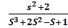
Program :
clc
clear
z=roots([1,0,2])
p=roots([1,2,-1,1])
Output :
z =
0 + 1.4142i
0 - 1.4142i
p =
-2.5468
0.2734 + 0.5638i
  - - 0.5638i

- H(s)= 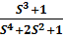
Program :
clc
clear
z=roots([1,0,0,1])
p=roots([1,0,2,0,1])
Output :
z =
-1.0000
0.5000 + 0.8660i
0.5000 - 0.8660i
p =
-0.0000 + 1.0000i
-0.0000 - 1.0000i
0.0000 + 1.0000i
0.0000 - 1.0000i

- H(s)=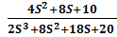
Program :
clc
clear
z=roots([4,8,10])
p=roots([2,8,18,20])

Output :
z =
-1.0000 + 1.2247i
-1.0000 - 1.2247i
p =
-1.0000 + 2.0000i
-1.0000 - 2.0000i
-2.0000
EXC: Use the MATLAB command “pzmap” to plot the poles and zeros of the following systems-
- H(s)=
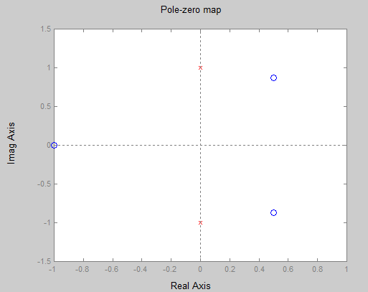
Program :
clc
clear
num=[1,0,0,1];
den=[1,0,2,0,1];
systf=tf(num,den)
pzmap(systf)

Frequency Response

The Freqz function computes and display the frequency response of given Z- Transform
of the function
freqz(b,a,npt,Fs)
b= Coeff. Of Numerator
a= Coeff. Of Denominator
Fs= Sampling Frequency
Npt= no. of free points between and Fs/2
X(Z) = [2+ 5Z-1+9Z-2+5Z-3+3Z-4]/ [5+ 45Z-1+2Z-2+Z-3+Z-4]
Matlab Code
b=[2 5 9 5 3]
a= [5 45 2 1 1]
freqz(b,a);

