Uloom AI
Detailed Design Document
Version: 0.1 (Draft)
Status: Working Draft — derived from SRS v1.0
Author: Ricardo Mitchell
Based on: Uloom AI SRS v1.0 (Final)

1. Purpose
This document translates the approved Software Requirements Specification (SRS v1.0) into concrete design artifacts: a data model (ERD), sequence diagrams for the primary flows, an API layer design, and per-service design notes. It is the detailed-design counterpart to SRS Sections 5 (Data Model), 6 (Architecture), and 8 (Initial Modules).
Scope note: the API layer design in Section 4 is intentionally kept implementation-agnostic. A formal OpenAPI schema (exact request/response bodies, status codes, error envelopes) is deferred until the endpoint surface and framework choices are locked, consistent with the provider-independence constraint in SRS Section 11.

2. Data Model / Entity-Relationship Diagram
Expands SRS Section 5. Five core entities support the v1 scope: authentication, document ingestion, chunked/embedded content, and conversational history with citations.
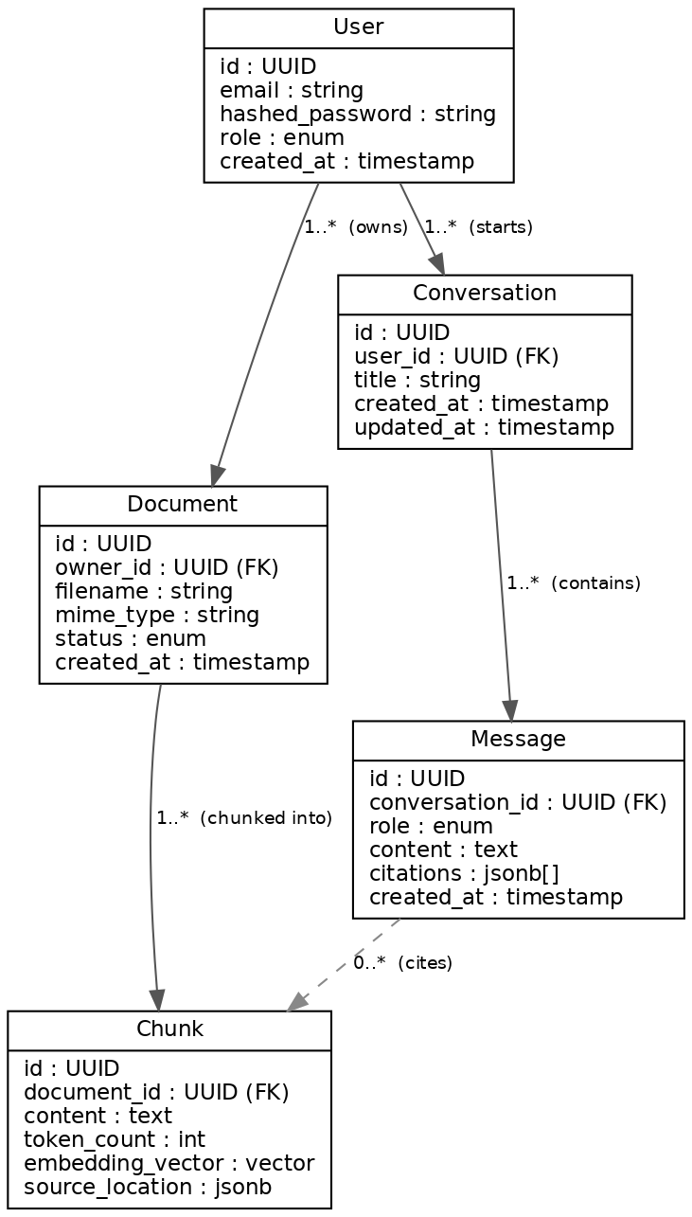
Figure 1 — Entity relationships (solid = ownership/foreign key, dashed = citation reference)

Notes
- Chunk.embedding_vector is stored via pgvector, co-located with relational data per SRS Section 7 (no separate vector database in v1).
- Message.citations is a JSON array of {chunk_id, document_id, source_location} references rather than a normalized join table, since citations are read together with the message and don't need independent querying in v1.
- Document.status and Chunk.source_location map directly to FR-004 acceptance criteria (processing SLA, source metadata).

3. Sequence Diagrams
Three primary flows cover the v1 functional scope (FR-001, FR-003–FR-007).

3.1 Authentication
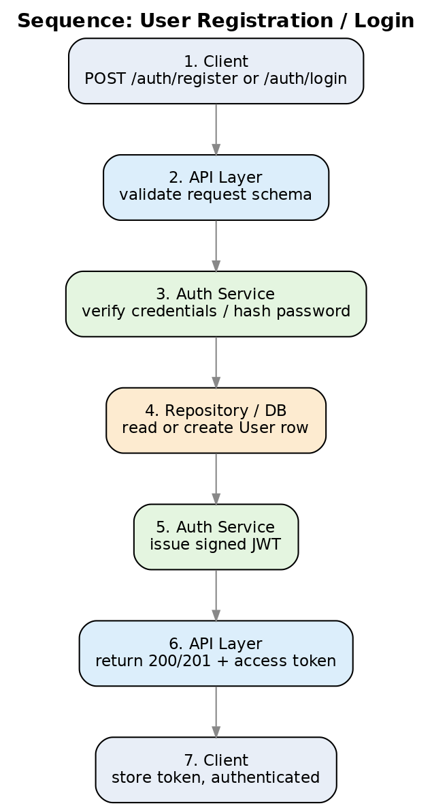
Figure 2 — Registration / login (FR-001)

3.2 Document Upload & Indexing
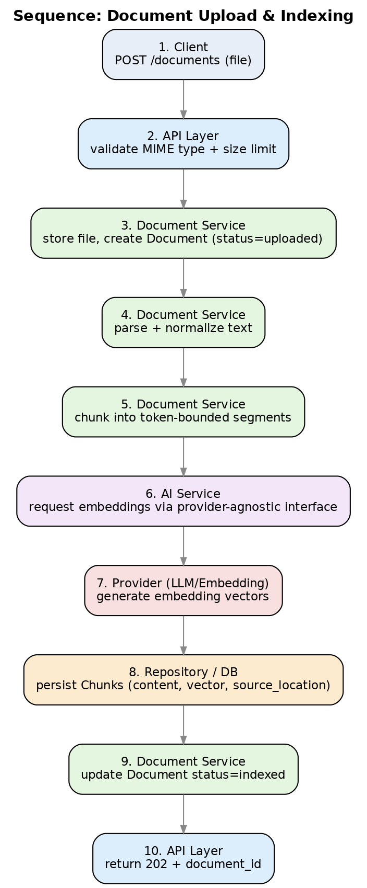
Figure 3 — Upload through indexing (FR-003, FR-004)

3.3 Conversational RAG Q&A
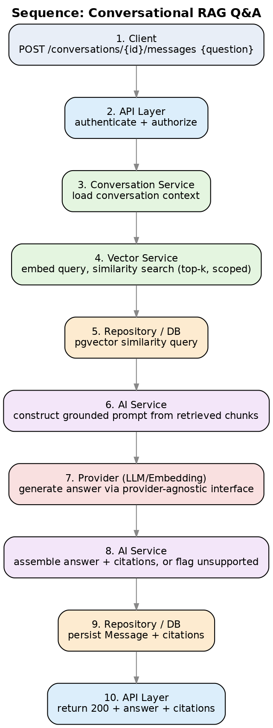
Figure 4 — Retrieval-augmented question answering (FR-005–FR-007)

4. API Layer Design (Provider-Agnostic)
This is a resource-and-responsibility map, not a formal contract. Exact request/response schemas, error envelopes, and pagination conventions are deliberately left open until framework and provider decisions are finalized — this keeps the API layer swappable per SRS Section 6 (API Layer owns validation/translation only) and Section 11 (provider independence).
Resource | Method(s) | Responsibility | Auth
/auth/register, /auth/login | POST | Create account / issue JWT (FR-001) | Public
/users/me | GET, PATCH | Read/update profile & role (FR-002) | User
/documents | POST, GET | Upload document; list owned/shared documents (FR-003) | User
/documents/{id} | GET, DELETE | Document status/metadata; delete + purge (FR-003, Sec.10) | Owner/Admin
/conversations | POST, GET | Create/list conversations (FR-008) | User
/conversations/{id}/messages | POST, GET | Ask question; retrieve message + citation history (FR-006, FR-007, FR-008) | User
/admin/users, /admin/documents, /admin/settings | GET, PATCH | Administration (FR-009) | Admin

Deferred to implementation phase
- Formal OpenAPI/JSON Schema generation (auto-derivable from FastAPI + Pydantic models per SRS Section 7).
- Error response envelope shape and error-code taxonomy (must cover the degraded-mode states in SRS Section 9).
- Pagination, filtering, and sorting conventions for list endpoints.
- Versioning strategy for the API layer (e.g., URL prefix vs. header-based).

5. Module / Service Design
Expands SRS Section 8. Each service is framework-agnostic business logic (SRS Section 6) sitting behind the API layer and above the repository layer.

5.1 Auth Service
Aspect | Detail
Responsibilities | Registration, credential verification, password hashing, JWT issuance/validation, role checks
Depends on | User Repository; secret store for signing key (NFR-004)
Key design points | Password hashing via bcrypt/argon2; JWT short-lived access token (+ refresh strategy TBD); role checks enforced in API layer via dependency injection, not scattered per-route
Open questions | Refresh token strategy; SSO/OAuth as a future provider-agnostic extension

5.2 Document Service
Aspect | Detail
Responsibilities | Upload validation (type/size), storage, parsing, normalization, chunking, status tracking, deletion (Sec.10)
Depends on | Document/Chunk Repository; AI Service (embeddings); object storage (location TBD)
Key design points | Chunking is a pluggable strategy behind an interface (token-range configurable per NFR admin control, FR-009); processing is async so upload returns immediately (202) while indexing completes within the FR-004 SLA
Open questions | Object storage backend (local volume vs. S3-compatible); virus/malware scanning on upload

5.3 Vector Service
Aspect | Detail
Responsibilities | Query embedding, top-k similarity search scoped to authorized documents (FR-005)
Depends on | Chunk Repository (pgvector); AI Service (embedding provider)
Key design points | Authorization scoping happens in the query itself (WHERE clause on accessible document IDs), not as a post-filter, to avoid leaking existence of unauthorized content
Open questions | Index type/tuning for pgvector (IVFFlat vs. HNSW) at target document volume

5.4 Conversation Service
Aspect | Detail
Responsibilities | Conversation/message CRUD, history ordering, orchestrating retrieval + AI Service calls (FR-006, FR-008)
Depends on | Conversation/Message Repository; Vector Service; AI Service
Key design points | Owns the "no relevant context above threshold" decision (FR-006) and the unsupported-answer flag (FR-007) before persisting a message
Open questions | Similarity threshold value(s); whether threshold is global or per-document-type configurable

5.5 AI Service
Aspect | Detail
Responsibilities | Provider-abstracted embeddings + generation, prompt construction, citation assembly, fallback/retry on provider failure (NFR-005, Sec.9)
Depends on | Provider adapters (OpenAI / Hugging Face / Ollama) behind a common interface; no other service calls a provider SDK directly
Key design points | A single internal interface (e.g., generate(), embed()) is implemented per provider; Business Services and Conversation Service depend only on this interface, so provider swaps touch one layer (SRS Sec.6, Sec.11)
Open questions | Interface method signatures and streaming-response support are intentionally not fixed yet — same rationale as the API layer being kept agnostic in Section 4

6. Summary of Deferred Decisions
Carried forward from this design pass, to be resolved before or during implementation:
- Formal API contract (OpenAPI) — deferred; resource map in Section 4 stands in for now.
- AI Service internal interface signatures — deferred pending provider evaluation.
- Object storage backend for raw uploaded files.
- Refresh-token / session strategy for Auth Service.
- Similarity threshold(s) governing the "unsupported answer" behavior.
- pgvector index tuning strategy.

