Uloom AI
Detailed Design Document
Version: 0.3 (Draft)
Status: Working Draft — derived from SRS v1.2
Author: Ricardo Mitchell
Based on: Uloom AI SRS v1.2 (Final)
Revision note: v0.3 consolidates to Google Gemini API as the single default provider for both generation and embeddings (Section 5.5), replacing the v0.2 two-vendor default (Claude + Voyage AI). Section 5.6 updated accordingly; the ChatProvider/EmbeddingProvider interface split is unchanged.
Revision note: v0.2 sets Anthropic Claude API as the default generation provider and Voyage AI as the default embedding provider (Section 5.5), and adds provider-swappability guidelines (Section 5.6).

1. Purpose
This document translates the approved Software Requirements Specification (SRS v1.0) into concrete design artifacts: a data model (ERD), sequence diagrams for the primary flows, an API layer design, and per-service design notes. It is the detailed-design counterpart to SRS Sections 5 (Data Model), 6 (Architecture), and 8 (Initial Modules).
Scope note: the API layer design in Section 4 is intentionally kept implementation-agnostic. A formal provider-specific schema (exact request/response bodies, status codes, error envelopes) is deferred until the endpoint surface and framework choices are locked, consistent with the provider-independence constraint in SRS Section 11.

2. Data Model / Entity-Relationship Diagram
Expands SRS Section 5. Five core entities support the v1 scope: authentication, document ingestion, chunked/embedded content, and conversational history with citations.
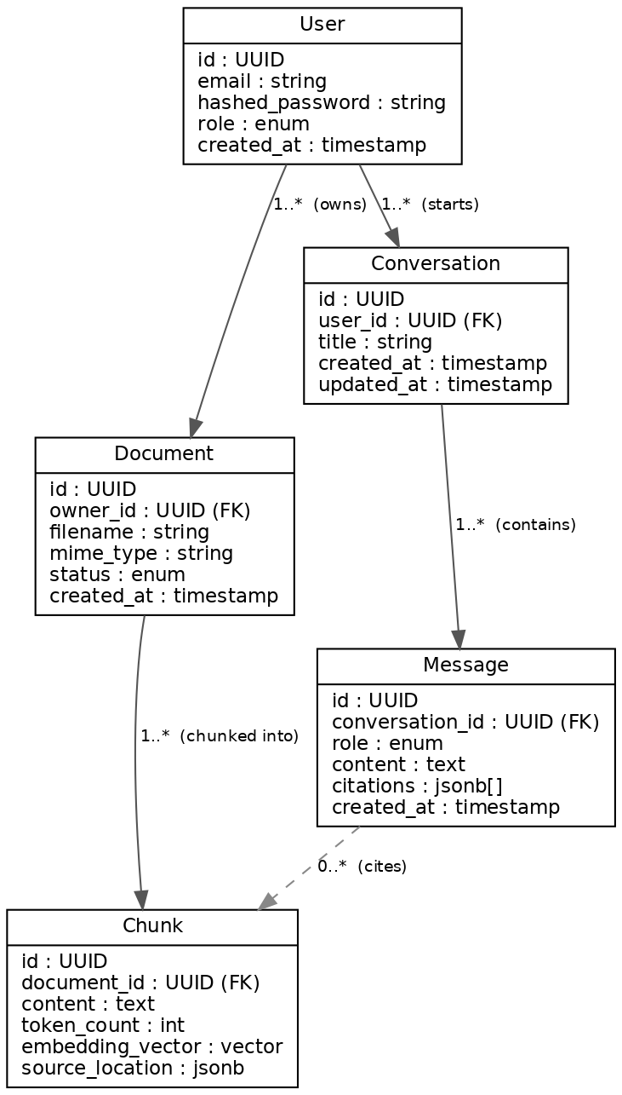
Figure 1 — Entity relationships (solid = ownership/foreign key, dashed = citation reference)

Notes
- Chunk.embedding_vector is stored via pgvector, co-located with relational data per SRS Section 7 (no separate vector database in v1).
- Message.citations is a JSON array of {chunk_id, document_id, source_location} references rather than a normalized join table, since citations are read together with the message and don't need independent querying in v1.
- Document.status and Chunk.source_location map directly to FR-004 acceptance criteria (processing SLA, source metadata).

3. Sequence Diagrams
Three primary flows cover the v1 functional scope (FR-001, FR-003–FR-007).

3.1 Authentication
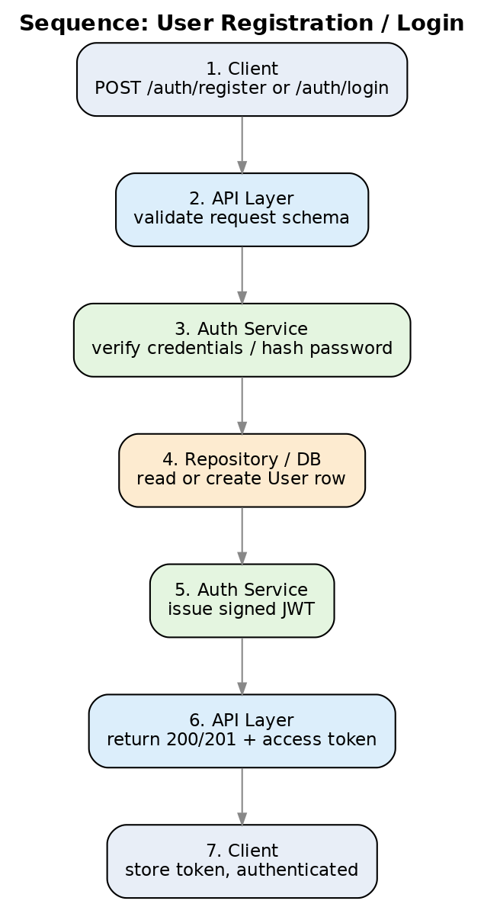
Figure 2 — Registration / login (FR-001)

3.2 Document Upload & Indexing
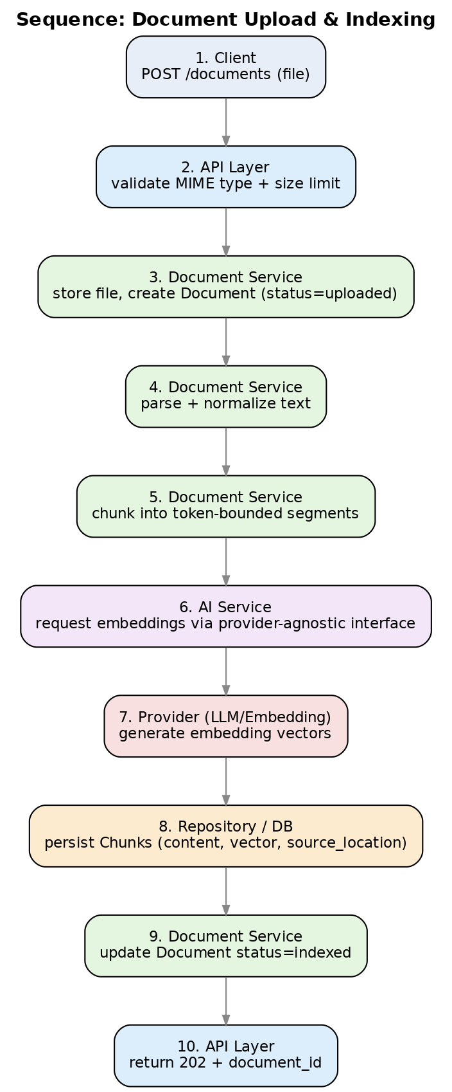
Figure 3 — Upload through indexing (FR-003, FR-004)

3.3 Conversational RAG Q&A
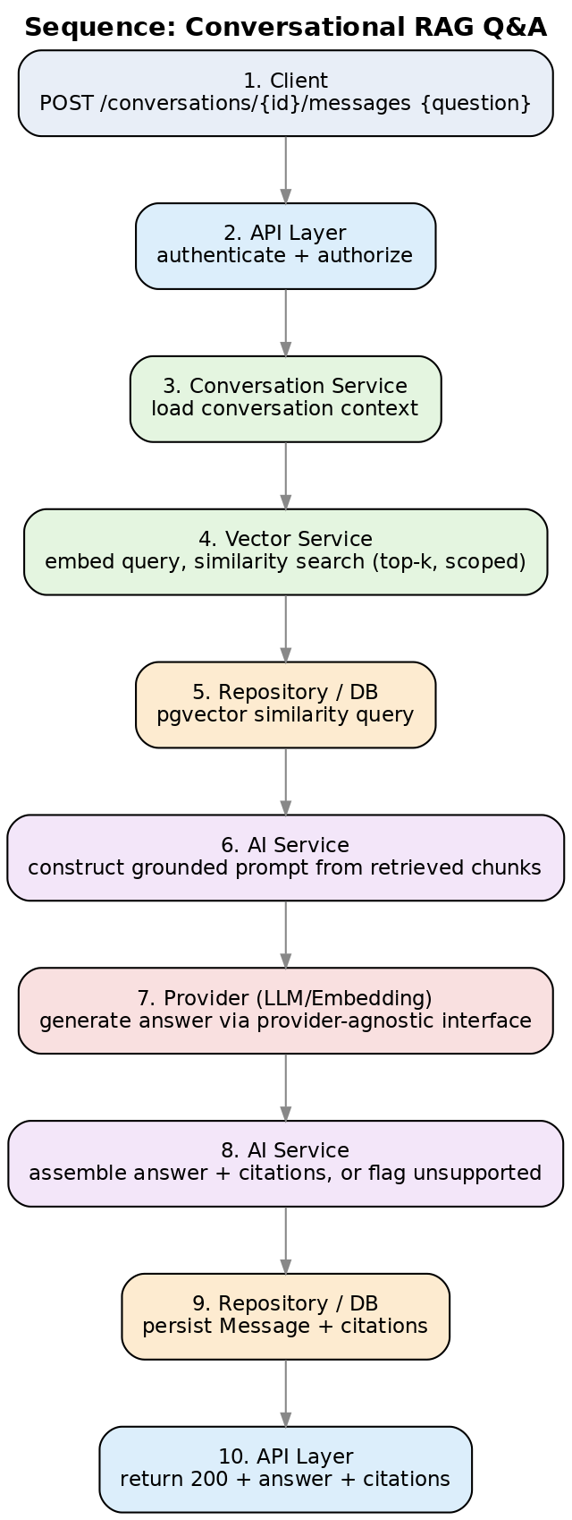
Figure 4 — Retrieval-augmented question answering (FR-005–FR-007)

4. API Layer Design (Provider-Agnostic)
This is a resource-and-responsibility map, not a formal contract. Exact request/response schemas, error envelopes, and pagination conventions are deliberately left open until framework and provider decisions are finalized — this keeps the API layer swappable per SRS Section 6 (API Layer owns validation/translation only) and Section 11 (provider independence).
Resource | Method(s) | Responsibility | Auth
/auth/register, /auth/login | POST | Create account / issue JWT (FR-001) | Public
/users/me | GET, PATCH | Read/update profile & role (FR-002) | User
/documents | POST, GET | Upload document; list owned/shared documents (FR-003) | User
/documents/{id} | GET, DELETE | Document status/metadata; delete + purge (FR-003, Sec.10) | Owner/Admin
/conversations | POST, GET | Create/list conversations (FR-008) | User
/conversations/{id}/messages | POST, GET | Ask question; retrieve message + citation history (FR-006, FR-007, FR-008) | User
/admin/users, /admin/documents, /admin/settings | GET, PATCH | Administration (FR-009) | Admin

Deferred to implementation phase
- Formal OpenAPI/JSON Schema generation (auto-derivable from FastAPI + Pydantic models per SRS Section 7).
- Error response envelope shape and error-code taxonomy (must cover the degraded-mode states in SRS Section 9).
- Pagination, filtering, and sorting conventions for list endpoints.
- Versioning strategy for the API layer (e.g., URL prefix vs. header-based).

5. Module / Service Design
Expands SRS Section 8. Each service is framework-agnostic business logic (SRS Section 6) sitting behind the API layer and above the repository layer.

5.1 Auth Service
Aspect | Detail
Responsibilities | Registration, credential verification, password hashing, JWT issuance/validation, role checks
Depends on | User Repository; secret store for signing key (NFR-004)
Key design points | Password hashing via bcrypt/argon2; JWT short-lived access token (+ refresh strategy TBD); role checks enforced in API layer via dependency injection, not scattered per-route
Open questions | Refresh token strategy; SSO/OAuth as a future provider-agnostic extension

5.2 Document Service
Aspect | Detail
Responsibilities | Upload validation (type/size), storage, parsing, normalization, chunking, status tracking, deletion (Sec.10)
Depends on | Document/Chunk Repository; AI Service (embeddings); object storage (location TBD)
Key design points | Chunking is a pluggable strategy behind an interface (token-range configurable per NFR admin control, FR-009); processing is async so upload returns immediately (202) while indexing completes within the FR-004 SLA
Open questions | Object storage backend (local volume vs. S3-compatible); virus/malware scanning on upload

5.3 Vector Service
Aspect | Detail
Responsibilities | Query embedding, top-k similarity search scoped to authorized documents (FR-005)
Depends on | Chunk Repository (pgvector); AI Service (embedding provider)
Key design points | Authorization scoping happens in the query itself (WHERE clause on accessible document IDs), not as a post-filter, to avoid leaking existence of unauthorized content
Open questions | Index type/tuning for pgvector (IVFFlat vs. HNSW) at target document volume

5.4 Conversation Service
Aspect | Detail
Responsibilities | Conversation/message CRUD, history ordering, orchestrating retrieval + AI Service calls (FR-006, FR-008)
Depends on | Conversation/Message Repository; Vector Service; AI Service
Key design points | Owns the "no relevant context above threshold" decision (FR-006) and the unsupported-answer flag (FR-007) before persisting a message
Open questions | Similarity threshold value(s); whether threshold is global or per-document-type configurable

5.5 AI Service
Aspect | Detail
Responsibilities | Provider-abstracted embeddings + generation, prompt construction, citation assembly, fallback/retry on provider failure (NFR-005, Sec.9)
Depends on | Single vendor for v1: Google Gemini API — generateContent for chat/generation, gemini-embedding-001 for embeddings. One adapter (GeminiAdapter) implements both capability interfaces. Anthropic Claude, OpenAI, Voyage AI, Hugging Face, and Ollama remain available as alternate adapters behind the same interfaces (SRS Sec.7).
Key design points | Two capability interfaces, not one: ChatProvider (generate/stream) and EmbeddingProvider (embed) stay separate even though a single adapter class implements both for v1. Business Services and Conversation Service depend only on these interfaces, never on a vendor SDK type — so de-consolidating later (e.g., only the embedding side to Voyage AI) is a new adapter for one interface, not a rewrite (SRS Sec.6, Sec.11).
Open questions | Exact interface method signatures and streaming-response support — principles fixed in Section 5.6, signatures TBD during implementation

5.6 Provider Abstraction & Swappability Guidelines
Google Gemini is the concrete default for v1 — one vendor, one adapter, covering both generation and embeddings — so there's no open gap at implementation time. The AI Service is still built so Gemini can be replaced, or split back into two vendors, without touching Document Service, Vector Service, or Conversation Service. Six practices keep that true:
- Split the interface by capability, not by vendor. Define ChatProvider (generate, stream) and EmbeddingProvider (embed) as separate interfaces, even when one vendor implements both. GeminiAdapter implements both interfaces for v1; nothing prevents a future GeminiAdapter (chat only) plus a separate VoyageAdapter (embeddings only) if the vendors need to split.
- Adapter per provider, interface-only elsewhere. GeminiAdapter implements ChatProvider and EmbeddingProvider using the Gemini SDK. Document Service, Vector Service, and Conversation Service import only the interface types, never google.generativeai (or equivalent) SDK types directly.
- Config-driven selection via a factory. Which adapter is active is chosen by config/environment (e.g., AI_CHAT_PROVIDER=gemini, AI_EMBEDDING_PROVIDER=gemini — independently settable even though they resolve to the same adapter today), resolved once at startup by a factory/DI container. Pointing AI_EMBEDDING_PROVIDER at a different adapter later is a config change, not a code change in calling services.
- Normalize the wire format at the boundary. Internal DTOs (ChatRequest/ChatResponse, EmbedRequest/EmbedResponse) are vendor-neutral; GeminiAdapter translates to/from Gemini's native request/response shape inside the adapter, not in business logic.
- Normalize errors, not just requests. Map provider-specific failures (rate limit, content policy, timeout, auth) to a small set of internal exception types, so the retry/fallback behavior required by NFR-005 and SRS Section 9 is written once against the interface, not once per vendor.
- Treat advanced features as advertised capabilities. Things like context caching, multimodal embeddings (e.g., gemini-embedding-2), or grounding vary by provider and model. An adapter exposes what it supports via a capability flag the caller checks, rather than the codebase assuming every provider behind ChatProvider or EmbeddingProvider can do everything Gemini can.

6. Summary of Deferred Decisions
Carried forward from this design pass, to be resolved before or during implementation:
- Formal API contract (OpenAPI) — deferred; resource map in Section 4 stands in for now.
- AI Service interface method signatures (exact ChatProvider/EmbeddingProvider shape) and streaming support — principles fixed in Section 5.6, signatures TBD.
- Object storage backend for raw uploaded files.
- Refresh-token / session strategy for Auth Service.
- Similarity threshold(s) governing the "unsupported answer" behavior.
- pgvector index tuning strategy.

