TOTAL NO. OF SHEETS: 5
SHEET NO.: 1/5
FIGURE 1:

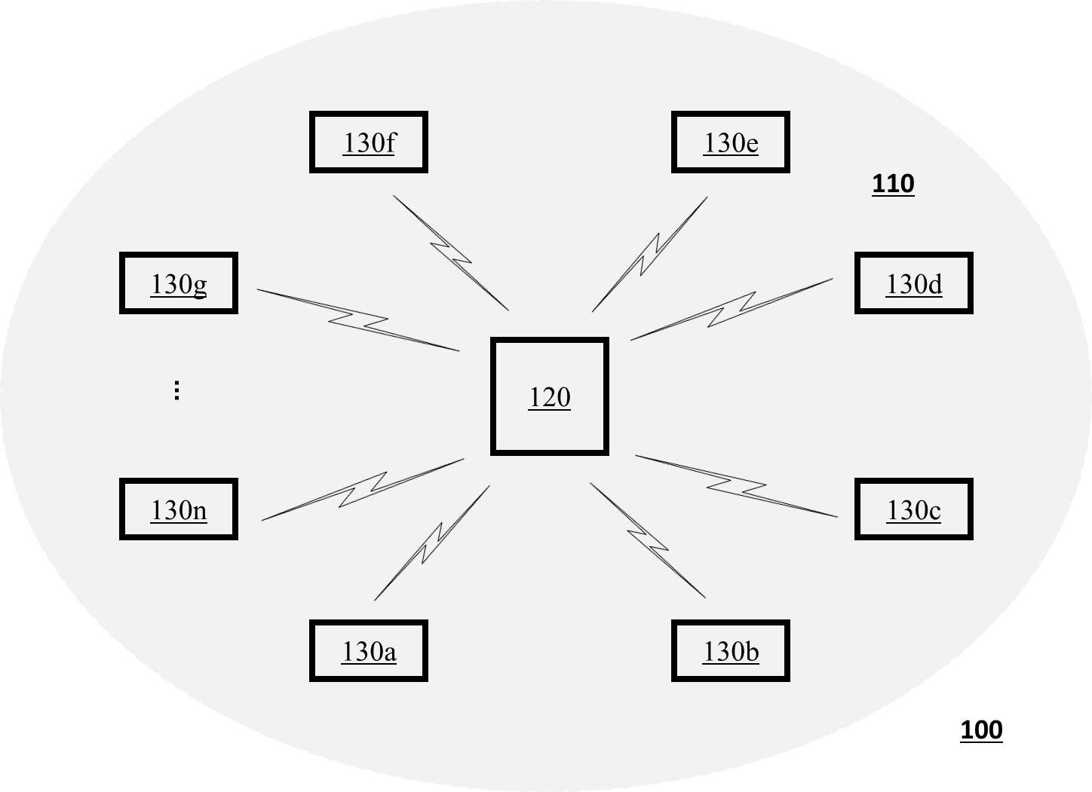

TOTAL NO. OF SHEETS: 5
SHEET NO.: 2/5
FIGURE 2:

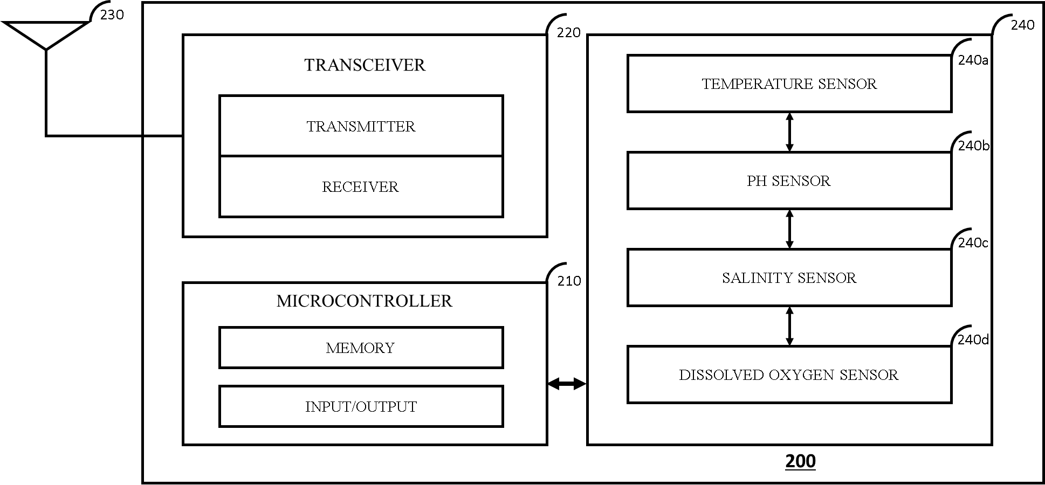

TOTAL NO. OF SHEETS: 5
SHEET NO.: 3/5
FIGURE 3:
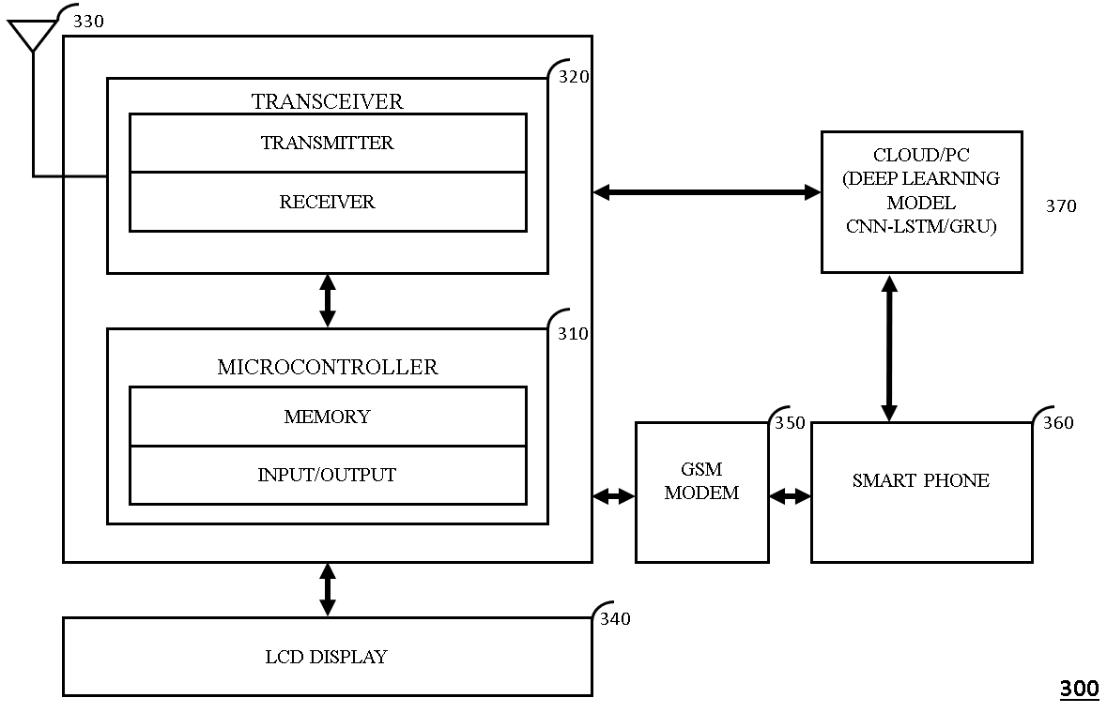

TOTAL NO. OF SHEETS: 5
SHEET NO.: 4/5
FIGURE 4:
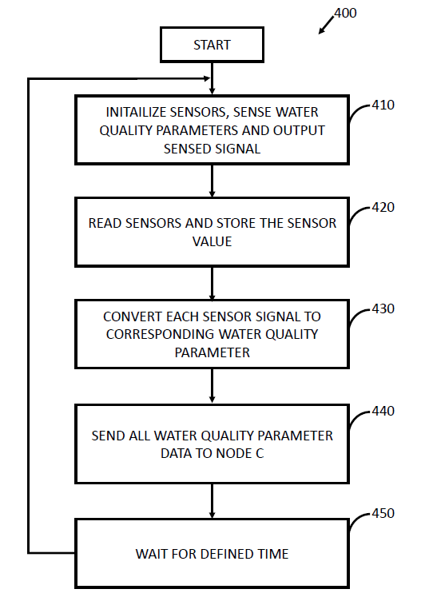

TOTAL NO. OF SHEETS: 5
SHEET NO.: 5/5
FIGURE 5:
