TOTAL NO. OF SHEETS: 5
SHEET NO.: 1/5
FIGURE 1:

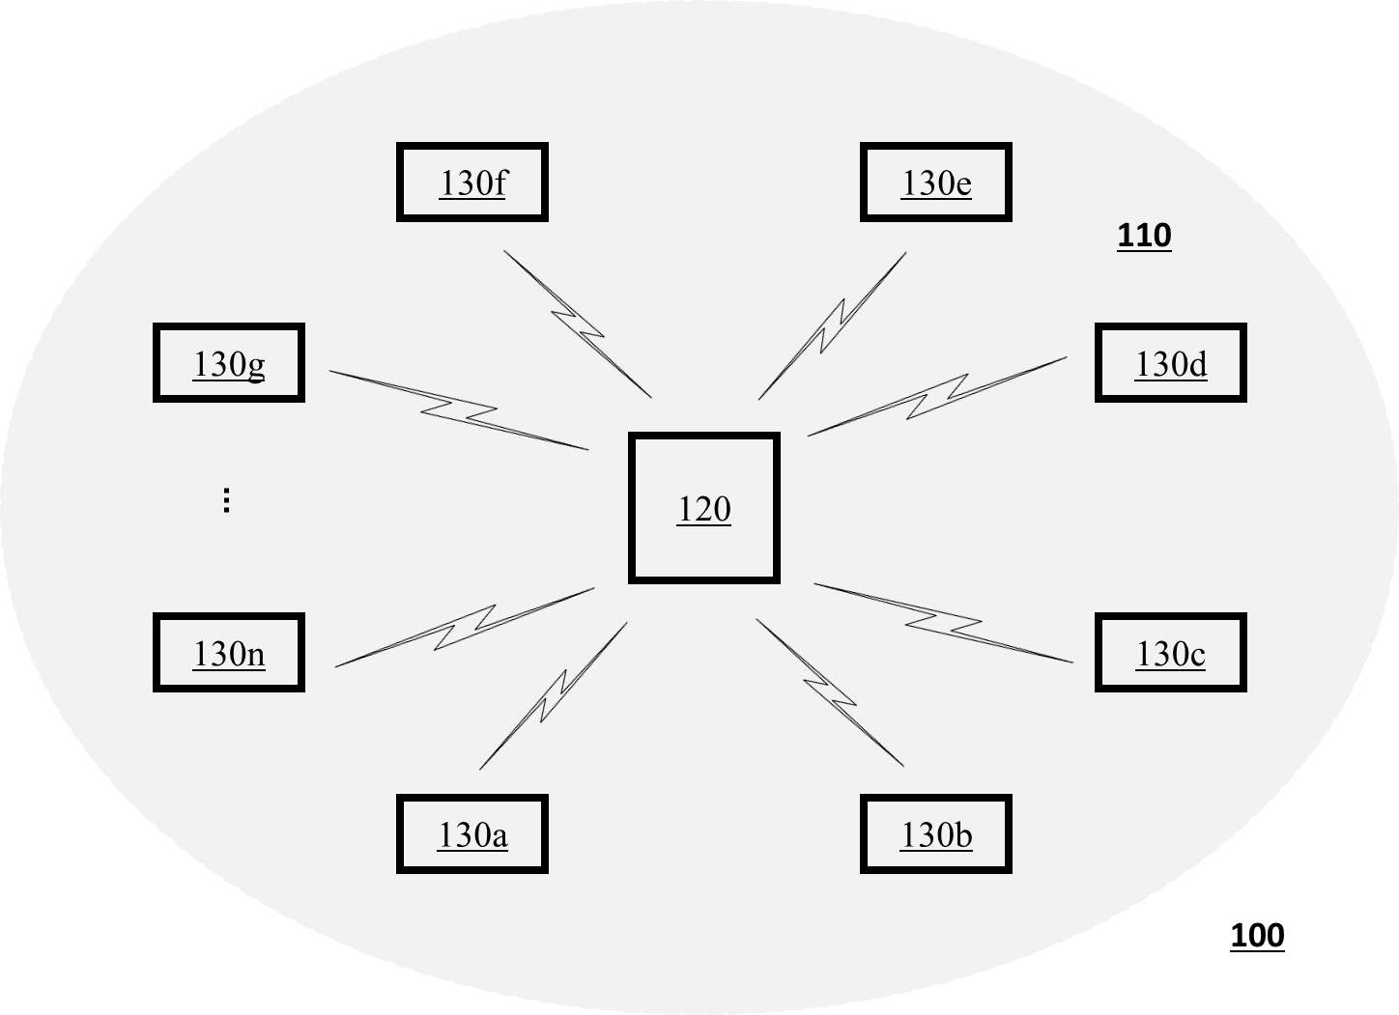

Dated this day of May 2021
Durgumahanthi Sai Meera [IN/PA-3410]
Agent for Applicant

TOTAL NO. OF SHEETS: 5
SHEET NO.: 2/5
FIGURE 2:

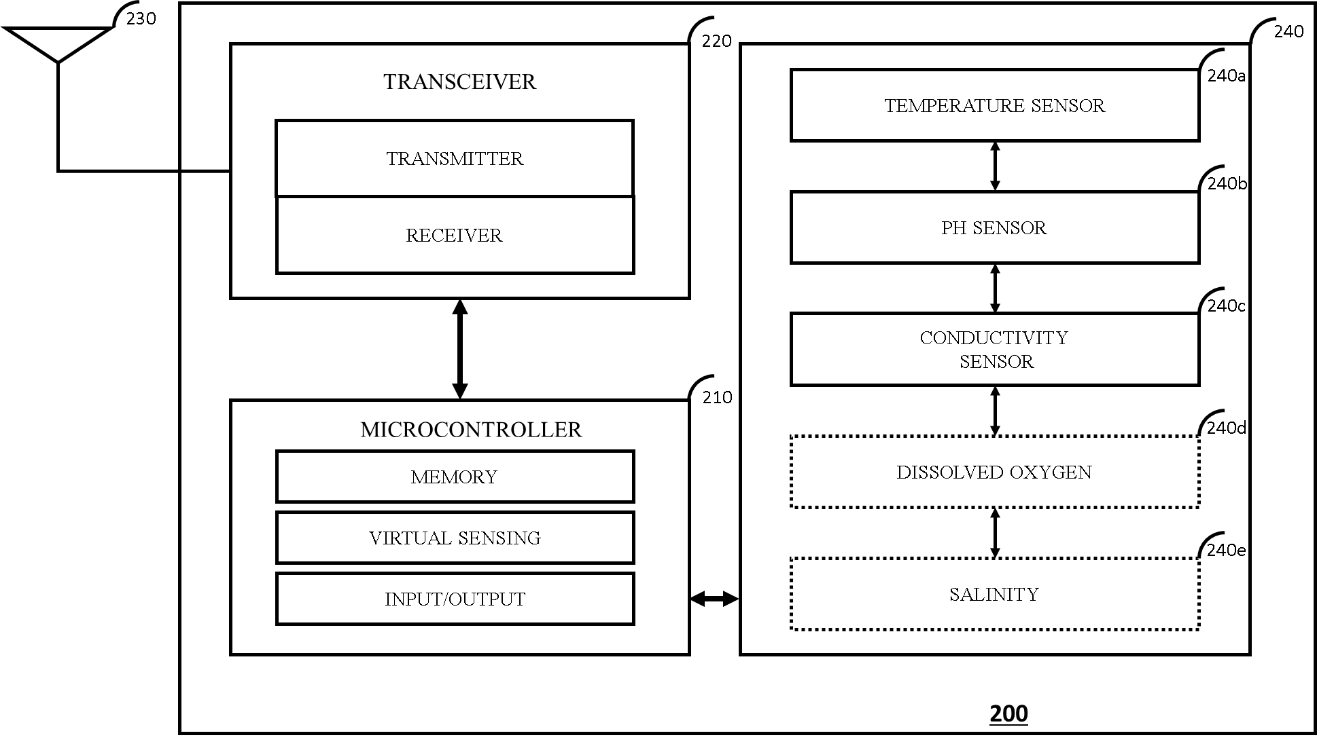

Dated this day of May 2021
Durgumahanthi Sai Meera [IN/PA-3410]
Agent for Applicant

TOTAL NO. OF SHEETS: 5
SHEET NO.: 3/5
FIGURE 3:
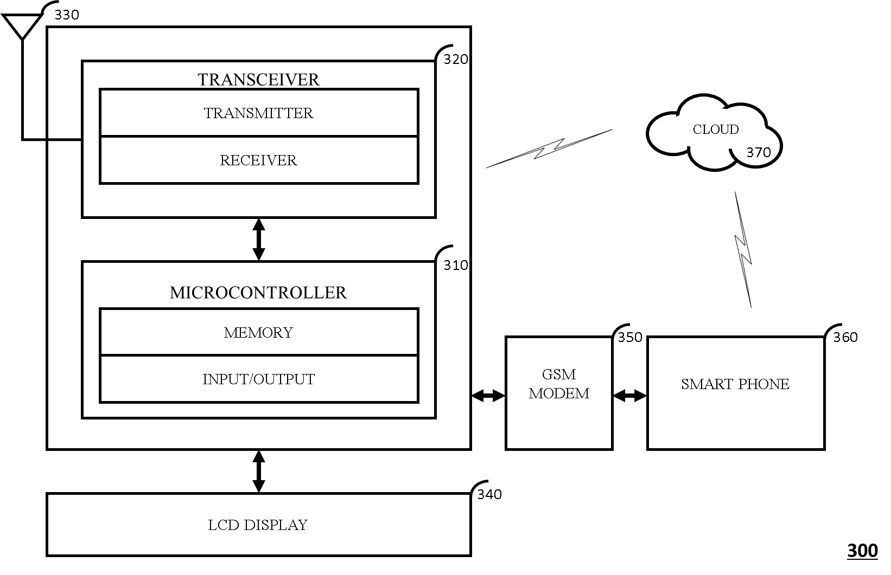

Dated this day of May 2021
Durgumahanthi Sai Meera [IN/PA-3410]
Agent for Applicant

TOTAL NO. OF SHEETS: 5
SHEET NO.: 4/5
FIGURE 4:
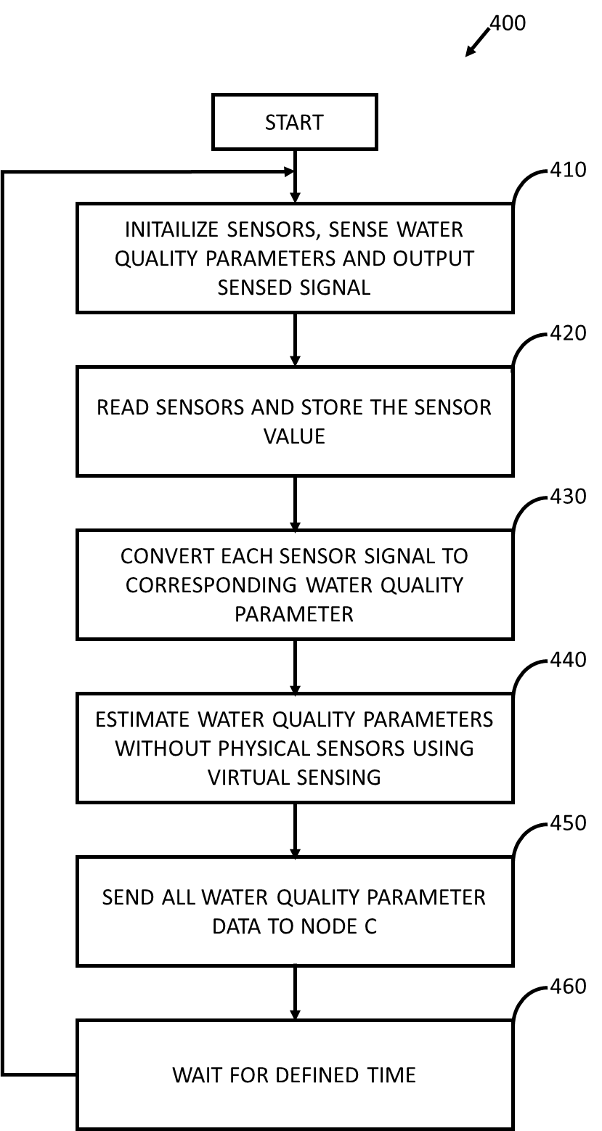
Dated this day of May 2021
Durgumahanthi Sai Meera [IN/PA-3410]
Agent for Applicant
TOTAL NO. OF SHEETS: 5
SHEET NO.: 5/5
FIGURE 5:
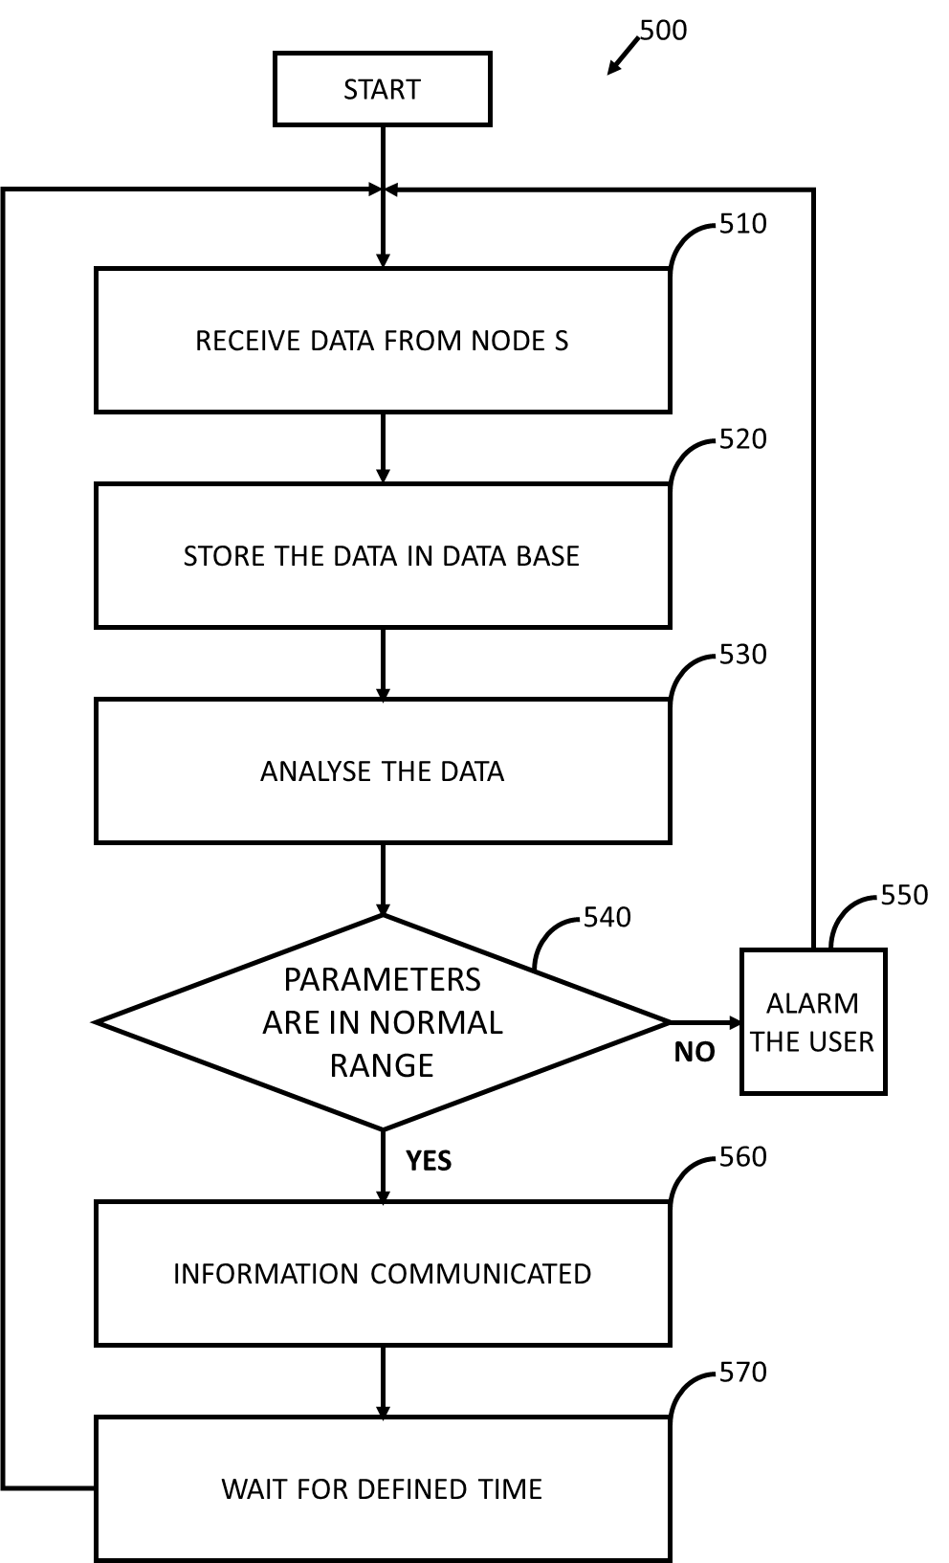
Dated this day of May 2021
Durgumahanthi Sai Meera [IN/PA-3410]
Agent for Applicant

