TOTAL NO. OF SHEETS: 7
SHEET NO.: 1/7
FIGURE 1:

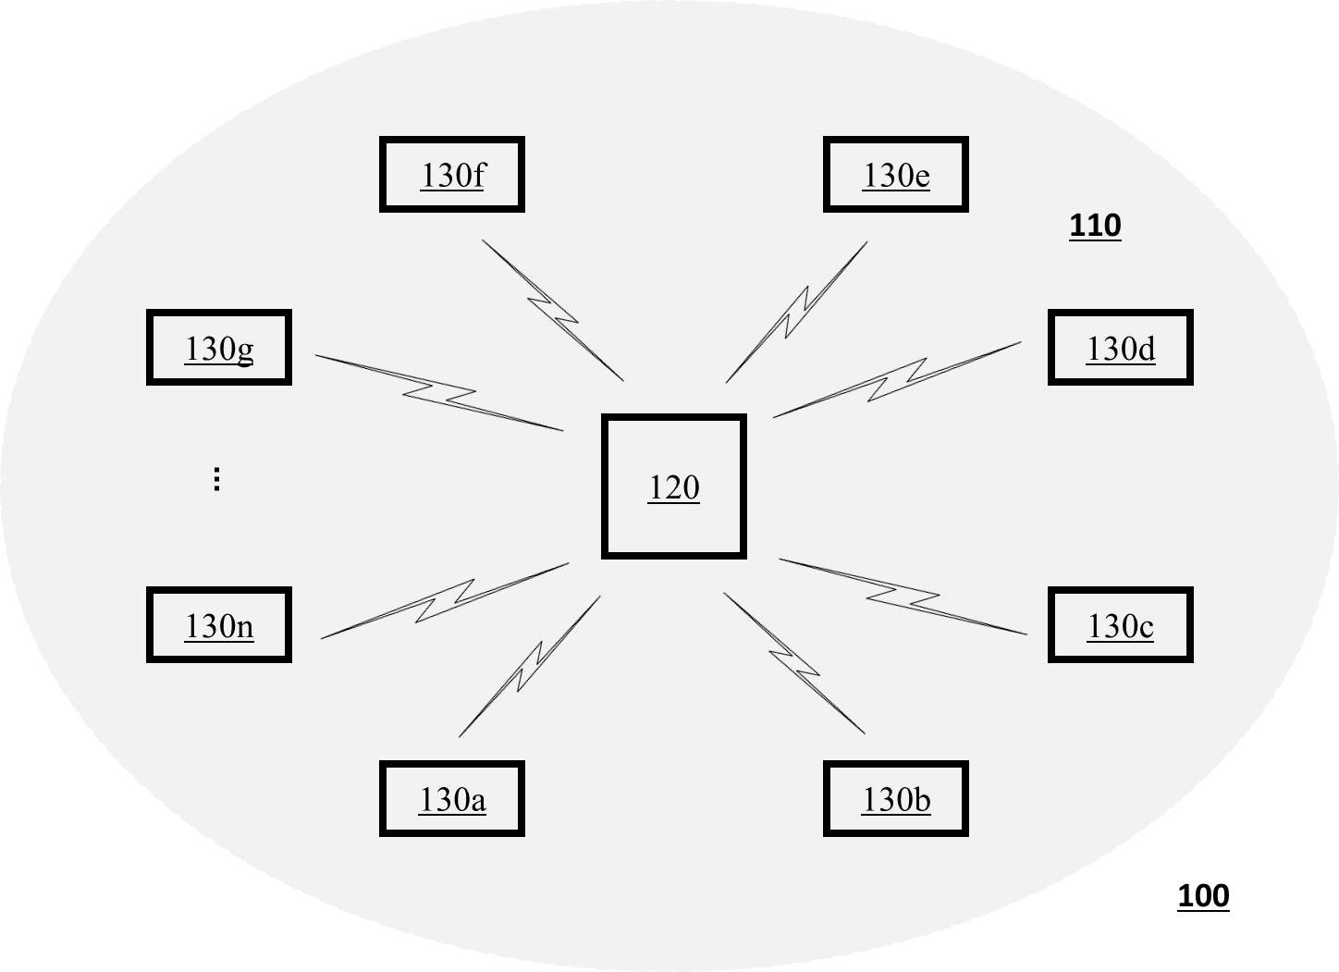

TOTAL NO. OF SHEETS: 7
SHEET NO.: 2/7
FIGURE 2:

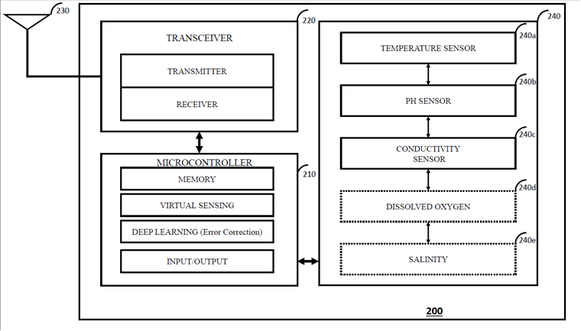

TOTAL NO. OF SHEETS: 7
SHEET NO.: 3/7
FIGURE 3:
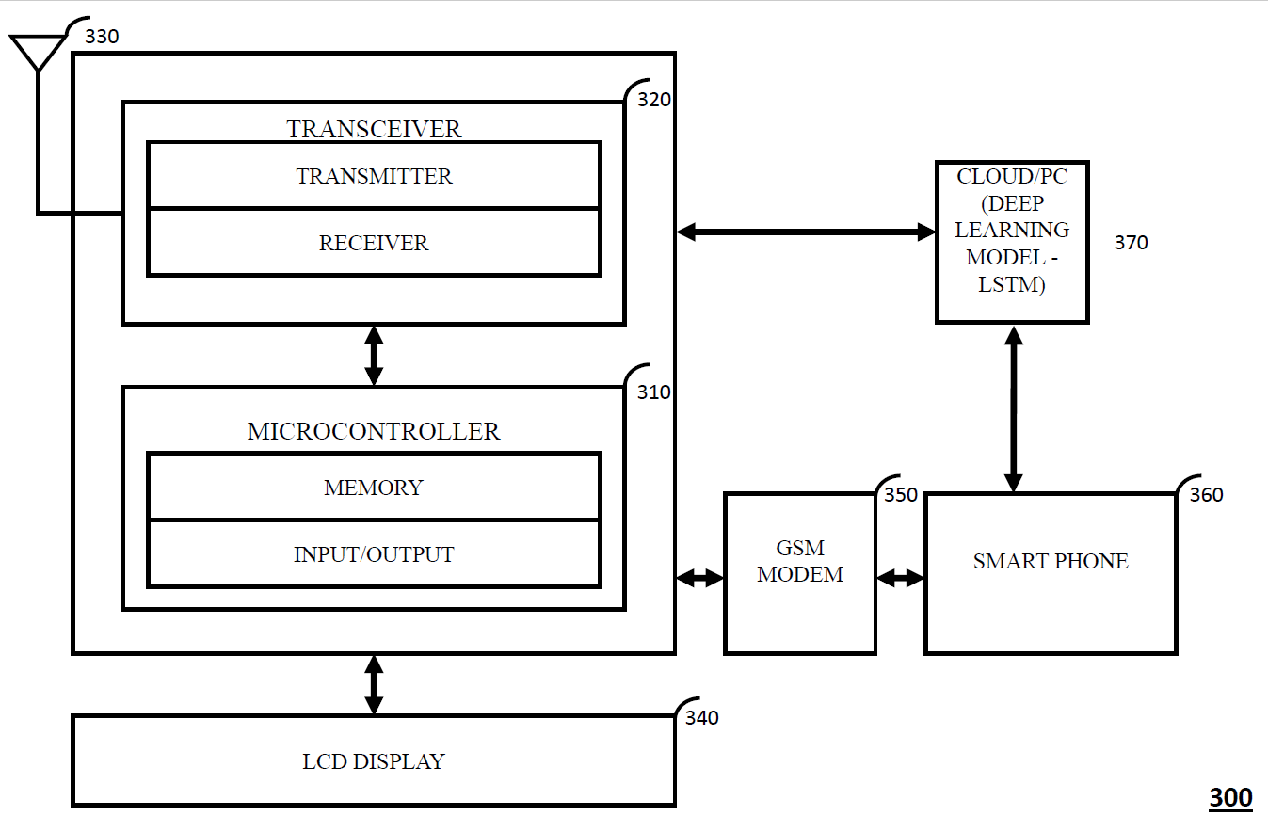

TOTAL NO. OF SHEETS: 7
SHEET NO.: 4/7
FIGURE 4:
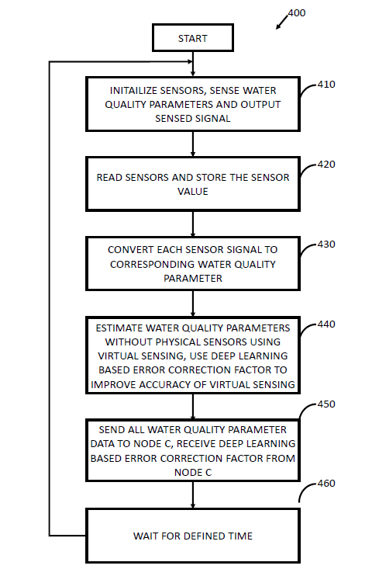

TOTAL NO. OF SHEETS: 7
SHEET NO.: 5/7
FIGURE 5:
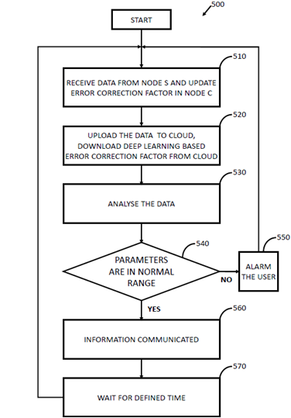

TOTAL NO. OF SHEETS: 7
SHEET NO.: 6/7
FIGURE 6:
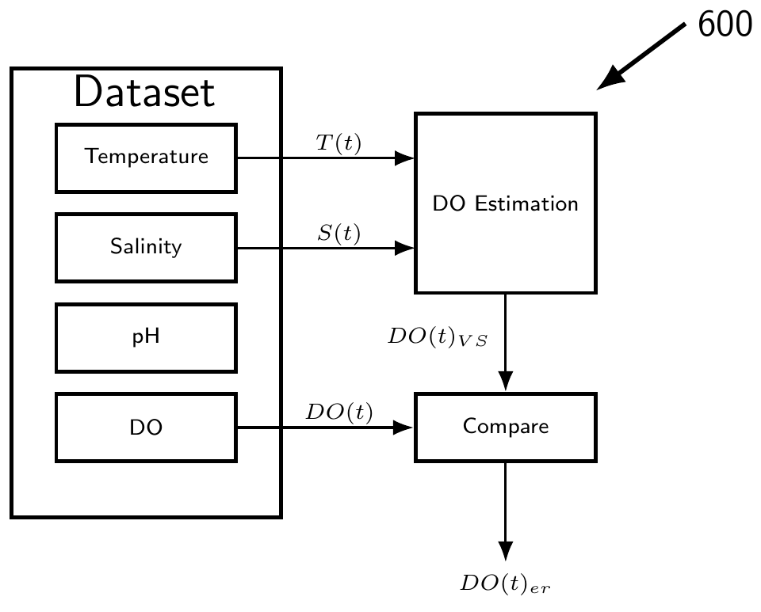

TOTAL NO. OF SHEETS: 7
SHEET NO.: 6/7
FIGURE 7:

