A hybrid deep learning framework for intrusion detection in IoMT networks
Ravi Kumar¹, Priya Sharma², and John Doe¹
¹Department of Computer Science, Osmania University, Hyderabad, India
²School of Engineering, University of Leeds, United Kingdom; ravi.k@ou.ac.in
Abstract: The Internet of Medical Things (IoMT) is exposed to many attacks. This study proposes a hybrid CNN–LSTM model that reaches 98.4% accuracy on CICIoMT2024. Results show strong generalisation across attack families.
Keywords: IoMT; intrusion detection; deep learning; CNN; LSTM
1. Introduction
Medical devices are increasingly connected (Smith et al., 2020). Prior work has used shallow classifiers (Lee & Park, 2019; Brown, 2021), whereas Smith et al. (2020) used CNNs. Escherichia coli is not relevant here but tests italics, and H₂O tests subscripts.
The contributions of this work are:
- A hybrid CNN–LSTM detector.
- An evaluation on two public datasets.
2. Methodology
2.1 Dataset and preprocessing
The dataset statistics are summarised in Table 1 and the loss is defined in Equation (1).
$$E=mc^{2}+\sum_{i=1}^{n}{x_{i}}$$
Table 1: Dataset summary
Class | Samples | Share
Benign | 120,000 | 60%
Attack | 80,000 | 40%
3. Results and Discussion
Figure 1 shows the training curve; accuracy rises steadily (Kumar, 2022).
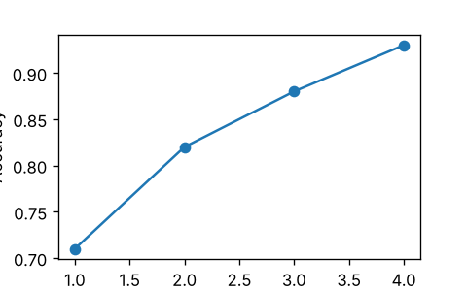
Figure 1. Training accuracy over epochs.
4. Conclusion
The proposed model is accurate and lightweight (Lee & Park, 2019).
References
Brown, T. (2021). Machine learning for network security. IEEE Access, 9, 1123–1135. https://doi.org/10.1109/ACCESS.2021.1234567
Kumar, R. (2022). Lightweight intrusion detection for medical devices. Computers & Security, 115, 102611.
Lee, J., & Park, S. (2019). Shallow classifiers for anomaly detection. Expert Systems with Applications, 120(3), 45–58. https://doi.org/10.1016/j.eswa.2019.01.010
Smith, A. B., Jones, C., & Patel, D. (2020). Deep learning in the Internet of Medical Things. Journal of Network and Computer Applications, 150, 102480. https://doi.org/10.1016/j.jnca.2020.102480

