

Contents
Introduction (Problem Statement): 2
Literature Review: 3
Traditional Method: 3
Modern Techniques: 4
Factors Influencing Device Selection: 4
Challenges in Flow Measurement in Canals: 5
Broad-Crested Weir 5
Sluice Gate 6
Methodology (By a Flow Chart): 7
Testing Procedure: 7
Broad-Crested Weir: 7
Sluice Gate: 8
Calculation & Graph: 8
Flow Over Broad-Crested Weir 8
Flow Beneath Sluice Gate 10
Analysis & Result: 13
Broad-Crested Weir: 13
Sluice Gate: 13
Comparative Analysis: 13
Discussion & Recommendation: 15
Discussion: 15
Measurement Accuracy: 15
Cost and Maintenance: 15
Adaptability: 15
Operational Utility: 15
Market Survey and Engineering Communication: 15
Recommendation: 16
i. Justification: 16
ii. Complementary Use of Sluice Gates: 16
iii. Future Consideration: 16
Conclusion: 16

Flow Measuring Device for Canal (Gozaria, Hatirjheel, Tongi etc.)

Introduction (Problem Statement):

Water resource management has become one of the most pressing challenges for rapidly urbanizing countries like Bangladesh, where cities such as Dhaka are expanding at an unprecedented rate. Dhaka’s network of canals, lakes, and rivers, including major waterways like Gozaria Canal, Hatirjheel, and Tongi Canal, forms the backbone of its urban drainage, flood protection, and ecological systems. These interconnected channels serve as vital arteries for stormwater discharge, flood mitigation, and maintaining groundwater balance. However, the effectiveness of these systems heavily depends on the accurate measurement and control of water flow. Inadequate flow monitoring can lead to severe consequences, such as waterlogging, damage to infrastructure, pollution accumulation, and the overall degradation of water quality and ecosystem health.

Among Dhaka’s urban canals, Hatirjheel stands as a model for multipurpose water management. It serves simultaneously as a stormwater reservoir, a drainage corridor, and a recreational area. The surrounding canal network, including Gozaria and Tongi, similarly contributes to controlling stormwater and supporting the natural drainage of the city. These canals are regulated by various hydraulic structures, most notably sluice gates and regulators, which control water levels and discharge into larger water bodies. The efficient operation of these control structures depends on reliable and continuous flow data. Without precise flow measurements, it becomes challenging to maintain optimal water levels, especially during monsoon periods when excess runoff can cause urban flooding.

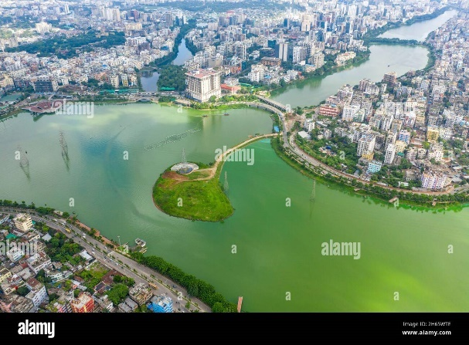
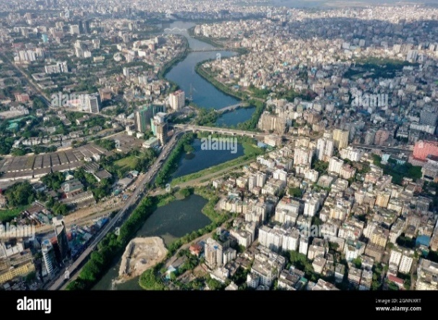

Fig: Hatirjheel Canal

The necessity of accurate flow measurement within these canal systems arises from three critical aspects. First, ‘flood control’, which requires precise inflow and outflow data to manage gate operations and prevent overflow into surrounding areas. Second, ‘water quality management’, where understanding flow helps in quantifying and controlling pollutant transport within the system. Third, ‘hydrologic balance’, which depends on consistent flow data to assess urban runoff, infiltration, and losses due to evaporation. Therefore, effective flow measurement forms the foundation for both operational management and environmental protection.
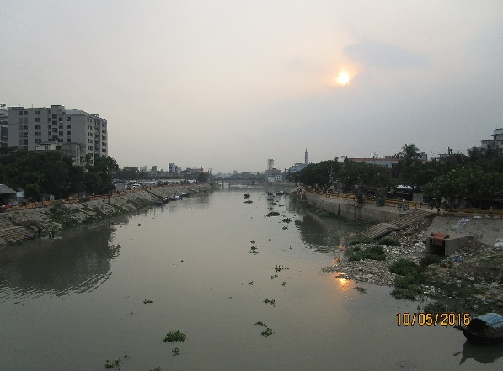
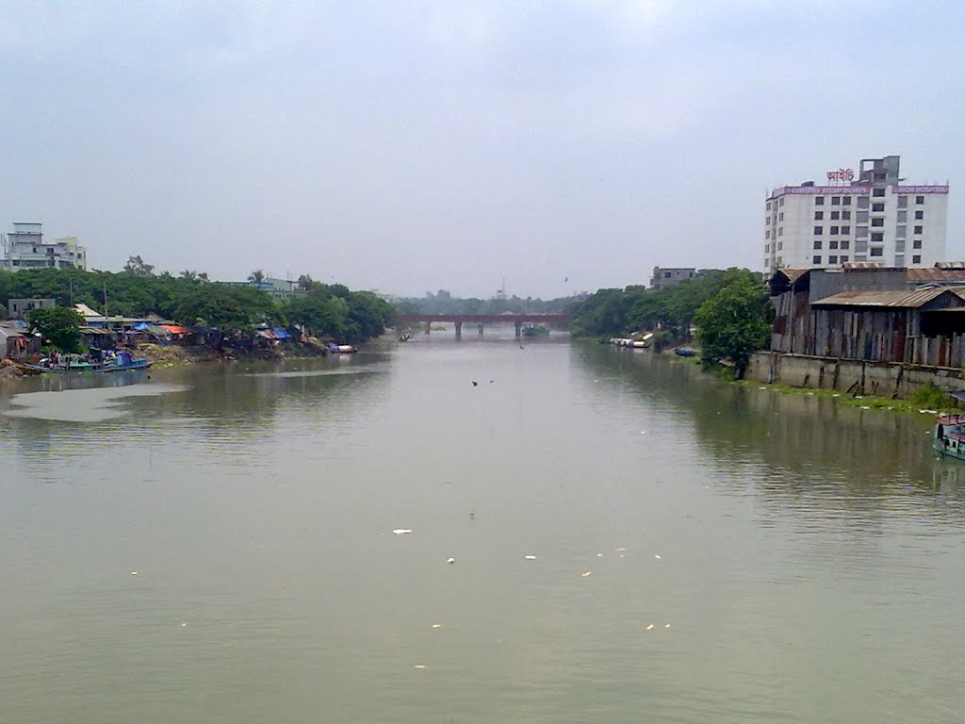

Fig: Tongi Khal River

Modern flow sensors, such as electromagnetic or ultrasonic meters, offer precision but are often unsuitable for Bangladesh’s canals due to their turbid, debris-laden, and sediment-rich water. These technologies are expensive, require frequent maintenance, and are prone to malfunction under harsh field conditions. Hence, there is a growing need for practical, cost-effective, and reliable hydraulic methods that can withstand these environments while providing accurate discharge measurements.

Literature Review:
Flow measurement in open channels like canals is a critical aspect of water resource management, irrigation, and environmental monitoring. Selecting the appropriate flow measuring device is essential for obtaining accurate and reliable data, which in turn informs effective water distribution, management, and conservation efforts in regions like Gazaria, Hatirjhil, and Tongi in Bangladesh.

Traditional Method:
- Weirs and Flumes: These are hydraulic structures that create a known relationship between the water level (head) and the discharge. Different types of weirs (e.g., rectangular, V-notch, Cipoletti) and flumes (e.g., Parshall, Venturi) are available, each suited for specific flow ranges and channel characteristics. The discharge is calculated using empirical formulas based on the measured head.
- Velocity-Area Method: This involves measuring the flow velocity at several points across a channel's cross-section and multiplying these velocities by their corresponding areas to determine the total discharge. Traditional methods for velocity measurement include current meters (mechanical or electromagnetic).

Modern Techniques:
- Acoustic Doppler Velocimeters (ADVs) and Acoustic Doppler Current Profilers (ADCPs): These instruments use the Doppler effect to measure water velocity at single or multiple points in the flow. ADCPs can provide a velocity profile across the entire water column, allowing for more accurate discharge calculations, especially in complex flow conditions.
- Ultrasonic Flow Meters: These devices measure flow velocity by transmitting and receiving ultrasonic waves across the channel. Transit-time ultrasonic flow meters measure the difference in travel time of acoustic pulses moving with and against the flow, while Doppler ultrasonic flow meters measure the frequency shift of waves reflected by particles in the water.
- Electromagnetic Flow Meters: These meters induce a magnetic field in the water and measure the voltage generated by the moving conductive fluid, which is directly proportional to the flow velocity. They are suitable for various flow conditions and are obstruction less.
- Image-Based Velocimetry (e.g., Particle Image Velocimetry - PIV, Surface Structure Image Velocimetry - SSIV): These non-contact methods use video recordings of the water surface with tracer particles (PIV) or natural surface features (SSIV) to estimate surface velocities. Algorithms are then used to calculate the overall flow field. Recent advancements have even explored the use of smartphone applications utilizing SSIV for flow measurement in small canals.

Factors Influencing Device Selection:
Several factors must be considered when selecting a flow measuring device for canals in the specified regions:
- Flow Rate and Range: The expected range of flow rates in the canal will dictate the suitable devices. Some devices are more accurate at low flows, while others are better for high flows.
- Channel Characteristics: The shape, size, and material of the canal, as well as its slope and roughness, will influence the choice of device and installation method.
- Water Quality: The presence of sediment, debris, vegetation, or other pollutants can affect the performance and lifespan of certain devices. For instance, mechanical meters can be obstructed by debris, while non-contact methods might be affected by surface disturbances.
- Accuracy Requirements: The required accuracy of the flow measurement will narrow down the options. Some methods, like weirs and flumes (when properly calibrated and maintained), and electromagnetic flow meters, can offer high accuracy.
- Cost: The initial investment, installation costs, and ongoing maintenance requirements vary significantly between different flow measurement techniques.
- Power Availability: Some sophisticated electronic devices require a reliable power supply, which might be a constraint in certain locations.
- Ease of Installation and Maintenance: The accessibility of the measurement site and the complexity of installation and maintenance should be considered. Non-contact methods often offer easier installation and reduced maintenance.
- Environmental Conditions: Factors like temperature variations, humidity, and potential for flooding can impact the durability and performance of the chosen device.

Challenges in Flow Measurement in Canals:
Measuring flow in open channels like the canals in Gazaria, Hatirjhill, and Tongi can present several challenges:
- Irregular Channel Geometry: Natural or unlined canals often have irregular cross-sections, making it difficult to apply standard formulas or install certain devices.
- Variable Flow Conditions: Flow rates in canals can fluctuate significantly due to rainfall, irrigation demands, and operational changes.
- Sediment and Debris: The presence of suspended sediment and floating debris can interfere with the operation of mechanical meters and affect the accuracy of acoustic and optical methods.
- Vegetation Growth: Aquatic vegetation within the canal can obstruct flow and affect velocity measurements.
- Accessibility and Power: Remote locations might lack easy access or reliable power sources for sophisticated instrumentation.
- Calibration and Maintenance: Regular calibration and maintenance are crucial for accurate measurements, but these can be challenging in field conditions.
- Submergence: Downstream water levels can affect the flow over hydraulic structures like weirs and flumes, requiring adjustments or the use of submerged flow equations.

Broad-Crested Weir
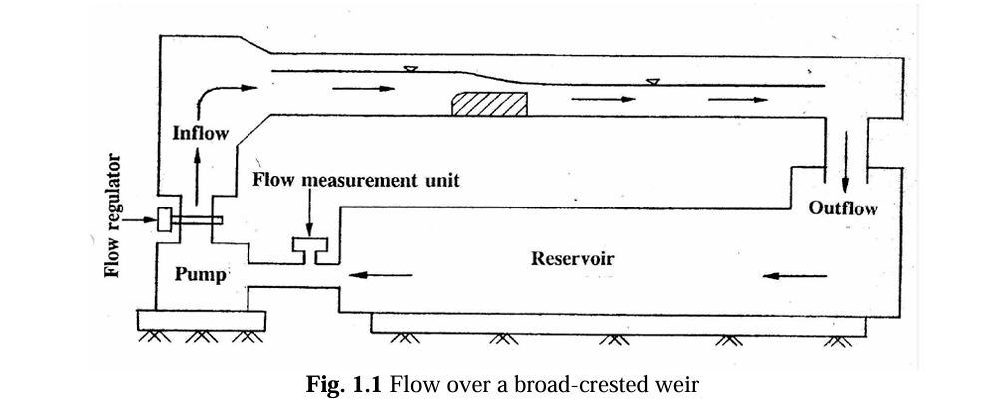

Fig: Flow Over Broad Crested Weir
A Broad-Crested Weir is a hydraulic structure used to measure and control the flow of water in open channels. It consists of a wide, flat crest over which water flows smoothly, allowing the relationship between head and discharge to be accurately determined. Due to its simple design, stability, and high accuracy, it is widely used in laboratory experiments, irrigation canals, and drainage systems. The broad crest minimizes flow turbulence and energy loss, making it suitable for sediment-laden and fluctuating flow conditions. Its durability and low maintenance requirements make it ideal for long-term field applications.
Criteria | Advantage | Disadvantage
Flow Measurement Accuracy | Provides stable and reliable flow measurement over wide flow range. | Less accurate at very low flows.
Structural Strength | Strong and durable, resists debris and sediment impact. | Larger size means it occupies more space.
Construction and Maintenance | Simple design, easier and cheaper to build and maintain. | Sediment can settle on the crest, requiring cleaning.
Flow Conditions | Handles variable flow well, less sensitive to upstream changes. | Requires critical flow on the crest for proper function.
Hydraulic Behavior | Smooth flow transition reduces turbulence and energy loss. | Complex flow patterns need advanced hydraulic analysis.

Sluice Gate
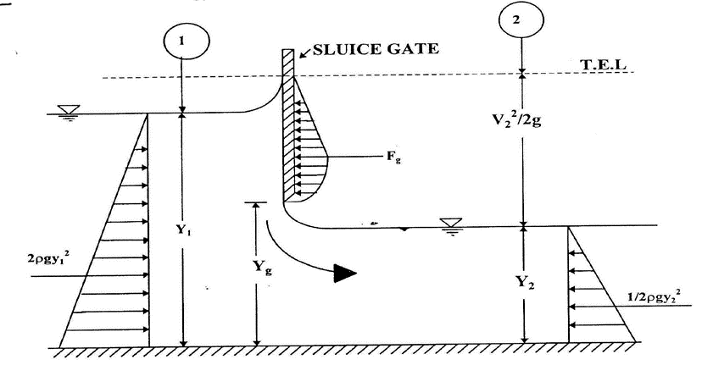

A Sluice Gate is a mechanical device used to control the flow of water in channels, canals, and reservoirs. It consists of a vertical gate that can be raised or lowered to regulate discharge and water levels. Sluice gates are widely used in irrigation systems, flood control, and hydraulic engineering projects where precise flow control is needed. While they provide adjustable regulation, flow beneath the gate is often turbulent, making them less accurate for direct discharge measurement. Despite this, their operational flexibility makes them essential for managing water distribution and channel control.

Criteria | Advantage | Disadvantage
Flow Control | Provides precise and adjustable control of water flow. | Requires manual or automated operation, which can be complex or costly.
Structural Design | Simple mechanical design, can be built from various materials. | Gates and seals may wear out, needing regular maintenance.
Operation Flexibility | Can be fully opened or closed, or adjusted for partial flow. | Potential for blockage due to debris or sediment buildup.
Installation Location | Suitable for narrow channels or confined spaces. | Requires strong supporting structures for stability.
Maintenance and Durability | Durable if well-maintained and properly operated. | Mechanical parts are prone to corrosion and damage over time.

Methodology (By a Flow Chart):
Define Objectives
& Requirements
Select
Location
Select Flow
Measuring Device
Analysis Data
Record Data
Conduct
Experiment
Conclusion & Recommendation

Testing Procedure:

Broad-Crested Weir:
- The experimental flume was first cleaned, and all connections were checked to ensure there was no leakage.
- The Broad-Crested Weir was placed securely at the designated section of the channel.
- The point gauge was adjusted to measure the water surface elevation (head) accurately.
- Water flow through the channel was gradually started and adjusted using the inlet valve to obtain a steady flow.
- The discharge through the channel was measured by collecting water in a measuring tank and noting the time taken to fill a known volume.
- Corresponding head over the weir crest (H) was measured using the point gauge at the approach section.
- The procedure was repeated for different flow rates by varying the inlet valve openings.

Sluice Gate:

- The sharp-crested weir is fixed vertically across the rectangular channel.
- The crest of the weir is kept sharp, and the height of the crest above the channel bed is measured.
- The weir setup is connected to the water supply system through flexible hoses.
- A point gauge is positioned upstream of the weir to measure the head over the crest.
- An air vent tube is connected at the underside of the nappe to create ventilated conditions when required.

Calculation & Graph:

Flow Over Broad-Crested Weir
Data Sheet:

Obs | Volume,  V (cm³) | Time,  t (s) | Q_{a}=V/t,  (cm³/s) | Q_{d},  (cm³/s) | H,  cm | h₁=H-P,  cm | Q_{t}= (2/3)^{1.5}g^{0.5}Bh₁^{1.5}  (cm³/s) | C_{d} | h₁/L
1 | 2000 | 53 | 37.74 | 36.83 | 4.9 | 1.4 | 42.36 | 0.89 | 0.28
2 | 3000 | 59 | 50.85 | 52.17 | 5.2 | 1.7 | 56.68 | 0.90 | 0.34
3 | 4000 | 59 | 67.80 | 66.00 | 5.5 | 2 | 72.33 | 0.94 | 0.4
4 | 5000 | 57 | 87.72 | 86.00 | 5.8 | 2.3 | 89.20 | 0.98 | 0.46

Calculation:
For Observation 4,

Length of the weir, L = 5 cm
Width of the weir, B = 1.5 cm
Height of the weir, P = 3.5 cm
Water depth, H = 5.8 cm
Volume, V = 5000 cm³
Collecting time, t = 57 s
Actual water depth, h₁ = H-P
= 5.8 - 3.5 = 2.3 cm
Actual Discharge, Q_{a} = $\frac{Volume}{Collecting time}$
=$\frac{5000}{57}$ = 87.72 cm³/s
k = (2/3)^{1.5}g^{0.5}B = (2/3)^{1.5} * (981)^{0.5} * 1.5 = 25.57
Theoretical Discharge, Q_{t} = (2/3)^{1.5}g^{0.5}Bh₁^{1.5}
= (2/3)^{1.5} * (981)^{0.5} * 1.5 * (2.3)^{1.5}
= 89.20 cm³/s
Discharge from display, Q_{d} = 5.16 L/min
= $\frac{5.16*1000}{60}$ = 86.00 cm³/s
Co-efficient of Discharge, C_{d} =$\frac{Qa}{Qt}$
=$\frac{87.72 }{89.20}$ = 0.98
Now, h₁/L =$\frac{2.3}{5}$ = 0.46
Similarly, for the other observations calculated.
Mean co-efficient of discharge, C_{d} =$\frac{0.89+0.90+0.94+0.98}{4}$
= 0.93
From Graph,
Constant Value, C = 21
Co-efficient of Discharge, C_{d} = $\frac{C}{k}$ = $\frac{21}{25.57}$
= 0.82

Graph 1: Actual Discharge vs Actual Depth (log-log paper)

Graph 2: Actual Discharge vs Actual Depth (plain paper)

Graph 2: Actual Discharge vs Actual Depth (plain paper)

Flow Beneath Sluice Gate

Data Sheet:

Obs | y_{g}  cm | y₁  cm | y₂  cm | V  cm³ | T  s | Q_{a}  cm³/s | Q_{d}  cm³/s | Q_{t}  cm³/s | C_{d} | C_{c} | C_{v} | y_{g}/y₁ | F_{g}  dyne | F_{H}  dyne | F_{g}/F_{H}
1 | 1.0 | 11.4 | 0.8 | 4000 | 35 | 114.29 | 115.17 | 224.33 | 0.51 | 0.80 | 0.66 | 0.09 | 47884.70 | 79578.72 | 0.60
2 | 1.0 | 8.3 | 0.9 | 5000 | 48 | 104.17 | 118.67 | 191.42 | 0.54 | 0.90 | 0.64 | 0.12 | 21604.61 | 39208.12 | 0.55
3 | 1.5 | 11.4 | 1.3 | 7000 | 39 | 179.49 | 182.67 | 336.50 | 0.53 | 0.87 | 0.65 | 0.13 | 39792.33 | 72110.86 | 0.55
4 | 1.5 | 12.4 | 1.1 | 8000 | 44 | 181.82 | 189.00 | 350.95 | 0.52 | 0.73 | 0.74 | 0.12 | 52425.26 | 87414.46 | 0.60

Calculation:
For observation 03,
Width of the gate, b = 1.5 cm
Gate opening, y_{g} = 1.5 cm
Up-stream depth, y₁ = 11.4 cm
Down-stream depth, y₂ = 1.3 cm
Volume of water, V = 7000 cm³
Collecting time, t = 39 s
Actual Discharge, Q_{a} = $\frac{Volume}{Collecting time}$
=$\frac{7000}{39}$ = 179.49 cm³/s
Theoretical Discharge, Q_{t} =by_{g}$\sqrt{2gy1}$
₌ 1.5 * 1.5 * $\sqrt{2*981*11.4}$
= 336.50 cm³/s
Discharge from display, Q_{d} = 10.96 L/min
= $\frac{10.96*1000}{60}$ = 182.67 cm³/s
Co-efficient of Discharge, C_{d} =$\frac{Qa}{Qt}$
=$\frac{179.49 }{336.50}$ = 0.53
Co-efficient of Curvature, C_{c} = y₂/y_{g}
=$\frac{1.3}{1.5}$ = 0.87
Co-efficient of Velocity, C_{v} = $\frac{Cd×\sqrt{\frac{Cc×y_{g}}{y_{1}}+1}}{Cc}$
= $\frac{0.53}{0.87}$ * $[\frac{0.87*1.5}{11.4}+1]$^{0.5}
= 0.65
Now, y_{g}/y₁ = $\frac{1.5}{11.4}$ = 0.13
F_{g} = $\frac{1}{2}×ρg×\frac{{(y_{1}-y_{2})}^{3}}{(y_{1}+y_{2})}$ = 39792.33 dyne
F_{H} = $\frac{1}{2}×ρg(y_{1}-y_{g})$² = 72110.86 dyne
Now, $\frac{F_{g}}{F_{H}}$ = $\frac{39792.33 }{72110.86}$ = 0.55
Similarly, for the other observations calculated.
Mean co-efficient of discharge, C_{d} =$\frac{0.51+0.54+0.53+0.52}{4}$
= 0.53

Graph 1: C_{c} & C_{d} vs y_{g}/y₁

Graph 2: Upstream Depth vs Actual Discharge

Graph 3: F_{g}/F_{H} vs y_{g}/y₁

Analysis & Result:
The experimental data collected from the broad-crested weir and sluice gate experiments were analyzed to evaluate their performance as flow measurement devices for Hatirjheel-Begunbari Khal canal system. The key parameters that should be considered are the coefficient of discharge (Cd), measurement accuracy under varying flow conditions, and operational suitability for sediment-heavy and fluctuating flow environments.

Broad-Crested Weir:
The experiment successfully investigated the flow over a broad-crested weir, allowing for the determination of the coefficient of discharge (C_{d}) under four different upstream head conditions.

- The mean co-efficient of discharge (C_{d}) of the broad-crested weir was calculated as 0.93, indicating higher accuracy.
- The co-efficient of discharge (C_{d}) value ranged from 0.89 to 0.98, suggesting slight variations due to changes in head and flow conditions.
- The weir demonstrated reliable accuracy for low to medium flows (37 to 88 cm³/s), with errors in discharge measurement primarily attributed to minor turbulence in the approach channel and small head measurement inaccuracies at lower flows.
- The weir’s simplicity and low cost were evident, as it required minimal equipment beyond a staff gauge for head measurement.

Sluice Gate:
The experiment successfully investigated the flow beneath a sluice gate, allowing for the determination of the coefficient of discharge (C_{d}) under four different upstream head & flow rate conditions.

- The mean co-efficient of discharge (C_{d}) of the sluice gate was calculated as 0.53, indicating medium accuracy.
- The co-efficient of discharge (C_{d}) value ranged from 0.51 to 0.554, suggesting slight variations due to changes in head and flow conditions.
- The gate demonstrated reliable accuracy for medium flows (100 to 180 cm³/s), with errors in discharge measurement primarily attributed to minor turbulence in the approach channel and small head measurement inaccuracies at lower flows.
- The gate’s operational flexibility was a significant advantage, allowing precise regulation of discharge for irrigation or flood management.

Comparative Analysis:

Criteria | Broad Crested Weir | Sluice Gate | Remark
Co-efficient of Discharge (C_{d}) | 0.93 | 0.53 | The higher Cd value (0.93) indicates that the Broad-Crested Weir has less energy loss and a closer relationship between theoretical and actual discharge.
Accuracy | High accuracy due to steady and uniform flow over the crest; less affected by turbulence or downstream conditions. | Lower accuracy as flow beneath the gate is turbulent and highly sensitive to gate opening and downstream head. | Broad-Crested Weir is more accurate and consistent in discharge measurement.
Cost & Maintenance | Simple structure with low initial and maintenance costs; no moving parts. | Higher cost due to metal components and mechanical operation; requires regular maintenance to prevent corrosion and jamming. | Broad-Crested Weir is more economical and requires minimal upkeep.
Adaptability to Sediment-Heavy Water | Performs well with sediment-laden flow; sediments can pass smoothly over the crest without major obstruction. | Less suitable for sediment-heavy flow; sediments tend to accumulate near or beneath the gate, affecting operation and accuracy. | Broad-Crested Weir is better for sediment-laden channels.
Operational Utility | Mainly used for accurate flow measurement and water level control; fixed and passive structure. | Used for flow regulation, control, and diversion; can adjust opening to manage discharge. | Sluice Gate offers better flow control, while Broad-Crested Weir is better for measurement.
Durability and Reliability | Very durable due to simple concrete design; long service life with little maintenance. | Mechanical parts can wear out over time; requires inspection and lubrication. | Broad-Crested Weir is more reliable for long-term use.

Fig: Accuracy of Two Different Device.

Discussion & Recommendation:
From the comparative analysis, the Broad-Crested Weir (C_{d} = 0.93) shows higher accuracy and reliability in flow measurement compared to the Sluice Gate (C_{d} = 0.53). The weir provides a stable discharge relation with minimal turbulence and low sensitivity to flow variations. It also requires less maintenance, performs better under sediment-heavy conditions, and ensures long-term durability. In contrast, the Sluice Gate is less accurate due to flow contraction and turbulence but offers better control over discharge regulation.

Discussion:

Measurement Accuracy:
- The Broad-Crested Weir (Cd = 0.93) provides higher accuracy and consistent discharge results due to stable flow over the crest.\
- The Sluice Gate (Cd = 0.53) shows lower accuracy because of turbulence and contraction of flow beneath the gate.
- Errors in head measurement affect the sluice gate more significantly than the weir.

Cost and Maintenance:
- Broad-Crested Weirs are simple, low-cost, and require minimal maintenance since they have no moving parts.
- Sluice Gates are costlier to install and maintain due to mechanical components and possible corrosion or blockage.
- Long-term operation favors the weir for economic and durability reasons.

Adaptability:
- Broad-Crested Weirs perform well in sediment-laden and variable flow conditions, allowing smooth sediment passage.
- Sluice Gates are less adaptable to sediment-heavy water, where deposition may hinder operation.
- The weir remains stable under fluctuating flow, while the gate’s performance depends on precise adjustments.

Operational Utility:
- Broad-Crested Weirs are mainly used for flow measurement and maintaining water levels.
- Sluice Gates are ideal for flow regulation and controlling discharge rates in canals and irrigation systems.
- Selection depends on whether the goal is measurement (weir) or regulation (gate).

Market Survey and Engineering Communication:
- Broad-Crested Weirs are widely used in field applications due to their simplicity and reliability.
- Sluice Gates are preferred in industrial or irrigation projects where adjustable control is necessary.
- Effective communication between engineers, manufacturers, and field operators ensures the right device is chosen for the intended purpose.

Recommendation:
Based on the experimental results and contextual analysis, the “Broad-Crested Weir” is recommended as the primary flow measurement device for the Hatirjheel-Begunbari Khal canal system, with the following considerations:
- Justification:
Based on the experimental study conducted on the Hatirjheel Canal, the Broad-Crested Weir is recommended for accurate and consistent flow measurement. Its higher discharge coefficient (C_{d} = 0.93), simple structure, and minimal maintenance make it suitable for long-term monitoring. Moreover, its good adaptability to sediment-heavy and fluctuating flow conditions commonly found in Hatirjheel ensures reliable performance.
- Complementary Use of Sluice Gates:
While the Sluice Gate (Cd = 0.53) demonstrates lower accuracy for discharge measurement, it is highly effective for flow control and regulation. In canal systems like Hatirjheel, sluice gates can be used together with broad-crested weirs — the gate managing flow levels and the weir providing accurate discharge data — to achieve better hydraulic control and measurement balance.
- Future Consideration:
For future work, it is suggested to include advanced flow measurement systems such as Venturi flumes, ultrasonic sensors, or automated data loggers to enhance measurement precision. Further studies under different flow conditions and sediment loads in Hatirjheel could also help assess the long-term efficiency and operational performance of both flow measurement structures.

Conclusion:
The experiment conducted on the Hatirjheel Canal aimed to determine the discharge characteristics and performance of a Broad-Crested Weir in comparison with a Sluice Gate under varying flow conditions. Based on the results and analysis, it can be concluded that the Broad-Crested Weir, with a discharge coefficient of 0.93, provides a more accurate and consistent means of measuring open channel flow compared to the Sluice Gate, which has a lower discharge coefficient of 0.53. The weir showed a steady flow pattern with minimal turbulence, resulting in more reliable readings and a closer match between theoretical and measured discharge values.
In terms of cost and maintenance, the Broad-Crested Weir proves to be more economical and durable, as it has no moving parts and requires little maintenance. The Sluice Gate, although useful for controlling discharge, involves higher installation and maintenance costs due to its mechanical components, which are prone to corrosion and blockage over time. The Broad-Crested Weir also displayed better adaptability to sediment-heavy and fluctuating flow conditions, which are typical in the Hatirjheel Canal. Sediments were able to pass smoothly over the crest without significantly affecting the flow profile, whereas sediment accumulation beneath the Sluice Gate often interferes with accuracy.
From an operational standpoint, the Broad-Crested Weir is most suitable for accurate discharge measurement and long-term monitoring, while the Sluice Gate remains important for regulating and controlling flow in canals or irrigation networks. Therefore, combining both systems can enhance hydraulic efficiency — using the weir for precise measurement and the gate for effective control.
Overall, this experiment demonstrates that the Broad-Crested Weir is a simple, cost-effective, and dependable structure for flow measurement in the Hatirjheel Canal, and its performance can be further improved through future integration with modern flow sensors and automated monitoring systems.
Modern flow sensors and automated monitoring systems in future applications.

