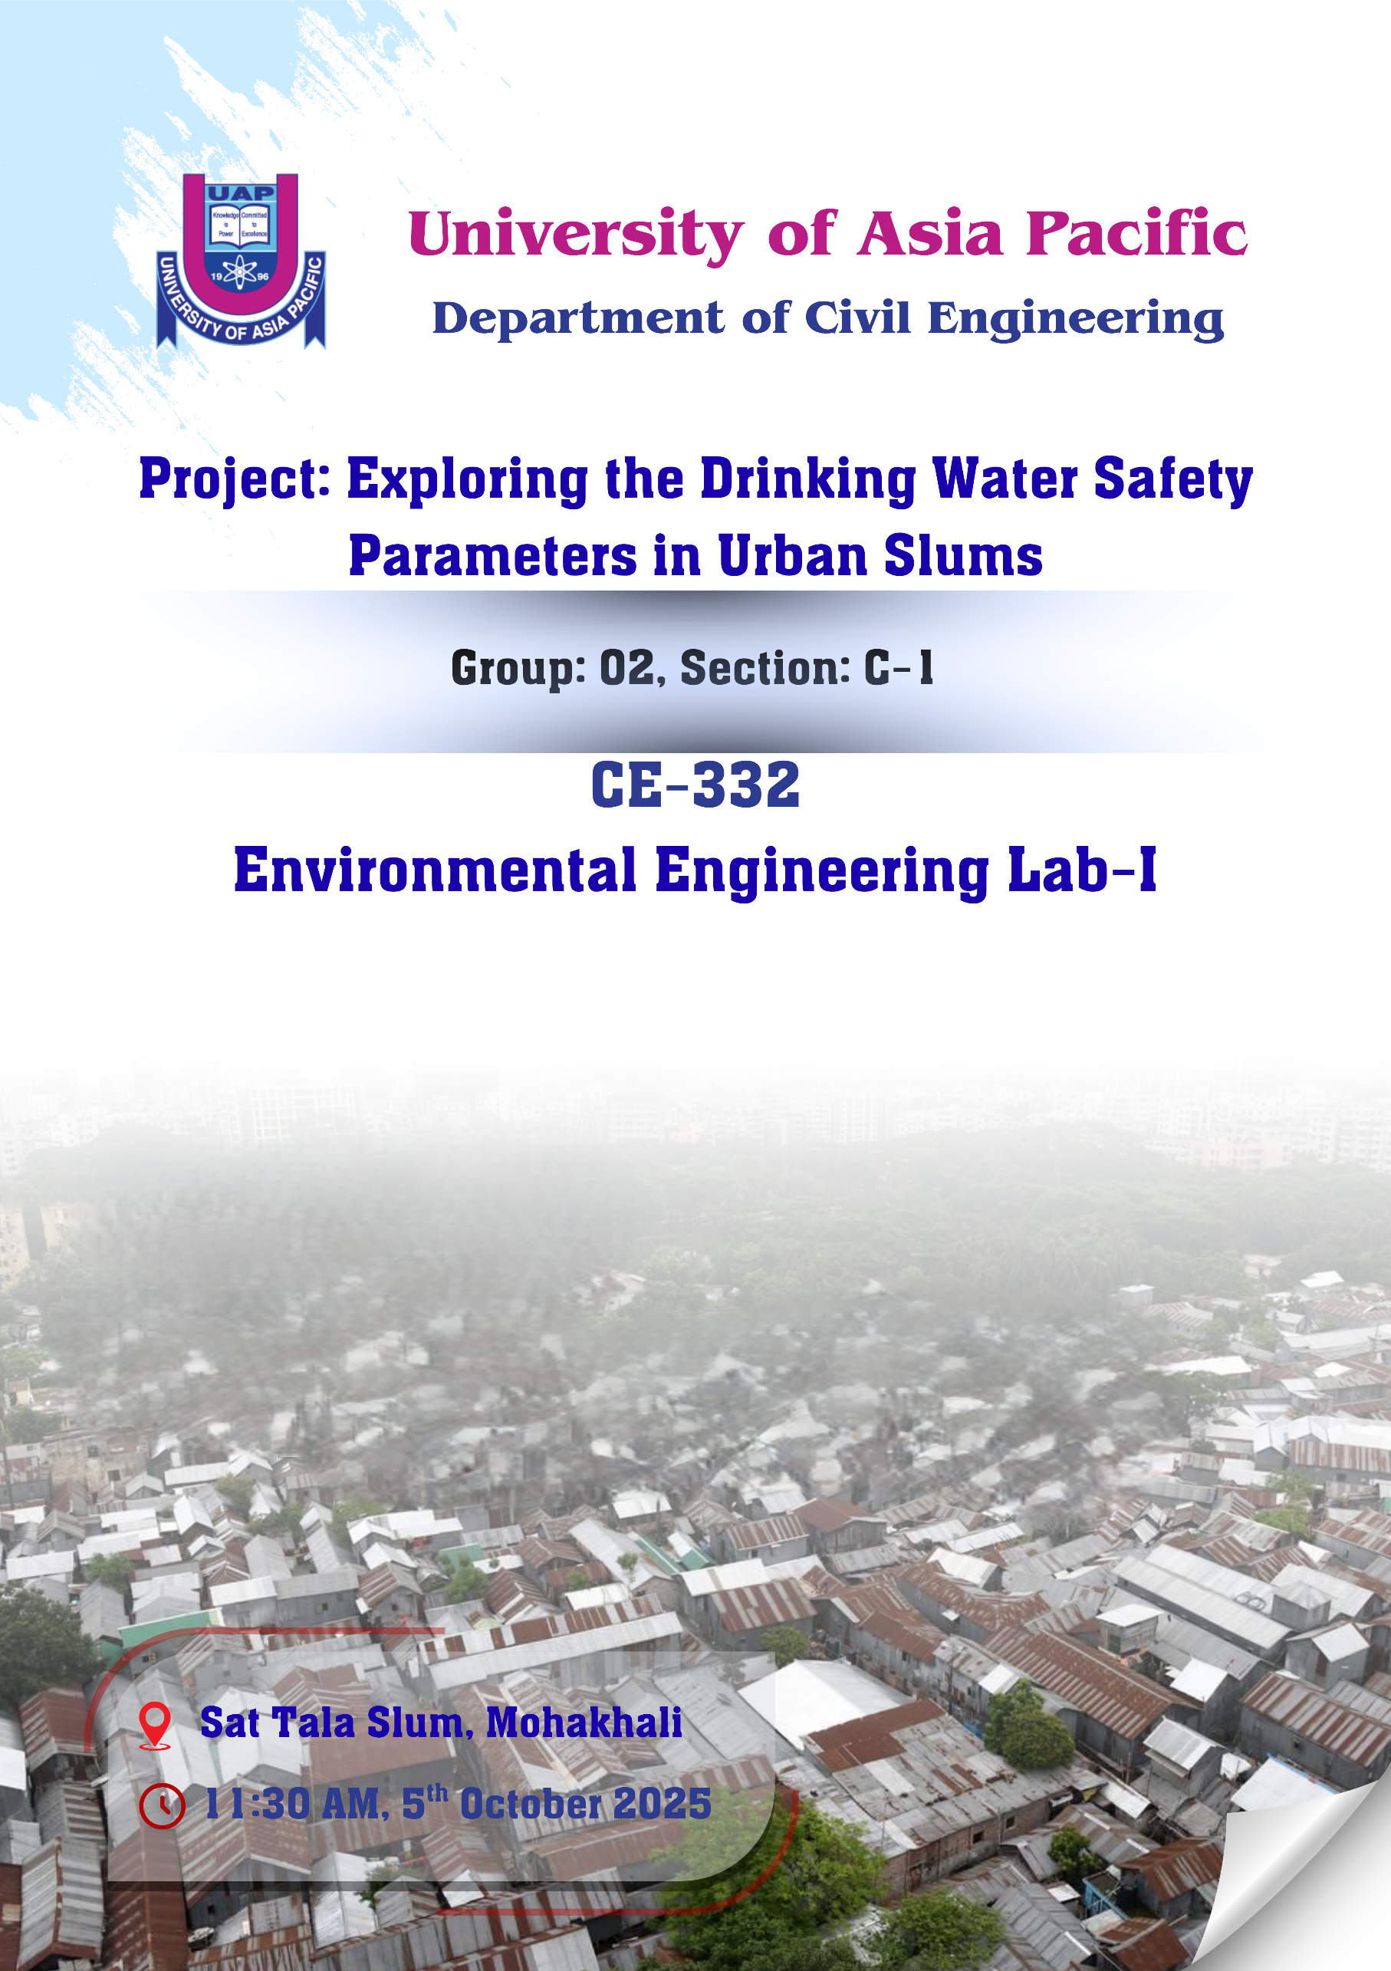

Group Information

Name | ID | Contribution
Mahfujur Rahman Bappy | 231105099 | Field Visit, pH Test.
Abdullah Al Rasheed | 20105100 | Field Visit, Turbidity Test, Abstract, Introduction, Problem Statement, Discussion, Conclusion, & Recommendation.
Saikat Hasan | 23105101 | Field Visit, Arsenic test, Data Calculation, Report Making, PPT Re-arranging.
Khadija Rahman | 23105102 | Field Visit, Iron & Alkalinity Test, PPT Making.

Sample Water Details

Amount of Sample : 500 mL
Location of the Sample : Sat Tala Slum, Mohakhali. (QCF3+PQ8 Dhaka)
Sample Collection Time : 11:30 AM.
Sample Collection Date : 5th October 2025.
Date of Experiment : 6th October 2025.

[All necessary pictures are attached on the last page of the report.]

Table of Contents
Abstract 4
Introduction 4
Objective: 5
Problem Statement: 5
Parameters: 5
pH 5
Turbidity 5
Iron 5
Alkalinity 6
Arsenic 6
1.pH 6
1.1 Introduction: 6
1.2 Objective: 6
1.3 Problem Statement 6
1.4 Procedure: 6
1.5 Data Table: 7
1.6 Calculation: 7
1.7 Result: 7
1.8 Discussion: 7
1.9 Conclusion: 7
2. Turbidity 7
2.1 Introduction: 7
2.2 Objective: 7
2.3 Problem Statement 7
2.4 Procedure: 8
2.5 Data Table: 8
2.6 Calculation: 8
2.7 Result: 8
2.8 Discussion: 8
2.9 Conclusion: 8
3. Iron 8
3.1 Introduction: 8
3.2 Objective: 9
3.3 Problem Statement 9
3.4 Procedure: 9
3.5 Data Table: 9
3.6 Calculation: 9
3.7 Result: 9
3.8 Discussion: 9
3.9 Conclusion: 10
4. Alkalinity 10
4.1 Introduction: 10
4.2 Objective: 10
4.3 Problem Statement 10
4.4 Procedure: 10
4.5 Data Table: 10
4.6 Calculation: 11
4.7 Result: 11
4.8 Discussion: 11
4.9 Conclusion: 11
5. Arsenic 11
5.1 Introduction: 11
5.2 Objective: 12
5.3 Problem Statement 12
5.4 Procedure: 12
5.5 Data Table: 12
5.6 Calculation: 12
5.7 Result: 12
5.8 Discussion: 12
5.9 Conclusion: 13
Data Comparison Table: 13
Discussion: 13
Conclusion: 13
Recommendation: 14
Reference: 14

Exploring the Drinking Water Safety Parameters in Urban Slums.

Abstract
Exploring the Drinking Water Safety Parameters in Urban Slums.
Access to safe drinking water remains a critical challenge in rapidly urbanizing nations, particularly within marginalized slum communities where waterborne diseases are prevalent due to poor infrastructure. This study assessed the potability of a drinking water source in the Sat Tala Slum of Mohakhali, Dhaka, by analyzing five parameters—pH, Turbidity, Iron, Alkalinity, and Arsenic—against WHO and ECR standards to propose effective intervention strategies.
Laboratory analysis revealed a complex safety profile that deems the water currently unsuitable for direct human consumption. While results for pH (6.86) and Arsenic (0.00 ppb) were compliant, two critical parameters indicated significant instability and risk. Firstly, the Turbidity measured 1.37 NTU, exceeding the WHO operational target of <1.0 NTU. This level of suspended particles compromises the efficacy of disinfection, creating an elevated and immediate microbiological risk. Secondly, the Total Alkalinity was measured at a severely low 25 mg/L, significantly below the ECR minimum of 200 mg/L. This extreme lack of buffering capacity makes the water chemically unstable and highly corrosive, leading to a long-term threat of heavy metal leaching from the supply system.
The overall assessment concludes that the source is fundamentally unreliable. Immediate corrective strategies are mandatory, focusing on short-term point-of-use boiling and filtration to reduce turbidity, alongside long-term authority-level intervention for chemical stabilization (alkalinity augmentation) to ensure water stability and safety.

Introduction
Access to safe and clean drinking water remains one of the most critical public health challenges in rapidly urbanizing nations like Bangladesh. While governmental bodies and non-governmental organizations strive to expand water coverage, marginalized communities, particularly those residing in urban slums, frequently rely on water sources of questionable quality. These sources are often vulnerable to contamination due to inadequate infrastructure, poor sanitation, and close proximity to pollutants. The consumption of unsafe water is directly linked to a high incidence of waterborne diseases, placing a disproportionate health and economic burden on these vulnerable populations. Therefore, an assessment of the actual quality of drinking water in urban slum settings is not just an academic exercise but a necessary step toward formulating effective public health interventions.

Objective:
- To assess the feasibility of drinking water sources in selected urban slums of Dhaka (Sat-Tala Slum, Mohakhali) for safe human consumption.
- To compare the test results with WHO and ECR standards to determine their suitability for potable use.
- To assess suitability of drinking water and propose treatment/management strategies.

Problem Statement:
The chosen area for testing the water is Sat Tala Slum. According to reports and local residents, frequent fire incidents occur in the Sat Tala Slum area, which severely affect the people’s financial condition and living stability. Due to these repeated losses, residents struggle to maintain proper housing and sanitation facilities. As a result, the water quality in the area is also poor. Physically, the water often appears turbid, with an unpleasant color and odor caused by old supply lines and improper storage. Chemically, high iron levels, low alkalinity, and occasional traces of arsenic or other dissolved solids are found, mainly due to shallow tube wells and unprotected sources. Biologically, the presence of fecal coliform and other harmful microorganisms indicates contamination from nearby drains and poor sanitation systems. Overall, the water is not suitable for drinking without proper purification or treatment.

Parameters:

pH
Definition: pH is a measure of how acidic or basic a substance or solution is. It is measured on a scale of 0 to 14. On this scale, a pH value of 7 is neutral, which means it is neither acidic nor basic.
Importance: It indicates water quality and safety. It affects taste, corrosion, and scaling in pipes, and the efficiency of disinfectants like chlorine. Extreme pH levels can harm health. The ideal pH range for drinking water is 6.5–8.5.
Reason to Choose: The pH test is the basic test for every water sample.

Turbidity
Definition: Turbidity is a measure of the level of particles such as sediment, plankton, or organic by-products, in a body of water.
Importance: The importance of turbidity for drinking water test is to measure water clarity and detect suspended particles. High turbidity can reduce disinfection efficiency, indicate contamination, and affect taste and appearance, making the water unsafe for drinking.
Reason to Choose: The water appeared somewhat turbid during sample collection.

Iron
Definition: The presence of dissolved and suspended iron minerals, which are common in the Earth's crust and can seep into groundwater.
Importance: The importance of iron in drinking water is that small amounts are essential for health, as iron helps in blood formation. However, excess iron can cause bad taste, discoloration, staining, and promote bacterial growth, making the water unpleasant and unsafe.
Reason to Choose: The floor of the tube well area appeared reddish-brown.

Alkalinity
Definition: Alkalinity is the capacity of water to neutralize acids. It measures the presence of substances like bicarbonates, carbonates, and hydroxides that buffer the water and help maintain a stable pH level.
Importance: The importance of alkalinity for drinking water test is to maintain pH stability, prevent pipe corrosion, and ensure effective disinfection. It also improves taste and indicates the buffering capacity, ensuring safe and good-quality drinking water.
Reason to Choose: Alkalinity indicates the water’s buffering capacity, or its ability to resist pH changes.

Arsenic
Definition: Arsenic is a naturally occurring chemical element found in the Earth’s crust. It can dissolve into groundwater through natural processes or pollution.
Importance: Arsenic has no beneficial importance in drinking water. It is a toxic element, and even at low concentrations, it can cause serious health issues such as skin diseases, cancer, and organ damage.
Reason to Choose: Arsenic is a highly toxic element that can cause serious long-term health effects, including skin lesions, cancer, and organ damage, even at low concentrations.

1.pH

1.1 Introduction:
pH is a measure of the acid or alkaline condition of water. It is a way of expressing the hydrogen ion concentration, or more preciously, the hydrogen ion activity. pH is defined as follows:
pH = -log {H+}
Where, {H+} is the concentration of hydrogen ion in moles per liter.

1.2 Objective:
- To determine the pH value of a given water sample.
- To assess whether the water is acidic, neutral, or alkaline
- To evaluate the suitability of the sample for drinking and other uses.

1.3 Problem Statement
Water with an improper pH level can lead to several environmental and health issues. Acidic water (pH below 6.5) can corrode pipes, release toxic metals like lead and copper, and give water a metallic taste. On the other hand, alkaline water (pH above 8.5) can cause scaling in pipes, reduce the efficiency of chlorine disinfection, and affect the taste and appearance of water. Hence, maintaining an optimal pH range (6.5–8.5) is essential to ensure water quality and prevent health and infrastructure problems.

1.4 Procedure:
- Collect about 100 ml of the water sample in a clean beaker without shaking to avoid gas exchange.
- Calibrate the pH meter using only distilled water, which has a pH value of 7.
- Insert the electrode into the sample, allow it to stabilize, and record the pH reading three times to obtain the average value.
- Rinse the electrode with distilled water after measurement and store it properly.

1.5 Data Table:

Observation | pH | Average pH
01 | 6.92 | 6.86
02 | 6.78
03 | 6.88

1.6 Calculation:
Average pH $=\frac{6.92+6.78+6.88}{3}$ = 6.86
1.7 Result:
The pH of the sample water is 6.86

1.8 Discussion:
The pH of the collected water sample was found to be 6.86, which is within the safe range for drinking water (6.5-8.5). This indicates that the water is slightly acidic to neutral but still safe for consumption. A pH of 6.86 will not cause corrosion of pipes or dissolve harmful metals, and it also does not have any bitter taste. Maintaining this pH level is important for the health of humans and aquatic life, as well as for the efficiency of water treatment processes like chlorination. Overall, the water quality in terms of pH is acceptable.

1.9 Conclusion:
The water tested has a pH of 6.86, showing that it is balanced and safe for daily use. This indicates that the water will not cause health issues or damage plumbing systems. From an environmental perspective, the water quality is suitable for aquatic life, supporting the survival of fish and other organisms. Keeping the pH within this range is essential for both public health and ecosystem stability. Regular checks help maintain clean, safe, and environmentally friendly water.

2. Turbidity

2.1 Introduction:
Turbidity is an indirect measure of particulates in the water. The term “turbid” is applied to water containing suspended matter that interferes with the passage of light through the water or in which visual depth is restricted. Turbidity may be caused by a wide variety of suspended substances of various sizes ranging from colloidal to coarse particles, depending on the degree of turbulence.

2.2 Objective:
- To measure the turbidity of drinking water and assess its clarity.
- To determine the presence of suspended particles, sediments, or impurities in the water.
- To evaluate the water quality and its suitability for safe consumption.

2.3 Problem Statement
Drinking water may contain suspended particles, sediments, or other impurities that make it cloudy or turbid. High turbidity can reduce water clarity, affect taste, and interfere with disinfection processes, potentially leading to health risks. Therefore, measuring turbidity is essential to assess the quality and safety of drinking water.

2.4 Procedure:
- Collect 10 mL water sample in a clean vial without air bubbles or dirt.
- Turn on the DR LANGE Turbidity Meter (DR 2800) and select Program No. 950 (860 nm)
- Calibrate the meter with standard turbidity solutions.
- Pour the sample into the cuvette, place it in the meter, and record the turbidity in NTU.

2.5 Data Table:

No. of Observation | Turbidity (NTU) | Average Turbidity
01 | 1.37 | 1.37
02 | 1.42
03 | 1.32

2.6 Calculation:
Average Turbidity $=\frac{1.37+1.42+1.32}{3}$ = 1.37 NTU

2.7 Result:
The Turbidity of the sample water is 1.37 NTU

2.8 Discussion:
The water sample had a turbidity level of 1.37 NTU. This is within the limits of both the Bangladesh Environment Conservation Rules (10 NTU) and the WHO guideline (5 NTU). However, it is slightly higher than the WHO operational standard of 1.0 NTU, which is needed for effective disinfection. Turbidity above 1.0 NTU can reduce the effectiveness of chlorination, as suspended particles may protect harmful germs. The higher turbidity might be caused by disturbed sediments, surface runoff, or poor water storage conditions. This increases the risk of waterborne diseases such as diarrhea and typhoid. Immediate action, like better source protection and filtration before disinfection, is recommended.

2.9 Conclusion:
The turbidity level of 1.37 NTU indicates that the water quality is acceptable under national and WHO guideline limits but slightly exceeds the ideal level for effective disinfection. This suggests potential interference with chlorination efficiency, possibly due to suspended sediments or poor storage conditions. Therefore, improving filtration and maintaining proper source protection are essential to ensure safe drinking water and minimize the risk of waterborne diseases.

3. Iron

3.1 Introduction:
Iron creates serious problems in public water supplies. The problems are most critical for groundwater. Iron exists in soils and minerals as insoluble ferric oxide/hydroxide and iron sulfide (pyrite).

3.2 Objective:
- To determine the concentration of iron (Fe) present in the drinking water sample.
- To evaluate whether the iron content is within the permissible limit for safe consumption.
- To assess the effect of iron concentration on the quality, taste, and appearance of drinking water.

3.3 Problem Statement
Excess iron in drinking water can cause undesirable taste, staining of clothes and fixtures, and discoloration of water. It may also promote the growth of iron bacteria and affect the overall quality of drinking water. Therefore, determining the iron concentration is essential to ensure the water meets the acceptable limit for safe consumption and household use.

3.4 Procedure:
- Collect the drinking water sample in a clean container and fill a 1" square glass sample cell.
- Turn on the HACH Spectrophotometer (DR-6000) and select Program No. 265 (wavelength 510 nm).
- Add the required iron reagent to the sample, mix well, and wait 3 minutes for the color to develop.
- Insert the sample cell into the spectrophotometer and record the iron concentration (mg/L Fe) displayed on the screen.

3.5 Data Table:

No. of Observation | Iron Concentration (mg/L) | Average Iron Concentration (mg/L)
01 | 0.43 | 0.44
02 | 0.45
03 | 0.44

3.6 Calculation:
Average Iron Concentration $=\frac{0.43+0.45+0.44}{3}$ = 0.44 mg/L

3.7 Result:
The Iron Concentration of the sample water is 0.44 mg/L

3.8 Discussion:
The measured iron concentration in the water sample was 0.44 mg/L, which is slightly below the WHO permissible limit of 0.3 mg/L and within the ECR (Bangladesh) standard of 0.3–1.0 mg/L. This indicates that the water contains a moderate amount of iron, which may originate from corrosion of iron pipes, tube-well casings, or naturally occurring iron in the soil and aquifer. Although the level is acceptable for drinking purposes, a slight metallic taste, reddish coloration, or staining on utensils and clothes may occur if the concentration increases further.

3.9 Conclusion:
The iron concentration of 0.44 mg/L in the water sample is within both WHO and ECR standards, indicating that the water is safe for consumption. However, it is close to the WHO permissible limit, so regular monitoring is recommended to prevent future increases. Maintaining this level is important to avoid problems such as taste changes, discoloration, and staining. Continuous observation of iron levels will help ensure the long-term safety and aesthetic quality of the water. Overall, the result reflects a satisfactory condition, but preventive measures should be taken to maintain stability.

4. Alkalinity

4.1 Introduction:
The alkalinity of water is a measure of its capacity to neutralize acids. The term acid neutralizing capacity (ANC) is sometimes used. The alkalinity of natural waters is due primarily to the salts of weak acids, although weak or strong bases may also contribute.

4.2 Objective:
- To determine the alkalinity of a given water sample by titration.
- To identify the types of alkalinity present (carbonate, bicarbonate, or hydroxide).
- To assess the buffering capacity of the water against acidification.
- To evaluate whether the alkalinity level is within the acceptable range for drinking water quality.

4.3 Problem Statement
Alkalinity, affects the water’s ability to neutralize acids and maintain pH stability, is an important factor for safe consumption. Low or high alkalinity can make the water unsuitable for drinking by affecting taste, safety, and health. Therefore, determining the alkalinity of the drinking water is essential to evaluate its suitability for consumption.

4.4 Procedure:
- Take 100 ml of the water sample in one beaker and 100 ml of distilled water in another.
- Add 3 drops of phenolphthalein; if pink appears, titrate with 0.02 N H₂SO₄ until pink disappears and record the volume. Otherwise, no need to titrate.
- Add 3 drops of methyl orange; if yellow appears, titrate with 0.02 N H₂SO₄ until a slight orange tinge appears and record the volume.

4.5 Data Table:

No. of Observation | Reading H₂SO₄  (P-Alkalinity) |  | Volume H₂SO₄  (P-Alkalinity)  (mL) | Reading  H₂SO₄  (M-Alkalinity) |  | Volume of H₂SO₄  (M-Alkalinity)  (mL) | Normality of H₂SO₄ (N)
 | Initial (mL) | Final (mL) |  | Initial (mL) | Final (mL)
01 | 43.0 | 43.0 | 0.0 | 43.0 | 45.5 | 2.5 | 0.02

4.6 Calculation:
Equivalent wt. of CaCO₃$=\frac{40+12+(16*3)}{2}$ = 50
MF$=\frac{Normality of H2SO4*Equivalent weight of CaCO3*1000}{ml of sample water take}$
$=\frac{0.02*50*1000}{100}$ = 10
P-Alkalinity = MF * Volume (V_{P-Alc})
= 10 * 0
= 0 mg/L as CaCO₃
M- Alkalinity = MF * Volume (V_{M-Alc})
= 10 * 2.5
= 25 mg/L as CaCO₃
Total Alkalinity = P-Alkalinity + M- Alkalinity
= 0 + 25
= 25 mg/L as CaCO₃

4.7 Result:
The Alkalinity of the sample water is 25 mg/L as CaCO₃

4.8 Discussion:
The measured alkalinity of the slum area water sample was 25 mg/L as CaCO₃, which is much lower than the acceptable limits and 200 mg/L by ECR (Environmental Conservation Rules, Bangladesh). This low alkalinity indicates weak buffering capacity and higher vulnerability to pH changes. It is common in Dhaka slum areas due to shallow tube-wells and surface water infiltration. Although it poses no direct health risk, it may cause corrosion and affect water taste and stability.

4.9 Conclusion:
The alkalinity level of 25 mg/L as CaCO₃ in the slum area water sample is significantly below both WHO and ECR standards, indicating weak buffering capacity and increased susceptibility to pH fluctuations. While this low alkalinity does not pose a direct health risk, it suggests potential issues such as pipe corrosion and undesirable taste. The result reflects typical water conditions in Dhaka’s slum areas, where shallow tube-wells and surface infiltration commonly affect water quality.

5. Arsenic

5.1 Introduction:
Arsenic (As) is a poisonous metalloid (atomic number 33) belonging to group VA of the periodic table. It is odorless, tasteless, and brittle, found in about 150 natural minerals. Arsenic is highly toxic and classified as a Group 1 carcinogen by IARC and the EU.

5.2 Objective:
- To measure the concentration of arsenic in the water sample.
- To compare the result with the WHO permissible limit.
- To assess the safety and potability of the drinking water.
- To identify potential health risks caused by arsenic contamination.

5.3 Problem Statement
Arsenic contamination in drinking water is a major environmental and public health concern. Long-term exposure to arsenic, even at low concentrations, can cause serious health problems such as cancer, skin lesions, and organ damage. Therefore, it is essential to test and monitor the arsenic concentration in drinking water to ensure it remains within the safe limit and suitable for human consumption.

5.4 Procedure:
- Insert one test strip into the reaction-bottle cap so the reactive pad completely covers the small hole; close the flap.
- Fill the reaction bottle to the 50 mL fill line with the sample (or use the 9.6 mL measuring vial and pour into reaction bottle if following the high-range instructions).
- Add Zinc powder mixture and Acid reagent directly into the sample.
- Immediately attach the cap with the strip to the reaction bottle. Swirl continuously for 60 seconds (do not shake or invert; avoid letting liquid touch the strip).
- Let the reaction proceed for 20 minutes; swirl the bottle twice during this period.
- Remove the test strip and immediately compare the developed color to the kit’s color chart (read in shade). Record the arsenic concentration (ppb).

5.5 Data Table:

No. of Observation | Arsenic Concentration (ppb) | Average Arsenic Concentration (ppb)
01 | 0.00 | 0.00
02 | 0.00
03 | 0.00

5.6 Calculation:
Average Arsenic Concentration $=\frac{0.00+0.00+0.00}{3}$ = 0.00 ppb

5.7 Result:
The Arsenic Concentration of the sample water is 0.00 ppb.

5.8 Discussion:
The arsenic concentration in the tested drinking water sample was found to be 0 ppb, indicating that arsenic is absent in the sample. This result confirms that the water is safe and free from arsenic contamination. According to the World Health Organization (WHO), the permissible limit for arsenic in drinking water is 0.01 mg/L (10 ppb), while the Environmental Conservation Rules (ECR, 1997) of Bangladesh allow up to 0.05 mg/L (50 ppb). Since the observed concentration is below both WHO and ECR limits, the sample meets the national and international standards for safe drinking water and poses no health risk related to arsenic exposure.

5.9 Conclusion:
The arsenic test of the drinking water sample from the slum area showed a concentration of 0 ppb, indicating that the water is free from arsenic contamination. The results are well within the WHO (0.01 mg/L) and ECR (0.05 mg/L) standards, confirming that the water is safe for human consumption with respect to arsenic. This suggests that the water source poses no health risk related to arsenic exposure.

Data Comparison Table:

Parameter | Unit | Measured Value | Standard Value
 |  |  | WHO | ECR
pH | - | 6.86 | 6.5-8.5 | 6.5-8.5
Turbidity | NTU | 1.37 | <1 | ≤10
Iron | mg/L | 0.44 | 0.3 | 0.3-1.0
Alkalinity | mg/L as CaCO₃ | 25.0 | - | 200
Arsenic | ppb | 0.0 | 10 | 50

Discussion:
The analysis of the drinking water sample from the urban slum revealed a complex safety profile, suggesting the source is not entirely suitable for safe human consumption without corrective measures. Parameters such as pH (6.86) and Arsenic (0.00 ppb) were well within both WHO and ECR standards, eliminating immediate concerns related to excessive acidity or geological contamination. However, two critical parameters indicated significant vulnerability: Total Alkalinity (25 mg/L) was dangerously low compared to the ECR minimum (200 mg/L), severely limiting the water's buffering capacity and increasing its corrosivity, posing a long-term risk of heavy metal leaching from pipes. Furthermore, the Turbidity (1.37 NTU) exceeded the vital WHO operational target of < 1.0 NTU, which means the suspended particles present could compromise the efficacy of disinfection (like chlorination), creating an elevated and immediate microbiological risk for waterborne diseases. While Iron (0.44 mg/L) was marginally above the WHO guideline, the combination of low stability (Alkalinity) and compromised disinfection potential (Turbidity) confirms the necessity for immediate and integrated treatment strategies before consumption.

Conclusion:
The overall assessment of the drinking water source in the selected urban slum leads to the definitive conclusion that the water is unsuitable for potable consumption without immediate and targeted corrective action. While positive findings such as the non-detectable Arsenic (0.00 ppb) and the compliant pH (6.86) eliminate major chemical and geological concerns, these are critically undermined by two major deficiencies. Firstly, the Turbidity of 1.37 NTU surpasses the vital WHO operational standard of < 1.0 NTU, which directly compromises the efficacy of disinfection and elevates the immediate microbiological risk of waterborne illness. Secondly, the severely low Total Alkalinity of 25 mg/L creates a chemically unstable environment, increasing the water's corrosivity and leading to a long-term risk of heavy metal leaching into supply. Therefore, the combined threat of poor disinfection potential and corrosive water quality confirms that the source is fundamentally unreliable for safe, sustained consumption until effective intervention strategies are implemented to address both turbidity and alkalinity.

Recommendation:
To address the identified safety and quality deficiencies, the following short-term and long-term recommendations are proposed for the slum community and responsible authorities:
A. Immediate Corrective Actions (Slum Community Level):
Boiling for Disinfection: Given the turbidity level compromises chemical disinfection, the most reliable immediate action is to boil all drinking water for a minimum of 3 minutes prior to consumption.
Improved Storage Hygiene: Promote the use of narrow-mouthed, covered containers for water storage and enforce regular cleaning (weekly) of all storage vessels to prevent post-collection contamination.
B. Infrastructure and Management Recommendations (Authority Level):
Turbidity Reduction: Implement simple, low-cost pre-treatment methods at the community level, such as the use of cloth filtration (Sari filtration) or simple cartridge filters at the point of collection to bring turbidity below the critical 1.0 NTU.
Chemical Stabilization: Conduct further investigation to understand the source of the low alkalinity. If the primary source is naturally low in minerals, the authority should explore affordable and safe methods of alkalinity augmentation (e.g., adding food-grade lime/calcium hydroxide) during community-level treatment to increase the buffering capacity to at least 50 mg/L.
Regular Monitoring: Establish a simplified, monthly monitoring program focused specifically on turbidity and Coliform count (when available) in the slum areas to track compliance and ensure sustained safety improvements.

Reference:
- World Health Organization (WHO). (2017). Guidelines for Drinking-water Quality: Fourth Edition Incorporating the First Addendum. Geneva: WHO Press.
https://www.who.int/publications/i/item/9789241549950
- Bangladesh Environment Conservation Rules (ECR). (1997). Schedule 3: Standards for Water Quality. Department of Environment, Government of the People’s Republic of Bangladesh.
- APHA, AWWA, WEF. (2017). Standard Methods for the Examination of Water and Wastewater (23rd Edition). American Public Health Association, Washington, D.C.
- HACH Company. (2019). HACH Water Analysis Handbook (9th Edition). Hach Company, Loveland, Colorado, USA.
(Covers procedures for turbidity, iron, pH, alkalinity, arsenic, etc.)
- Environmental Protection Agency (EPA, USA). (2009). National Primary Drinking Water Regulations. Office of Water, U.S. Environmental Protection Agency.
https://www.epa.gov/ground-water-and-drinking-water
- Department of Public Health Engineering (DPHE), Bangladesh. (2010). National Policy for Safe Water Supply & Sanitation.

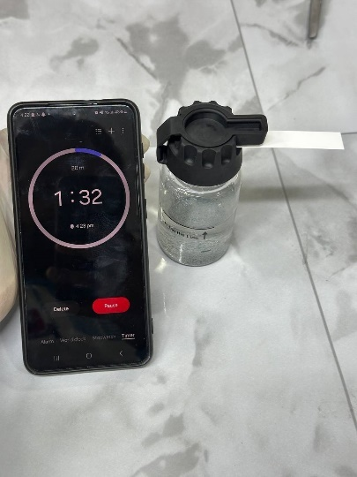
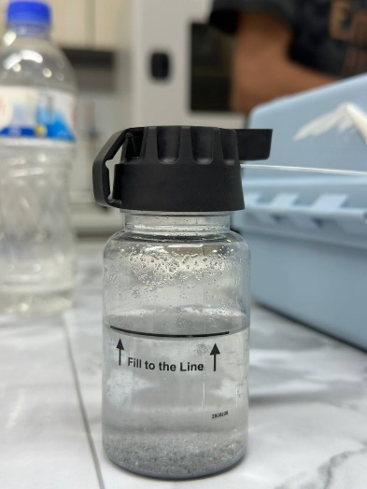
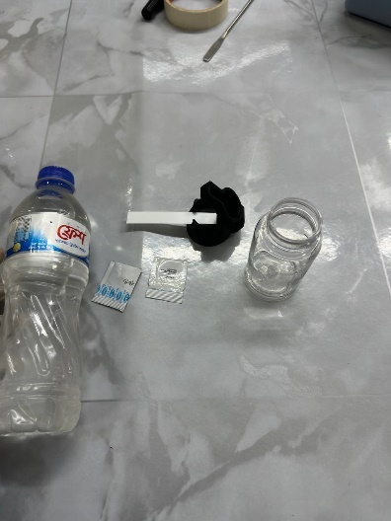
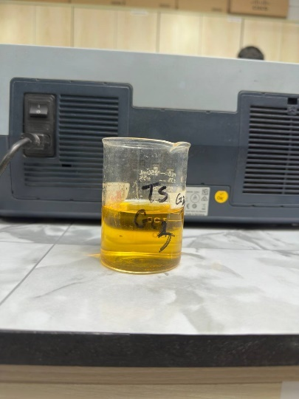
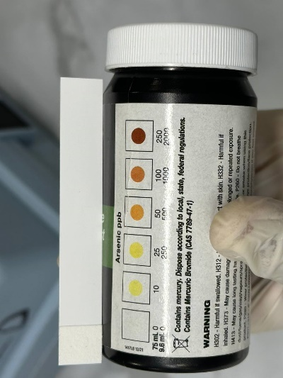
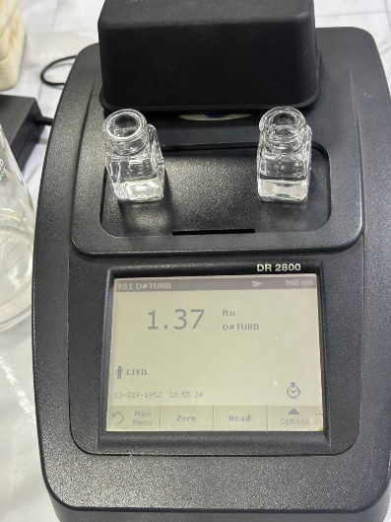
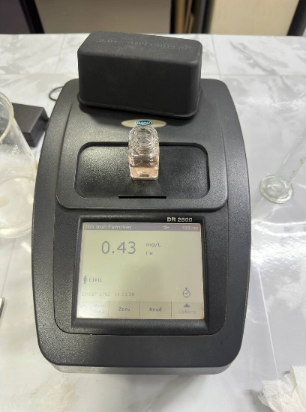
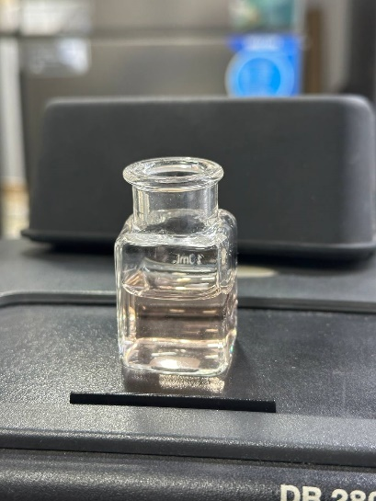
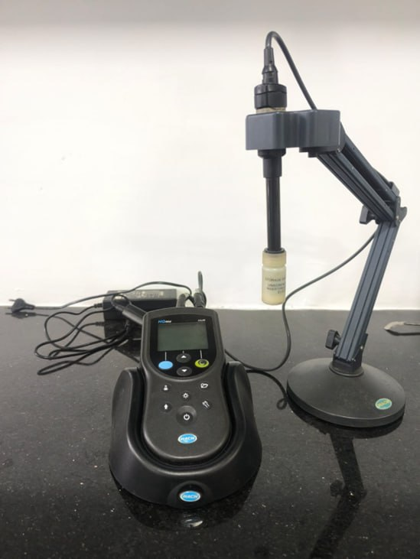
Fig: Arsenic Test Bottle
Fig: Arsenic Test
Fig: Arsenic Test Kit
Fig: Alkalinity Test
Fig: Arsenic Result Test
Fig: Turbidity Test
Fig: Iron Test Sample
Fig: Iron Test
Fig: pH Meter


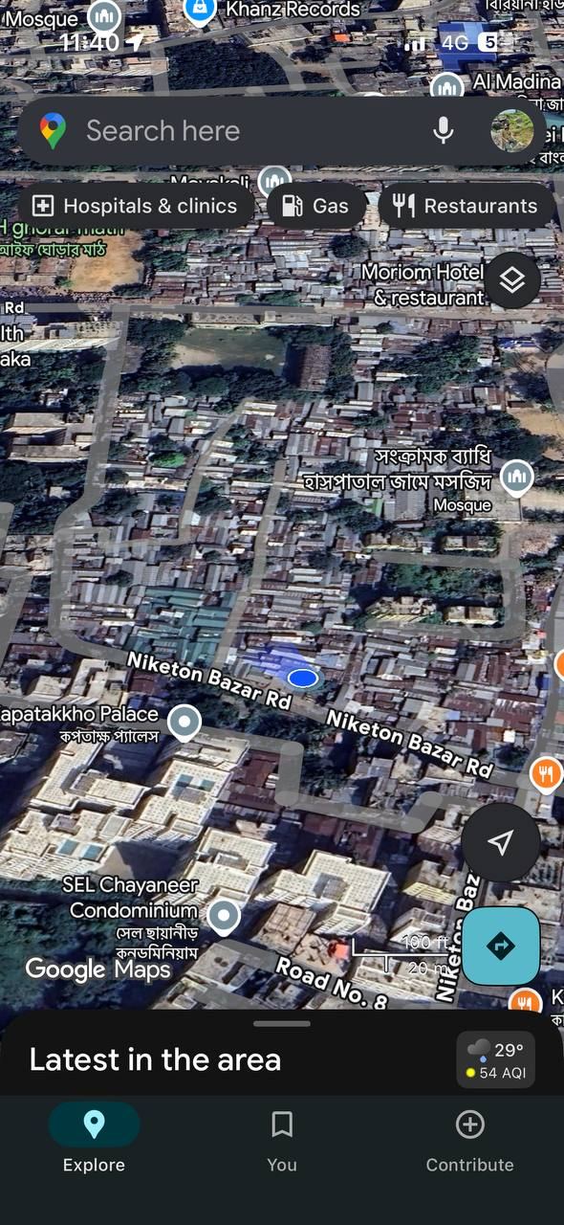
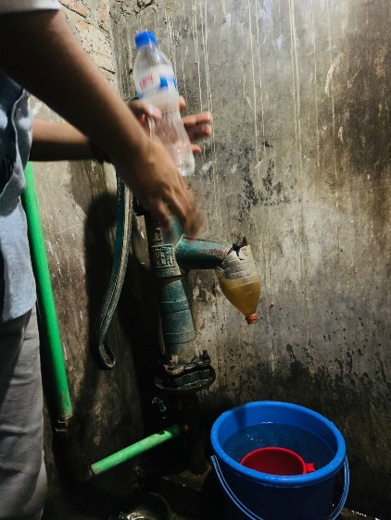
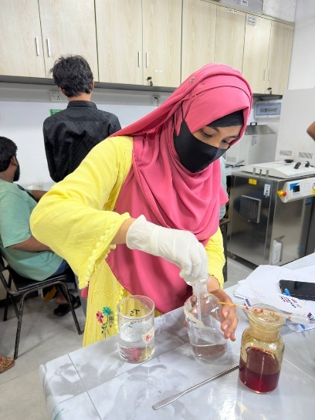
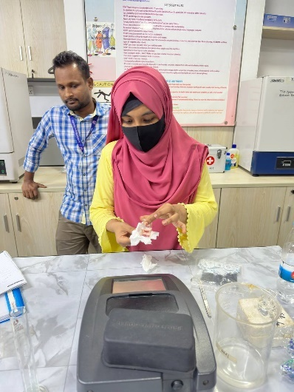
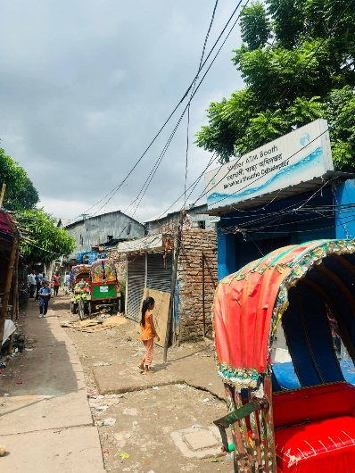
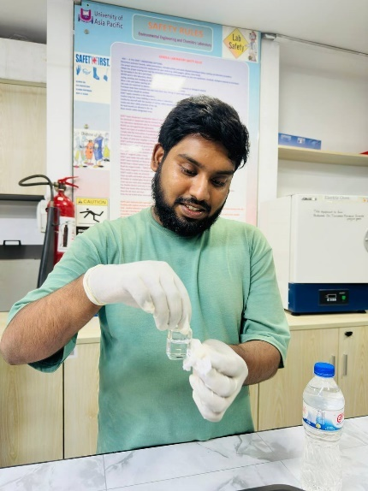
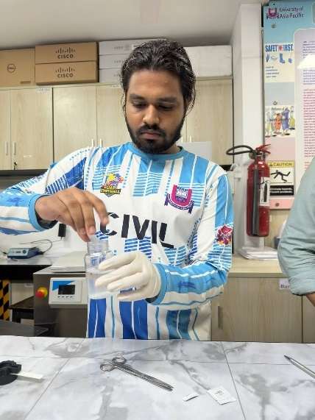
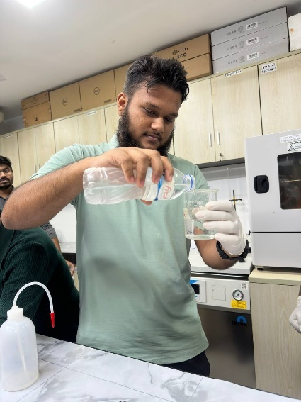
Fig: Local Person
Fig: Live Location
Fig: Sample Collecting
Fig: Slum Area Road
Fig: Iron Test Sample
Fig: Alkalinity Test Sample

