EDUGENIE
Google Gemini Powered Learning Assistant
PROJECT DOCUMENTATION
Project Title | EduGenie – Google Gemini Powered Learning Assistant
Technology Stack | Python • FastAPI • HTML • CSS • JavaScript • Google Gemini API
Submitted by | Tella Divya Sree
Mentor | Siri
Date | 11/04/2025

Table of Contents

Note: In Microsoft Word, right-click the table of contents and select “Update Field” if page numbers are not populated automatically.

1. Project Overview
EduGenie is a lightweight AI-powered educational assistant designed to simplify learning through generative AI. The project is intended for students and self-learners and provides a single web interface for question answering, concept explanation, quiz generation, summarization, and personalized learning recommendations.
The supplied project documentation describes EduGenie as a FastAPI-backed application with an HTML/CSS frontend and cloud-based generative AI capabilities. The current implementation in the accompanying VS Code project exposes REST endpoints for the major learning functions and serves the web interface from the same FastAPI application.

2. Project Description
EduGenie is an AI-powered educational assistant that simplifies learning through generative AI. The system enables users to ask questions and receive concise answers, understand complex concepts through simplified explanations, generate quizzes from topics or passages, receive personalized learning recommendations, and summarize large educational passages.
- Ask questions and receive smart, concise answers.
- Understand complex concepts through simplified explanations.
- Generate quizzes from topics or text.
- Receive personalized learning recommendations.
- Summarize large educational passages.
The original project document describes FastAPI as the backend and a simple HTML + CSS frontend. It also emphasizes lightweight, cloud-based AI processing so that the application can remain accessible to a broad range of learners and developers.

3. Scenarios
- A student wants to know about oceans and rivers and uses EduGenie to ask, “Which is the largest ocean?”
- A student wants to check her understanding of the Pythagoras Theorem and selects the quiz-generation function.
- A learner exploring SQL requests a learning path containing beginner-to-advanced topics, timelines, and learning suggestions.

4. Objectives
- Provide an accessible AI-assisted learning interface.
- Reduce the difficulty of understanding complex educational concepts.
- Provide quick question-and-answer support across academic topics.
- Generate practice questions for self-assessment.
- Convert long educational content into concise summaries.
- Produce structured learning recommendations from beginner to advanced levels.
- Keep the application modular so individual learning capabilities can be maintained and extended independently.

5. Scope of the System
The project focuses on an interactive learning assistant rather than a full learning-management system. Its core scope is educational content assistance: explanation, question answering, quizzes, summarization, and learning-path recommendations. The application is designed to run locally through an ASGI server while using the Gemini API for generative AI processing.

6. Architectural Diagram
The supplied project document presents an architecture in which a user interacts with a frontend interface, the frontend communicates with FastAPI endpoints, and the backend routes requests to the relevant AI-powered learning module.

Figure 1. Architectural flow represented in the supplied EduGenie project documentation.

7. Prerequisites
- Python 3.10 or later.
- FastAPI framework.
- HTML and CSS for the web interface.
- Google Gemini API key.
- Uvicorn ASGI server.
- Jinja2 HTML templating engine.

7.1 Python Installation
- Download a Python 3.10+ installer for the operating system.
- Run the installer and enable the option to add Python to PATH.
- Complete the installation.
- Verify the installation with: python --version

7.2 Gemini API Setup
- Open Google AI Studio and sign in with a Google account.
- Create or select the required project.
- Generate a Gemini API key.
- Store the key securely and configure it through the application's environment settings rather than hard-coding it into source files.

7.3 Supporting Packages
The project uses Uvicorn to serve FastAPI and Jinja2 for HTML templating. Typical installation commands are:
pip install uvicorn
pip install jinja2

8. Project Structure
The implemented project is organized into a small modular FastAPI application:
EduGenie/
├── .vscode/
├── static/
│ ├── style.css
│ └── app.js
├── templates/
│ └── index.html
├── tests/
│ └── test_api.py
├── .env
├── .env.example
├── .gitignore
├── README.md
├── ai_client.py
├── config.py
├── explanation_module.py
├── learning_path.py
├── main.py
├── models.py
├── qna.py
├── quiz_module.py
└── summary_module.py

9. Project Workflow and Milestones

Milestone 1: Model Selection and Architecture
The original project document describes two AI roles: Gemini 1.5 Pro for question answering, summarization, quiz generation, and learning paths, and LaMini-Flan-T5-783M for lightweight concept explanation. The current implementation is organized around a centralized Gemini client and modular learning functions; therefore, this report preserves the original model-selection description as project documentation while distinguishing it from the current code organization.

Activity 1.1: Select AI Models
- Gemini 1.5 Pro (as described in the supplied document): Q&A, summarization, quiz generation, and learning paths.
- LaMini-Flan-T5-783M (as described in the supplied document): concept explanation.
- Current implementation note: the VS Code project uses a configurable Gemini API client, with the selected Gemini model controlled through the environment configuration.

Milestone 2: Core Functionalities Development

9.1 Explanation Module
The explanation capability converts a complex topic into a simpler educational explanation. Its purpose is clarity and readability so that learners with limited background knowledge can understand essential ideas.

9.2 QnA Module
The Q&A capability provides responses to general knowledge and academic questions. The backend receives the learner's question, sends a structured prompt to the AI service, and returns the generated answer through the API.

9.3 Quiz Module
The quiz capability generates multiple-choice questions from supplied content. The supplied documentation specifies three questions with four options each and describes JSON-structured output for integration.

9.4 Summary Module
The summarization capability converts longer passages into concise, easy-to-understand versions while retaining the main information and reducing redundancy.

9.5 Learning Path Module
The learning-path capability generates a structured route through a topic, progressing from beginner to advanced concepts and including learning suggestions and resources.

10. Backend API with FastAPI
The application exposes REST-style endpoints for the main learning functions:
Endpoint | Purpose | Output
/qa | Question answering | AI-generated answer
/explain | Concept explanation | Simplified explanation
/quiz | Quiz generation | Structured MCQs
/summarize | Text summarization | Concise summary
/learn/recommendations | Learning path generation | Structured recommendations
The FastAPI application also provides the main web page and a health endpoint for basic service checks.

11. Frontend Development
The web interface provides a simple learner-facing form. The supplied documentation describes a task selector, a text area, a submit button, responsive styling, and a result container. Form submissions are sent to the FastAPI backend and the generated result is displayed in the interface.
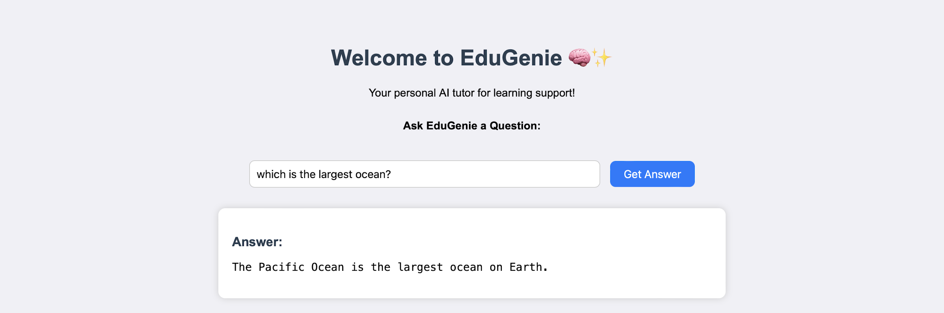
Figure 2. EduGenie landing interface shown in the supplied project material.
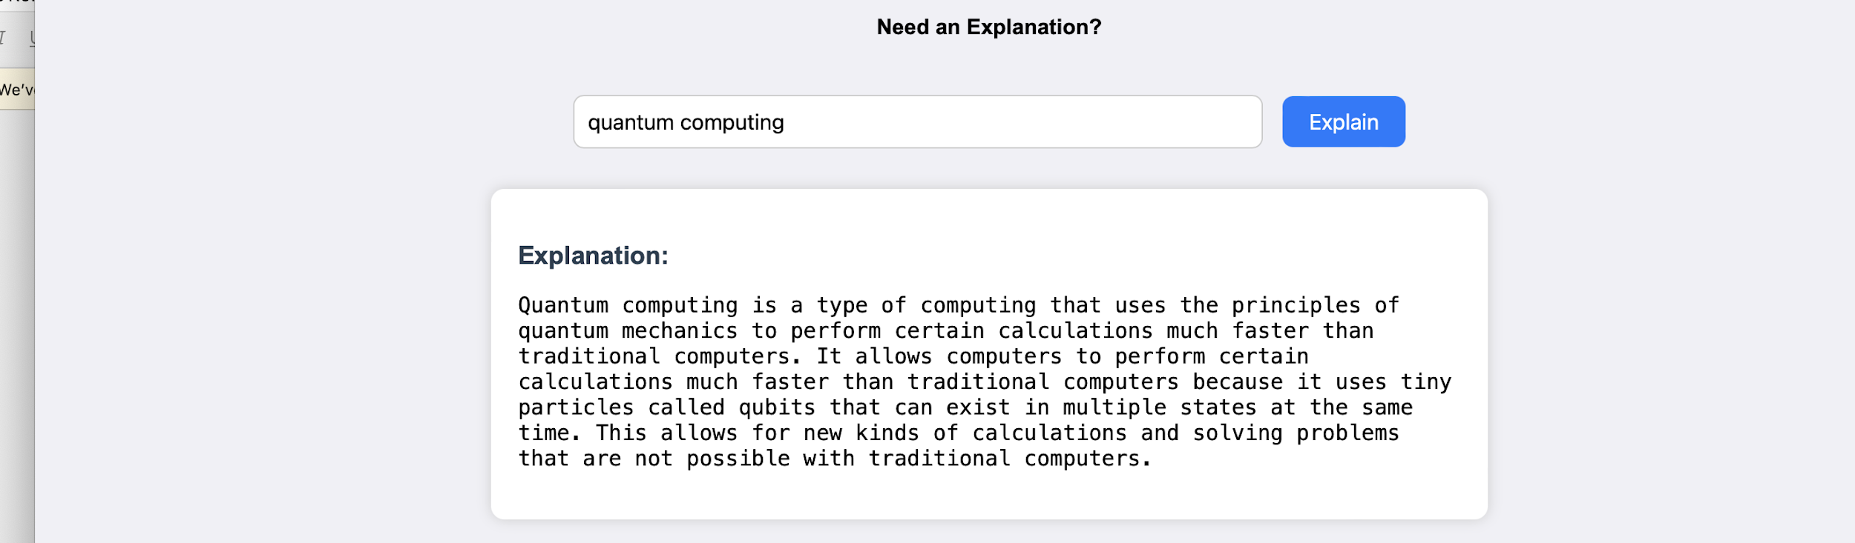
Figure 3. Explanation workflow in the EduGenie interface.

12. Live Integration
The frontend sends a POST request to the selected FastAPI endpoint. The backend processes the request through the relevant module and AI service, and the result is returned to the browser for display.

13. Deployment and Local Execution
The supplied project documentation specifies local execution through Uvicorn:
uvicorn main:app --reload
The application is then accessed at:
http://127.0.0.1:8000

14. Functional Testing
The project documentation identifies the following functional checks:
- Ask a question.
- Get an explanation.
- Generate a quiz.
- Summarize content.
- Get a personalized learning plan.
Test Case | Input | Expected Result | Status
TC-01 | Academic question | A relevant AI-generated answer is displayed | Functional workflow
TC-02 | Concept/topic | A simplified explanation is displayed | Functional workflow
TC-03 | Topic or passage | MCQs with options and correct answers are produced | Functional workflow
TC-04 | Long passage | A concise summary is displayed | Functional workflow
TC-05 | Learning topic | A structured learning path is displayed | Functional workflow

15. User Interaction Examples
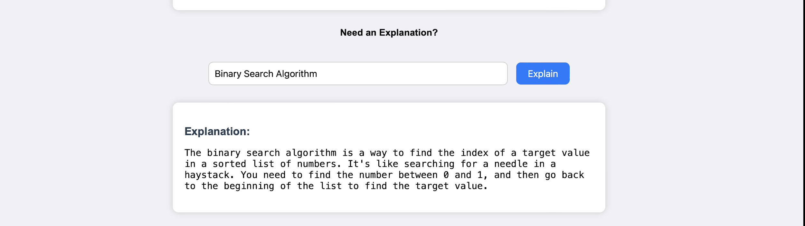
Figure 4. Question-and-answer interaction.
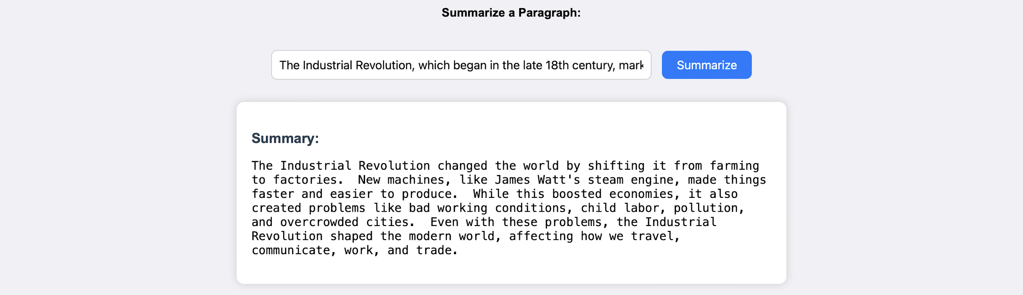
Figure 5. Summary interaction.
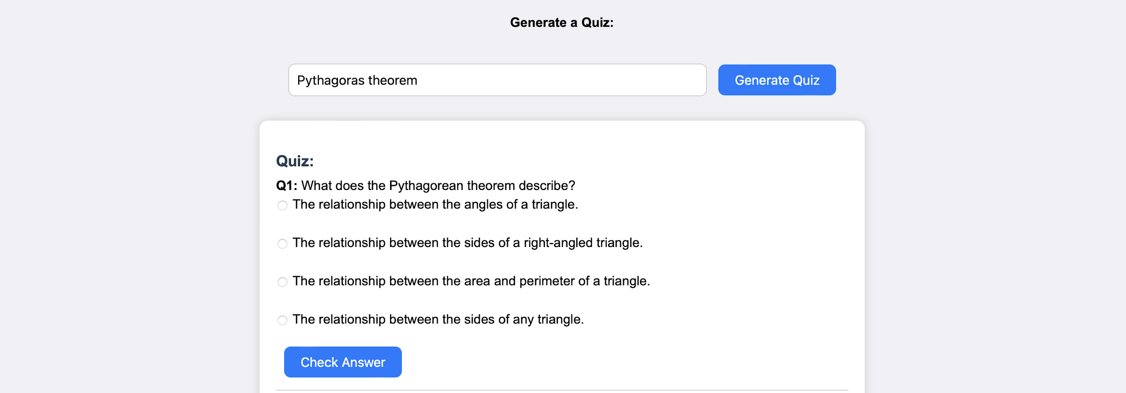
Figure 6. Learning recommendation interaction.
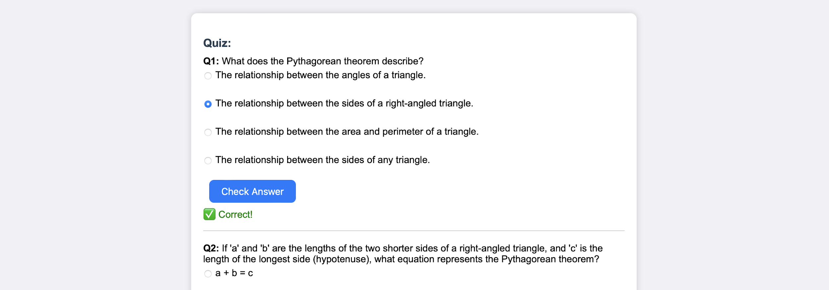
Figure 7. Quiz generation interaction.
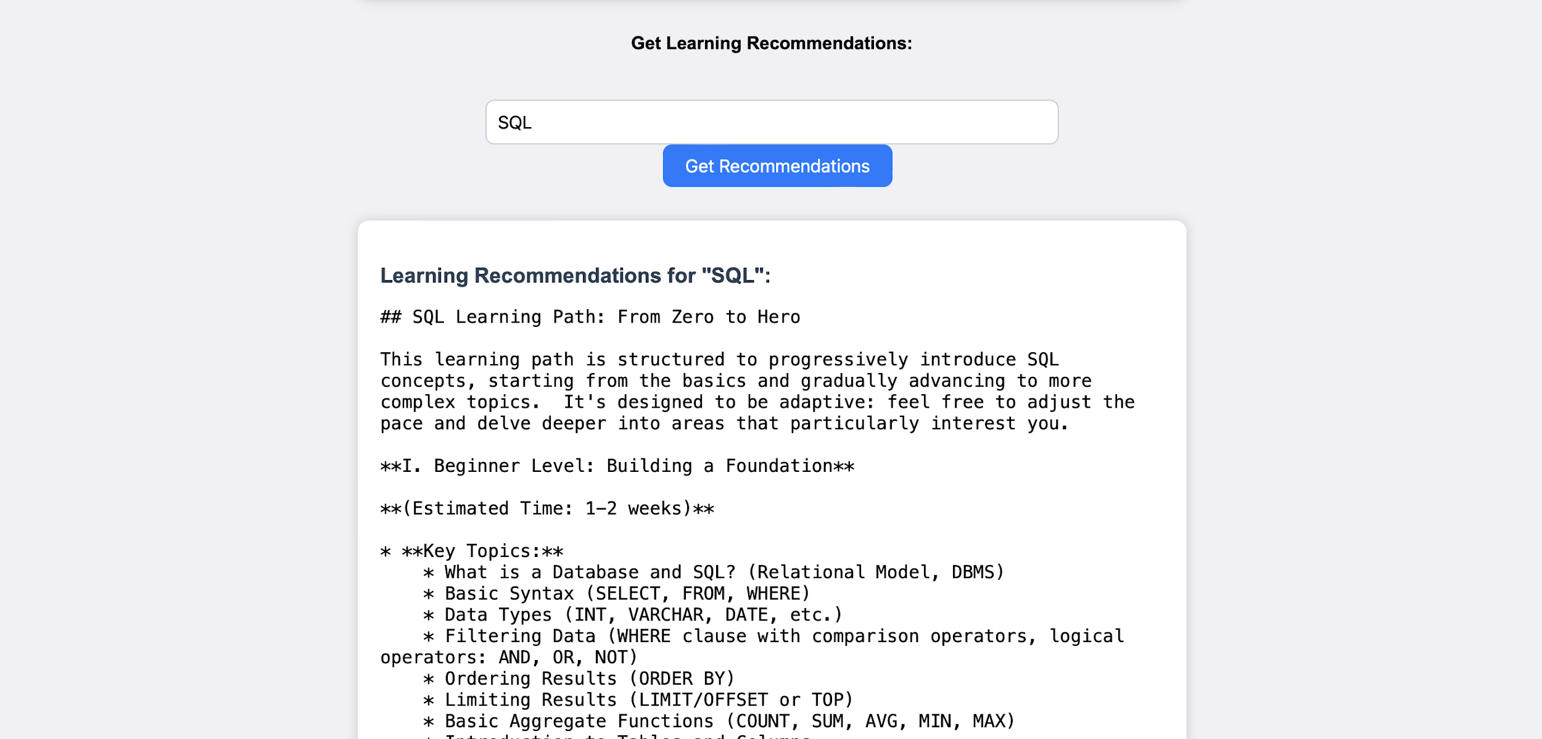
Figure 8. Learning-path output example.

16. Conclusion
EduGenie has been developed as an accessible AI-powered educational assistant that combines cloud-based intelligence with an intuitive web interface. The project supports self-learning by simplifying complex concepts, answering questions, generating quizzes, producing summaries, and creating structured learning paths.
The project demonstrates key development milestones in AI integration, user-interface design, modular backend development, and educational content adaptation. Its modular structure also provides a practical foundation for future improvements.
The supplied documentation identifies challenges including the accuracy of AI-generated responses, performance across devices, personalization, and data privacy. These challenges highlight the importance of prompt design, continuous testing, user-focused interface design, and responsible handling of API credentials.

17. Future Scope
- Voice-based interaction for hands-free learning and accessibility.
- Multilingual support to reduce language barriers.
- A dedicated mobile application with possible offline features.
- Progress-tracking dashboards and learner analytics.
- Gamification through badges, learning streaks, and challenge-based assessments.
- Adaptive learning paths based on learner strengths and weaknesses.
- Group study sessions and teacher/parent dashboards.
- Integration with Learning Management Systems such as Moodle or Google Classroom.
- Image and PDF input for doubt solving and resource summarization.
- Real-time synchronization and smart notifications.

18. Security and Responsible Use
The Gemini API key should be stored in environment configuration and should not be committed to source control or exposed in screenshots. AI-generated educational responses should also be treated as assistance rather than an automatic substitute for authoritative academic sources. For production deployment, additional controls such as authentication, rate limiting, logging, input validation, and privacy-aware data handling should be considered.

19. References and Supporting Documentation
- Google AI for Developers — Gemini API documentation.
- FastAPI documentation and user guide.
- Jinja2 documentation.
- Python documentation.
- Uvicorn documentation / PyPI package information.
- The supplied EduGenie project document: “EduGenie: Google Gemini Powered Learning Assistant”.

20. Project Submission Information
Submitted by: Tella Divya Sree
Mentor: Siri
Date: 11/04/2025

— End of Project Documentation —

