How to use College Pool

**CONTENTS**

1. Log In and Basic site navigation………………………………………………………………. 2
2. How to view Tables……………………………………………………………………………...3
3. How to view Reports………………………………………………………………………….... 5
4. How to view Dashboards………………………………………………………………………. 6
5. How to Log out …………………………………………………………………………………. 7

This document demonstrates how to access and use the CollegePool database reports and dashboards.

A] Basic site navigation

Step 1: Login at login.salesforce.com.

Step 2: Click app drawer button on the top left corner.

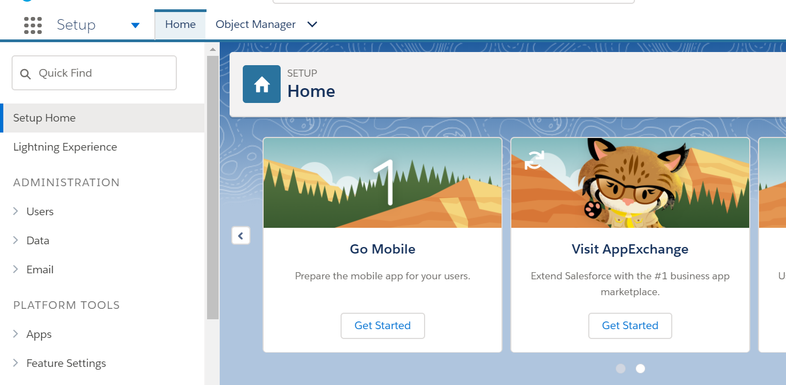

Step 3: Click on the CollegePool application

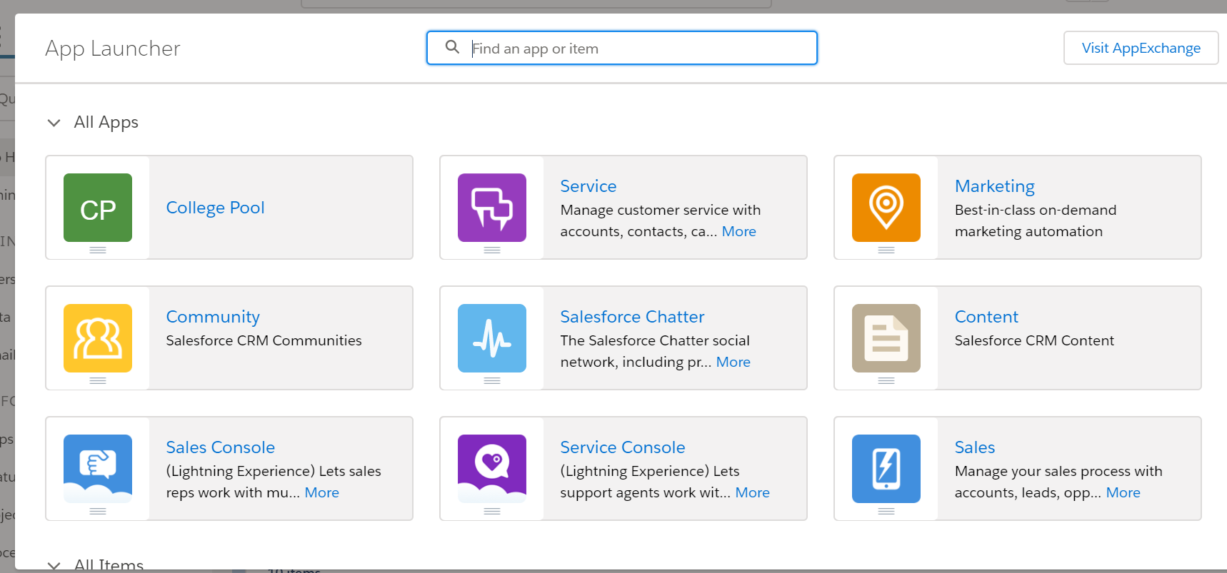

This is the main menu bar of the application. Clicking on any of the tab will take you to that page. Demonstrated below are 3 items you can view on the application.



B] To View a table (University table)

1. Click on the university tab. This page shows the recently made entries in this table.

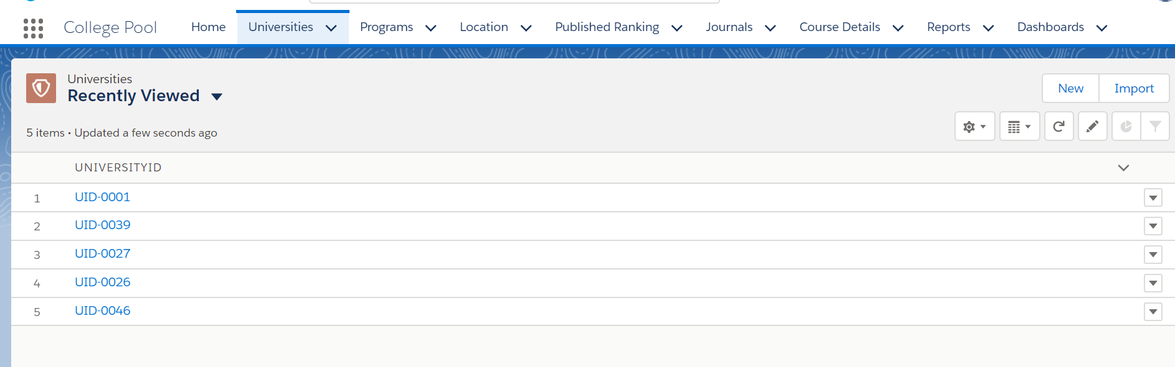

2. Clicking on the ID takes you to that particular record’s details.

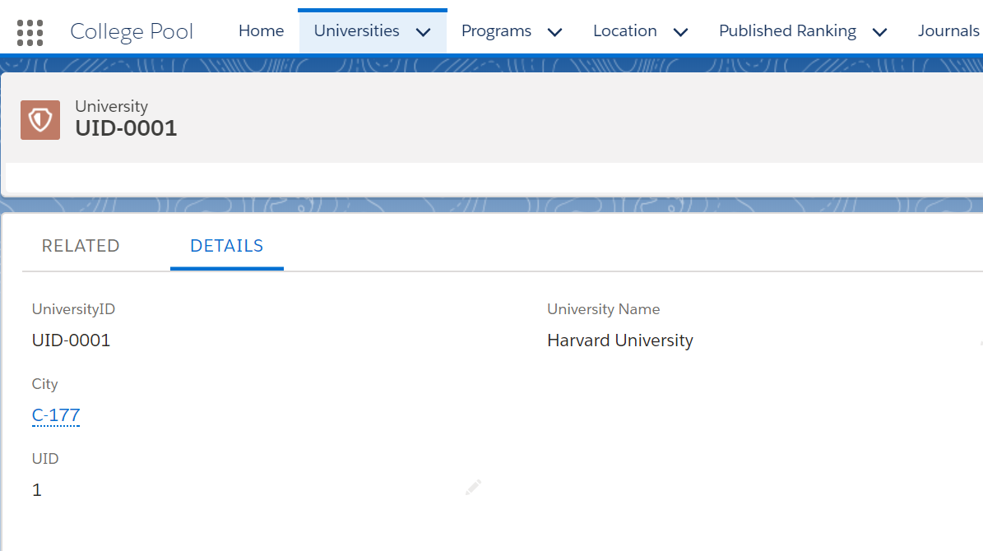

3. All other related records to this record can be checked by clicking on the ‘Related’ button.

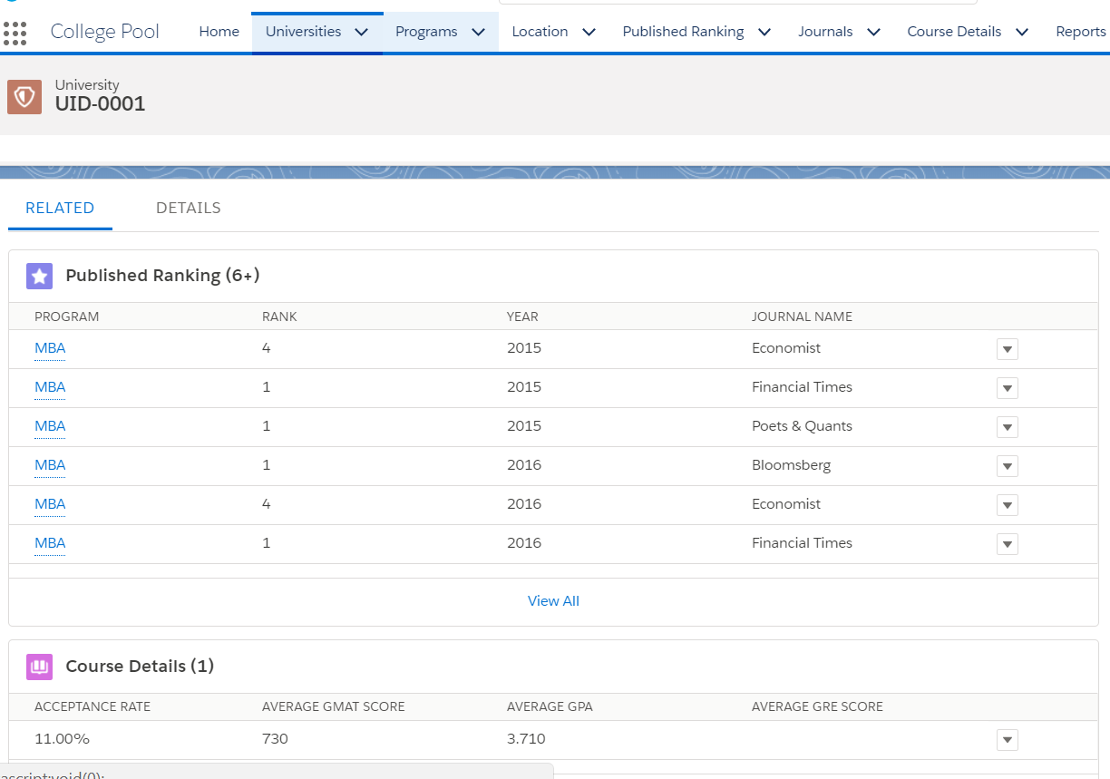

C] To view reports

1.Click on the Reports tab



2. Select any record that you want to view form the list of the records.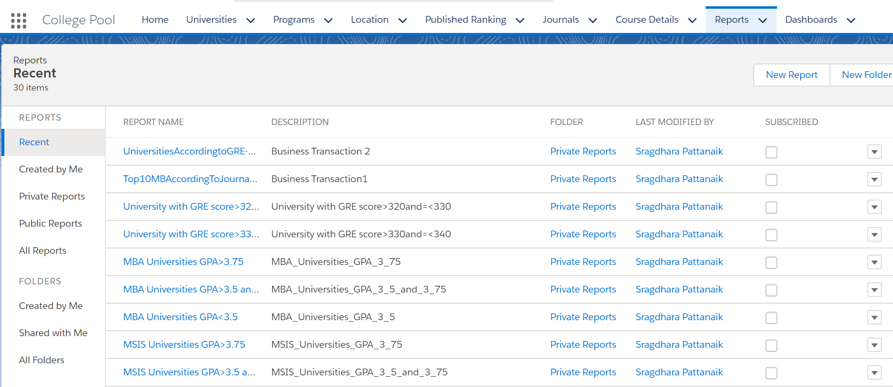

3. This is the record view. Clicking on any entry ID will take you to the record page.

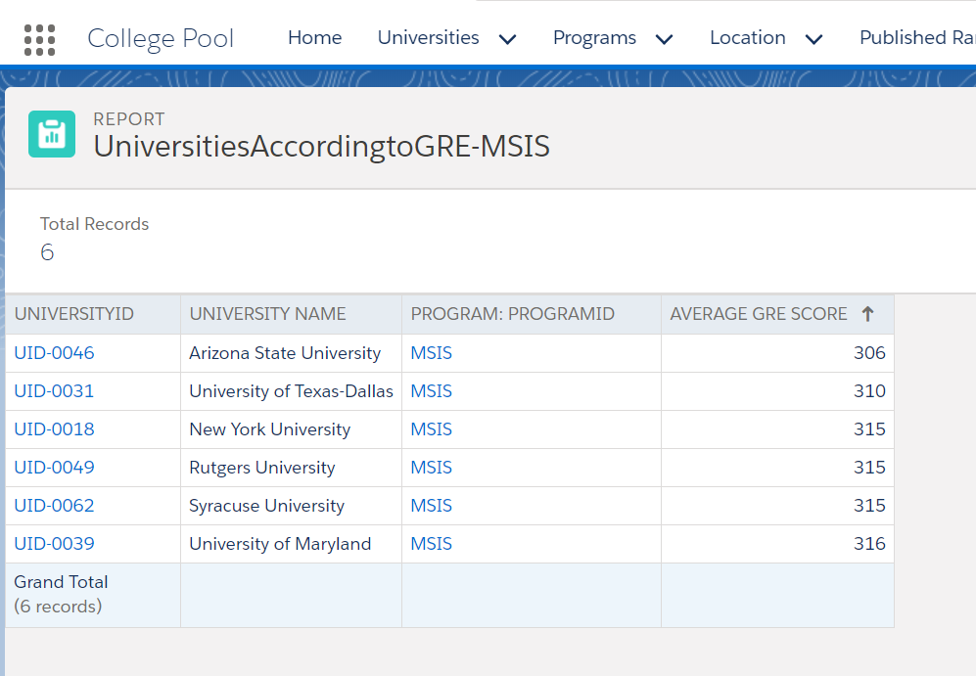

D] To view Dashboards

1. Click on Dashboard on the main tab. It will show you the list of dashboards available for viewing.

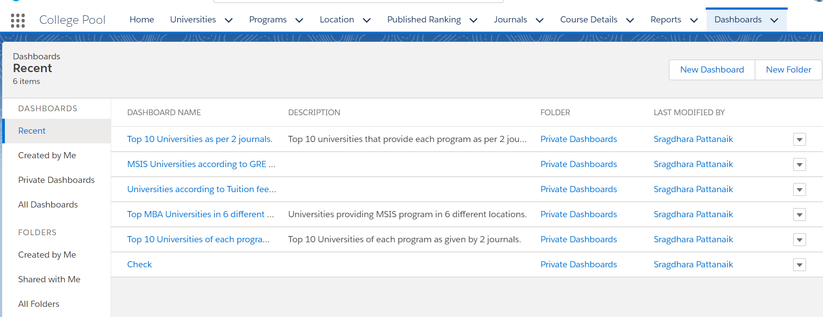

2. Clicking on the particular dashboard will show you the dashboard.

Following are the examples of dashboards on our system:

1. Top 10 universities as per 2 journals

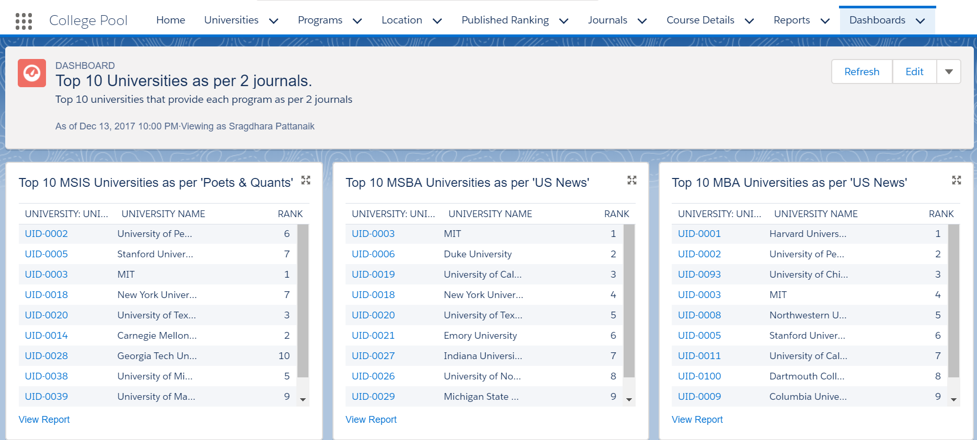

b) Top MBA universities in 5 different popular states as given by US News

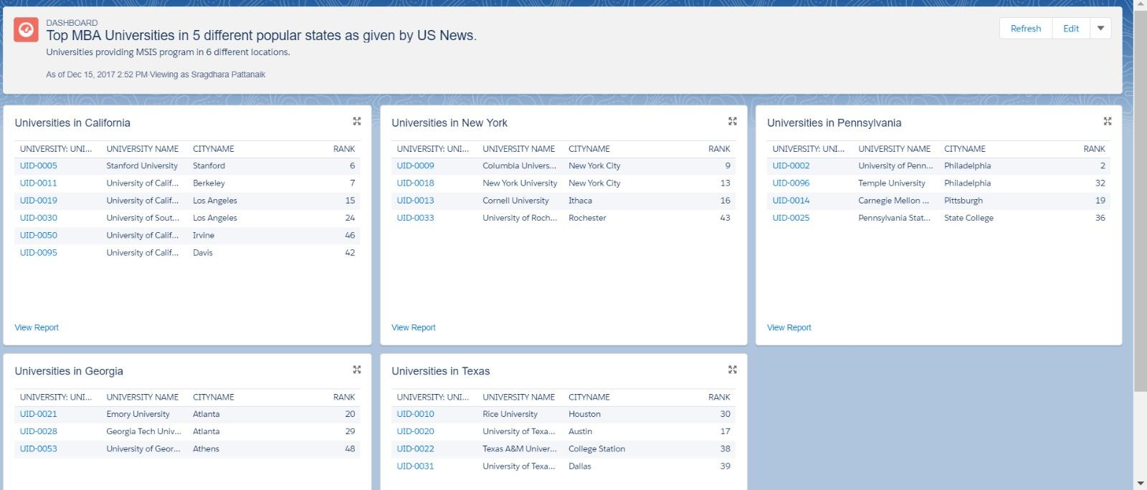

c) MSIS Universities according to GRE Marks

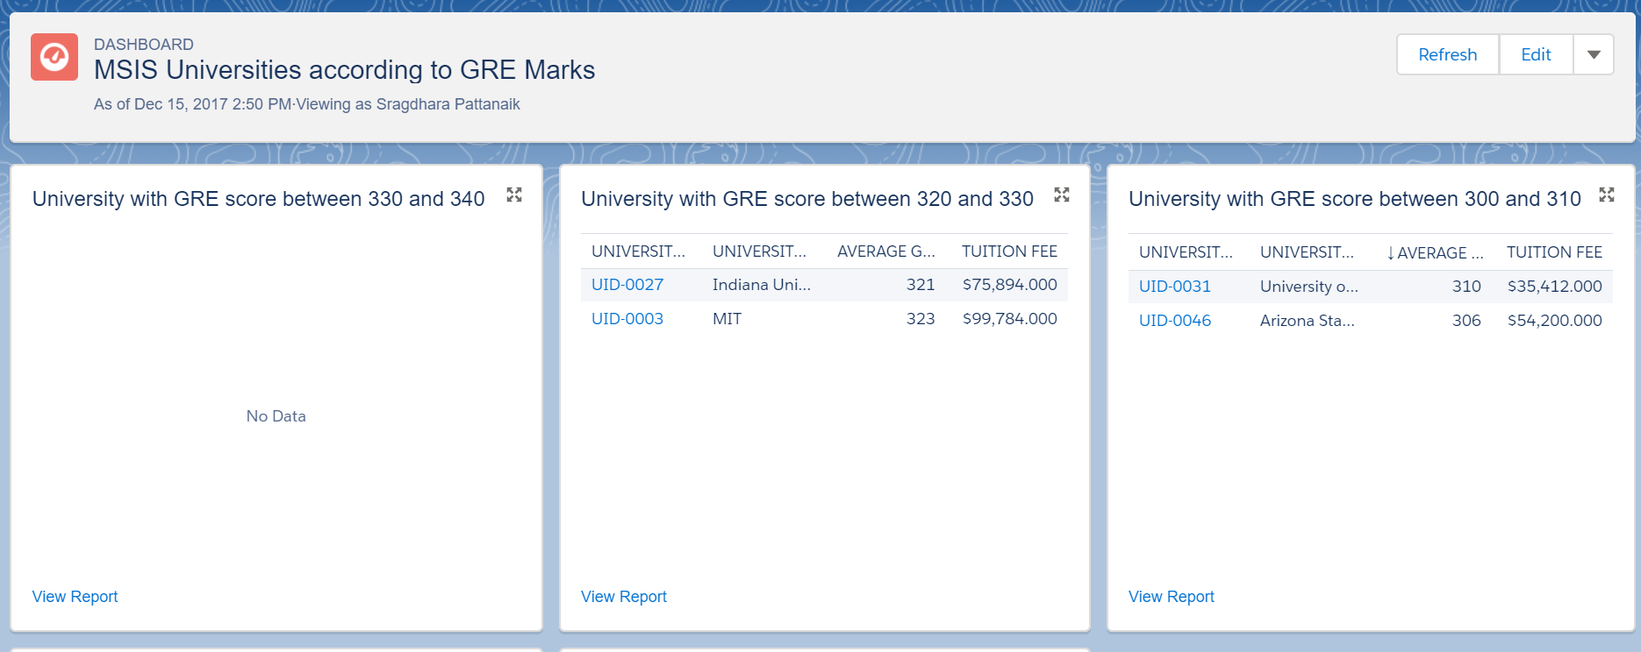

d) Universities according to their Tuition fees (for MBA)

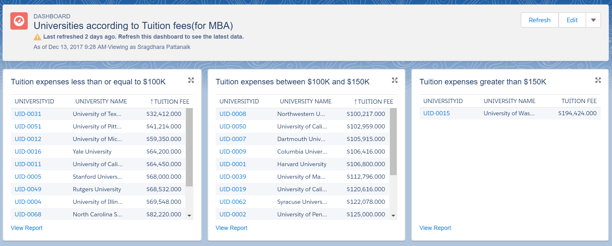

e) Universities according to GPA - user can customize using filter conditions and can select which report to view

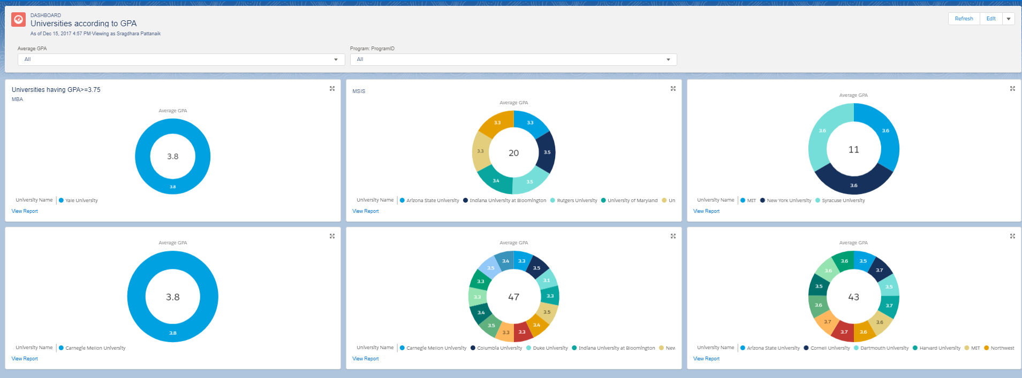

E] Steps to Log Out

1. Click on the user icon on top right corner of any page.
2. Click on logout.

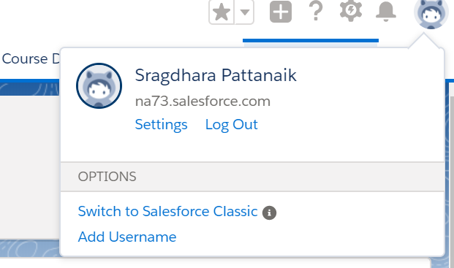

Thank you for using CollegePool!