print('{0},{1},{2}'.format('apple','banana','carrot','pen'))

print('{},{},{}'.format('apple','banana','carrot'))

print('{2},{1},{0}'.format('apple','banana','carrot'))

print('{2},{1},{1},{0}'.format('apple','banana','carrot'))

print('{2},{1},{0}'.format(*'abcd'))

print('{0},{1},{0}'.format('apple','banana','carrot'))

print('coordinates:{latitude},{longitude}'.format(

latitude='37.24N',longitude='115.81W'))

print('welcome:{name},your college is:{college}'.format(name='harish',college='IMSUC'))

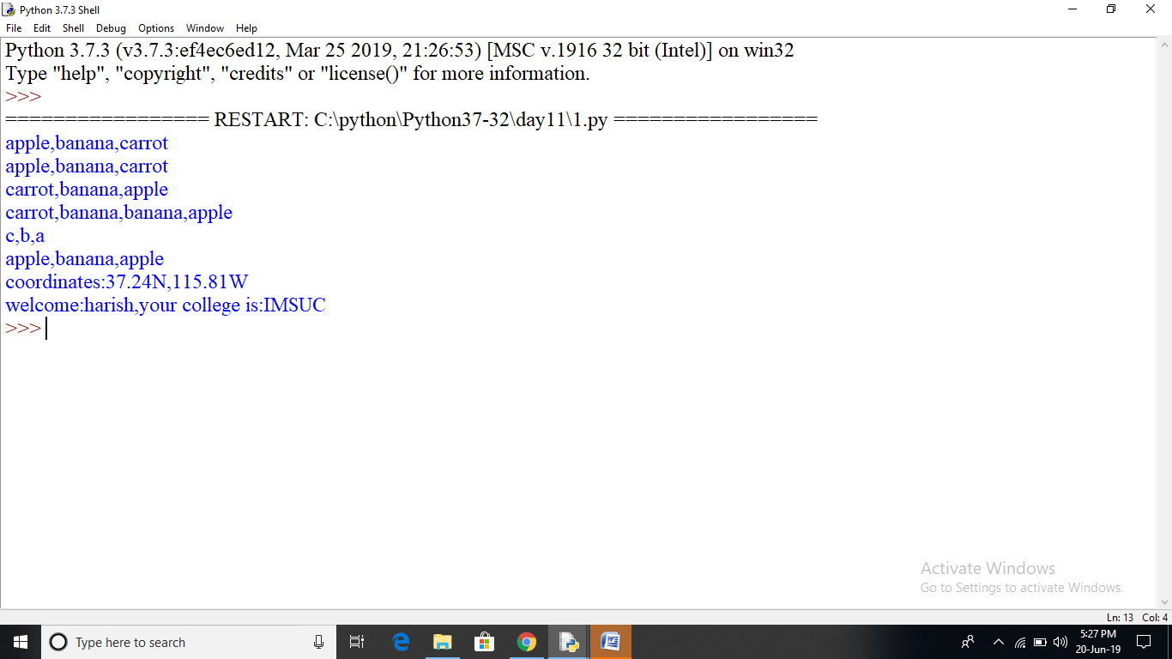

coord={'latitude':'37.24N','longitude':'-115.81W'}

print('coordinates:{latitude},{longitude}'.format(**coord))

c=3-5j

print("the complex number {0}is formed from the real\

part {0.real} and the imaginary part {0.imag}.".format(c))

coord=(3,5)

abc=(2,9)

print('X:{0[0]};Y:{0[1]};abc:{1[0]},{1[1]}'.format(coord,abc))

coord=[(3,9),(2,4)]

print('first tuple:{0[0]},{0[1]},second tuple:{1[0]},{1[1]}'.format (*coord))

print('{:#<30}'.format('apple'))

print('{:*<30}'.format('apple'))

print('{:^30}'.format('apple'))

print('{:*^30}'.format('apple'))

print("int:(0:d); hex:{0:x};oct:{0:o};bin:{0:b}".format(42,55))

print("int:(1:d); hex:{1:x};oct:{1:o};bin:{1:b}".format(42,55))

print('{:,}'.format(123456780))

points=19.0;total=22

print('correct answer:{:.4%}'.format(points/total))

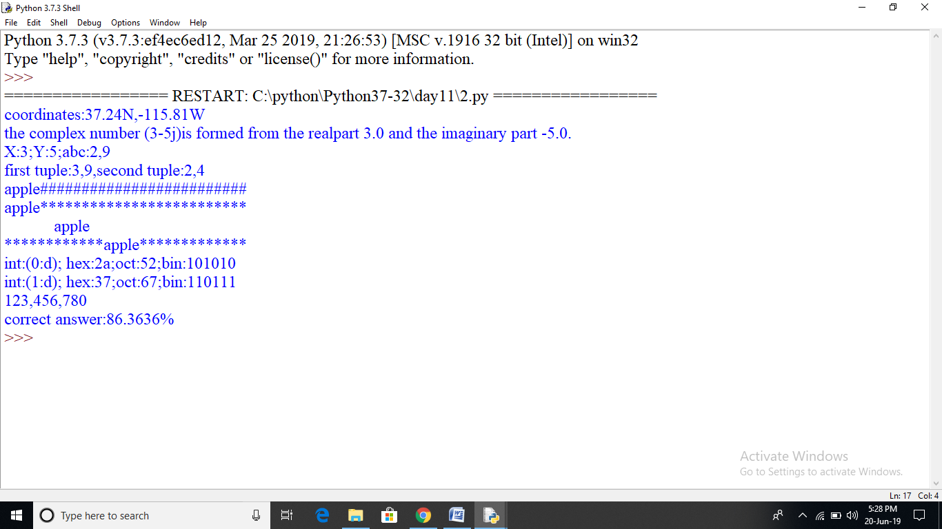

def demo_yield():

print("code of segment1 executed")

yield 1

print("code of segment2 executed")

yield 2

print("code of segment3 executed")

yield 3

print("code of segment4 executed")

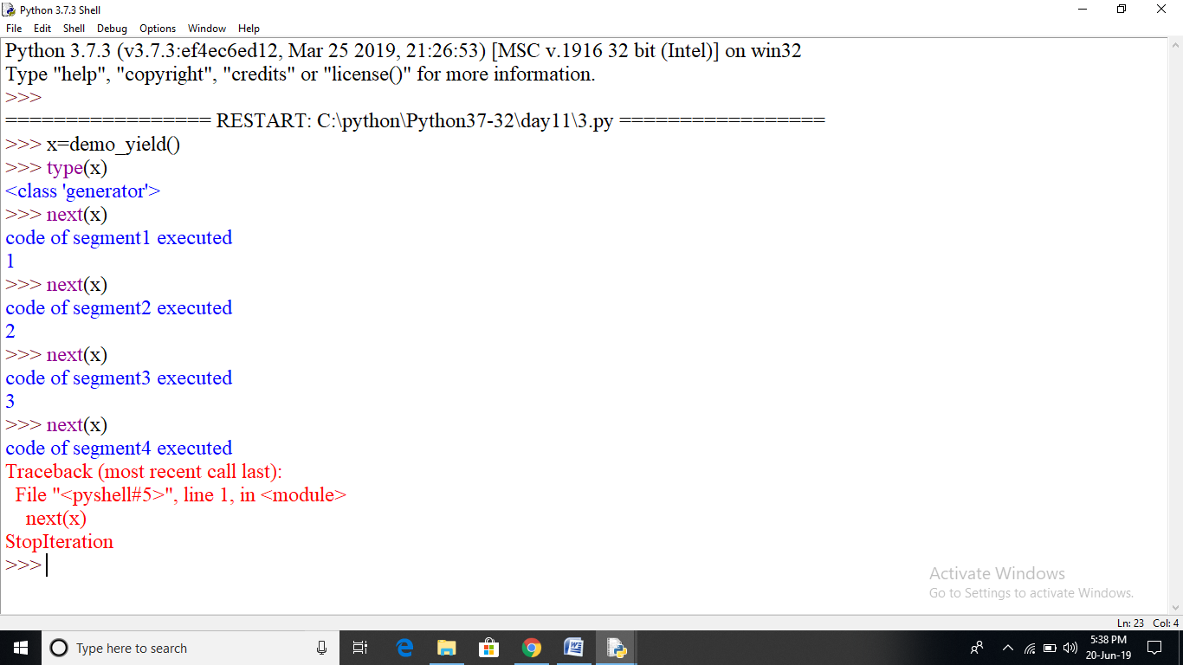

def sum_num(x):

res=0

for i in range (x+1):

res=res+i

print("i=",i,"res=",res)

yield res

ob=sum_num(10)

for i in range(11):

print(next(ob))

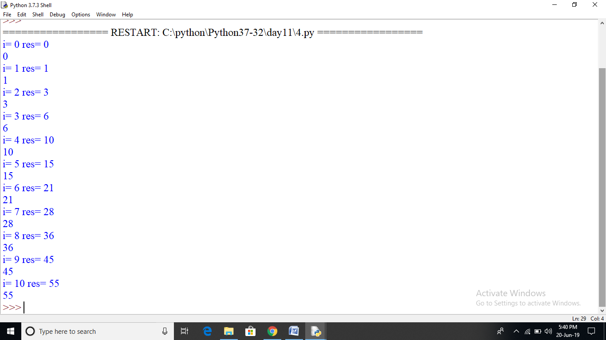

a=7

b=1 if a>=5 else 42

print(b)

status=1

msg="logout" if status==1 else "login"

print(msg)

c=1 if 2+2==5 else 2

print(c)

