import numpy as np

from sklearn import preprocessing

input_data=np.array([[2.1,-1.9,5.5],[-1.5,2.4,3.5],[0.5,-7.9,5.6],[5.9,2.3,-5.8]])

print("inputData:\n",input_data)

#binarization

data_binarized=preprocessing.Binarizer(threshold=1.5).transform(input_data)

print("\nBinarized data:\n",data_binarized)

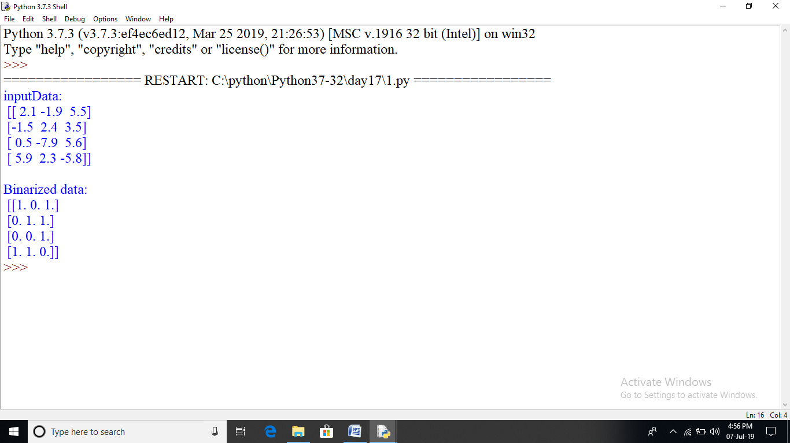

import numpy as np

from sklearn import preprocessing

input_data=np.array([[2.1,-1.9,5.5],[-1.5,2.4,3.5],[0.5,-7.9,5.6],[5.9,2.3,-5.8]])

print("inputData:\n",input_data)

#meanRemoval

print("mean=",input_data.mean(axis=0))

print("std deviation=",input_data.std(axis=0))

data_scaled=preprocessing.scale(input_data)

print("data_scaled:\n",data_scaled)

print("mean=",data_scaled.mean(axis=0))

print("std deviation=",data_scaled.std(axis=0))

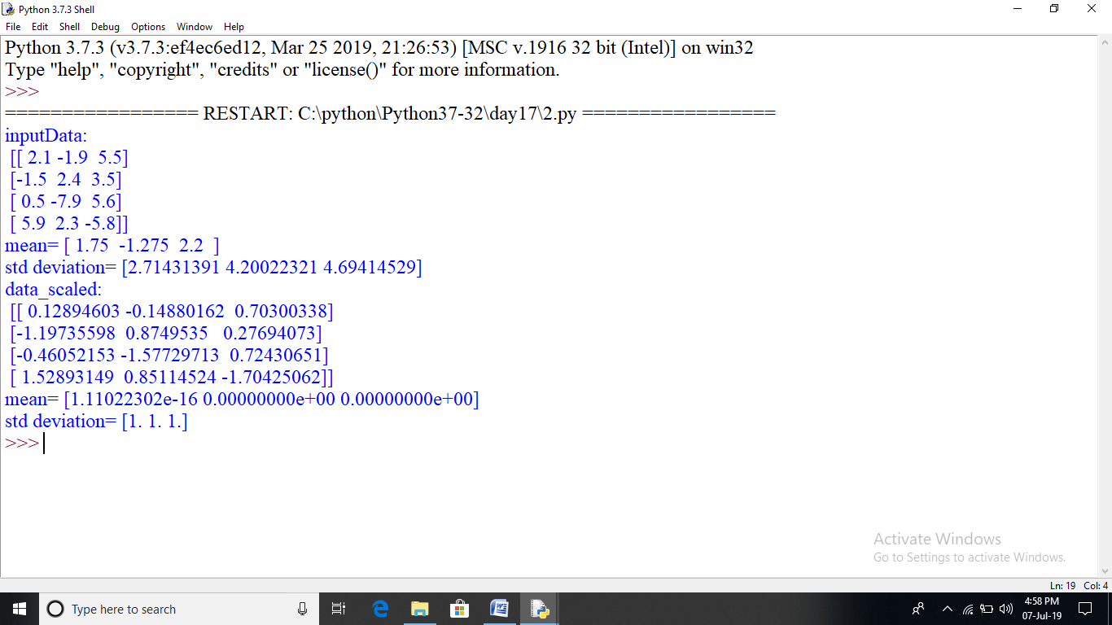

import matplotlib.pyplot as plt

xs=[2,3,4,5,6,7,8,9,10,11,12,13,14,15,16,17,18,19,20,21,22,23,24,25]

ys=[10,12,20,22,21,25,30,21,32,34,35,30,50,45,55,60,66,64,67,72,74,80,79,84]

print(len(xs),len(ys))

import numpy as np

def slope_intercept(x_val,y_val):

x=np.array(x_val)

y=np.array(y_val)

m=(((np.mean(x)*np.mean(y))-np.mean(x*y))/

(np.mean(x)**2-np.mean(x**2)))

m=round(m,2)

b=(np.mean(y)-np.mean(x)*m)

return m,b

m,b=slope_intercept(xs,ys)

reg_line=[(m*x)+b for x in xs]

plt.scatter(xs,ys,color="red")

plt.plot(xs,reg_line)

plt.ylabel("dependent variable")

plt.xlabel("Independent variable")

plt.title("making regression line")

plt.show()

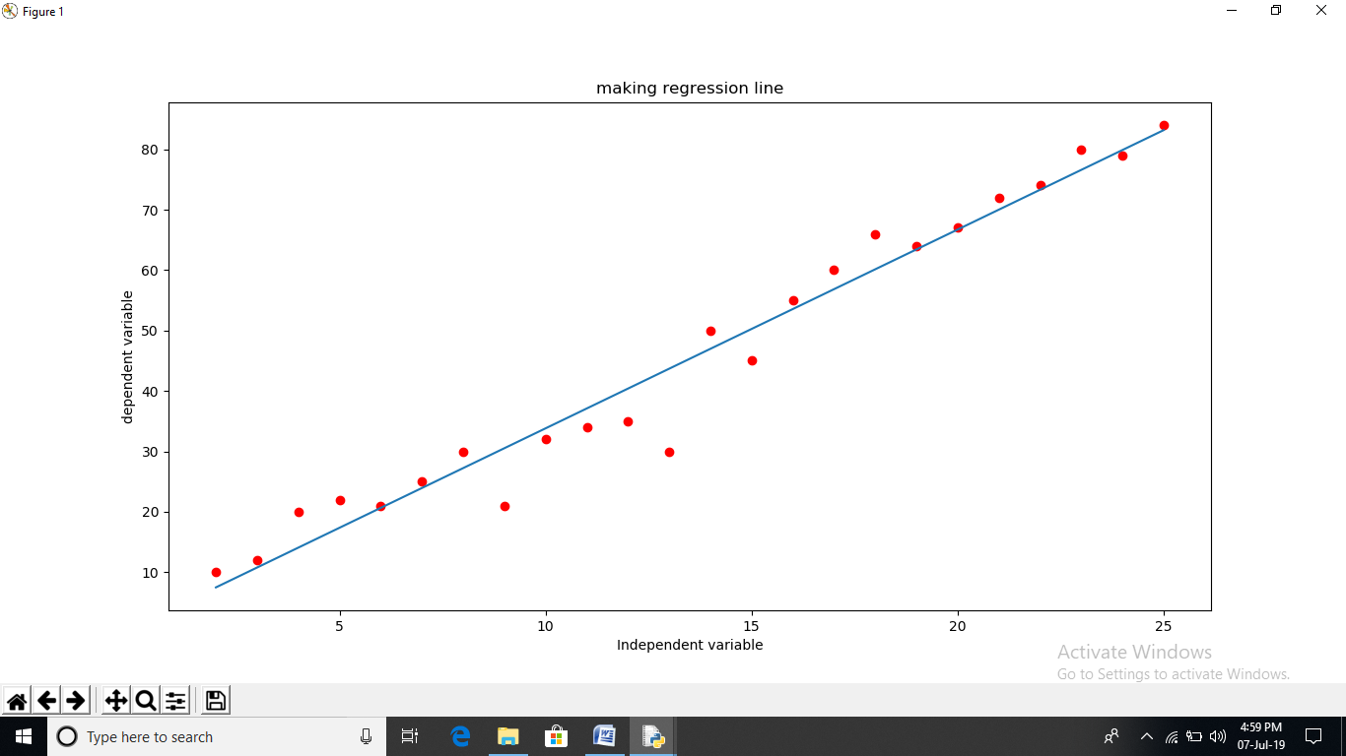

from sklearn import tree

clf=tree.DecisionTreeClassifier()

#[height,hair,length,voice-pitch]

X=[[180,15,0],

[167,42,1],

[136,35,1],

[174,15,0],

[141,28,1]]

Y=['man','woman','woman','man','woman']

clf=clf.fit(X,Y)

prediction=clf.predict([[120,10,1]])

print(prediction)

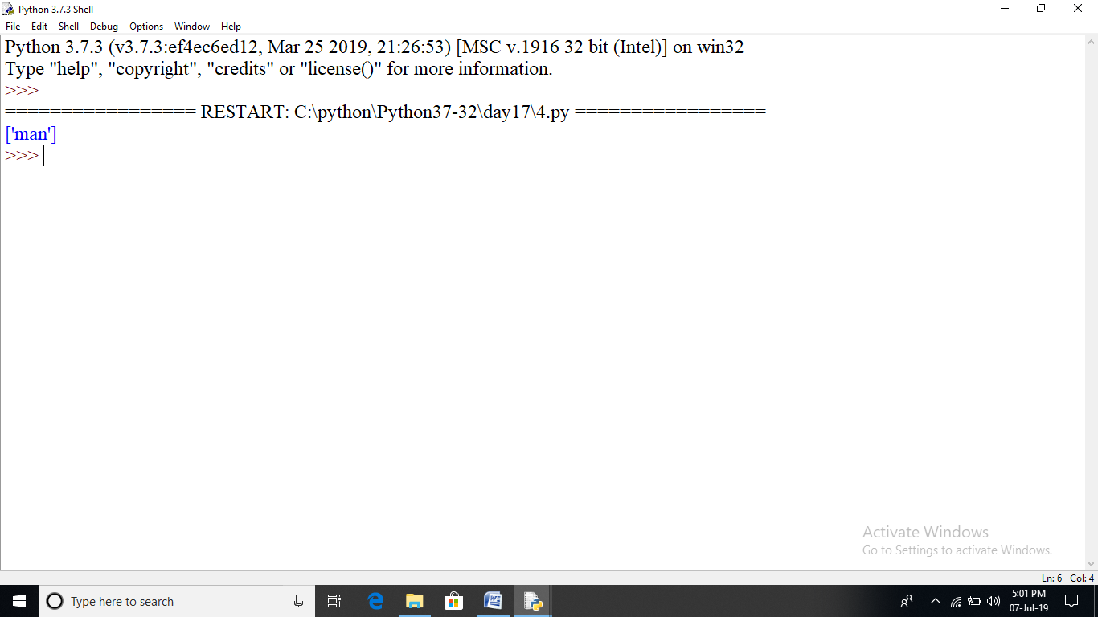

import sklearn

from sklearn.datasets import load_breast_cancer

data=load_breast_cancer()

label_names=data['target_names']

labels=data['target']

feature_names=data['feature_names']

features=data['data']

print("label names:",label_names)

print(labels[0])

print(feature_names[0])

print(features[0])

#forganizing data into sets

from sklearn.model_selection import train_test_split

train,test,train_labels,test_labels=train_test_split(features,labels,test_size=0.40,random_state=42)

#building the model

#native bayes algo

from sklearn.naive_bayes import GaussianNB

gnb=GaussianNB()

model=gnb.fit(train,train_labels)

#evaluating the model and its accuracy

preds=gnb.predict(test)

print(preds)

from sklearn.metrics import accuracy_score

print(accuracy_score(test_labels,preds))

