//Volume of a box

import math

l=float(input("enter length"))

b=float(input("enter breadth"))

h=float(input("enter height"))

vol=l\*b\*h

print("the volume is ",vol)

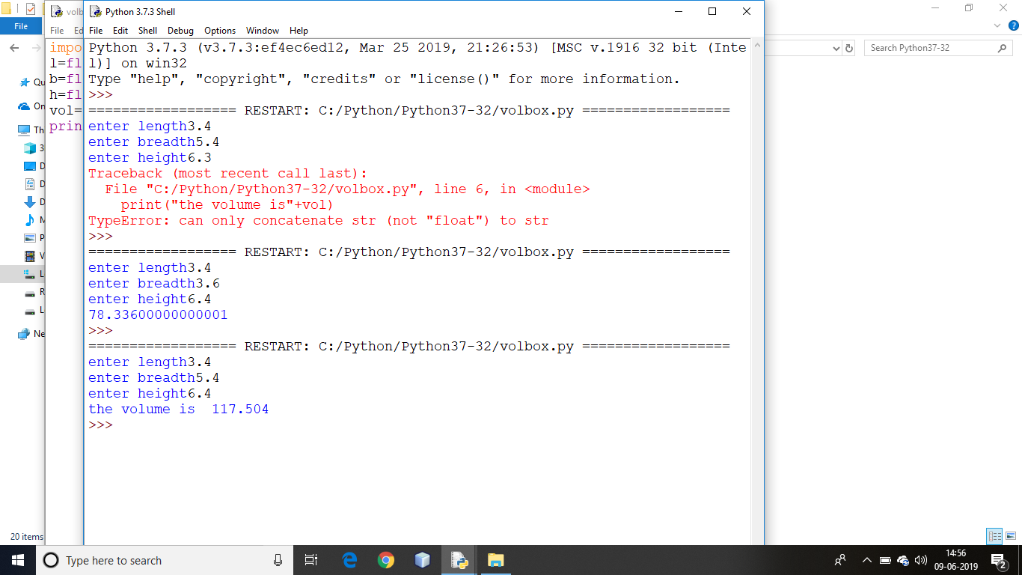

//Volume of earth

import math

p=math.pi

r=6.4\*10\*\*6

vol=4/3\*p\*r\*\*3

print("the volume of earth is metre cube is:",vol)

